Requirement: Macro Research Dashboard
- User Story:
Title: Macro Research Dashboard | Jira Id: | Priority: High | Estimate:
User Story:

As an Admin

I want to view registration of Macro Research Proposal dashboards and able to download the registration in excel format,

So that: User will view registration of Macro Research Proposal and able to download it excel format.

Acceptance Criteria:
- Login Page
Given I am at Macro Research Admin Login Page,

When the page loads,

Then I should see the following elements:
- User will view IIBF Symbol.
- User will view username and password.
- User will view captcha for verification.

- Individual Dashboard
Given I am at Macro Research Admin Page,

When I select Individual from sidebar menu,

Then I should see the following elements:
- User will view details of registration in list format. Details like Name, Designation, Address, Email, Contact No., Title of the Macro Research, Major objective of Research and FL.
- User will also able to download all the registration in excel format and in pdf format.

- Joint Dashboard
Given I am at Macro Research Admin Page,

When I select Joint from sidebar menu,

Then I should see the following elements:
- User will view details of registration in list format. Details like Name, Designation, Address, Email, Contact No., Title of the Macro Research, Major objective of Research and FL.
- User will also able to download all the registration in excel format and in pdf format.

- Institutional Dashboard
Given I am at Macro Research Admin Page,

When I select Institutional from sidebar menu,

Then I should see the following elements:
- User will view details of registration in list format. Details like Name, Designation, Address, Email, Contact No., Title of the Macro Research, Major objective of Research and FL.
- User will also able to download all the registration in excel format and in pdf format.

- Functional Requirement:

- User will login in Macro Research Admin.
- User will view the Macro Research Dashboard. In which user will able to select the type of registration as Individual, Joint and Institutional from side bar menu.

Individual Dashboard
- User will view details of registration in list format. Details like Name, Designation, Address, Email, Contact No., Title of the Macro Research, Major objective of Research and FL.
- User will also able to download all the registration in excel format and in pdf format.

Joint Registration
- User will view details of registration in list format. Details like Name, Designation, Address, Email, Contact No., Title of the Macro Research, Major objective of Research and FL.
- User will also able to download all the registration in excel format and in pdf format.

Institutional Registration
- User will view details of registration in list format. Details like Name, Designation, Address, Email, Contact No., Title of the Macro Research, Major objective of Research and FL.
- User will also able to download all the registration in excel format and in pdf format.

- Non-functional Requirement:
- NFR1- Performance-

Sr. No. | Number of Records/Users | Expected Response Time
1 | 1 (Signle User) Admin | <= 2 Seconds
2 | 1 (Signle User) Client | <= 2 Seconds
3 | Upto 100 Users | <= 2 Seconds
4 | 100 to 500 Users | <= 4 Seconds
5 | More than 500 Users | <= 6 Seconds

- NFR2- Compatibility- The login page shall be compatible with major web browsers (Chrome, Firefox, Safari, Edge) and mobile devices.

- Roles & Permissions: NA

- Field level specification: NA

- Exception Handling: NA

- Prerequisites: NA

- Impact Analysis on Other Modules: NA

- Risks: NA

- Wireframes:
This design is just for the reference, it may change as per the designer perspective.
Individual Dashboard
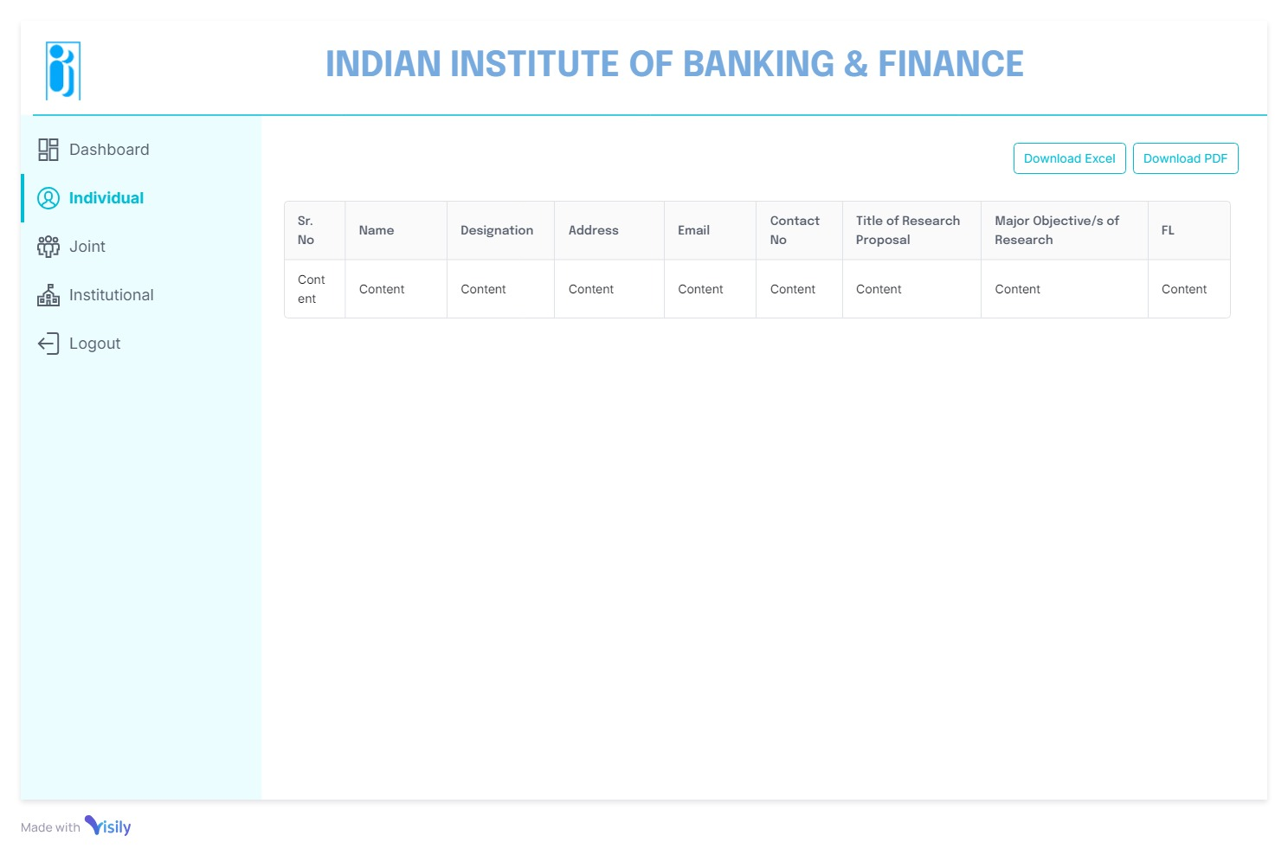

Joint Dashboard
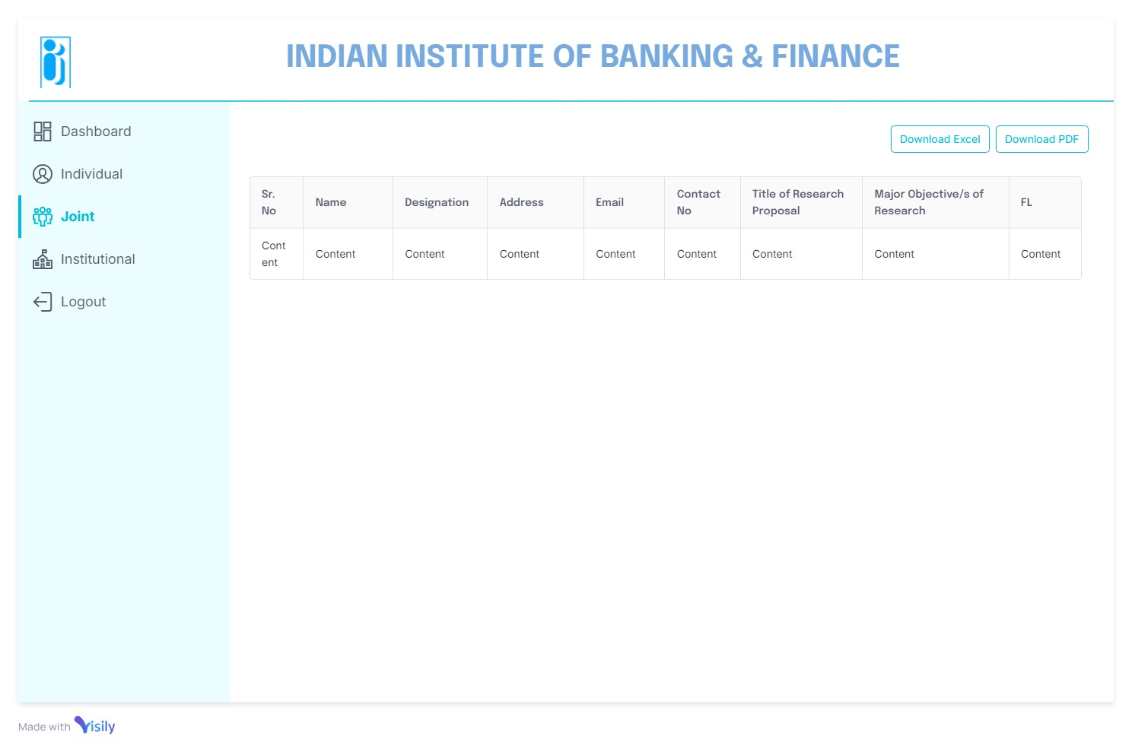

Institutional Dashboard
