Observations on Macro research application form

For all categories i.e. Individual, Joint and Institution
1.
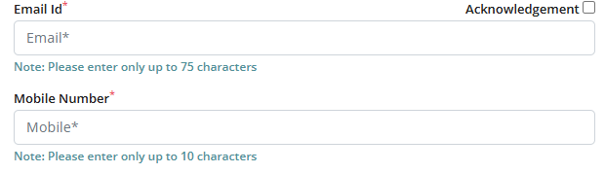
- In the blank box, Email Id
- In the blank box, Mobile Number

- Upon choosing Contractual or part-time in ‘Nature of job’ field, the fields such as Title of research proposal, Major objectives of Research proposal, theme, proposal, are not disabled, please disable all these fields.

- Macro-Research form should be written as: Macro Research Application Form

- A disclaimer should be there in the form in which an email id/phone no. from ESDS may be mentioned below the form where applicant may approach in case he/she faces any technical glitch.

- Special characters should be allowed for ‘Employer’ field

- In Proposal field, only MS-Word files should be allowed, it was observed that it is allowing pdf file also.

Incase a candidate upload file other than MS-Word, then below-mentioned message should be pop-up

Please upload MS-Word file only up to 5MB in size

- It was observed that the form do not accept a mobile number/e-mail id more than once. Please remove this criteria. We accept more than one entry from same person.

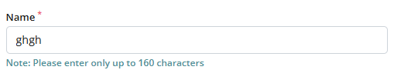
- Before the Name field, ‘Salutation’ field may be added with the dropdown
Mr.
Ms.
Mrs.
Dr.

- Acknowledgement mail is not received on successfully submitting the application.

- 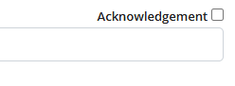

- This field should be named as: Acknowledgement required
- We may allow the acknowledgement on more than one e-mail id.

For ‘Institute’ category

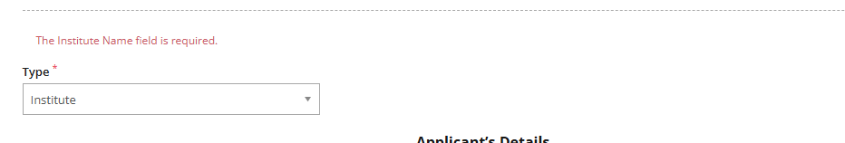

- Not able to submit the details in ‘Institute’ category.
- The form under ‘Institute’ category is not as per the word file shared by IIBF. Please make the changes accordingly.

Observations for Admin portal
- In the admin portal, please add the option to export the data in Excel file.
- In the admin portal, there should be a tab where proposals from all categories (Individual, Joint, Institute) can be seen. In this tab, there should be an option for bulk download of Proposals and Forwarding letter.
- In each tab (Individual, Joint, Institute), there should be an option for bulk download of Proposals and Forwarding letter.
- The proposal should be download with file name as the first name of applicant (first author). And forwarding letter should be download with file name as the first name of applicant (first author)_FL.

