8 August DRA module Retesting
Bug 1 = Clicked on Admit card redirected to version 1 : Showstopper
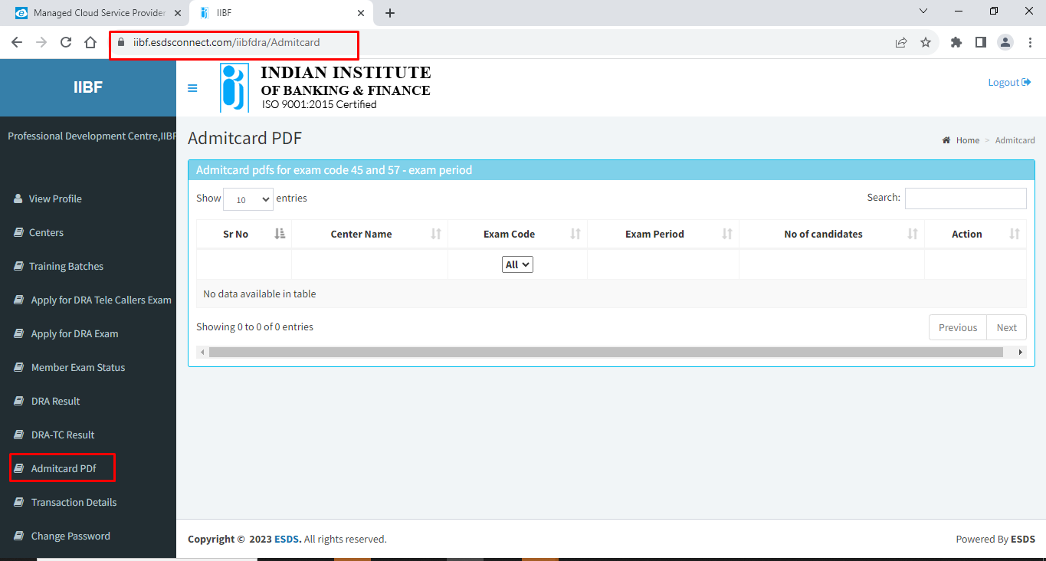

Bug 2 : Click on Member exam status showing in appropriate page. : Showstopper
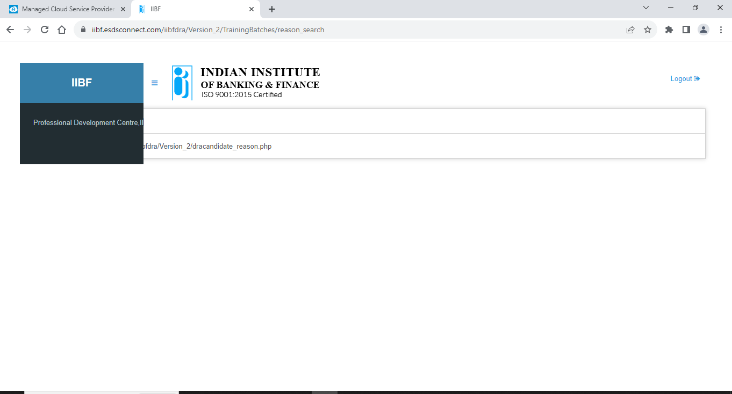

Bug 3 : Clicking on Change password redirected to version 1 : Showstopper
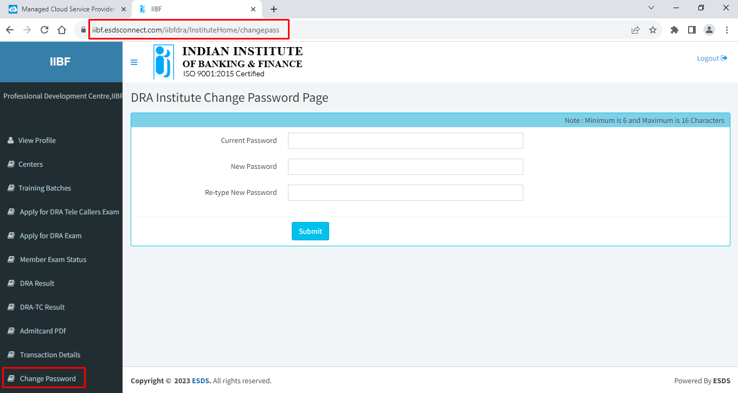

Bug 4 = Training batches => Batch preview => view document=> Text file is downloaded but not showing on browser. : High
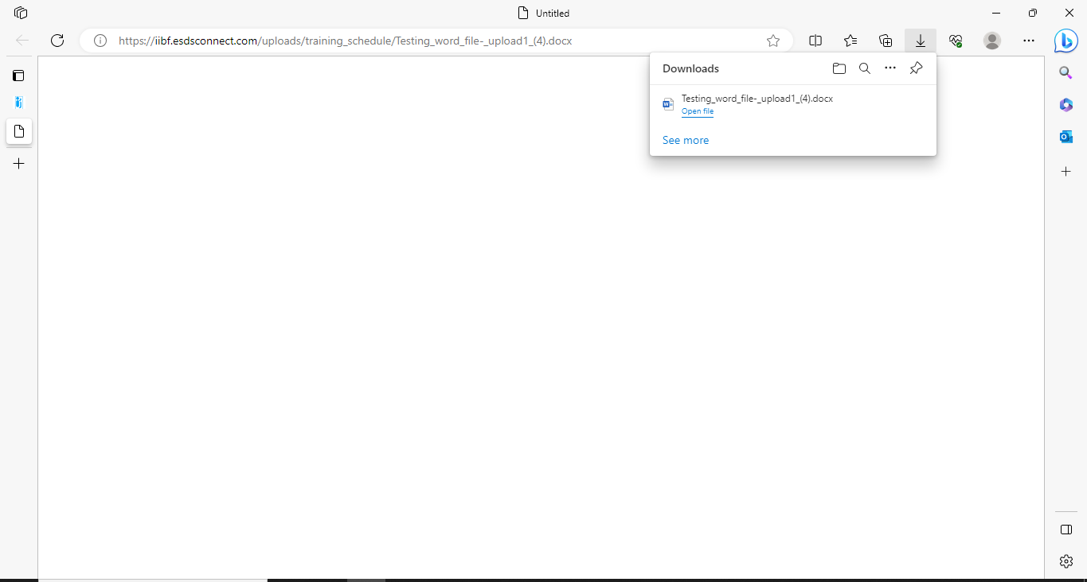

Bug 5 : Institute login=> Training batches => Batch preview => Batch communication & submit button are merged.: Minor Cosmetic error
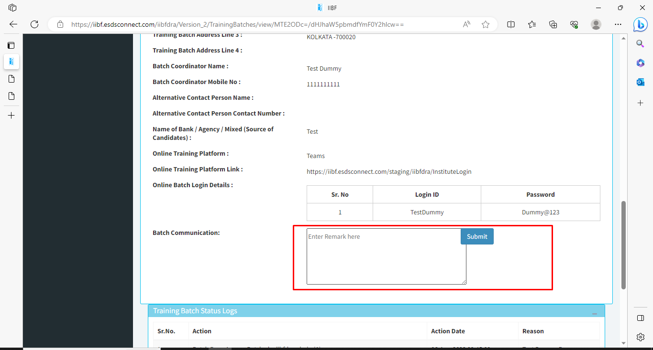
Bug 6 : Admin login => Add faculty => upload faculty photo=> does not accept PNG files : High
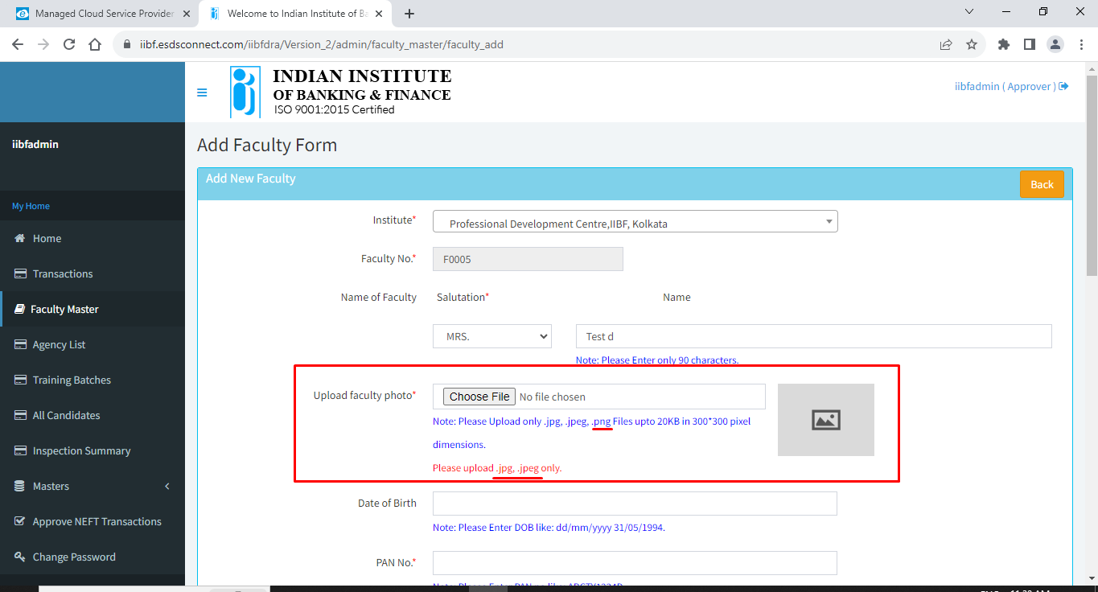

Bug 7 : It is requirement that break durations have to be in red font color? Minor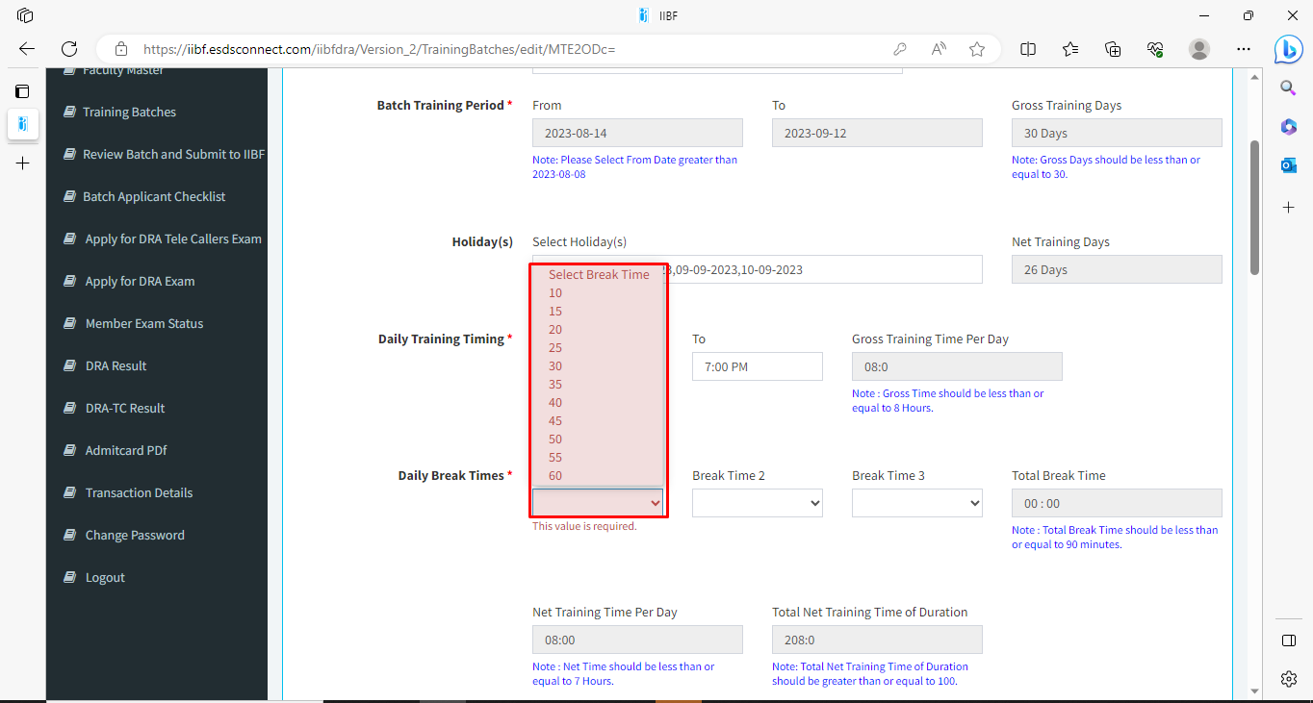

Bug 8: At admin login, We directed to candidate list from training batch details ‘All candidates”. There is no back button to navigate to Training Batch list. : Medium
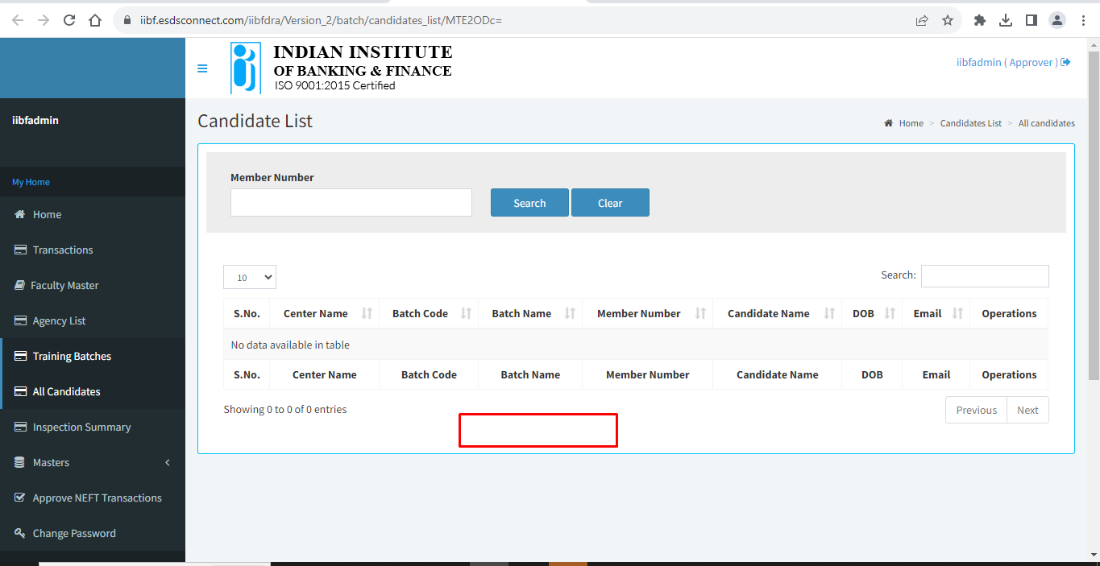
Bug 9 : In add candidate => When I enter mobile number, which are already exists, it is showing an error. High
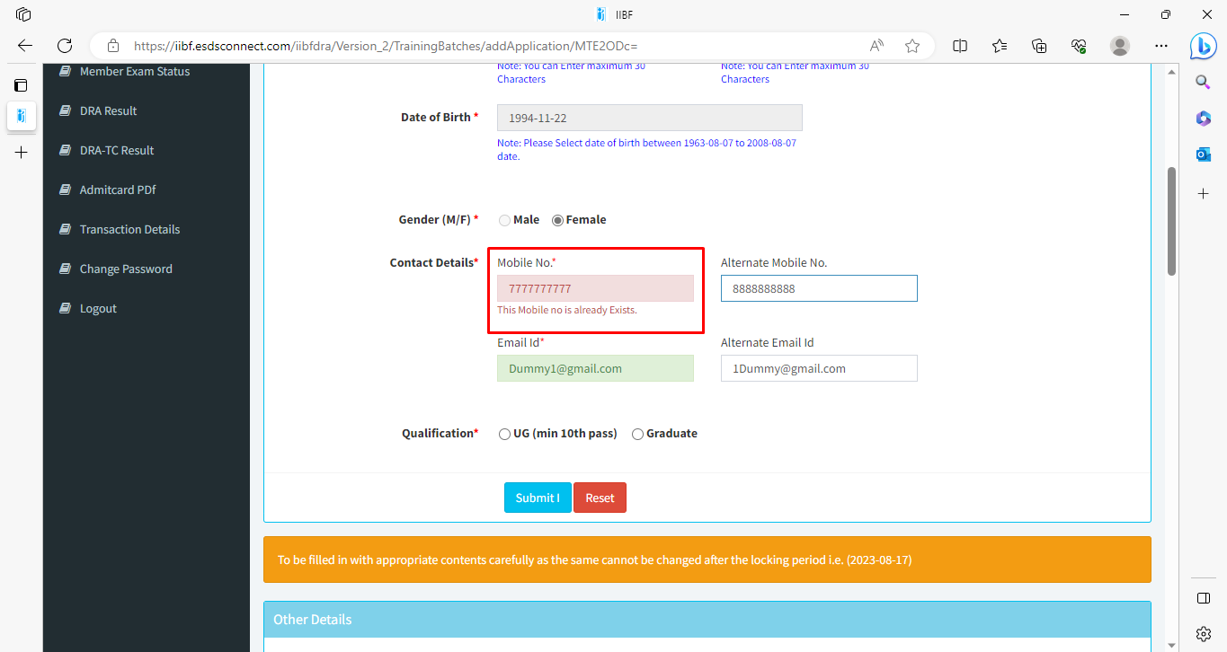
But, when I corrected it, the error msg is till there,
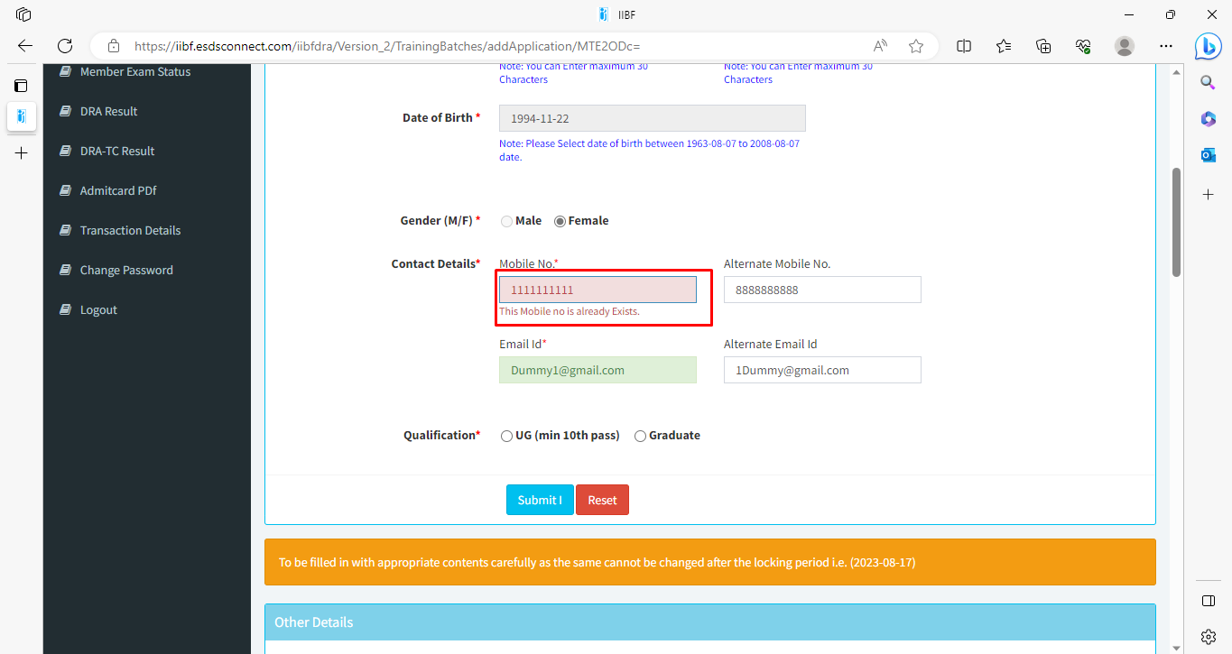

When I clicked on other textbox then, error msg gone.
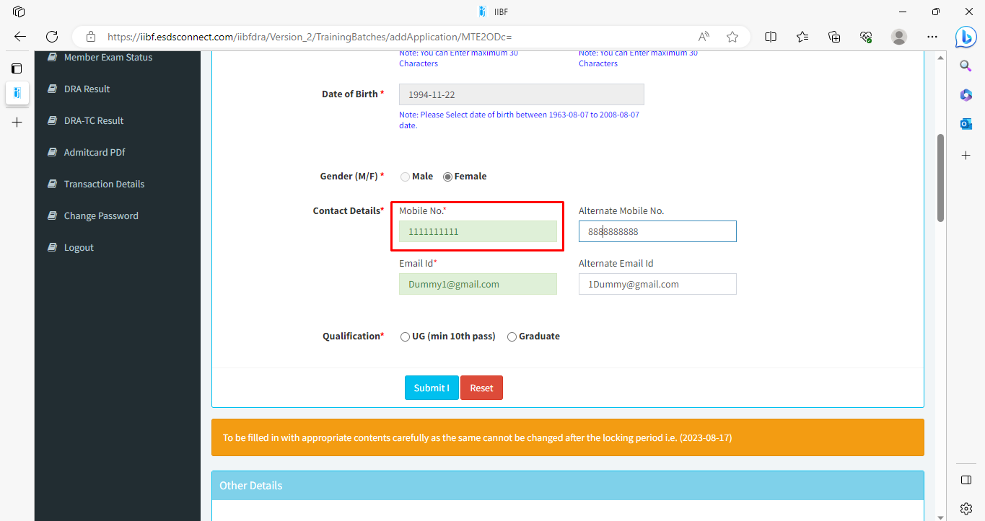
Bug 10 : In form 1 I have selected qualification as UG
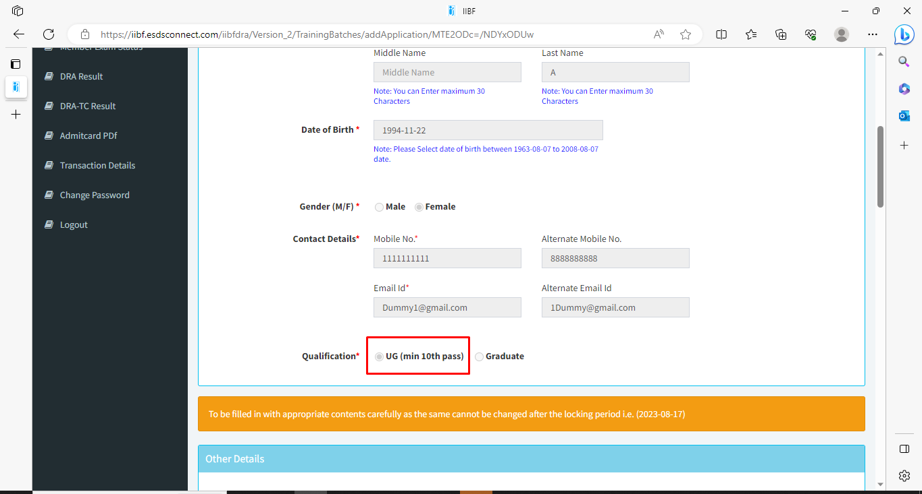

In form 2 Graduation and Post-Graduation is enabled.
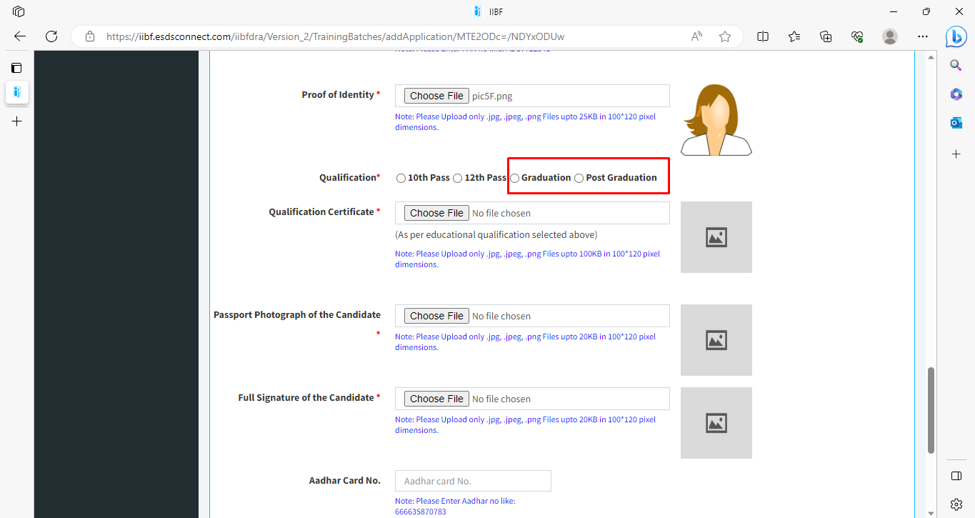

Bug 11 : When I check candidate details in Training Batches module at Admin login. And go to Edit candidate, make changes, submit the form & click on Back button, it redirected to Candidate list of “All Candidate” : Medium
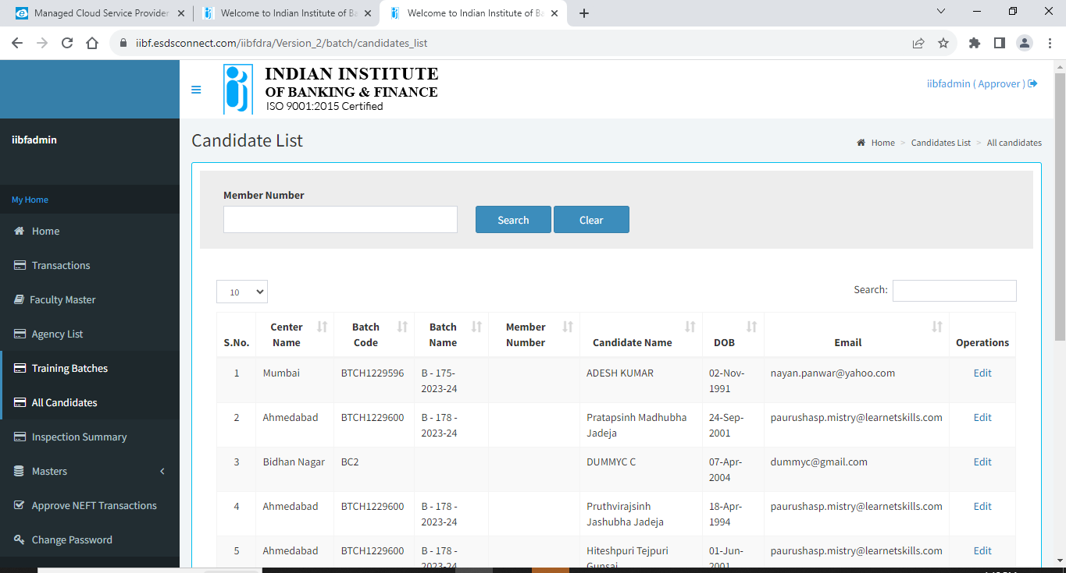

Bug 12 : Candidate list two heading rows : Minor
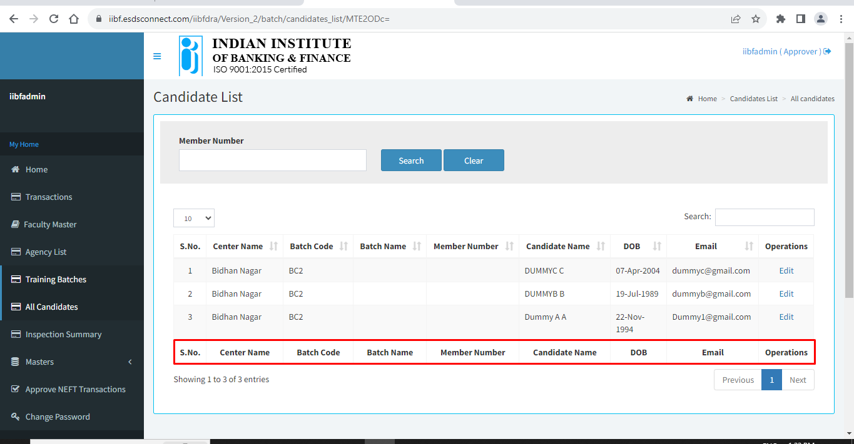
Bug 13 : Inspector report point 7ii. Question mark is not mention in MOM : Minor
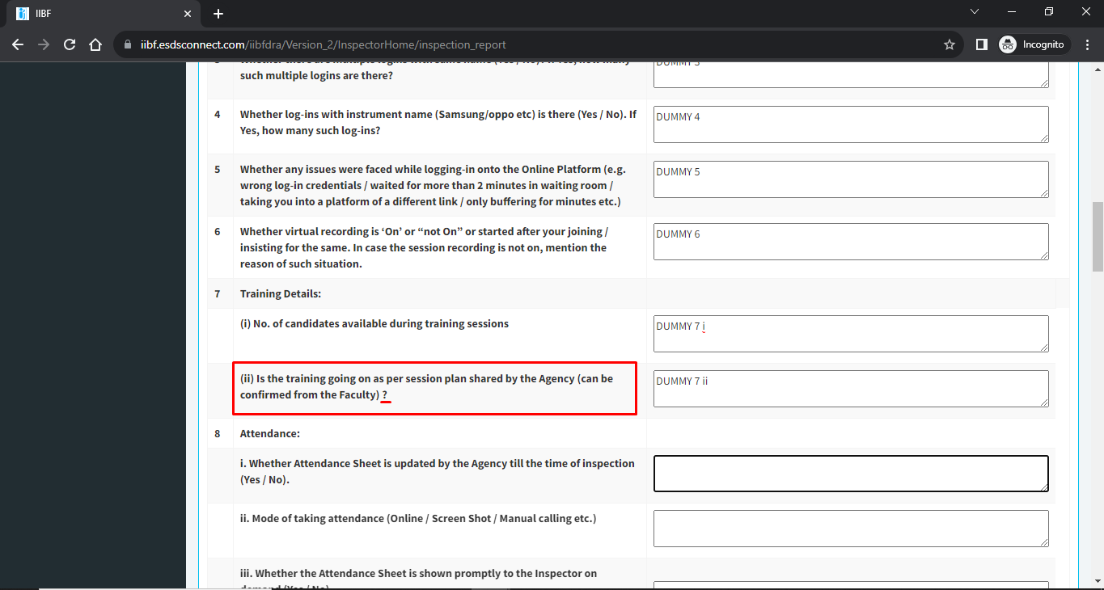

Bug 14 : I have Added and submitted Inspection report, now at Inspection Report the report is blank, BECAUSE I HAVE NOT ADDED CANDIDATE, So, we can show message to add candidate, or without adding candidate, we are not allowed to assign inspector : High
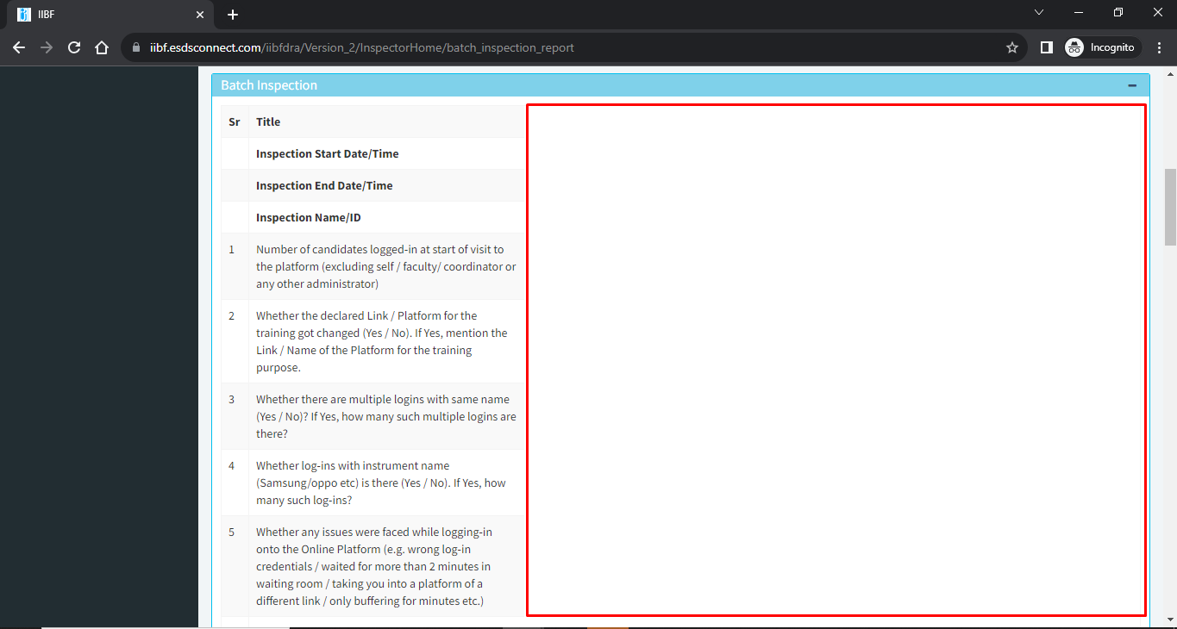

Bug 15 : After submitting candidate form, It is not redirecting to the error mentioned, : High
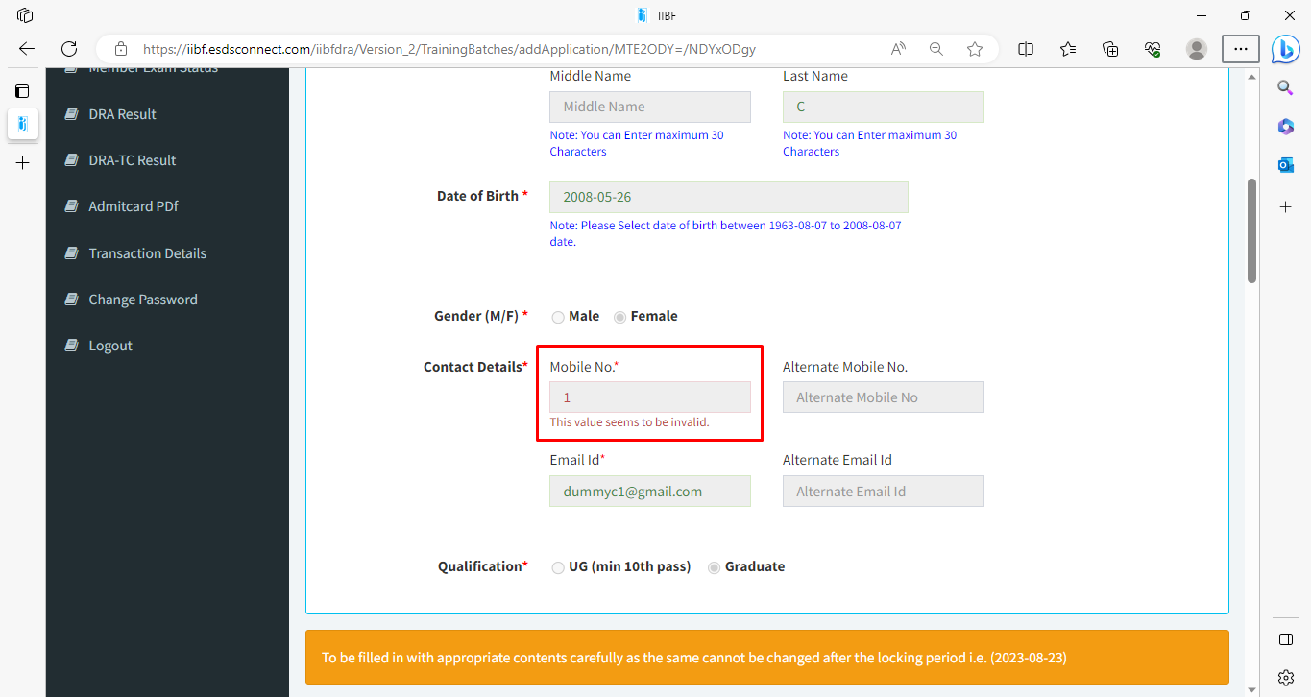

Bug 16 : Add candidate, Mobile number I was entered 0000000001, and it accepts the mobile number in form 1. When submitting form 2 it shows an error. : Major
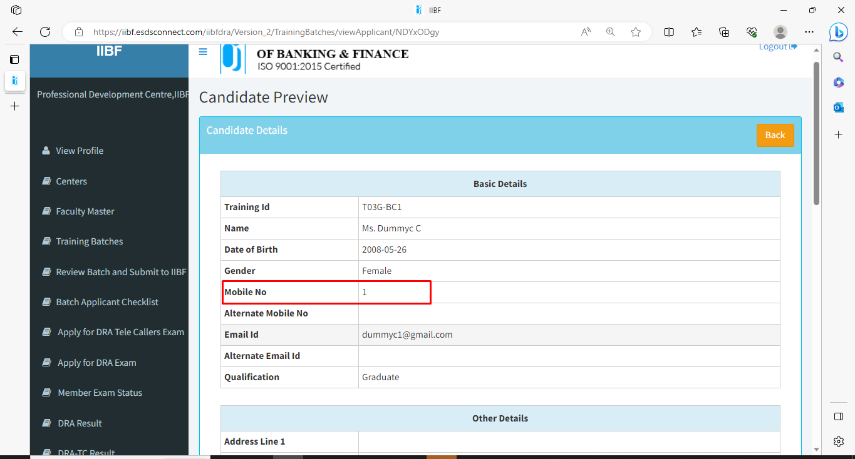

Bug 17 : At Admin side in edit form validations are changed. It is requirement?: Major
