**REGRESSION TESTING**

Shell Script: regressionScript

#!/bin/bash

set -o pipefail

echo Regression tests suit

echo 'Number of Loops = ' $1

echo 'EmailResultsPerson = ' $2

status=PASS

for((i=1;i<=$1;i+=1));

do

echo 'Run test for ' $i 'time'

./gradlew testRelease 2>&1 | tee output.log

if [ $? -ne 0 ]; then

status=FAIL

break

fi

done

echo All done

if [ "$2" != "" ]; then

echo "Sending email to - " $2

python send_email.py $2 $status output.log

else

echo "There is no EmailResultsPerson"

fi

Send Email python script: send_email.py

# Python code to illustrate Sending mail from your Gmail account

import smtplib

import sys

email_from = "" # needs to be real email ID

email_pwd = "" # needs to be real password

email_to = sys.argv[1]

# creates SMTP session

s = smtplib.SMTP('smtp.gmail.com', 587)

# start TLS for security

s.starttls()

# Authentication

s.login(email_from, email_pwd)

# message to be sent

message = '''\

Subject: {0}

{1}

'''.format(sys.argv[2], open(sys.argv[3], 'r').read())

# sending the mail

s.sendmail(email_from, email_to, message)

print("email sent successfully")

# terminating the session

s.quit()

To Run above script:

First parameter is number of loops

Second parameter is EmailResultsPerson, Default value is empty.

Without Email:

*./regressionScript 1*

With Email: (Also, in order to run send_email python script, we have to pass real credentials which are missing in above script)

*./regressionScript 1 rupalirajput27@gmail.com*

Output:

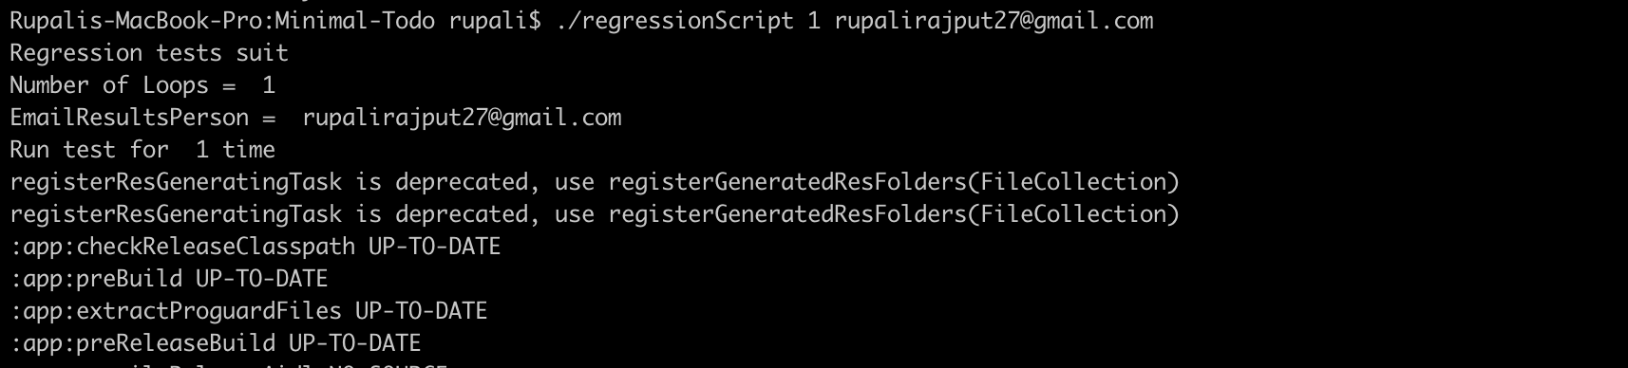



Email Message:

