Customer Lifetime Value Prediction for E-Commerce
Assignment 6 – Regression Models (Linear Regression, Decision Tree)

1. Introduction
Customer Lifetime Value (LTV) is the revenue a customer is expected to generate over their relationship with a business. For an e-commerce platform it guides how much to spend on acquisition and retention, which customers to reward, and how to forecast long-term revenue. This project predicts each customer’s future spend from their past behaviour using Linear Regression and Decision Tree regressors.
Key drivers considered: purchase frequency, average transaction value, recency (loyalty and engagement), tenure and product variety.

2. Dataset
The pipeline is designed for the UCI Online Retail II transaction log (Invoice, StockCode, Quantity, InvoiceDate, Price, Customer ID, Country). The sandbox used to build this project could not download that file, so the reported numbers come from a synthetic log with the identical schema (about 99,000 rows, 4,500 customers, Dec 2010 – Dec 2011). Placing the real file in data/ makes the notebook use it automatically; the figures and metrics below should then be regenerated.

3. Data Preprocessing and Feature Engineering
- Cleaning: removed rows with no Customer ID, cancelled invoices (prefix C), non-positive quantity or price, and duplicates (95,006 of 99,452 rows kept); created Revenue = Quantity × Price.
- Leakage control: features use only the feature window (Dec 2010 – 7 Sep 2011). The target is each customer’s spend in the following 3 months. Customers with no purchases in that window have LTV = 0 (59% of the 4,370 customers).
- Features: Recency, Frequency, Monetary (RFM), AvgOrderValue, Tenure, UniqueProducts, AvgItemsPerOrder, PurchaseRate, Last90dOrders, IsUK, plus a K-Means customer segment (k = 4, fitted on training data only, on log-RFM).
- Outliers in skewed features and the target were capped at the 99th percentile. Features were standardised for Linear Regression only.
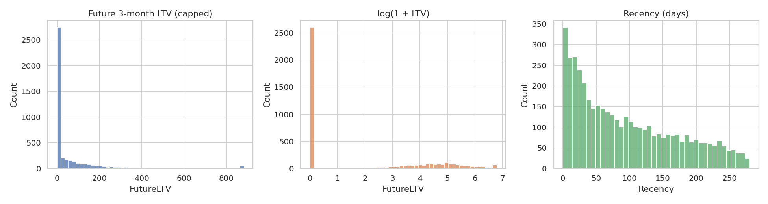
Figure 1: Distribution of future LTV, log LTV and recency
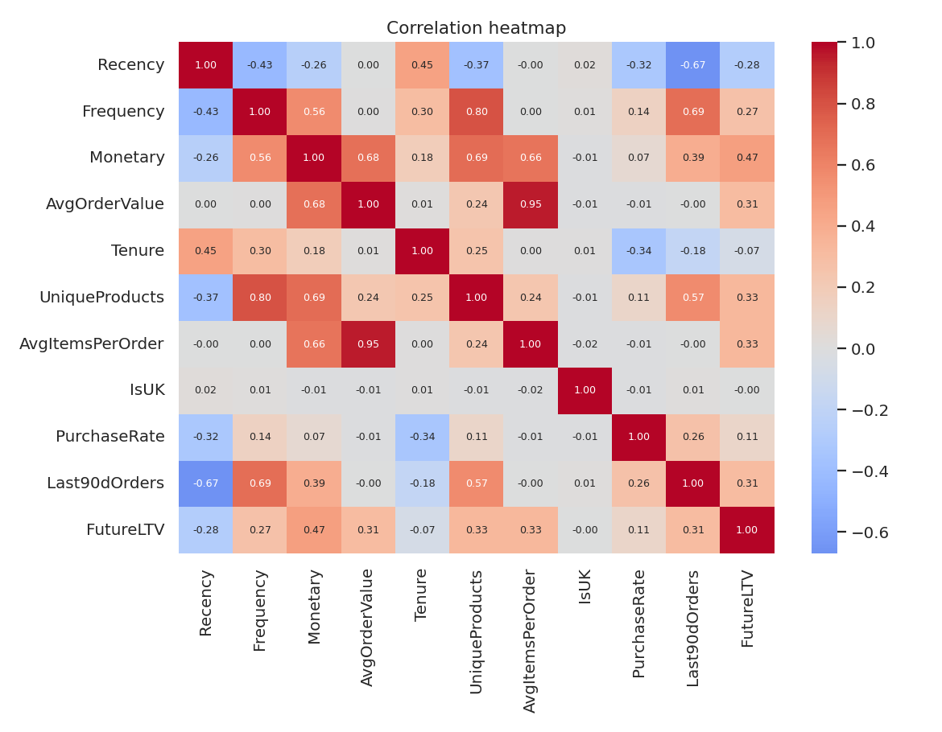
Figure 2: Correlation heatmap

4. Model Development
The data was split 80/20 into training and test sets. Linear Regression was trained on scaled features. The Decision Tree was tuned with 5-fold GridSearchCV over max_depth (3–8) and min_samples_leaf (5–50); the best setting was depth 5 with at least 50 samples per leaf (CV R² = 0.238).

5. Evaluation
Model | Test R² | MAE | RMSE
Linear Regression | 0.246 | 80.8 | 134.3
Decision Tree (depth 5, min leaf 50) | 0.225 | 78.5 | 136.2
Baseline (predict mean) | – | 95.0 | –

Both models beat the mean baseline (MAE drops from 95.0 to about 79–81). Linear Regression has the higher R², the tree a slightly lower MAE, so neither is clearly better. The modest R² is expected: future spend is noisy and most customers spend nothing in the target window.
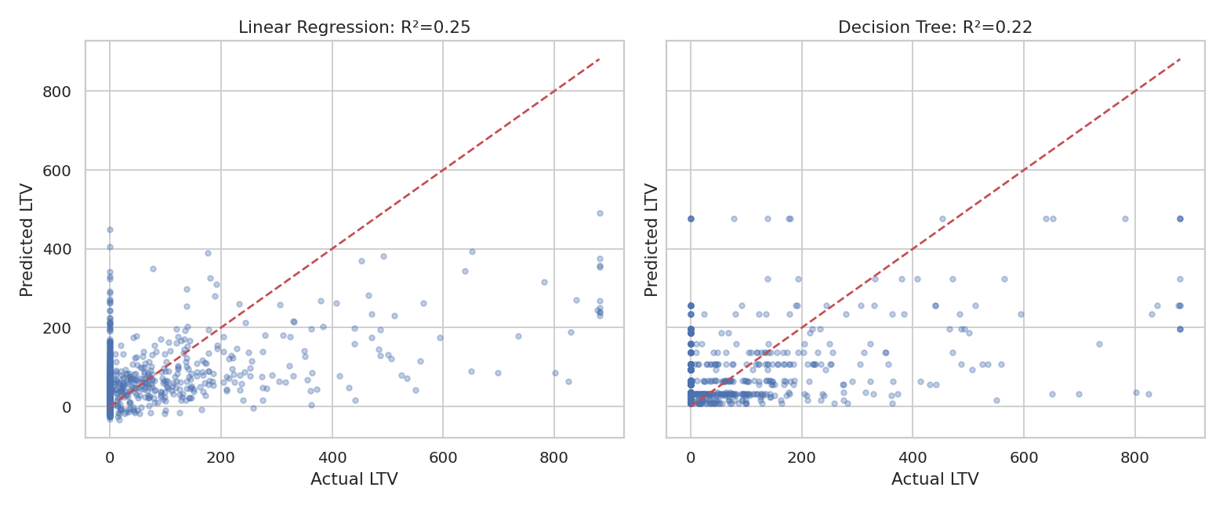
Figure 3: Predicted vs actual LTV
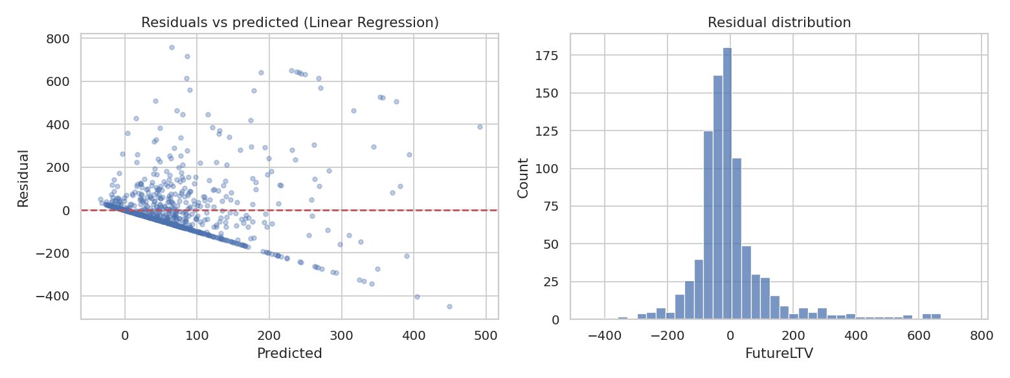
Figure 4: Residual analysis for Linear Regression

6. Model Interpretation and Insights
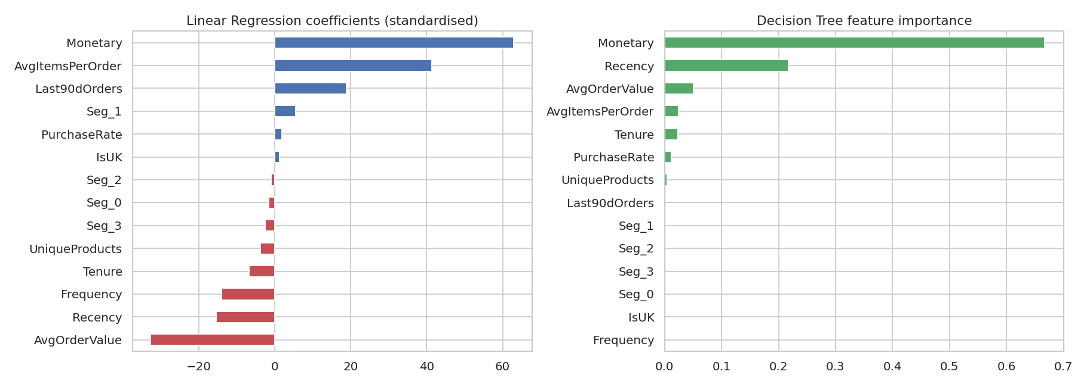
Figure 5: Linear Regression coefficients and Decision Tree feature importance
- Monetary value and Recency dominate. Monetary has the largest coefficient and 67% of tree importance; Recency (negative) has 22%.
- Caution: Monetary = Frequency × AvgOrderValue, so these are correlated and individual linear coefficients (such as the negative AvgOrderValue) should be read together.
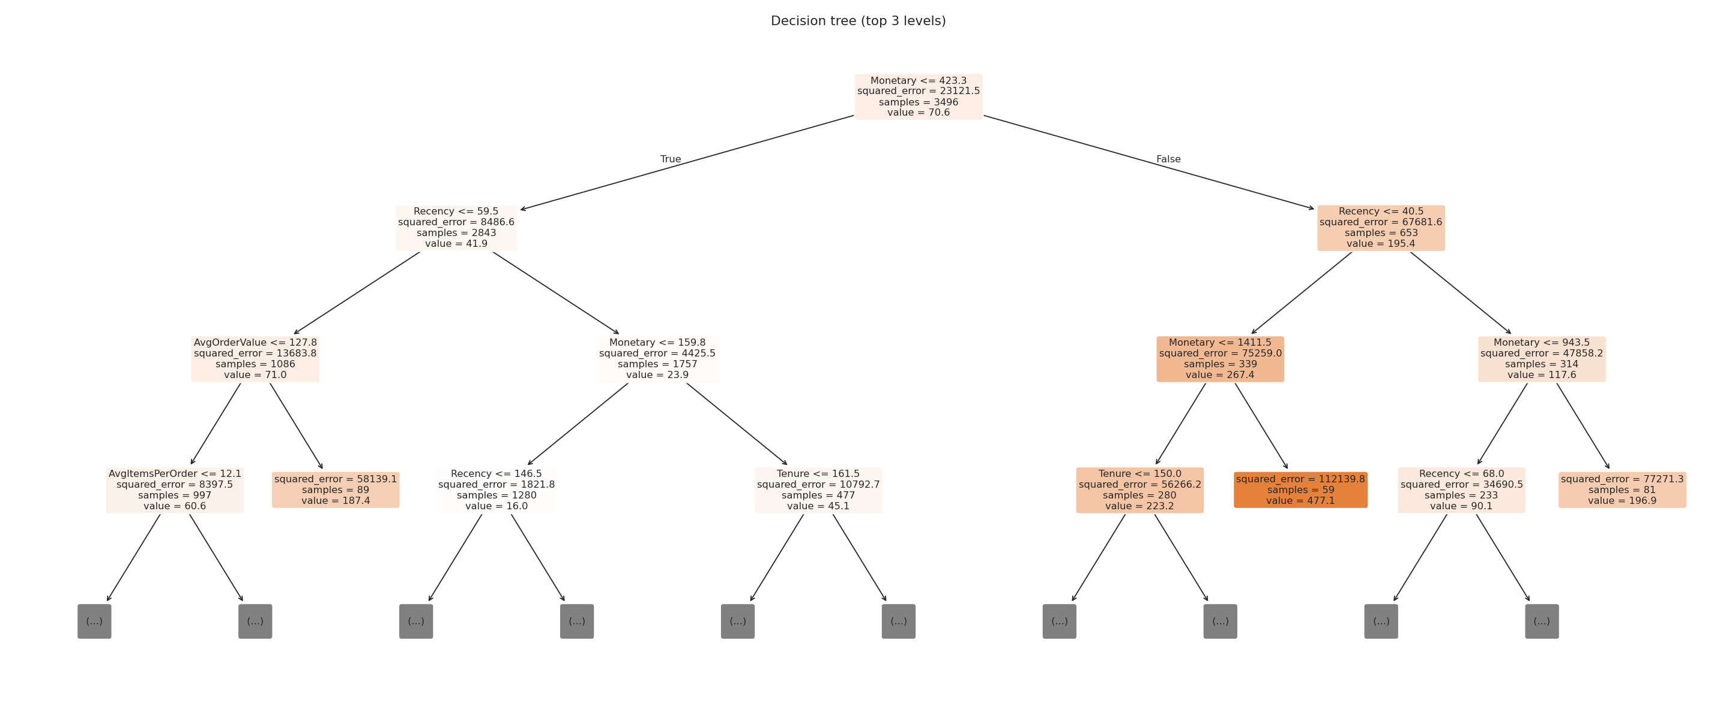
Figure 6: Decision tree, top three levels
- The root split is Monetary ≤ 423 (mean future spend about 42 vs 195). Customers with Monetary above about 1,411 who also bought within about 40 days form the highest-value leaf, at about 477 over the next 3 months.
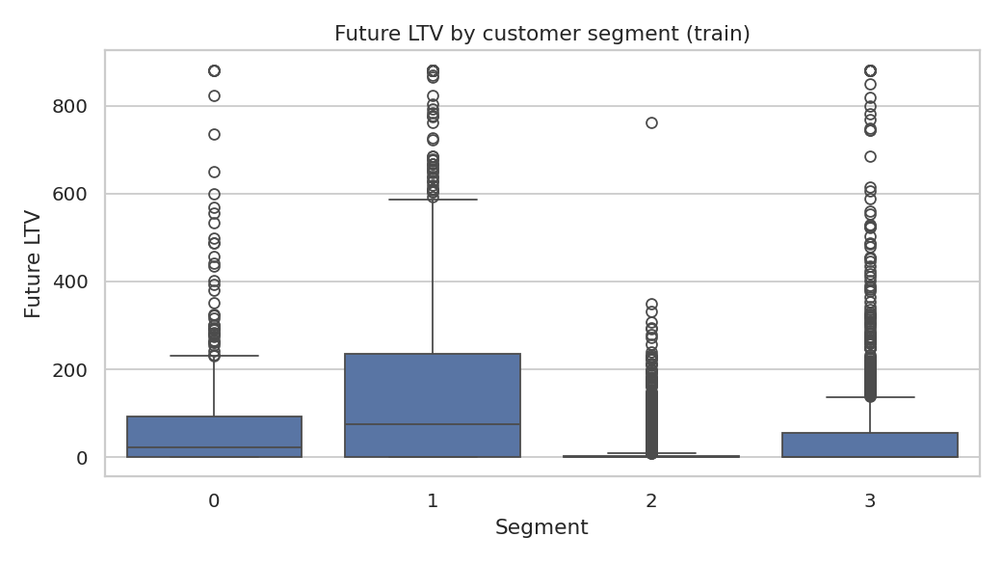
Figure 7: Future LTV by customer segment
- The segment with about 7 orders and 30 days since last purchase averages about 167 future spend, versus about 20 for the long-lapsed one-order segment.

7. Business Recommendations
- Protect high-value, recently active customers with loyalty rewards and early access.
- Trigger win-back offers when recency drifts past about 100 days.
- Nudge one-order customers toward a second purchase; frequency is what moves customers into higher-value segments.

8. Limitations and Conclusion
Results here come from synthetic data and must be regenerated on the real Online Retail II file. The dataset has no true demographics, the horizon is only 3 months, and outliers were capped. Future work includes Random Forest or Gradient Boosting and probabilistic BG/NBD + Gamma-Gamma models. In conclusion, simple RFM-based regression models explain a useful share of future customer value and give clear, actionable retention insights.

