Automatic Number Plate Recognition

A PROJECT REPORT

Submitted by

RUPAM GANGULY
URMILA KEWAT
JAMUNA MAJHI

in partial fulfilment for the award of the degree

of

BACHELOR OF TECHNOLOGY
IN

INFORMATION TECHNOLOGY
Year:2019


GOVERNMENT COLLEGE OF ENGINEERING AND CERAMIC TECHNOLOGY

73, ABINASH CHANDRA BANERJEE LANE, KOLKATA, WEST BENGAL, 700010

BONAFIDE CERTIFICATE

Certified that this project report “AUTOMATIC NUMBER PLATE RECOGNITION” is the bonafide work of “RUPAM GANGULY , URMILA KEWAT, JAMUNA MAJHI” who carried out the project work under my supervision.

SIGNATURE | SIGNATURE
Dr. MOUSUMI MAITRA | Mr. PRANAY ADAK
 | Assistant Professor
HEAD OF THE DEPARTMENT | SUPERVISOR
INFORMATION TECHNOLOGY | INFORMATION TECHNOLOGY
Government College of Engineering | Government College of Engineering
& Ceramic Technology | & Ceramic Technology
73, A.C. Banerjee Lane, | 73, A.C. Banerjee Lane,
Kolkata-700010 | Kolkata-700010
SIGNATURE
External Examiner:

ACKNOWLEDGEMENT

I take this opportunity to express my profound gratitude and deep regards to my project guide Mr. Pranay Adak for his exemplary guidance, monitoring and constant encouragement throughout the course of the project. The help and guidance given by him time to time will carry us a long journey of life on which we are about to embark.

RUPAM GANGULY | (GCECTB-L-17-2006)
URMILA KEWAT | (GCECTB-R16-2037)
JAMUNA MAJHI | (GCECTB-L17-2002)

ABSTRACT

Automatic recognition of license plate number became a very important in our daily life because of the unlimited increase of cars and transportation systems which make it impossible to be fully managed and monitored by humans, examples are so many like traffic monitoring, tracking stolen cars, managing parking toll, red-light violation enforcement, border and customs checkpoints. Yet it’s a very challenging problem, due to the diversity of plate formats, different scales, rotations and non-uniform illumination conditions during image acquisition. The system is implemented and simulated in Python, and it performance is tested on real image. It is observed from the experiment that the developed system successfully detects and recognize the vehicle number plate on real images.

TABLE OF CONTENTS

CHAPTER NO.

TITLE

PAGE

NO.

ABSTRACT

iii

1. | INTRODUCTION |  |  | 1
2. | METHODOLOGY |  |  | 2
 | 2.1 | Number plate detection |  | 2
 | 2.2 | Performing some image processing on the License plate |  | 4
 | 2.3 | Character Segmentation |  | 5

2.4 | Character Recognition | 6

3. | IMPLEMENTATION USING PYTHON |  | 10
 | 3.1 | Number plate detection | 10
 | 3.2 | Performing some image processing on the License plate | 12
 | 3.3 | Character Segmentation | 19
 | 3.4 | Character Recognition | 21
4. | CONCLUSION |  | 25
5. | FUTURE SCOPE |  | 25
6. | REFERENCES |  | 26

Fig 2.1-1 (a), Fig 2.1-1(b), Fig 2.1-1(c) | Edge Features, Line Features, Four Rectangle Features
Fig 2.1.2 | Face image
Fig 2.3.1 | Green contour drawing
Fig 2.3.2 | Segmented by contour
Fig 2.4.1 | Neural net
Fig 2.4.2 | 3d RGB matrix
Fig 2.4.3 | Filter
Fig 2.4.4 | Relu
Fig 2.4.5 | Maxpool
Fig 3.1.1 | Number plate detection cascade classifier
Fig 3.1.2 | Output image number plate detection
Fig 3.1.3 Fig 3.1.4 | 2 input image 3 output image
Fig 3.2.1 | Image processing code threshold
Fig 3.2.2 | Output
Fig 3.3.1 | Contour code
Fig 3.3.2 | Sorting code
Fig 3.3.2 | Output phase
Fig 3.3.3, Fig 3.3.4 | Number Segmentation
Fig 3.4.1 | Keras Model Structure
Fig 3.4.2 | Directory Structure of Dataset
Fig 3.4.3 | At Epoch2 Training Accuracy
Fig 3.4.4 | At Epoch50 Training Accuracy
Fig 3.4.5 | Code of Accuracy and Loss Graph Plotting
Fig 3.4.6 | Graph of Accuracy and Loss
Fig 3.4.7 | Predicted Output

LIST OF FIGURES

1. INTRODUCTION

In last few years, ANPR or license plate recognition (LPR) has been one of the useful approaches for vehicle surveillance. It is can be applied at number of public places for fulfilling some of the purposes like traffic safety enforcement, automatic toll text collection, car park system and Automatic vehicle parking system. ANPR algorithms are generally divided in four steps:
(1) Number plate detection
(2) Performing some image processing on the License plate
(3) Character segmentation
and
(4) Character recognition.
These systems follow different approaches to locate vehicle number plate from vehicle and then to extract vehicle number from that image. Most of the ANPR systems are based on common approaches like artificial neural network (ANN)
A neural network is a powerful data modelling tool that is able to capture and represent complex input/output relationships. Neural network resembles the human brain in acquiring the knowledge and storing it within interneuron connection strengths. A neural network model is a structure that can be adjusted to produce a mapping from a given set of data to features of relationships among the data.
A back-propagation network consists of at least three layers: an input layer, at least one hidden layer and output layer. Input units are connected to in a feed forward fashion with input units fully connected to the units in the hidden layer and hidden units fully connected to the units in the output layer. As the name suggested, the errors propagate backwards from the output nodes to the inner nodes. This method can be effectively used for the feature matching
2. METHODOLOGY

This section deals with the description of the algorithm development proposed by this paper. It also discusses the necessity and output of every step-in detail. This is just a simple procedure to detect the number plate and display it. This procedure is valid for tilted image as well

2.1 Number plate detection

Several approaches based on edge detections and morphological operations have been proposed for LP detection because license plates have clear edges and character shapes. These approaches are intuitive and powerful when the scenery images of the license plates are not noisy. However, the character edges in a license plate can be unobtainable owing to environmental challenges. On the other hand, text feature–based license plate detection approaches do not require an accurate extraction of such edges. These approaches perform better than edge detection–based or morphological operation–based approaches when the boundary of a license plate is unclear. Our approach is also that of a text feature–based approach. These approaches are computationally expensive, especially when the scene is complex and many edges are present. However, our technique is very fast and can detect license plates in a high-resolution image within a significantly shorter period of time in comparison with state-of-the art text feature–based LP detection approaches.
Haar-like cascade classifier is good for face detection, but its application to license plate localization largely depends on selection of positive and negative samples.

Haar Cascade is a machine learning object detection algorithm used to identify objects in an image or video and based on the concept of ​​ features.
It is a machine learning based approach where a cascade function is trained from a lot of positive and negative images. It is then used to detect objects in other images. It is well known for being able to detect faces and body parts in an image, but can be trained to identify almost any object.

The algorithm has four stages:
Haar Feature Selection
Creating Integral Images
Adaboost Training
Cascading Classifiers
First step is to collect the Haar Features. A Haar​ feature considers adjacent rectangular regions at a specific location in a detection window, sums up the pixel intensities in each region and calculates the difference between these sums.
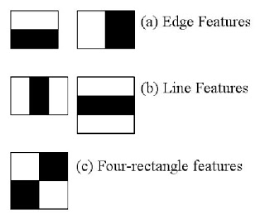
Fig 2.1.1 (a), Fig 2.1.1 (b), Fig 2.1.1 (c)

Integral Images are used to make this super-fast. But among all these features we calculated, most of them are irrelevant. For example, consider the image below. Top row shows two good features. The first feature selected seems to focus on the property that the region of the eyes is often darker than the region of the nose and cheeks. The second feature selected relies on the property that the eyes are darker than the bridge of the nose. But the same windows applying on cheeks or any other place is irrelevant.
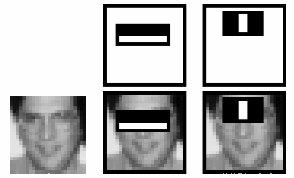
Fig 2.1.2

So how do we select the best features out of 160000+ features? This is accomplished using a concept called Adaboost which both selects the best features and trains the classifiers that use them. This algorithm constructs a “strong” classifier as a linear combination of weighted simple “weak” classifiers. The process is as follows.
During the detection phase, a window of the target size is moved over the input image, and for each subsection of the image and Haar features are calculated. You can see this in action in the video below. This difference is then compared to a learned threshold that separates non-objects from objects. Because each Haar feature is only a "weak classifier" (its detection quality is slightly better than random guessing) a large number of Haar features are necessary to describe an object with sufficient accuracy and are therefore organized into cascade classifiers to form a strong classifier.
Cascade Classifier​ - The cascade classifier consists of a collection of stages, where each stage is an ensemble of weak learners. The weak learners are simple classifiers called decision stumps. Each stage is trained using a technique called boosting. Boosting provides the ability to train a highly accurate classifier by taking a weighted average of the decisions made by the weak learners.
Each stage of the classifier labels the region defined by the current location of the sliding window as either positive or negative. Positive indicates that an object was found and negative indicates no objects were found. If the label is negative, the classification of this region is complete, and the detector slides the window to the next location. If the label is positive, the classifier passes the region to the next stage. The detector reports an object found at the current window location when the final stage classifies the region as positive.
The stages are designed to reject negative samples as fast as possible.
Cascade classifier training requires a set of positive samples and a set of negative images. We must provide a set of positive images with regions of interest specified to be used as positive samples.
2.2 Performing some image processing on the License plate

Resizes the input coming from plate detection step to a dimension such that all characters seem distinct and clear.
Then convert the coloured image to a grey scaled image i.e instead of 3 channels (BGR), the image only has a single 8-bit channel with values ranging from 0–255 where 0 corresponds to black and 255 corresponds to white. We do this to prepare the image for the next process.
Now the threshold function converts the grey scaled image to a binary image i.e each pixel will now have a value of 0 or 1 where 0 corresponds to black and 1 corresponds to white. It is done by applying a threshold that has a value between 0 and 255, here the value is 200 which means in the grayscale image for pixels having value above 200, in the new binary image that pixel will be given a value of 1. And for pixels having value below 200, in the new binary image that pixel will be given a value of 0.
The image is now in binary form and ready for the next process Eroding.
Eroding is a simple process used for removing unwanted pixels from the object’s boundary meaning pixels that should have a value of 0 but are having a value of 1. It works by considering each pixel in the image one by one and then considering the pixel’s neighbour (the number of neighbours depends on the kernel size), the pixel is given a value 1 only if all its neighbouring pixels are 1, otherwise it is given a value of 0.
Dilation is a process of structural improvement of an image by filling holes, adding pixels and joining broken lines for sharpening the boundary of an image as well as for increasing brightness. In the pre-processing stage RGB to Gray conversion results in the loss of some details of the original image. Even noise can also corrupt the image. So, dilation is necessary to enhance the converted image and make it suitable for edge processing, by removing noise and sharpening edges. By making the edge sharper the difference of grey value in the neighbouring pixels of an object increases. It further enhances Edge Processing. Due to pre-processing some key features of an image, like brightness, light edge, colour difference may get lost. By dilation such losses can be overcome and the pre-processed image is sharpened and the brightness is increase. The image is now clean and free of boundary noise, we will now dilate the image to fill up the absent pixels meaning pixels that should have a value of 1 but are having value 0. The function works similar to eroding but with a little catch, it works by considering each pixel in the image one by one and then considering the pixel’s neighbour (the number of neighbours depends on the kernel size), the pixel is given a value 1 if at least one of its neighbouring pixels is 1.
The next step now is to make the boundaries of the image white. This is to remove any out of the frame pixel in case it is present.
Next, we define a list of dimensions that contains 4 values with which we’ll be comparing the character’s dimensions for filtering out the required characters.
Through the above processes, we have reduced our image to a processed binary image and we are ready to pass this image for character extraction.

2.3 Character segmentation

Image segmentation creates a pixel-wise mask for each object in the image. This technique gives us a far more granular understanding of the object(s) in the image.
Image segmentation is a process by which we partition images into different regions. Whereas the contours are the continuous lines or curves that bound or cover the full boundary of an object in an image. Contour is an outline representing or bounding the shape or form of something
And, here we will use image segmentation technique called contours to extract the parts of an image.
Also, contours are very much important in Object detection and Shape analysis.
And they have very much broad field of application from the real-world image analysis to medical image analysis such as in MRI’s

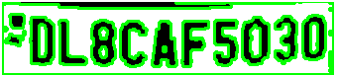
Fig 2.3.1

After finding all the contours we consider them one by one and calculate the dimension of their respective bounding rectangle. Now consider bounding rectangle is the smallest rectangle possible that contains the contour. Let me illustrate the bounding rectangle by drawing them for each character here.


Fig 2.3.2

2.4 Character Recognition

The goal of this stage is to recognize and classify the binary images that contain characters received from the previous one. Here we use Neural Network that will be intelligent enough to recognize the characters after training. Many artificial intelligence tasks can be solved by identifying the right set of features, and then providing these features to classifier. All classification tasks depend upon labelled datasets; that is, humans must transfer their knowledge to the dataset in order for a neural network to learn the correlation between labels and data. This is known as supervised learning. The layers are made of nodes. A node is just a place where computation happens, loosely patterned on a neuron in the human brain, which fires when it encounters sufficient stimuli. A node combines input from the data with a set of coefficients, or weights, that either amplify or dampen that input, thereby assigning significance to inputs with regard to the task the algorithm is trying to learn; e.g. which input is most helpful is classifying data without error? These input-weight products are summed and then the sum is passed through a node’s so-called activation function, to determine whether and to what extent that signal should progress further through the network to affect the ultimate outcome, say, an act of classification. If the signals pass through, the neuron has been “activated.” A node layer is a row of those neuron-like switches that turn on or off as the input is fed through the net. Each layer’s output is simultaneously the subsequent layer’s input, starting from an initial input layer receiving your data. Deep-learning networks are distinguished from the more commonplace single-hidden-layer neural networks by their depth; that is, the number of node layers through which data must pass in a multistep process of pattern recognition. In deep-learning networks, each layer of nodes trains on a distinct set of features based on the previous layer’s output. The further you advance into the neural net, the more complex the features your nodes can recognize, since they aggregate and recombine features from the previous layer.
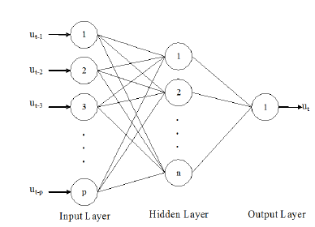

Fig 2.4.1

In neural networks, Convolutional neural network (ConvNets or CNNs) is one of the main categories to do images recognition, images classifications. Objects detections, recognition faces etc., are some of the areas where CNNs are widely used.
ConvNet is able to successfully capture the Spatial and Temporal dependencies in an image through the application of relevant filters. The architecture performs a better fitting to the image dataset due to the reduction in the number of parameters involved and reusability of weights. In other words, the network can be trained to understand the sophistication of the image better.
CNN image classifications takes an input image, process it and classify it under certain categories (Eg., Dog, Cat, Tiger, Lion). Computers sees an input image as array of pixels and it depends on the image resolution. Based on the image resolution, it will see
h x w x d (h = Height, w = Width, d = Dimension). E.g., An image of 6 x 6 x 3 array of matrix of RGB (3 refers to RGB values) and an image of 4 x 4 x 1 array of matrix of grayscale image.
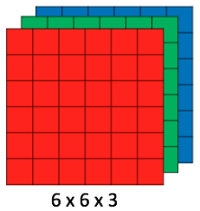
Fig 2.4.2
deep learning CNN models to train and test, each input image will pass it through a series of convolution layers with filters (Kernals), Pooling, fully connected layers (FC) and apply Softmax function to classify an object with probabilistic values between 0 and 1. The below figure is a complete flow of CNN to process an input image and classifies the objects based on values.
Convolution is the first layer to extract features from an input image. Convolution preserves the relationship between pixels by learning image features using small squares of input data. It is a mathematical operation that takes two inputs such as image matrix and a filter or kernel. Convolution of an image with different filters can perform operations such as edge detection, blur and sharpen by applying filters. The below example shows various convolution image after applying different types of filters (Kernels).
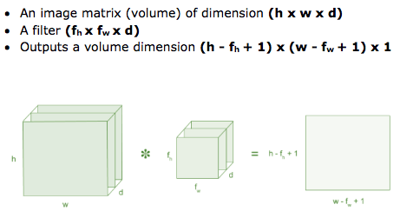
Fig 2.4.3

In our ANPR, the first layer will be a convolutional layer with 32 output filters, a convolution window of size (5,5), and ‘Relu’ as activation function.
ReLU stands for Rectified Linear Unit for a non-linear operation.
The output is ƒ(x) = max(0,x).
ReLU’s purpose is to introduce non-linearity in our ConvNet. Since, the real-world data would want our ConvNet to learn would be non-negative linear values.
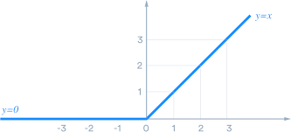
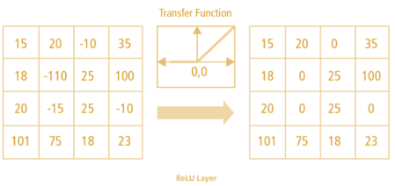
Fig 2.4.4

There are other nonlinear functions such as tanh or sigmoid that can also be used instead of ReLU. Most of the data scientists use ReLU since performance wise ReLU is better than the other two.

Next, we’ll be adding a max-pooling layer with a window size of (2,2).
Pooling layers section would reduce the number of parameters when the images are too large. Spatial pooling also called subsampling or down sampling which reduces the dimensionality of each map but retains important information. Spatial pooling can be of different types:
Max Pooling
Average Pooling
Sum Pooling
Max pooling takes the largest element from the rectified feature map. Taking the largest element could also take the average pooling. Sum of all elements in the feature map call as sum pooling.

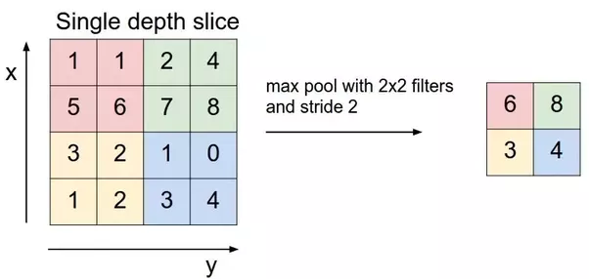
Fig 2.4.3

Now, we will be adding some dropout rate to take care of overfitting. Large neural nets trained on relatively small datasets can overfit the training data.
This has the effect of the model learning the statistical noise in the training data, which results in poor performance when the model is evaluated on new data, e.g. a test dataset.
Dropout is a regularization method that approximates training a large number of neural networks with different architectures in parallel.
During training, some number of layer outputs are randomly ignored or “dropped out.” This has the effect of making the layer look-like and be treated-like a layer with a different number of nodes and connectivity to the prior layer. In effect, each update to a layer during training is performed with a different “view” of the configured layer.
Dropout has the effect of making the training process noisy, forcing nodes within a layer to probabilistically take on more or less responsibility for the inputs.

Now it’s time to flatten the node data so we add a flatten layer for that. Flatten layer takes data from the previous layer and represents it in a single dimension. We flatten the output of the convolutional layers to create a single long feature vector. And it is connected to the final classification model, which is called a fully-connected layer. In other words, we put all the pixel data in one line and make connections with the final layer.

Finally, we will be adding 2 dense layers, one with the dimensionality of the output space as 128, activation function=’relu’ and other, our final layer with 36 outputs for categorizing the 26 alphabets (A-Z) + 10 digits (0–9) and activation function=’ softmax’
We use softmax as the output function of the last layer in neural networks (if the network has n layers, the n-th layer is the softmax function). This fact is important because the purpose of the last layer is to turn the score produced by the neural network into values that can be interpreted by humans.
3. IMPLEMENTATION USING PYTHON

The Implementation consist of 4 modules
License_plate_extraction which find and extract the license plate of a input image.
Character_segmentation which is use for pre-processing the image which is output of the previous program and this is also pass the processed image to the next program through function calling.
Plate_detection is segmenting the plate according to character.
CNN_model is used for training the model

3.1 Number plate detection:

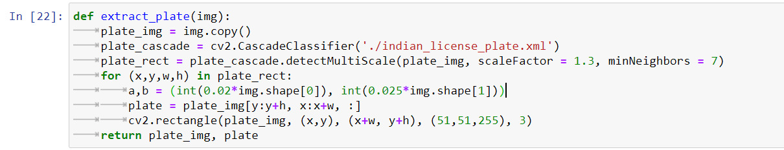
Fig 3.1.1
The above function works by taking image as input, then applying ‘haar cascade’ that is pre-trained to detect Indian license plates, here the parameter scaleFactor stands for a value by which input image can be scaled for better detection of license plate. minNeighbors is just a parameter to reduce false positives, if this value is low, the algorithm may be more prone to giving a misrecognized output.

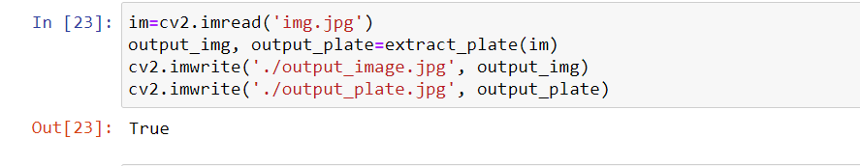
Fig 3.1.2
We give the function a PNG or JPG file then the job of this particular function is to detect the number plate then draw a rectangle then crop the image respect to the rectangle

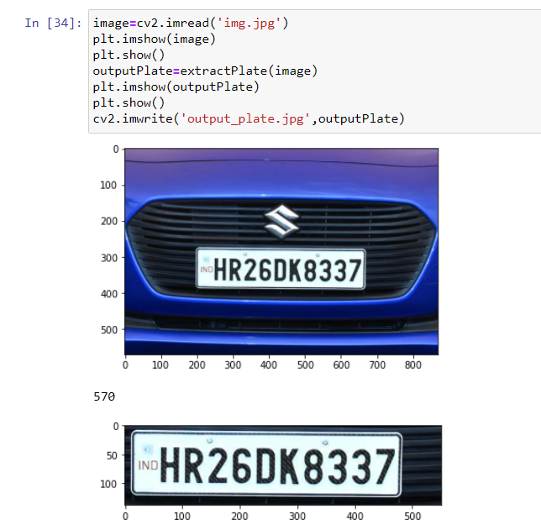
Fig 3.1.3

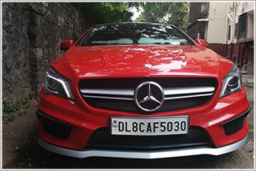 | 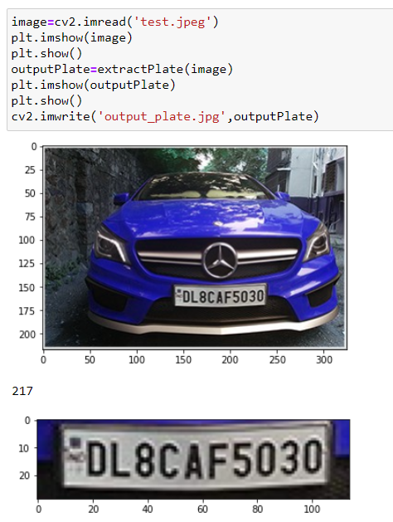
Fig 3.1.4

3.2 Performing some image processing on the License plate

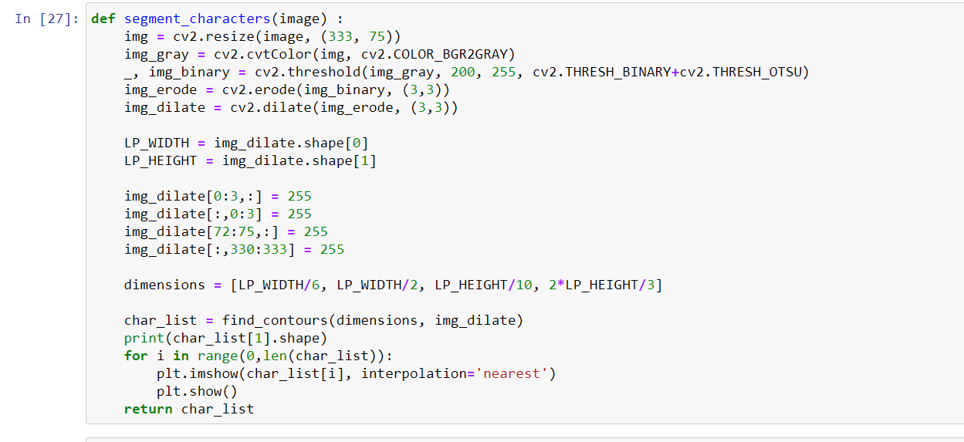
Fig 3.2.1

Here we performing Resize 333*75, then we convert the color image to Grayscale image, then the threshold is applied.
Now the image is Binary Image.
Now ERODING and DILATING enhance the image for character segmentation.

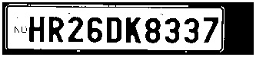
Fig 3.2.2

Output of this phase

3.3 Character segmentation

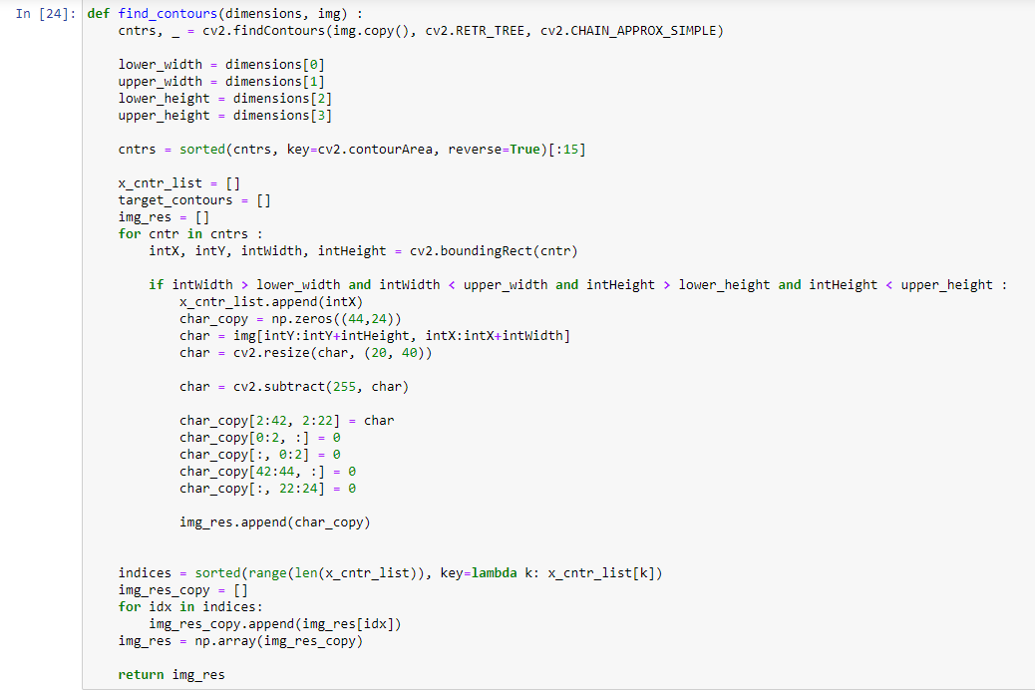
Fig 3.3.1

Cv2.findContours is use for finding contours of inputted image.

Fig 3.3.2
Sorted function is used to sorts the character according to the position of their bounding rectangle from the left boundary of the plate.

The Output of this Phase is Following:
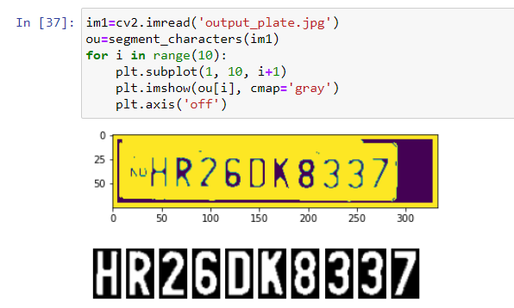

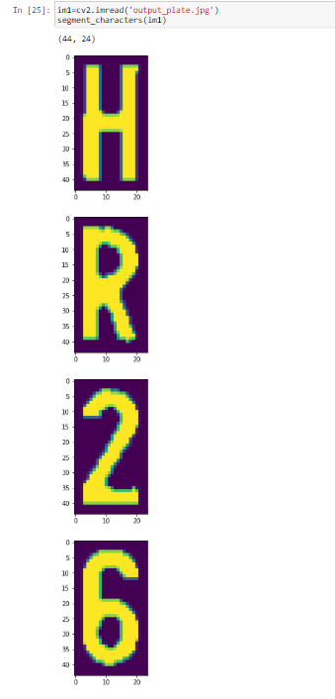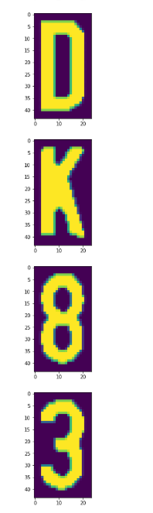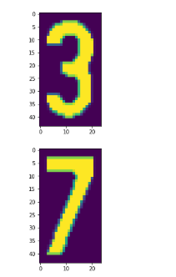

Fig 3.3.3
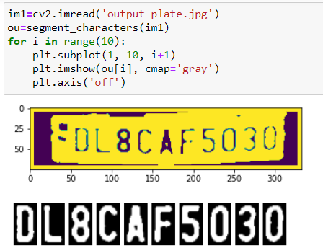
Fig 3.3.4
3.4 Character recognition

The data is all clean and ready, now it’s time do create a Neural Network that will be intelligent enough to recognize the characters after training.

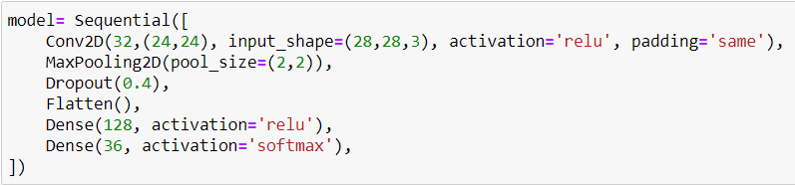
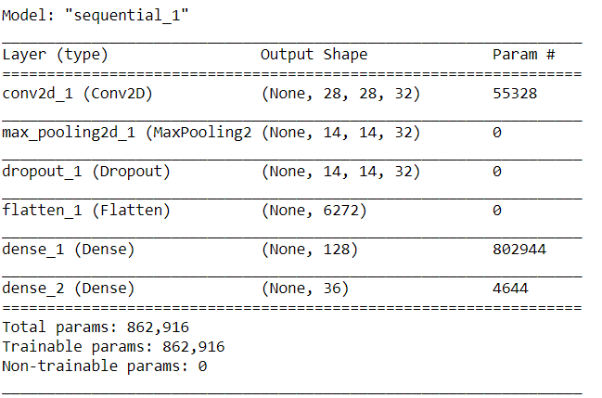
Fig 3.4.1

This the model structure where we train our dataset.

The first layer will be a convolutional layer with 32 output filters, a convolution window of size (5,5), and ‘Relu’ as activation function.
Next, we’ll be adding a max-pooling layer with a window size of (2,2).
Now, we will be adding some dropout rate to take care of overfitting.
Dropout is a regularization hyperparameter initialized to prevent Neural Networks from Overfitting.
Now to flatten the node data so we add a flatten layer for that. Flatten layer takes data from the previous layer and represents it in a single dimension.
Finally, we will be adding 2 dense layers, one with the dimensionality of the output space as 128, activation function=’relu’ and other, our final layer with 36 outputs for categorizing the 26 alphabets (A-Z) + 10 digits (0–9) and activation function=’ softmax’

The dataset contains two directory one is train and other is valid. Train folder contains 36 sub folder of A-Z and 0-9 images. Total 1,679 Files present in train folder. Valid folder contains 36 sub folders of A-Z and 0-9 images. Total 216 Files present in valid folder.

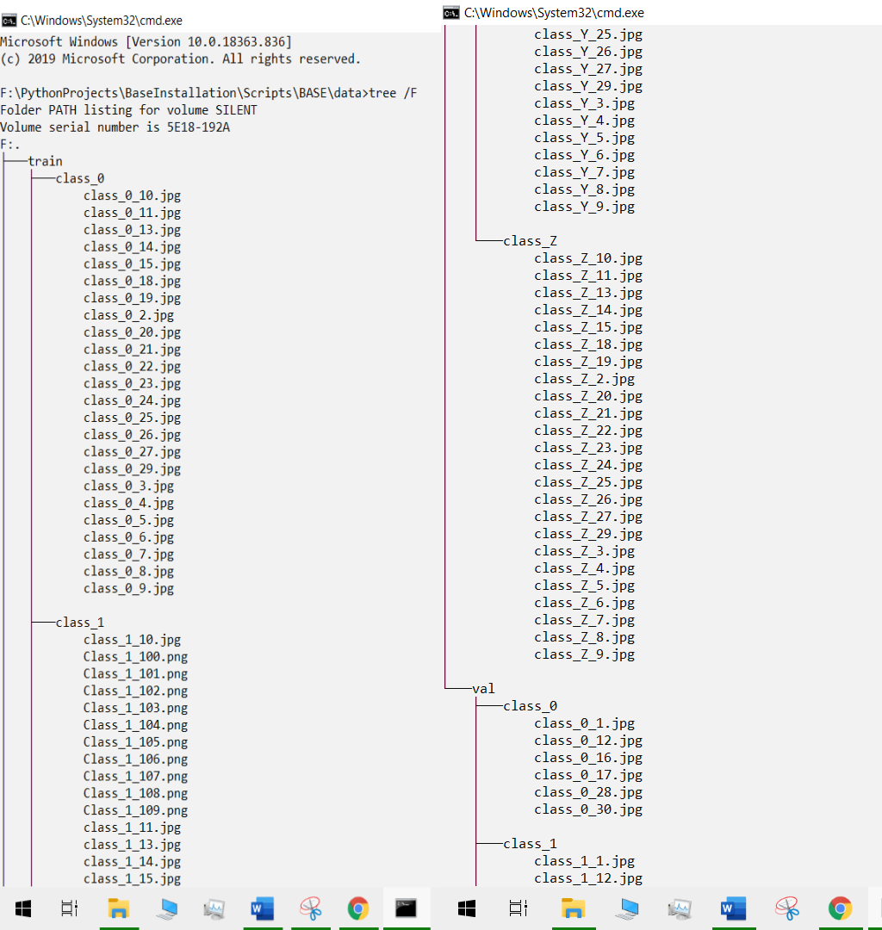
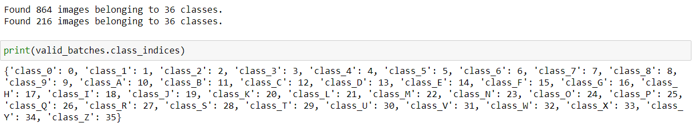
Fig 3.4.2

We just create 36 Classes by passing 36 folders name.
At 1st EPOCH:

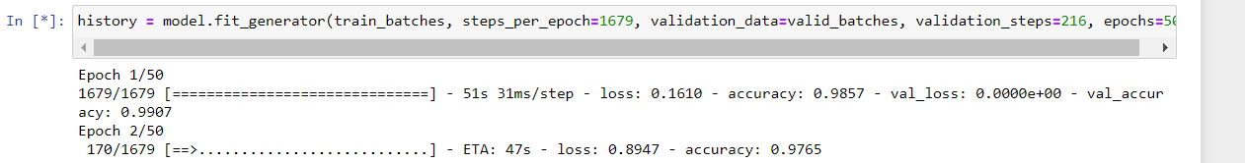
Fig 3.4.3

At 50th EPOCH:
Accuracy: 0.98, Val Accuracy:0.99

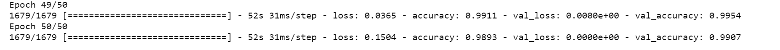
Fig 3.4.4

Graph of Model Accuracy and Model Loss:
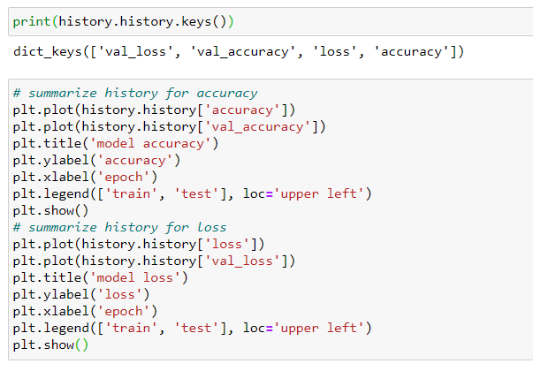
Fig 3.4.5
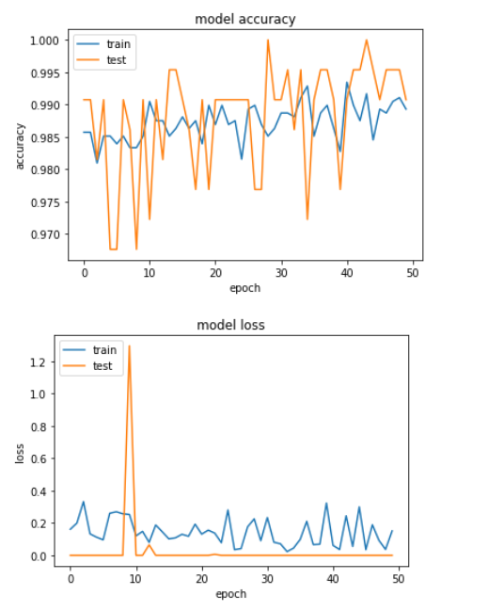
Fig 3.4.6

Prediction:

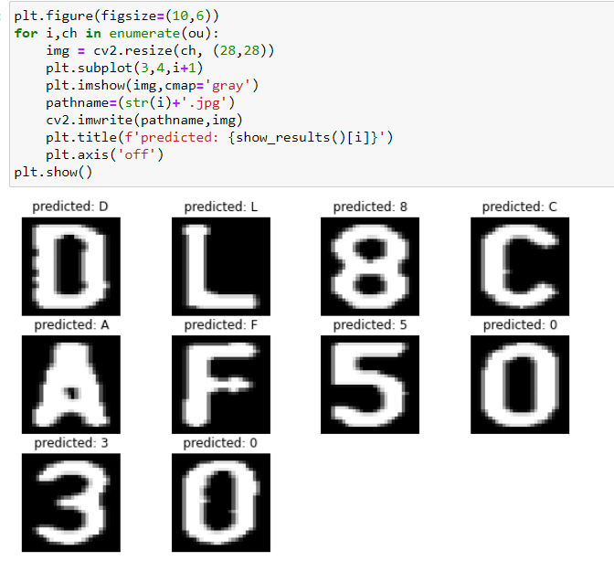

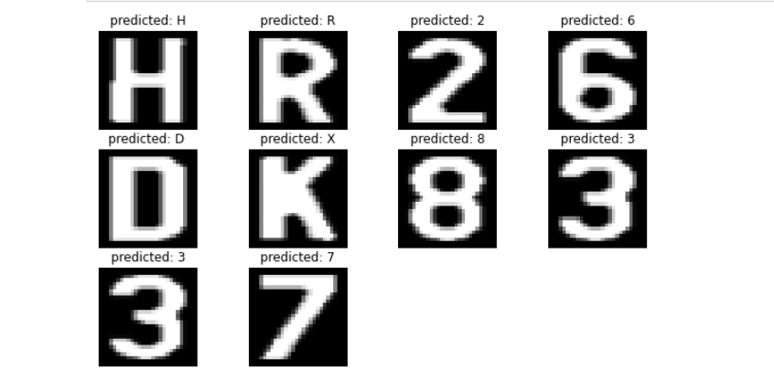

Fig 3.4.7

4. CONCLUSION

While ANPR has come a long way, and is a useful technology in several applications, its imperfections mean that one should carefully evaluate whether it is indeed the best technology for the problem being solved. As one moves away from applications in Western Europe where licence plates are of exceptional quality, the selection of provider, camera technology and application fit need to be far more carefully examined to determine whether the solution is going to deliver the most value for the least expenditure. It may still be more viable to install a ticket gate. It may be more viable to use a radar speed system instead of an ANPR average speed system. It is likely more viable to continue to use human labour in backoffice infringement processing, or at the least a human in-the-loop in an intelligent and efficient way. It is quite clear that ANPR is difficult system because of different number of phases and presently it is not possible to achieve 100% overall accuracy as each phase is dependent on previous phase. Certain factors like different illumination conditions, vehicle shadow and non-uniform size of license plate characters, different font and background colour affect the performance of ANPR.

5. FUTURE SCOPE

Train the Model with larger Dataset.
Achieve number plate detection through a video.

6. REFERENCES

A Review Paper on Automatic Number Plate Recognition ...
http://www.iosrjournals.org/iosr-jce/papers/Vol18-issue4/Version-3/F1804033440.pdf

Keras | TensorFlow Core
https://www.tensorflow.org/guide/keras

Can we train a haar-cascade to detect numbers and alphabets ... https://stackoverflow.com/questions/42991316/can-we-train-a-haar-cascade-to-detect-numbers-and-alphabets

A Comprehensive Guide to Convolutional Neural Networks ...
https://towardsdatascience.com/a-comprehensive-guide-to-convolutional-neural-networks-the-eli5-way-3bd2b1164a53

