A Major Project Report on
AN INTELLIGENT DEEP LEARNING-BASED SYSTEM FOR BONE TUMOR CLASSIFICATION USING X-RAY IMAGES
Submitted in partial fulfilment of the requirements for the award of the degree of
BACHELOR OF TECHNOLOGY
in
[Branch name - e.g. Computer Science and Engineering (Artificial Intelligence and Machine Learning)]
Submitted by
N. Nandini (2311CS020469)
N. Rupa Lakshmi (2311CS020480)
P. Varshitha (2311CS020499)
Under the guidance of
Asst. Prof. Vineela
Assistant Professor, Department of AIML
[University logo]
DEPARTMENT OF ARTIFICIAL INTELLIGENCE AND MACHINE LEARNING
SCHOOL OF ENGINEERING
MALLA REDDY UNIVERSITY
[City, State]
2023 - 2027

CERTIFICATE
This is to certify that the major project report entitled "An Intelligent Deep Learning-Based System for Bone Tumor Classification Using X-Ray Images" is a bonafide record of work carried out by N. Nandini (2311CS020469), N. Rupa Lakshmi (2311CS020480) and P. Varshitha (2311CS020499) in partial fulfilment of the requirements for the award of the degree of Bachelor of Technology in [Branch name], Department of AIML, School of Engineering, Malla Reddy University, during the academic year [2026 - 2027].

Project Guide Head of the Department
Asst. Prof. Vineela [Name of HOD]
Department of AIML Department of AIML

External Examiner [Signature]

DECLARATION
We hereby declare that the major project report entitled "An Intelligent Deep Learning-Based System for Bone Tumor Classification Using X-Ray Images" submitted to Malla Reddy University in partial fulfilment of the requirements for the award of the degree of Bachelor of Technology is a record of original work carried out by us under the guidance of Asst. Prof. Vineela, Department of AIML. The results embodied in this report have not been submitted to any other university or institute for the award of any degree or diploma.

N. Nandini (2311CS020469)
N. Rupa Lakshmi (2311CS020480)
P. Varshitha (2311CS020499)

Place: [City] Date: [DD/MM/YYYY]

ACKNOWLEDGEMENT
We express our sincere gratitude to our project guide, Asst. Prof. Vineela, Department of AIML, for her continuous guidance, valuable suggestions and encouragement throughout this project.
We thank [Name of HOD], Head of the Department of AIML, and [Name of Dean / Principal] for providing the facilities and support required to complete this work. We also thank the project review committee for their feedback during the reviews.
We acknowledge the authors of the BTXRD dataset (Yao et al., Scientific Data, 2025) for making their radiograph collection publicly available under the CC BY 4.0 licence, without which this work would not have been possible.
Finally, we thank our families and friends for their constant support. [Edit this acknowledgement as required.]

ABSTRACT
Bone tumors may be benign or malignant, and distinguishing the two on plain radiographs requires expert interpretation that is time-consuming and can vary between observers. This project develops a computer-aided system that classifies a bone-tumor X-ray as benign or malignant and explains each prediction.
The system uses a ResNet50 convolutional neural network pretrained on ImageNet and adapted by two-stage transfer learning: the new classification head is trained first on frozen features, and the deepest residual blocks are then fine-tuned at a lower learning rate. It was trained and evaluated on the public BTXRD dataset, using its 1,867 tumor radiographs (1,525 benign, 342 malignant) split 70/15/15 into training, validation and test sets with stratification. Images are converted to grayscale, resized to 224 x 224 pixels and normalised; training images are additionally augmented. Class imbalance is handled with a class-weighted loss, and the checkpoint with the best validation F1-score is retained.
On 281 held-out test radiographs the model achieved an accuracy of 0.890, a ROC-AUC of 0.945, and, for the malignant class, a precision of 0.692, a recall of 0.706 and an F1-score of 0.699. An ablation study on the same split showed that data augmentation raised malignant recall from 0.608 to 0.706 and ROC-AUC from 0.901 to 0.945. Grad-CAM heatmaps, verified with a weight-randomisation check, show which image regions influenced each prediction, and a plain-language explanation reports how reliable predictions of the same confidence were on the test set. The system is delivered as a web prototype that runs on macOS, Windows and Google Colab. It is intended as a preliminary screening aid that must be reviewed by a radiologist, not as a diagnostic tool.
Keywords: bone tumor classification, X-ray, deep learning, ResNet50, transfer learning, data augmentation, Grad-CAM, explainable AI, BTXRD.

TABLE OF CONTENTS
CERTIFICATE
DECLARATION
ACKNOWLEDGEMENT
ABSTRACT
TABLE OF CONTENTS
LIST OF FIGURES
LIST OF TABLES
INTRODUCTION
1.1 Background
1.2 Problem Statement
1.3 Motivation
1.4 Objectives
1.5 Scope of the Project
1.6 Organisation of the Report
LITERATURE SURVEY
2.1 Existing Approaches
2.2 Related Work
2.3 Research Gap
SYSTEM ANALYSIS
3.1 Existing System
3.2 Proposed System
3.3 Advantages of the Proposed System
3.4 Hardware and Software Requirements
3.5 Feasibility
METHODOLOGY AND SYSTEM DESIGN
4.1 System Architecture
4.2 Dataset
4.3 Preprocessing
4.4 Data Augmentation
4.5 Model Architecture
4.6 Training Strategy
4.7 Evaluation Metrics
4.8 Explainability with Grad-CAM
IMPLEMENTATION
5.1 Project Structure
5.2 Training Implementation
5.3 Prototype Application
5.4 Verification of the Implementation
RESULTS AND DISCUSSION
6.1 Training Behaviour
6.2 Test-Set Performance
6.3 Effect of Data Augmentation
6.4 Explainability
6.5 Error Analysis and Reliability
6.6 Discussion
CONCLUSION AND FUTURE SCOPE
7.1 Conclusion
7.2 Limitations
7.3 Future Scope
REFERENCES
APPENDIX A: HOW TO RUN THE PROJECT

[If the contents list is empty, right-click it in Word and choose Update Field -> Update entire table.]

LIST OF FIGURES
Figure 4.1: Overall pipeline of the proposed system
Figure 4.2: Sample benign and malignant radiographs from BTXRD
Figure 5.1: Web application showing the prediction, Grad-CAM heatmap and explanation (a known failure case)
Figure 6.1: Training and validation loss and accuracy (epochs 1-5: stage 1; 6-24: stage 2)
Figure 6.2: Confusion matrix on the test set
Figure 6.3: ROC curve on the test set (AUC = 0.945)
Figure 6.4: Test-set metrics with and without augmentation
Figure 6.5: X-rays (top) and Grad-CAM heatmaps (bottom) for two correct predictions and one error

LIST OF TABLES
Table 2.1: Comparison of existing approaches to bone tumor assessment
Table 2.2: Summary of related work
Table 3.1: Software requirements
Table 3.2: Hardware requirements
Table 4.1: Data split (stratified, random seed 42)
Table 4.2: Training configuration
Table 5.1: Main source files
Table 6.1: Test-set classification report
Table 6.2: Ablation: with versus without data augmentation
Table 6.3: Test accuracy by prediction confidence

CHAPTER 1

INTRODUCTION

1.1 Background
Bone tumors are abnormal growths of bone tissue. They range from benign lesions such as osteochondroma, simple bone cyst and giant cell tumor to malignant tumors such as osteosarcoma. Plain radiography (X-ray) is usually the first imaging examination, and the radiographic appearance guides whether a lesion needs further imaging, biopsy or treatment. Early and accurate distinction between benign and malignant tumors is therefore clinically important.
Deep learning, and in particular convolutional neural networks (CNNs), can learn discriminative visual features directly from labelled images. Transfer learning allows networks pretrained on large natural-image collections to be adapted to medical images with comparatively small datasets. This project applies these techniques to bone-tumor radiographs.

1.2 Problem Statement
Manual interpretation of bone X-rays is time-consuming and depends on specialist experience, and the subtle differences between benign and malignant lesions make consistent classification difficult. The problem addressed in this project is to automatically classify a bone-tumor X-ray image into one of two categories, benign (0) or malignant (1), and to present the result together with an explanation of which image regions influenced it.

1.3 Motivation
- Benign and malignant lesions can show overlapping radiographic features, so a second, consistent opinion is valuable.
- Manual analysis of every image requires time and specialist knowledge.
- Deep learning can learn complex image patterns without manually defining every feature.
- An automated classifier can provide fast preliminary support and reduce manual effort during initial screening.

1.4 Objectives
- To design and develop a deep learning-based system for bone tumor classification using X-ray images.
- To preprocess X-ray images using resizing, normalisation and data augmentation techniques.
- To implement a ResNet50-based model to classify bone tumors into benign and malignant categories.
- To evaluate the proposed model using accuracy, precision, recall and F1-score.

1.5 Scope of the Project
In scope: preprocessing of X-ray images (resizing and normalisation), deep learning-based classification of the selected tumor classes (benign and malignant), ResNet50-based model training and evaluation, performance analysis using standard classification metrics, and a prototype application for preliminary assessment.
Out of scope: final medical diagnosis or treatment recommendation, replacement of radiologists or clinicians, classification beyond the selected dataset and classes (normal images and tumor subtypes), and any claim of guaranteed accuracy in clinical use.

1.6 Organisation of the Report
Chapter 2 reviews existing approaches and related work. Chapter 3 analyses the existing and proposed systems and lists the requirements. Chapter 4 describes the dataset, preprocessing, model and evaluation methodology. Chapter 5 explains the implementation and the prototype. Chapter 6 presents and discusses the results. Chapter 7 concludes the report and outlines limitations and future work.

CHAPTER 2

LITERATURE SURVEY

2.1 Existing Approaches
Table 2.1: Comparison of existing approaches to bone tumor assessment
Approach | Advantages | Limitations
Manual X-ray examination | Experts interpret image context and clinical information | Time-consuming; depends on experience; varies between observers
Traditional image processing | Enhances images and extracts predefined features | Hand-crafted features may miss complex tumor patterns
Machine learning classification | Automates classification after feature extraction | Depends on manually selected features and data quality
Deep learning models | Learn discriminative features automatically | Need suitable datasets, computation and careful validation

2.2 Related Work
He et al. (2020) showed in a preliminary study that deep learning can classify primary bone tumors on conventional radiographs in binary and three-way settings, while noting that external generalisation remained to be established [1]. Kwon et al. (2022) compared ResNet50, InceptionV3 and EfficientNet with transfer learning for benign, malignant and no-tumor classification of the proximal femur and found CNN models promising, although limited to one anatomical region [2].
A 2024 study in European Radiology combined ResNet and transformer features with similarity-based retrieval, classifying tumors and retrieving similar past cases; it requires a curated reference database [3]. A 2025 study in Scientific Reports applied pretrained models including ResNet50 together with explainable AI on an osteosarcoma dataset, showing the value of transfer learning and explanation [4]. More recent work (2026) used attention-augmented hybrids such as ResNet50-CBAM and CNN-Transformer models with class balancing and reported strong performance at a higher architectural complexity [5], and a multi-centre study showed that medical-image pretraining improves robustness under external testing [6]. The BTXRD dataset used in this project was published by Yao et al. (2025) and provides 3,746 radiographs with image-level labels, bounding boxes and masks [7].
Table 2.2: Summary of related work
Study | Method | Key finding | Limitation
[1] He et al., 2020 | DL on preoperative radiographs | DL can classify primary bone tumors | Preliminary; external validation needed
[2] Kwon et al., 2022 | ResNet50 / InceptionV3 / EfficientNet | CNNs promising for 3-class task | Proximal femur only
[3] Eur. Radiology, 2024 | ResNet + transformer, retrieval | Classification with similar-case retrieval | Needs curated reference database
[4] Sci. Reports, 2025 | Pretrained CNNs + XAI | Transfer learning + XAI useful | Osteosarcoma focus
[5] BSPC, 2026 | ResNet50-CBAM, CNN-Transformer | Strong radiographic classification | Higher complexity
[6] Multi-centre, 2026 | Medical-image pretraining | Better robustness | Needs multi-centre data

2.3 Research Gap
Existing work demonstrates that CNNs can classify bone tumors from radiographs, but many studies focus on a single anatomical region or on complex architectures, and the effect of individual design choices such as augmentation is rarely isolated. Predictions are also often presented without an explanation of what the model looked at or how reliable a given confidence level is. This project therefore builds a focused benign-versus-malignant pipeline on a public multi-site dataset, measures the effect of augmentation with an ablation study, and attaches a Grad-CAM heatmap and a reliability-based explanation to every prediction.

CHAPTER 3

SYSTEM ANALYSIS

3.1 Existing System
In current practice a radiologist examines each X-ray and judges whether a lesion appears benign or malignant from its radiographic features. This depends on expert availability and experience, takes time for every image, and may vary between observers. Automated tools based on hand-crafted features exist but may not capture complex tumor patterns.

3.2 Proposed System
The proposed system accepts a bone X-ray image, applies the same preprocessing used during training, and passes it to a fine-tuned ResNet50 classifier that outputs probabilities for the benign and malignant classes. A Grad-CAM heatmap computed from the same model highlights the regions that drove the prediction, and an explanation reports the confidence level, where the evidence is located and how often predictions of similar confidence were correct on the test set. The system is delivered through a web interface and a command-line tool.

3.3 Advantages of the Proposed System
- Fast, consistent preliminary classification of each X-ray.
- Transparent output: heatmap and explanation instead of a bare label.
- Measured reliability: confidence bands calibrated on held-out test data.
- Reproducible and portable: runs on macOS, Windows and Google Colab.

3.4 Hardware and Software Requirements
Table 3.1: Software requirements
Component | Version / tool used | Purpose
Programming language | Python 3.12 - 3.14 | Implementation
Deep learning framework | PyTorch 2.14.1, torchvision 0.29.1 | Model, training, Grad-CAM
Metrics and plots | scikit-learn 1.9.1, Matplotlib 3.11.2 | Evaluation, figures
Image processing | Pillow 12.3.0, NumPy 2.5.4 | Loading and preprocessing
Data handling | pandas 3.1.0, openpyxl 3.1.5 | Reading dataset metadata
User interface | Gradio 6.30.0 | Web prototype
Operating system | macOS, Windows 10/11, Google Colab | Deployment

Table 3.2: Hardware requirements
Use | Minimum | Used / recommended
Running the demo | Any 64-bit laptop, 8 GB RAM, ~3 GB disk | CPU is sufficient
Training the model | GPU strongly recommended | Apple-silicon GPU (MPS) or NVIDIA GPU / Google Colab T4

3.5 Feasibility
Technical feasibility: the required libraries are open source and the model trains in roughly 25 minutes on an Apple-silicon GPU. Economic feasibility: the dataset is freely available under CC BY 4.0 and no paid software is required. Operational feasibility: the prototype is used through a web browser with one-click launch scripts.

CHAPTER 4

METHODOLOGY AND SYSTEM DESIGN

4.1 System Architecture
Figure 4.1 shows the overall pipeline. An X-ray from the dataset or from a user upload is standardised, augmented during training only, classified by the ResNet50 model, and explained with Grad-CAM.
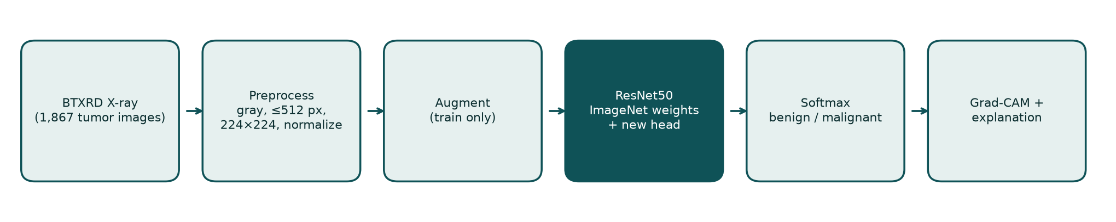
Figure 4.1: Overall pipeline of the proposed system

4.2 Dataset
The Bone Tumor X-ray Radiograph Dataset (BTXRD) [7] contains 3,746 radiographs collected from several centres, of which 1,879 are normal and 1,867 contain a tumor. Each image has clinical metadata and image-level labels; tumor images are labelled benign or malignant together with the tumor subtype. In line with the project scope, only the 1,867 tumor images were used: 1,525 benign and 342 malignant (18.3%). The labels were taken from the dataset's benign and malignant columns; no image carried both labels or neither.
Table 4.1: Data split (stratified, random seed 42)
Split | Images | Benign | Malignant
Training (70%) | 1,306 | 1,066 | 240
Validation (15%) | 280 | 229 | 51
Test (15%) | 281 | 230 | 51
Total | 1,867 | 1,525 | 342

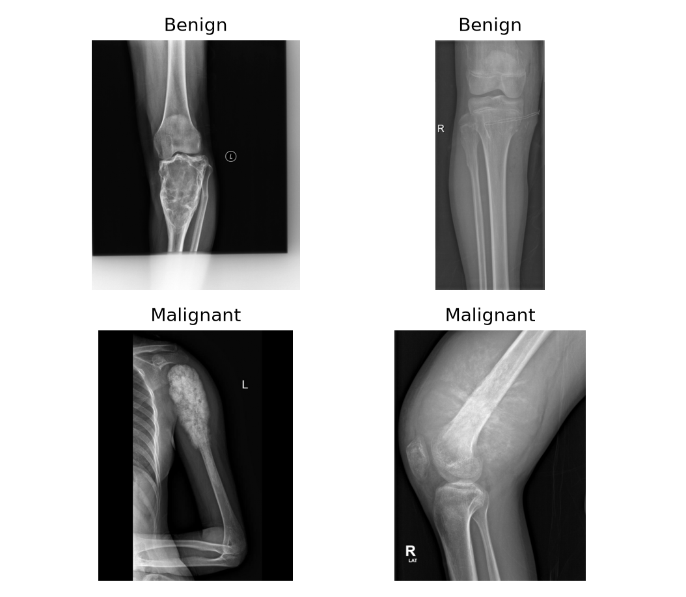
Figure 4.2: Sample benign and malignant radiographs from BTXRD

4.3 Preprocessing
All images, both for training and in the deployed application, pass through the same standardisation function so that the model always sees data in the format it was trained on:
- Correct orientation using EXIF metadata and rescale 16-bit images to 8 bits.
- Convert to 8-bit grayscale and downscale so that the longest side is at most 512 pixels.
- Replicate the grayscale channel to three channels, as required by the ImageNet-pretrained backbone.
- Resize to 224 x 224 pixels.
- Normalise with the ImageNet mean (0.485, 0.456, 0.406) and standard deviation (0.229, 0.224, 0.225).

4.4 Data Augmentation
To improve generalisation from the limited number of malignant examples, the following random transformations are applied to training images only: random resized crop covering 80-100% of the image, horizontal flip, rotation of up to +/-15 degrees, translation of up to 5%, and brightness and contrast changes of up to 20%. Validation and test images are never augmented.

4.5 Model Architecture
ResNet50 [8] is a 50-layer residual network whose skip connections allow very deep networks to be trained effectively. The ImageNet-pretrained backbone is kept, and its final fully connected layer is replaced with a new classification head: Dropout (0.4) -> Linear (2048 -> 256) -> ReLU -> Dropout (0.3) -> Linear (256 -> 2). A softmax over the two outputs gives the probabilities of the benign and malignant classes.

4.6 Training Strategy
Table 4.2: Training configuration
Setting | Value
Stage 1 (feature extraction) | Backbone frozen; head trained for 5 epochs; learning rate 1e-3
Stage 2 (fine-tuning) | layer3, layer4 and head trained for up to 20 epochs; learning rate 1e-4
Optimizer | AdamW, weight decay 1e-4, batch size 32
Loss | Cross-entropy with class weights 0.613 (benign) and 2.721 (malignant)
Learning-rate schedule | Halved when validation F1 does not improve for 2 epochs
Early stopping | After 6 epochs without validation-F1 improvement
Model selection | Checkpoint with the highest validation F1 (malignant class)

The class weights are inversely proportional to the class frequencies in the training set, so that errors on the minority malignant class contribute more to the loss.

4.7 Evaluation Metrics
With TP, TN, FP and FN denoting true positives, true negatives, false positives and false negatives (malignant is the positive class), the following metrics are used:
Accuracy = (TP + TN) / (TP + TN + FP + FN)
Precision = TP / (TP + FP) Recall (sensitivity) = TP / (TP + FN)
F1-score = 2 x Precision x Recall / (Precision + Recall)
The ROC-AUC (area under the receiver operating characteristic curve) measures how well the predicted malignant probability ranks malignant images above benign ones across all thresholds. A confusion matrix summarises class-wise performance.

4.8 Explainability with Grad-CAM
Gradient-weighted Class Activation Mapping (Grad-CAM) [9] produces a heatmap of the regions that increased the score of a chosen class. For the feature maps A^k of ResNet50's last residual block and the score y^c of the predicted class c, each map is weighted by its average gradient and the weighted sum is passed through a ReLU:
alpha_k = mean over (i, j) of dy^c / dA^k_ij L_Grad-CAM = ReLU( sum_k alpha_k A^k )
The map is upsampled to 224 x 224 and overlaid on the X-ray. From it the system derives the location and size of the main evidence region and whether that region lies mostly on dark background rather than bone.

CHAPTER 5

IMPLEMENTATION

5.1 Project Structure
Table 5.1: Main source files
File | Responsibility
config.py | Paths, image size, split ratios, hyper-parameters, device selection
prepare_btxrd.py | Sorts BTXRD into benign / malignant folders
dataset.py | Standardisation, stratified split, augmentation, data loaders
model.py | ResNet50 with new head; freezing; safe checkpoint loading
train.py | Two-stage training, early stopping, checkpointing
evaluate.py, metrics.py | Metrics, confusion matrix, ROC, error gallery, confidence bands
compare.py | Augmentation ablation table and chart
predict.py | Single-image prediction, Grad-CAM, explanation
app.py | Gradio web application

5.2 Training Implementation
Training uses PyTorch with automatic device selection (CUDA, Apple MPS or CPU). The core of stage 2 is shown below.
unfreeze_top(model) # layer3, layer4 and fc become trainable
optimizer = AdamW(trainable_params, lr=1e-4, weight_decay=1e-4)
for epoch in range(20):
train_one_epoch(model, train_loader, weighted_cross_entropy, optimizer)
val_f1 = f1_score(val_labels, predict(model, val_loader) >= 0.5)
scheduler.step(val_f1)
if val_f1 > best_f1: save_checkpoint(model) # keep best model
elif epochs_without_improvement >= 6: break # early stopping

5.3 Prototype Application
The Gradio web application lets a user upload an X-ray (PNG, JPEG, BMP or TIFF) and returns the benign and malignant scores, the Grad-CAM heatmap and a plain-language explanation. The application rejects unreadable files, images smaller than 64 x 64 pixels and blank images with clear messages, and refuses to start if the model file is missing or was trained for different classes. It runs locally at http://127.0.0.1:7860, with one-click scripts for Windows and a notebook for Google Colab.
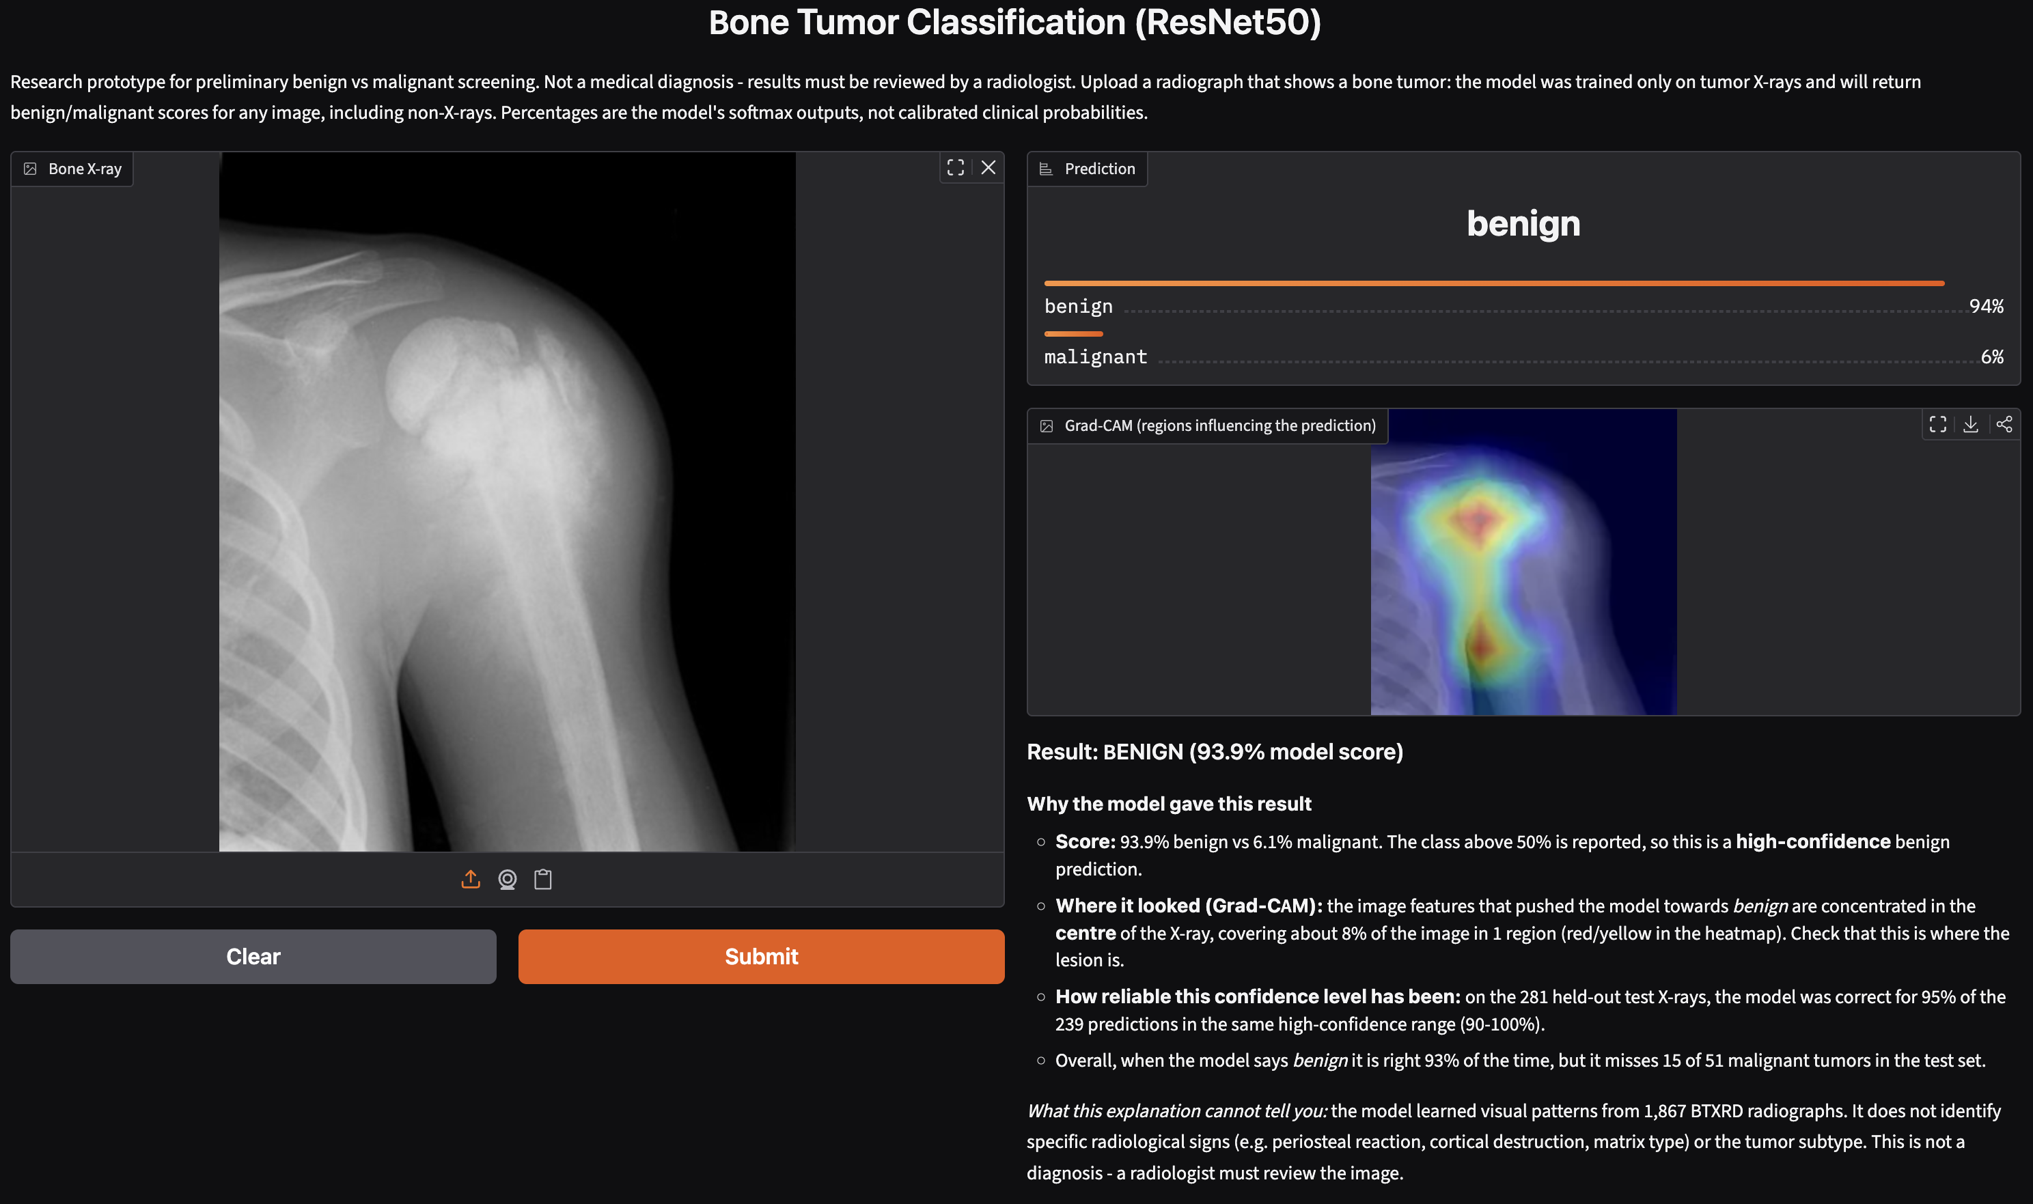
Figure 5.1: Web application showing the prediction, Grad-CAM heatmap and explanation (a known failure case)

5.4 Verification of the Implementation
- The application's predictions match the evaluation pipeline on all 281 test images (maximum difference 3 x 10^-7) and reproduce the reported accuracy.
- Uploading the original full-resolution BTXRD files gives the same predictions as the standardised copies (0 of 281 changed).
- Grad-CAM passed a model-randomisation sanity check: maps differ between images and target classes, and change completely when trained weights are randomised.
- Invalid inputs (PDF, corrupted or truncated files, blank and tiny images) are rejected with readable messages.

CHAPTER 6

RESULTS AND DISCUSSION

6.1 Training Behaviour
Figure 6.1 shows the loss and accuracy per epoch. Training accuracy rises steadily to 0.99, while validation accuracy levels off between 0.87 and 0.90, indicating overfitting in later epochs. Early stopping selected epoch 18 (the 13th fine-tuning epoch), with a validation F1-score of 0.743; training stopped after epoch 24.
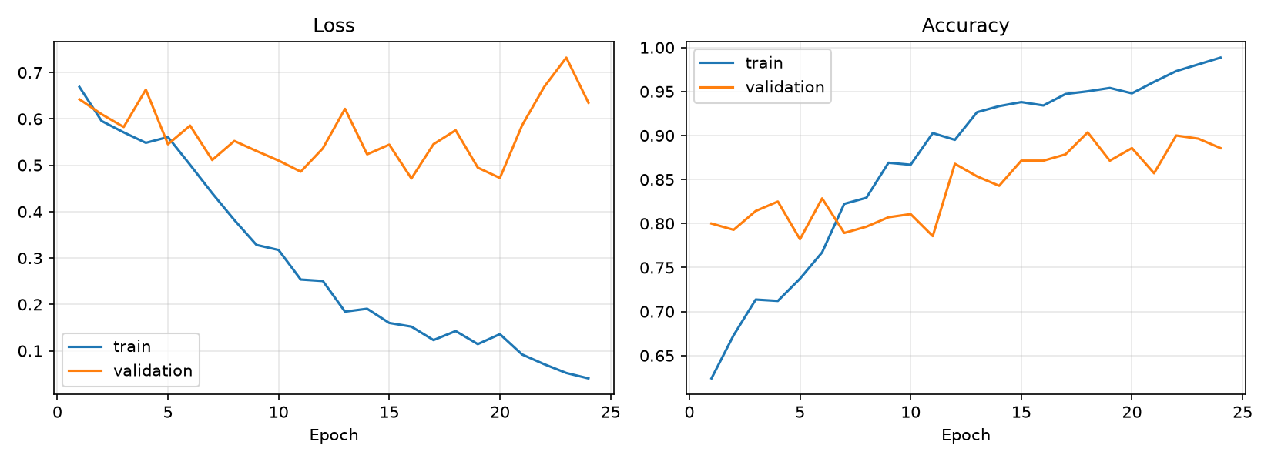
Figure 6.1: Training and validation loss and accuracy (epochs 1-5: stage 1; 6-24: stage 2)

6.2 Test-Set Performance
The selected model was evaluated once on the 281 test images, which were not used for training or model selection.
Table 6.1: Test-set classification report
Class | Precision | Recall | F1-score | Support
Benign | 0.934 | 0.930 | 0.933 | 230
Malignant | 0.692 | 0.706 | 0.699 | 51
Macro average | 0.813 | 0.818 | 0.816 | 281
Accuracy |  |  | 0.890 | 281
ROC-AUC |  |  | 0.945 | 281

The overall accuracy of 0.890 is influenced by the majority benign class. The malignant-class metrics are more informative: the model detects 36 of the 51 malignant tumors (sensitivity 0.706), and 36 of the 52 images it labels malignant are truly malignant (precision 0.692). Specificity is 0.930 (214 of 230 benign images correctly identified).
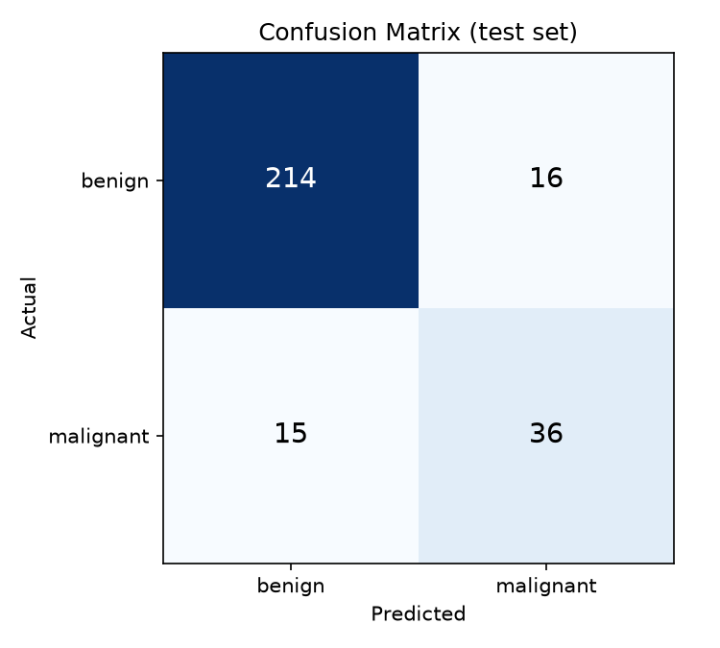
Figure 6.2: Confusion matrix on the test set
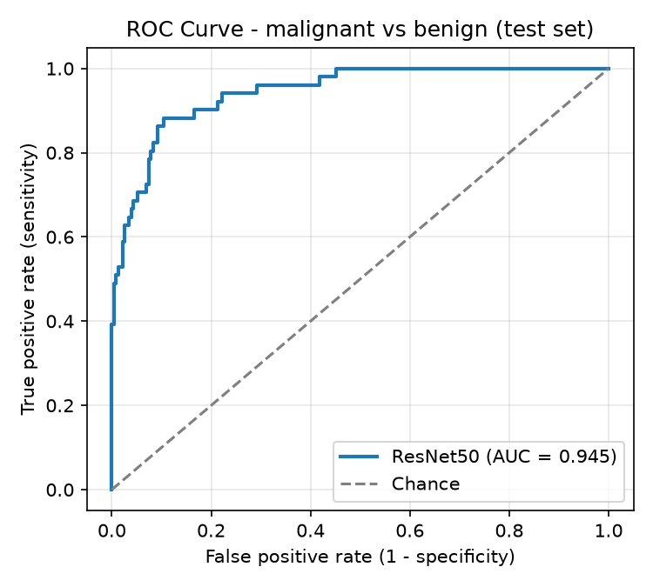
Figure 6.3: ROC curve on the test set (AUC = 0.945)

6.3 Effect of Data Augmentation
To measure the contribution of augmentation, an identical model was trained on the same split with augmentation disabled. Table 6.2 and Figure 6.4 compare the two models on the test set.
Table 6.2: Ablation: with versus without data augmentation
Model | Acc. | Prec. | Recall | F1 | AUC | Missed (of 51)
With augmentation (proposed) | 0.890 | 0.692 | 0.706 | 0.699 | 0.945 | 15
Without augmentation | 0.875 | 0.674 | 0.608 | 0.639 | 0.901 | 20

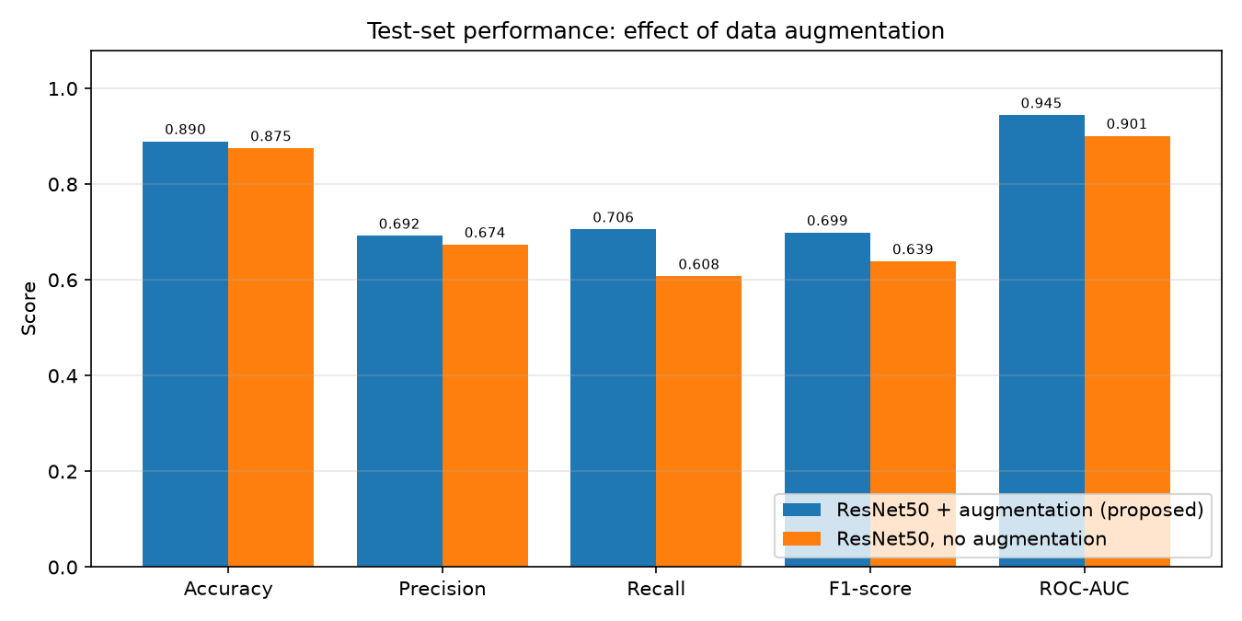
Figure 6.4: Test-set metrics with and without augmentation
Augmentation improved every metric, most notably malignant recall (+0.098) and ROC-AUC (+0.044), and reduced missed malignant tumors from 20 to 15. Each configuration was trained once, so part of the difference may be due to run-to-run variation.

6.4 Explainability
Figure 6.5 shows Grad-CAM for three test images. For the correctly classified malignant femur the evidence is concentrated on the lesion. For the benign pelvis the map partly covers the 'R' side marker, which suggests the model may sometimes use non-anatomical cues. For the misclassified malignant humerus the heatmap lies on the lesion, yet the prediction is benign with 93.9% confidence - Grad-CAM shows where the model looked, not whether its conclusion is correct.
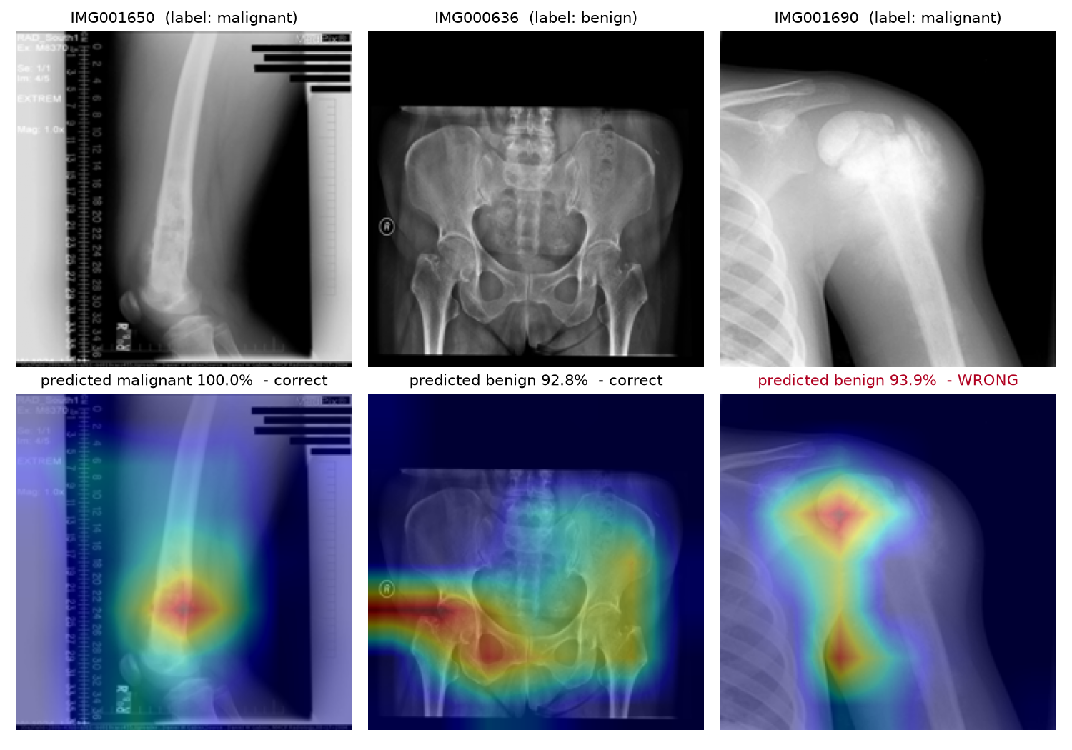
Figure 6.5: X-rays (top) and Grad-CAM heatmaps (bottom) for two correct predictions and one error

6.5 Error Analysis and Reliability
The model made 31 errors on the test set: 15 false negatives (malignant predicted benign) and 16 false positives. Table 6.3 groups test predictions by the model's confidence; the application quotes these figures in its explanation of every prediction.
Table 6.3: Test accuracy by prediction confidence
Confidence of the predicted class | Test images | Correct
High (>= 90%) | 239 | 95.4%
Moderate (70-90%) | 28 | 67.9%
Low (< 70%) | 14 | 21.4%

Confidence is a useful indicator of reliability: high-confidence predictions were correct 95% of the time, whereas low-confidence predictions were usually wrong and should be treated as uncertain. However, some errors occur with high confidence, so no prediction can be accepted without expert review.

6.6 Discussion
The results confirm that ResNet50 transfer learning can separate benign and malignant bone tumors on radiographs with good discrimination (ROC-AUC 0.945). Sensitivity for malignant tumors (0.706) remains the main weakness and is linked to the small number of malignant training images (240). The ROC curve indicates that a lower decision threshold could raise sensitivity at the cost of more false alarms, which may be preferable in a screening setting. Because BTXRD does not provide patient identifiers, different views of the same patient may appear in both training and test sets, so the reported figures may be somewhat optimistic.

CHAPTER 7

CONCLUSION AND FUTURE SCOPE

7.1 Conclusion
This project designed, implemented and evaluated a deep learning system that classifies bone-tumor X-rays as benign or malignant. All four objectives were achieved: images are preprocessed with resizing, normalisation and augmentation; a ResNet50 model was trained with two-stage transfer learning; and the model was evaluated with accuracy (0.890), precision (0.692), recall (0.706), F1-score (0.699) and ROC-AUC (0.945) on held-out data. An ablation study showed that augmentation measurably improves malignant detection. Each prediction is accompanied by a Grad-CAM heatmap and an explanation of its reliability, and the system is available as a working prototype on several platforms. The system is suitable as a preliminary screening aid whose output is reviewed by a radiologist; it is not a diagnostic tool.

7.2 Limitations
- Only 342 malignant images are available; 15 of 51 malignant test cases were missed.
- BTXRD has no patient identifiers, so patient-level separation of the splits could not be enforced.
- Evaluation used a single dataset without external validation from another hospital.
- Each configuration was trained once; results include run-to-run variation.
- The model cannot recognise non-X-ray inputs and will return a score for any image.
- Grad-CAM indicates where the model looked but not which radiological signs it used, and it can highlight markers.

7.3 Future Scope
- Collect more malignant cases and multi-centre data to reduce imbalance and test generalisation.
- Use patient-level splits and validate on an external dataset.
- Tune the decision threshold to favour sensitivity for screening.
- Compare EfficientNet, DenseNet, Vision Transformers and attention models such as CBAM.
- Extend to tumor-subtype classification using BTXRD's subtype labels.
- Add localisation or segmentation using BTXRD's masks, and an out-of-distribution check to reject non-X-ray images.

REFERENCES
[1] He, Y., Pan, I., Bao, B., et al. (2020). Deep learning-based classification of primary bone tumors on radiographs: A preliminary study. EBioMedicine, 62, 103121.
[2] Kwon, et al. (2022). Artificial intelligence-based classification of bone tumors in the proximal femur on plain radiographs: System development and validation. PLOS ONE.
[3] Recommender-based bone tumour classification with radiographs - a link to the past. European Radiology (2024).
[4] Enhancing bone cancer detection through optimized pre-trained deep learning models and explainable AI using the osteosarcoma tumor assessment dataset. Scientific Reports (2025).
[5] Deep learning driven radiographic classification of primary bone tumors using attention augmented hybrid models. Biomedical Signal Processing and Control (2026).
[6] Medical image pretraining-based transfer learning for generalizable and robust diagnosis of bone tumors on radiographs: a multi-center study (2026).
[7] Yao, S., Huang, Y., Wang, X., Zhang, Y., et al. (2025). A radiograph dataset for the classification, localization, and segmentation of primary bone tumors. Scientific Data, 12, 88. https://doi.org/10.1038/s41597-024-04311-y
[8] He, K., Zhang, X., Ren, S., & Sun, J. (2016). Deep residual learning for image recognition. Proceedings of the IEEE Conference on Computer Vision and Pattern Recognition (CVPR), 770-778.
[9] Selvaraju, R. R., Cogswell, M., Das, A., Vedantam, R., Parikh, D., & Batra, D. (2017). Grad-CAM: Visual explanations from deep networks via gradient-based localization. Proceedings of the IEEE International Conference on Computer Vision (ICCV), 618-626.
[10] Paszke, A., et al. (2019). PyTorch: An imperative style, high-performance deep learning library. Advances in Neural Information Processing Systems 32.

APPENDIX A: HOW TO RUN THE PROJECT

A.1 macOS / Linux
cd bone_tumor_classification/src
../.venv/bin/python app.py # web demo: http://127.0.0.1:7860
../.venv/bin/python predict.py ../samples/malignant_IMG001650.png
../.venv/bin/python evaluate.py # recompute test metrics
../.venv/bin/python train.py # retrain (~25 min, Apple GPU)

A.2 Windows
Install Python 3.12 (tick "Add python.exe to PATH"), then double-click setup_windows.bat once and run_demo.bat to start the demo. download_dataset.bat, evaluate.bat and train.bat are only needed to re-evaluate or retrain. Full instructions are in WINDOWS_SETUP.md.

A.3 Google Colab
Open notebooks/bone_tumor_colab.ipynb, select a T4 GPU runtime, upload the project archive and run the cells in order. The notebook downloads BTXRD, trains, evaluates and launches the demo with a public link.

