Rupanpreet kaur

PH: +1 647 5 23 7805

Email Id: [rupanpreetkaur53@gmail.com](mailto:rupanpreetkaur53@gmail.com)

Address: 377 Staines road Scarborough

**Objective:**

A hardworking and responsible Teenager seeking a challenging career and responsible position in reputed

organization, which can add to my overall skills and provide an atmosphere conductive to

continuous growth and advancement based on personal competency

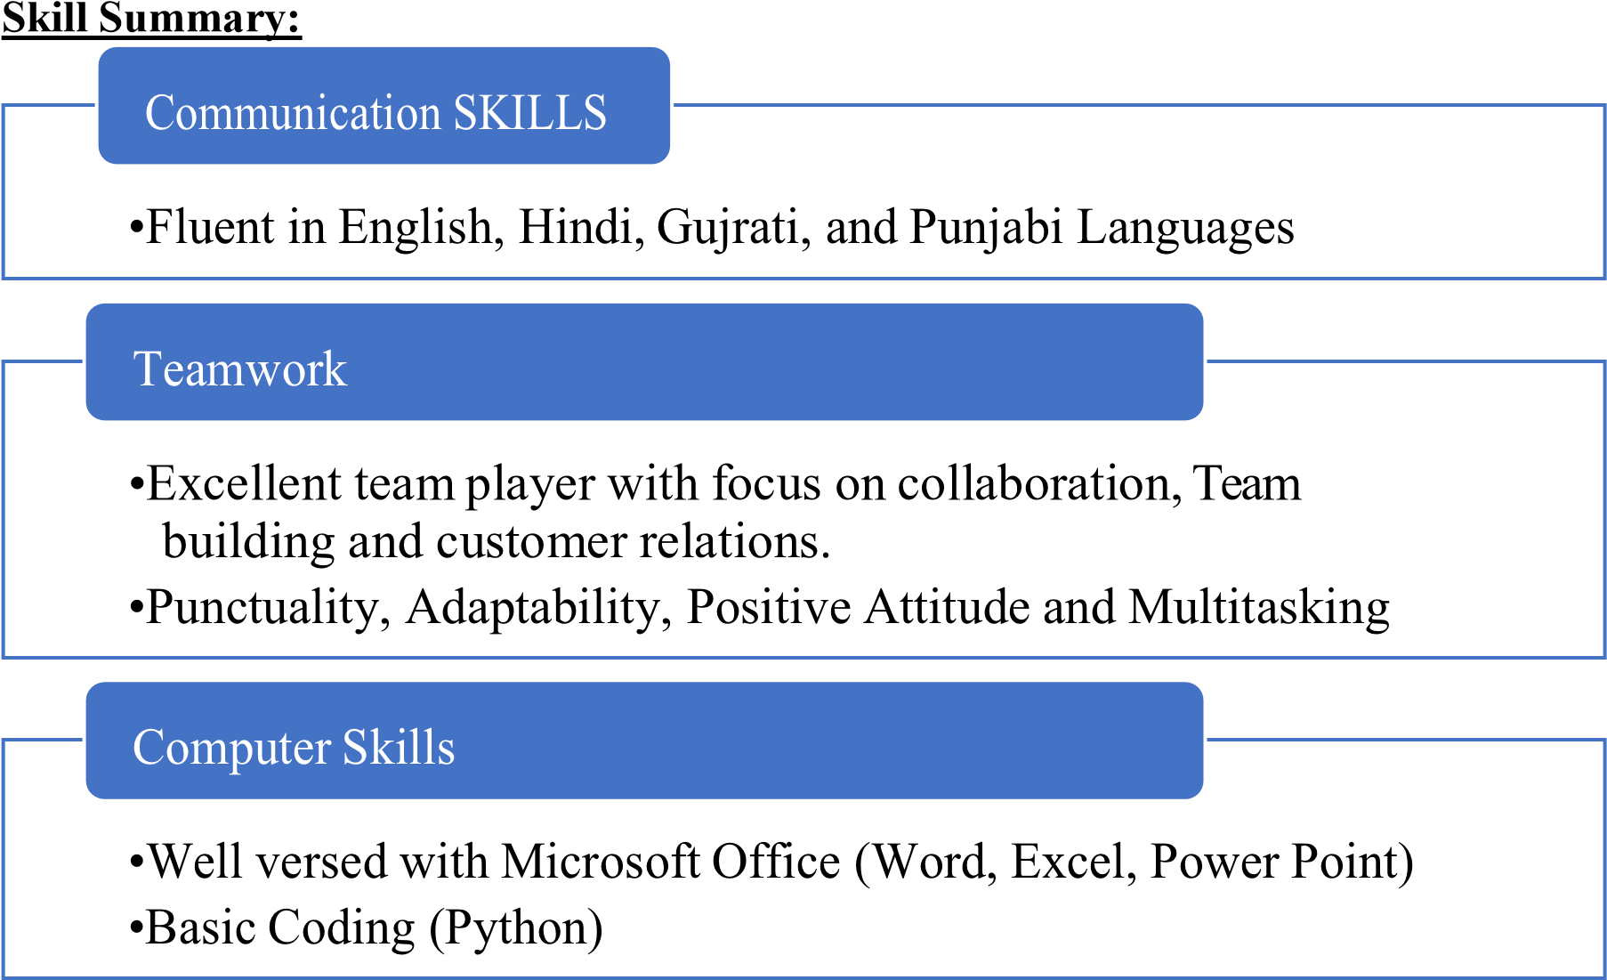

**Education:**

Pursuing Diploma in Computer Programming (2 Years

Course)2022, In Seneca College, International

Academy, Ontario

**Work Experience**:

* Worked as a cook at Nando’s for 6 months.
* Working experience of front grill, front of house as food runner and back grill.
* Experience of working with other co-workers and to take direction and to work in a team environment to work calmly and effectively under pressure.
* Also, worked in an Indian restaurant as Helper in the kitchen and Front of the house as cashier, food runner, server.

Availability: Flexible Schedule