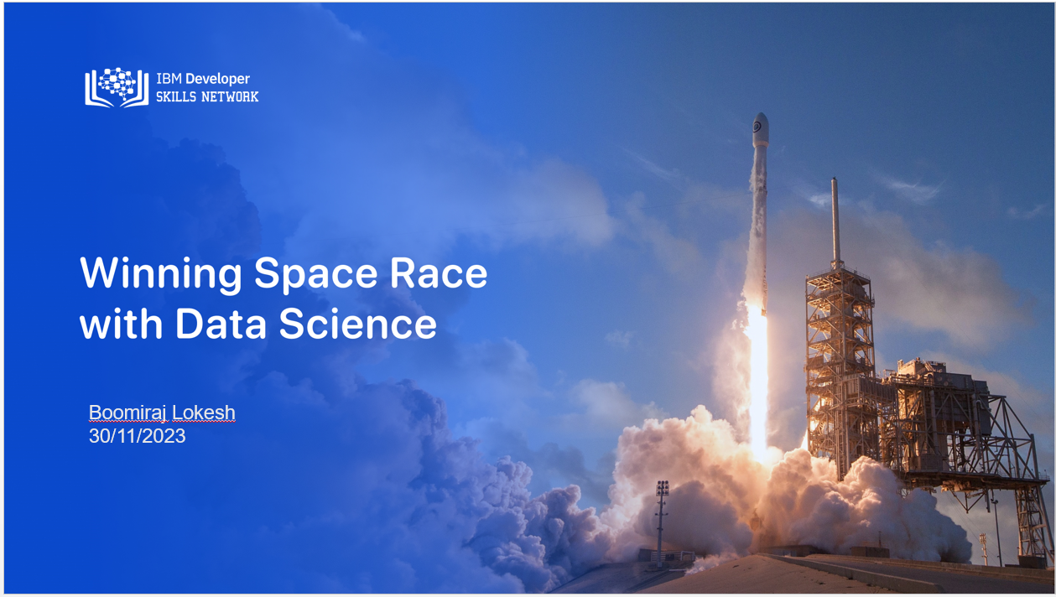

**1. Data Collection:**

Explanation: Data collection is the process of gathering relevant information for analysis. In your spacey data science project, this involves sourcing data related to space launches, such as launch sites, payloads, success/failure outcomes, etc.

Importance: The quality and comprehensiveness of your dataset directly impact the accuracy and effectiveness of subsequent analyses. It's crucial to gather data from reliable sources to ensure the reliability of your findings.

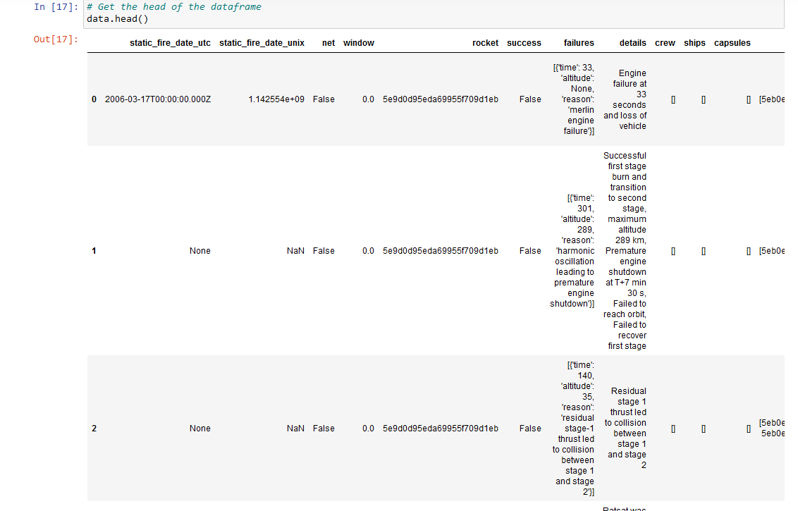

**2. Data Wrangling:**

Explanation: Data wrangling involves cleaning, organizing, and transforming raw data into a format suitable for analysis. This includes handling missing values, addressing outliers, and structuring the data appropriately.

Importance: Clean and well-organized data is essential for accurate analysis. Data wrangling ensures that your dataset is in a form that allows for meaningful insights during subsequent stages.

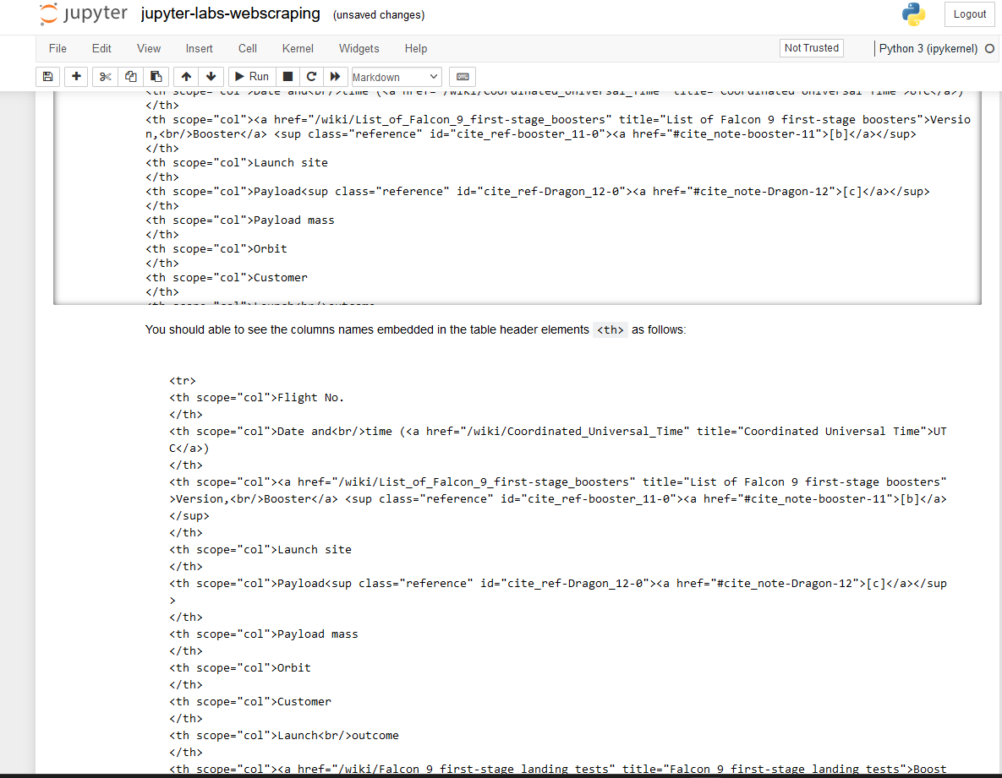

**3. Exploratory Analysis using SQL:**

Explanation: Exploratory data analysis (EDA) using SQL involves querying and examining the dataset using SQL queries. This step helps in understanding the structure of the data, identifying patterns, and obtaining initial insights.

Importance: SQL is powerful for handling large datasets and extracting valuable information efficiently. It allows you to explore relationships within the data and retrieve specific subsets for further investigation.

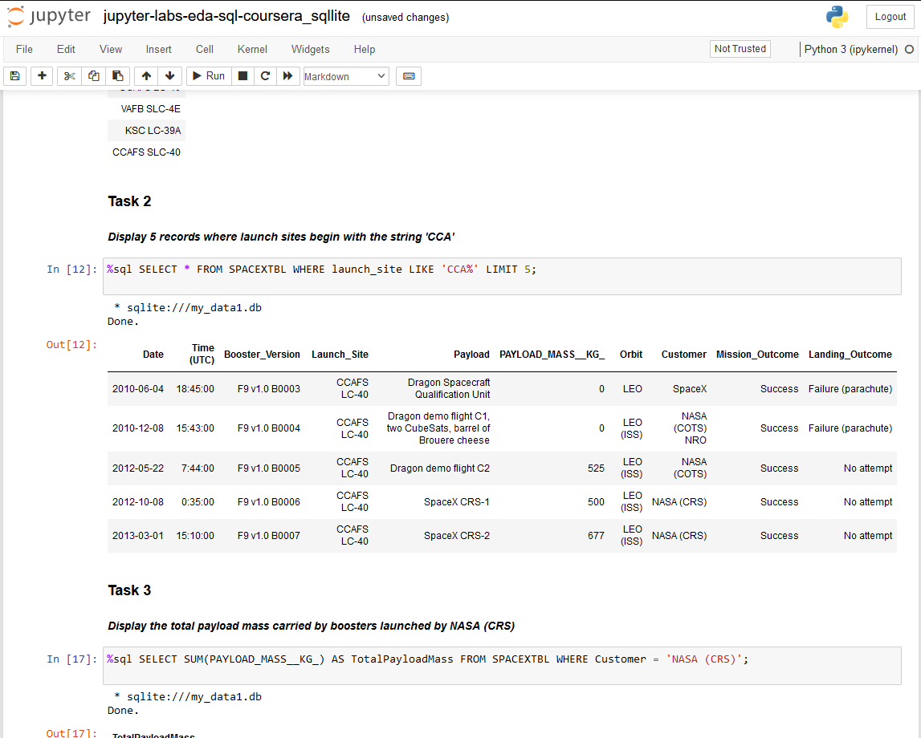

**4. Exploratory Analysis using Pandas and Matplotlib:**

Explanation: Pandas and Matplotlib are Python libraries used for data manipulation and visualization. Exploratory analysis using these tools involves using statistical methods and creating visualizations to understand the characteristics and trends in the data.

Importance: Python libraries like Pandas and Matplotlib provide a flexible and comprehensive environment for detailed data exploration. Visualization aids in the interpretation of patterns and trends.

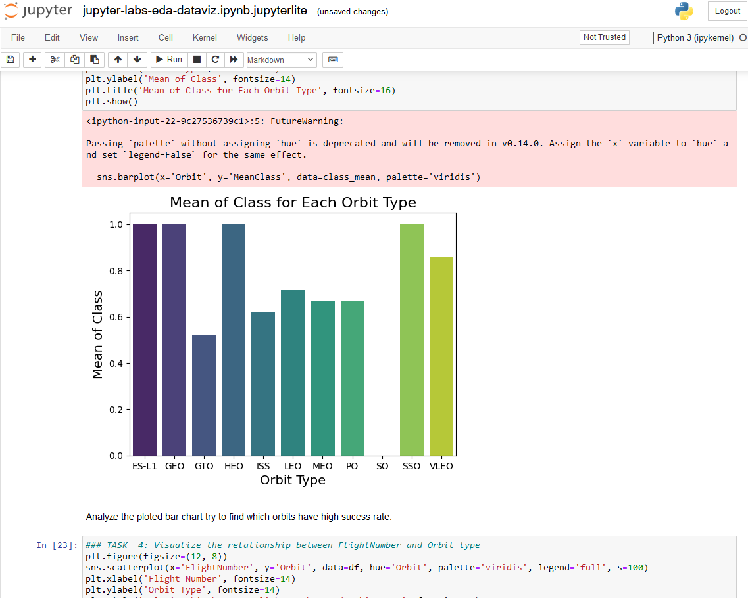

**5. Dashboard:**

Explanation: A dashboard is a visual representation of your data and analysis results. It usually includes interactive visualizations, graphs, and charts to convey insights to stakeholders in a user-friendly manner.

Importance: Dashboards provide a concise and accessible way to communicate complex information. They allow stakeholders to interact with the data, making it easier to understand and derive actionable insights.

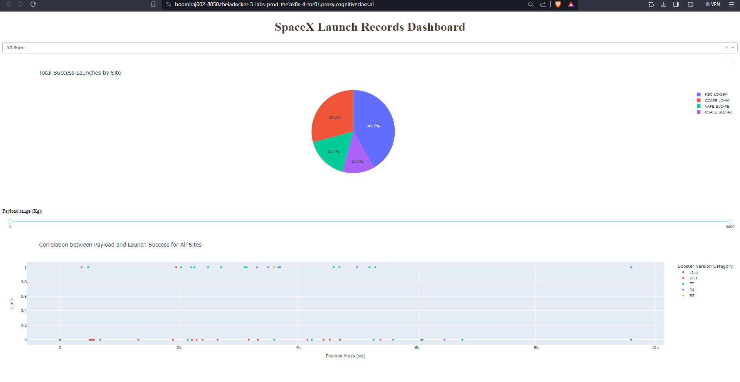

**6. Predictive Analysis:**

Explanation: Predictive analysis involves using historical data to make predictions about future trends or outcomes. In your spacey data science project, this could involve predicting the success of future space launches based on historical data.

Importance: Predictive analysis enables proactive decision-making by anticipating future events. It can assist in optimizing resources, identifying potential risks, and improving overall project planning.

These topics collectively form a comprehensive data science workflow, from collecting and cleaning data to exploring it using various tools and techniques, and finally, using predictive analytics to make informed decisions. Each stage contributes to the overall success of your spacey data science project.

FOR MORE INFO, PLEASE CHECK OUT THE GITHUB.