Exp. 2. Simulation of Density of States of Quantum Well Structure with Various Nanometer Thickness

Aim
To simulate the density of states of a quantum well structure with various nanometre thickness.

Software
NanoHub Online Tool — Thermoelectric Power Factor Calculator for Nanocrystalline Composites.

Theory
A quantum well is a potential well with only discrete energy values. The classic model used to demonstrate a quantum well is to confine particles, which were originally free to move in three dimensions, to two dimensions by forcing them to occupy a planar region. The effects of quantum confinement take place when the quantum well thickness becomes comparable to the de Broglie wavelength of the carriers (generally electrons and holes), leading to energy levels called "energy subbands", i.e. the carriers can only have discrete energy values.

Procedure
- Open nanoHUB.
- Go to Resources → Tools.
- Select Quantum wells in Tags.
- Select Thermoelectric Power Factor Calculator for Nanocrystalline Composites in Resources.
- Press Launch tool in the info section.
- Enter appropriate values in the required section.
- Select the Materials (Germanium / Silicon).
- Enter the material thickness required.
- Press Simulate to view results.
- Repeat for the next thickness and compare both the results.

Simulation Parameters
- Temperature: 300 K; Temperature Gradient: 10 K
- Silicon Doping: 1e+18 /cm³; Germanium Doping: 1e+18 /cm³
- Substrate Composition Si(x)Ge(1–x): x = 1
- Mat 1 Material: Silicon; Mat 2 Material: Germanium
- Boundary Condition: Reflective
- Result selected: Density of States – Centerline

Output — Base Simulation (Thickness 0.2 nm)
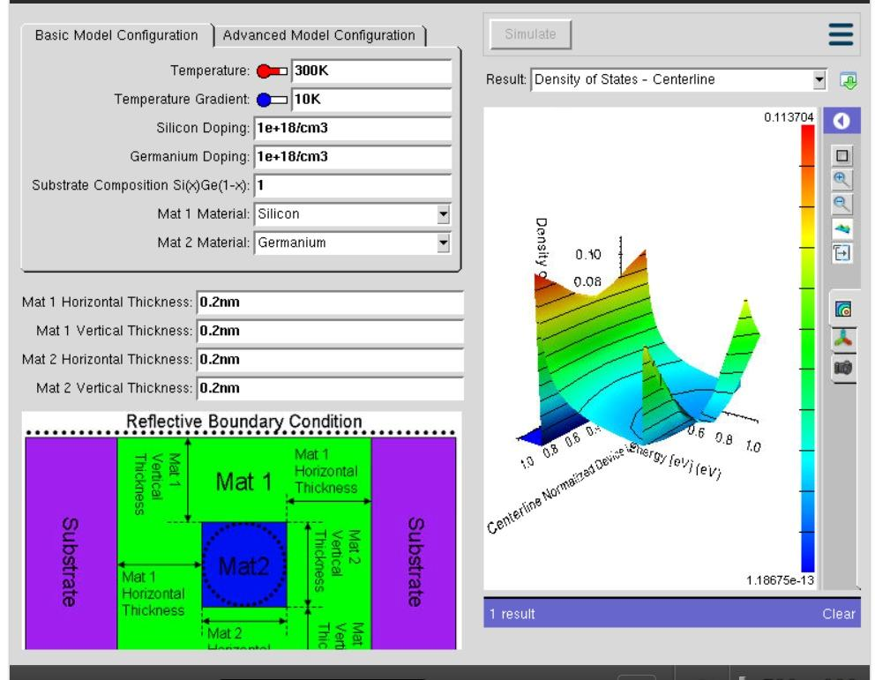
Explanation of Output:
The output is a 3-D surface plot of Density of States against the centerline normalised device energy (eV). The maximum density of states obtained is 0.113704 and the minimum is 1.18675e-13.
The plot is not a smooth continuous curve as would be expected for a bulk semiconductor. Instead it shows distinct raised peaks separated by deep valleys. This confirms quantum confinement: because the well width (0.2 nm) is comparable to the de Broglie wavelength of the electron, the energy is no longer continuous but is quantised into discrete sub-bands. Each visible peak corresponds to the onset of a new confined sub-band, and the near-zero regions between the peaks are the forbidden energy gaps where no allowed electronic states exist.
The colour scale (blue → red) represents increasing state density, so the red-topped ridges indicate the energy values at which the largest number of electronic states are available for occupation.

Case Study 1: Simulate the density of states of a quantum well of thickness 0.5 nm
Aim: To simulate the density of states of the Si/Ge quantum well when all four thickness parameters (Mat 1 horizontal, Mat 1 vertical, Mat 2 horizontal, Mat 2 vertical) are set to 0.5 nm, and to compare the result with the 0.2 nm case.
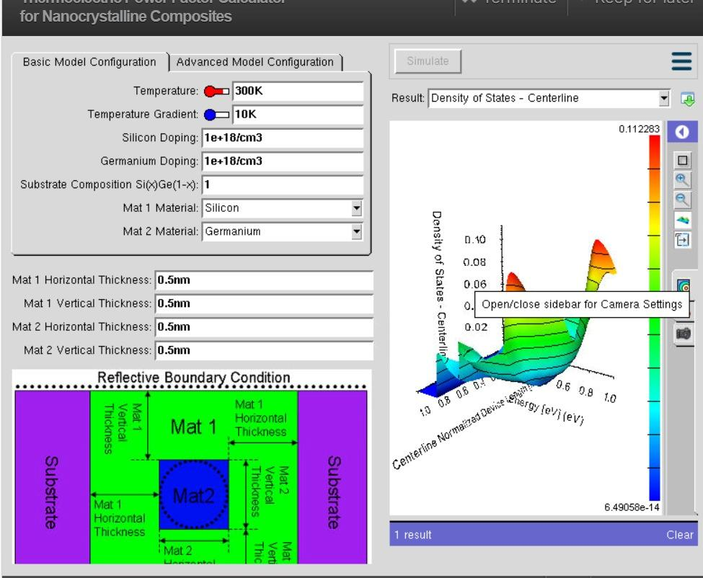
Simulation values recorded: barrierLx = barrierLy = wellLx = wellLy = 0.5 nm; maximum DOS = 0.113704; minimum = 6.49058e-14.
Explanation of Output:
On increasing the well thickness from 0.2 nm to 0.5 nm, the maximum density of states remains at 0.113704 while the minimum value rises from 1.18675e-13 to 6.49058e-14. The surface plot shows peaks that are broader and less sharply separated than in the 0.2 nm structure.
This is because a wider well relaxes the quantum confinement. As the confinement dimension increases, the spacing between the quantised sub-band energy levels decreases (E ∝ 1/L², where L is the well width). The sub-bands therefore move closer together, the sharp isolated peaks begin to merge, and the DOS profile starts to approach the smoother, staircase-like behaviour of a bulk material.

Case Study 2: Simulate the density of states of a quantum well of thickness 0.6 nm
Aim: To simulate the density of states of the Si/Ge quantum well with all thickness parameters set to 0.6 nm and to observe the trend of DOS with further increase in well width.
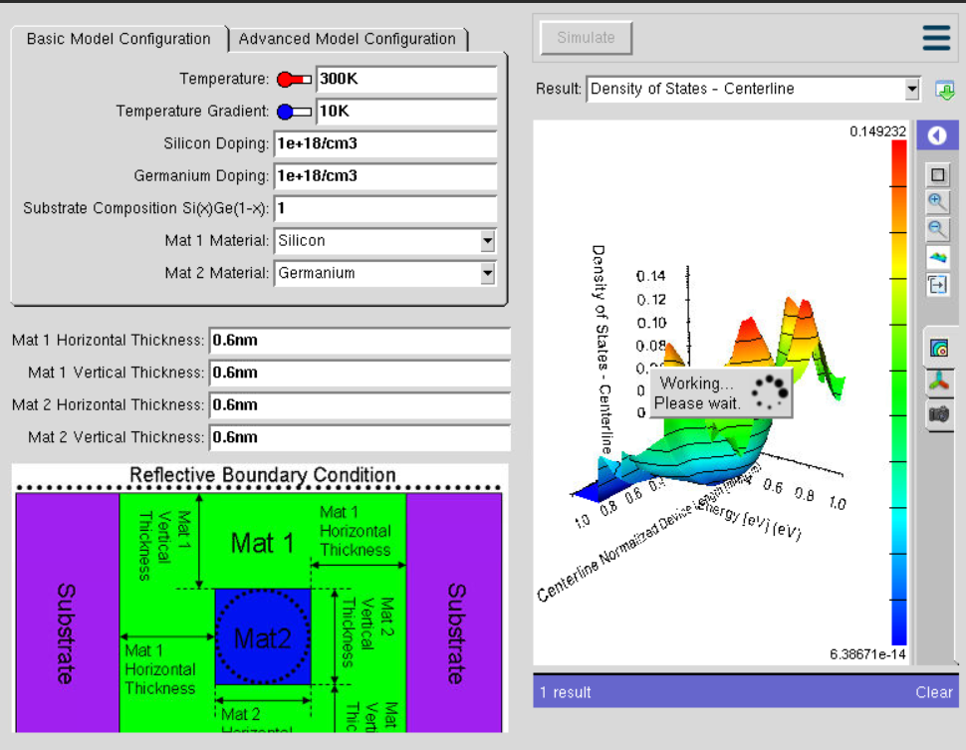
Simulation values recorded: barrierLx = barrierLy = wellLx = wellLy = 0.6 nm; maximum DOS = 0.244901; isoline value = 0.0890549; minimum = 6.38671e-14.
Explanation of Output:
At 0.6 nm the maximum density of states rises sharply to 0.244901, which is more than double the value obtained for the 0.2 nm and 0.5 nm wells. The 3-D surface shows multiple well-defined peaks distributed across the energy axis, with an isoline marked at 0.0890549.
With the larger well width more quantised sub-bands are able to fit within the same energy window, so a greater number of allowed states appear in the plotted range. This raises the overall peak DOS value considerably. The valleys between the peaks are also shallower than in the 0.2 nm case, confirming that the forbidden gaps between sub-bands shrink as confinement weakens.

Inference
- Reducing the well thickness increases the energy spacing between sub-bands and produces sharp, well-separated DOS peaks.
- Increasing the well thickness reduces the sub-band spacing, allows more states within the same energy range, and drives the DOS towards bulk-like behaviour.
- The density of states of a low-dimensional structure can therefore be engineered simply by controlling the physical thickness of the well.

Result
Simulation of density of states of quantum well structure with various nanometer thickness is accomplished.

Exp. 3. Simulation of Energy States of Quantum Dot using NanoHub

Aim
To obtain the energy states of quantum dots.

Software
NanoHub Online Tool — Quantum Dot Lab.

Theory
Quantum dots (QD) are very small semiconductor particles, only several nanometres in size, so small that their optical and electronic properties differ from those of larger particles. Many types of quantum dot will emit light of specific frequencies if electricity or light is applied to them, and these frequencies can be precisely tuned by changing the dots' size, shape and material.
Quantum dots exhibit properties that are intermediate between those of bulk semiconductors and those of discrete molecules. Their optoelectronic properties change as a function of both size and shape. Larger QDs (diameter of 5–6 nm) emit longer wavelengths resulting in emission colours such as orange or red, while smaller QDs (diameter of 2–3 nm) emit shorter wavelengths resulting in colours like blue and green. Potential applications include transistors, solar cells, LEDs, diode lasers, quantum computing and medical imaging.

Procedure
- Open nanoHUB.
- Go to Resources → Tools.
- Select Quantum Dot in Tags.
- Select Quantum dot → Quantum Dot Lab.
- Press Launch tool in the info section.
- Select the type of Quantum Dot Structure.
- Select Energy Bandgap and enter the value.
- Press Simulate to view results.
- Select Result → Energy States.
- Repeat the above steps for simple and multi-layer quantum dots and compare the results.

Output — Structure Configuration (Pyramid Quantum Dot)
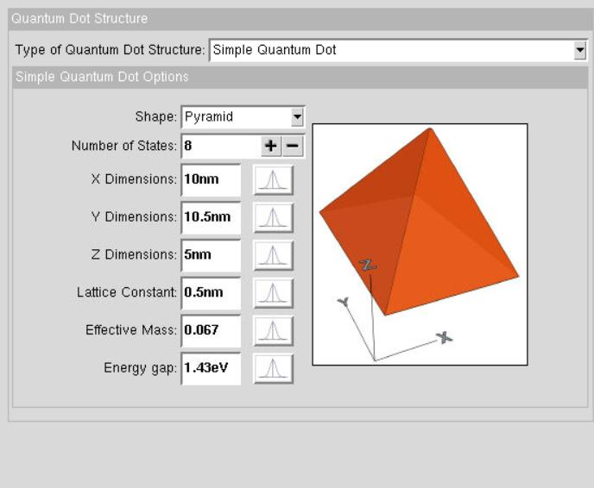
Parameters set: Type – Simple Quantum Dot, Shape – Pyramid, Number of States – 8, X = 10 nm, Y = 10.5 nm, Z = 5 nm, Lattice Constant = 0.5 nm, Effective Mass = 0.067, Energy Gap = 1.43 eV.

Optical Configuration
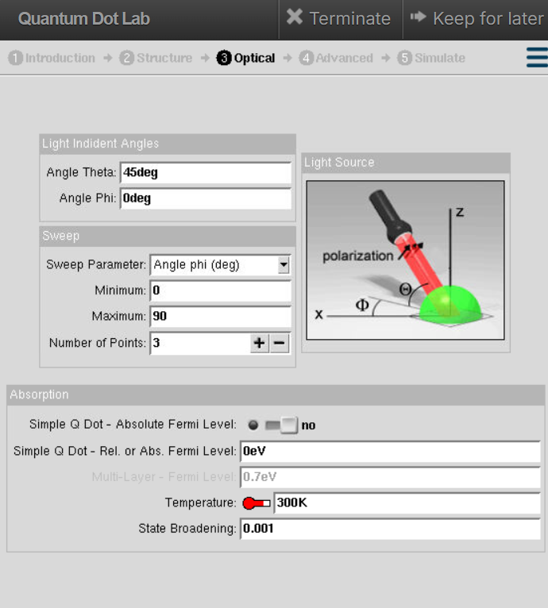
Light incident angles Theta = 45° and Phi = 0°; sweep parameter Angle phi from 0° to 90° with 3 points; Simple Q Dot relative Fermi level 0 eV; Temperature 300 K; State Broadening 0.001. These settings define the polarisation and direction of the incident light used to compute optical absorption between the confined states.

Output — All Eigen Energies (Pyramid Dot)
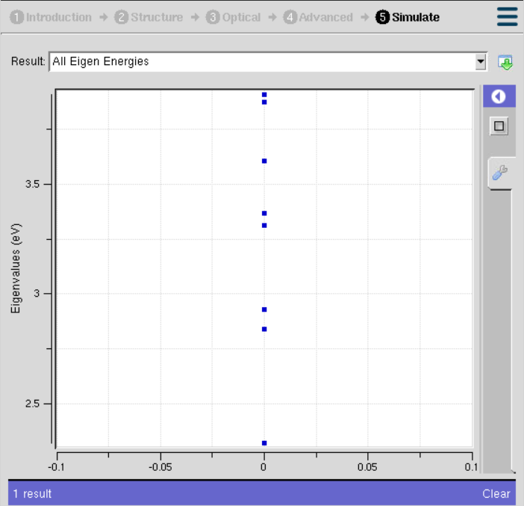
Explanation of Output:
The output is a plot of Eigenvalues (eV) shown as a set of discrete points lying on a single vertical line at x = 0. The eight computed eigen energies are spread between roughly 2.3 eV and 3.8 eV.
Because a quantum dot confines the carrier in all three dimensions, it has no continuous energy band at all — only a set of sharply defined, atom-like discrete energy levels. This is why the result appears as separated points rather than a curve. The vertical spacing between the points gives the energy separation between successive confined states.
Some points lie very close together or overlap. These are degenerate states, i.e. different quantum states having nearly the same energy, which arise from the symmetry of the pyramidal geometry. The lowest point represents the ground state and the higher points are the excited states of the dot.

Case Study 1: Simulate the energy states of a cylindrical quantum dot of X = 15 nm, Y = 10.5 nm and Z = 8 nm
Aim: To determine the eigen energy spectrum of a cylindrical quantum dot of larger dimensions and to compare it with the smaller pyramidal dot.
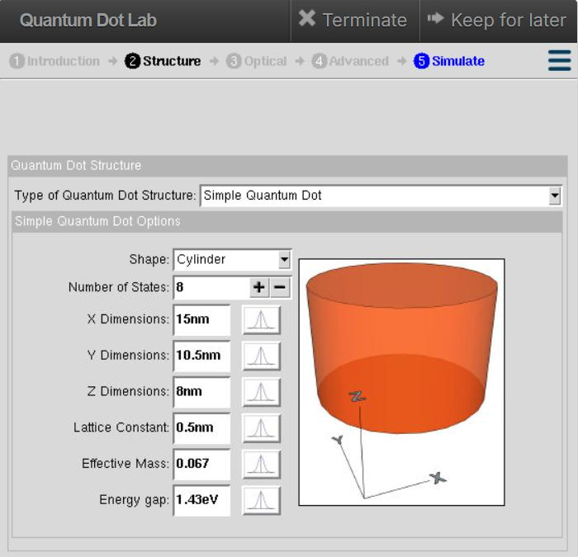
Parameters set: Shape – Cylinder, Number of States – 8, X = 15 nm, Y = 10.5 nm, Z = 8 nm, Lattice Constant = 0.5 nm, Effective Mass = 0.067, Energy Gap = 1.43 eV.
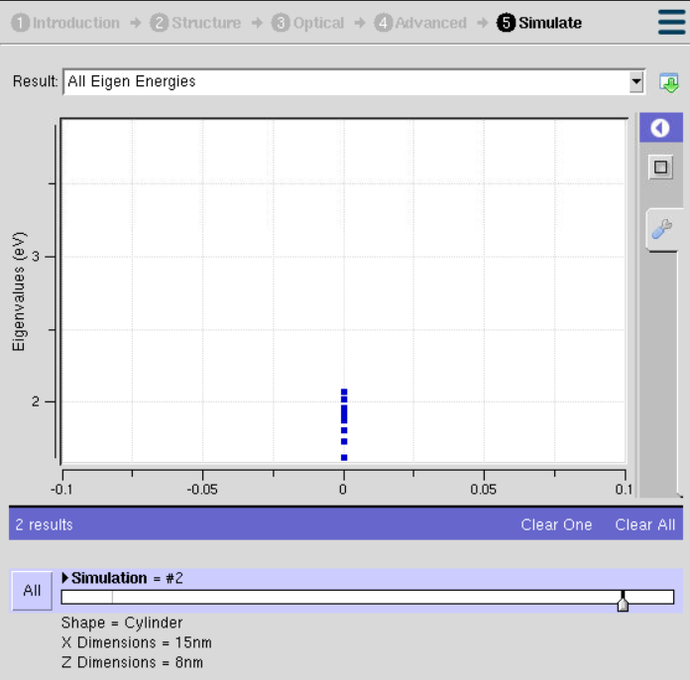
Explanation of Output:
For the cylindrical dot the eight eigen energies are clustered tightly around 2 eV, in contrast to the pyramid dot whose levels were spread up to 3.8 eV. All the states now lie in a narrow band with very small separation between them.
This happens because the cylinder is physically much larger (15 nm × 10.5 nm × 8 nm) than the pyramid. As the confinement volume increases, the confinement energy falls (E ∝ 1/L²), so all the levels shift downward and the spacing between successive levels becomes small. The dot therefore behaves in a more bulk-like manner. The circular cross-section of the cylinder is also highly symmetric, which produces a large number of degenerate states — visible here as points that almost coincide with one another.
Case Study 2: Simulate the energy states of a two-layer cuboid quantum dot
Aim: To simulate the eigen energy states of a multi-layer (two-layer) cuboidal GaAs–InAs–GaAs quantum dot including strain and local band effects.
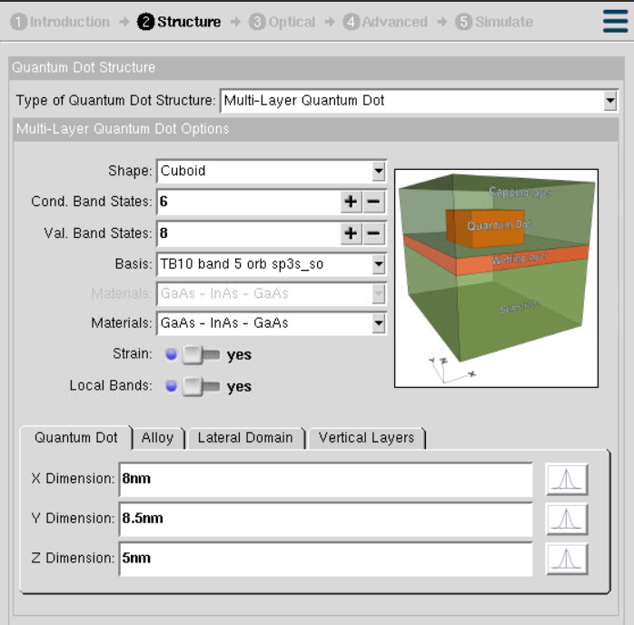
Parameters set: Structure type – Multi-Layer Quantum Dot, Shape – Cuboid, Conduction Band States – 6, Valence Band States – 8, Basis – TB10 band 5 orb sp3s_so, Materials – GaAs / InAs / GaAs, Strain – Yes, Local Bands – Yes, X = 8 nm, Y = 8.5 nm, Z = 5 nm.
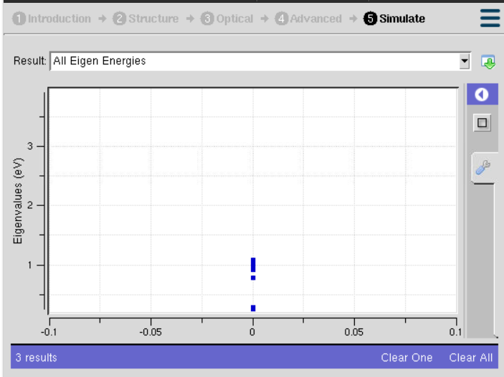
Explanation of Output:
The eigen energies for the two-layer cuboid dot lie between approximately 0.2 eV and 1.05 eV, with a dense cluster of states between 0.9 eV and 1.05 eV and one isolated low-lying state near 0.2 eV. These values are significantly lower than those of both the pyramid and the cylinder.
Two reasons account for this. First, the InAs quantum dot region is embedded between GaAs barrier layers, and InAs has a much smaller band gap than GaAs, so the confined levels naturally sit at lower energies. Second, the simulation includes strain, which arises from the lattice mismatch between InAs and GaAs; strain modifies the local band edges and shifts the confined levels further.
The tight-binding basis (TB10, sp3s*_so) used here is a more physically realistic atomistic model than the simple effective-mass model used in the earlier cases, so the results represent the actual band structure of the heterostructure more accurately. Separate conduction-band and valence-band states are computed, and the energy difference between the lowest conduction state and the highest valence state gives the effective optical transition energy of the dot.

Analytical
A thin film of SiO₂ is deposited on a silicon substrate. The film has a thickness of 50 nm and a refractive index of 1.5. Calculate the wavelength of light that experiences constructive interference in the film.
Given: t = 50 nm, n = 1.5.
Condition for constructive interference in a thin film: 2nt = mλ
For the first order (m = 1): λ = 2nt = 2 × 1.5 × 50 nm = 150 nm
For higher orders: m = 2 → λ = 300 nm; m = 3 → λ = 450 nm

Inference
- A quantum dot confines carriers in all three dimensions and therefore possesses only discrete, atom-like energy levels.
- Smaller dots give larger level spacing and higher confinement energies; larger dots give closely spaced, lower-energy levels.
- The shape of the dot determines the degree of degeneracy — more symmetric shapes such as the cylinder show more degenerate states.
- Multi-layer heterostructure dots with strain shift the energy levels considerably and require atomistic tight-binding models for accurate prediction.

Result
The simulation of energy states of quantum dots is accomplished.

Exp. 4. Kronig–Penney Model

Aim
To simulate the Energy Functional vs Energy graph using the Kronig–Penney model.

Software
NanoHub Online Tool — Periodic Potential Lab.

Theory
The Kronig–Penney model is a simplified theoretical model used in solid-state physics to describe the behaviour of electrons in a periodic potential, such as the potential experienced by electrons in a crystal lattice. It was introduced by Ralph Kronig and William G. Penney in 1931 and is particularly useful for understanding electronic band structure in materials like semiconductors and insulators.
The model assumes that the electron moves in a one-dimensional periodic potential, usually modelled as a series of square wells or delta-function wells, with free-electron behaviour between the wells. The potential can be written as V(x) = –V₀ for |x| ≤ a/2 and V(x) = 0 for |x| > a/2, where V₀ is the strength of the well, a is its width, and the potential repeats with period b (the distance between two adjacent wells).

Procedure
- Open nanoHUB.
- Go to Resources → Tools.
- Select Kronig Penney Model in Tags.
- Select Kronig Penney Model → Periodic Potential Lab.
- Press Launch tool in the info section.
- Select Potential Type → Step well.
- Select Energy Details → Maximum Barrier Height → 1 eV.
- Press Simulate to view results.
- Select Result → Energy Functional vs Energy.

Output — Step Potential
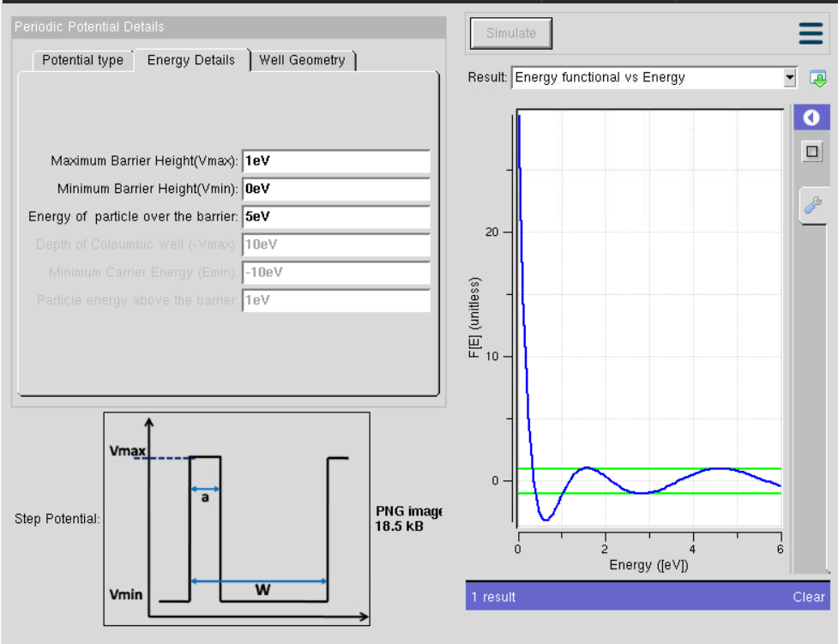
Parameters: Maximum barrier height Vmax = 1 eV, minimum barrier height Vmin = 0 eV, energy of particle over the barrier = 5 eV.
Explanation of Output:
The plot of F[E] (unitless) against energy shows a very sharp fall from a high value near E = 0, followed by a damped oscillation about the two horizontal green lines. The green lines mark the allowed limits of the energy functional. Wherever the oscillating blue curve lies between the two green lines, the corresponding energy is an allowed energy band; wherever it goes outside them, that energy is forbidden. This reproduces the classical Kronig–Penney result — a periodic array of rectangular barriers produces alternating allowed and forbidden energy bands.

Case Study 1: Simulate the output for a Triangular well
Aim: To obtain the Energy Functional vs Energy characteristics when the periodic potential is changed from a step well to a triangular well.
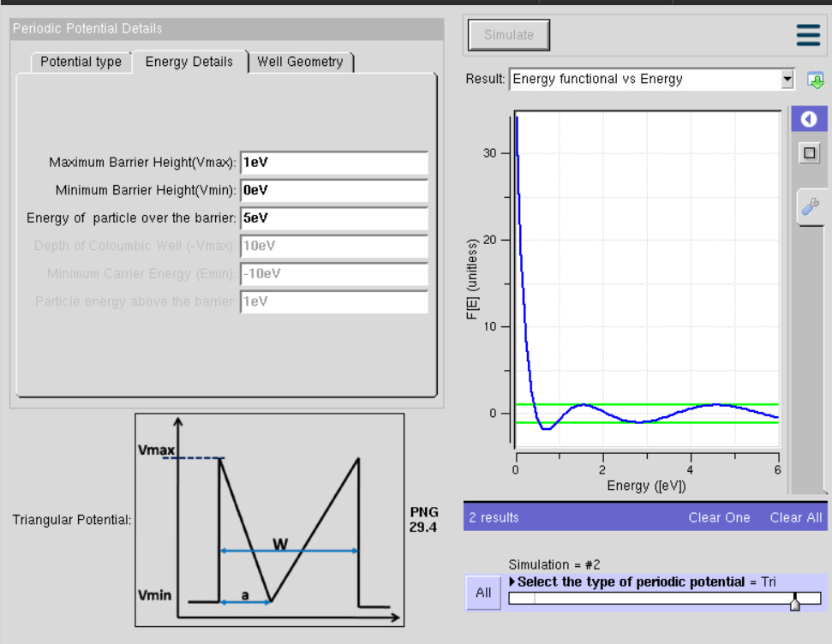
Explanation of Output:
With a triangular periodic potential the curve rises to a higher initial value (about 30) and the subsequent oscillations are smoother and shallower than for the step potential. Because the potential varies gradually instead of abruptly, the allowed bands become wider and the forbidden gaps become narrower. The shape of the periodic potential therefore directly controls the width of the energy bands.

Case Study 2: Simulate the output for a Sinusoidal potential
Aim: To obtain the Energy Functional vs Energy characteristics when the periodic potential is a sinusoidal profile, and to compare all three potential shapes.
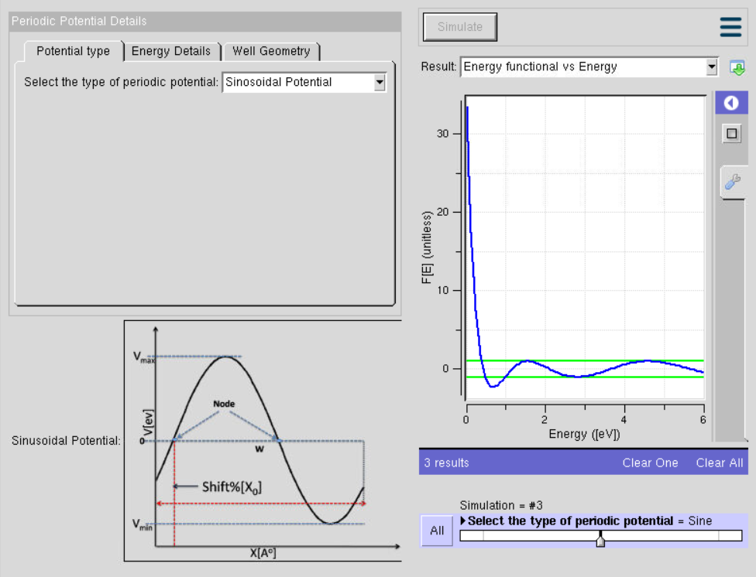
Explanation of Output:
For the sinusoidal potential the energy functional again starts near 30 and settles into a smooth, gently decaying oscillation within the green limit lines. Since the sinusoidal potential is the most gradually varying of the three, it produces the smoothest band structure with the least pronounced band gaps.
Comparing all three cases confirms that a sharper, more abrupt periodic potential creates stronger scattering of the electron wave and hence larger forbidden gaps, while a smoothly varying potential gives wider allowed bands and smaller gaps.

Analytical
Finding energy bands for a simple Kronig–Penney model.
Given: depth of potential well V₀ = 1 eV, width of potential well a = 0.2 nm, periodicity b = 1 nm = 1 × 10⁻⁹ m, mass of electron m = 9.11 × 10⁻³¹ kg, ℏ = 1.055 × 10⁻³⁴ J·s.
The first energy band is given by E₁ ≈ (ℏ²π²) / (2mb²)
E₁ ≈ (1.055 × 10⁻³⁴)² π² / [2 × (9.11 × 10⁻³¹) × (1 × 10⁻⁹)²]
E₁ ≈ 0.48 eV
Thus, the first allowed energy band is approximately 0.48 eV.

Result
The Energy Functional vs Energy graph using the Kronig–Penney model is simulated.

