Exp. 5. Band Structure Simulation for Graphene and CNTs using NanoHub

Aim
To simulate the band structure of a nanowire for various materials.

Software
NanoHub Online Tool — ABACUS (Assembly of Basic Applications for Coordinated Understanding of Semiconductors) → Band Structure Lab.

Theory
A quantum wire is an electrically conducting wire in which quantum effects influence the transport properties. Usually such effects appear in the dimension of nanometres. If the diameter of a wire is sufficiently small, electrons will experience quantum confinement in the transverse direction. As a result, their transverse energy will be limited to a series of discrete values.
One consequence of this quantization is that the classical formula for calculating the electrical resistance of a wire, R = ρ l / A, no longer holds, because conduction takes place through a countable number of discrete sub-bands rather than a continuum of states.

Procedure
- Open nanoHUB.
- Go to Resources → Tools.
- Select Nanowire in Tags.
- Select ABACUS – Assembly of Basic Applications for Coordinated Understanding of Semiconductors in Resources.
- Press Launch tool in the info section.
- Select Applications → Band Structure Lab.
- Select Geometry → 1D Nanowire.
- Device cross section → Circular.
- Select the Material Type.
- Press Simulate to view results.
- Repeat for other materials and compare the results.

Output — Device Type Configuration (Silicon Nanowire)
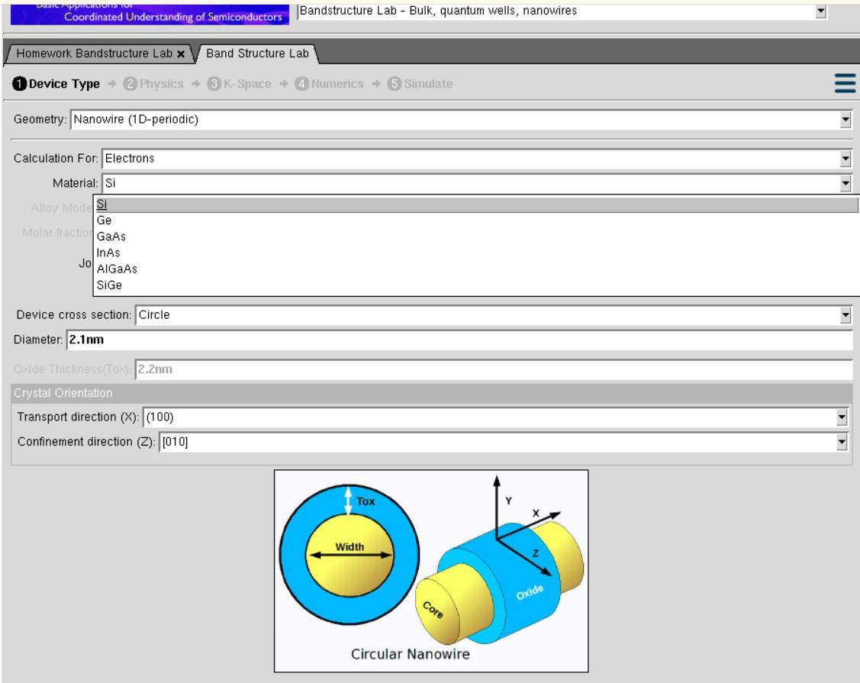
Device Type tab — Geometry: Nanowire (1D-periodic), Material: Si, Cross section: Circle, Diameter: 2.1 nm
Parameters set: Geometry – Nanowire (1D-periodic), Calculation For – Electrons, Material – Si, Job Type – Calculate the wire band structure, Device cross section – Circle, Diameter – 2.1 nm, Transport direction (X) – (100), Confinement direction (Z) – [010]. The material dropdown shows the available options: Si, Ge, GaAs, InAs, AlGaAs and SiGe.

Physics Configuration
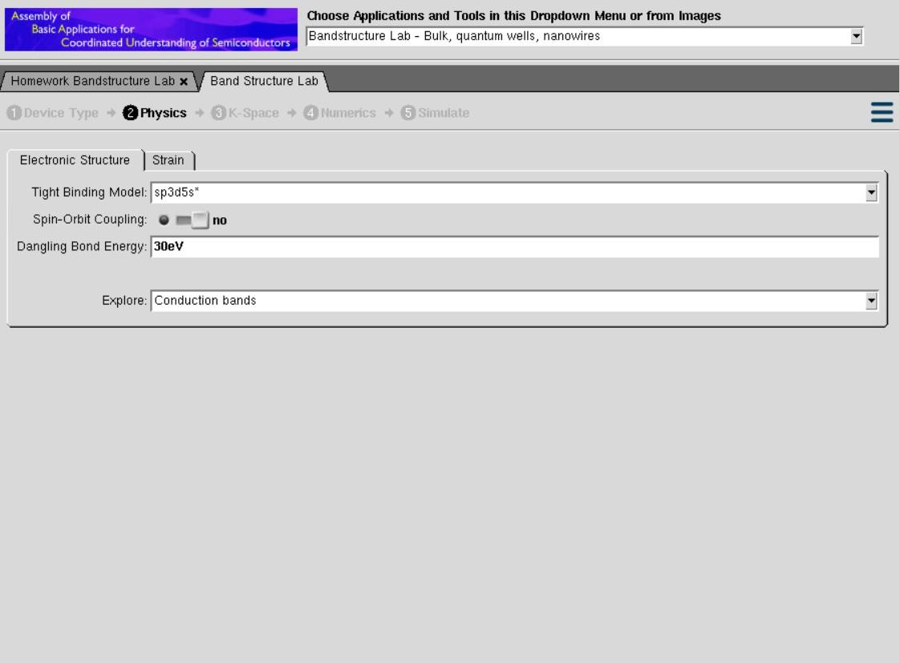
Physics tab — Tight Binding Model: sp3d5s*, Spin-Orbit Coupling: no, Dangling Bond Energy: 30 eV, Explore: Conduction bands
The sp3d5s* tight-binding model is chosen because it reproduces the conduction and valence bands of the bulk semiconductor accurately over the whole Brillouin zone. The dangling bond energy of 30 eV is a large artificial value assigned to the unterminated surface bonds so that surface states are pushed far away from the band gap and do not contaminate the physically meaningful bands.
Output — Band Structure of Silicon Circular Nanowire
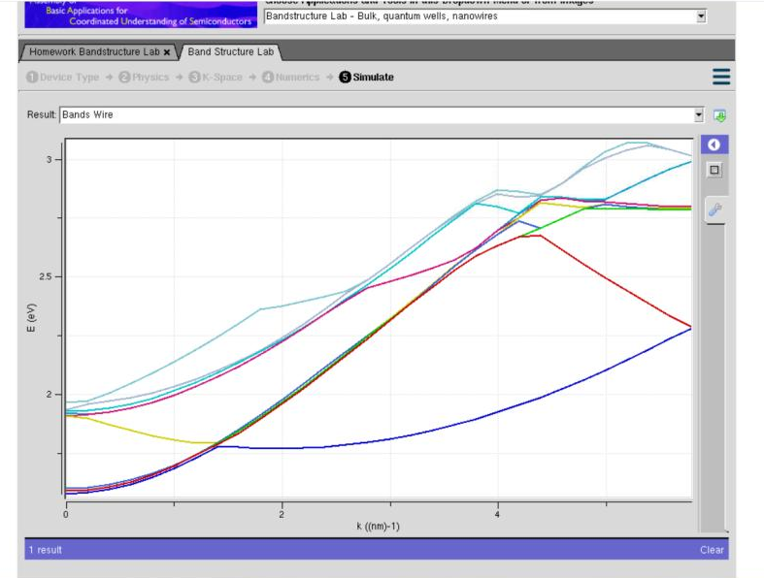
Result: Bands Wire — E (eV) vs k (nm⁻¹) for Si nanowire of 2.1 nm diameter
Explanation of Output:
The output plots the electron energy E (eV) against the wave vector k (nm⁻¹) along the transport direction. Instead of the two or three broad bands seen in bulk silicon, a large number of closely spaced sub-band curves appear between about 1.8 eV and 3.1 eV.
This splitting into many sub-bands is the direct signature of quantum confinement in the transverse (Z) direction. Because the wire diameter is only 2.1 nm, the transverse energy is quantised, and every allowed transverse mode generates its own one-dimensional sub-band along k. The lowest curve (dark blue) is the conduction band minimum of the nanowire and its position above the bulk conduction band edge represents the confinement energy added by the small diameter.
The minimum of the lowest sub-band does not occur at k = 0 but at a finite k value, which reflects the indirect band gap nature of silicon. The curvature of each band is inversely related to the effective mass of the carriers in that band — the flatter yellow and cyan curves correspond to heavier effective masses and therefore lower carrier mobility.

Case Study 1: Simulate the band-structure of an InAs circular nanowire
Aim: To obtain the band structure of a circular nanowire when the channel material is changed from silicon to indium arsenide, keeping the geometry identical.
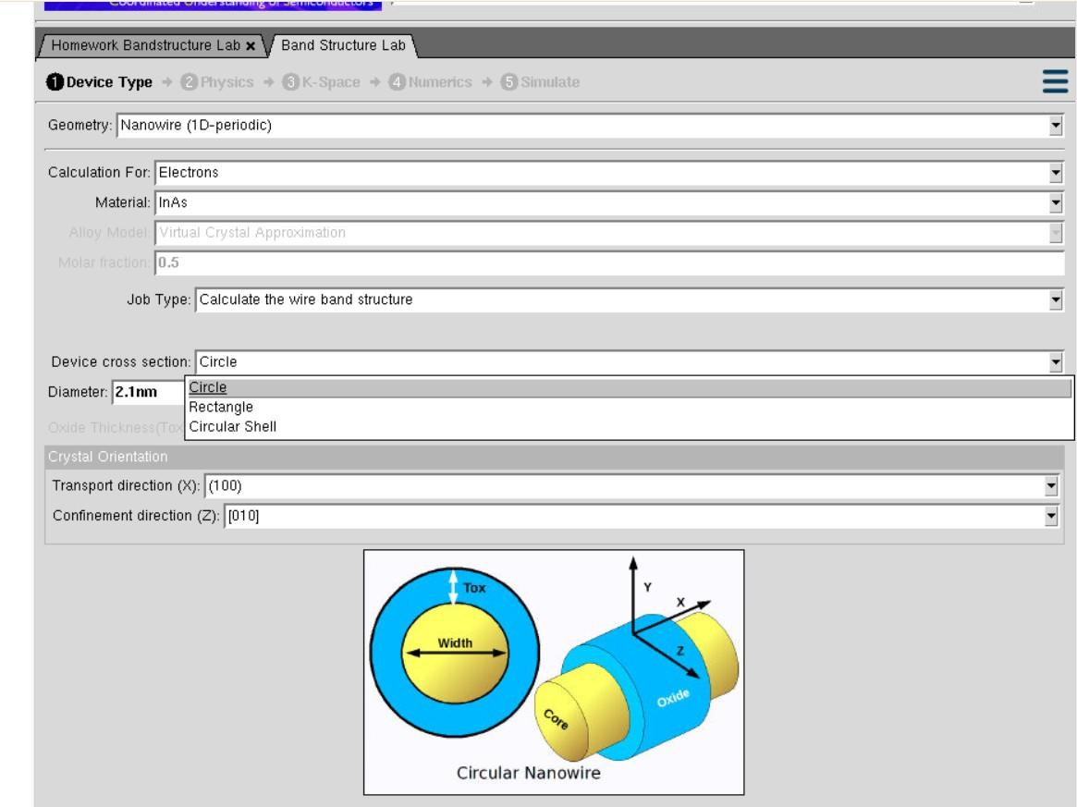
Device Type tab — Material changed to InAs; cross-section options Circle / Rectangle / Circular Shell
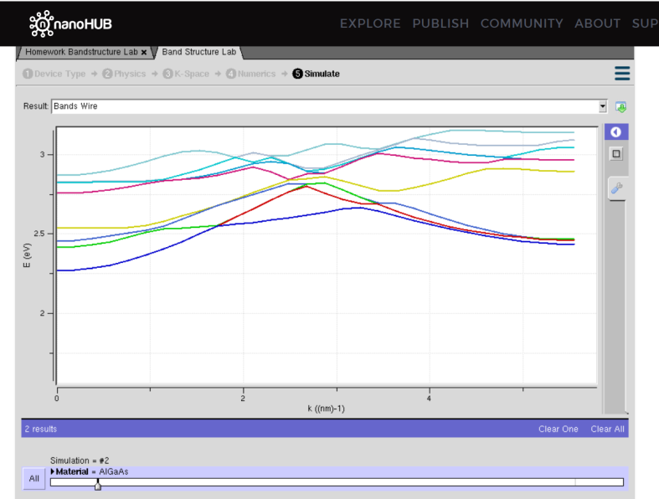
Result: Bands Wire for InAs nanowire (Simulation #2, Material = InAs)
Explanation of Output:
For the InAs nanowire the band structure is completely different in character from silicon. The lowest sub-band starts near 1.75 eV at k = 0 and rises steeply and smoothly with k, reaching about 2.55 eV. The band minimum now lies at k = 0, confirming that InAs is a direct band gap material, unlike the indirect silicon wire.
The lowest band is much more sharply curved than any of the silicon bands. Since the effective mass is inversely proportional to the curvature (m* ∝ 1/(d²E/dk²)), this steep curvature indicates a very small electron effective mass in InAs, which is why InAs nanowires are attractive for high-mobility, high-speed transistor channels.
The higher sub-bands between 2.5 eV and 3.2 eV are more closely packed and show band anti-crossing, where two bands approach and then repel each other instead of intersecting. This coupling between sub-bands is a genuine quantum-mechanical effect captured by the tight-binding model.

Case Study 2: Simulate the band-structure of an AlGaAs circular nanowire
Aim: To obtain the band structure of a circular nanowire made of the ternary alloy AlGaAs and to compare it with the Si and InAs wires.
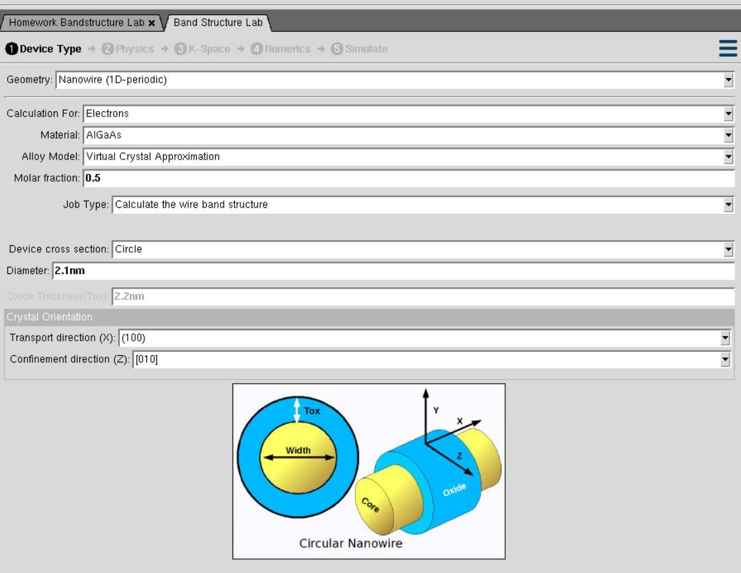
Device Type tab — Material: AlGaAs, Alloy Model: Virtual Crystal Approximation, Molar fraction: 0.5
Because AlGaAs is an alloy and not an elemental or binary crystal, the Alloy Model field becomes active and is set to the Virtual Crystal Approximation with a molar fraction of 0.5, i.e. Al₀.₅Ga₀.₅As. In this approximation the alloy is treated as a perfect periodic crystal whose atomic potential is the composition-weighted average of the AlAs and GaAs potentials.
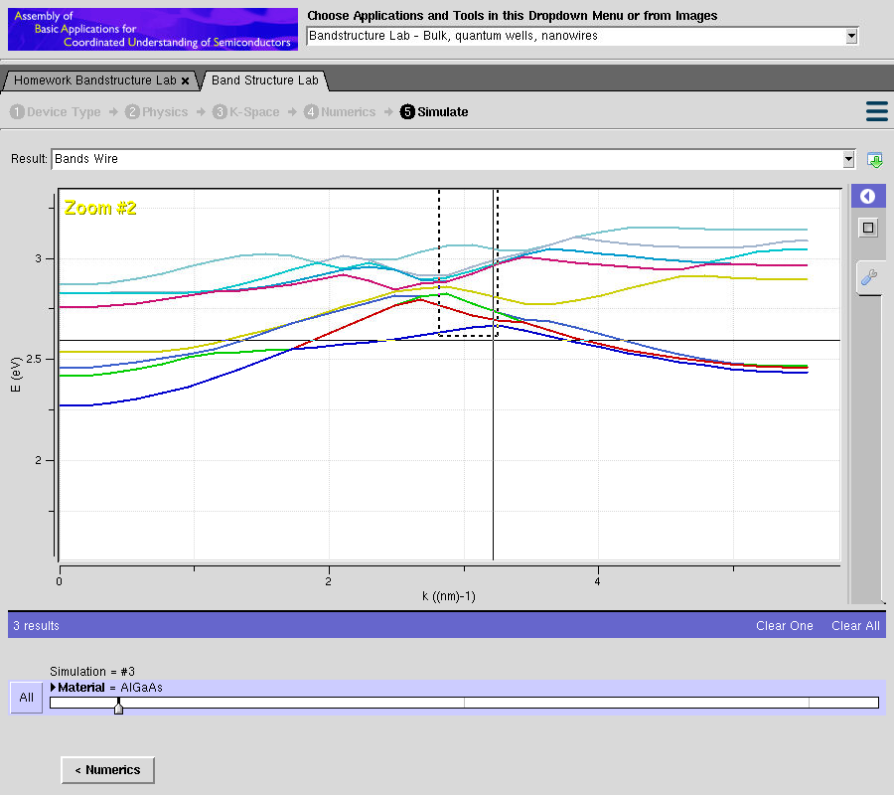
Result: Bands Wire for AlGaAs nanowire with Zoom #2 applied (Simulation #3)
Explanation of Output:
The AlGaAs nanowire bands lie between roughly 2.3 eV and 3.2 eV, which is higher than both the Si and InAs wires. This is expected because AlGaAs has a wider band gap than GaAs or InAs, and the gap widens further as the aluminium fraction increases.
The bands are noticeably flatter and more tightly bunched than the InAs bands. Flatter bands mean a larger effective mass and hence lower carrier mobility, which is why AlGaAs is normally used as the wide-gap barrier layer in a heterostructure rather than as the conducting channel itself.
The zoomed view highlights several regions where two sub-bands approach one another around k ≈ 2–3 nm⁻¹ and repel instead of crossing. These anti-crossing points arise from the mixing of different transverse confinement modes and become more frequent in alloys, where the averaged potential couples states that would otherwise remain independent.

Inference
- Reducing the nanowire diameter quantises the transverse energy and splits each bulk band into a family of one-dimensional sub-bands.
- Silicon nanowires retain an indirect band minimum at finite k, whereas InAs nanowires show a direct minimum at k = 0.
- The curvature of the lowest sub-band directly indicates the effective mass — InAs (sharp curvature, light mass) > Si > AlGaAs (flat bands, heavy mass) in terms of expected mobility.
- Alloy materials such as AlGaAs require the Virtual Crystal Approximation and show pronounced sub-band anti-crossing.

Result
Simulation of band structure of nanowire for various materials is accomplished.

Exp. 6. Demonstration of Quantum Tunneling

Aim
To learn and analyse the demonstration of quantum tunneling and observe the key learning points using the nanoHUB simulation tool.

Software
NanoHub Online Tool — Piece-Wise Constant Potential Barriers Sim2L.

Theory
Quantum tunneling is a phenomenon where particles penetrate energy barriers that they classically cannot overcome. It is pivotal in the realm of nanoelectronics, where the tunneling current through a nanoscale junction depends on the barrier height, barrier width and the material properties.
The Piece-Wise Constant Potential Barriers Sim2L tool simulates the quantum mechanical transmission and reflection coefficients for potential barriers. It models structures with multiple segments of constant potential, which makes it useful for analysing quantum tunneling, resonant tunneling diodes and band formation in periodic potentials. The tool supports both the transfer matrix method and the tight-binding method, allowing a detailed analysis of barrier structures, effective mass variations and resonance peaks.
Key applications that rely on tunneling include tunnel diodes, single-electron transistors and flash memory cells. The same effect also causes gate leakage current in scaled MOSFETs, which is the main limitation on how thin the gate oxide can be made.

Procedure
- Open nanoHUB.
- Go to Explore → Resources.
- Select Tools → Piece-Wise Constant Potential Barriers Sim2L.
- Press Launch tool in the info section.
- Enter into the app mode tab in the Jupyter environment.
- Press Simulate to view results.
- Compare the results.

Output — Potential Energy vs Distance
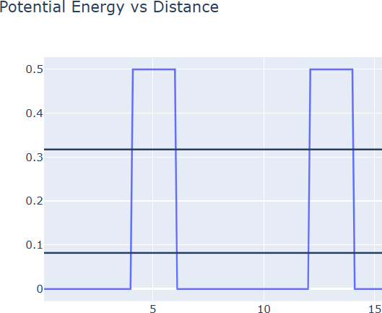
Double-barrier potential profile with the two computed resonant energy levels marked
Explanation of Output:
The plot shows the potential energy profile of a double-barrier structure along the distance axis. Two rectangular barriers of height 0.5 eV are separated by a well region of zero potential, forming a quantum well between them. Two horizontal lines are drawn at approximately 0.08 eV and 0.32 eV.
These two horizontal lines are the quasi-bound (resonant) energy levels of the well trapped between the barriers. A particle incident with an energy exactly equal to one of these levels can pass through the entire double-barrier structure with a transmission probability approaching unity, even though its energy is far below the 0.5 eV barrier height. This is the phenomenon of resonant tunneling, and it is the operating principle of the resonant tunneling diode.

Output — Wave-functions from Tight-Binding
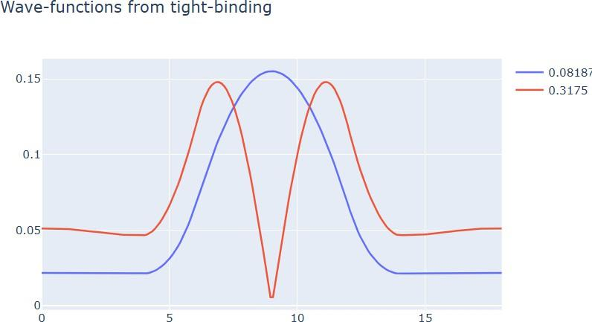
Wave functions corresponding to the two resonant energies, 0.081875 eV and 0.3175 eV
Explanation of Output:
The blue curve is the wave function at the lower resonant energy of 0.081875 eV and the red curve is the wave function at the higher resonant energy of 0.3175 eV.
The blue wave function has a single maximum at the centre of the well and no node inside it — this is the ground state of the quantum well. The red wave function has two maxima with a clear node (a point of zero amplitude) at the centre, identifying it as the first excited state. The number of nodes increasing by one for each higher level is the standard behaviour of a confined quantum state.
Crucially, the amplitude of both wave functions is not zero outside the barriers — it decays exponentially inside each barrier but emerges on the far side with a finite value. This non-zero amplitude beyond a classically forbidden region is precisely what tunneling means: there is a finite probability of finding the particle on the other side of a barrier it does not have enough energy to climb over.

Case Study 1: Analysis of the Transmission Coefficient vs Energy characteristics on a refined grid
Aim: To obtain and compare the transmission coefficient versus energy characteristics computed on a refined energy grid and on a homogeneous energy grid, using both the Transfer Matrix method and the Tight-Binding method.
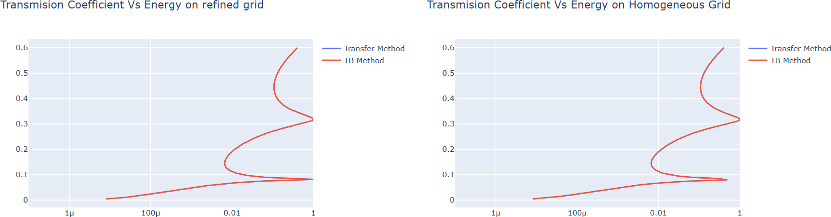
Transmission Coefficient vs Energy — refined grid (left) and homogeneous grid (right)
Explanation of Output:
The transmission coefficient is plotted on a logarithmic axis from 1 µ (10⁻⁶) up to 1, against the particle energy on the vertical axis. At low energies the transmission is extremely small, of the order of 10⁻⁶, showing that the barrier almost completely blocks the particle. As the energy rises, the transmission increases and two sharp resonance peaks appear where the coefficient reaches almost 1 — at approximately 0.08 eV and 0.32 eV.
These two peaks occur at exactly the same energies as the quasi-bound levels identified in the potential energy plot, confirming that resonant tunneling gives near-perfect transmission at the resonant energies. Between the peaks the transmission drops by several orders of magnitude, which is why the logarithmic scale is necessary.
Comparing the two panels, the refined grid resolves the resonance peaks with a smooth, well-defined shape, whereas the homogeneous grid samples the same curve at uniformly spaced energy points and therefore represents the narrow peaks less accurately. Since resonance peaks are extremely sharp in energy, a refined (adaptive) grid that places more sample points near the resonances is essential to capture the true peak height and width. The Transfer Matrix and Tight-Binding results overlap closely, which validates both numerical approaches against each other.

Case Study 2: Analysis of the Reflection Coefficient vs Energy on a Homogeneous Grid
Aim: To obtain the reflection coefficient versus energy characteristics on refined and homogeneous grids and verify conservation of probability against the transmission results.
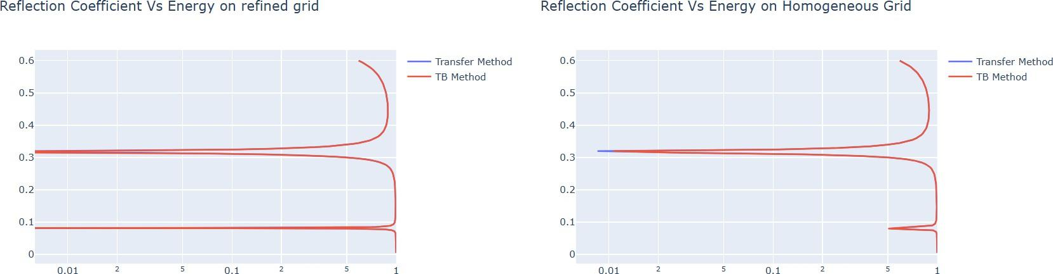
Reflection Coefficient vs Energy — refined grid (left) and homogeneous grid (right)
Explanation of Output:
The reflection coefficient stays very close to 1 over almost the entire energy range, meaning that the particle is almost always reflected by the double-barrier structure. Two sharp dips appear at approximately 0.08 eV and 0.32 eV, exactly where the transmission curve showed its peaks.
This is a direct verification of conservation of probability: for every energy, T + R = 1. Wherever transmission rises to unity at a resonance, reflection must fall to nearly zero, and the two plots are therefore mirror images of one another. The fact that the simulation reproduces this relationship confirms that the numerical solution is physically consistent.
As with the transmission case, the refined grid captures the narrow dips more faithfully than the homogeneous grid, and the Transfer Matrix and Tight-Binding curves agree throughout.

Analytical Problem
A particle with mass m = 9.1 × 10⁻³¹ kg (electron mass) and energy E = 0.5 eV is incident on a potential barrier of height V₀ = 1.0 eV and width a = 1.0 nm.
Key equations:
Tunneling coefficient: κ = √[ 2m(V₀ – E) / ℏ² ]
Transmission probability: T ≈ e^(–2κa)
Tunneling current density: J ∝ T
If the barrier width a is reduced from 1.0 nm to 0.8 nm, the new transmission probability T′ is obtained from the same expression with a = 0.8 nm, and the ratio T′/T = e^(2κ × 0.2 nm) shows the exponential sensitivity of tunneling to barrier width. Since the tunneling current density is proportional to T, a current density of J₀ = 1.0 nA/m² at a = 1.0 nm scales up by the same ratio when a is reduced to 0.8 nm.
Discussion: Because the transmission probability falls off exponentially with barrier thickness, even a small reduction in the gate oxide thickness of a MOSFET produces a very large increase in gate leakage current. This exponential dependence is the fundamental physical limit on the miniaturisation of nanoelectronic devices and is the reason why high-κ dielectrics were introduced to replace thin SiO₂ gate oxides.

Inference
- A particle can penetrate a barrier that is classically forbidden; the wave function decays exponentially inside the barrier but is non-zero beyond it.
- A double-barrier structure has quasi-bound levels at which transmission approaches unity — resonant tunneling.
- Transmission and reflection are complementary at every energy, T + R = 1.
- A refined energy grid is required to resolve narrow resonance peaks accurately; a homogeneous grid may miss or distort them.

Result
Thus the demonstration of quantum tunneling is analysed and the key learning points are observed using the nanoHUB simulation tool.

Exp. 7. MOSFET Scaling Analysis and Subthreshold Swing Calculation using NanoHub

Aim
To study the current–voltage characteristics and the transconductance efficiency of a single-gate MOSFET using the NanoHUB FETToy simulator.

Tools Required
- Computer with an internet connection.
- FETToy simulator on the NanoHUB platform.

Theory
A single-gate MOSFET is a fundamental semiconductor device used for amplification and switching in modern electronics. It operates by modulating the flow of charge carriers between the source and drain terminals, controlled by the gate voltage (V_G).
Drain Current (I_D) is the current flowing from drain to source, influenced by both the gate voltage (V_G) and the drain voltage (V_D). Transconductance Efficiency (g_m/I_D) measures how effectively the MOSFET converts a change in gate voltage into a change in drain current; a higher value indicates better efficiency. In the Saturation Region, I_D becomes relatively constant despite increasing V_D, which occurs once the channel is fully pinched off.

Formulae Used
Transconductance efficiency: g_m / I_D = ΔI_D / (ΔV_G · I_D)
Drain current change: ΔI_D = I_D(V_G = x) – I_D(V_G = y)

Procedure
- Log in to the NanoHUB platform and navigate to the FETToy simulator.
- In the Device tab, choose Model: Single-Gate MOSFET and enter the device parameters.
- In the Models tab, enter the threshold voltage and the gate and drain control parameters.
- In the Environment tab, set the ambient temperature and configure the gate and drain voltage sweeps.
- Click Simulate to generate the results.
- View the Drain Current vs Gate Voltage, Drain Current vs Drain Voltage and gm/Id vs Gate Voltage plots.
- Export the data and calculate the transconductance efficiency and the saturation region.

Output — Device Tab Configuration
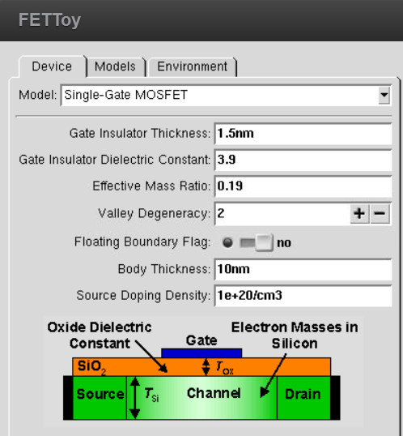
FETToy Device tab — Single-Gate MOSFET parameters
Parameters set: Gate Insulator Thickness – 1.5 nm, Gate Insulator Dielectric Constant – 3.9 (SiO₂), Effective Mass Ratio – 0.19, Valley Degeneracy – 2, Floating Boundary Flag – no, Body Thickness – 10 nm, Source Doping Density – 1e+20 /cm³.

Output — Models Tab Configuration
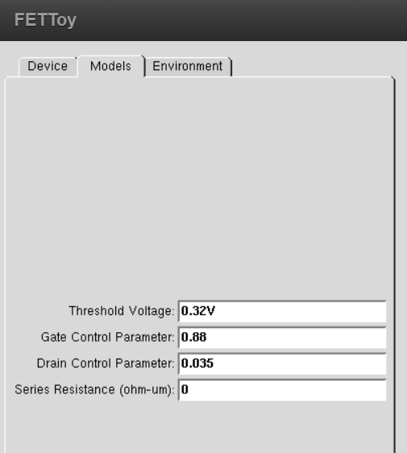
FETToy Models tab — electrical model parameters
Parameters set: Threshold Voltage – 0.32 V, Gate Control Parameter – 0.88, Drain Control Parameter – 0.035, Series Resistance – 0 Ω·µm. The gate control parameter of 0.88 indicates that 88 % of the applied gate voltage is effective in controlling the channel potential, while the small drain control parameter of 0.035 quantifies the unwanted influence of the drain on the channel barrier, i.e. the drain-induced barrier lowering.

Output — Environment Tab Configuration
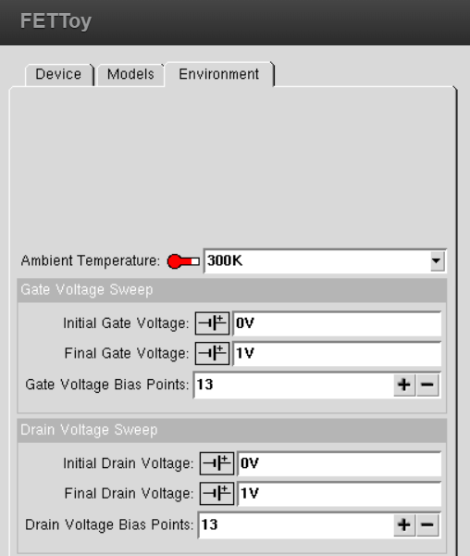
FETToy Environment tab — temperature and voltage sweep settings
Parameters set: Ambient Temperature – 300 K; Gate Voltage Sweep – 0 V to 1 V with 13 bias points; Drain Voltage Sweep – 0 V to 1 V with 13 bias points.

Output — Drain Current vs Gate Voltage
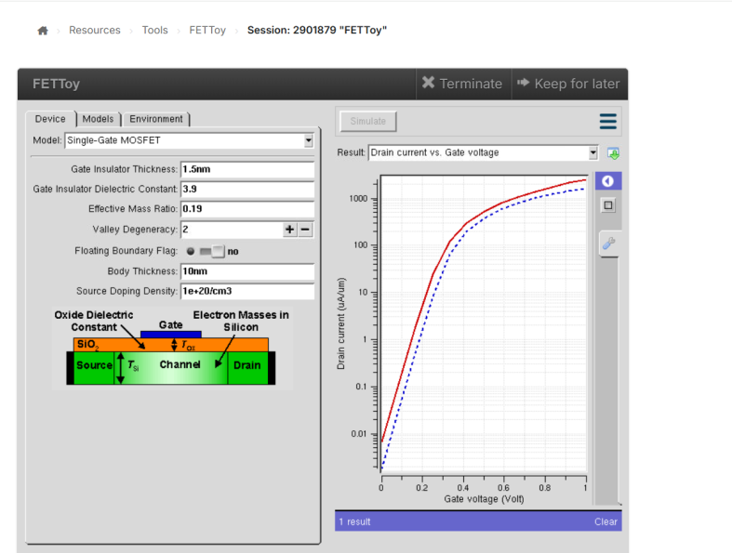
Result: Drain current vs Gate voltage, plotted on a logarithmic current axis
Explanation of Output:
The drain current is plotted on a logarithmic scale from about 0.001 µA/µm to over 2000 µA/µm against the gate voltage from 0 V to 1 V. Two curves are shown, corresponding to two different drain bias conditions.
Below the threshold voltage of 0.32 V the curve is a straight line on the logarithmic axis. A straight line on a log scale means the current is increasing exponentially with gate voltage — this is the subthreshold region, where conduction is governed by thermionic emission of carriers over the source-to-channel barrier. The slope of this straight portion gives the subthreshold swing, the number of millivolts of gate voltage needed to change the drain current by one decade. The theoretical minimum at 300 K is 60 mV/decade, and a steeper (smaller) swing means the transistor can be switched off more sharply.
Above threshold the curve bends over and rises much more slowly, because the device has entered strong inversion where the current grows only linearly or quadratically with gate overdrive rather than exponentially. The vertical separation between the two curves at a fixed gate voltage is a measure of the drain-induced barrier lowering caused by the higher drain bias.

Output — Drain Current vs Drain Voltage
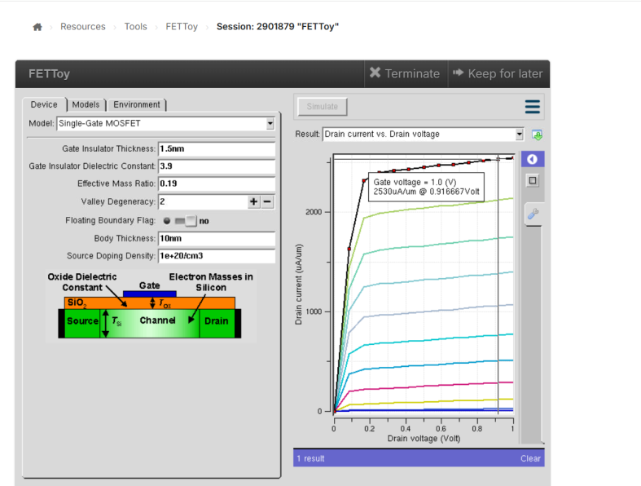
Result: Drain current vs Drain voltage family of curves; marked point 2530 µA/µm at V_D = 0.9167 V for V_G = 1.0 V
Explanation of Output:
This is the family of output characteristics, one curve for each of the 13 gate bias points from 0 V to 1 V. Each curve rises steeply and almost linearly at small drain voltage and then flattens into a nearly horizontal plateau.
The steep initial portion is the linear (triode) region, where the channel behaves like a voltage-controlled resistor and I_D increases in proportion to V_D. The flat portion is the saturation region, reached once V_D exceeds V_G – V_th; beyond this point the channel is pinched off at the drain end and further increases in drain voltage no longer increase the current appreciably. The residual gentle upward slope in saturation is due to channel length modulation.
The topmost curve corresponds to V_G = 1.0 V and the marked data point shows a drain current of 2530 µA/µm at V_D = 0.9167 V. The vertical spacing between successive curves widens as the gate voltage increases, which reflects the fact that the saturation current depends on the square of the gate overdrive (V_G – V_th).

Output — gm/Id vs Gate Voltage
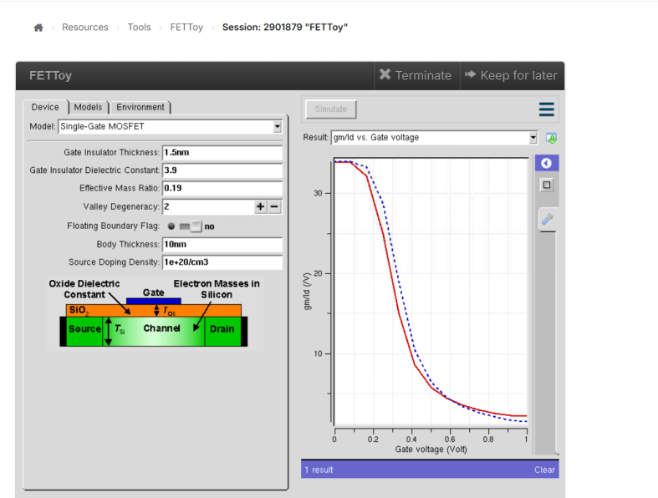
Result: Transconductance efficiency gm/Id (1/V) vs Gate voltage
Explanation of Output:
The transconductance efficiency starts at a high value of about 34 V⁻¹ at low gate voltage, remains roughly flat up to about 0.2 V, then falls steeply between 0.2 V and 0.5 V, and finally settles at a low value of about 3 V⁻¹ near V_G = 1 V.
The high plateau at low gate voltage corresponds to the subthreshold region. Here the current changes exponentially with gate voltage, so each additional volt of gate bias produces the largest possible relative change in current — this is the most power-efficient operating point, and it is where low-power analog circuits are biased. The theoretical ceiling for this plateau is q/(nkT), which is approximately 38 V⁻¹ at 300 K for an ideal device; the simulated value of 34 V⁻¹ is close to this limit and confirms good gate control.
The sharp fall around the threshold voltage marks the transition from exponential subthreshold conduction to strong inversion. In strong inversion the current no longer grows exponentially, so the same increase in gate voltage produces a much smaller fractional current change and the efficiency drops. Operating at high gate voltage therefore gives large drive current but poor efficiency — the fundamental speed-versus-power trade-off in MOSFET design.

Tabulation of Results
Gate Voltage V_G (V) | Drain Voltage V_D (V) | Drain Current I_D (µA/µm) | Transconductance Efficiency gm/I_D (1/V)
0.25 | 1.0 | 24.4 | 25
0.50 | 1.0 | 517 | 5.8
0.75 | 1.0 | 1400 | 2.94

Sample Calculation
For V_G = 0.5 V and V_D = 1.0 V: I_D = 517 µA/µm.
Change in I_D from V_G = 0.5 V to V_G = 0.75 V: ΔI_D = 1400 – 517 = 883 µA/µm.
Transconductance efficiency at V_G = 0.25 V: gm/I_D = 25 V⁻¹.

Case Analysis
Case 1 — Increase in V_G: As V_G increases, the drain current I_D increases exponentially in the subthreshold region and the device enters the saturation region earlier.
Case 2 — Variation in V_D: The drain current I_D saturates for higher V_D at a fixed V_G, becoming almost independent of the drain voltage once the channel is pinched off.

Result
- The MOSFET exhibits saturation at higher V_D for V_G = 0.5 V.
- gm/I_D decreases with increasing V_G, indicating reduced transconductance efficiency at higher gate voltages.
Thus the current–voltage characteristics and the transconductance efficiency of a single-gate MOSFET are studied using the NanoHUB FETToy simulator.

