Exp. 1. Simulation of Scattering and Absorption of Multi-layer Sphere and Core-Shell Nanoparticle using Mie-Plot tool

Aim
To simulate and analyse the scattering, absorption and extinction characteristics of multi-layer spheres and core–shell nanoparticles using the Mie-Plot tool.

Software
Mie-Plot tool (nanoComposix Mie theory calculator) — https://nanocomposix.com/pages/mie-theory-calculator

Theory
When light interacts with nanoparticles whose size is comparable to the wavelength of light, scattering and absorption phenomena occur. The Mie Theory, derived from Maxwell’s equations, provides an exact analytical solution for the scattering of electromagnetic radiation by spherical particles.
For a core–shell nanoparticle, the optical response depends on the core and shell refractive indices, the core diameter and shell thickness, the surrounding medium refractive index, and the incident light wavelength.
The extinction cross-section (Cₑₓₜ) represents the total light removed from the incident beam due to both scattering (Cₛᴄₐ) and absorption (Cₐᵇₛ):
Cₑₓₜ = Cₛᴄₐ + Cₐᵇₛ
Localized Surface Plasmon Resonance (LSPR) occurs when the conduction electrons in metallic nanoparticles oscillate in resonance with the incident light, producing strong absorption or scattering peaks. These optical properties can be tuned by modifying the particle size, composition and surrounding medium.

Procedure
- Open the Mie-Plot tool using the given link.
- Select a Core Material (e.g. Au, Ag, Si, TiO₂) from the dropdown menu.
- Enter the core diameter in nanometres.
- If the core type is set to Other, manually input the real part of the refractive index (n).
- To include a shell, select a Shell Material (e.g. SiO₂, Al₂O₃, ZnO) and enter the shell thickness in nanometres.
- If no shell is needed, select None for the shell option.
- Set the starting and ending wavelengths for the spectral range to be simulated.
- Enter the refractive index of the surrounding medium (e.g. 1.33 for water).
- Click “Plot!” to generate the extinction, absorption and scattering cross-section plots.

Output — Scattering and Absorption Spectra for a Core–Shell Nanoparticle
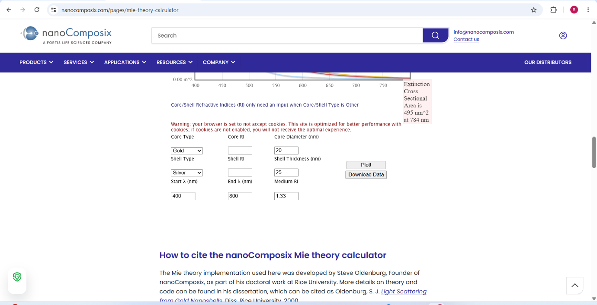
Input panel — Core: Gold, 20 nm; Shell: Silver, 25 nm; λ range 400–800 nm; Medium RI 1.33
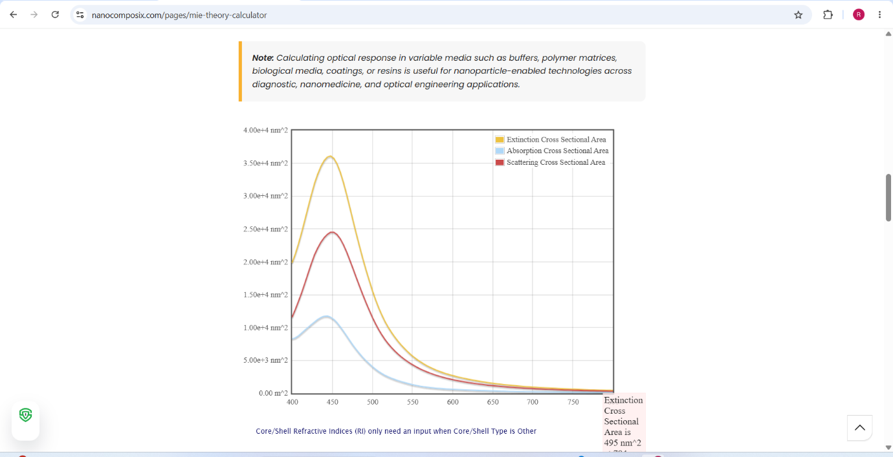
Extinction, absorption and scattering cross-sections for the Au–Ag core–shell nanoparticle
Explanation of Output:
The plot shows three curves — extinction (yellow), absorption (light blue) and scattering (red) cross-sectional area — against wavelength from 400 nm to 800 nm. All three curves rise to a single sharp peak at approximately 420–430 nm and then decay to near zero beyond 600 nm. The peak extinction cross-section reaches about 3.6 × 10⁴ nm² and the tool reports an extinction cross-sectional area of 495 nm² at 784 nm.
The prominent peak near 420 nm is the Localized Surface Plasmon Resonance of the composite particle. Because the outer 25 nm shell is silver, the resonance is governed mainly by the silver shell rather than the gold core — silver has its plasmon resonance in the blue region around 400–420 nm, whereas pure gold resonates near 520–530 nm. This demonstrates the central design principle of core–shell particles: the shell material and thickness dominate the optical response, allowing the resonance to be tuned independently of the core.
The scattering curve (red) lies well above the absorption curve (blue) at the peak, indicating that for this relatively large 70 nm total diameter the particle scatters more light than it absorbs. This is expected because scattering efficiency scales with the sixth power of the particle radius while absorption scales only with the third power, so scattering dominates as particles grow larger.

Case Study 1: Scattering and absorption spectra for a single-layer sphere (core only)
Aim: To obtain the scattering, absorption and extinction spectra of a single-layer dielectric sphere with no shell, and to contrast a dielectric material with the metallic core–shell case.
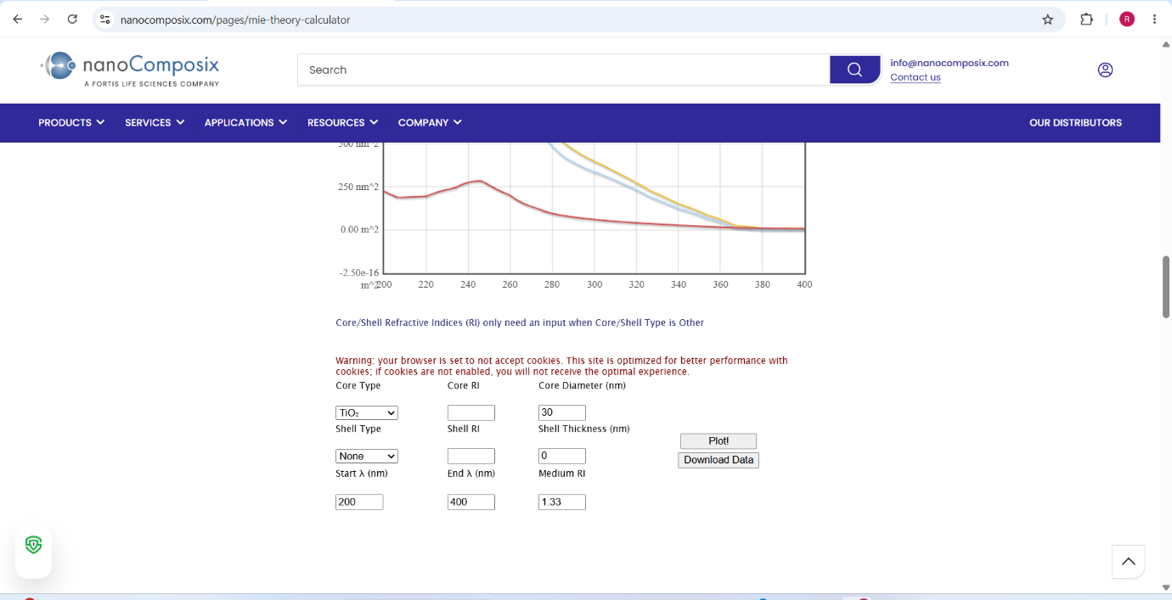
Input panel — Core: TiO₂, 30 nm; Shell: None; λ range 200–400 nm; Medium RI 1.33
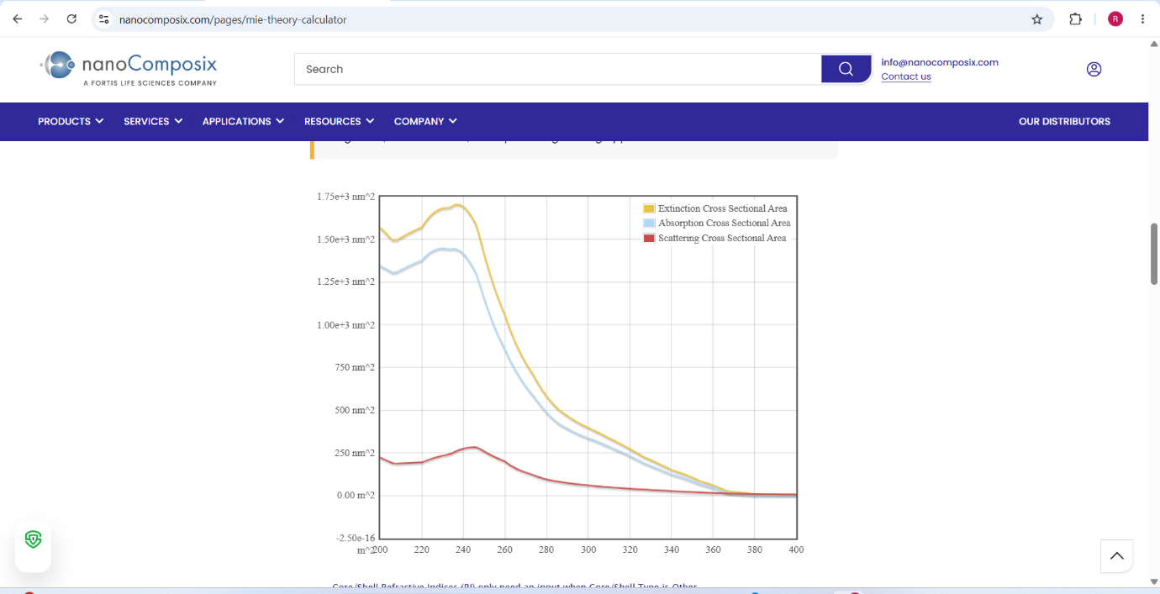
Cross-sections for the single-layer TiO₂ sphere over 200–400 nm
Explanation of Output:
For the 30 nm TiO₂ sphere the extinction cross-section reaches a maximum of about 1.7 × 10³ nm² near 230–240 nm and then falls steadily, reaching essentially zero beyond 380 nm. The absorption curve (blue) closely tracks the extinction curve, while the scattering curve (red) stays low throughout, peaking at only about 250 nm².
The behaviour here is fundamentally different from the metallic case. There is no sharp plasmon peak because TiO₂ is a dielectric semiconductor with no free conduction electrons to oscillate collectively. Instead, the rise in the ultraviolet is due to interband absorption across the TiO₂ band gap of approximately 3.2 eV, which corresponds to a wavelength of about 390 nm. Below this wavelength the material absorbs strongly; above it, it becomes essentially transparent.
Since the particle diameter of 30 nm is very small compared with the wavelength, absorption dominates completely over scattering — the opposite of the larger core–shell particle. This is why TiO₂ nanoparticles of this size are used as transparent UV blockers in sunscreens: they absorb ultraviolet radiation efficiently while scattering very little visible light, so they appear clear on the skin.

Case Study 2: Simulate the optical response of a gold (Au) nanoparticle of 50 nm diameter in water medium
Aim: To simulate the optical response of a bare 50 nm gold nanoparticle suspended in water and to identify its plasmon resonance wavelength.
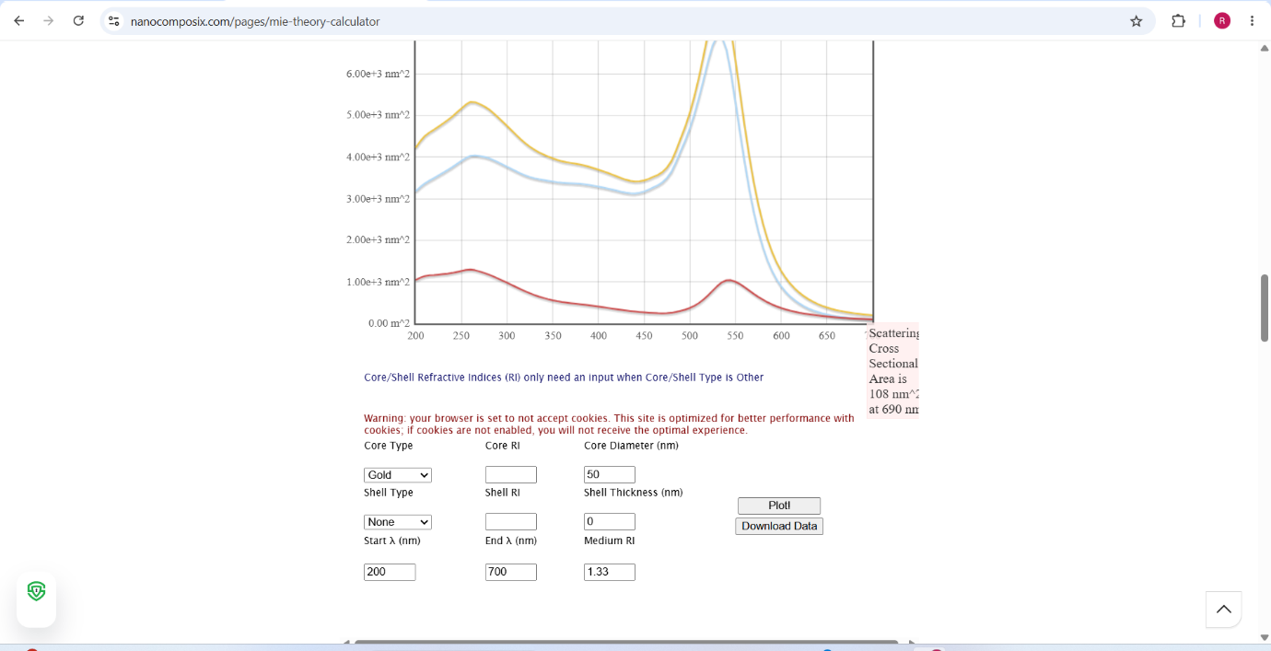
Input panel — Core: Gold, 50 nm; Shell: None; λ range 200–700 nm; Medium RI 1.33 (water)
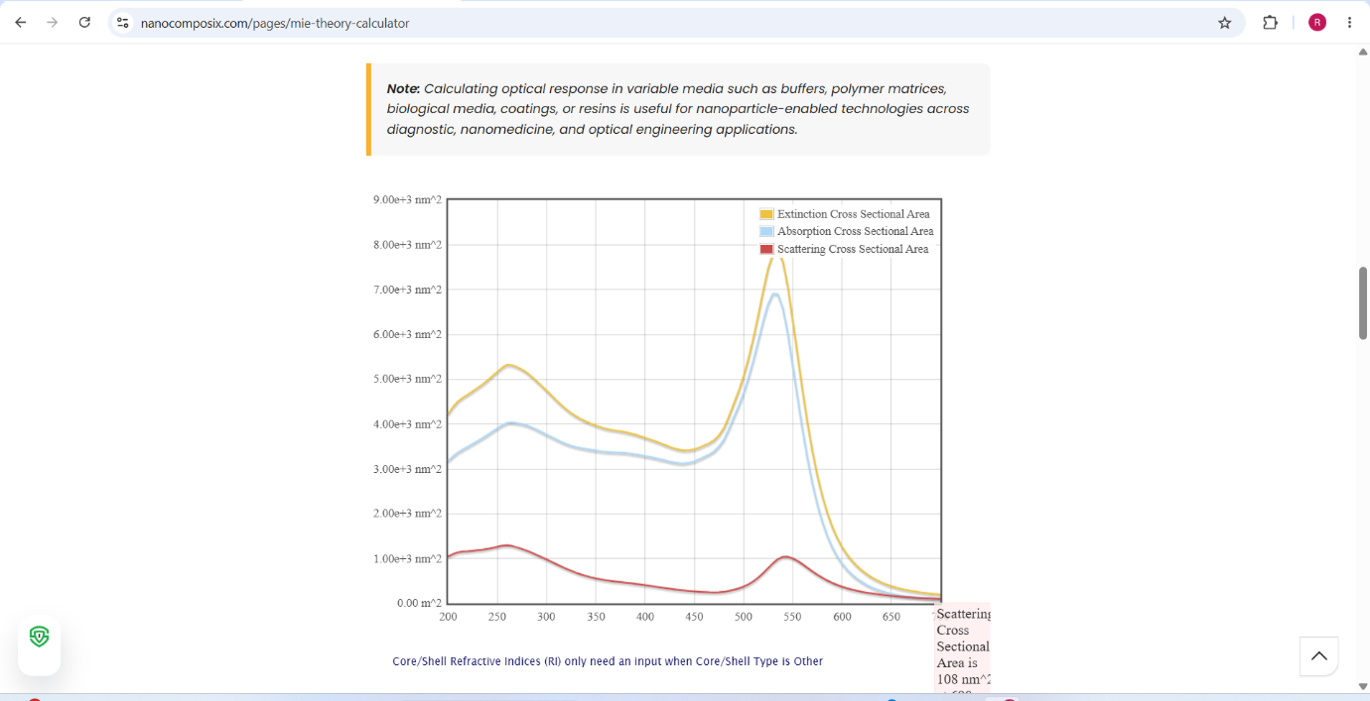
Cross-sections for the 50 nm gold nanoparticle in water; scattering cross-sectional area 108 nm² at 690 nm
Explanation of Output:
The spectrum shows two distinct features. A broad shoulder appears around 250–270 nm with extinction reaching about 5.3 × 10³ nm², and a much sharper, taller peak appears near 530–540 nm with extinction rising to approximately 8 × 10³ nm². The tool reports a scattering cross-sectional area of 108 nm² at 690 nm.
The sharp peak at approximately 530 nm is the classic Localized Surface Plasmon Resonance of gold. Comparing this with Case Study 1, the difference is striking: gold shows a well-defined resonance peak because its free conduction electrons oscillate collectively in phase with the incident field, while TiO₂ showed only a smooth absorption edge. It is this 530 nm resonance that gives colloidal gold nanoparticle suspensions their characteristic ruby-red colour — green light near 530 nm is removed from the transmitted beam, leaving red.
The broad ultraviolet shoulder near 250 nm arises from interband transitions in gold, where electrons are excited from the filled d-band to the conduction band. This is a separate mechanism from the plasmon resonance and is not tunable with particle size.
The absorption curve (blue) lies close to the extinction curve at the peak while scattering (red) is comparatively small, showing that at 50 nm diameter gold still absorbs more than it scatters. The surrounding water medium with refractive index 1.33 red-shifts the resonance slightly compared with a particle in air, because the higher dielectric constant of the medium screens the restoring force on the oscillating electrons.

Case Study 3: Simulate a core–shell nanoparticle with a gold core (30 nm) and silica shell (10 nm)
Aim: To simulate the optical response of a gold core coated with a dielectric silica shell and to observe how a non-metallic shell modifies the plasmon resonance.
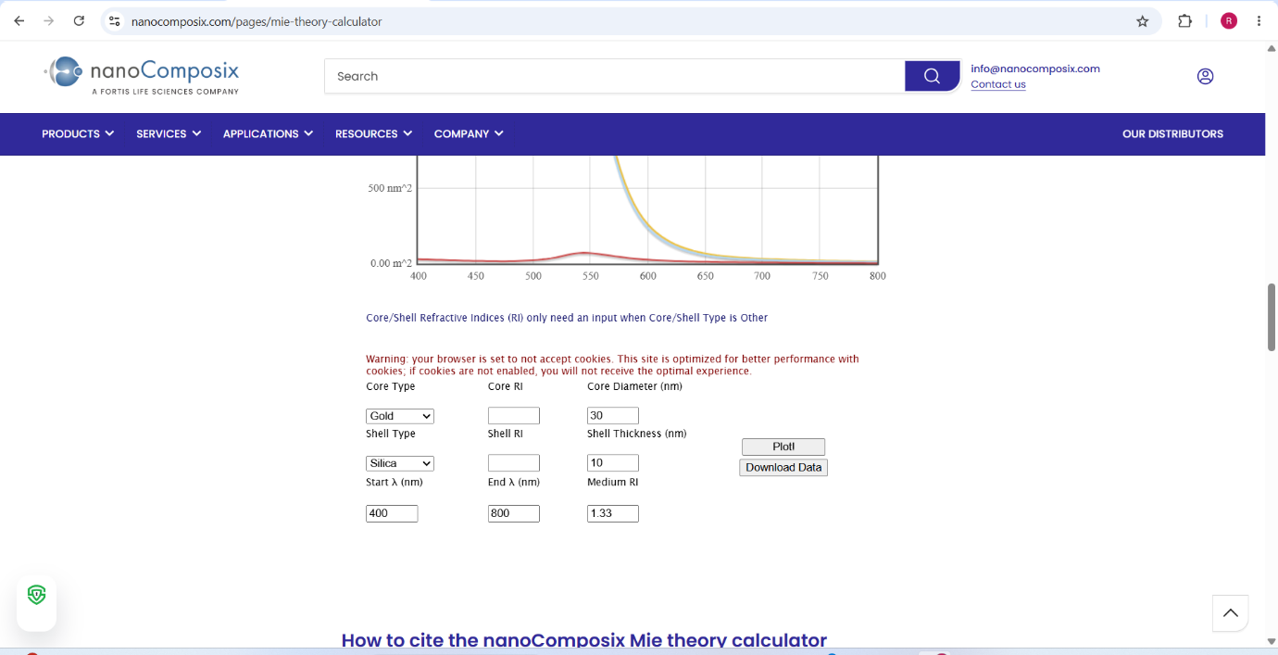
Input panel — Core: Gold, 30 nm; Shell: Silica, 10 nm; λ range 400–800 nm; Medium RI 1.33
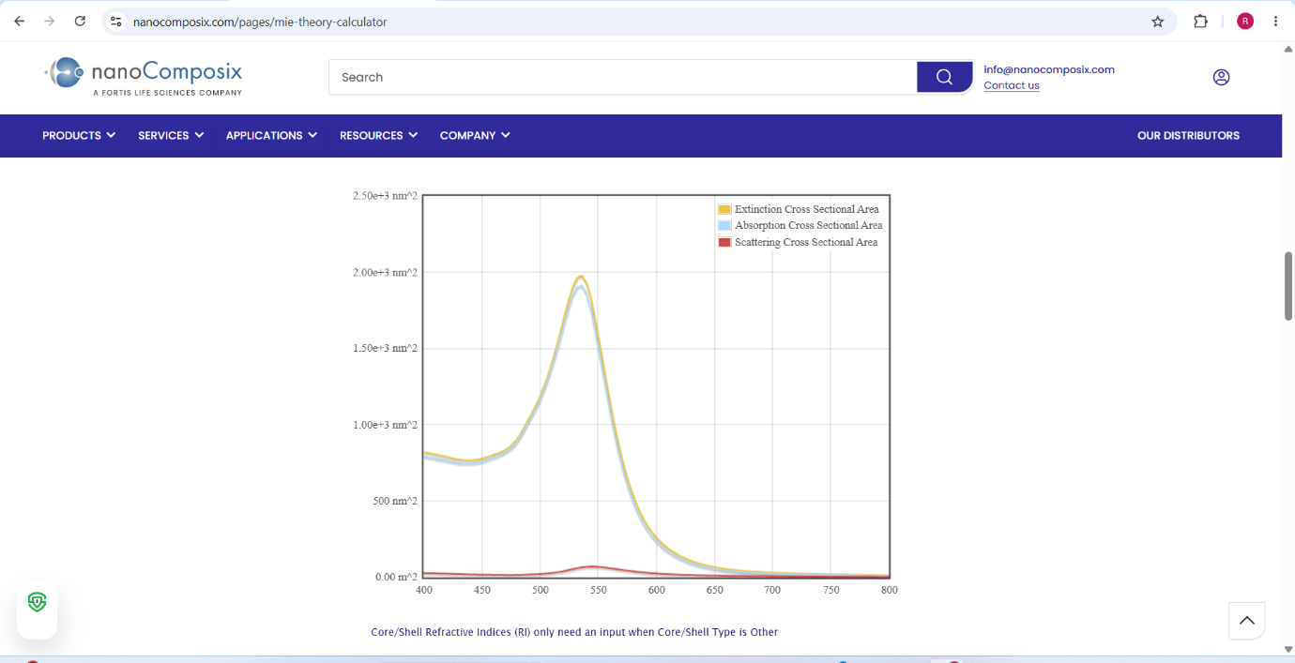
Cross-sections for the Au core – silica shell nanoparticle
Explanation of Output:
The spectrum shows a single well-defined peak at approximately 530–540 nm with a maximum extinction cross-section of about 2.0 × 10³ nm². The extinction and absorption curves lie almost exactly on top of one another, while the scattering curve remains very close to zero across the whole range.
Comparing with Case Study 2, the resonance wavelength has stayed at roughly the same position near 530 nm, confirming that the plasmon resonance is set by the gold core and not by the dielectric shell. However, the peak magnitude has dropped substantially — from about 8 × 10³ nm² to about 2 × 10³ nm² — because the gold core here is only 30 nm rather than 50 nm, and the plasmon cross-section scales strongly with the volume of metal present.
Contrasting this with the base simulation (gold core with a silver shell) makes the role of the shell clear. A metallic silver shell shifted the resonance right down to 420 nm because it introduced its own free electrons. A dielectric silica shell, by contrast, has no free electrons and therefore leaves the resonance position essentially where the gold core put it, producing only a small red-shift due to the higher local refractive index. Silica shells are used in practice for exactly this reason: they provide chemical stability and a surface for biofunctionalisation without disturbing the optical response of the gold core.
The near-total absence of a scattering contribution confirms that at a 30 nm core diameter the particle is firmly in the absorption-dominated regime.

Analytical
Consider a spherical particle of radius r = 25 nm and refractive index nₚ = 0.2 + 3.0i (gold) in a surrounding medium of refractive index nₘ = 1.33. Calculate the size parameter (x) using:
x = 2π r nₘ / λ
For an incident wavelength λ = 520 nm:
x = (2 × 3.1416 × 25 × 1.33) / 520 = 208.9 / 520 ≈ 0.402
Interpretation: The size parameter is much less than 1, which places the particle in the Rayleigh regime rather than the full Mie regime. In this regime the scattering efficiency varies as x⁴ (i.e. as r⁶/λ⁴) while the absorption efficiency varies only as x, so absorption dominates strongly over scattering — exactly as observed in Case Studies 2 and 3. As the particle radius grows and x approaches or exceeds 1, scattering rises much faster than absorption and eventually dominates, which is what was seen for the larger 70 nm Au–Ag core–shell particle.

Inference
- Metallic nanoparticles exhibit a sharp Localized Surface Plasmon Resonance; dielectric nanoparticles such as TiO₂ show only a smooth band-edge absorption.
- The resonance wavelength is set by the outermost metallic layer — a silver shell shifts it to ~420 nm, while a dielectric silica shell leaves the gold core resonance at ~530 nm.
- Small particles (size parameter x ≪ 1) are absorption-dominated; larger particles become scattering-dominated.
- The optical response can therefore be engineered by choosing the core material, shell material, shell thickness and surrounding medium.

Result
The scattering, absorption and extinction spectra for multi-layer spheres and core–shell nanoparticles are obtained using the Mie-Plot tool. The results demonstrate the effect of particle size, shell thickness and refractive index on the optical resonance behaviour of nanoparticles.

Exp. 8. Simulation of VI Characteristics of FINFET, CNTFET and GFET using NanoHub

(a) FinFET

Aim
To obtain the VI characteristics of a FinFET by varying the gate channel length and oxide thickness.

Software
NanoHub Online Tool — FinFET / nanosheet simulator (Jupyter app mode).

Background Concepts
FinFET technology takes its name from the fact that the FET structure used looks like a set of fins when viewed. The main characteristic of the FinFET is that it has a conducting channel wrapped by a thin silicon "fin", from which it gains its name. The thickness of the fin determines the effective channel length of the device.
In terms of structure, it typically has a vertical fin on a substrate which runs between a larger drain and source area. The gate orientation is at right angles to the vertical fin, and to traverse from one side of the fin to the other it wraps over the fin, enabling it to interface with three sides of the fin or channel. This form of gate structure provides improved electrical control over the channel conduction, helps reduce leakage current levels and overcomes some short-channel effects. The term FinFET is used to describe any fin-based, multigate transistor architecture regardless of the number of gates.

Procedure
- Open nanoHUB.
- Go to Resources → Tools.
- Select FinFET.
- Press Launch tool in the info section.
- Select the appropriate device and bias parameters → Simulate.
- Select the appropriate simulated output → VI Characteristics.
- Repeat the above steps for the given case study problem statement.

Output — Drain Current vs Gate Voltage
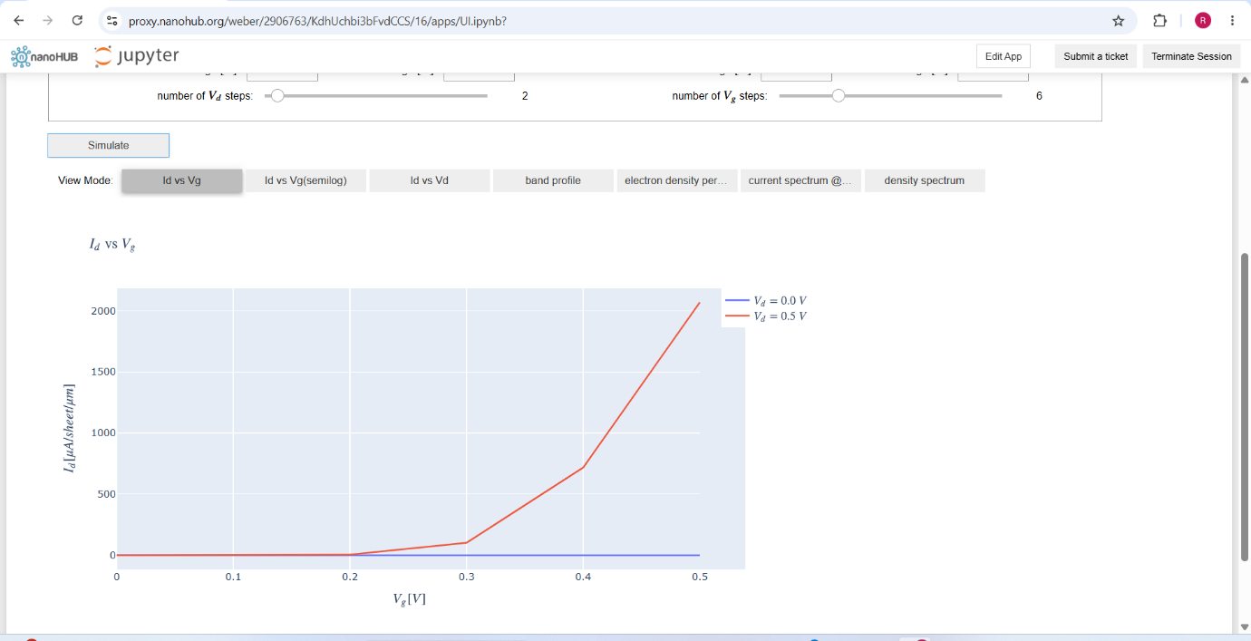
Iₔ vs Vₑ for Vₔ = 0.0 V and Vₔ = 0.5 V; number of Vₔ steps = 2, number of Vₑ steps = 6
Explanation of Output:
The plot shows drain current Iₔ in µA/sheet/µm against gate voltage Vₑ from 0 V to 0.5 V, for two drain bias conditions. The blue curve at Vₔ = 0.0 V remains flat at essentially zero current throughout, since no lateral field exists to drive carriers from source to drain.
The red curve at Vₔ = 0.5 V stays near zero up to about Vₑ = 0.2 V, then begins to rise, and climbs steeply beyond 0.3 V to reach approximately 2050 µA/sheet/µm at Vₑ = 0.5 V. The point at which the current begins to rise, around 0.2 V, marks the threshold voltage of the device. Below it the transistor is in the off state and only a small subthreshold leakage flows; above it the channel is inverted and the device conducts strongly.
The sharpness of this turn-on is the direct benefit of the FinFET architecture. Because the gate wraps around three sides of the fin, electrostatic control over the channel is far better than in a planar single-gate MOSFET, giving a steeper subthreshold slope and a lower off-state leakage current for the same threshold voltage.

Output — Drain Current vs Drain Voltage
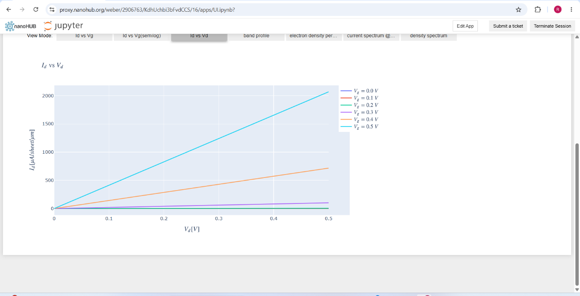
Iₔ vs Vₔ family of curves for Vₑ = 0.0 V to 0.5 V in six steps
Explanation of Output:
This is the family of output characteristics, with one curve for each gate bias from 0 V to 0.5 V. The curves for Vₑ = 0.0 V, 0.1 V and 0.2 V lie almost flat along the bottom axis at near-zero current, confirming that the device is below threshold at these gate voltages.
For Vₑ = 0.3 V a small current develops, for Vₑ = 0.4 V the orange curve rises to about 720 µA/sheet/µm at Vₔ = 0.5 V, and for Vₑ = 0.5 V the cyan curve rises linearly to approximately 2050 µA/sheet/µm.
An important observation is that all the conducting curves remain essentially linear over the plotted 0–0.5 V drain range and do not yet flatten into saturation. This is because saturation only begins once Vₔ exceeds Vₑ − Vₜₕ, and with a maximum gate voltage of only 0.5 V and a threshold near 0.2 V, the saturation onset would occur around 0.3 V and full saturation lies beyond the plotted range. The device is therefore operating largely in the linear (triode) region here, behaving as a gate-controlled resistor whose conductance increases sharply with gate voltage.
The widening vertical spacing between successive curves as Vₑ increases reflects the square-law dependence of drive current on gate overdrive.

Case Study 1: Simulate and obtain the current spectrum characteristics for the last bias point of the FinFET. Analyse the performance for different oxide layer thicknesses
Aim: To obtain the energy-resolved current spectrum at the final bias point and to interpret how the oxide thickness influences the transport window.
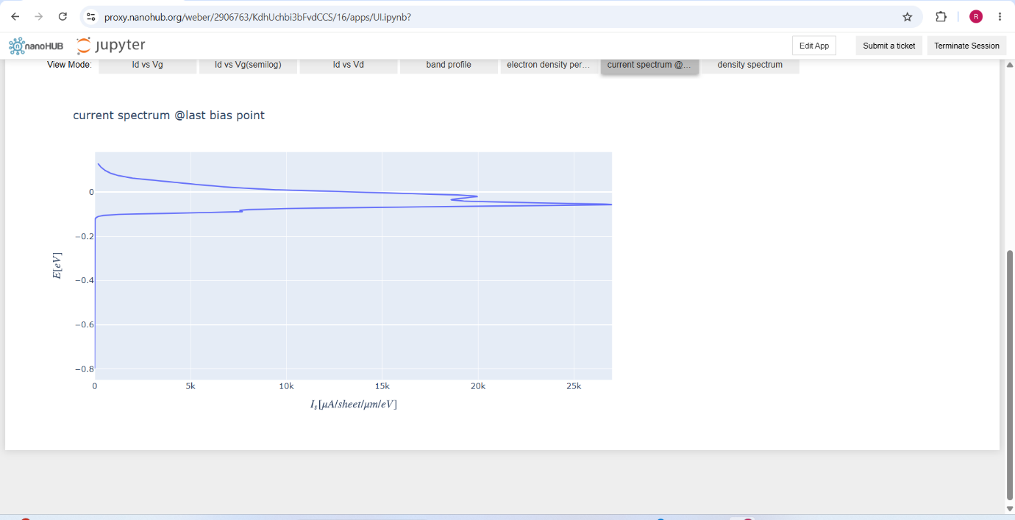
Current spectrum at the last bias point — E (eV) vs Iₛ (µA/sheet/µm/eV)
Explanation of Output:
The current spectrum plots energy E in eV on the vertical axis against the spectral current density Iₛ in µA/sheet/µm/eV on the horizontal axis. The spectrum forms a closed lobe that is confined to a narrow energy window between approximately −0.15 eV and +0.05 eV, with the current density extending out to about 25–27 kµA/sheet/µm/eV at its widest point near −0.05 eV.
This plot answers the question of which electrons actually carry the current. Only carriers whose energy lies inside this narrow window contribute; states well below the window are blocked because they lie beneath the source–channel barrier, and states well above it are empty because the Fermi distribution has fallen off. The width of the lobe is therefore set jointly by the applied drain bias, which defines the separation between the source and drain Fermi levels, and by the thermal broadening of a few kT at 300 K.
Regarding oxide thickness: a thinner gate oxide increases the gate capacitance and therefore lowers the source-to-channel barrier more effectively for the same applied gate voltage. This pushes more states into the conducting window and raises the peak spectral current density, improving the on-current. However, reducing the oxide thickness too far causes direct tunnelling of carriers through the oxide itself, producing gate leakage current. The choice of oxide thickness is therefore always a compromise between drive current and leakage, which is why high-κ dielectrics are used to obtain a large effective capacitance at a physically thicker oxide.

Case Study 2: Simulate and obtain the electron density per sheet characteristics of the FinFET. Analyse its performance with different gate region lengths
Aim: To obtain the spatial distribution of electron density along the device and to interpret how the gate region length controls the channel barrier.
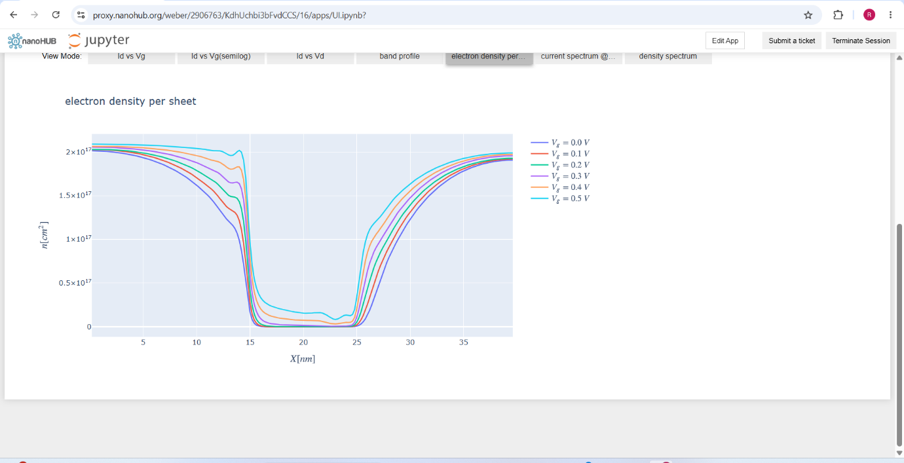
Electron density per sheet n [cm⁻²] vs position X [µm] for Vₑ = 0.0 V to 0.5 V
Explanation of Output:
The plot shows the electron sheet density along the length of the device for the six gate bias values. The density is very high, around 2 × 10¹⁷ cm⁻², in the two outer regions (X below about 14 and above about 25), and it collapses by several orders of magnitude to near zero in the central region between roughly X = 15 and X = 25.
The two high-density plateaux are the heavily doped source and drain regions, where the carrier concentration is fixed by the doping and is essentially independent of the gate bias. The deep depleted valley in the middle is the gate-controlled channel region. The width of this valley, about 10 units on the X axis, corresponds directly to the gate region length.
The effect of gate voltage is clearly visible in the ordering of the curves: as Vₑ increases from 0.0 V (dark blue, lowest) to 0.5 V (pink, highest), the entire family shifts upward and the floor of the valley lifts. A higher gate voltage lowers the channel barrier and injects more carriers into the channel, which is exactly what produces the increase in drain current seen in the earlier VI plots.
Regarding gate length: a longer gate region produces a wider and deeper depletion valley, which means better isolation between source and drain and hence lower off-state leakage, but also higher channel resistance and therefore lower drive current and slower switching. A shorter gate narrows the valley; if it becomes too short the source and drain depletion regions begin to merge, the gate loses control of the barrier, and short-channel effects such as drain-induced barrier lowering and punch-through appear. The three-sided wrap-around gate of the FinFET is precisely what allows the gate length to be scaled down further than in a planar device before these effects become unmanageable.

Analytical
A FinFET has the following parameters: Hₑᵢₙ = 30 nm, Wₑᵢₙ = 10 nm, Lᴄₕ = 20 nm, Cₒₓ = 2 µF/cm², µ = 200 cm²/V·s, Vₜₕ = 0.4 V. Find the drain current in the linear and saturation regions for Vᴳₛ = 0.8 V, with Vₔ = 0.3 V (linear) and Vₔ = 1.0 V (saturation).
Step 1 — Effective width:
Wₑᶠᶠ = 2 · Hₑᵢₙ + Wₑᵢₙ = 2 × 30 nm + 10 nm = 70 nm = 70 × 10⁻⁹ m
Step 2 — Drain current in the linear region:
Iₔ = µ · Cₒₓ · (Wₑᶠᶠ / Lᴄₕ) · [(Vᴳₛ − Vₜₕ)Vₔ − Vₔ²/2]
Iₔ = (200 × 10⁻⁴)(2 × 10⁻⁶)(70 × 10⁻⁹ / 20 × 10⁻⁹)[(0.8 − 0.4)(0.3) − 0.3²/2] = 10.5 µA
Step 3 — Drain current in the saturation region:
Iₔ = [µ · Cₒₓ · Wₑᶠᶠ / (2 · Lᴄₕ)] · (Vᴳₛ − Vₜₕ)²
Iₔ = [(200 × 10⁻⁴)(2 × 10⁻⁶)(70 × 10⁻⁹) / (2 × 20 × 10⁻⁹)](0.8 − 0.4)² = 11.2 µA
Observations: In the linear region the drain current depends on both Vₔ and Vᴳₛ, following a parabolic relationship, and for small Vₔ it increases approximately linearly with Vₔ. In the saturation region the drain current depends only on Vᴳₛ and Vₜₕ; once Vₔ > Vᴳₛ − Vₜₕ the channel becomes pinched off and further increases in Vₔ have little effect on Iₔ.

Outcome
Thus, the simulation of VI characteristics of FinFET by varying the gate channel length and oxide thickness is analysed and the key learning points are observed.

(b) GFET

Aim
To simulate the voltage–current (VI) characteristics of a Graphene Field Effect Transistor (GFET) using appropriate simulation tools, analyse its performance under varying gate voltages and drain–source voltages, and understand its behaviour as a high-mobility semiconductor device.

Software
NanoHub Online Tool — GFET Tool.

Theory
Graphene is a semimetal with a small overlap between the valence and the conduction bands, i.e. a zero bandgap material. It is an allotrope of carbon consisting of a single layer of carbon atoms arranged in a hexagonal lattice, and it is the basic structural element of many other allotropes of carbon such as graphite, diamond, charcoal, carbon nanotubes and fullerenes.
Graphene is a zero-gap semiconductor because its conduction and valence bands meet at the Dirac points, which are six locations in momentum space on the edge of the Brillouin zone, divided into two non-equivalent sets of three points labelled K and K′. The sets give graphene a valley degeneracy of gᵥ = 2. If the in-plane direction is confined, in which case it is referred to as a nanoribbon, its electronic structure changes: for a "zig-zag" edge the bandgap is zero, while for an "armchair" edge the bandgap is non-zero. The resistivity of graphene sheets is around 10⁻⁶ Ω·cm, which is less than the resistivity of silver, the lowest otherwise known at room temperature.

Procedure
- Open nanoHUB.
- Go to Resources → Tools.
- Select Graphene → GFET.
- Press Launch tool in the info section.
- Select the Width and Length.
- Click on Simulation.
- Select Result → Ids vs Vds.
- Repeat the above steps for various widths, lengths and mobility values.

Output — Id vs Vd Characteristics
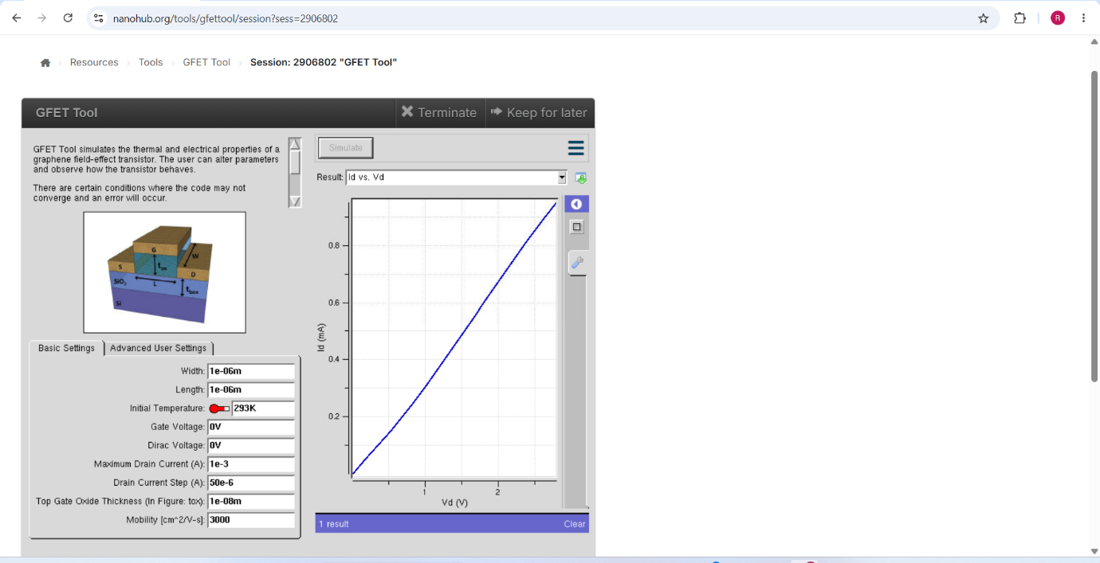
GFET Tool — Basic Settings and the resulting Id vs Vd curve
Parameters set: Width = 1e–06 m, Length = 1e–06 m, Initial Temperature = 293 K, Gate Voltage = 0 V, Dirac Voltage = 0 V, Maximum Drain Current = 1e–3 A, Drain Current Step = 50e–6 A, Top Gate Oxide Thickness tₒₓ = 1e–08 m, Mobility = 3000 cm²/V·s.
Explanation of Output:
The output plots the drain current Id in mA against the drain voltage Vd. The curve rises smoothly and almost linearly from the origin, reaching approximately 0.9 mA at Vd ≈ 3 V, with only a slight downward curvature at the higher voltages.
The near-linear behaviour and the complete absence of a flat saturation plateau are the defining signature of a graphene FET, and they distinguish it sharply from the silicon MOSFET and the FinFET studied earlier. In a conventional MOSFET the current saturates once the channel pinches off at the drain end. In graphene there is no bandgap, so the channel can never be fully depleted of carriers — as the gate or drain field pushes the Fermi level through the Dirac point, the conduction simply switches from electrons to holes rather than shutting off. The channel therefore continues to conduct at all bias conditions and the device behaves much more like a resistor.
This is simultaneously the greatest strength and the greatest weakness of graphene as a transistor material. The very high mobility of 3000 cm²/V·s and low intrinsic resistance give excellent high-frequency performance, which makes GFETs attractive for analog and radio-frequency amplifiers. However, the inability to switch fully off means a poor on/off current ratio, which rules graphene out for conventional digital logic unless a bandgap is artificially introduced, for example by patterning it into narrow nanoribbons or applying a perpendicular field to bilayer graphene.
The slight downward curvature at higher Vd is attributable to self-heating and to velocity saturation of the carriers, both of which reduce the effective mobility as the field increases.

Outcome
The VI characteristics of the Graphene Field Effect Transistor were successfully simulated. The device demonstrated a continuous, near-linear increase in drain current with drain voltage due to its high carrier mobility and the absence of a bandgap, with no distinct saturation region. The simulation confirms the potential of GFETs for high-speed and low-power analog applications while highlighting their limitation for digital switching.

Exp. 9. Simulation of Tunneling Magnetoresistance (TMR) by Varying Barrier Height using NanoHub

Aim
To obtain the Tunnelling Magnetoresistance (TMR) characteristics by varying the barrier height.

Software
NanoHub Online Tool — Magnetic Tunnel Junction Lab.

Theory
Tunnel magnetoresistance (TMR) is a magnetoresistive effect that occurs in a magnetic tunnel junction (MTJ), which is a component consisting of two ferromagnets separated by a thin insulator. If the insulating layer is thin enough, typically a few nanometres, electrons can tunnel from one ferromagnet into the other. Since this process is forbidden in classical physics, tunnel magnetoresistance is a strictly quantum mechanical phenomenon.
The resistance of the junction depends on the relative orientation of the magnetisation of the two ferromagnetic layers. When the two layers are magnetised parallel to one another the resistance is low, because majority-spin electrons in the reference layer find plenty of available majority-spin states in the free layer. When they are antiparallel the resistance is high, because majority-spin electrons must tunnel into the minority-spin band. The TMR ratio quantifies this difference.
Magnetic tunnel junctions are manufactured in thin film technology. On an industrial scale the film deposition is done by magnetron sputter deposition; on a laboratory scale molecular beam epitaxy, pulsed laser deposition and electron beam physical vapour deposition are also used. The junctions are patterned by photolithography.

Procedure
- Open nanoHUB.
- Go to Resources → Tools.
- Select Magnetic Tunnel Junction Lab.
- Press Launch tool in the info section.
- Select the barrier height.
- Click on Simulation.
- Select Result → Tunneling Magneto-Resistance (TMR).
- Repeat the above steps for various barrier heights and compare the results.

Case Study 1: Characteristics of TMR with a barrier height of 0.85 eV
Aim: To obtain the TMR versus bias voltage characteristics of an MgO-based magnetic tunnel junction with a barrier height of 0.85 eV.
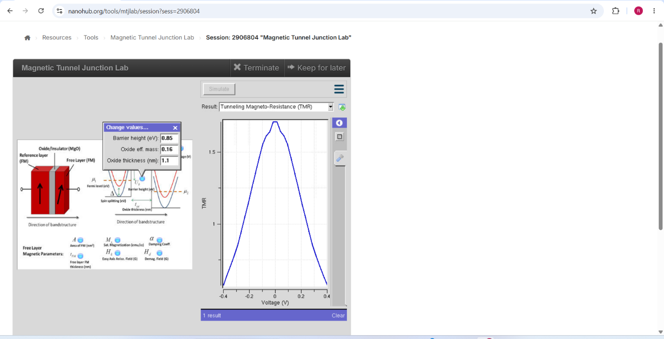
Magnetic Tunnel Junction Lab — Barrier height 0.85 eV, oxide effective mass 0.16, oxide thickness 1.1 nm
Explanation of Output:
The plot shows the TMR ratio against the applied bias voltage from −0.4 V to +0.4 V. The curve is symmetric about zero bias, peaking at a maximum TMR of approximately 1.75 at V = 0 and falling off steadily on both sides to about 0.7 at ±0.4 V. The overall shape is a broad, rounded dome with a flattened top.
The maximum at zero bias occurs because at zero bias the electrons tunnel elastically between states at the Fermi level of the two electrodes, where the spin polarisation of the density of states is highest. The spin filtering effect of the MgO barrier is therefore most effective here and the difference between the parallel and antiparallel resistances is greatest.
The steady decrease of TMR with increasing bias in either direction is a well-known and practically important effect. As the bias rises, electrons tunnel into states further above the Fermi level of the receiving electrode, where the spin polarisation is lower. In addition, hot electrons excite magnons (spin waves) at the barrier interfaces, and each magnon emission event flips an electron spin and destroys the spin information being carried. Both mechanisms degrade the spin filtering and hence reduce the TMR. This is why magnetic random access memory devices are read at the lowest practical bias voltage.
The symmetry of the curve about zero bias reflects the structural symmetry of the junction — both interfaces are nominally identical, so reversing the polarity of the applied voltage produces the same magnitude of TMR reduction.

Case Study 2: Characteristics of TMR with a barrier height of 1.0 eV
Aim: To obtain the TMR versus bias voltage characteristics for an increased barrier height of 1.0 eV and to compare the result with the 0.85 eV case.
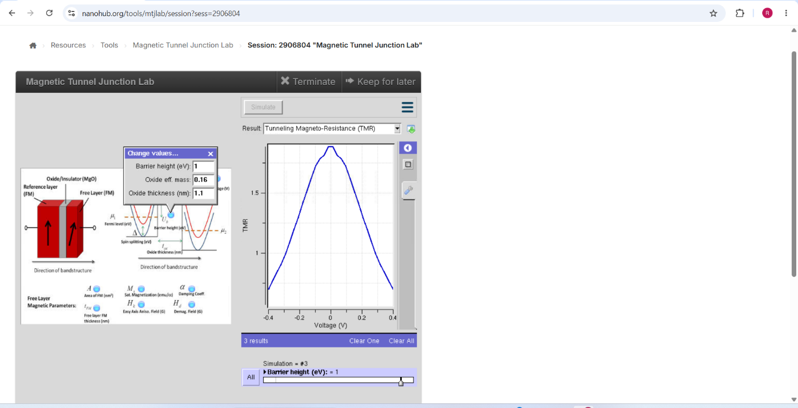
Magnetic Tunnel Junction Lab — Barrier height 1.0 eV, oxide effective mass 0.16, oxide thickness 1.1 nm (Simulation #3)
Explanation of Output:
With the barrier height raised from 0.85 eV to 1.0 eV the TMR curve retains the same symmetric dome shape and the same peak value of approximately 1.75 at zero bias, but the peak is noticeably narrower and more sharply defined. The curve now falls away more steeply on both sides, dropping to roughly 0.6 at ±0.4 V compared with about 0.7 in the 0.85 eV case.
Two effects are at work. First, raising the barrier height increases the decay constant κ of the electron wave function inside the oxide, since κ ∝ √(2m*Φ) where Φ is the barrier height. A larger κ means the wave function decays more rapidly through the barrier, which enhances the selectivity of the barrier for particular symmetry states and sharpens the spin filtering. This is why the peak becomes narrower and better defined.
Second, a higher barrier reduces the overall tunnelling probability, so the absolute junction current falls even though the TMR ratio itself — which is a normalised quantity comparing parallel and antiparallel resistances — stays similar at zero bias. The steeper fall-off with bias arises because the effective barrier is now more strongly deformed by the applied voltage, and the bias-induced degradation mechanisms therefore act more rapidly.
In practical MgO-based junctions the barrier height is controlled through the oxidation conditions during MgO deposition. The design trade-off is clear from these two case studies: a higher barrier gives sharper spin filtering but a lower read current, while a lower barrier gives more current but a broader, less selective TMR response.

Inference
- TMR is maximum at zero bias and decreases symmetrically as the bias voltage increases in either polarity.
- The bias dependence arises from reduced spin polarisation at higher energies and from magnon excitation at the barrier interfaces.
- Increasing the barrier height from 0.85 eV to 1.0 eV sharpens the TMR peak by increasing the wave-function decay constant, but reduces the overall tunnelling current.
- The oxide thickness of 1.1 nm and effective mass of 0.16 together with the barrier height determine the tunnelling probability and hence the junction resistance.

Result
Simulation of Tunnelling Magnetoresistance (TMR) by varying barrier height is accomplished.

