PROJECT REPORT
Online Course Enrollment Data Analysis
Enrollment, completion and certificate-integrity analysis using Python, Pandas, NumPy and Matplotlib
Prepared by: Vivek
Academic year: 2025-26

1. Project Overview
This project analyses online-course enrollments for a batch of 5,707 real students (roll numbers and names taken from students_25_26.csv). Each student is enrolled in one to three courses out of eight. For every enrollment the program records the instructor, month, watch-time, reported progress, genuine progress, status, certificate decision and the student's rating.
The project has four goals:
- Popularity: find which subjects are taken the most.
- Completion: measure completion, drop-out and progress for every course.
- Instructor guidance: recommend the better instructor for each course to new students, based on past outcomes.
- Anti-cheat: withhold certificates when a student's seek-bar shows 100% but the genuinely watched time is below 90%.

Key figure | Value
Students loaded | 5,707
Total enrollments (rows) | 10,827
Columns in dataset | 15
Courses / instructors | 8 courses, 2 instructors each (16)
Months covered | Jan-2026 to Jun-2026
Overall completion rate | 19.5% (2,111 completed)
Certificates issued / withheld | 1,398 issued / 713 withheld
Average progress | 71.78%

2. Dataset Details
The final dataset, course_enrollment_data.csv, has 15 columns. Three columns (Branch, BatchYear, ProgressGap) were added in this version to extend the original 12-column dataset.
# | Column | Type | Description
1 | RollNo | Text | Student roll number from the uploaded CSV
2 | StudentName | Text | Student name from the uploaded CSV
3 | Branch (new) | Text | Branch code read from the roll number, e.g. 25B11AE001 gives AE
4 | BatchYear (new) | Number | Batch year read from the roll number, e.g. 25 gives 2025
5 | Course | Text | One of the 8 courses
6 | Instructor | Text | One of the 2 instructors teaching that course
7 | EnrollmentMonth | Text | Jan-2026 to Jun-2026
8 | CourseDurationHours | Number | Fixed course length in hours (6 to 12)
9 | WatchedHours | Number | Hours the student genuinely watched
10 | Progress | Number | Progress % shown on the video seek-bar (can be skipped ahead)
11 | GenuineProgress | Number | WatchedHours divided by course duration, in %
12 | ProgressGap (new) | Number | Progress minus GenuineProgress; a large gap means skipping
13 | Status | Text | Completed (100), In Progress (40-99) or Dropped (below 40)
14 | CertificateStatus | Text | Issued, Withheld - Rewatch Required, or Not Applicable
15 | StudentRating | Number | Rating out of 5; blank when genuine progress is below 50%

Note on the data: student names and roll numbers are real, but the enrollment records are generated by the program using a fixed random seed (42), so the results can be reproduced exactly. Because courses are assigned randomly, the popularity differences between courses are small.

3. Implementation Details
Tools used: Python 3, Pandas, NumPy, Matplotlib, Google Colab.
Step | Task | What the code does
1 | Load students | Uploads students_25_26.csv and checks for RollNo and StudentName columns
2-3 | Create dataset | Builds enrollments with 1 to 3 courses per student, saves the CSV and previews 10 rows
4-5 | Inspect and clean | Prints shape, columns, data types and missing values; removes duplicates; trims text
6 | New enrollment | Interactive input to enroll a student; shows each instructor's completion rate and rating; applies the certificate rule
7-9 | Popularity and completion | Counts enrollments per course and instructor; completion rate overall and per course
10 | Instructor report | Ranks the two instructors of each course by completion rate and average rating
11 | Certificate integrity | Lists withheld certificates and the average progress gap
12-13 | Statistics | NumPy and Pandas summaries; top and bottom 5 students
14-19 | Charts | Six charts saved as PNG files
20 | Prediction | Rule-based prediction: likely to complete, at risk or likely to drop

Business rules used
- Status: progress of 100 is Completed; 40 to 99 is In Progress; below 40 is Dropped.
- Certificate: a completed course gets a certificate only when genuine watch-time is at least 90%; otherwise it is withheld and the student must rewatch.
- Cheating simulation: 15% of students who reach 80% or more are assumed to skip ahead and show 100% after watching only 5% to 35%.
- Rating: only students with at least 50% genuine progress can rate the course.

4. Subject Analysis: Most Taken Courses
Cyber Security Fundamentals is the most taken subject with 1,409 enrollments (13% of all enrollments). Web Development (1,365) and Machine Learning Basics (1,363) follow. Database Management Systems is the least taken with 1,317.
# | Course | Enrollments | Share | Avg progress | Completed | Dropped | Rating
1 | Cyber Security Fundamentals | 1,409 | 13% | 62.1% | 7% | 15.8% | 3.11
2 | Web Development | 1,365 | 12.6% | 71.1% | 22.3% | 12.2% | 3.82
3 | Machine Learning Basics | 1,363 | 12.6% | 61.1% | 6.7% | 16.1% | 3.05
4 | Artificial Intelligence | 1,355 | 12.5% | 71.4% | 24.9% | 12.2% | 3.84
5 | Cloud Computing | 1,352 | 12.5% | 73.6% | 20.7% | 7.5% | 3.80
6 | Python Programming | 1,341 | 12.4% | 78.4% | 27.1% | 4.3% | 4.03
7 | Data Structures & Algorithms | 1,325 | 12.2% | 78.9% | 24.7% | 3.9% | 4.08
8 | Database Management Systems | 1,317 | 12.2% | 78.6% | 23.5% | 3.6% | 4.03

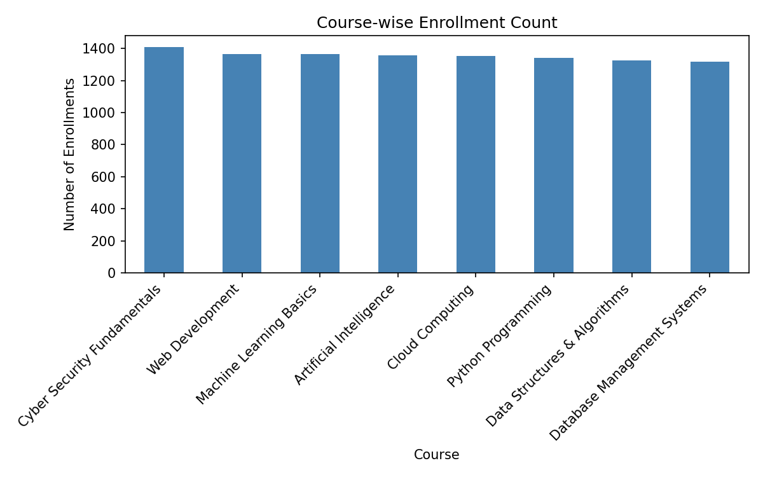
Figure 1: Course-wise enrollment count

Findings
- Most taken: Cyber Security Fundamentals (1,409), Web Development (1,365), Machine Learning Basics (1,363), Artificial Intelligence (1,355).
- Spread: the gap between the most and least taken course is only 92 enrollments (about 0.8 percentage points of share), so demand is almost even.
- Most popular is not the best completed: Cyber Security Fundamentals has the most enrollments but only 7.0% completion and a 3.11 rating. Machine Learning Basics is similar (6.7% completion).
- Best performing: Python Programming has the highest completion (27.1%), while Data Structures & Algorithms has the highest average progress (78.9%) and rating (4.08).
- Courses per student: 1,988 students take 1 course, 2,318 take 2 and 1,401 take 3.
- Top branches by enrollments: AI (2,718), CS (2,259), EC (1,938), DS (1,178), EE (418), using the new Branch column.

Best instructor for each course
Course | Recommended | Completion | Rating | Other instructor | Completion
Artificial Intelligence | Dr. P. Anitha | 44.8% | 4.55 | Dr. M. Sarma | 5.1%
Python Programming | Ms. A. Kavitha | 44.3% | 4.53 | Dr. K. Ramesh | 10.1%
Web Development | Mr. J. Varun | 38.9% | 4.43 | Ms. R. Sindhu | 5.2%
Cloud Computing | Prof. T. Rao | 34.1% | 4.33 | Mr. D. Vamsi | 5.9%
Data Structures & Algorithms | Prof. S. Lakshmi | 27.9% | 4.19 | Mr. B. Suresh | 21.3%
Database Management Systems | Ms. C. Haritha | 27.8% | 4.12 | Dr. V. Naidu | 19%
Cyber Security Fundamentals | Ms. P. Devi | 8.4% | 3.13 | Dr. S. Naresh | 5.7%
Machine Learning Basics | Dr. N. Kalyani | 6.9% | 3.02 | Dr. A. Prasad | 6.5%

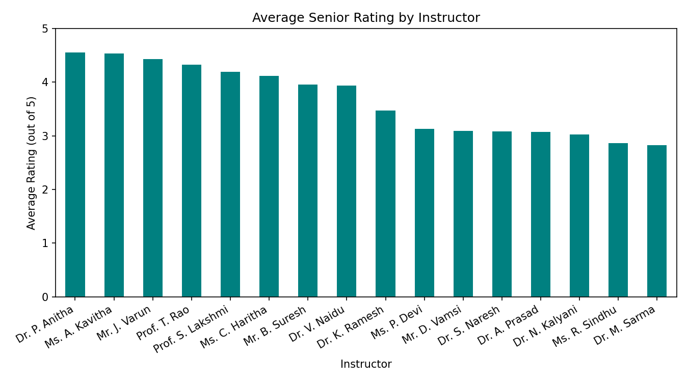
Figure 2: Average student rating by instructor

5. Output Screenshots and Proofs
Each screenshot below shows the console output of the program for one step. They come from a complete run of course_enrollment_project.py on the 5,707-student file. The long certificate table is shortened to its first rows in the picture.
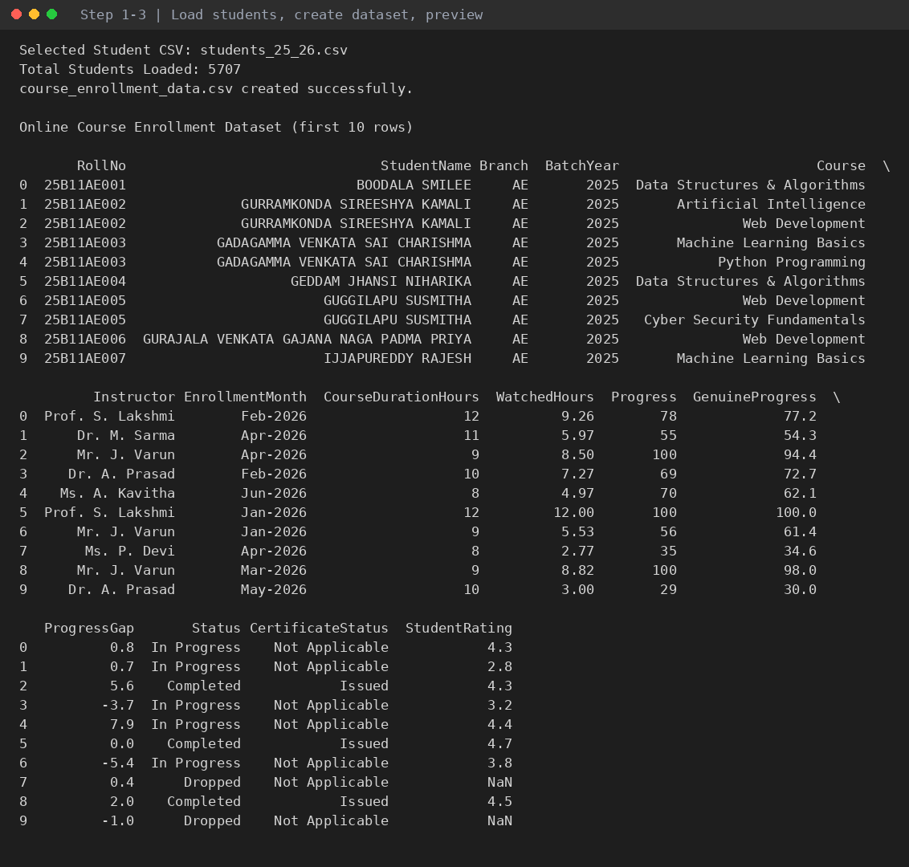
Output 1: Students loaded, dataset created and first 10 rows (15 columns).
Evidence: Proves the 5,707 students were loaded and the dataset includes the three new columns.
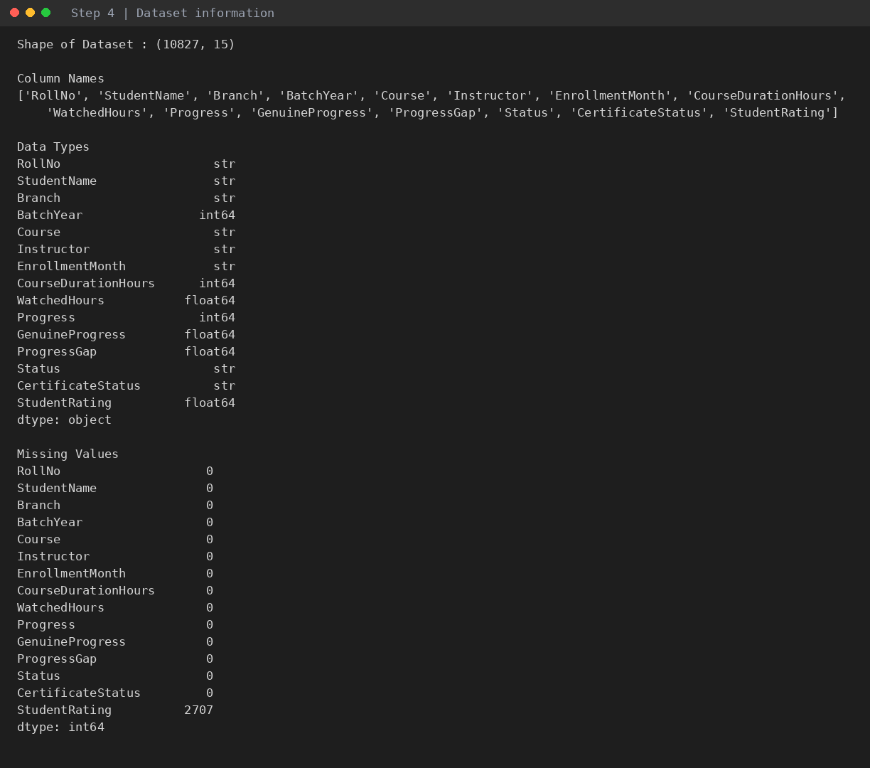
Output 2: Dataset information: shape, column names, data types and missing values.
Evidence: Proves the dataset has 10,827 rows and 15 columns. Only StudentRating has blanks (2,707).
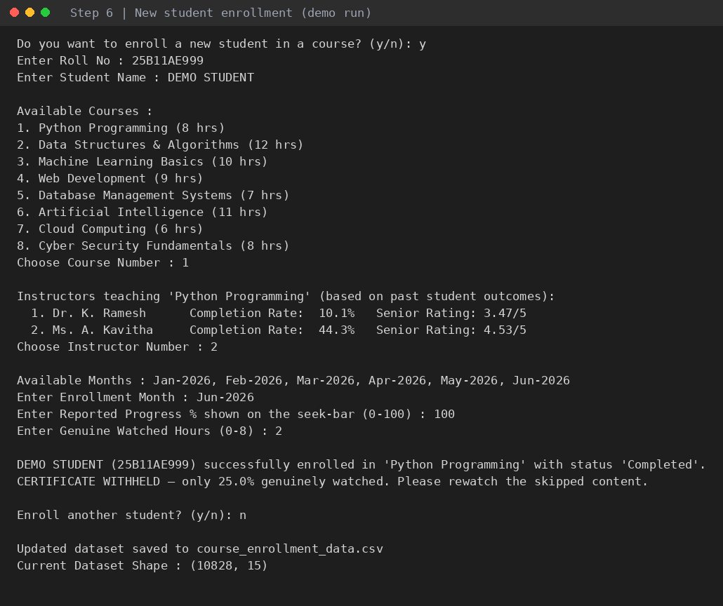
Output 3: Enrolling a new student (demo entry). Instructor completion rates and ratings are shown before choosing.
Evidence: Proves the interactive enrollment and the certificate rule: reported progress 100 but only 25% genuinely watched, so the certificate is withheld. DEMO STUDENT is a test entry and is not part of the delivered CSV.
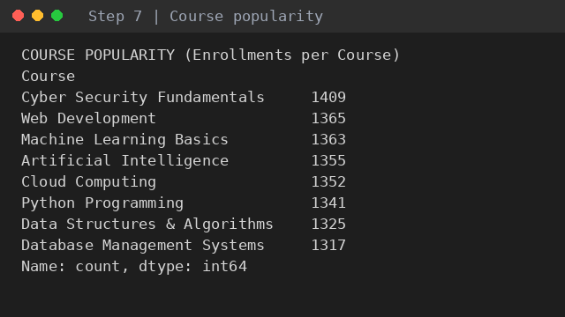
Output 4: Course popularity (enrollments per course).
Evidence: Proves the most taken subject is Cyber Security Fundamentals.
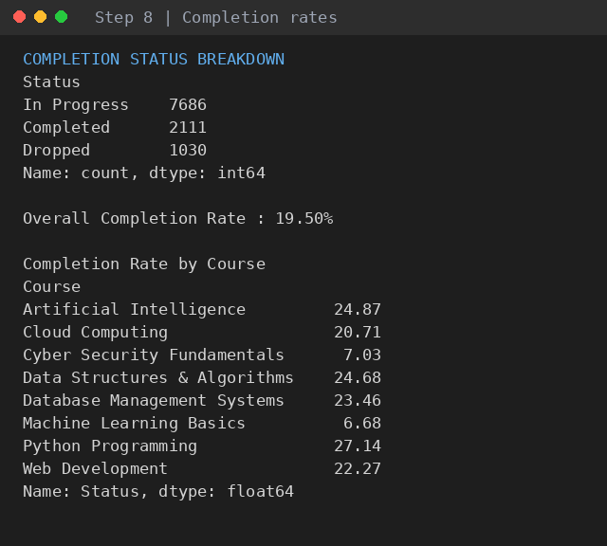
Output 5: Completion status breakdown and completion rate by course.
Evidence: Overall completion rate is 19.50%.
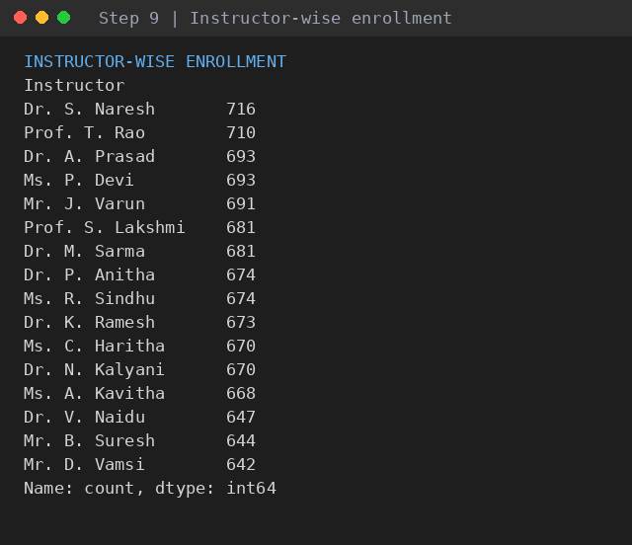
Output 6: Instructor-wise enrollment counts.
Evidence: Shows how many students each of the 16 instructors has.
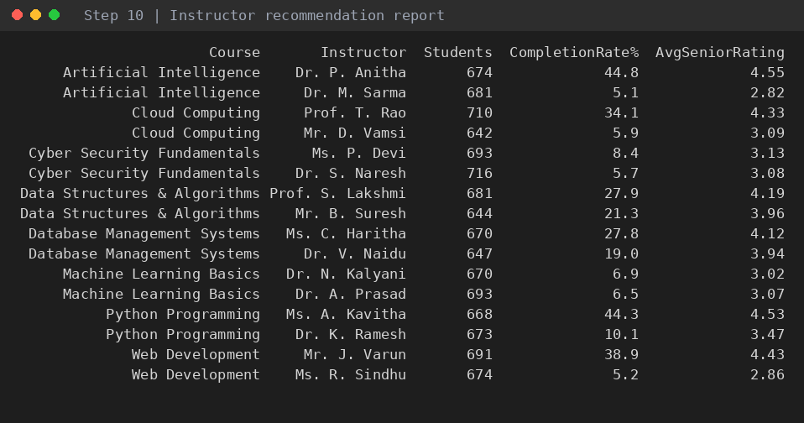
Output 7: Instructor recommendation report for new students.
Evidence: Ranks the instructors of each course by completion rate and rating.
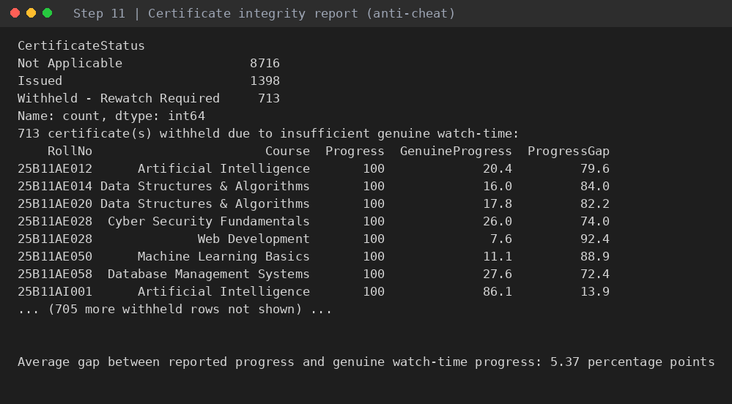
Output 8: Certificate integrity (anti-cheat) report. Student names omitted and only the first rows are shown.
Evidence: 713 certificates withheld; average gap between reported and genuine progress is 5.37 points.
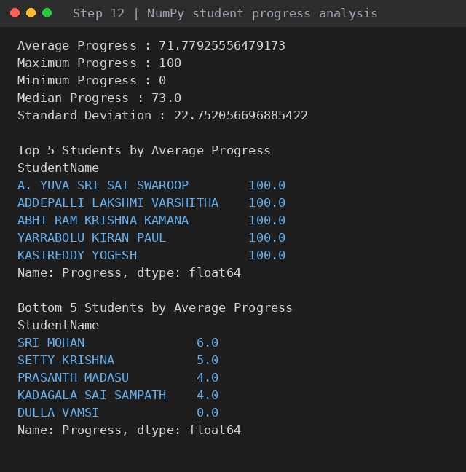
Output 9: NumPy student progress analysis with top 5 and bottom 5 students.
Evidence: Average progress 71.78, median 73, maximum 100, minimum 0.
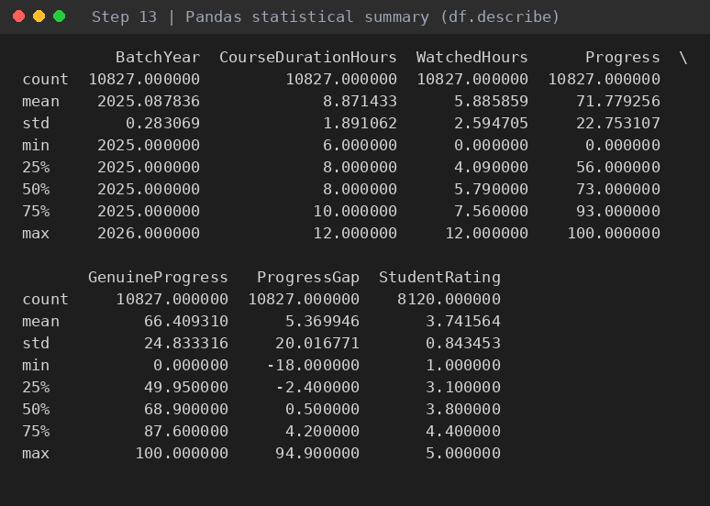
Output 10: Pandas statistical summary (describe) of the numeric columns.
Evidence: Includes the new BatchYear and ProgressGap columns.
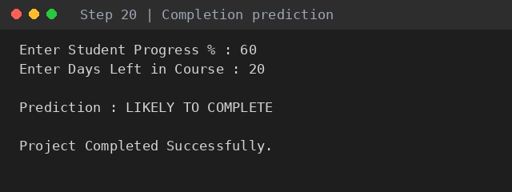
Output 11: Completion prediction (60% progress, 20 days left).
Evidence: Gives LIKELY TO COMPLETE for this input.

Charts generated by the program
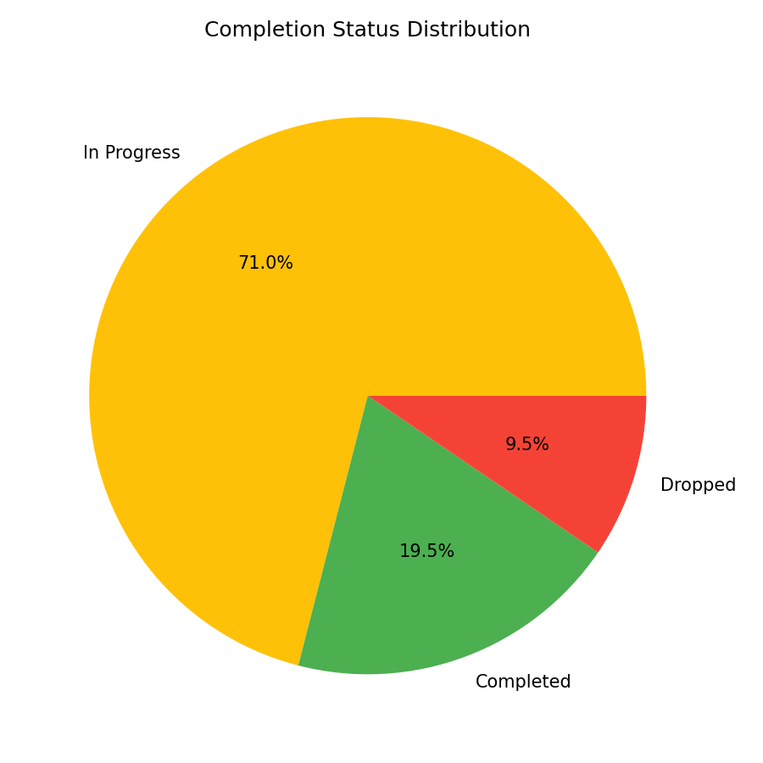
Output 12: Completion status distribution (pie chart)
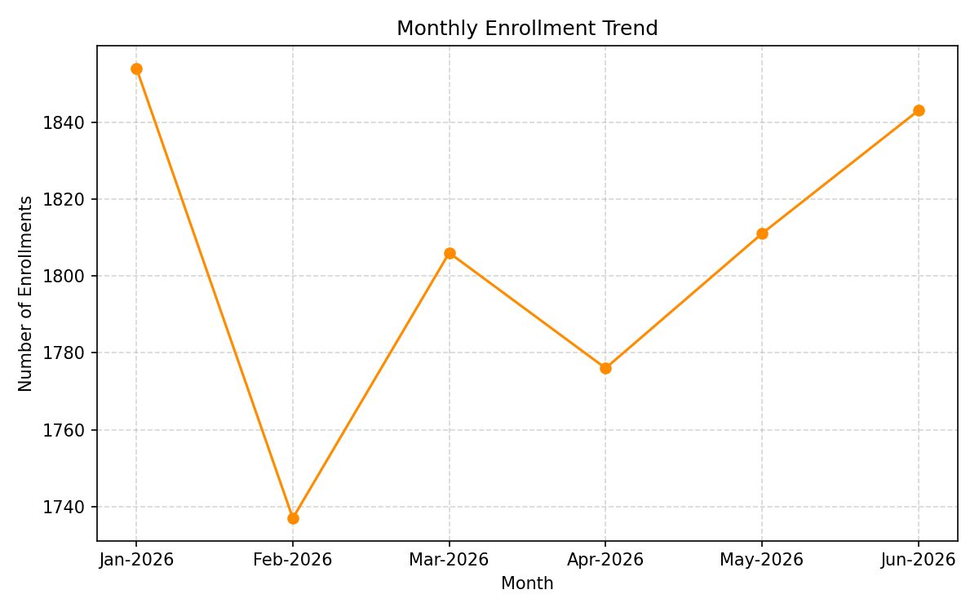
Output 13: Monthly enrollment trend
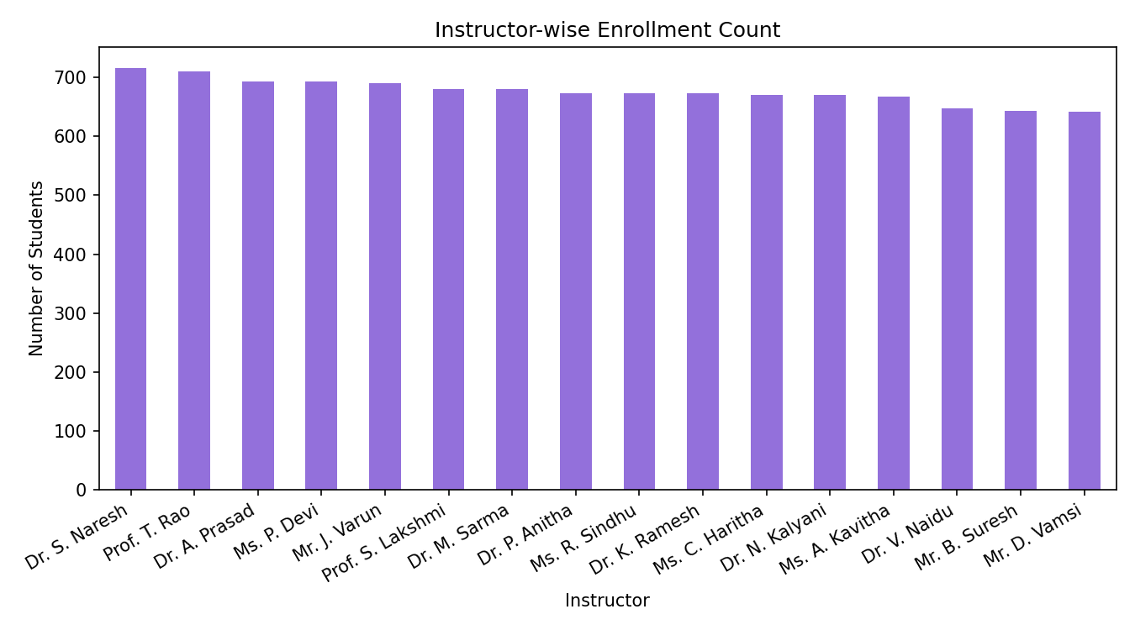
Output 14: Instructor-wise enrollment count
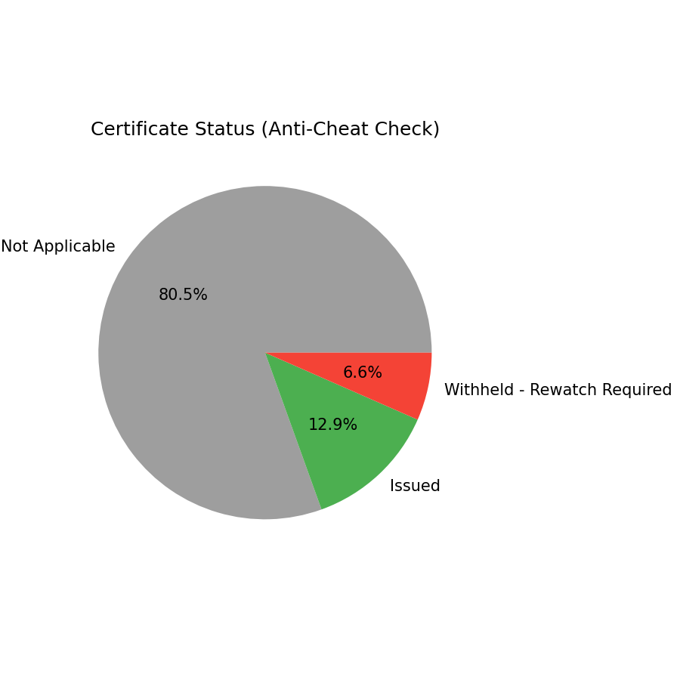
Output 15: Certificate status (anti-cheat check)

6. Verification of Results
Automated checks were run on the final CSV file to confirm that the data is complete and that the program's rules were applied correctly.
Check | Result | Status
Rows x columns | 10,827 x 15 | Passed
Unique students covered (CSV had 5,707) | 5,707 | Passed
Duplicate rows | 0 | Passed
Progress and GenuineProgress within 0-100 | all rows | Passed
ProgressGap = Progress - GenuineProgress | 0 mismatches | Passed
Status follows rule (100 = Completed, 40-99 = In Progress, <40 = Dropped) | 0 mismatches | Passed
Certificate follows 90% genuine watch-time rule | 0 mismatches | Passed
Branch matches Roll No. (characters 6-7) | 0 mismatches | Passed
BatchYear matches Roll No. (first 2 digits) | 0 mismatches | Passed
Missing values only in StudentRating (genuine progress < 50%) | 2,707 blank ratings | Passed

The program is also reproducible: the random seed is fixed at 42, so running it again on the same student file gives identical numbers.

7. Conclusion
- The program processed 5,707 students and 10,827 enrollments across 8 courses and produced all planned reports and charts without errors.
- Cyber Security Fundamentals is the most taken course, but it, like Machine Learning Basics, has very low completion. These two courses need attention.
- Python Programming, Data Structures & Algorithms and Database Management Systems have the best completion, ratings and lowest drop-out.
- The anti-cheat rule withheld 713 certificates, about one-third of all completions, which protects the value of the certificates.
- The instructor recommendation report helps new students choose between two instructors using real past outcomes.

Future scope
- Branch-wise completion analysis using the new Branch column.
- A machine-learning model to predict drop-out instead of the current rule-based prediction.
- A web dashboard to show the reports live.

