Assignment – Building No Code App in Flutter Flow & Firebase – Rupayan Bhakta

1. Here is the Sign Up Page

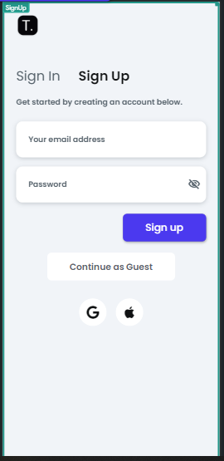

1. Here below is the Login Page

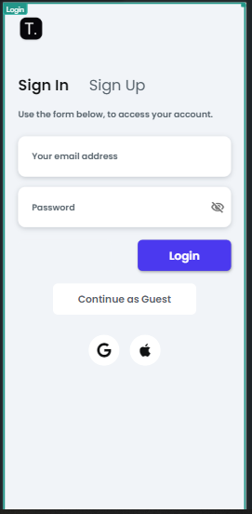

1. Below is the Home Page where Filter is applied according to the category of the pets selected by the users. They can either select cats or dogs.

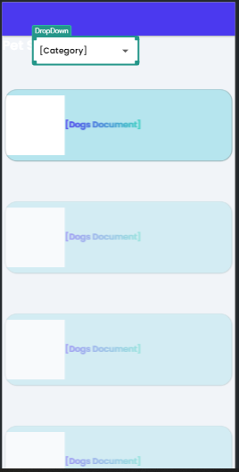

1. Below is the Firebase integration done for Cats and Dogs as Product Catalogue.

