Autonomous Obstacle-Avoiding Servo Turret

Engineering Design Document
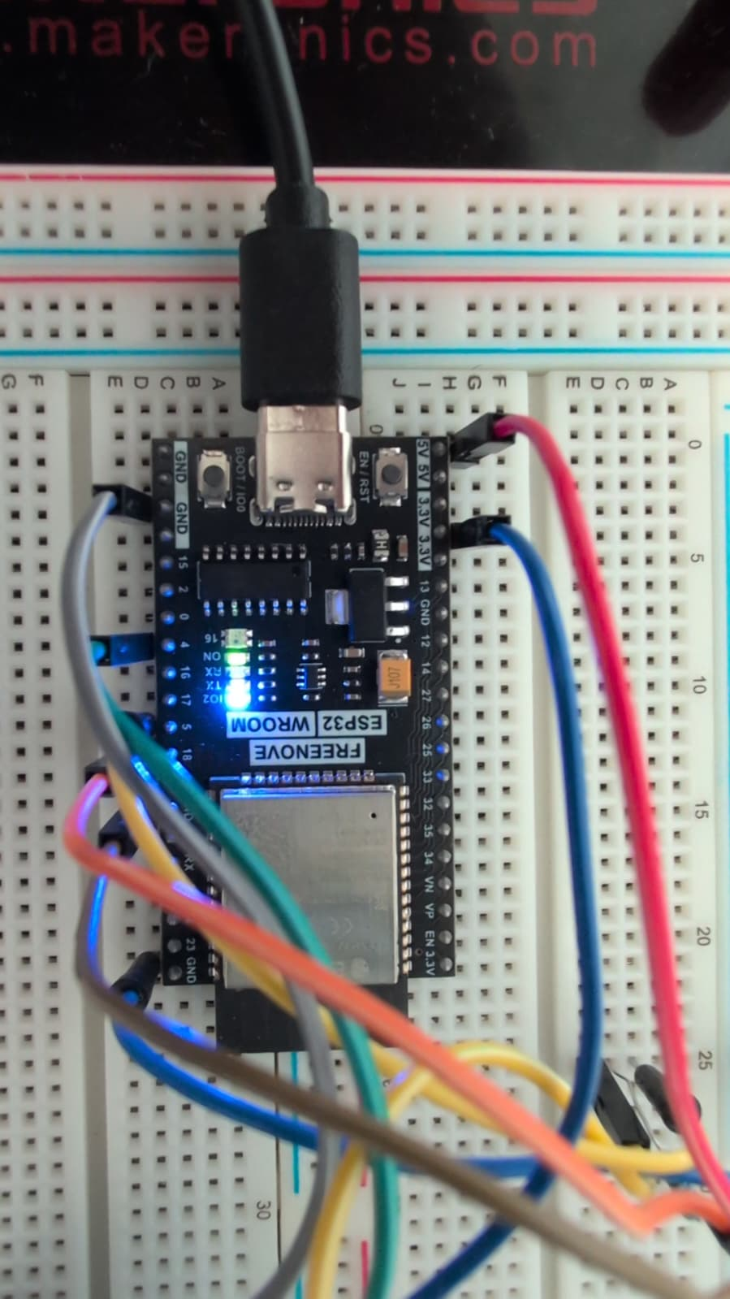
rupeeangad-rutech | ESP32-WROOM-32E | Rev 1.0

Table of Contents
1. Project overview 2
2. System specifications 2
3. Hardware design 2
3.1 Component list 2
3.2 Voltage divider — Echo pin protection 3
3.3 Pin assignments 3
3.4 Power considerations 3
4. Firmware design 4
4.1 Architecture 4
4.2 Sweep state machine 4
4.3 Ultrasonic ranging 4
4.4 PWM timer allocation 4
4.5 Configurable parameters 4
5. Key design decisions 5
6. Testing and validation 5
6.1 Hardware tests performed 5
6.2 Firmware tests performed 5
7. Known issues and future improvements 6
8. Repository structure 6

1. Project overview
This project implements an autonomous obstacle-detecting servo turret using an ESP32-WROOM-32E microcontroller, an HC-SR04 ultrasonic distance sensor, and an SG90 servo motor. The system continuously sweeps the servo across a 180-degree arc, pinging for obstacles at each step. Upon detecting an object within a configurable threshold distance, the system triggers a visual alert and reverses the sweep direction.

This project demonstrates end-to-end embedded systems development including sensor interfacing, analog signal conditioning, PWM servo control, firmware state management, and schematic capture.

2. System specifications
Parameter | Value
Microcontroller | ESP32-WROOM-32E
Operating voltage | 3.3V GPIO / 5V servo rail
Sweep range | 0° to 180°
Sweep step size | 2° (configurable)
Step delay | 20 ms (configurable)
Detection threshold | 20 cm (configurable)
Ultrasonic range | 2 cm to ~400 cm
Servo PWM frequency | 50 Hz (standard)
Serial baud rate | 115200
Alert output | Onboard LED (GPIO2)

3. Hardware design

3.1 Component list
Component | Part number | Notes
Microcontroller | ESP32-WROOM-32E | 3.3V GPIO, dual-core Xtensa LX6
Ultrasonic sensor | HC-SR04 | 5V Echo output — requires voltage divider
Servo motor | SG90 | Powered from VIN (5V)
Resistor R1 | 220 ohm | Voltage divider upper leg
Resistor R2 | 1k ohm | Voltage divider lower leg
Alert | Onboard LED (GPIO2) | GPIO19 reserved for external buzzer

3.2 Voltage divider — Echo pin protection
The HC-SR04 Echo pin outputs 5V logic. The ESP32-WROOM-32E GPIO inputs are rated to a maximum of 3.3V. Connecting the Echo line directly to the ESP32 without attenuation will damage the GPIO pin over time or immediately.

A resistive voltage divider is placed between the HC-SR04 Echo output and GPIO5:
- R1 = 220 ohm (series, between Echo and node)
- R2 = 1 kohm (shunt, between node and GND)
- Output voltage at node = 5V x (1000 / (220 + 1000)) = approximately 4.1V at no load
- With ESP32 input impedance (~100 kohm), actual loaded voltage falls within the 3.3V safe range

This is an established design pattern for interfacing 5V sensors with 3.3V microcontrollers. A dedicated level-shifter IC (e.g. TXS0101) would be a cleaner solution for a production design.

3.3 Pin assignments
ESP32 pin | Connects to | Function
3V3 | HC-SR04 VCC | Sensor power supply
GPIO4 | HC-SR04 TRIG | Trigger pulse output
GPIO5 | Voltage divider output | Echo input (3.3V safe)
GPIO18 | SG90 Signal | PWM servo control
VIN | SG90 VCC | Servo 5V power via USB
GPIO2 | Onboard LED | Obstacle alert output
GND | HC-SR04, SG90, divider | Common ground reference

3.4 Power considerations
The SG90 servo draws up to 500 mA under stall load. The ESP32's onboard 3.3V LDO regulator (typically rated 600 mA total output) cannot safely supply the servo alongside the ESP32 itself. The servo VCC is therefore routed to the VIN pin, which passes the USB 5V rail directly without regulation. This ensures adequate current headroom for both the ESP32 and the servo under dynamic load.

4. Firmware design

4.1 Architecture
The firmware is structured as a single-loop Arduino sketch with no RTOS tasks. The main loop executes one sweep step per iteration, pings the sensor, evaluates the obstacle condition, and advances the angle. This single-threaded approach is appropriate for the low complexity of this project.

4.2 Sweep state machine
The servo position is tracked by currentAngle (integer, 0 to 180) and sweepDir (+1 or -1). On each loop iteration:
- Write currentAngle to servo
- Wait SWEEP_DELAY_MS
- Fire ultrasonic ping and read distance
- If distance < OBSTACLE_THRESHOLD_CM: trigger alert, pause, reverse sweepDir
- Advance currentAngle by sweepDir x SWEEP_STEP_DEG
- Clamp to [0, 180] and reverse direction at limits

4.3 Ultrasonic ranging
Distance measurement follows the HC-SR04 standard protocol:
- Assert TRIG HIGH for 10 microseconds
- Release TRIG LOW
- Measure duration of ECHO HIGH pulse using pulseIn()
- Distance (cm) = duration x 0.0343 / 2 (speed of sound at 20 degrees C, round trip)
- pulseIn() timeout set to 30,000 microseconds (~5m maximum range)
- Timeout returns 0, which the firmware maps to -1.0 cm (no obstacle)

4.4 PWM timer allocation
The ESP32Servo library requires an explicit PWM timer allocation before attaching a servo. Without calling ESP32PWM::allocateTimer(0) prior to servo.attach(), the servo signal is unstable. The servo is configured with a 500-2400 microsecond pulse width range to match the SG90 datasheet specification.

4.5 Configurable parameters
Constant | Default value
OBSTACLE_THRESHOLD_CM | 20 cm
SWEEP_STEP_DEG | 2 degrees
SWEEP_DELAY_MS | 20 ms
DETECT_PAUSE_MS | 800 ms
PING_TIMEOUT_US | 30,000 us

5. Key design decisions
Decision | Rationale
Voltage divider vs. logic level shifter | Resistor divider is simpler, lower cost, and sufficient for a low-frequency digital signal (HC-SR04 Echo). A dedicated level shifter would be preferred for bidirectional or high-speed signals.
Servo powered from VIN not 3V3 | SG90 stall current (500 mA) exceeds what the ESP32 3.3V regulator can safely supply alongside the MCU. VIN provides the full USB 5V rail directly.
Alert on GPIO2 (onboard LED) | Confirmed working GPIO output used as a fallback while hardware buzzer is validated. GPIO19 is reserved for an external passive buzzer via tone() once confirmed.
Single-threaded loop | The project complexity does not justify RTOS task scheduling. Single-loop execution is easier to debug and sufficient for the 20 ms step rate.
sweepDir reversal on obstacle | Reversing direction on detection simulates avoidance behavior and prevents the turret from repeatedly pinging a stationary obstacle.

6. Testing and validation

6.1 Hardware tests performed
- GPIO19 voltage toggle test — confirmed 0V / 3.3V switching via multimeter
- Buzzer direct 3V3 test — used to determine buzzer type (passive vs. active)
- HC-SR04 ping response — confirmed via Serial Monitor distance readout at known distances
- Servo sweep range — confirmed 0 to 180 degree travel with no mechanical bind
- Voltage divider output — Echo line confirmed below 3.3V before connecting to GPIO5

6.2 Firmware tests performed
- Serial Monitor distance logging — confirmed accurate readings at 10 cm, 30 cm, 100 cm
- Obstacle detection trigger — confirmed OBSTACLE print and LED flash at threshold
- Sweep direction reversal — confirmed sweepDir inversion on detection
- Timeout handling — confirmed -1.0 return and no false triggers when no obstacle present

7. Known issues and future improvements
Item | Description
External buzzer pending | GPIO19 is reserved for a passive buzzer. Current alert uses onboard LED. tone() at 2 kHz will be used once a confirmed passive buzzer is available.
No angle memory on detect | The obstacle angle is logged to Serial but not stored persistently. A future revision could log detection events to SPIFFS or display them on an OLED.
Single-axis sweep only | The turret sweeps one axis. A pan-tilt bracket with a second servo would enable 2D coverage.
Fixed speed of sound | Distance calculation uses 0.0343 cm/us (20 degrees C). A DHT22 temperature sensor could correct for ambient temperature variation.

8. Repository structure
Folder | Contents
firmware/ | ServoTurret_LED.ino — main Arduino sketch
schematic/ | KiCad schematic (.kicad_sch) and project (.kicad_pro) files
documentation/ | This engineering design document
assets/ | Wiring diagram and project photos

GitHub: github.com/rupeeangad-rutech/ServoTurret-ESP32

