**Name: Rupen Dhandhukiya**

**Company: MSG Global Solutions India Private Limited**

**Country:** **India**

**ASSIGNMENT**

**TOP 3 COUNTRIES HIGHEST STANDARD VAT RATE & TOP 3 COUNTRIES LOWEST REDUCED VAT RATES**

**25-JAN-2023**

**Objective**

Build a microservice which exposes a REST API for:

• Return three EU countries with the highest standard VAT rate

• Return three EU countries with the lowest reduced VAT rates

Input: [https://euvatrates.com/rates.json](https://eur03.safelinks.protection.outlook.com/?url=https%3A%2F%2Feuvatrates.com%2Frates.json&data=05%7C01%7C%7C291163ebb0834e1093ee08dad697583a%7Cc2350a4a56c64ec19195e636c90735d6%7C0%7C0%7C638058242808176820%7CUnknown%7CTWFpbGZsb3d8eyJWIjoiMC4wLjAwMDAiLCJQIjoiV2luMzIiLCJBTiI6Ik1haWwiLCJXVCI6Mn0%3D%7C3000%7C%7C%7C&sdata=Nqx2a3rDR3E0nwY%2FOKMsH0gfzG2BFNE5tS1MowXBdy8%3D&reserved=0)

**Guidelines: Keep it clean and simple (with some design for future extensions). Implement as a Maven project using Spring Boot or Quarkus. Provide source code, a way to run it and some kind documentation for the API.**

**High Level Diagram**

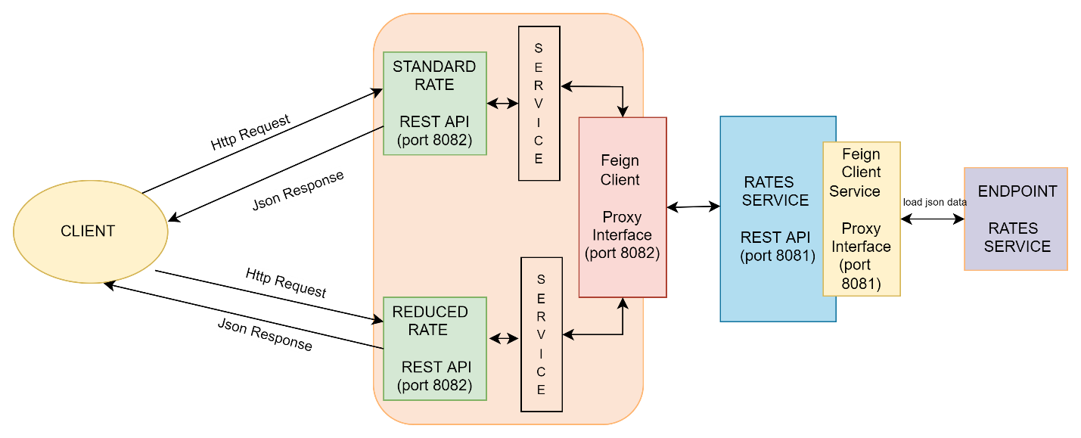

**Frameworks, Tools & Languages**

* Eclipse
* Spring Boot
* Java
* Swagger UI

**API’s Details**

**Service-1: rate-service**

rate-service project is used to load json data from external end point service (<https://euvatrates.com//rates.json>). To communicate external service, it is used feignclient cloud API as proxy interface and the service runs on 8081 port as a separate service (<http://localhost:8081/rates_microservice/vat/rates>).

* **RateController Rest API**

The rest API is used to load the entire json data from external end point service and the loadRatesJsonData() method used to inject the service component to load the json data. Once the response is OK status then the countries and rates list sent as http ResponseEntity

* **RateService Service**

The service component is used to inject the rateServiceProxy interface to communicate and load the entire json data. Once data loaded then filtered the data as list of countries and rates by using Jackson API

* **RateServiceProxy Interface**

The proxy interface is used to register the cloud feign rest client by passing service name and URL details to communicate the services

**Service-2: standard-reduced-rates-service**

standard-reduced-rates-service project used to load the filtered json data from service1 (<http://localhost:8081/rates_microservice/vat/rates>). To communicate service1, it is used feignclient cloud API as proxy interface and the service2 runs on 8082 port as a separate services

(<http://localhost:8082/standard-reduced-rates-service//vat/rate/getStandardRates>) and ([http://localhost:8082/standard-reduced-rates-service//vat/rate/getReducedRates](http://localhost:8082/standard-reduced-rates-service//vat/rate/getStandardRates))

* **StandardRateRestController Rest API**

The rest API is used to load the list of countries and rates json data from service1 and getHighestThreeCountriesStandardRates() method is used to inject the standardRateRestService service component to get the top highest three countries and standard vat rates data. Once the response is OK status then the countries and rates list sent as http ResponseEntity

* **ReducedRateRestController Rest API**

The rest API is used to load the list of countries and rates json data from service1 and getLowestThreeCountriesReducedRates() method is used to inject the reducedRateRestService service component to get the top lowest three countries and reduced vat rates data. Once the response is OK status then the countries and rates list sent as http ResponseEntity

* **StandardRateRestService Service**

The service component is used to inject the countriesRatesServiceProxy interface to load the filtered json data and applied business logic to get the top highest countries and standard vat rates

* **ReducedRateRestService Service**

The service component is used to inject the countriesRatesServiceProxy interface to load the filtered json data and applied business logic to get the top lowest countries and reduced vat rates

* **CountriesRatesServiceProxy Interface**

The proxy interface is used to register the cloud feign rest client by passing service name and URL details to communicate the service1

**Steps to Test the Application**

* Return three EU countries with the highest standard VAT rate
* Return three EU countries with the lowest reduced VAT rates

1. Execute the URL :

[http://localhost:8082/swagger-ui/index.html#](http://localhost:8082/swagger-ui/index.html)

1. click "**GET**" button to test as per functional requirements

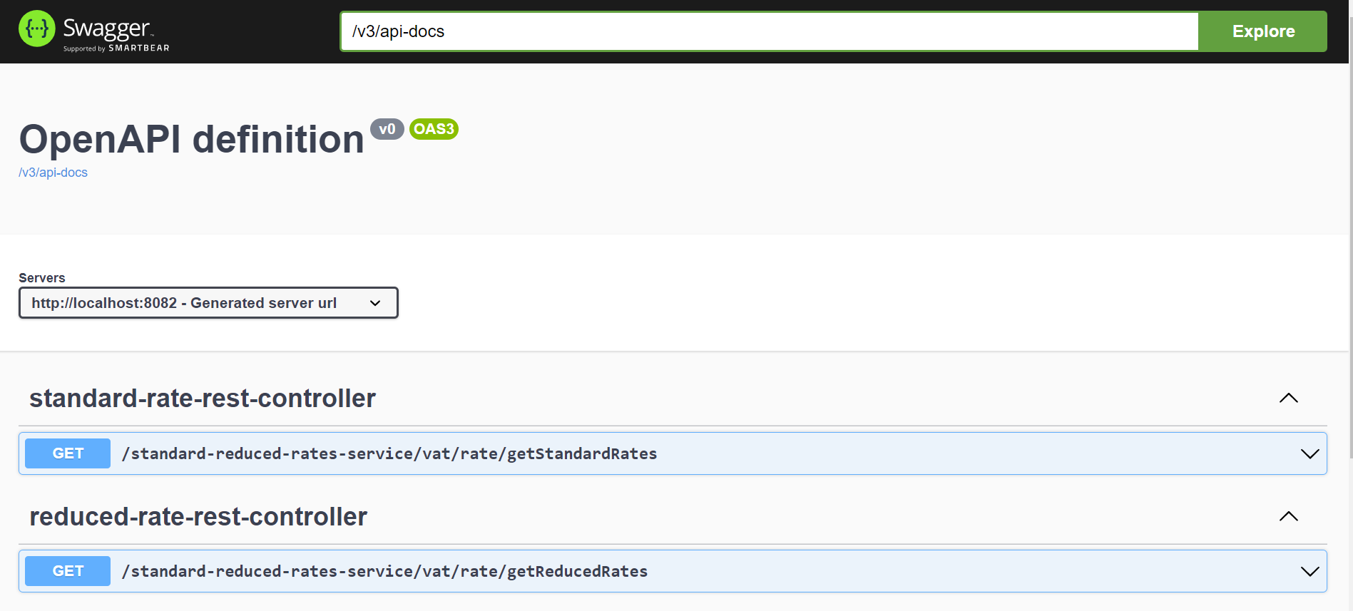

1. Click “**Try it out**” button

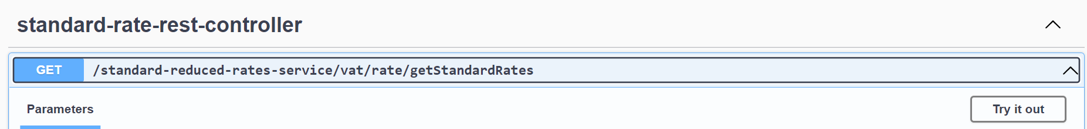

1. Click “**Execute**” button

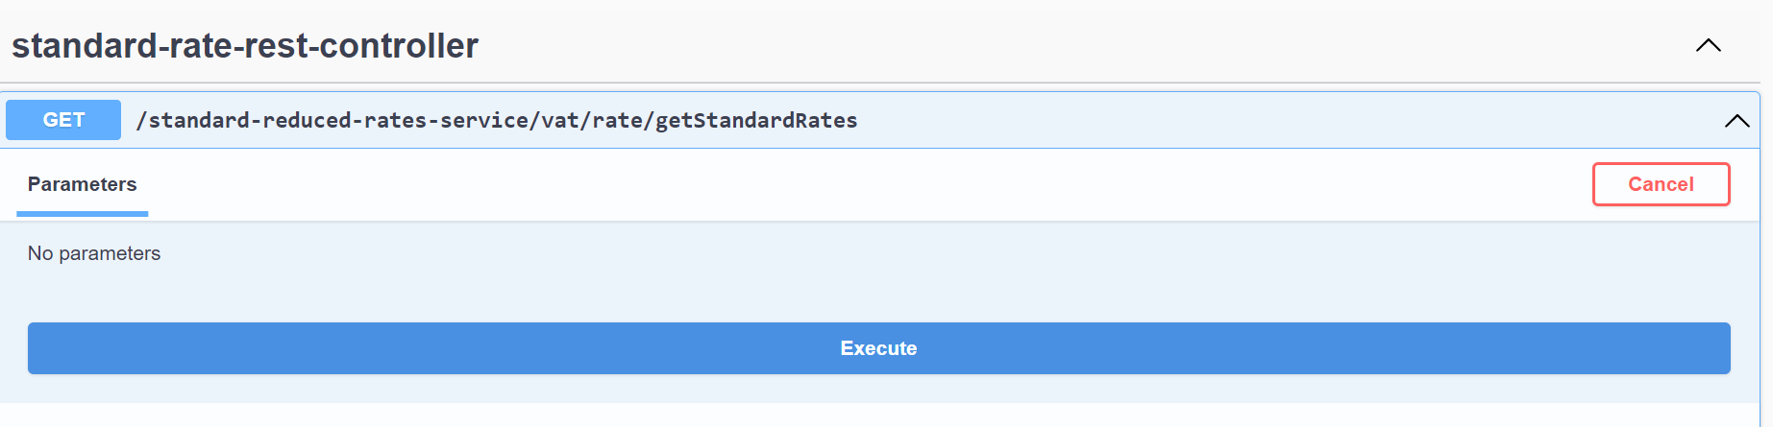

1. Results

Return three EU countries with the highest standard VAT rate

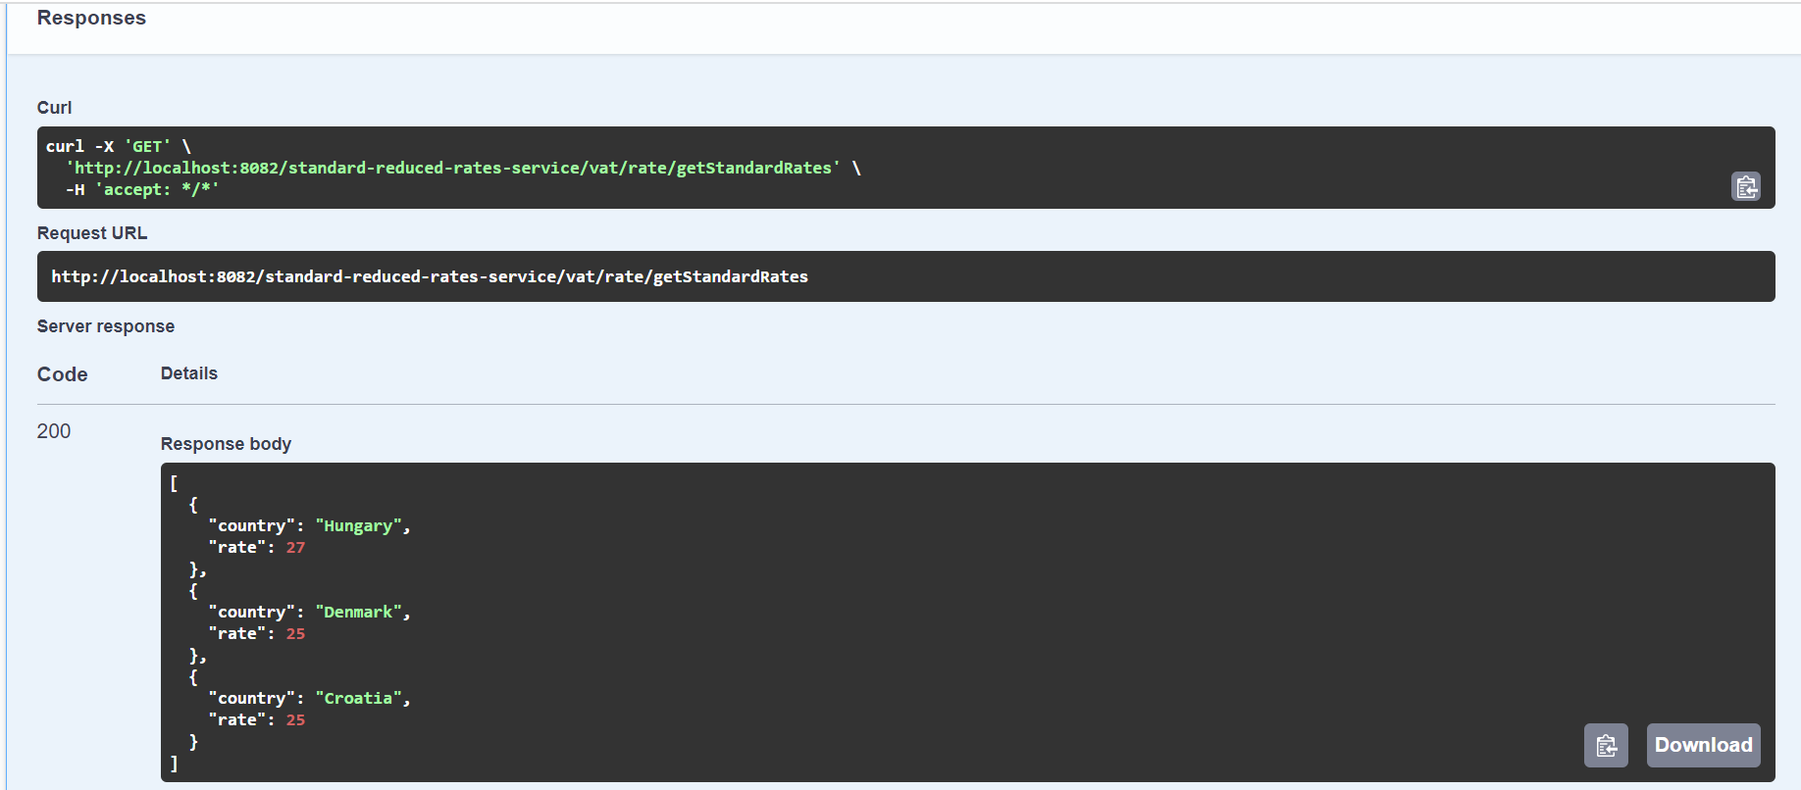

Return three EU countries with the lowest reduced VAT rates

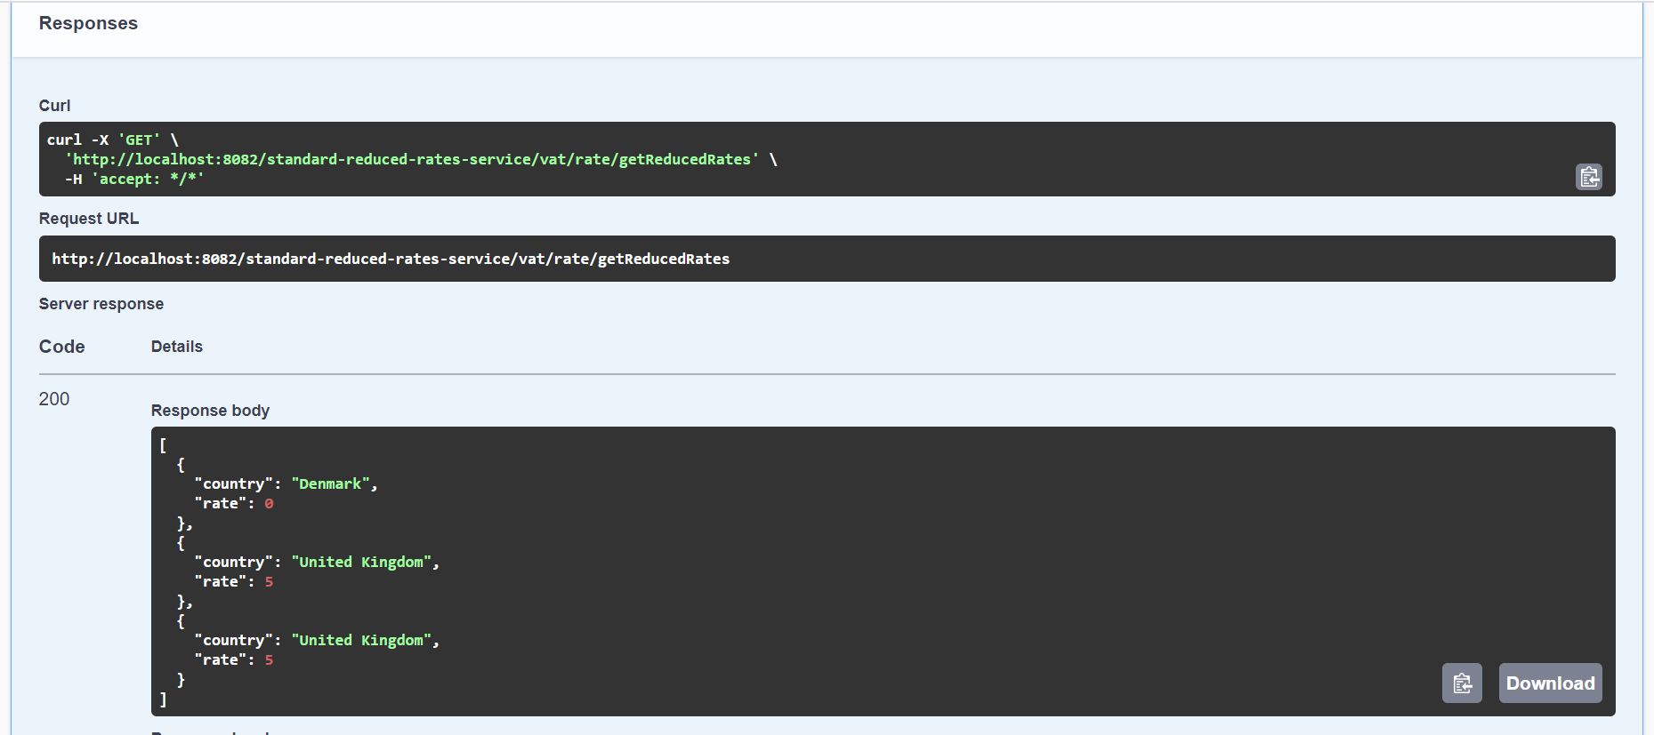

**Steps to download and execute (in eclipse ide)**

1. Go to command prompt and navigate to workspace folder and execute below said git command

**git clone** [**https://github.com/rupen-dhandhukiya/assessment**](https://github.com/rupen-dhandhukiya/assessment)

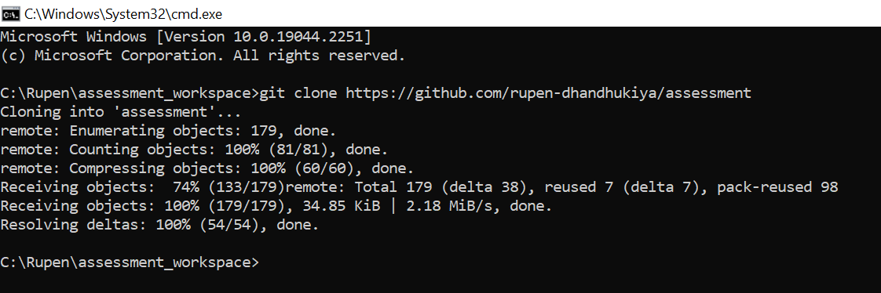

1. Go to windows workspace folder path and make sure all files downloaded from git repo

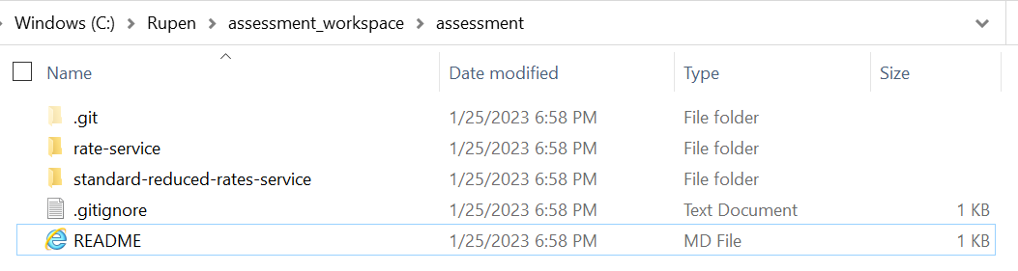

1. Open eclipse tool and select the downloaded project workspace folder and launch

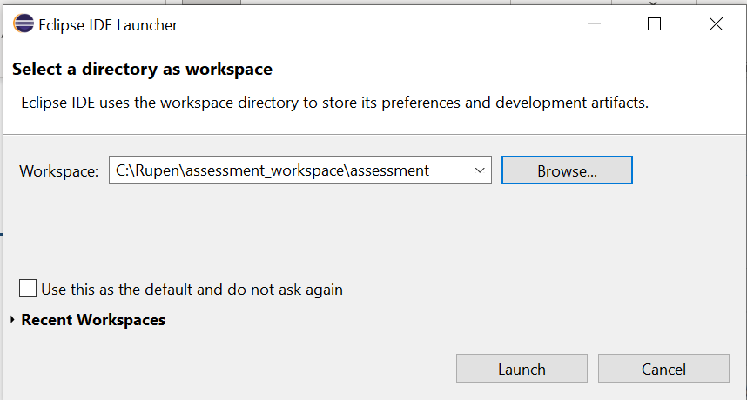

Below steps to be followed for both projects (**rate-service and standard-reduced-rates-service**)

**rate-service**

1. Select **File** and **Import**

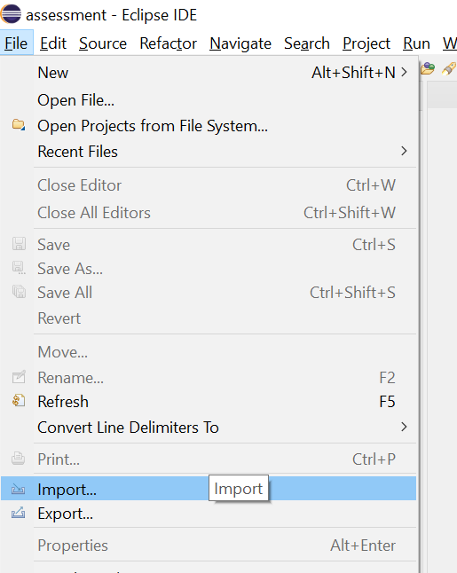

1. Select "**Existing Maven Projects**"

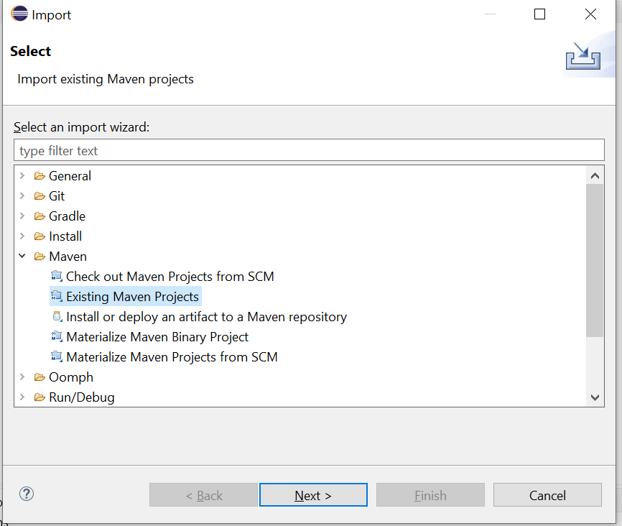

1. Click **Browse** to select the directory and select **pom.xml checkbox** and Click **Finish**

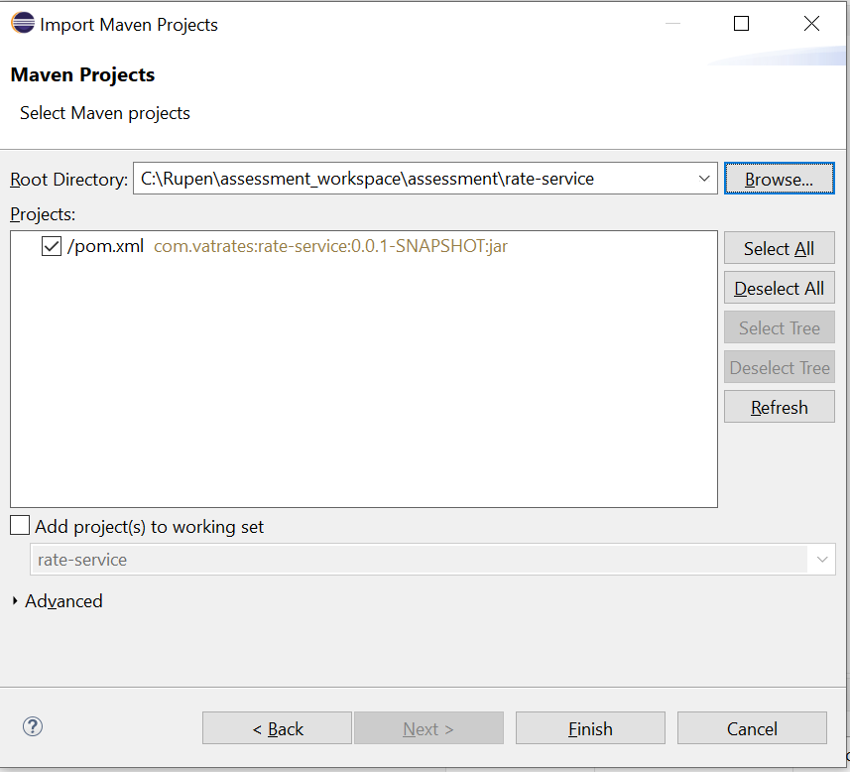

1. Once project downloaded into eclipse then select the project and **right click -> Maven -> Update Project**

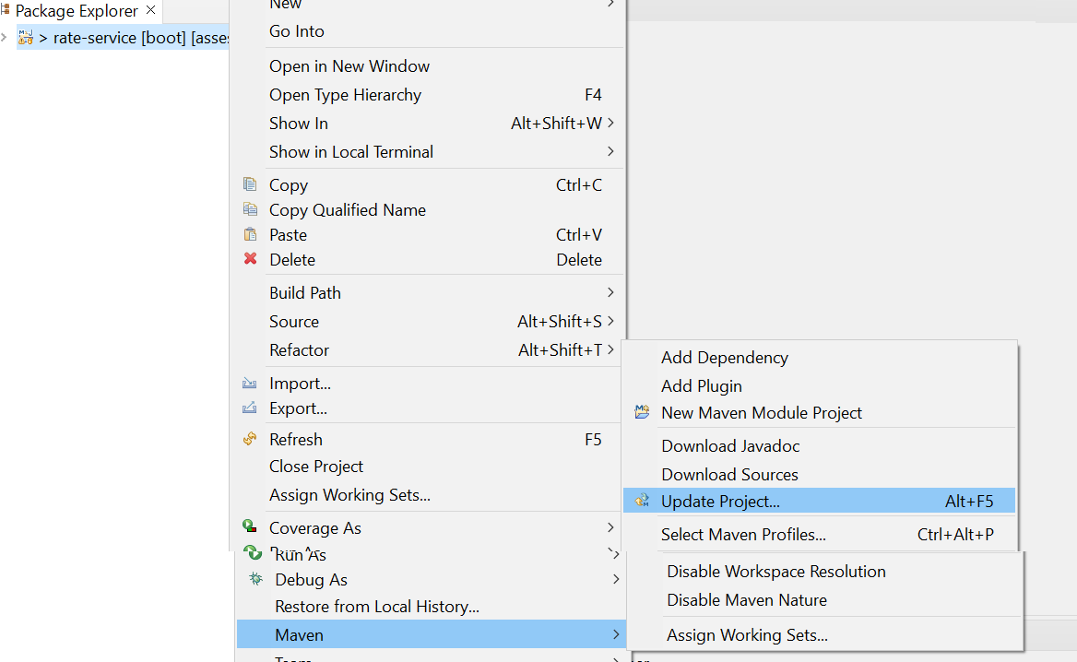

1. Select project and Select "**Force Update of Snapshots/Releases** checkbox and Click **OK** button

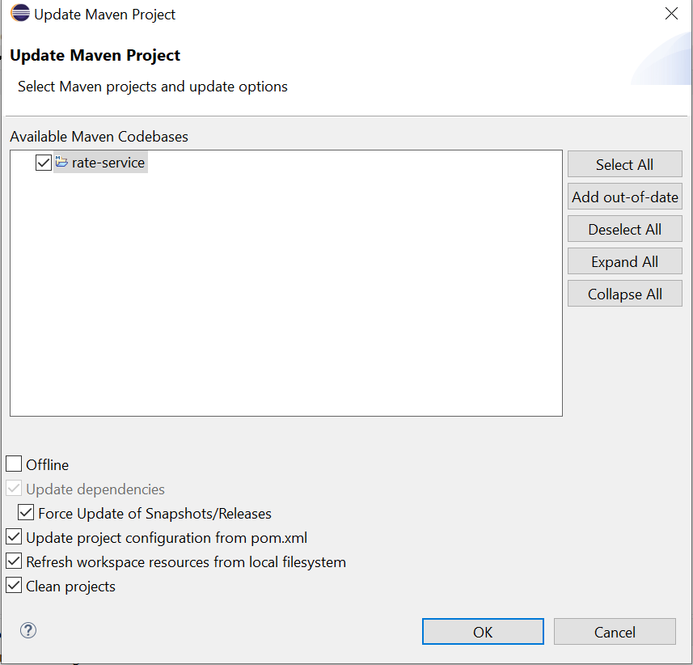

1. Project Structure

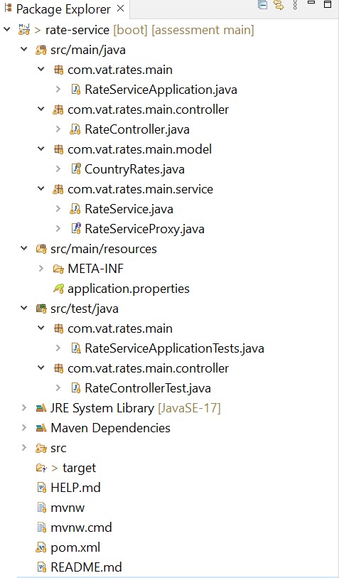

1. Go to Command Prompt and navigate to project workspace and execute below command

**mvn spring-boot:run**

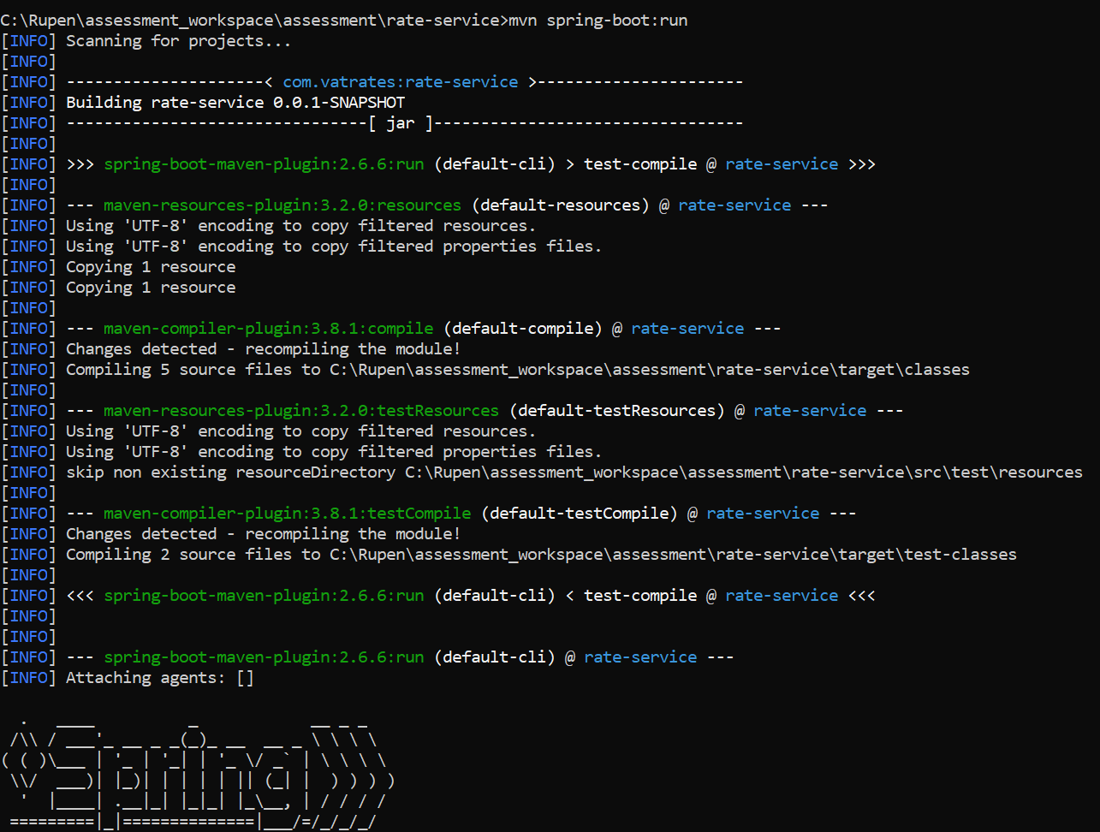

1. Once Rate-Service (8081) project server started then go to browser run the swagger UI in browser to confirm the application service is UP

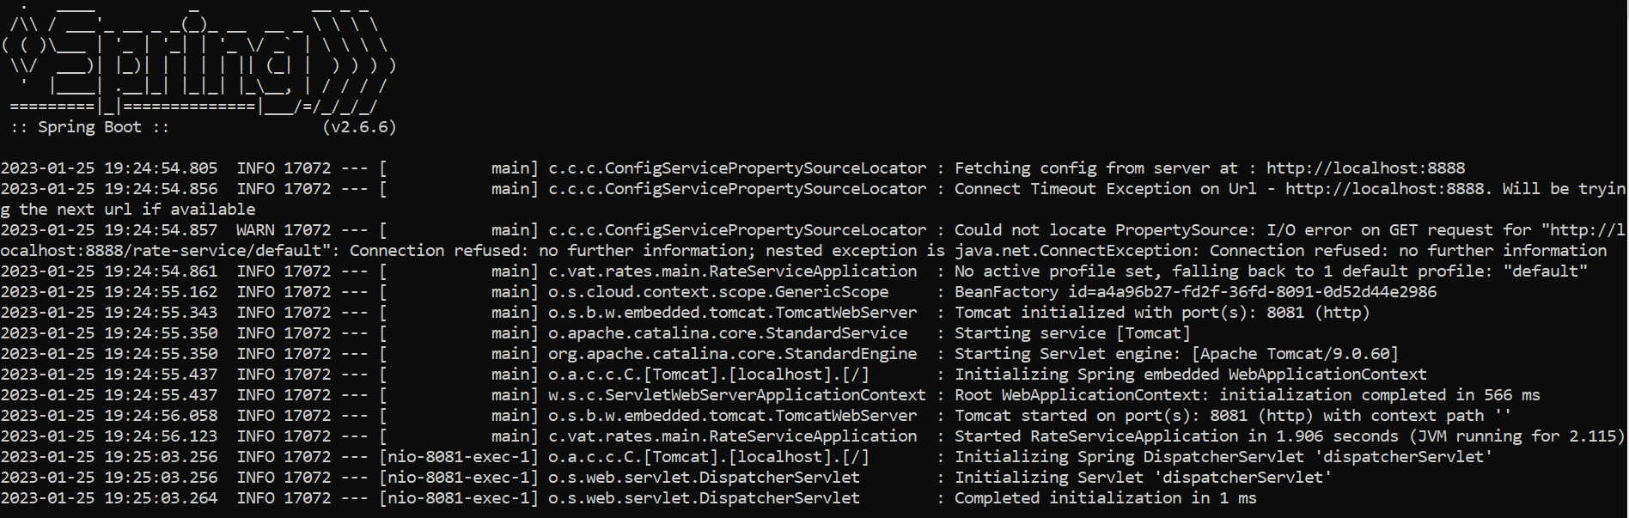

[**http://localhost:8081/swagger-ui/index.html**](http://localhost:8081/swagger-ui/index.html)

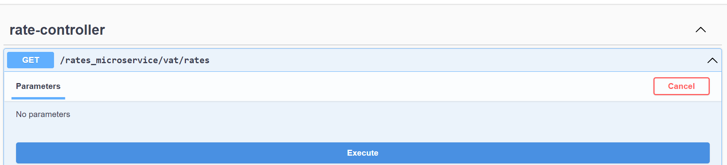

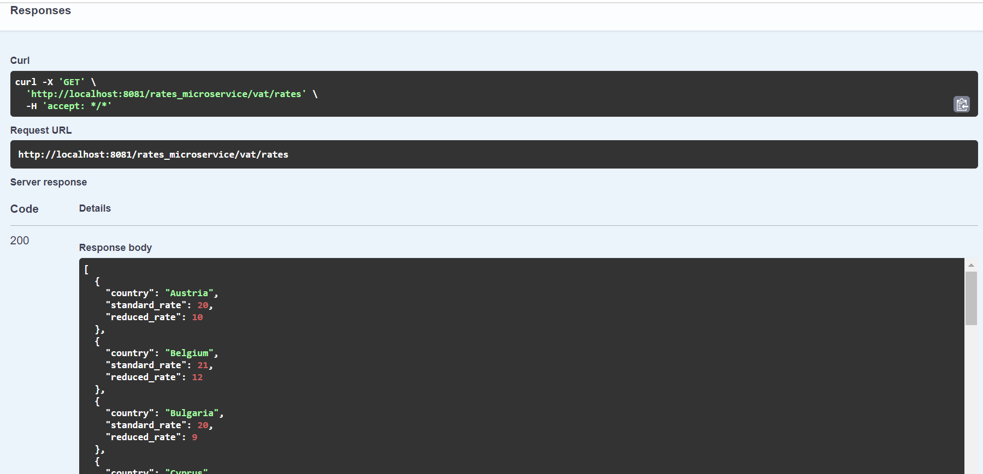

**standard-reduced-rates-service**

1. Select **File** and **Import**



1. Select "**Existing Maven Projects**"



1. Click **Browse** to select the directory and select **pom.xml checkbox** and Click **Finish**

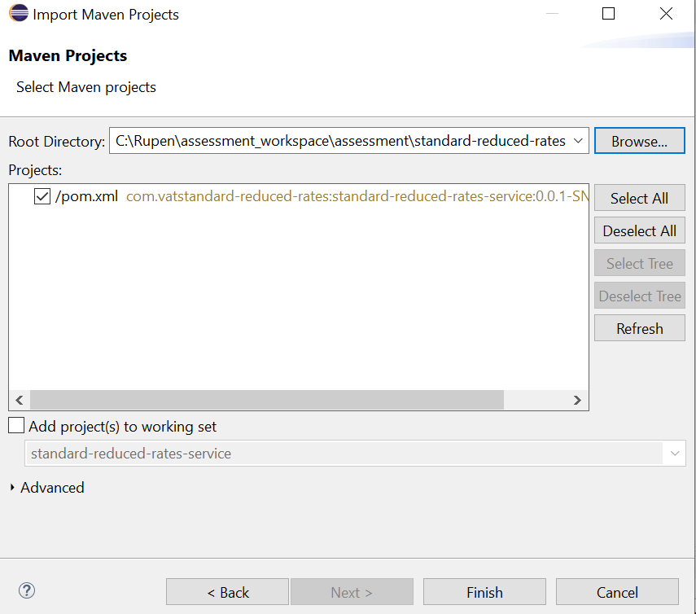

1. Once project downloaded into eclipse then select the project and **right click -> Maven -> Update Project**

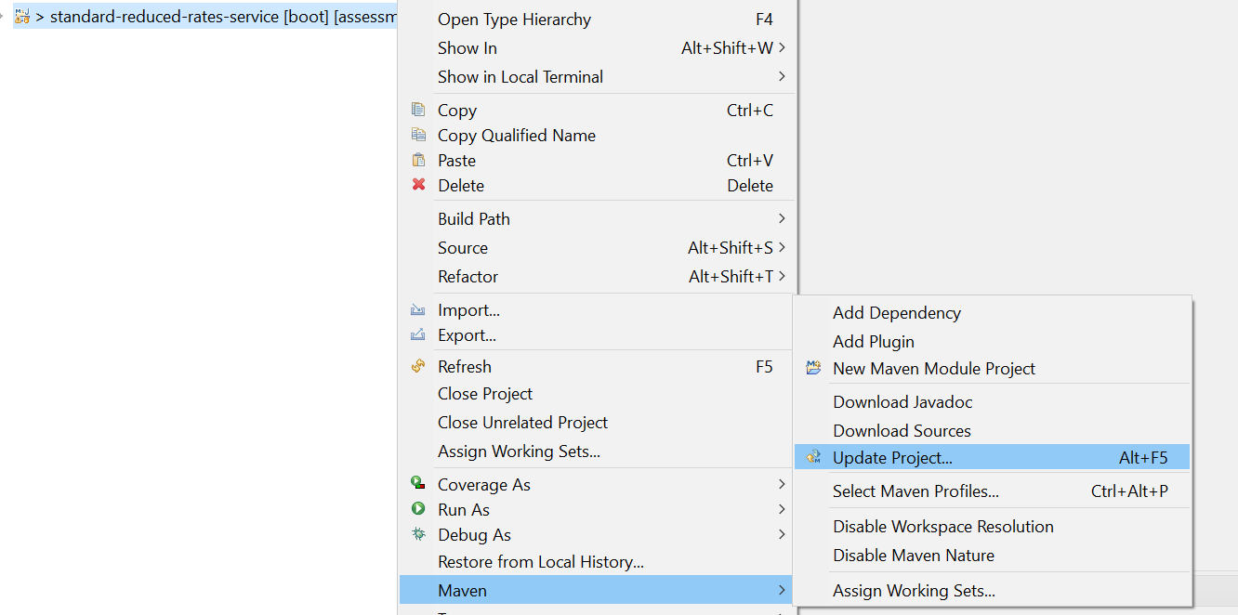

1. Select project and Select "**Force Update of Snapshots/Releases** checkbox and Click **OK** button

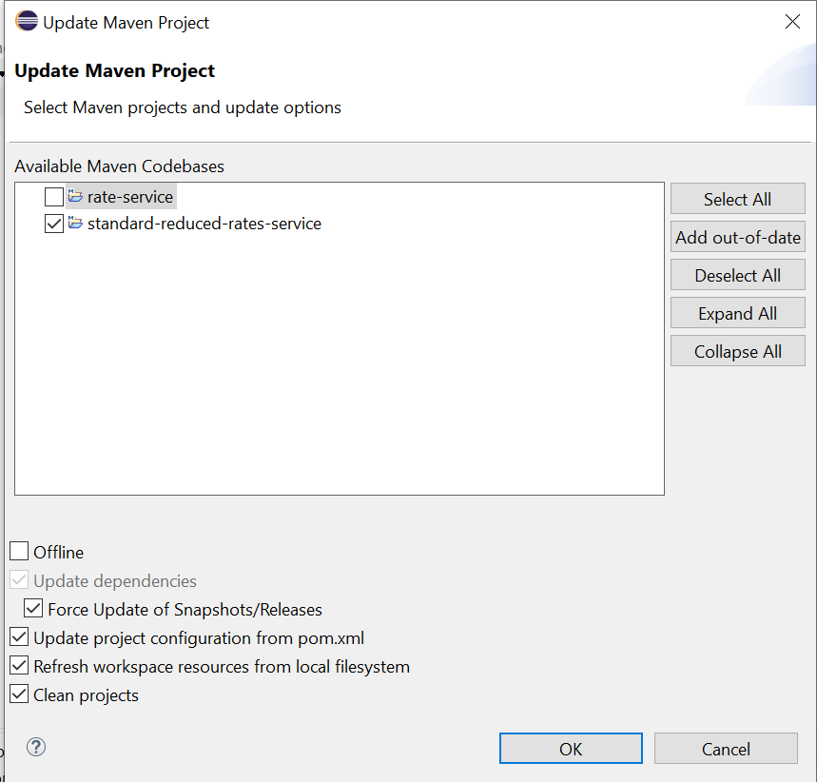

1. Project Structure

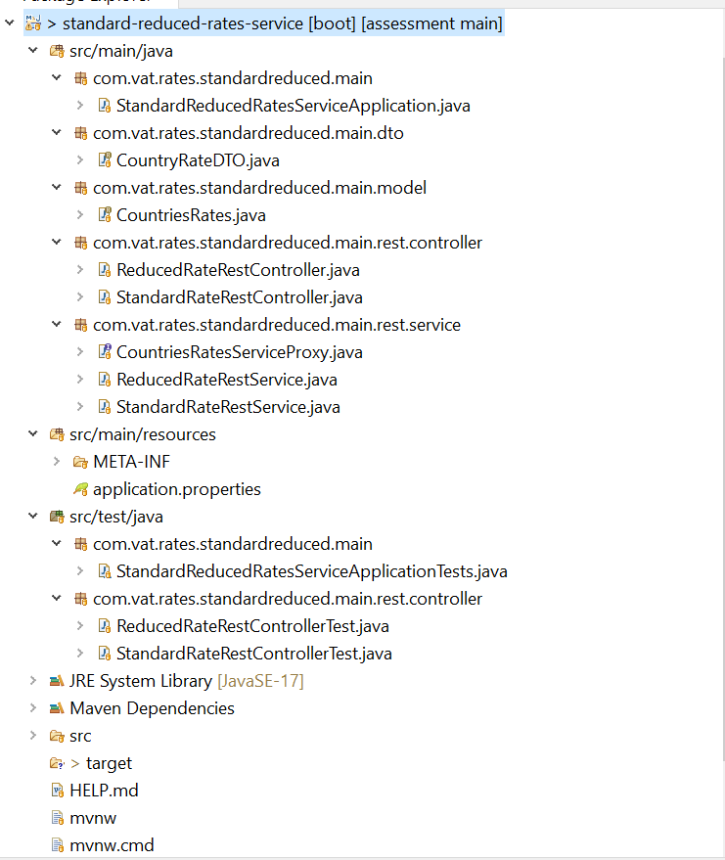

1. Go to Command Prompt and navigate to project workspace and execute below command

**mvn spring-boot:run**

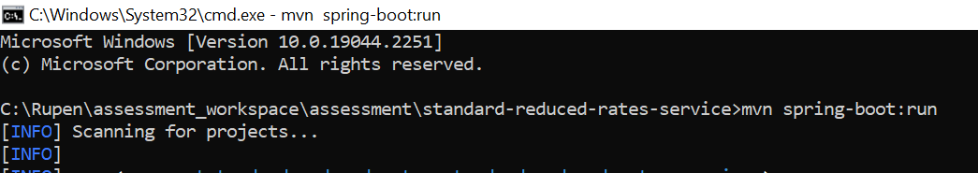

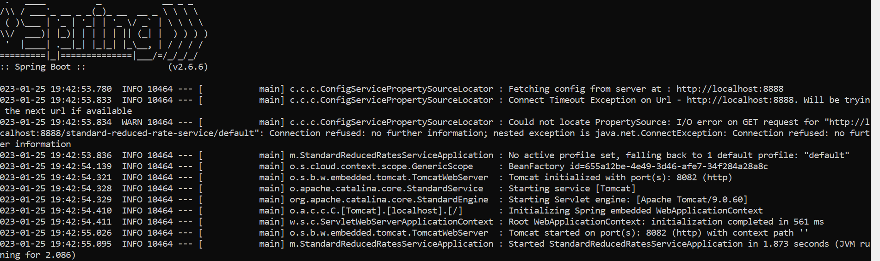

1. Once **standard-reduced-rates-service** (8082) project server started then go to browser and run the swagger UI to test the requirements

Return three EU countries with the highest standard VAT rate



Return three EU countries with the lowest reduced VAT rates

