API Installation / User Guide

* **Open Code and Run**

1. Open project ClientAPICore in visual studio code.
2. Go to terminal window:
3. Go to *enrollmentapi* path using cd command.
4. Build project command : dotnet build
5. Run the project command: dotnet run

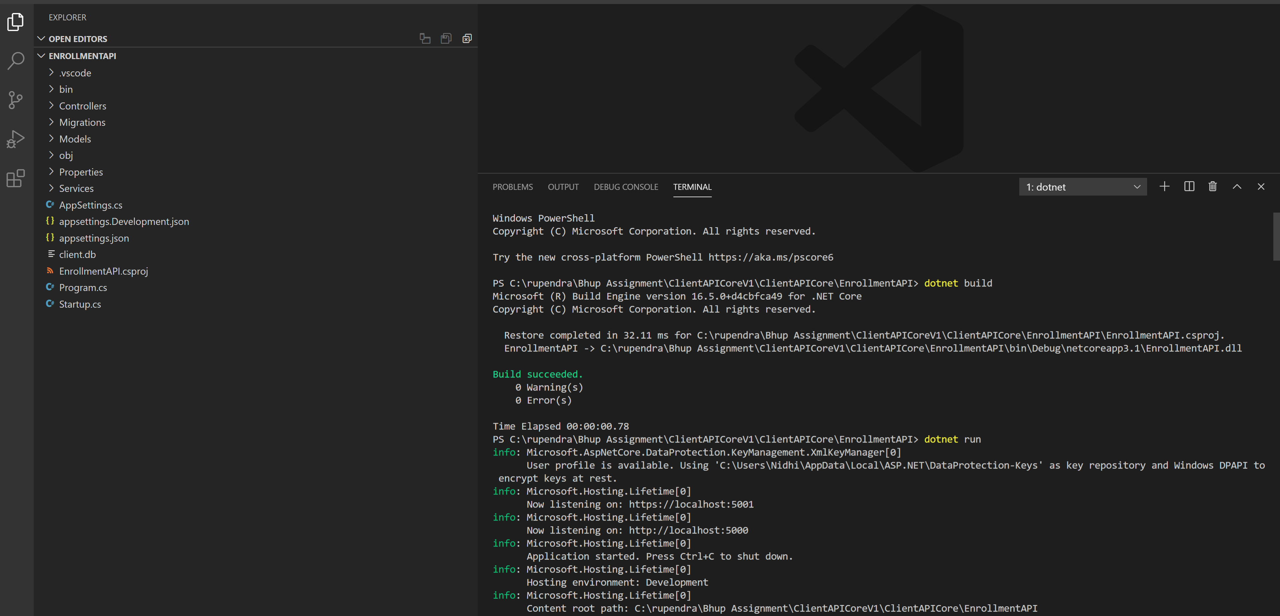

* **Import Postman collection**

1. Import postman collection provided in folder ”**Bupa_ClientAPIUserTests.postman_collection**”

* **Flow of project**

1. First we need to authenticate the admin or normal user.
2. Token will be return from Api.
3. Hence forward any request to Api required token for authentication passed from frontend or postman
4. When admin token is passed than all the request will have access and return the details as per required
5. When normal token is passed than no details will be return.

* **Running unit test**

1. Open project ClientAPICore in visual studio code.
2. Go to terminal window:
3. Go to EnrollmentAPITests using cd command.
4. Build project command : dotnet build
5. Run the project command: dotnet test

