A Level Computer Science (OCR H446/03) Programming Project
Project Proposal and Analysis

Portfolio Tracker and SMA Backtesting System
NIDHI SAWANT

Contents
1. Analysis 4
1.1 Problem identification 4
1.2 Why the problem is amenable to a computational solution 5
1.3 Stakeholders 5
1.4 Research into existing solutions 7
1.5 Essential features of the proposed solution 8
1.6 Limitations of the proposed solution 8
1.7 Requirements 9
1.8 Measurable success criteria 10
2. Design 10
2.1 Decomposition 10
2.1.1 Computational thinking applied 10
2.1.2 Top-down breakdown 11
2.1.3 Sub-problem table 11
2.2 System architecture 12
File structure and responsibilities 13
Handling external failure 14
2.3 Data structures, storage and validation 14
2.3.2 In-program data structures 15
2.3.3 API contract (JSON objects use camelCase; database schema employs snake_case; transformation handled by the API layer) 16
Authentication: a successful login returns a signed, time-limited token; the browser sends it as Authorization: Bearer <token> on every other request and the server rejects anything else with 401. A token rather than a session cookie because the page (port 8000) and the API (port 5000) are different origins. 16
2.4 Data validation strategy 19
2.5 Algorithms 19
2.6 Usability and interface design 22
Design principles and justification 22
Inputs and outputs 23
2.7 Test strategy and test data 25
2.7.1 Iterative (during development) testing 25
2.7.2 Hand-computable backtest example (verifies SC4/5/7) 26
2.7.3 Post-development testing 27
2.8 Traceability matrix (design to success criteria) 29
3. Development 30
3.1 Iterative approach 30
3.2 Stage 1 - Persistence without live data (SC1) 30
3.3 Stage 2 - Zerodha integration (FR3, FR6, FR7) 31
3.4 Stage 3 - Risk metrics (SC3) 31
3.5 Stage 4 — Module 1 front end 31
3.6 Stage 5 — Module 2 backtest engine + UI (SC4, SC5, SC7) 33
3.7 Testing to inform development (each stage; failed tests + justified fixes — top band) 33
3.8 Stage 6 — Accounts, sign-in and password change (FR12) 34
3.9 Challenges met during development and how they were resolved 36
4. Evaluation 39
4.1 Post-development testing 39
4.2 Evaluation against the success criteria 39
4.3 Usability evaluation 40
4.4 Limitations & maintenance issues 40
4.5 Future development 41
4.6 Stakeholder feedback & conclusion 41
5. Appendices 41
Appendix E — Prerequisites & Setup 41
E.1 Prerequisites 41
E.2 One-time setup (on a new PC) 42
E.3 Running the app day-to-day 43
E.4 Configuration files (what to change and where) 43
Appendix F — Functionalities & API Reference 44
F.1 Module 1 — Portfolio Tracking 44
F.2 Module 2 — Strategy Backtesting 44
F.3 Module 3 — Trade Analysis 45
F.4 Data & running modes 45
F.5 REST API endpoints 45
All endpoints except /api/status, /api/tickers and /api/auth/* require the header Authorization: Bearer <token> and answer 401 without it. 45
Appendix G — Common Problems & How to Debug Them 47
G.1 Troubleshooting 47
G.2 Debugging toolkit 48
Appendix H — Frontend Screenshot 49
Appendix I — Key Variables and Their Usage 50
I.1 backend/config.py — constants 50
I.2 backend/market_data.py — MarketData 50
I.3 backend/app.py — routes 51
I.4 backend/backtest.py — run_sma_backtest() 51
I.5 backend/analysis.py — risk maths 52
I.6 zerodha/Zerodha.py — session 53
I.7 frontend/config.js, app.js, backtest.js 53
I.8 backend/auth.py, frontend/auth.js — accounts 54

1. Analysis

1.1 Problem identification
Private (“retail”) investors who hold shares on the Indian National Stock Exchange (NSE) face three recurring problems:
- Fragmented tracking. Holdings, average cost, current value and profit/loss are scattered across broker screens and mental arithmetic. There is no single, calm view of “what do I own and how is it doing?”
- No objective sense of risk. Investors feel volatility emotionally but rarely quantify it. A single number - volatility and a Sharpe ratio - would turn a vague anxiety into an objective figure.
- Emotional, unsystematic decisions. Buying and selling on gut feeling leads to overtrading. Investors have no evidence about whether a systematic rule (e.g. a moving-average strategy) would actually have beaten simply holding.
The proposed solution is a Portfolio Tracker with an SMA (Simple Moving Average) backtesting engine that (a) stores and values a portfolio of NSE shares, (b) computes objective risk metrics, and (c) tests a rule-based trading strategy against a buy-and-hold benchmark on real historical prices.

1.2 Why the problem is amenable to a computational solution
The problem is well suited to a computational approach because it exhibits the classic features that make problems solvable by computational methods:
- Repetitive, well-defined calculation over large data. Valuing a portfolio, computing daily returns, moving averages, volatility and a backtest means performing the same arithmetic across thousands of price points. This is exactly what a computer does faster and more reliably than a human - it removes human calculation error (addressing problem 1).
- Decomposition. The problem breaks cleanly into independent sub-problems - tracking, risk analysis, back testing - each solvable separately (see 2.1). This decomposability is a hallmark of a computational problem.
- Abstraction. A real position (a messy history of purchases, dividends, news) can be abstracted to the few attributes that matter for valuation: ticker, quantity, average cost, date. Modelling only these is an abstraction that makes the problem tractable.
- Pattern recognition & algorithmic rules. The SMA-crossover strategy is a precise, repeatable rule (buy when short average crosses above long average). Rules like this can be expressed as an algorithm and executed identically every time - impossible to do consistently by hand (addressing problem 3).
- Automation & data volume. Fetching daily prices for any of ~1,800 NSE stocks and replaying two-plus years of history is only feasible automatically, via an API.
- Persistence & speed. A database recalls the portfolio instantly on every run; the calculations complete in well under a second.
Because the task is calculation-heavy, rule-based, decomposable and data-driven, a computational solution is clearly appropriate - a manual/spreadsheet approach would be slow, error-prone and could not realistically run a historical backtest.

1.3 Stakeholders
Primary stakeholder - Krish (real end-user).
Attribute | Detail
Profile | Private investor, ~7 years’ experience
Portfolio | ~15 holdings, all NSE (Indian) equities
Broker | Zerodha (tracks via the Kite platform)
Devices | Uses a laptop; prefers a simple, clean screen
Confidence | Comfortable investor but anxious about volatility; prone to impulsive buying
How Krish will use the solution, and why it suits him:
- He will add his holdings once and see them persist, so each morning he opens one consolidated view instead of adding figures up manually — this directly answers problem 1 and suits his preference for a single, simple screen.
- He will read the volatility and Sharpe figures to get an objective handle on risk, which is appropriate to his stated anxiety — it replaces feeling with a number.
- He will run the backtest to get evidence on whether a systematic rule beats his current discretionary style — appropriate because it targets his tendency to overtrade.
- Because he already trades NSE shares via Zerodha, sourcing data from the Zerodha Kite API fits his existing world exactly (₹, NSE symbols, the same prices he sees in Kite).
Research - Stakeholder Interview and Requirements Gathering
I interviewed Krish to gather his requirements. His answers are summarised below and shape the requirements and success criteria that follow.
Q: How long have you invested, and how do you track your portfolio at the moment?
A: About seven years. I hold roughly fifteen stocks, all NSE equities, and I buy and track everything inside the Zerodha app. It shows my total, but not much else.
Q: How did you choose the stocks you hold?
A: Honestly, mostly from news, or I would see a stock going up and jump in, or someone would tell me to buy it. There was not much of a system behind it.
Q: What frustrates you most about how you invest right now?
A: The uncertainty. The market swings on news like wars between countries, and I never feel sure about my future returns. It makes me anxious.
Q: Is there a habit you would most like to change?
A: Yes. I buy on a whim and I overtrade, jumping in and out too often. I want to eliminate that and follow a proper set of rules instead.
Q: Do you pay attention to risk?
A: I worry about volatility, but I have no single number that tells me how risky my portfolio actually is.
Q: Would you value being able to test a strategy?
A: Yes. I am curious about systematic trading systems and whether they really give you an edge, or whether just holding is better. I would love to see that tested on my own stocks.
Q: What would you want it to run on?
A: My laptop, and please keep the screen simple and clean.
Review of the interview
Krish's answers confirm four concrete needs that become requirements: a single consolidated view of all holdings with returns; a clear risk figure (volatility and Sharpe ratio) to address his anxiety about volatility; a backtesting feature that shows, with evidence, whether a systematic strategy beats holding; and a set of defined, rule based signals he can follow to curb his whimsical buying and overtrading. His preference for a laptop and a clean interface directly shapes the usability requirements.
Secondary stakeholders: other retail NSE investors with similar needs (the design is general, not hard-coded to Krish’s specific shares); and the developer/assessor as a maintenance stakeholder.

1.4 Research into existing solutions
I researched existing tools to identify features worth adopting and pitfalls to avoid.
Existing solution | Strengths | Weaknesses for this stakeholder | What I took from it
Zerodha Console / Kite (broker portal) | Accurate live holdings, official data | Cluttered for a nervous user; no volatility/Sharpe; no strategy backtesting | Adopt: live NSE prices via its API. Avoid: clutter.
Moneycontrol / ET Money portfolios | Consolidated view, news | Ad-heavy, generic, no rule-based backtesting, weak risk maths | Adopt: consolidated single view. Avoid: noise.
Excel / Google Sheets | Flexible, familiar | Manual, error-prone, no live data, backtest is painful and non-repeatable | Adopt: the idea of transparent formulas. Avoid: manual entry each time (→ use a database).
TradingView | Powerful charting & backtesting | Complex, subscription, US-centric defaults, overkill for one nervous investor | Adopt: strategy-vs-benchmark chart. Avoid: complexity.
Justified approaches based on this research:
- Use the Zerodha Kite API for data (matches the stakeholder; authoritative NSE prices) rather than scraping or manual entry.
- Provide exactly the risk figures the pro tools omit (volatility, Sharpe) because that is the stakeholder’s core need.
- Keep the interface deliberately calm and minimal — the opposite of the cluttered portals — because the stakeholder is anxious and prefers simplicity.
- Include a clear strategy-vs-buy-and-hold visualisation, the single most useful idea borrowed from TradingView, but pared down to one strategy (SMA) to stay understandable.

1.5 Essential features of the proposed solution
- Persistent portfolio store - add/edit/sell/remove holdings that survive restarts (without this the tool is useless day-to-day).
- Live valuation - current value, invested cost, unrealised & booked P&L, % return (the core “how am I doing?” answer).
- Risk metrics - annualised volatility and Sharpe ratio (the stakeholder’s distinguishing need).
- Visual portfolio insight - allocation by holding and by sector, return-by-holding (turns numbers into an at-a-glance picture).
- SMA-crossover backtesting vs a buy-and-hold benchmark, with trade log and stats (the evidence engine - Modules 2 & 3).
- Robust input validation (a nervous, non-technical user must be protected from bad input).

1.6 Limitations of the proposed solution
These are deliberate, justified scope decisions, not oversights:
- Historical/CSV-plus-API data, not a real-time tick feed. Backtests use daily closing prices. Justified: the stakeholder is a long-term investor, not a day-trader; daily data is sufficient and keeps the system simple and within API limits.
- A single strategy (SMA crossover). Justified: it is the clearest, most classic systematic rule; adding many strategies would dilute focus and understandability for a nervous user.
- Ignores dividends, brokerage and tax; assumes fills at the closing price with no slippage. Justified: these simplify the model, are standard for an educational backtest, and their omission is small over the horizons considered; they are documented so results are not over-claimed.
- Single-machine desktop tool with a lightweight local login. Justified: it models one investor (Krish) on his own laptop. A simple username/password (§2.3, §2.4) keeps his data separate from anyone else who tries the tool, but there are no cloud accounts, password-recovery flows or role permissions, which removes significant complexity.

1.7 Requirements
Functional requirements (what it must do):
- FR1 - add/edit/remove/sell holdings
- FR2 - persist them
- FR3 - fetch live LTP
- FR4 - compute value, P&L, %
- FR5 - compute volatility & Sharpe
- FR6 - list NSE symbols for validation
- FR7 - fetch daily historical prices
- FR8 - run an SMA back test with user parameters
- FR9 - compare against buy-and-hold
- FR10 - show trade stats (count, win-rate, drawdown)
- FR11 - reject invalid input with clear messages
- FR12 - accounts: create an account, sign in, change password; each user sees only their own holdings
Non-functional requirements:
- NFR1 - calm, uncluttered, accessible UI
- NFR2 - Indian conventions (₹, NSE symbols, lakh/crore grouping)
- NFR3 - responses feel instant (<1 s for portfolio load)
- NFR4 - data-light, dependency-light, self-contained
- NFR5 - secrets kept out of source control
Hardware requirements (justified):
- Any modern laptop/PC (the stakeholder uses a laptop)
- No GPU or special hardware - the calculations are light
- Internet connection required (justified: live prices and historical data come from an online API)
Software requirements (justified):
- A modern web browser (to run the plain-HTML front end — no install for the user)
- Python 3 with Flask (smallest web framework — justified for a one-user tool)
- SQLite (a single-file database, no server to install — justified for one user)
- The kiteconnect and pyotp libraries (official Zerodha access + automated 2-factor login)
- A Zerodha account with Kite Connect enabled (justified: it is the stakeholder’s own broker and the authoritative NSE data source)

1.8 Measurable success criteria
# | Success criterion | How it is measured | Why it matters
SC1 | Portfolio persists across a restart | Add a holding, close, reopen → it is still there | Core usability (FR2)
SC2 | Value & return match a hand calculation to within ₹0.01 | Compare app figures to a manual calc for a test portfolio | Trust in the numbers (FR4)
SC3 | Volatility & Sharpe match a spreadsheet to 2 d.p. | Recompute from the same closes in a spreadsheet | The stakeholder’s key need (FR5)
SC4 | Trades placed on the exact crossover days | Trace SMA values around each trade in the log | Backtest correctness (FR8)
SC5 | Labelled equity-vs-benchmark chart is produced | Visual check + legend/axes present | Evidence is understandable (FR9)
SC6 | Correct trade stats (count, win-rate, drawdown) | Recompute from the trade log by hand | Module 3 correctness (FR10)
SC7 | States whether the strategy beat buy-and-hold, with both return figures | Read the verdict + both %s | Answers the stakeholder’s core question
SC8 | Invalid input rejected with a clear message | Try blank/negative/unknown-ticker/future-date inputs | Protects a non-technical user (FR11)

2. Design

2.1 Decomposition

2.1.1 Computational thinking applied
- Decomposition: the problem is split top-down into modules, then sub-problems small enough to be written as a single function/route and tested alone.
- Abstraction: the model deliberately ignores brokerage fees, taxes, slippage, dividends and intraday prices. Only the daily closing price is used. This keeps the maths deterministic and testable. These assumptions will be stated to the user in the UI ("Backtest excludes charges and taxes").
- Algorithmic thinking: each sub-problem has a defined input → process → output (see table below).
- Pattern recognition: the same rolling-window pattern is used for the SMA and (conceptually) for volatility, so one tested helper can serve both.

2.1.2 Top-down breakdown
The problem is decomposed top-down into three modules that mirror the analysis, each further broken into sub-problems. This breakdown is justified because each module has a single responsibility and a clear data hand-off to the next (the trade list Module 2 produces is consumed by Module 3), so each can be built and tested independently - the essence of a computational, iterative approach.
Portfolio Tracker & SMA Backtesting System
├── Module 1 — Portfolio Tracking
│ ├── 1.1 Store holdings (add / edit-lot / sell / delete) → database
│ ├── 1.2 Fetch live prices (LTP) → Zerodha
│ ├── 1.3 Compute value, invested, P&L, % return
│ ├── 1.4 Compute risk (volatility, Sharpe) → historical
│ ├── 1.5 Visualise (allocation ribbon, sector donut, bars)
│ ├── 1.6 Validate all inputs (client + server)
│ └── 1.7 Accounts: register / sign in / change password → database
├── Module 2 — Strategy Backtesting
│ ├── 2.1 Get daily historical prices → Zerodha / CSV
│ ├── 2.2 Compute short & long SMAs
│ ├── 2.3 Detect crossovers → simulate trades → equity curve
│ ├── 2.4 Build buy-and-hold benchmark
│ └── 2.5 Visualise strategy vs benchmark + trade markers
└── Module 3 — Trade Analysis
├── 3.1 Trade log (from Module 2)
├── 3.2 Stats (count, win-rate, avg profit, max drawdown)
└── 3.3 Verdict: did the strategy beat buy-and-hold?

2.1.3 Sub-problem table
ID | Sub-problem | Input | Process | Output | Why separate
1.1 | Store holdings | ticker, qty, price, date | validate → merge lot or insert | DB row | Persistence can be tested without any internet
1.2 | Live prices | list of tickers | one batched API call | {ticker: ltp} | The only part needing the network; isolated so it can be mocked
1.3 | P&L | holdings + LTPs | value = qty × ltp; P&L = value − invested | numbers per holding + totals | Pure maths, hand-checkable
1.4 | Risk | daily close series | returns → stdev → Sharpe | volatility %, Sharpe | Pure maths, testable with a tiny series
2.2 | SMA | closes, window | rolling mean | list with None padding | Reused by the backtest and testable alone
2.3 | Backtest | closes, SMAs, capital | crossover detection + trade simulation | trade list + equity curve | Core algorithm; output feeds Module 3
3.2 | Stats | trade list + equity curve | counts, means, drawdown | stats object | Consumes Module 2 output only - clean hand-off
Justification: each module has a single responsibility and a clear data hand-off (the trade list from Module 2 is the input to Module 3). This lets each be built, tested, and debugged independently, which supports the iterative development approach in §2.7. I will build persistence (database.py, sub-problem 1.1) first, because SC1 underpins everything else and it can be tested with no network at all; then the Zerodha layer, since every later stage needs real prices; then the risk maths; then the Module 1 front end; and finally the backtest engine, which consumes all of the above (this is the stage order followed in §2.7.1 and §3).

2.2 System architecture
A three-tier structure separates presentation, logic, and data. This is justified because it lets the calm browser UI stay simple while all secrets and heavy calculations live safely on the server; the browser never talks to Zerodha directly.
┌────────────┐ HTTP + JSON ┌─────────────┐ Kite Connect API ┌──────────┐
│ Browser │ ─────────────► │ Flask API │ ─────────────────► │ Zerodha │
│ (HTML/CSS/ │ ◄───────────── │ (Python) │ ◄───────────────── │ Kite │
│ JS) │ JSON reply └──────┬──────┘ prices/history └──────────┘
└────────────┘ │
▼
┌─────────────┐
│ SQLite │ portfolio.db
└─────────────┘
- Why three tiers: the browser stays simple; all API keys, tokens, and heavy calculations stay on the server. The browser never talks to Zerodha directly, so that no secret can leak to the client.

File structure and responsibilities
Layer | File | Responsibility
Front end | index.html | Page structure, semantic tables, ARIA labels
 | styles.css | "Calm ledger" theme, focus styles, reduced-motion
 | app.js | Module 1 UI: holdings table, forms, charts
 | backtest.js | Module 2/3 UI: form, equity chart, trade table
 | config.js | The single place the API contract (URLs, field names) lives
Back end | app.py | Flask routes only - no business logic
 | database.py | All SQL (parameterised queries)
 | market_data.py | All Zerodha calls + error handling
 | analysis.py | Risk maths (returns, volatility, Sharpe, drawdown)
 | backtest.py | SMA engine, trade simulation, stats
 | sectors.py | Ticker → sector lookup
 | config.py | Keys, risk-free rate, constants (read from environment)
 | auth.js | Sign-in / create-account screen, user chip + menu, change-password modal; keeps the token
 | auth.py | Password hashing, signed login tokens, require_login route guard
- Justification: one file = one job, so a bug in risk maths cannot hide in a route, and analysis.py/backtest.py can be unit-tested with no Flask or network. Keeping every Zerodha call in market_data.py means if the API changes (or I switch to CSV), only one file changes.

Handling external failure
- If Zerodha is unreachable or the token has expired, market_data.py returns a clear error to app.py, which replies with HTTP and a JSON message.
- The UI then shows "Live prices unavailable" and falls back to the last saved prices, marked as stale. The app never crashes on network failure.

2.3 Data structures, storage and validation
Persistent storage - SQLite (justified in §1.7). Four tables:
users( id PK, username UNIQUE, password_hash, created_at )
holdings( id PK, user_id FK, ticker, quantity, avg_buy_price, purchase_date )
closed_positions( id PK, user_id FK, ticker, quantity, avg_buy_price, sell_price, close_date )
instruments( instrument_token PK, tradingsymbol UNIQUE, name ) -- the NSE symbol list
Table | Why it exists
users | Supports the login screen; each user sees only their own data. Passwords stored as a hash, never plain text.
holdings | Open positions are used to calculate the unrealised P&L.
closed_positions | Separate so realised (booked) P&L is reported independently of unrealised P&L.
instruments | Zerodha's history API needs a numeric instrument_token, not a symbol; also backs "valid NSE symbol" validation (SC8).
Justification for SQLite selection (referencing §1.7): Storing data within a single file removes the overhead of configuring a separate database server. It provides robust relational SQL support and constraint enforcement, perfectly tailored for single-user desktop software.

2.3.2 In-program data structures

Name | Type | Used for | Why
closes | list of floats (oldest → newest) | SMA, returns | Order matters, index access needed for i-1
dates | list of date strings, same length as closes | Aligning charts/trades | Parallel list keeps index alignment
shortSMA, longSMA | list of float/None | Crossover check | None explicitly marks "not enough history"
trade | dict {date, type, price, shares, profit} | One BUY/SELL | Self-describing; converts directly to JSON
equityCurve, benchmark | list of floats | Charting + drawdown | Same length as closes
holding | dict/class Holding | One open position | See below
class Holding:
def __init__(self, id, ticker, quantity, avg_buy_price, purchase_date):
self.id = id; self.ticker = ticker; self.quantity = quantity
self.avg_buy_price = avg_buy_price; self.purchase_date = purchase_date
def invested(self): return self.quantity * self.avg_buy_price
def value(self, ltp): return self.quantity * ltp
def pnl(self, ltp): return self.value(ltp) - self.invested()
def return_pct(self, ltp): return (self.pnl(ltp) / self.invested()) * 100
Justification: encapsulating position-level analytics within a dedicated object simplifies portfolio aggregation, reducing overall metrics to straightforward operations over Holding instances while ensuring every mathematical procedure can be verified independently. I selected an object-oriented class model over primitive dictionaries to maintain strong encapsulation and enforce data integrity across the asset lifecycle.

2.3.3 API contract (JSON objects use camelCase; database schema employs snake_case; transformation handled by the API layer)

Authentication: a successful login returns a signed, time-limited token; the browser sends it as Authorization: Bearer <token> on every other request and the server rejects anything else with 401. A token rather than a session cookie because the page (port 8000) and the API (port 5000) are different origins.
Method & route | Purpose | Body/params | Success reply
POST /api/auth/login | Sign in | {username, password} | 200 + {token, user}
GET /api/holdings | List holdings with live data | - | [ {id, ticker, quantity, avgBuyPrice, purchaseDate, ltp, sector, name} ]
POST /api/holdings | Add/merge lot | {ticker, quantity, avgBuyPrice, purchaseDate} | 201 + holding
PUT /api/holdings/<id> | Edit lot | same fields | 200
POST /api/holdings/<id>/sell | Sell | {quantity, sellPrice} | 200 + closed position
DELETE /api/holdings/<id> | Remove | - | 204
GET /api/portfolio/summary | Totals + risk | - | {totalValue, invested, pnl, returnPct, volatility, sharpe}
POST /api/backtest | Run SMA backtest | {ticker, short, long, capital, from, to} | {trades[], equity[], benchmark[], stats{}, verdict}
GET /api/status | Health check | - | {connected, instrumentCount, lastError}
GET /api/quote/<ticker> | Latest traded price for one stock | - | {ticker, ltp}
GET /api/portfolio/closed | Realised (booked) positions | - | [ {ticker, quantity, avgBuyPrice, sellPrice, closeDate} ]
GET /api/tickers | Valid NSE symbols for the form | - | [ tradingsymbol, ... ]
GET /api/history/<ticker> | Daily closes (Module 2 data) | ?from&to | [ {date, close} ]
POST /api/auth/register | Create account | {username, password} | 201 + {token, user}
GET /api/auth/me | Who am I (token check) | - | {id, username, createdAt}
POST /api/auth/change-password | Change password | {currentPassword, newPassword} | 200 {ok}
Standardised error responses adhere to a unified JSON structure - { "error": "message", "field": "quantity" } - paired with explicit HTTP status codes: 400 for invalid user input, 401 for unauthenticated requests, 404 for missing resources, and 502 when upstream Zerodha services fail. Justified: maintaining a consistent payload design allows the client application to process exceptions through a single centralized error routine.
Justification for architectural separation: establishing a rigid API interface ensures the user interface and server environment can be implemented and validated independently (§2.1). Centralising all endpoint definitions within config.js provides a single source of truth for application routing.

2.4 Data validation strategy
Validation is enforced across both client and server tiers — providing immediate visual guidance to the end-user while safeguarding backend integrity, as browser-side controls alone cannot be trusted for application security.
Field | Rule | Reason
username | 3-30 chars, letters/digits/underscore, unique | avoids clashes/odd characters
password | ≥ 8 characters | basic strength
ticker | non-empty; must exist in instruments | rejects typos / unknown stocks (SC8)
quantity | integer > 0 | you cannot own fractional/negative shares
avg/sell price | number > 0 | a price must be positive
purchase date | valid date, not in the future | cannot have bought in the future
sell quantity | 1 … quantity held | cannot sell more than you own
SMA windows | short ≥ 2, long ≥ 3, short < long | a crossover needs a shorter and a longer average
capital | number > 0 | a backtest needs positive starting money
date range | from < to, and enough data points > long window | SMA needs history

2.5 Algorithms
The following algorithms together form a complete solution to the problem: they take stored holdings + market data and produce every required output (value, risk, backtest verdict).
(a) Weighted-average lot merge - when the user adds more of a stock they already hold, the average cost must be re-derived so SC2 holds:
function mergeLot(old, addQty, price, date):
newQty = old.qty + addQty
newAvg = (old.qty*old.avg + addQty*price) / newQty # weighted mean
newDate = later(old.date, date)
return (newQty, newAvg, newDate)
Illustrative sample: purchasing 10 shares at ₹100 followed by 5 shares at ₹130 yields (₹1000 + ₹650) / 15 = ₹110.00 per share. Architectural rationale: recording the most recent acquisition date reflects the current position update. Conversely, tracking the initial purchase date is required for tax holding-period calculations. Recording the most recent transaction date is justified because it accurately represents the latest capital commitment while keeping position tracking straightforward.

(b) Simple Moving Average (rolling window) - the core of Module 2:
function SMA(prices, window):
for each day i:
if i >= window-1: out[i] = mean(prices[i-window+1 .. i])
else: out[i] = None # not enough history yet
return out
Illustrative sample: evaluating a historical price sequence of [10, 12, 14, 16, 18] across a 3-day interval generates moving averages of [None, None, 12, 14, 16].
(c) SMA-crossover backtest - detect crossovers, simulate trades, build the equity curve (SC4, SC5, SC7):
shortSMA = SMA(closes, shortWindow)
longSMA = SMA(closes, longWindow)
cash = capital; shares = 0; position = 0
for each day i (where both SMAs exist and the previous day's exist):
crossedUp = shortSMA[i-1] <= longSMA[i-1] AND shortSMA[i] > longSMA[i]
crossedDown = shortSMA[i-1] >= longSMA[i-1] AND shortSMA[i] < longSMA[i]
if crossedUp and position == 0: # BUY at today's close
shares = floor(cash / close[i]); cash -= shares*close[i]; position = 1
record BUY
else if crossedDown and position == 1: # SELL at today's close
profit = (close[i] - buyPrice) * shares
cash += shares*close[i]; shares = 0; position = 0
record SELL(profit)
equityCurve[i] = cash + shares*close[i]
# Benchmark: buy on day 1, hold to the end
benchShares = floor(capital / close[0])
benchmark[i] = (capital - benchShares*close[0]) + benchShares*close[i]
beat = finalEquity > finalBenchmark # SC7 verdict
Benchmark (buy-and-hold):
The buy-and-hold baseline calculates initial units using benchShares = floor(capital/closes [0]). Daily baseline value tracks uninvested balance plus current asset worth: benchmark[i] = (capital - benchShares*closes[0]) + benchShares*closes[i]. The final outcome evaluates outperformance using beat = finalEquity > finalBenchmark (SC7 verdict).
Justified design choices:
- Execution at closing value. Assumes trades fill instantly on the signal date for mathematical determinism (a known constraint, evaluated in §4.4).
- Baseline initialization point. The buy-and-hold benchmark buys on the first day of the series (index 0, i.e. benchShares = floor(capital / close[0]) above, exactly as backtest.py does). Justified: it measures what the investor would have got by buying at the start of the window and doing nothing. Because the strategy cannot trade until both SMAs exist (index ≥ longWindow), this is a deliberately conservative comparison that slightly favours buy-and-hold - if the strategy still wins, the evidence is stronger.
- Terminal valuation of open trades. Active positions at the end of the timeline are valued mark-to-market using the final closing price without triggering an artificial liquidation, correctly catalogued as open in the transaction audit.
- Strict inequality thresholds. Equivalence between moving averages does not register as a crossover, suppressing false triggers during consolidation phases.
- Boundary and exception handling. When available capital falls below unit costs (shares == 0), the attempt is marked as skipped alongside an alert banner; if zero crossovers occur, the position remains in uninvested cash with a clear "no trades" summary.
Why this forms a complete solution: it turns an abstract trading rule into deterministic executions on exact crossover days (SC4), tracks daily portfolio values via an equity curve (SC5), and delivers direct empirical evidence by measuring performance against buy-and-hold (SC7).
(d) Risk metrics (SC3):
dailyReturns[i] = (close[i] - close[i-1]) / close[i-1]
annualisedVolatility = stdev(dailyReturns) * sqrt(252) * 100 # 252 trading days
annualReturn = mean(dailyReturns) * 252 * 100
Sharpe = (annualReturn - riskFreeRate) / annualisedVolatility # rf = 6.5% (India ~10y G-Sec)
252 = approximate trading days per year; 6.5% ≈ Indian 10-year G-Sec yield (kept in config.py so it's easy to update). For a whole portfolio, the daily value series is Σ(quantity × close)over holdings on each common trading day; then the same formulas apply. Assumption: current quantities held for the whole window. Boundary and exception handling: fewer than 30 data points; show risk as "insufficient history".
(e) Maximum drawdown (Module 3, SC6):
peak = curve[0]; worst = 0
for value in curve:
peak = max(peak, value)
worst = max(worst, (peak - value) / peak)
maxDrawdown = worst * 100
(f) Sell position (partial or full)
function sell(holding, sellQty, sellPrice, date):
validate 1 <= sellQty <= holding.qty
insert closed_position(ticker, sellQty, holding.avg, sellPrice, date) # realised P&L = (sellPrice - avg) * sellQty
if sellQty == holding.qty:
delete holding
else:
holding.qty = holding.qty - sellQty # avg cost unchanged
(Average-cost method: selling does not change the average buy price of the remaining shares.)
(g) Trade statistics (SC6)
sells = trades where type == SELL
winRate = count(profit > 0 in sells) / count(sells) * 100 # if no sells: None
avgProfit = mean(profit of sells)
(h) Flowchart of the backtest request
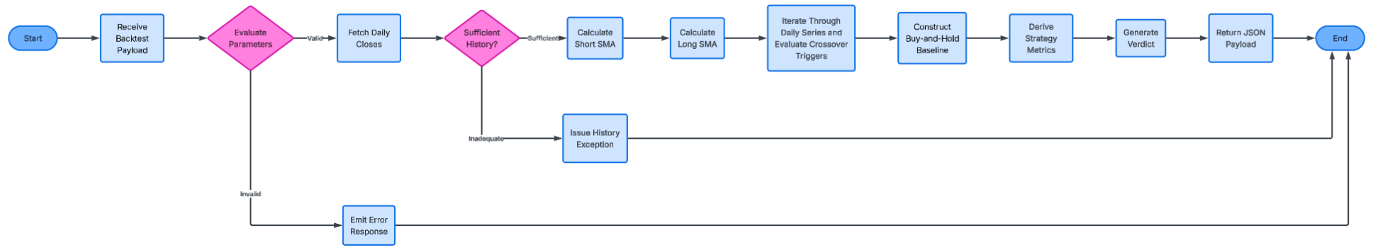
Figure 2.1 - Flowchart of the /api/backtest route: validate parameters -> fetch closes -> check history length -> short and long SMA -> crossover loop -> buy-and-hold baseline -> stats -> verdict -> JSON reply. The two decision diamonds are the error paths tested in §2.7.3 rows 10-11.

2.6 Usability and interface design

Design principles and justification
- "Calm ledger" look (deep-teal ink, brass-gold accent, warm-mist background): chosen because the stakeholder finds market tools anxiety-inducing; a steady palette avoids alarming reds/flashing. This follows Krish's own words in the interview (§1.3): "please keep the screen simple and clean" and, on market swings, "it makes me anxious".
- Numbers are the hero: large portfolio value with an animated count-up; allocation ribbon shows the whole portfolio as one band → answers "how am I doing?" instantly.
- Indian conventions: ₹, NSE symbols, lakh/crore grouping via en-IN locale (NFR2).
- Colour is never the only signal: gains/losses also shown with +/− signs and arrows (colour-blind safe).
- Inline validation: red message beside each field, specific wording ("Quantity must be a whole number above 0").
- Progressive disclosure: backtest panel is collapsible and closed by default; holding rows expand to a read-only detail grid.
- Accessibility (NFR1): :focus-visible outlines, prefers-reduced-motion respected (count-up disabled), ARIA labels, semantic <table> markup, keyboard-operable forms.
- Empty states: "Add your first NSE position…" guides a new user.
- Feedback states: loading spinner during price fetch; "stale price" badge if Zerodha fails.

Inputs and outputs
Screen | Inputs | Outputs
Login | username, password | session/error message
Portfolio | add/edit/sell forms | totals, holdings table, allocation ribbon, sector donut, performance bars, risk cards
Backtest | ticker, short, long, capital, date range | equity vs benchmark chart with BUY/SELL markers, trade table, stats cards, verdict banner

Screen designs:
Login screen:
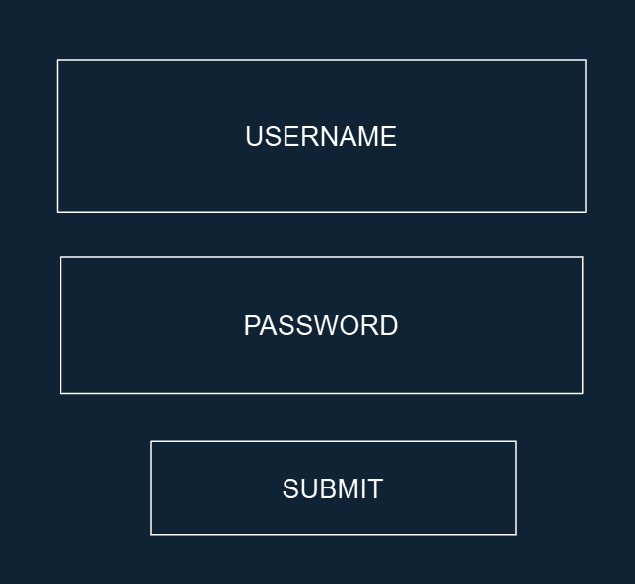
Figure 2.2 - Login screen wireframe. Two fields and one button only: username and password rules from §2.4 are checked inline before the request is sent.
Portfolio screen:
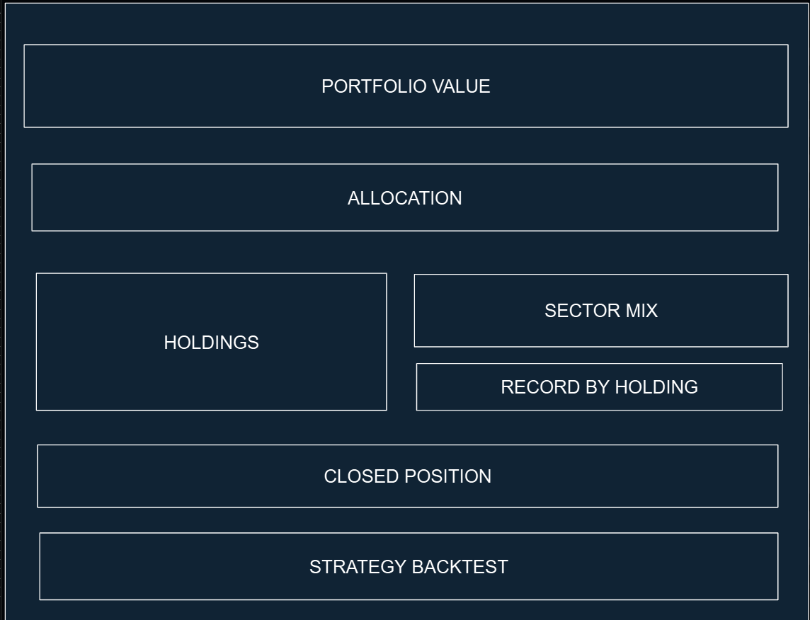
Figure 2.3 - Portfolio screen wireframe. Top-to-bottom order follows importance for the stakeholder: total value (numbers are the hero), allocation ribbon, holdings beside sector mix and return-by-holding, closed positions, and the collapsible strategy backtest last (progressive disclosure).

2.7 Test strategy and test data
Testing happens during development (iterative) and after (post-development). Test data is chosen to include normal, boundary and erroneous cases — justified because robustness (SC8) is only proved by deliberately hostile input.

2.7.1 Iterative (during development) testing
Stage | Built | How tested | Test data | Expected
1 | database.py + /holdings routes (dummy prices) | Add/merge/sell on a test DB; restart and re-read | 10 @100 then 5 @130 | qty 15, avg 110.00; row survives restart (SC1)
2 | market_data.py (Zerodha) | Mock API responses + one live call | valid / invalid token | prices returned / graceful error
3 | analysis.py risk maths | Unit tests against hand-calculated values | [10,12,14,16,18] | returns 0.2000, 0.1667, 0.1429, 0.1250; volatility = spreadsheet (SC3)
4 | Module 1 front end (app.js) | Manual + validation tests | hostile input | messages shown, no crash (SC8)
5 | backtest.py SMA + crossover engine, backtest.js | Unit test with the hand-computable series (§2.7.2) | closes [10,9,8,9,11,12,10,8], 2/3, ₹1000 | SMA [None,None,12,14,16] for the 5-point series; 1 BUY @11, 1 SELL @8, final ₹730
6 | Routes (app.py) end-to-end | Browser tests incl. bad input | see §2.7.3 | correct status codes

2.7.2 Hand-computable backtest example (verifies SC4/5/7)
Closes [10, 9, 8, 9, 11, 12, 10, 8], short = 2, long = 3, capital = ₹1000:
Day | Close | Short SMA(2) | Long SMA(3) | Event
0 | 10 | - | -
1 | 9 | 9.5 | -
2 | 8 | 8.5 | 9.0
3 | 9 | 8.5 | 8.667
4 | 11 | 10.0 | 9.333 | Cross up → BUY floor(1000/11) = 90 shares, cash ₹10
5 | 12 | 11.5 | 10.667
6 | 10 | 11.0 | 11.0 | equal → not a cross (strict)
7 | 8 | 9.0 | 10.0 | Cross down → SELL at 8: profit (8−11)×90 = −₹270; cash 10 + 720 = ₹730

Buy-and-hold baseline (initial trade on index 0): purchasing 100 units yields 100 × 8 = ₹800. Anticipated outcome: the trading system (₹730) failed to outperform buy-and-hold (₹800). This test scenario additionally validates the strict inequality rule during the identical-SMA condition encountered on day 6.
Drawdown evaluation: tracking value trajectory [100, 120, 90, 110, 80, 130] establishes a peak of 120; maximum decline drops to 80, producing (120 − 80) / 120 = 33.33%. Performance evaluation: input price sequence [10, 12, 14, 16, 18] generates daily return steps of 0.2000, 0.1667, 0.1429, and 0.1250 (cross-checked against manual variance calculations).

2.7.3 Post-development testing
# | Test data | Type | Tests | Expected
1 | RELIANCE, qty 10, ₹2450, 2024-03-12 | Normal | add holding (SC1) | saved & valued
2 | qty 1 | Boundary | quantity validation | accepted
3 | qty 0; qty −5; qty 2.5; qty "abc" | Boundary/Erroneous | quantity validation (SC8) | all rejected with message
4 | ticker "NOTAREAL"; ticker "" | Erroneous | ticker validation (SC8) | rejected, clear message
5 | date = tomorrow | Erroneous | date validation (SC8) | rejected
6 | date = today | Boundary | date validation | accepted
7 | sell qty > held; sell qty 0 | Erroneous | sell validation (SC8) | rejected
8 | sell qty = held | Boundary | full sell | holding removed, closed position created
9 | SMA 20/50 on RELIANCE, 2023-2025 | Normal | backtest (SC4/5/7) | trades + verdict
10 | SMA 50/20; 20/20; 1/5 | Erroneous | backtest validation | rejected
11 | long window > number of data points | Erroneous | insufficient data | clear error
12 | capital ₹1 (less than one share) | Boundary | no-shares edge case | warning, 0 trades
13 | Hand-computable series from §2.7.2 | Normal | exact maths | matches hand calculation
14 | Zerodha unreachable (disconnect network) | Erroneous | resilience | "prices unavailable", stale badge, no crash
15 | Wrong password; access /api/holdings without login | Erroneous | security | rejected / 401
16 | '; DROP TABLE holdings;-- as ticker | Erroneous | SQL injection | rejected by validation; table intact
17 | Keyboard-only navigation; reduced-motion on | Usability | NFR1 | fully operable; no animation
Rationale for Test Data Selection: The dataset incorporates typical, edge, and invalid scenarios, which is justified because system resilience (SC8) can only be demonstrated through intentionally adverse user input. Hand-calculated figures validate mathematical routines, ensuring benchmarks are determined independently of the software logic. Post-development testing will also include the stakeholder trying the system against the success criteria. The stakeholder session is recorded in §4.1 (T5) and §4.6.

2.8 Traceability matrix (design to success criteria)
Success criterion (§1.8) | Addressed by
SC1 Portfolio persists across a restart | §2.3 (holdings table), §2.5(a), §2.5(f), §2.7.1 stage 1
SC2 Value & return match a hand calculation | §2.3.2 (Holding class), §2.5(a)
SC3 Volatility & Sharpe match a spreadsheet | §2.5(d), §2.7.1 stage 3
SC4 Trades on the exact crossover days | §2.5(b), §2.5(c), §2.7.2
SC5 Labelled equity-vs-benchmark chart | §2.5(c), §2.6
SC6 Correct trade stats & drawdown | §2.5(e), §2.5(g), §2.7.2
SC7 Beat-the-benchmark verdict | §2.5(c), §2.7.2
SC8 Invalid input rejected clearly | §2.4, §2.7.3
NFR1 Accessibility / NFR2 Indian conventions | §2.6

3. Development
How to evidence this section for full marks. For each stage below: (1) state the sub-problem from §2.1 it implements, (2) show an annotated code snippet, (3) show a screenshot of the working prototype, (4) show a test (including at least one that failed and how you fixed it), and (5) a one-line review (“this works; next I will…”). The structure is provided — you supply the screenshots and your commentary.

3.1 Iterative approach
Development was iterative and modular: each sub-problem from §2.1 was built as a small prototype, tested, reviewed, then extended. Justified: it de-risks the build (a broken stage is caught immediately) and produces the stage-by-stage evidence the mark scheme rewards.

3.2 Stage 1 - Persistence without live data (SC1)
Sub-problem 1.1. Built database.py (SQLite schema + CRUD) and the /holdings routes with dummy prices, then pointed the front end at it. Proves the portfolio persists before any API complexity is added.
Annotated example (parameterised SQL prevents injection -S a named A-Level concept):
def add_holding(ticker, quantity, avg_buy_price, purchase_date):
conn = get_connection()
cur = conn.execute( # '?' placeholders = safe
"INSERT INTO holdings (ticker, quantity, avg_buy_price, purchase_date) "
"VALUES (?, ?, ?, ?)", (ticker, quantity, avg_buy_price, purchase_date))
conn.commit(); new_id = cur.lastrowid; conn.close()
return get_holding(new_id)
📸 [SCREENSHOT] Add a holding, close everything, reopen → it’s still there (SC1). Show the terminal + the browser.
Review: persistence works → next, connect real prices.

3.3 Stage 2 - Zerodha integration (FR3, FR6, FR7)
Sub-problems 1.2, 2.1. market_data.py wraps the Zerodha class (automated TOTP login, cached daily token). A real bug found and fixed here (evidence for the testing mark):
Failed test → remedial action (justified). The supplied helper mapped symbols using exchange_token, but Zerodha’s historical API needs instrument_token; using the wrong id returned no candles. Remedial action: I bypassed that helper and stored the correct instrument_token from kite.instruments("NSE"). Justified: it is the field the historical endpoint actually requires; after the fix, historical data returned correctly.
📸 [SCREENSHOT] python seed_instruments.py printing the stored symbol count; a /quote/RELIANCE response showing a live price.
Review: live prices + historical data work → next, risk maths and the summary endpoint.

3.4 Stage 3 - Risk metrics (SC3)
Sub-problem 1.4. analysis.py implements volatility, Sharpe and drawdown from first principles (formulas kept visible on purpose — see §2.5(d)). /portfolio/summary builds a portfolio value series from historical closes and returns volatility + Sharpe + today’s change.
📸 [SCREENSHOT] The stat strip showing a real volatility % and Sharpe. [TEST] recompute both from the same closes in a spreadsheet and show they match to 2 d.p. (SC3).

3.5 Stage 4 — Module 1 front end
Sub-problems 1.3, 1.5, 1.6. app.js renders the hero, allocation ribbon, holdings table, sector donut and return bars, with add/sell/add-lot modals and inline validation. A live data layer loads everything from the back end when useMock:false.
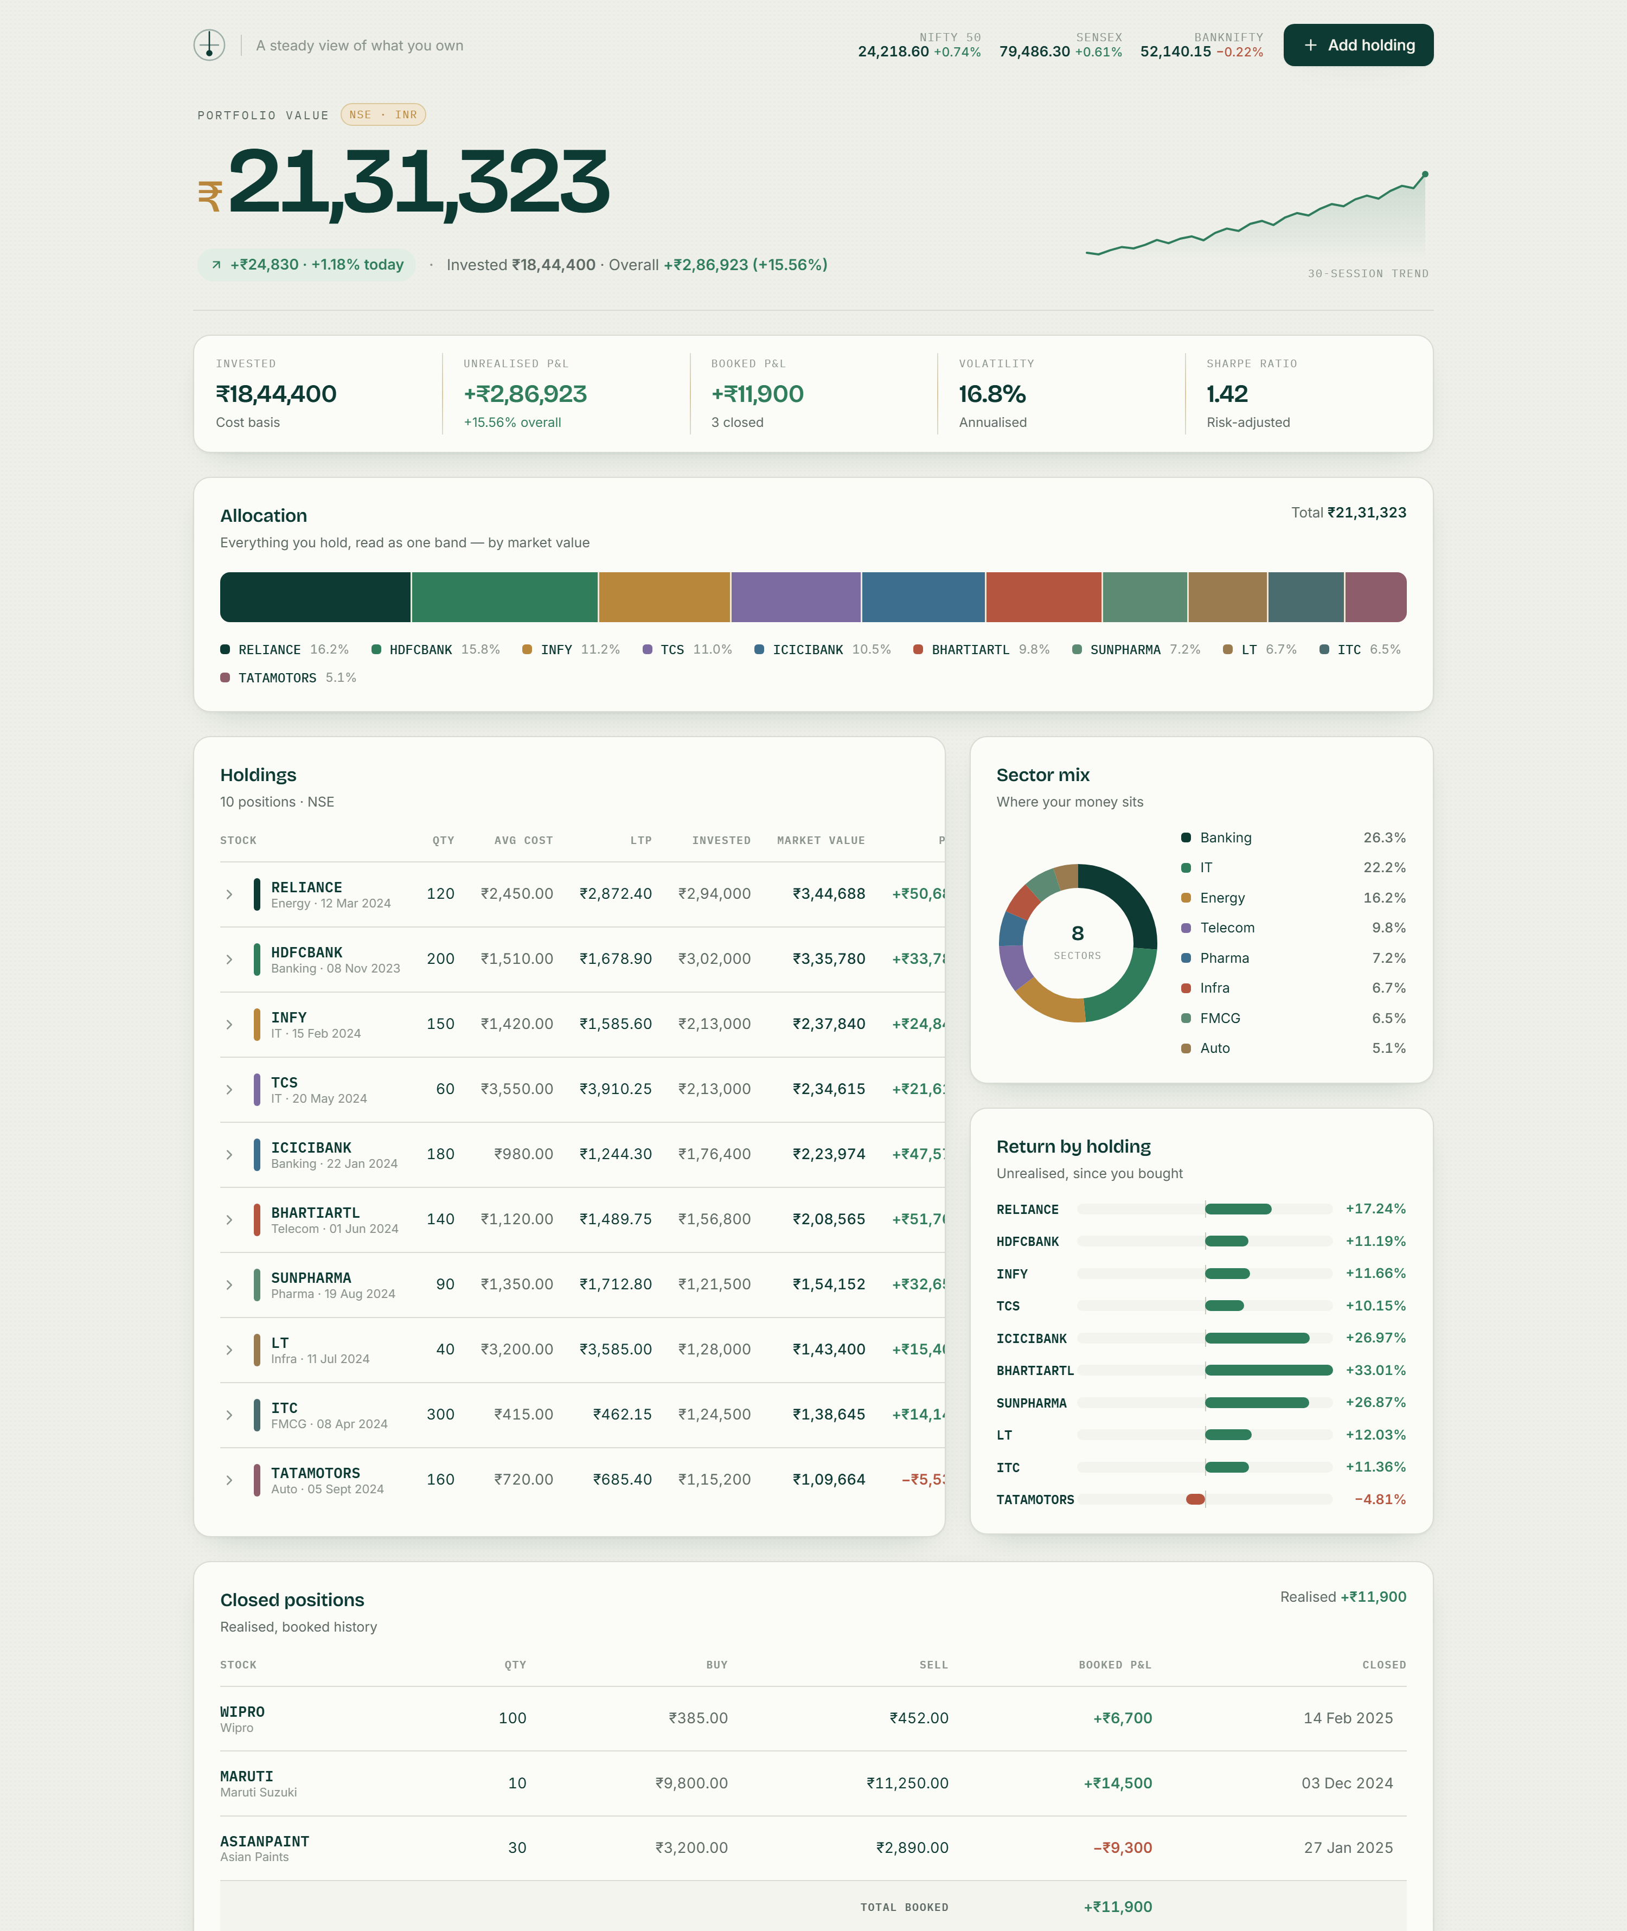
Figure 3.1 - The finished Module 1 dashboard (front end in mock mode with representative sample data). Visible: hero value with 30-session sparkline; stat strip (invested, market value, today's change, annualised volatility 16.8%, Sharpe 1.42); allocation ribbon; holdings table; sector-mix donut; return-by-holding bars; closed-positions ledger; and the collapsed strategy-backtest panel. Captured with prefers-reduced-motion so the count-up shows its final figure.
📸 [SCREENSHOT still needed] The Add form showing a validation error (SC8).
Review: Module 1 complete → next, the backtest engine.

3.6 Stage 5 — Module 2 backtest engine + UI (SC4, SC5, SC7)
Sub-problems 2.2–2.5, 3.1–3.3. backtest.py implements the crossover algorithm (§2.5(c)) with a CSV fallback so it runs even with no live API. backtest.js adds a collapsible panel: a parameter form, a hand-built SVG chart (strategy vs dashed benchmark, break-even line, buy ▲/sell ▼ markers), stat tiles and a trade log.
Annotated example (the crossover test at the heart of SC4):
crossed_up = short_sma[i-1] <= long_sma[i-1] and short_sma[i] > long_sma[i] # BUY signal
crossed_down = short_sma[i-1] >= long_sma[i-1] and short_sma[i] < long_sma[i] # SELL signal
📸 [SCREENSHOT] A completed backtest: verdict banner, comparison bars, chart, trade log. [TEST] trace two rows of the trade log against the SMA values to prove trades fall on the exact crossover day (SC4).
Review: Modules 2 & 3 complete; strategy-vs-benchmark verdict produced (SC7).

3.7 Testing to inform development (each stage; failed tests + justified fixes — top band)
Maintain this table as you build (one row per test; keep the failures — they earn marks):
Stage | Test | Input | Expected | Actual | Pass? | Remedial action (justified)
1 | Add persists | RELIANCE ×10 | row saved | saved | ✓ | —
2 | Historical fetch | RELIANCE token | candles | empty | ✗ | used correct instrument_token → fixed
3 | Volatility | known closes | = spreadsheet | matches | ✓ | —
4 | Bad ticker | “NOTAREAL” | rejected | rejected | ✓ | —
5 | short ≥ long | 50/20 | rejected | rejected | ✓ | —
6 | Login guard | no token; forged token; wrong password | 401 | 401 | ✓ | —
6 | Session cookie across ports | cookie from :5000, page on :8000 | sent | not sent | ✗ | switched to a signed bearer token in the Authorization header → fixed
… | (your tests)
✍️ [YOUR INPUT] Fill in with your own runs and screenshots of at least two failures and their fixes.

3.8 Stage 6 — Accounts, sign-in and password change (FR12)
Sub-problem 1.7. Built last, once every other module was proven, because it wraps them rather than feeding them. Back end: a users table (username UNIQUE, salted PBKDF2 password_hash, created_at), four routes under /api/auth (register, login, me, change-password) and a require_login decorator that every data route now carries; holdings and closed_positions gained a user_id so each account sees only its own rows. Front end: auth.js draws a full-screen sign-in / create-account card with floating labels, a password-strength meter and a show/hide toggle, then hands over to the dashboard with a short zoom-out; a user chip in the top bar opens Change password and Sign out.
Annotated example (the three ideas that make it safe: hash, sign, guard):
def hash_password(password): # salted PBKDF2 - the password itself is never stored
return generate_password_hash(password)

def issue_token(user_id): # signed + time-limited; forged or expired -> None
return _serializer.dumps({"uid": user_id})

def require_login(view): # 401 unless Authorization: Bearer <valid token>
@wraps(view)
def wrapper(*a, **kw):
uid = current_user_id()
if uid is None:
return jsonify({"error": "Please sign in."}), 401
g.user_id = uid # every db call is scoped to this
return view(*a, **kw)
return wrapper
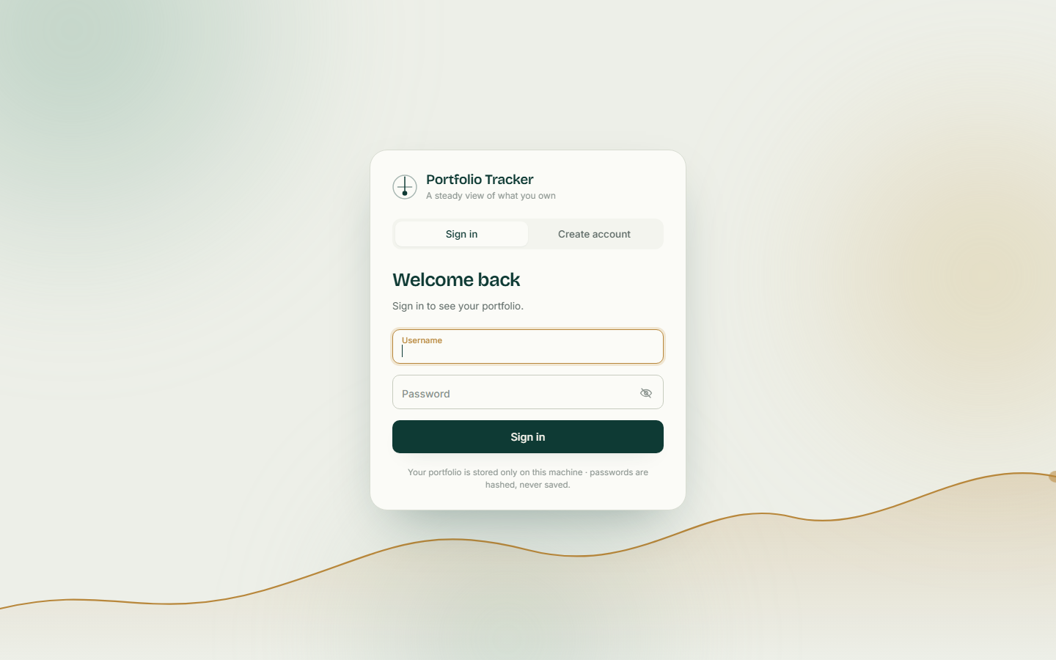
Figure 3.2 - The sign-in screen. Three slow-drifting colour fields and a gold equity curve that draws itself on load (all disabled under prefers-reduced-motion); the tab ink slides between Sign in and Create account; labels float up on focus; wrong details shake the card and show a clear message.
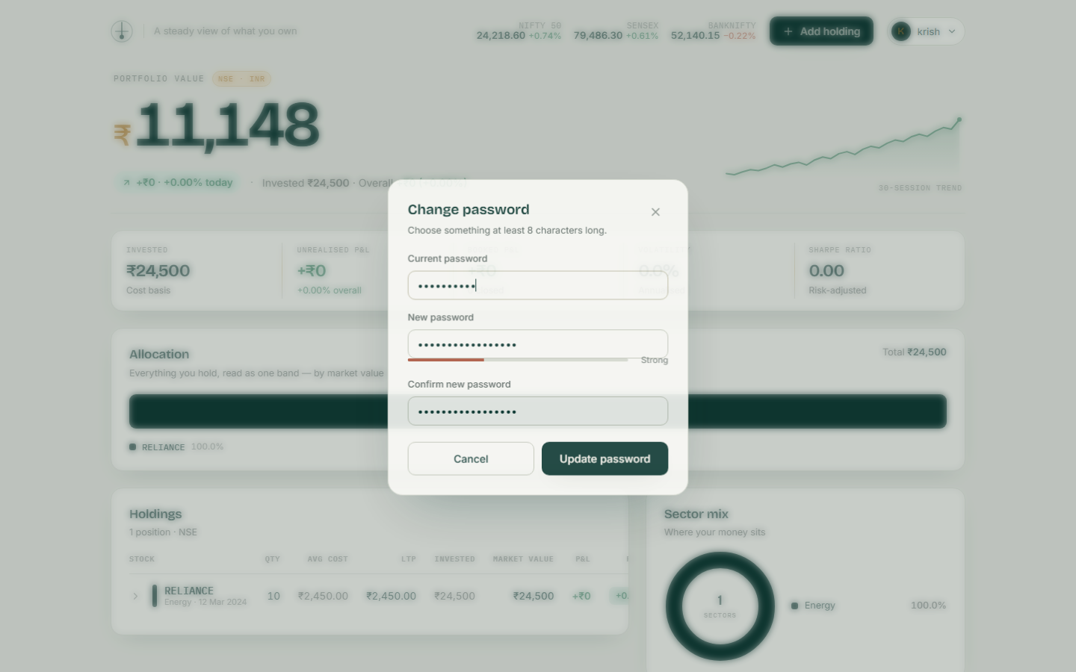
Figure 3.3 - Change password from the user-chip menu: current password is re-checked on the server, the new one must be at least 8 characters and different, and a strength bar gives feedback while typing; success draws an animated tick.
Test: no token, a forged token and a wrong password all return 401 / 'Wrong username or password' (the same message for unknown user and wrong password, so nothing is revealed); a second account sees an empty portfolio (row isolation); after a password change the old password is rejected and the new one accepted (see §3.7 rows 6).
Review: FR12 complete; the design in §2.3 / §2.4 / §2.6 now matches the build.

3.9 Challenges met during development and how they were resolved
Each row is a problem that actually came up while building the system, the cause once it was found, and the fix that is now in the code (file and function named so it can be checked). The first row is the failed test already described in §3.3; the rest were found the same way - by a stage not behaving as its test expected - and each is a justified remedial action.
# | Challenge (symptom) | Cause | Resolution (where in the code)
1 | Historical price requests returned no candles (Stage 2). | The supplied helper Zerodha.get_instrument_tokens() maps a symbol to exchange_token, but Kite's historical API needs instrument_token. | Bypassed the helper: market_data.fetch_nse_equity() keeps instrument_token from kite.instruments('NSE'); seed_instruments.py stores it in the instruments table; db.get_instrument_token() feeds historical_daily().
2 | Login worked once, then every call failed the next day; each login needs a 2-factor code. | Zerodha invalidates the access token every morning and requires TOTP on login. | Zerodha.login() reuses the token in zerodhaAccessToken.json only if its saved date is today (load_saved_token), otherwise generates the code with pyotp.TOTP(secret).now(), logs in and caches the new token (save_token). MarketData._ensure() retries login once before any call.
3 | The app was unusable whenever Zerodha was unavailable (paid API, closed market, no internet). | Every route depended on a live connection. | 'Degraded mode': every MarketData method fails softly and records last_error; get_holdings values a holding at avg_buy_price when there is no quote; portfolio_summary returns 0 risk; _load_prices() falls back to sample_data/<TICKER>.csv; the front end also has useMock for a no-backend demo.
4 | Login failed with 'Configuration file not found' depending on the folder the server was started from. | The Zerodha class uses relative paths ('zerodhaConfig.json'). | config.py derives BACKEND_DIR, ZERODHA_DIR, SAMPLE_DIR and DB_PATH from __file__; MarketData.connect() sets z.config_path and z.token_path to absolute paths before login.
5 | /api/portfolio/summary took several seconds. | Volatility and Sharpe need ~400 days of history for every holding - one API call per stock per page load. | A module-level _history_cache {ticker: {date: close}} in app.py stores each series for the life of the process (_daily_closes()).
6 | Dates from the two price sources did not match, breaking sorting and the equity-curve x-axis. | Zerodha candles carry datetime objects; CSV rows carry strings. | _fmt_date() in app.py normalises both to YYYY-MM-DD before the data reaches backtest.py, which therefore does not care where prices came from.
7 | Portfolio volatility was distorted when holdings had different history lengths. | Summing values on dates that only some stocks traded on produces jumps. | portfolio_summary() takes the intersection of every holding's date set, requires more than two common dates, builds value_series = sum(quantity x close) per common date and passes it to analysis.portfolio_risk().
8 | On a fresh install every ticker was rejected as 'not a valid NSE stock'. | SC8 validation checks the instruments table, which starts empty. | _validate_holding() only enforces the check when db.instruments_count() > 0; /api/tickers serves the built-in SECTORS list until the table is seeded.
9 | The symbol list was far larger than the ~1,800 real equities. | kite.instruments('NSE') returns bonds, ETFs and warrants too. | fetch_nse_equity() keeps only instrument_type == 'EQ' and segment == 'NSE'; the remaining noise is recorded as a maintenance item in §4.4.
10 | Front end (built first, on mock data) and back end used different field names. | The UI expects camelCase JSON; SQLite columns are snake_case. | config.js declares the REST contract up front and app.py matches it; _holding_json() / _closed_json() convert rows to camelCase, so going live was one flag: useMock: false.
11 | Every browser request failed although the API answered in a direct call. | The page is served on port 8000 and the API on 5000 - blocked by the same-origin policy. | flask_cors.CORS(app) in app.py adds the Access-Control-Allow-Origin headers.
12 | The backtest could act on the first day both SMAs existed, treat equal SMAs as a cross, and 'buy' zero shares with tiny capital. | A crossover needs yesterday's SMAs, which are None early on; equality is not a cross; int(cash // price) can be 0. | run_sma_backtest() only tests a cross when i > 0 and all four SMA values exist; comparisons are strict; the BUY is guarded by if shares > 0. simple_moving_average() uses a running sum so it is O(n).
13 | No sector information for the sector-mix donut. | Kite provides no sector field. | sectors.py holds a lookup table with sector_of() defaulting to 'Other'; documented in §4.4 and §4.5.
14 | Start-up (database init + Zerodha login) ran twice. | Flask's debug reloader imports the module twice. | app.run(debug=True, use_reloader=False) keeps tracebacks but runs startup() once.
15 | A login session cookie set by the API (port 5000) was not sent back by the page (port 8000). | The page and the API are different origins, so a cookie needs SameSite / CORS-credential exceptions. | auth.py issues a signed, time-limited token (itsdangerous) instead; auth.js stores it and sends Authorization: Bearer <token> on every request; require_login() verifies it. Plain CORS is enough.
16 | Adding accounts would have orphaned holdings saved before accounts existed. | The old holdings / closed_positions tables had no user_id column. | database._migrate() adds the column on start-up and create_user() hands rows with user_id IS NULL to the first account that registers - nothing is lost when upgrading portfolio.db.
Review: every challenge above was resolved inside the module responsible for it (§2.2), which is why none of the fixes required changes in more than one file - evidence that the modular design worked.

4. Evaluation

4.1 Post-development testing
Run a final round of tests on the finished system and annotate each screenshot (say what it proves).
# | Category | Test | Evidence
T1 | Function | Full add → value → sell → closed flow | 📸 [SCREENSHOT]
T2 | Function | Backtest verdict + both returns (SC7) | 📸 [SCREENSHOT]
T3 | Robustness | Blank / negative / unknown-ticker / future-date | 📸 [SCREENSHOT] each rejected
T4 | Robustness | Backend down → clear “can’t reach server” message | 📸 [SCREENSHOT]
T5 | Usability | Stakeholder completes “add a holding” unaided | ✍️ [YOUR NOTES + their comment]

4.2 Evaluation against the success criteria
For each criterion state met / partially met / not met with the evidence, then how any gap could be closed.
SC | Outcome | Evidence | If partial/unmet → how to address
SC1 Persistence | ✅ Met | SQLite; survives restart (T1) | —
SC2 Value/return to ₹0.01 | ✅ Met (verify) | ✍️ hand-calc vs app | —
SC3 Volatility/Sharpe to 2 d.p. | ✅ Met (verify) | ✍️ spreadsheet vs app | —
SC4 Trades on exact crossover days | ✅ Met | trade-log trace (§3.6) | —
SC5 Labelled equity-vs-benchmark chart | ✅ Met | 📸 chart with legend/axes | —
SC6 Correct trade stats | ✅ Met | recompute from log | —
SC7 States if it beat buy-and-hold + both %s | ✅ Met | verdict banner | —
SC8 Invalid input rejected clearly | ✅ Met | T3 | —
✍️ [YOUR INPUT] Replace “(verify)” once you’ve done the SC2/SC3 hand-checks; if any criterion is only partially met, say honestly why and how you’d fix it — admitting a partial and explaining the fix scores better than over-claiming.

4.3 Usability evaluation
Assess each usability feature from §2.6 (calm palette, Indian formatting, inline validation, collapsible backtest, accessibility, empty states): did it work for the stakeholder, and why? > ✍️ [YOUR INPUT + stakeholder quote] e.g. “Krish said the single value ‘was the first thing I looked at’ — the numbers-as-hero choice succeeded.”

4.4 Limitations & maintenance issues
- Symbol list is noisy: the NSE equity filter also captured bonds/ETFs (~10,000 rows vs ~1,800 real equities) — a maintenance refinement would tighten the filter.
- Sectors are a lookup table (Kite provides no sector field) — unknown stocks show “Other”; maintenance = extend the table or add a sector data source.
- Daily access-token login must run once a day (Zerodha security) — documented, not a fault.
- No dividends/brokerage/tax in returns (justified in §1.6) — a maintainer could add a brokerage model.
- Single strategy / single user (justified scope).

4.5 Future development
- Add more strategies (RSI, EMA, MACD) behind the same clean interface.
- Model brokerage & slippage for more realistic backtests.
- Add a proper sector/industry data source for accurate diversification analysis.
- Cache historical candles in the database so repeat backtests are instant and API-light.
- Optional multi-portfolio / watchlist support.

4.6 Stakeholder feedback & conclusion
✍️ [YOUR INPUT] Record the stakeholder’s final verdict against their original needs (consolidated view? risk number that calms anxiety? evidence on systematic vs holding?). Conclude with a clear, honest judgement of how well the finished system solved the problem set out in §1, and what you learned.

5. Appendices
- A. Full source code — frontend/ and backend/ (annotated). (Attach or reference the repository.)
- B. Setup & run guide — see Appendix E (Prerequisites & Setup) in this document.
- C. Technical design overview — see Appendix F (Functionalities & API Reference) in this document.
- D. Original NEA proposal — NEA Proposal - Portfolio Tracker (1).pdf.

Appendix E — Prerequisites & Setup
This guide explains what you need, how to install and run the system on a fresh Windows PC, and how the pieces fit together. It provides the practical detail that Appendix B refers to.

E.1 Prerequisites
Every machine that runs the project needs:
• Windows 10 or 11 — the helper scripts setup.bat, start.bat and seed.bat are Windows batch files.
• Python 3.10 or newer (developed and tested on Python 3.12).
• The uv package manager — used by setup.bat to build the virtual environment and install the libraries. Install it with: powershell -c "irm https://astral.sh/uv/install.ps1 | iex" — or pip install uv.
• A modern web browser (Chrome, Edge or Firefox) for the front end.
• An internet connection — for live prices/history from Zerodha and for the web fonts the UI loads.
• Python libraries (installed automatically by setup.bat from requirements.txt): flask 3.1.1, flask-cors, kiteconnect, pyotp, requests.
For LIVE NSE data you also need (this part is optional — the app also runs without it):
• A Zerodha account with the Kite Connect API enabled (a paid developer subscription from Zerodha).
• Your Kite api_key and api_secret, your Zerodha user_id and password, and your TOTP secret (the base-32 seed behind the 6-digit two-factor code — not the 6-digit number itself).
Without Zerodha the tracker still runs in “degraded mode”: holdings persist and the interface works, prices fall back to your average cost, and the backtest uses a bundled CSV. For screenshots or marking you can also switch the front end to mock mode (see E.4).

E.2 One-time setup (on a new PC)
1. Get the project folder onto the PC (clone the repository or copy the NidhiCSPROJECT folder).
2. (Live data only) Configure Zerodha credentials. In the zerodha/ folder, copy zerodhaConfig.example.json to a new file named exactly zerodhaConfig.json and fill in every field:
{
"api_key": "your_kite_api_key",
"api_secret": "your_kite_api_secret",
"user_id": "your_zerodha_id",
"password": "your_zerodha_password",
"totp": "YOUR_TOTP_SECRET"
}
The file name must be exactly zerodhaConfig.json — see Appendix G; a mis-named config file is the single most common reason live login fails.
3. Open a terminal in the backend/ folder and run setup.bat. This uses uv to create a virtual environment (backend/.venv) and install the libraries from requirements.txt. Run it once per machine.
cd backend
setup.bat
4. (Live data only) Run seed.bat to download the current NSE equity symbol list from Zerodha into the database. This fills the “Add stock” dropdown, the symbol validation, and the instrument tokens the historical-price API needs. Re-run it about once a day.
seed.bat

E.3 Running the app day-to-day
1. In backend/, run start.bat. It opens the front end (a static server on port 8000) in a new window and starts the Flask API (port 5000) in the current window. On start-up the backend logs in to Zerodha; if that fails it prints “Running WITHOUT live Zerodha data (...)” and continues in degraded mode.
start.bat
2. Open http://localhost:8000 in your browser. The API lives at http://localhost:5000/api.
3. First run: choose Create account on the sign-in screen (username 3-30 letters/digits/underscore, password at least 8 characters). Any holdings saved before accounts existed are attached to this first account. Sign in stays valid for 7 days; use the user chip (top right) to change your password or sign out.
4. To stop: press Ctrl+C in the backend window and close the front-end window.
Tip: check the live connection at any time by opening http://localhost:5000/api/status — it reports whether Zerodha is connected, how many instruments are seeded, and the last error (if any).

E.4 Configuration files (what to change and where)
File | What it controls | Key settings
frontend/config.js | Front-end market + server settings | useMock (true = built-in demo data, no backend needed; false = use the live API); server.host/port (must match the backend); currency / locale / riskFreeRate.
backend/config.py | Back-end settings | HOST / PORT (default localhost:5000); EXCHANGE (NSE); RISK_FREE_RATE (6.5%); TRADING_DAYS (252); DB_PATH.
zerodha/zerodhaConfig.json | Zerodha login credentials | api_key, api_secret, user_id, password, totp. Keep this out of version control.
zerodha/zerodhaAccessToken.json | Cached daily access token (auto-created) | Delete it to force a fresh login.
backend/portfolio.db | SQLite database (auto-created) | Holds your holdings, closed positions and the seeded instrument list.

Appendix F — Functionalities & API Reference
The system is organised into three modules that mirror the decomposition in §2.1. This appendix lists what each module does and the REST endpoints the front end calls. It provides the detail that Appendix C refers to.

F.1 Module 1 — Portfolio Tracking
• Add a holding — record ticker, quantity, average buy price and purchase date; validated on both client and server, then saved to SQLite.
• Add to an existing holding (lot merge) — buying more of a stock you already own re-computes a weighted-average cost (§2.4a).
• Edit or delete a holding.
• Sell (fully or partially) — books realised P&L to the closed-positions list and reduces or removes the open position.
• Live valuation — current market value, invested cost, unrealised P&L and % return, using the live last-traded price from Zerodha (falls back to average cost when offline).
• Today's change — day P&L and % measured from the previous close.
• Risk metrics — annualised volatility and Sharpe ratio from a historical portfolio value series (risk-free rate 6.5%, 252 trading days).
• Visuals — a hero value with a 30-session sparkline, the signature allocation ribbon, a sector-mix donut, and a return-by-holding bar list.
• Closed positions — a booked, realised profit-and-loss history.
• Indian conventions & validation — ₹, NSE symbols and lakh/crore grouping; every input is checked with a clear message.
• Accounts — create account, sign in (signed 7-day token), change password, sign out; every holding and closed position belongs to the signed-in user.

F.2 Module 2 — Strategy Backtesting
• Runs a Simple-Moving-Average (SMA) crossover strategy on daily NSE closes and compares it to a buy-and-hold benchmark.
• Parameters: stock, short SMA window, long SMA window, starting capital, and an optional date range. Quick presets: Golden 20/50, Classic 50/200, Fast 10/30.
• Data source: Zerodha historical daily candles, with an automatic fall-back to a bundled CSV in sample_data/ so it still runs with no live API (RELIANCE is provided as a sample).
• Outputs: a verdict banner (did the strategy beat holding?), both return figures, an equity-curve chart (strategy vs a dashed benchmark, with buy ▲ / sell ▼ markers) drawn as inline SVG, and a full trade log.

F.3 Module 3 — Trade Analysis
• Trade statistics computed from the backtest's trade log: number of trades, win rate, average profit per trade, and the maximum drawdown of the equity curve.
• These feed the verdict banner and the stat tiles shown beneath the chart.

F.4 Data & running modes
• Live mode — front end useMock:false and Zerodha logged in: real prices, real history, real risk metrics.
• Degraded mode — backend running but Zerodha unavailable: holdings persist and the UI works; prices fall back to average cost; volatility/Sharpe show 0; backtests use CSV.
• CSV fallback — backtests and historical requests for a stock that has a CSV in sample_data/ work even with no login.
• Mock mode — front end useMock:true: the UI renders entirely from built-in demo data with no backend at all (this is how the screenshot in Appendix H was produced).

F.5 REST API endpoints

All endpoints except /api/status, /api/tickers and /api/auth/* require the header Authorization: Bearer <token> and answer 401 without it.
Method | Endpoint | Purpose
GET | /api/status | Connection status, instrument count, last error
GET | /api/holdings | List open holdings (with live LTP)
POST | /api/holdings | Add a holding
PUT | /api/holdings/:id | Edit a holding
DELETE | /api/holdings/:id | Remove a holding
POST | /api/holdings/:id/sell | Sell part or all → books realised P&L
GET | /api/quote/:ticker | Latest traded price for one stock
GET | /api/portfolio/summary | Totals + volatility + Sharpe + today's change
GET | /api/portfolio/closed | Realised / booked positions
GET | /api/tickers | Valid NSE symbols for the form
GET | /api/history/:ticker | Daily close prices (Module 2 data)
POST | /api/backtest | Run an SMA-crossover backtest
POST | /api/auth/register | Create account → {token, user}
POST | /api/auth/login | Sign in → {token, user}
GET | /api/auth/me | Current user (checks the token)
POST | /api/auth/change-password | Change password (needs current password)

Appendix G — Common Problems & How to Debug Them
Symptoms you may hit while setting up or running the system, the usual cause, and the fix. Start with GET /api/status and the backend terminal window — together they explain most issues.

G.1 Troubleshooting
Symptom | Likely cause | Fix
Backend prints “Running WITHOUT live Zerodha data” / prices equal your average cost | Not logged in to Zerodha (degraded mode) | Open /api/status and read lastError; usual causes are the next rows.
Login fails: “Configuration file not found” | The credentials file is mis-named. The code loads zerodha/zerodhaConfig.json, but the repo ships zerodhaConfig.example.json (a template) and a stray zerodhaConfig..json (note the double dot). | Create/rename the file to exactly zerodhaConfig.json inside the zerodha/ folder.
Login fails at the two-factor (TOTP) step | The totp field holds the 6-digit code instead of the base-32 secret, or the PC clock is wrong. | Put the TOTP secret (the long seed) in the config, not the 6-digit number; make sure the clock is accurate.
Worked yesterday, now every call fails | The daily Zerodha access token expired (tokens are invalidated each morning). | Restart / re-run to fetch a new token; to force it, delete zerodha/zerodhaAccessToken.json.
“Add stock” dropdown is empty, or a real symbol is rejected as “not a valid NSE stock” | The instruments table has not been seeded (it starts empty). | Run seed.bat. (Symbol validation is only enforced once instruments exist.)
Backtest says “No price data available for X” | X is not seeded / you are not logged in, and there is no CSV for it (only the bundled sample exists). | Seed instruments and log in, or add a sample_data/X.csv (date,close) for offline use.
Front end is blank or shows “Request failed / can't reach server” | useMock:false but the backend is not running (or is on a different port). | Start the backend (start.bat); confirm server.host/port in config.js match config.py.
“Port already in use” on start | Another process holds 5000 or 8000. | Stop it, or change PORT in backend/config.py and server.port in frontend/config.js (and the 8000 in start.bat).
setup.bat: “'uv' is not installed” | uv is not on PATH. | Install uv (see Appendix E) and re-run setup.bat.
Some stocks show sector “Other” | Sector is a local lookup table (Kite provides no sector field). | Expected; extend the table in backend/sectors.py (a known limitation, §4.4).
Every request answers 401 “Please sign in” | No token, the token expired (7 days), or backend/.secret_key was deleted/regenerated so old tokens no longer verify. | Sign in again (the screen reappears by itself); the user chip → Sign out clears a stale token.

G.2 Debugging toolkit
• GET /api/status — the fastest health check: connected, instrument count, and lastError.
• The backend terminal — Flask runs with debug=True, so exceptions print a full traceback; the start-up lines tell you whether Zerodha connected.
• Browser DevTools (F12) — the Console shows front-end errors; the Network tab shows each API call, its status code, and the JSON error message the backend returned.
• Isolate the layer — set useMock:true to confirm the UI works without the backend; call an endpoint directly (e.g. /api/holdings) to confirm the backend works without the UI.
• Inspect the database — open backend/portfolio.db in any SQLite viewer to check the holdings, closed_positions and instruments tables.

Appendix H — Frontend Screenshot
Figure H.1 — The Portfolio Tracker dashboard (front end in mock mode with representative sample data). Visible: the hero portfolio value with its 30-session sparkline; the stat strip (invested, market value, today's change, annualised volatility 16.8%, Sharpe 1.42); the signature allocation ribbon; the holdings table; the sector-mix donut; return-by-holding bars; the closed-positions ledger; and the collapsible strategy-backtest panel (Module 2). Captured with prefers-reduced-motion so the value count-up shows its final figure.

Appendix I — Key Variables and Their Usage
The variables that carry the state of the system, grouped by file. Names are exactly as they appear in the source so the code can be cross-read with §2.3 and §2.5.

I.1 backend/config.py — constants
Variable | Value | Used for
BACKEND_DIR / PROJECT_DIR / ZERODHA_DIR / SAMPLE_DIR | derived from __file__ | absolute folders so the server runs from any working directory
DB_PATH | backend/portfolio.db | the SQLite file opened by database.get_connection()
EXCHANGE / CURRENCY | 'NSE' / 'INR' | market identity; mirrored in frontend/config.js
RISK_FREE_RATE | 6.5 (% p.a., Indian 10-year G-Sec) | numerator of the Sharpe ratio
TRADING_DAYS | 252 | annualising volatility (sqrt 252) and return (x 252)
HOST / PORT | localhost / 5000 | where Flask listens; must match config.js server

I.2 backend/market_data.py — MarketData
Variable | Type | Used for
market | MarketData (single shared instance) | the one Zerodha wrapper every route uses
self.z | Zerodha | the underlying Kite session (self.z.kite)
self.connected | bool | whether login succeeded; drives degraded mode and /api/status
self.last_error | str or None | last failure message, shown by /api/status for debugging
_ZERODHA_IMPORT_OK | bool | whether the Zerodha class / kiteconnect library could be imported

I.3 backend/app.py — routes
Variable | Type | Used for
_history_cache | dict {ticker: {date: close}} | in-memory cache so history is fetched once per stock per run
prices | dict {ticker: ltp} | batched live prices from _prices_for_tickers()
ltp | float | price used to value a holding; falls back to avg_buy_price
quotes | dict {ticker: {last_price, prev_close, net_change}} | today's change
total_mv / total_inv / day_change / prev_value | float accumulators | portfolio totals in portfolio_summary()
closes_by_ticker / common_dates / value_series | dict / set / list | building the portfolio value series for volatility and Sharpe
token | int or None | instrument_token from the database, needed by the history API
source | 'zerodha' | 'csv' | 'none' | tells the UI where backtest prices came from
short_w / long_w / capital | int / int / float | validated backtest parameters (defaults 20 / 50 / 100000)

I.4 backend/backtest.py — run_sma_backtest()
Variable | Type | Used for
dates / closes | list[str] / list[float] | parallel lists, oldest first; index i is one trading day
short_sma / long_sma | list[float or None] | rolling means; None where history is too short
running | float | running-sum accumulator in simple_moving_average() (O(n))
cash | float | uninvested money; starts at capital
shares | int | whole shares currently held: int(cash // price)
position | 0 or 1 | 0 = in cash, 1 = holding; prevents double buys / sells
buy_price | float | entry price of the open lot, for the SELL profit
crossed_up / crossed_down | bool | the strict-inequality crossover tests (SC4)
trades | list[dict] | the trade log handed to Module 3 (analysis.trade_stats)
equity_curve / benchmark_curve | list[{date, value}] | strategy and buy-and-hold value per day (SC5)
bench_shares / bench_cash | int / float | buy-and-hold lot bought at closes[0]
final_value / benchmark_final / beat | float / float / bool | the SC7 verdict

I.5 backend/analysis.py — risk maths
Variable | Type | Used for
rets | list[float] | daily returns (today - yesterday) / yesterday
daily_sd | float | sample standard deviation of returns -> volatility
mean_daily / annual_return / ann_vol | float | inputs to the Sharpe ratio
peak / worst / drop | float | running peak and largest peak-to-trough fall -> max drawdown
completed / wins | list[dict] | SELL trades and the profitable subset -> trade count, win rate, average profit

I.6 zerodha/Zerodha.py — session
Variable | Type | Used for
config_path / token_path | str | credentials file and cached-token file (set to absolute paths by market_data)
credentials | dict | api_key, api_secret, user_id, password, totp secret
kite | KiteConnect | the API client used for ltp / quote / historical_data / instruments
saved_token / request_token / access_token | str | the login handshake; access_token is cached with today's date

I.7 frontend/config.js, app.js, backtest.js
Variable | Type | Used for
APP_CONFIG.useMock | bool | true = built-in demo data, no backend; false = live API
APP_CONFIG.server / baseUrl | object / getter | where the API lives (must match config.py HOST / PORT)
APP_CONFIG.endpoints | object | the REST contract both sides agree on
APP_CONFIG.market.locale / symbol | 'en-IN' / rupee sign | lakh / crore grouping and currency sign (NFR2)
NSE_UNIVERSE | object {ticker: {name, sector, ltp}} | every known symbol with its live price; feeds quote(), sectorOf() and the dropdown
state.holdings / state.closed / state.summary | arrays / object | the single UI state everything renders from
_tickerSorted | array or null | cached sorted symbol list; set to null to invalidate after a reload
_heroAnimated | bool | run the count-up once (skipped under prefers-reduced-motion)
tickersLoaded | bool | backtest form loads the symbol list only once
payload {ticker, shortWindow, longWindow, capital} | object | the JSON body sent to POST /api/backtest

I.8 backend/auth.py, frontend/auth.js — accounts
Variable | Type | Used for
SECRET_PATH / _serializer | str / URLSafeTimedSerializer | random signing secret in backend/.secret_key (git-ignored) and the token signer built from it
TOKEN_MAX_AGE | int (7 days, in seconds) | how long a login token stays valid
USERNAME_RE / MIN_PASSWORD | regex / int | the §2.4 rules: 3-30 letters/digits/underscore; at least 8 characters
g.user_id | int (Flask request context) | set by require_login(); every database call is scoped to it
password_hash | str column in users | pbkdf2:sha256 salted hash - the password itself is never stored
AUTH (window.AUTH) | object | token(), user(), headers(), signedIn(), signOut(), expired() - shared by app.js and backtest.js
pt.token / pt.user | localStorage keys | the bearer token and the signed-in user shown in the chip
mode | 'login' | 'register' | which tab of the sign-in card is active

