# PCTMonitor
Robotic control software

To run the application from Netbeans IDE follow these steps

1. Open the project Libraries\java\netbeans\PCTMonitor.

2. Build project PCTMonitor.

3. Run project PCTMonitor.

4. If a warning window comes up select "Disable Modules and Continue".

5. The application should come up with one window, "ControlPanel Window".

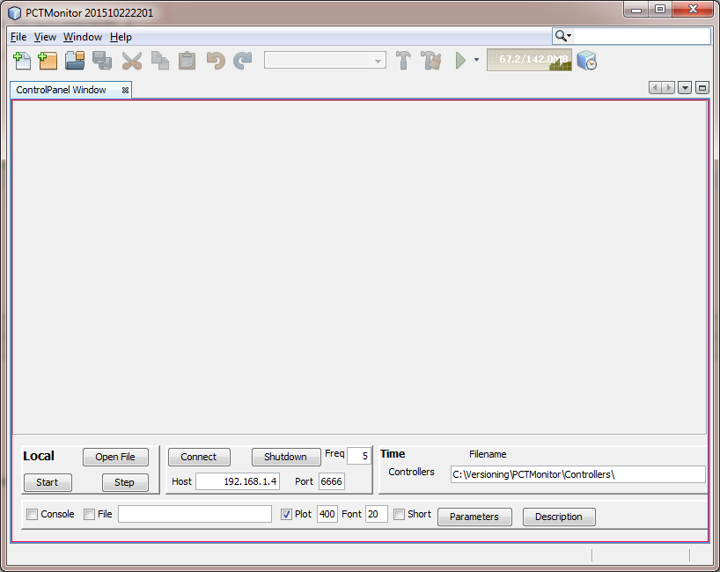

6. To run a control system click the "Open File" button.

7. Select the file Controllers\Models\000-000-Sine.xml.

NB: The path to the Controllers folder can be set as an evironmental variable, CPA_CONTROLLERS.

8. This should bring up "PlotPanel Window", which can be undocked. Also the control system is displayed in the "ControlPanel Window" window. It can be viewed by clicking on the "Sources" label.

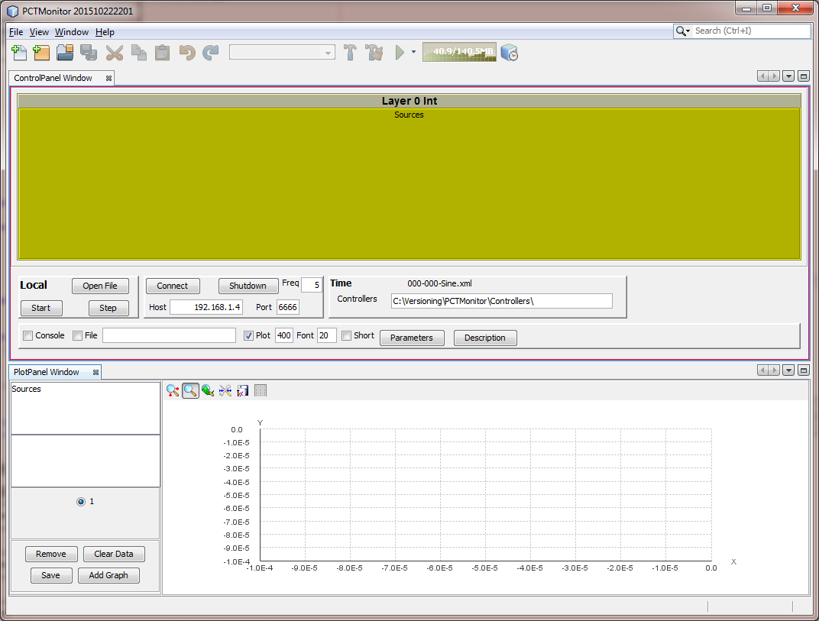

9. To run the system click the "Start" button. You should see the values of the system displayed in the "ControlPanel Window" window.

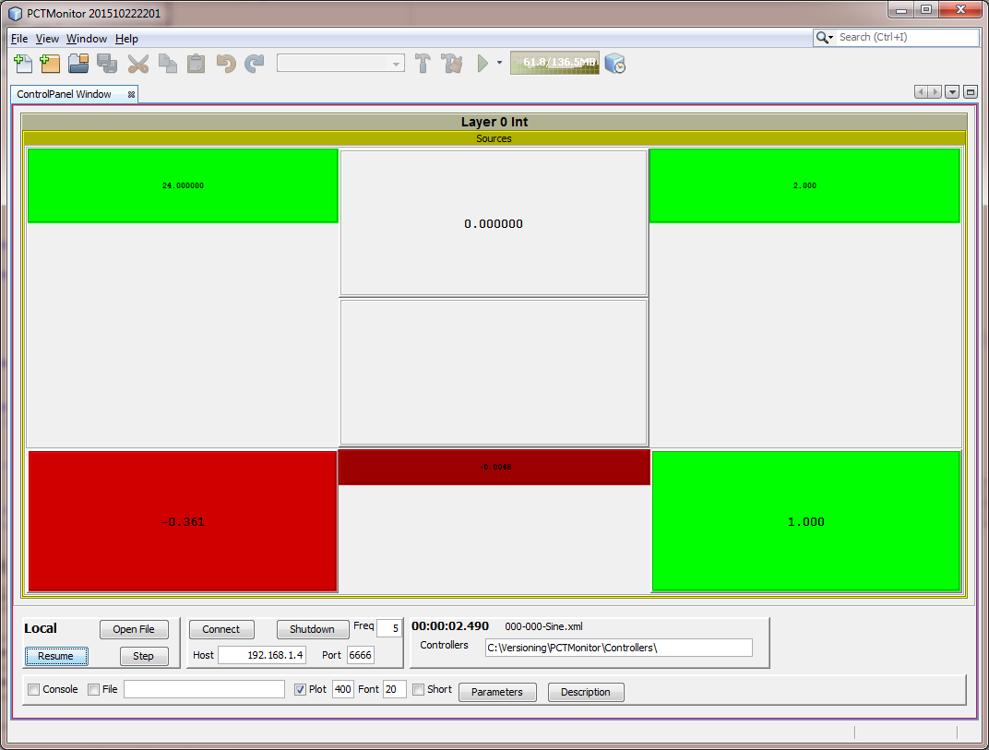

10. To view a plot, click the "Sources" label in the top left box of "PlotPanel Window". Then from the box below select one of the values to display, e.g. "SineSensor".

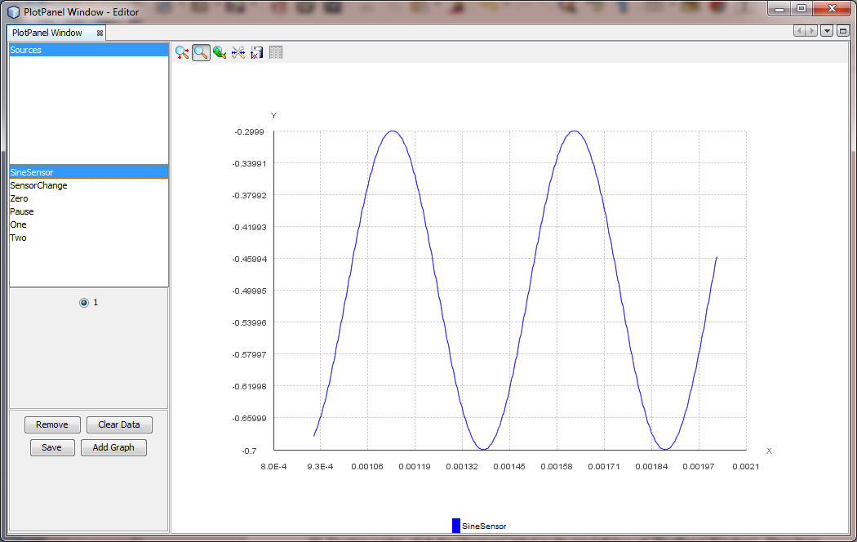

11. To stop the system runnng click the "Stop" button.

12. To exit the application click "x" in the top right of the main window.

