Bank Statement Anomaly Detection - Stateless MVP

Overview
Detect anomalies in daily bank statements using an autoencoder model. The input is raw transaction records. We transform them so that one row represents one account (and currency) for one day. Anomalies are flagged based on business rules and reconstruction error, and are reported at the account level.

Data Transformation (One Day to One Data Point)
The raw statement has many records. Each record is a single transaction belonging to an account. A single account can have many transactions in a day, across different business units, currencies, amounts, and transaction codes. The model does not look at single transactions. It looks at one summary row per account.

Grouping Key
We group all transactions of one day using the key below, then collapse each group into one row.
Group key: (bank_account_code, currency, value_date)
We add currency to the key because the same account can operate in more than one currency. Mixing currencies into a single amount sum would be misleading (for example adding USD and JPY directly). Keeping one row per account-currency keeps amounts comparable and lets the model learn a clean pattern per currency. If an account uses only one currency, it simply produces one row.

From Many Records to One Row
For each group we calculate the 23 stateless features. The many transaction records become a single feature vector.
Before: 14 transaction rows for account ACC_1029 in USD on 2026-06-11
After: 1 row for ACC_1029 / USD / 2026-06-11 with 23 feature columns
Transformation steps:
Step 1: Load the day's statement (all accounts, many records).
Step 2: Group records by (bank_account_code, currency, value_date).
Step 3: For each group, compute the 23 features (counts, sums, ratios, entropy, etc.).
Step 4: Output one row per group. This row is the data point fed to the model.

The exact same transformation is used for training and for inference. This is important. If training and inference compute features differently, the model will behave incorrectly.

Stateless Features (Current Day Only)

Volume Features
These measure transaction activity for the day.

1. txn_count
Count of all transactions for the account today
2. amount_sum
Total amount across all transactions (absolute values)
3. amount_mean
Average transaction amount
4. amount_max
Largest single transaction amount
5. amount_stddev
Standard deviation of transaction amounts (measures spread)

Direction Features
These measure money flow patterns.

6. credit_count
Number of incoming transactions (money in)
7. debit_count
Number of outgoing transactions (money out)
8. credit_debit_ratio
Ratio of credits to debits. Formula: credit_count / debit_count
9. credit_amount_sum
Total money received today
10. debit_amount_sum
Total money sent today
11. net_amount
Net flow for the day. Formula: credit_amount_sum - debit_amount_sum

Business Unit Features
These measure which business units the account interacted with.

12. unique_BU_count
How many different business units in today's transactions
13. BU_concentration_ratio
What percentage went to the top BU. Formula: (transactions with most common BU) / (total transactions)
14. BU_entropy
Measures how spread out transactions are across BUs. High = diversified, Low = concentrated

Currency Features
These measure currency usage patterns within the row.

15. unique_currency_count
How many different currencies appeared for the account that day (across rows)
16. dominant_currency_ratio
What percentage in the main currency
17. foreign_currency_count
Number of non-primary currency transactions

Transaction Type Features
These measure transaction code patterns.

18. unique_txn_code_count
How many different transaction codes used
19. txn_code_concentration_ratio
What percentage used the most common code

Timing Features
These measure which day transactions happened on.

20. weekend_txn_count
Number of transactions on Saturday or Sunday
21. weekend_txn_ratio
Percentage of transactions on weekend. Formula: weekend_txn_count / txn_count

Balance Features
These measure consecutive patterns.

22. max_consecutive_credits
Longest streak of only incoming transactions
23. max_consecutive_debits
Longest streak of only outgoing transactions

Anomalies Detectable with Stateless Features

Using Reconstruction Error

1. Volume Spike
What: Account suddenly has way more transactions than usual
Why flagged: Model learned typical daily count, sees huge spike
Example: Usually 5-10 transactions, today 80 transactions
2. Large Amount
What: Single very large transaction or high daily total
Why flagged: Model learned normal amount ranges, sees extreme value
Example: Usually $10K-50K daily, today $2M
3. All Credits or All Debits
What: Only money coming in OR only going out
Why flagged: Model learned balanced patterns, sees one-sided activity
Example: 20 credits, 0 debits (possible mule account)
4. BU Concentration Change
What: All transactions with single BU when usually spread out
Why flagged: Model learned diverse BU patterns, sees concentration
Example: Usually 5-7 BUs, today only 1 BU
5. BU Diversity Change
What: Transactions spread across many BUs when usually few
Why flagged: Model learned concentrated patterns, sees scatter
Example: Usually 2-3 BUs, today 15 different BUs
6. Currency Mixing
What: Using multiple currencies when usually single currency
Why flagged: Model learned single currency, sees mix
Example: Usually USD only, today USD+EUR+GBP
7. Transaction Code Diversity
What: Many different transaction types in one day
Why flagged: Model learned 1-2 codes typical, sees many
Example: Usually code 101 only, today using 101, 105, 203, 301
8. Weekend Activity
What: Transactions on Saturday/Sunday when usually weekdays only
Why flagged: Model learned weekday patterns, sees weekend
Example: Usually 0% weekend, today 80% weekend
9. Net Flow Extreme
What: Very high net positive or negative for the day
Why flagged: Model learned balanced flows, sees extreme
Example: Usually net ±$5K, today net +$500K

Using Business Rules (Threshold-Based)
These are checked before the autoencoder. They are cheap, explainable, and catch obvious cases.

10. Zero Activity with Amount
Rule: txn_count = 0 but amount_sum > 0 (data error)
11. Single Large Transaction
Rule: txn_count = 1 AND amount_max > threshold
12. Perfect Concentration
Rule: BU_concentration_ratio = 1.0 AND unique_BU_count = 1
13. All Weekend
Rule: weekend_txn_ratio = 1.0 (all transactions on weekend)
14. Foreign Only
Rule: foreign_currency_count = txn_count (no primary currency used)

Model Training
We train an autoencoder on the historical data. An autoencoder is a neural network that compresses the input into a small internal representation and then tries to rebuild the original input. When trained on mostly normal data, it learns to rebuild normal patterns well. Unusual rows are rebuilt poorly, producing a high reconstruction error. We use that error as the anomaly signal.

Training Steps
Step 1: Take 3 years of historical statements and apply the same transformation described above. This gives one row per account-currency per day, each with 23 features.
Step 2: Scale the features (StandardScaler or MinMaxScaler) so large columns like amount_sum do not dominate. Save the fitted scaler as an artifact.
Step 3: Define the autoencoder. Input layer = 23, a few smaller hidden layers down to a small bottleneck, then symmetric layers back up to 23 output. The bottleneck forces the model to learn the core normal structure.
Step 4: Train the model to minimize reconstruction error (for example mean squared error) between input and output. Use a validation split to avoid overfitting.
Step 5: Run the trained model over all training rows and record each row's reconstruction error.
Step 6: Pick a threshold so that only about 2-3% of training rows fall above it. These top-error rows are treated as anomalies of some type. The threshold is the error value at roughly the 97th-98th percentile.
Step 7: Save the artifacts: the trained model, the scaler, and the chosen threshold value.

Why 2-3%: Real statements are mostly normal. We do not have labels, so we assume the large majority is normal and only the most unusual small fraction is worth flagging. Targeting 2-3% keeps the alert volume manageable for analysts while still surfacing the clearest outliers. This percentage can be tuned later based on review feedback.

Training Artifacts
- autoencoder_model (trained network)
- feature_scaler (fitted scaler used to normalize features)
- reconstruction_threshold (single value at the 2-3% cutoff)

Inference Pipeline
The pipeline runs once per day. The payload is one day of statement data containing all accounts of the client. The goal is to produce anomaly decisions at the account level.

Pipeline Steps
Step 1: Receive the daily payload (all accounts, many transaction records).
Step 2: Transform the data exactly as in training: group by account and currency, compute the 23 features, produce one row per account-currency.
Step 3: Run business rule checks on each row. If a rule fires, flag the account immediately with the rule name. These cases do not need the model.
Step 4: For rows not caught by rules, scale the features using the saved scaler and pass them through the autoencoder to get the reconstruction error.
Step 5: Compare the error to the saved threshold. If error > threshold, flag the account as a model-based anomaly.
Step 6: Produce the account-level output. Each account gets one decision, with the method (rule or model), the type, and the supporting feature values.

Business rules run first because they are fast and easy to explain. Anything they do not catch falls through to the autoencoder, which catches the subtler patterns. The final result is always reported per account, not per transaction.

Inference Flowchart
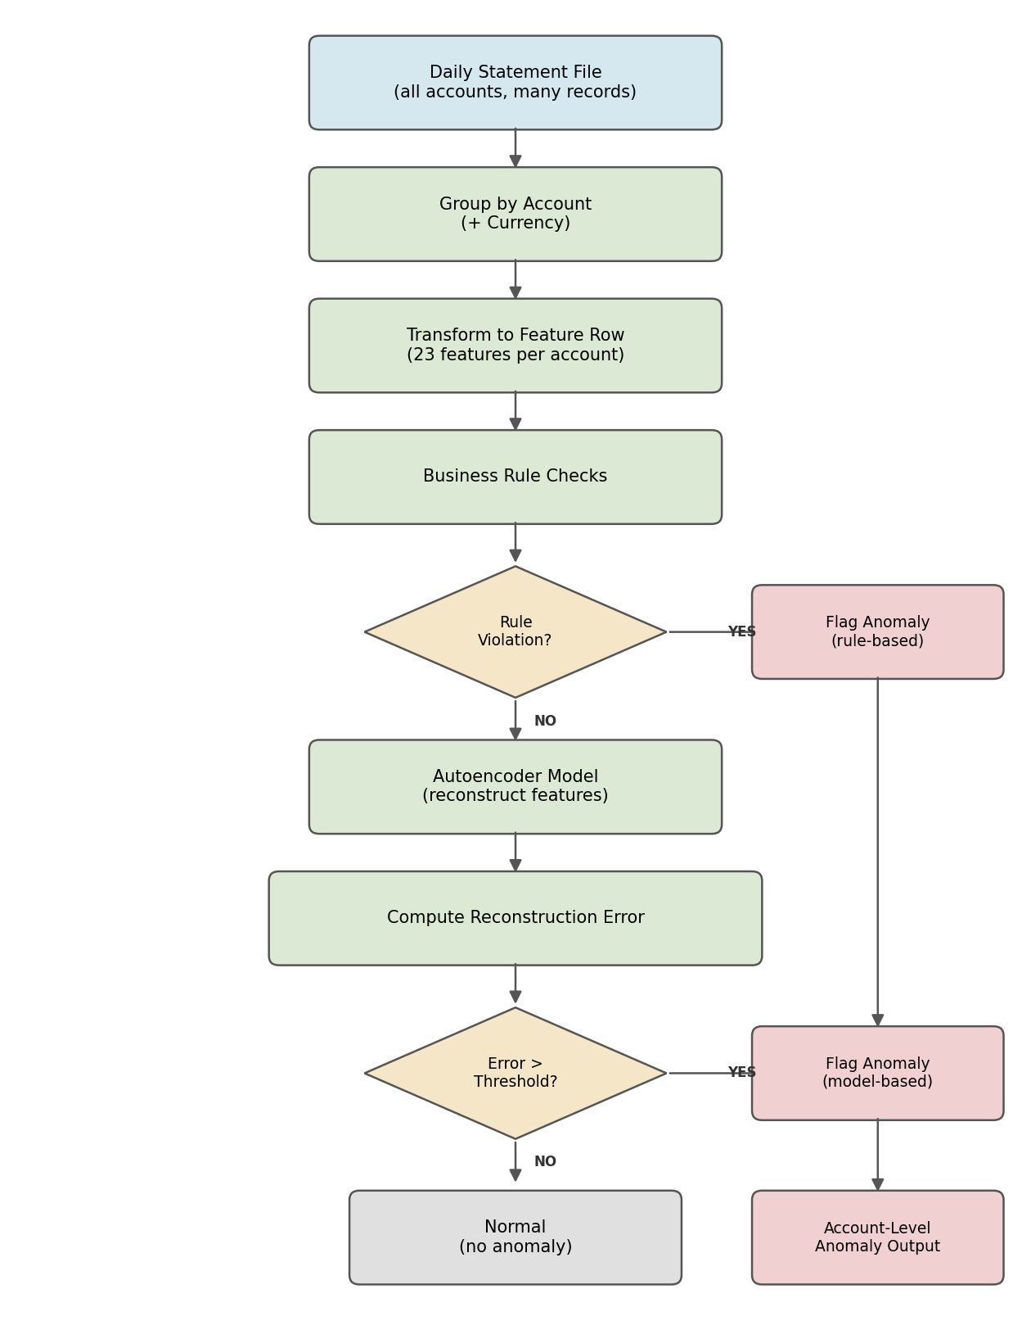

Sample Response JSON
Example output for one daily run. Each account has its own result. Rule-based hits have no reconstruction error; model-based hits include the error and the threshold.

{
"statement_date": "2026-06-11",
"client_id": "CLIENT_00482",
"total_accounts_processed": 37,
"anomalies_found": 2,
"results": [
{
"account_code": "ACC_1029",
"currency": "USD",
"is_anomaly": true,
"detection_method": "business_rule",
"anomaly_type": "Perfect Concentration",
"rule_triggered": "BU_concentration_ratio = 1.0 AND unique_BU_count = 1",
"reconstruction_error": null,
"threshold": null,
"feature_snapshot": {
"txn_count": 14,
"amount_sum": 845000.0,
"unique_BU_count": 1,
"BU_concentration_ratio": 1.0
}
},
{
"account_code": "ACC_2274",
"currency": "EUR",
"is_anomaly": true,
"detection_method": "autoencoder",
"anomaly_type": "Volume Spike / Large Amount",
"rule_triggered": null,
"reconstruction_error": 0.8123,
"threshold": 0.4150,
"top_contributing_features": [
"txn_count",
"amount_sum",
"amount_max"
],
"feature_snapshot": {
"txn_count": 76,
"amount_sum": 2150000.0,
"amount_max": 980000.0,
"unique_BU_count": 6
}
},
{
"account_code": "ACC_3301",
"currency": "USD",
"is_anomaly": false,
"detection_method": "autoencoder",
"anomaly_type": null,
"reconstruction_error": 0.1204,
"threshold": 0.4150
}
]
}

Summary
Stateless MVP covers:
- One row per account-currency per day, built from raw transactions
- 23 features from current day transactions only
- 9 anomaly types via reconstruction error
- 5 business rule violations checked before the model
- Threshold tuned so about 2-3% of training rows are anomalies
- Anomalies reported at the account level
- No historical tracking needed, simpler deployment

