ANOVA stands for Analysis of Variance.
It is used when we want to compare the means of 3 or more groups to see if they are significantly different.
“Are these groups really different, or is the difference just due to random chance?”
Suppose a teacher wants to check whether three different teaching methods affect student marks.
Method | Marks
Method A | 78, 82, 85
Method B | 88, 90, 92
Method C | 70, 72, 68
The teacher wants to know:
Do these teaching methods produce different results?
This is where ANOVA is used.
ANOVA compares two types of variation:
1️⃣ Variation Between Groups
How much the group averages differ.
2️⃣ Variation Within Groups
How much the values inside each group differ.
If:
- Between-group variation is large
- Within-group variation is small
Then the groups are significantly different.
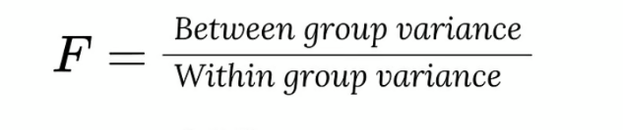

Example Problem
A researcher wants to check whether three teaching methods produce different student scores.
Method A | Method B | Method C
78 | 88 | 70
82 | 90 | 72
85 | 92 | 68
We will perform One-Way ANOVA manually.

Step 1: State the Hypothesis
Null Hypothesis (H₀)
All means are equal.
μ₁ = μ₂ = μ₃
Alternative Hypothesis (H₁)
At least one mean is different.

Step 2: Calculate Group Means

Method A
Mean
(78 + 82 + 85) / 3 = 81.67

Method B
(88 + 90 + 92) / 3 = 90

Method C
(70 + 72 + 68) / 3 = 70

Step 3: Calculate Overall Mean (Grand Mean)
First add all observations.
78 + 82 + 85 + 88 + 90 + 92 + 70 + 72 + 68 = 725
Total observations = 9
Grand Mean:
725 / 9 = 80.56

Step 4: Calculate Sum of Squares Between Groups (SSB)
SSB measures variation between group means.
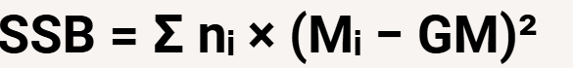
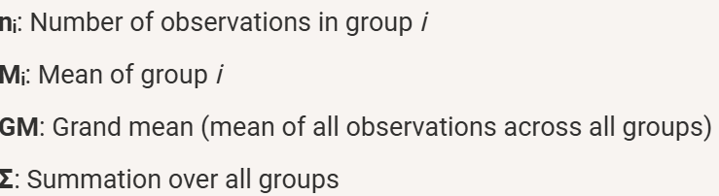

For Method A
n = 3
(81.67 − 80.56)² = 1.23
SSB₁
3 × 1.23 = 3.69

For Method B
(90 − 80.56)² = 89.06
SSB₂
3 × 89.06 = 267.18

For Method C
(70 − 80.56)² = 111.51
SSB₃
3 × 111.51 = 334.53

Total SSB
SSB =
3.69 + 267.18 + 334.53
SSB = 605.40

Step 5: Calculate Sum of Squares Within Groups (SSW)
This measures variation inside each group.
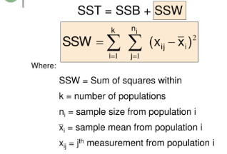

Method A
Mean = 81.67
Value | Calculation | Result
78 | (78−81.67)² | 13.46
82 | (82−81.67)² | 0.11
85 | (85−81.67)² | 11.09
SSW₁
= 24.66

Method B
Mean = 90
Value | Calculation | Result
88 | (88−90)² | 4
90 | (90−90)² | 0
92 | (92−90)² | 4
SSW₂
= 8

Method C
Mean = 70
Value | Calculation | Result
70 | (70−70)² | 0
72 | (72−70)² | 4
68 | (68−70)² | 4
SSW₃
= 8

Total SSW
SSW =
24.66 + 8 + 8
SSW = 40.66

Step 6: Degrees of Freedom
df_{between} = k - 1
Where k = number of groups
k = 3
df_between = 2

df_{within} = N - k
Where
N = total observations
N = 9
df_within = 6

Step 7: Mean Square

Mean Square Between

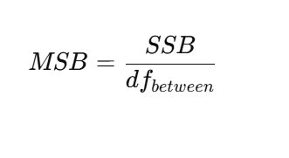
MSB
605.40 / 2 = 302.70
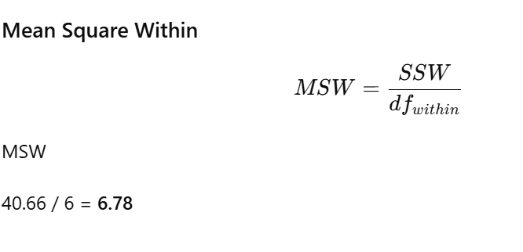

Step 8: Calculate F Statistic
F = MSB/MSW
F
302.70 / 6.78
F ≈ 44.66

