What is Chi-Square Test?
The Chi-Square test checks whether the difference between observed data and expected data is due to chance or due to a real relationship.

Simple Idea
It answers the question:
“Are the results we observed significantly different from what we expected?”
If the difference is large, something interesting is happening.
If the difference is small, it may just be random chance.
Suppose a teacher believes boys and girls prefer different programming languages.
A survey of 100 students produced:
Gender | Python | Java | Total
Boys | 30 | 20 | 50
Girls | 10 | 40 | 50
Total | 40 | 60 | 100
This is called observed data (O).

Hypothesis Formulation

Null Hypothesis (H₀)
Programming language preference is independent of gender.

Alternative Hypothesis (H₁)
Programming language preference depends on gender.
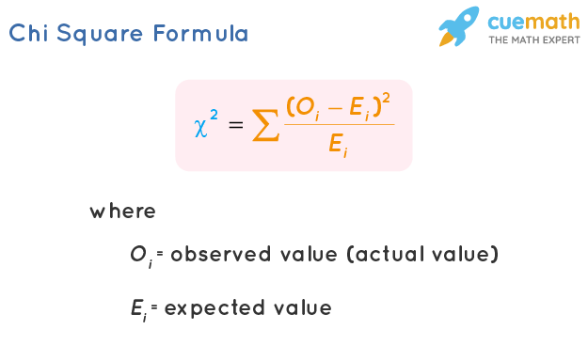

Step 1: Calculate Expected Frequencies
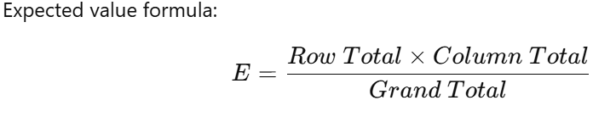
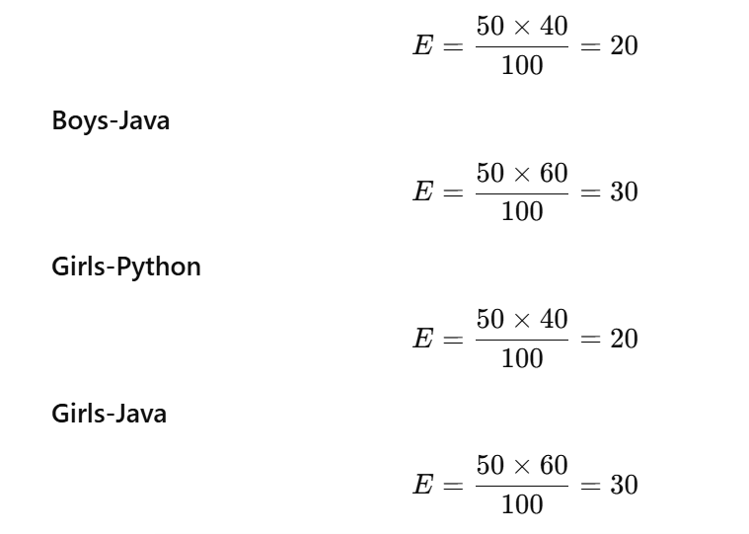
Gender | Python | Java
Boys | 20 | 30
Girls | 20 | 30
Step 2: Compute χ² Statistic

Cell | O | E | (O-E)²/E
Boys-Python | 30 | 20 | 5
Boys-Java | 20 | 30 | 3.33
Girls-Python | 10 | 20 | 5
Girls-Java | 40 | 30 | 3.33

Chi-Square Value

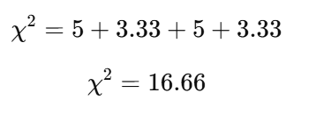

Degrees of Freedom
Formula:
df = (r-1)(c-1)
Where
- r = rows
- c = columns
Here
r = 2
c = 2

df=(2−1)(2−1)=1 df = (2-1)(2-1) = 1 df=(2−1)(2−1)=1

Decision Rule:

If p-value <= 0.05,reject Null hypothesis

Else accept Null hypothesis

