import pandas as pd
import numpy as np
import matplotlib.pyplot as plt
import seaborn as sns
data=pd.read_excel('CardioGoodFitness-1.xlsx')
data.info()
<class 'pandas.core.frame.DataFrame'>
RangeIndex: 180 entries, 0 to 179
Data columns (total 9 columns):
# Column Non-Null Count Dtype
--- ------ -------------- -----
0 Product 180 non-null object
1 Age 180 non-null int64
2 Gender 180 non-null object
3 Education 180 non-null int64
4 MaritalStatus 180 non-null object
5 Usage 180 non-null int64
6 Fitness 180 non-null int64
7 Income 180 non-null int64
8 Miles 180 non-null int64
dtypes: int64(6), object(3)
memory usage: 12.8+ KB
data.describe()
Age Education Usage Fitness Income \
count 180.000000 180.000000 180.000000 180.000000 180.000000
mean 28.788889 15.572222 3.455556 3.311111 53719.577778
std 6.943498 1.617055 1.084797 0.958869 16506.684226
min 18.000000 12.000000 2.000000 1.000000 29562.000000
25% 24.000000 14.000000 3.000000 3.000000 44058.750000
50% 26.000000 16.000000 3.000000 3.000000 50596.500000
75% 33.000000 16.000000 4.000000 4.000000 58668.000000
max 50.000000 21.000000 7.000000 5.000000 104581.000000
Miles
count 180.000000
mean 103.194444
std 51.863605
min 21.000000
25% 66.000000
50% 94.000000
75% 114.750000
max 360.000000
Age: Mean:29 Range:18-50 Majority of customers are young Income: Mean:53719 Range:29562-104581 Most customers belong to middle income group Usage: Mean 3.4 themes/week customers typically exercises 3-4 days per week Miles: mean 103 miles/week some suctomers run very high distances indicating serious runners
data.nunique()
Product 3
Age 32
Gender 2
Education 8
MaritalStatus 2
Usage 6
Fitness 5
Income 62
Miles 37
dtype: int64
data['Product'].value_counts()
TM195 80
TM498 60
TM798 40
Name: Product, dtype: int64
TM195 is the most popular product TM798 is the niche product
data['Gender'].value_counts()
Male 104
Female 76
Name: Gender, dtype: int64
Male customers dominate the dataset
data.groupby('Product')['Income'].mean()
Product
TM195 46418.025
TM498 48973.650
TM798 75441.575
Name: Income, dtype: float64
TM798 is a premium product Income strongly influences product selection
data.groupby('Product')['Usage'].mean()
Product
TM195 3.087500
TM498 3.066667
TM798 4.775000
Name: Usage, dtype: float64
Premium treadmill users exercise more frequently serious fitness users prefer advanced treadmills
data.groupby('Product')['Fitness'].mean()
Product
TM195 2.9625
TM498 2.9000
TM798 4.6250
Name: Fitness, dtype: float64

Customers with higher fitness levels choose premium treadmills
data.corr(numeric_only=True)
Age Education Usage Fitness Income Miles
Age 1.000000 0.280496 0.015064 0.061105 0.513414 0.036618
Education 0.280496 1.000000 0.395155 0.410581 0.625827 0.307284
Usage 0.015064 0.395155 1.000000 0.668606 0.519537 0.759130
Fitness 0.061105 0.410581 0.668606 1.000000 0.535005 0.785702
Income 0.513414 0.625827 0.519537 0.535005 1.000000 0.543473
Miles 0.036618 0.307284 0.759130 0.785702 0.543473 1.000000
People who use the treadmill more run more miles. Higher fitness levels correspond to higher activity levels.
sns.countplot(x='Product',data=data)
<AxesSubplot:xlabel='Product', ylabel='count'>
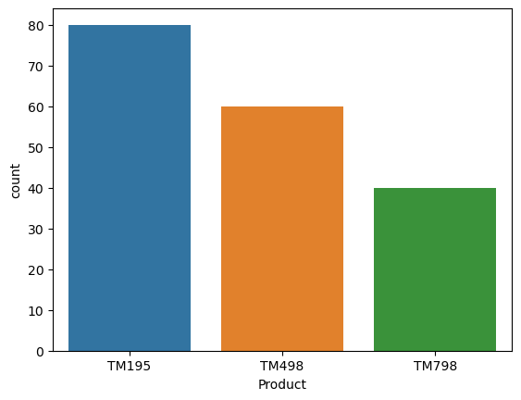
TM195 has highest sales TM798 has lowest sales Premium treadmill serves a smaller but high value market
sns.boxplot(x='Product',y='Income',data=data)
<AxesSubplot:xlabel='Product', ylabel='Income'>
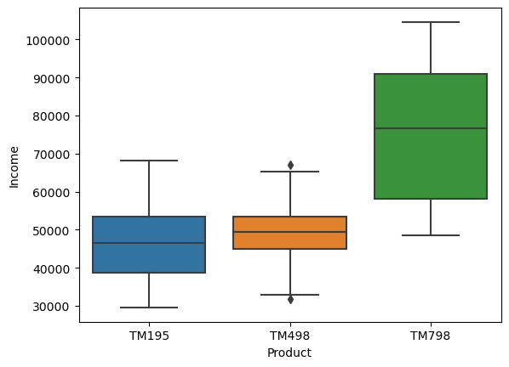
sns.boxplot(x='Gender',y='Miles',data=data)
<AxesSubplot:xlabel='Gender', ylabel='Miles'>
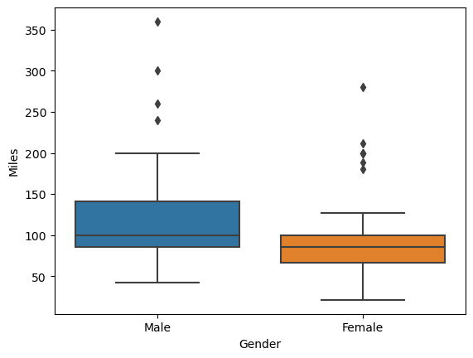
Male customers tend to: run more miles show higher activity levels
sns.histplot(data['Age'],bins=10)
<AxesSubplot:xlabel='Age', ylabel='Count'>
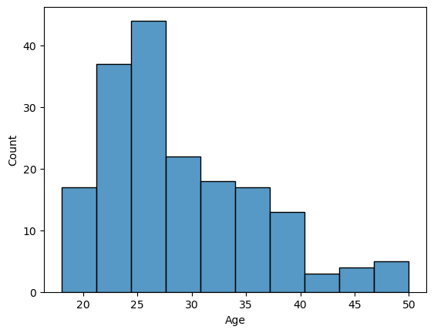
#Inferential statistics
#parameter ---- numerical measure describing the population
#Eg:Average income of all employees in a company
#statistic
'''numerical value calculated from a sample.
Eg:Average income of 100 selected employees.'''
#Sampling
'''The process of selecting a subset from the
population.'''
#Hypothesis
'''A hypothesis is a testable assumption or
statement about a population parameter based
on sample data'''
#Null hypothesis(H0)
'''represents:
no effect
no difference
status quo
The claim we try to reject
Eg:A company claims:
Average customer monthly data usage is 50GB'''
#Alternative Hypothesis(Ha):
'''represents:
what we want to prove
opposite to null hypothesis'''
'''A coca cola company claims 500 ml of coke in a bottle.
'''
#Types of alternative hypothesis
#1.Two tailed test
'''Testing any difference'''

#2.Right tailed test:
#testing greater than
#3.Left tailed test:
#testing less than
'''A gym trainer claims:
Average daily steps of members is 10000 steps:
'''
#p-value
'''probability value.
is the probability of observing the sample result
assuming null hypothesis is true.
p-value tells us how strong the evidence is
against the null hypothesis.'''
#Decision rule:
#significance level(alpha)=0.05
#if p<=alpha ---- reject null hypothesis
#if p>alpha ---- accept null hypothsis
#Z-test
'''1.population standard deviation is known
2.sample size is large(n>=30) or data is normally
distributed.'''
#procedures
'''1.Formulate hypothesis
2.select signifinace level(alpha)
alpha=0.05
3.collect sample data
compute mean
compute sample size
4.calculate z statistic
5.calculate p value
6.Make decision'''
'''Avg wt of its product=500g
population std=20g
sample=36 items
sample mean=510'''
'''Formulate hypothesis'''

