**Synopsis**

**On**

**“Markov chain model of Rainfall Probability for agricultural Planning in Anand”**



**Submitted By:**

**Rupesh Patel(06-0222-2016)**

**Roll No: 19**

|  |  |  |
| --- | --- | --- |
| **Major Guide By** | **Minor Guide By:** | |
| **Dr. R.S. Prmar** |  | **Dr.V.I Mehra** |
|  |  |  |

Index

Contents

1. Title 3

2. Introduction 3

3. Scope 3

4. Objectives 3

5. Methodology: 4

6. Software Requirement: 6

7. Hardware Requirement: 6

8. Module 6

9. DFD(Data Flow Diagram) 7

Level 0 7

10. ER(Entity-Relation) Diagram 7

11. Data Dictionary 8

12. References 10

# 

# Title

Markov chain model of Rainfall Probability for agricultural Planning in Anand

# Introduction

The yield of crop particularly under rain fed condition depends on the rainfall pattern. Simple criteria related to sequential phenomena like dry and wet spells could be used for analyzing rainfall data to obtain specific information recognized as a suitable model to explain the long term frequency behavior of wet or dry spells. Several authors have demonstrated its practical utility in agricultural planning for both long and short term periods. This model enables to determine the probability of occurrence of dry and wet spells during a particular week.

# Scope

Web Based Markov Model for wet and dry analysis, tools is the web based system using which Scientist can generate graphs and reports based on the weather data by the observatory for various purpose of their research or Agricultural Planning.

# Objectives

* To create DBMS for Rainfall data of Agro meteorological observatory of Anand.
* To develop tool for Markov Model for wet and dry analysis, Descriptive data analysis and Rainfall data Normal.
* To harness Information Technology to achieve the above objectives.

# Methodology:

* **Markov chain Model :**

Markov chain is a probabilistic automaton. The probability distribution of state transitions is typically represented as the Markov chain’s transition matrix. If the Markov chain has N possible states, the matrix will be an N x N matrix, such that entry (I, J) is the probability of transitioning from state I to state J. Additionally, the transition matrix must be a stochastic matrix, a matrix whose entries in each row must add up to exactly 1. This makes complete sense, since each row represents its own probability distribution.

A Wet week (or a Dry week) has been defined as one with ≥ 5 mm (≤ 5 mm) of rainfall according to definition proposed by the Indian Meteorological Department. This gives a sequence of wet and dry weeks. Further, under the assumption that the occurrence of a wet or a dry week is influenced only by the weather condition of the previous week, the process of occurrence of wet and dry weeks can be described by a 2- state Markov chain with wet and dry weeks as the two states. The transition probability matrix P, which describes the 2 – state Markov chain model is given by

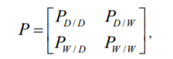

with PD/D+PD/W=1 and PW/D+PW/W=1, where PD/D, PD/W, PW/D and PW/W are the transition probabilities. That is, they are respectively the probabilities of the following conditional events:

ED/D: A week is a dry week given that the preceding week was a dry week. EW/D: A week is a wet week given that the preceding week was a dry week. ED/W: A week is a dry week given that the preceding week was a wet week. EW/W: A week is a wet week given that the preceding week was a wet week.

Suppose that each week from January to December is classified according to the occurrence of the four events ED/D, ED/W, EW/D and EW/W such that 1st week depends on the 52nd week of December. Then, repeating this process for each year, frequencies of the occurrences of events are counted. Let these observed frequencies be denoted a, b, c and d

for the respective events with a + b = n0 and c + d = n1. The maximum likelihood estimates of the unknown probabilities PD/D, PD/W, PW/D and PW/W i.e., the parameters of the model are obtained as,

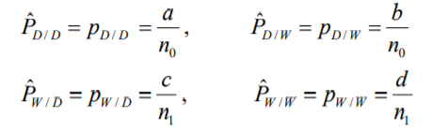

The transition probabilities are conditional probabilities. But, the probability of a dry week (PD) and the probability of wet week (PW) are estimated from the observed frequencies of the conditional events as follows:

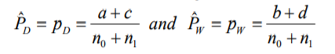

These unconditional probabilities are also called binomial probabilities treating a wet week as a success and a dry week as a failure.

# Software Requirement:

* Language : Python 3
* Framework : Django
* Database : Mysql
* Text editor : Vs code
* Os : Win 7,8,10 or Linux, or Mac
* Browser : chrome Browser

# Hardware Requirement:

* Processors: Intel Atom® processor or Intel® Core™ i3 processor
* RAM : Minimum 4GB for Windows Os
* Hard Disk : Minimum 500 GB

# Module

1. **Data Analysis module:**

This is the important part of this platform where the scientist or researchers can generate different types of graphs by selecting different types of weather or climatic parameters. Here they can view graphs and data according to their selection. The registered scientist or researchers can also download the graphs in .pdf format.

1. **Data Input module:**

This is the important part of this platform where the registered scientist can upload the data in the standard format and after admin verify the format and then data will be inserted in the database.

1. **Admin module:**

This part is basically created for the maintenance of the platform. The admin will be the final authority to take decision regarding any misuse or any complaint. The first job done using this module would be that the admin could see all the registered scientist or researchers in this web based application.

# DFD(Data Flow Diagram)

## Level 0

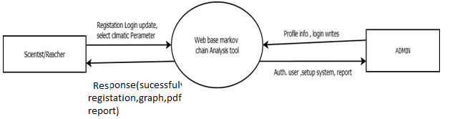

# ER(Entity-Relation) Diagram

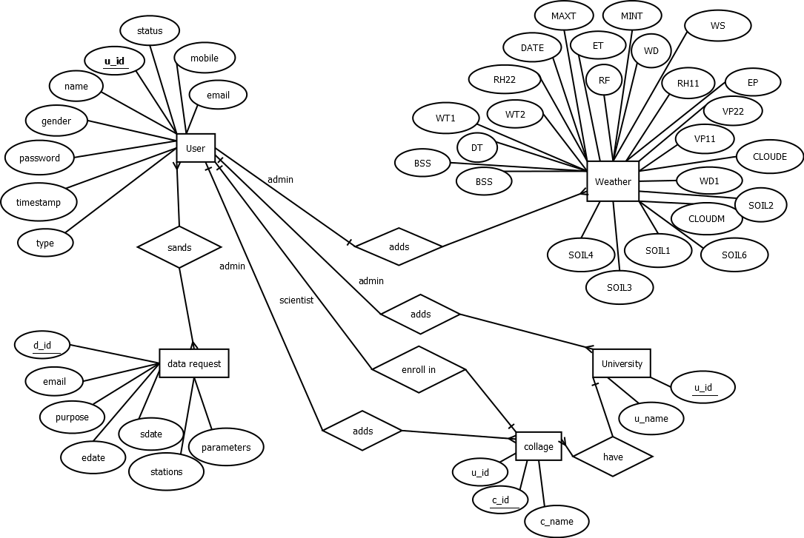

# Data Dictionary

1. **Registration Table**

|  |  |  |  |  |
| --- | --- | --- | --- | --- |
| Ssr | Field | Datatype | Keys | Descript. |
| 01 | Id | Int | Primary Key | Scientist registration Id |
| 02 | name | varchar(MAX) |  | Scientist Name |
| 03 | gender | varchar(MAX) |  | Scientist gender |
| 04 | mobile | varchar(MAX) | Unique | Scientist mobile no |
| 05 | university | varchar(MAX) |  | Scientist university |
| 06 | department | varchar(MAX) |  | Scientist department |
| 07 | email | varchar(MAX) | Unique | Scientist email |
| 08 | password | varchar(MAX) |  | Scientist password |
| 09 | type | varchar(MAX) |  | Scientist type |
| 10 | status | varchar(MAX) |  | Scientist status |
| 11 | timeStamp | Date |  | Scientist timestamp |
| 12 | College | varchar(MAX) |  | Scientist College |

1. **College Table**

|  |  |  |  |  |
| --- | --- | --- | --- | --- |
| Sr.no | Field | Datatype | Keys | Descript. |
| 01 | C_id | Int | Primary Key | College id |
| 02 | C_name | varchar(MAX) |  | College name |
| 03 | U_id | int | Foreign Key | University id |

1. **University Table**

|  |  |  |  |  |
| --- | --- | --- | --- | --- |
| Sr.no | Field | Datatype | Keys | Descript. |
| 01 | U_id | Int | Primary Key | University id |
| 02 | U_name | Varchar |  | University name |

1. **Data Request Table**

|  |  |  |  |  |
| --- | --- | --- | --- | --- |
| Sr.no | Field | Datatype | Keys | Descript. |
| 01 | D_ID | Int | Primary Key | Auto generated ID |
| 02 | Email | varchar(MAX) |  | Email of registered User |
| 03 | User Category | varchar(MAX) |  | UserCategory |
| 04 | sdate | Date |  | Starting Date |
| 05 | edate | Date |  | Ending Date |
| 06 | stations | varchar(MAX) |  | Station from where data collected |
| 07 | Purpose | varchar(MAX) |  | Purpose |
| 08 | Parameters | varchar(MAX) |  | Parameters Required |
| 09 | Time Stamp | DateTime |  | Time stamp at which User request for data |

1. **Weather Table**

|  |  |  |  |  |
| --- | --- | --- | --- | --- |
| Sr.no | Field | Data type | Keys | Descript. |
| 1 | Date | Date |  | Daily Date |
| 2 | EP | Decimal(5,2) |  | Evaporation |
| 3 | ET | Decimal(5,2) |  | Evapo- transpiration |
| 4 | BSS | Decimal(5,2) |  | Sunshine hour |
| 5 | WS | Decimal(5,2) |  | Wind Speed |
| 6 | WD1 | Decimal(5,2) |  | Wind Direction Morning |
| 7 | WD2 | Decimal(5,2) |  | Wind Direction Afternoon |
| 8 | RH1 | Decimal(5,2) |  | Relative Humidity Morning |
| 9 | RH2 | Decimal(5,2) |  | Relative Humidity Afternoon |
| 10 | Mean RH | Decimal(5,2) |  | Mean Relative Humidity |
| 11 | MaxTemp | Decimal(5,2) |  | Maximum temperature |
| 12 | MinTemp | Decimal(5,2) |  | Minimum temperature |
| 13 | MeanTemp | Decimal(5,2) |  | Mean temperature |
| 14 | VP1 | Decimal(5,2) |  | Vapour Pressure morning |
| 15 | VP2 | Decimal(5,2) |  | Vapour  Pressure  afternoon |
| 16 | VPMean | Decimal(5,2) |  |  |
| 17 | Soil(5cm)M | Decimal(5,2) |  | Soil temp at depth of 5 cm Morning |
| 18 | Soil(10cm)M | Decimal(5,2) |  | Soil temp at depth of 10 cm  Morning |
| 19 | Soil(20cm)M | Decimal(5,2) |  | Soil temp at depth of 15 cm  Morning |
| 20 | Soil(5cm)A | Decimal(5,2) |  | Soil temp at depth of 5 cm  Afternoon |
| 21 | Soil(10cm)A | Decimal(5,2) |  | Soil temp at depth of 10 cm  Afternoon |
| 22 | Soil(20cm)A | Decimal(5,2) |  | Soil temp at depth of 20 cm  Afternoon |
| 23 | RD | Decimal(5,2) |  | Rainy Day |
| 24 | RF | Decimal(5,2) |  | Rain Fall |
| 25 | CC1 | Decimal(5,2) |  | Cloud Day morning |
| 26 | CC2 | Decimal(5,2) |  | Cloud Day afternoon |

# References

1. CALIFORNIA INSTITUTE OF TECHNOLOGY, Ma 3/103 KC Border Introduction to Probability and Statistics Lecture 13: Markov Chains and Martinagles
2. Introduction to Markov Chains To word Data science [<https://towardsdatascience.com/introduction-to-markov-chains-50da3645a50d>]
3. International Journal of Innovative Research in Science, Engineering and Technology (An ISO 3297: 2007 Certified Organization) Vol. 4, Issue 7, July 2015 Copyright to IJIRSET DOI:10.15680/IJIRSET.2015.0407199 6644 Markov Chain Model for Probability of Weekly Rainfall in Mandya District, Karnataka
4. [<http://www.ijirset.com/upload/2015/july/199_krishnamurthy%20int%20jul.pdf>]