GYRE
A Two-Rotor Privacy and Denial-of-Service Defense Network Fabric
Complete Technical Documentation
Rupesh Bharambe
github.com/rupeshbharambe24/Gyre
rupeshbharambe24.github.io/Gyre
Version 0.1.0 · Experimental, unaudited research build · 15 crates, 225 tests
This document is written to be honest by construction: every performance and anonymity claim is measured against a named adversary and a baseline, and the hard limits are stated inline with the mechanisms that reach them. It is intended both as implementation documentation and as the basis for a peer-reviewed research paper.

Abstract
Gyre is a single relay fabric that performs two distinct jobs at once. Its outbound rotor (the Mixer) dissolves a person into a crowd so that a partial network observer cannot link who they are to what they reach; its inbound rotor (the Shield) hides and protects a system so that its origin cannot be found, targeted, or flooded at the application layer. The design reuses the field’s strongest proven cores — the Sphinx packet format [2], onion routing as proven by Tor [3], and the continuous-cover mix strategy of Loopix [4] — and integrates them with a complete, deployable denial-of-service admission gate in a way no single system ships today.
We make honesty the project’s load-bearing property, stating the ceilings first: no system beats a global passive observer at low latency; anonymity is the size of the concurrent crowd and cannot be manufactured [11]; the anonymity trilemma forces a choice among strong anonymity, low latency, and low overhead [5]; endpoint compromise deanonymises regardless of the network; and no application-layer mechanism defends a saturated link. Within those limits, the inbound rotor is deployable today and its security argument survives zero users, while the outbound rotor is built and measured but gated on adoption. The implementation is 15 Rust crates with 225 automated tests; anonymity is evaluated with a discrete-event simulator that drives the real protocol code against a maximum-likelihood, optimally-solved correlation attacker, which corrected the project’s own earlier figures by roughly 4.5×.

Contents
Abstract
Contents
1. Introduction
1.1 The central asymmetry
1.2 Scope of this document
2. Design Philosophy and Principles
3. Threat Model and Honest Ceilings
3.1 The named adversary
3.2 The ceilings — stated first
4. System Architecture
4.1 Crate map
4.2 Data plane and control plane
5. Core Data Structures and Wire Formats
5.1 The admission challenge
5.2 The capability token
6. Onion Routing and the Sphinx Format
7. Mixing and Cover Traffic
8. Erasure-Coded Multipath
9. The FAST/MIX Dial
10. Rendezvous Origin-Hiding
11. Moving-Target-Defense Ingress
12. The Admission Protocol
12.1 Load-scaled difficulty
13. Proof-of-Work Puzzles
14. Denial-of-Service Defense in Depth
15. The Denial-of-Service Taxonomy
16. Capability Tokens (Authorization)
16.1 Unlinkability and the key-partitioning defense
16.2 Issuance binding and epochs
17. Decentralized Directory and Attestation
18. Private Information Retrieval
19. Forward-Secret Sessions
20. Obfuscation and Pluggable Transports
21. Steganography (situational)
22. The Thirteen Dimensions of Coverage
23. Attacks Defended, and How
24. Security Analysis and Failure Modes
25. Methodology
26. Anonymity Results
27. Real-Binary Simulation (Shadow)
28. Microbenchmarks
29. Honest Reading of the Numbers
30. Implementation and Testing
31. Deployment and Operations
32. Honesty and Corrections Record
33. Related Work
34. Limitations and Future Work
35. Conclusion
Appendix A — Decision Log (D1–D22)
Appendix B — Parameter Reference
Appendix C — Glossary
References

Part I — Overview

1. Introduction
Two needs are usually met by two different tools. A person who wants their traffic unobservable reaches for an anonymity network; an operator who wants a service that cannot be located or flooded reaches for a content-delivery network or a scrubbing provider. Tor is the existence proof that one relay fabric can host both: client anonymity through onion-routed circuits, and onion-service origin-hiding through rendezvous [3]. Gyre takes that observation as its thesis and builds a fabric that spins both ways — a gyre being a spiraling vortex current.

1.1 The central asymmetry
The two rotors are not symmetric, and the asymmetry is the single most important engineering fact about the system. The inbound rotor’s security comes from cost and topology: a proof-of-work price that is a property of a hash function, and an origin that publishes no inbound address because it only ever dials out. Both hold with exactly one user. The outbound rotor’s security comes from indistinguishability from other people, for which there is no substitute and which no amount of code manufactures. We therefore position the inbound rotor as the deployable wedge and the outbound rotor as the crowd-gated goal (decision D20).

1.2 Scope of this document
This is whole-project technical documentation. Part I covers philosophy and threat model; Part II the architecture, crate map, and wire formats; Parts III–V every mechanism of the two rotors and the supporting cryptography; Part VI the coverage map and security analysis; Part VII the measured evaluation; Part VIII the implementation, deployment, and the project’s honesty-and-corrections record; Part IX related work and conclusions. Appendices give the full decision log, a parameter reference, and a glossary.

2. Design Philosophy and Principles
Gyre’s design is governed by twenty-two recorded decisions (Appendix A). Five principles run through all of them.
- Honesty over marketing. Every claim is measured against a baseline and a named adversary; a claim that cannot be backed is retracted with a dated note rather than softened. This is the project’s credibility and is treated as a hard requirement, not a preference.
- Orthogonal breadth, not depth (D10). Layers help only when they are independent and cover different threats; stacking same-threat mechanisms adds latency, bugs, and new leaks. Gyre is a wide matrix of orthogonal defenses, each the single best answer to a distinct threat.
- Never roll your own crypto (D11). The fabric is built from established, widely-used primitives — Sphinx, X25519, the RFC 9497 VOPRF, Reed–Solomon, HMAC-SHA256. Kerckhoffs’s principle [21] is applied to the whole system: security rests on keys and on public, reviewable design, never on secrecy of the design.
- Measure before trusting. Anonymity is evaluated against an optimal attacker, and every security property is guarded by a discriminating test — one confirmed to fail when the code it protects is reverted.
- State the ceilings first. The hard limits (next section) are written at the top of every artifact, because a privacy tool’s credibility dies the moment it overclaims.

3. Threat Model and Honest Ceilings

3.1 The named adversary
Gyre is tuned for a bounded, explicit adversary so that every later claim can be read against it (D4):
- A partial network observer that controls or watches a fraction of relays and links and correlates flows by timing. This is the attack that deanonymises real users in practice, and it is strengthened by modern learned correlation attacks such as DeepCorr [18] and DeepCoFFEA [19], which we treat as in-scope.
- A censoring or blocking ISP that recognises and drops the fabric’s traffic by its appearance (addressed by the pluggable-transport layer).
- Sybil relay operators who run many nodes to raise observation coverage or to mint identities cheaply (addressed by priced admission and a threshold directory).

3.2 The ceilings — stated first
- Global passive observer at low latency. Nobody defeats an adversary that sees both ends of a low-latency path; Gyre does not claim to.
- The crowd. Anonymity is the size of the concurrent anonymity set — a social/adoption property, not a cryptographic one [11, 12]. Synthetic cover from a single operator adds traffic volume but not independent senders, and against an end-to-end correlator it is measured as overhead, not anonymity.
- The anonymity trilemma [5]. Strong anonymity forces a price in latency and/or bandwidth; Gyre makes the trade explicit and dialable rather than hiding it.
- Endpoint compromise. A keylogged or seized device deanonymises its user regardless of any network defense.
- Volumetric L3/L4 flooding. A saturated link is physics; the answer is anycast scrubbing capacity, not an application-layer puzzle. Gyre complements a scrubber and makes it un-bypassable (D22); it does not replace one.
Part II — Architecture

4. System Architecture
Gyre is a Rust workspace of 15 product crates (plus a dev-only benchmark crate). The relay fabric is shared; the two rotors are modes of use over it. Figure 1 shows the structure and the asymmetry.
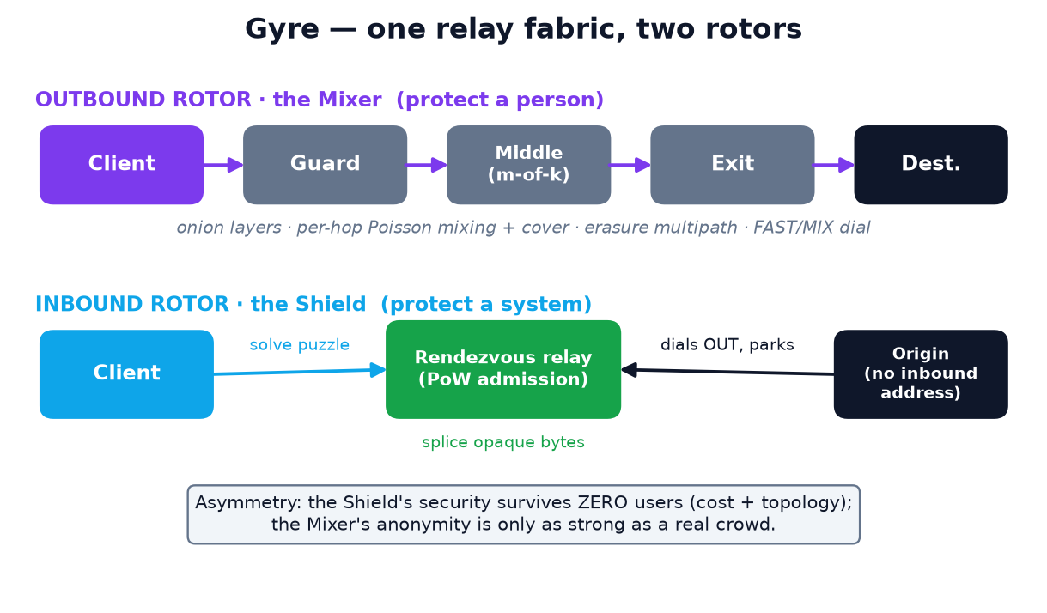
Figure 1. The two-rotor architecture. The outbound Mixer protects a person against timing correlation; the inbound Shield protects a system by removing its origin as a target and pricing admission.

4.1 Crate map
Table 1. The fifteen product crates and their responsibilities.
Crate | Role
gyre-common | Shared types and constants for the fabric.
gyre-sphinx | Ergonomic wrapper over the Sphinx mix-packet format (S0).
gyre-node | In-process Sphinx circuit demo (S0).
gyre-net | Async transport, directory, and relay server carrying onions over the network (S1).
gyre-fec | Reed–Solomon m-of-k erasure coding for multipath (S3).
gyre-adversary | The GATE: deterministic adversary-emulation harness (superseded by gyre-sim).
gyre-sim | Discrete-event simulation driving the real code against an optimal-assignment correlation attacker.
gyre-shield | The inbound rotor: MTD ingress, admission protocol, PoW, rendezvous, capability tokens.
gyre-obfs | Obfuscation / pluggable transports — swappable first-hop wire appearance (Addition 1).
gyre-endpoint | Endpoint hardening — forward-secret ratchet, compartmentalized personas (Addition 2).
gyre-directory | Decentralization + attestation — t-of-n signed consensus, equivocation detection (Addition 4).
gyre-pir | Private directory retrieval — 2-server information-theoretic PIR (Addition 6).
gyre-stego | Deniability (situational) — LSB steganography with explicit limits (Addition 5).
gyre-crowd | The crowd/incentive layer — k-anonymity governor and staking Sybil-pricing model (P4).
gyre-cli | Standalone relay/client/origin binaries and the live dashboard — real processes on real sockets.

4.2 Data plane and control plane
The outbound data plane carries real Sphinx onions [2] with per-hop Poisson mixing delays and cover traffic in the Loopix style [4], optionally erasure-coded across disjoint middle paths [16]. The inbound plane is a guarded rendezvous relay. The control plane is a threshold-signed directory (gyre-directory) that distributes relay descriptors, public keys, moving-target parameters, and the proof-of-work difficulty floor, with reproducible-build attestation so that a lying directory leaves public cryptographic evidence.

5. Core Data Structures and Wire Formats

5.1 The admission challenge
A challenge is self-authenticating, so the server can verify one it issued without having stored it — the SYN-cookie pattern. Its on-the-wire layout is:
Challenge (CHALLENGE_LEN = 77 bytes)
id : 32 bytes random, single-use identifier
expiry : 8 bytes big-endian milliseconds
difficulty : 4 bytes big-endian bits, in [8, 20]
algorithm : 1 byte puzzle tag (1 = SHA-256, 2 = Equi-X)
tag : 32 bytes HMAC-SHA256(server_key, id||expiry||difficulty||algorithm)
The difficulty and algorithm sit inside the authenticated body, so a client cannot downgrade either without breaking the tag. The client’s admission response is mode-tagged:
MODE_POW (0x01): challenge || proof_len (u16) || proof || cookie
MODE_TOKEN (0x02): seed (32) || output (64) || cookie
proof_len is bounded by MAX_PROOF_LEN = 64 and checked BEFORE any allocation.
SHA-256 proof = 8-byte nonce; Equi-X proof = 8-byte nonce || 16-byte solution.

5.2 The capability token
The token is a VOPRF output over ristretto255-SHA512 [6]. Sizes, in bytes:
Table 2. Capability-token field sizes.
Field | Bytes | Meaning
ELEMENT_LEN | 32 | ristretto255 group element (blinded point, public key)
PROOF_LEN | 64 | Chaum–Pedersen DLEQ proof (two scalars)
OUTPUT_LEN | 64 | SHA-512 VOPRF output
SEED_LEN | 32 | token seed (the finalize input)
TOKEN_LEN | 96 | seed || output, presented at redemption
Part III — The Outbound Rotor (the Mixer)

6. Onion Routing and the Sphinx Format
Each message is wrapped in layered encryption across three hops (capped at three by D5: deeper circuits add latency and more chances to hit a hostile relay for near-zero marginal anonymity). The guard learns the sender but not the destination; the exit learns the destination but not the sender; no relay sees both ends — Chaum’s separation-of-knowledge [1]. Gyre uses the Sphinx packet format [2], giving fixed-size, unlinkable packets with integrity and replay protection and a compact header, over X25519 group operations [15]. A 3-hop onion is built in ≈142µs and each hop is peeled in ≈45µs (Section 28).

7. Mixing and Cover Traffic
Low-latency onion routing leaves timing intact, which is what a correlating observer exploits. Gyre adds a per-hop exponential (Poisson) mixing delay sampled by a real Loopix sampler and sealed inside the onion, plus loop/drop cover traffic so an observer cannot tell when a user is sending [4] (D6). Cover traffic buys unobservability — a different property from anonymity-set size — and is honestly accounted: against the end-to-end correlator a self-generated loop returns to its sender and never reaches a real destination, so it is measured as pure bandwidth overhead (Section 26, Table 10), never folded into the anonymity figure (anti-overclaim rule 3).

8. Erasure-Coded Multipath
A flow may be Reed–Solomon split m-of-k across disjoint middle relays [16], so any m fragments reconstruct it and a partial observer on one path sees fragments rather than the flow. We state the honest scope precisely (D7): this is probabilistic middle-path hardening against a partial observer, not an endpoint-protecting reconstruction threshold — the guard and exit remain exposed, and multipath in fact widens endpoint exposure, so it is opt-in. The codec runs at roughly 0.8–1.7 GiB/s (Section 28).

9. The FAST/MIX Dial
The latency/anonymity trade is exposed as a per-flow dial (D8): a FAST lane (no mixing, Tor-class latency and, honestly, Tor-class correlatability) and a MIX lane. The choice is sealed inside the onion so the network never learns a flow’s latency preference. This is the concrete answer to the trilemma [5]: spend the anonymity budget only where it is needed. The measured cost of the dial is in Section 26.
Part IV — The Inbound Rotor (the Shield)

10. Rendezvous Origin-Hiding
The protected origin binds no inbound listener. It dials out to a rendezvous relay and waits behind a shared cookie; a client reaches it through the same relay (D9). The relay is a meeting point, not a middlebox: it never learns either endpoint’s location, because the origin only ever made an outbound connection. There is thus no origin IP to discover or flood directly — the onion-service posture [3]. The splice copies opaque bytes; the relay cannot read the end-to-end content.

11. Moving-Target-Defense Ingress
A moving-target-defense ingress schedule makes the reachable address a keyed function of a time window, so a scanner never has a stable target [22]. Gyre is explicit about the honest scope (D22): MTD requires client-held keys and therefore serves a closed, authorized client set — it can harden an enterprise or authorized tunnel but can never front an open web service, and in the current build it returns a 32-byte ingress label that a production dialer must consume (an engineering item in Section 34).

12. The Admission Protocol
A bare rendezvous relay would park any connection, so a flood exhausts its memory for free. Gyre fronts every connection with a real admission protocol built on four properties, each of which a raw cost function lacks:
- The server picks the challenge, not the client, so a client cannot choose a favourable one or reuse offline work.
- Challenges expire, bounding both the pre-compute window and the size of the spent set.
- A solution is single-use: the server records redeemed challenge ids and prunes the set by TTL, so it is bounded by the solutions seen in one TTL window, not by all-time traffic.
- Difficulty and algorithm are bound into the authenticated tag, so neither can be downgraded.
Crucially, issuing is stateless — the self-authenticating challenge means the server stores nothing per issue, so flooding the issue endpoint is itself not a denial of service. Verification costs one HMAC plus one hash; the attacker pays the whole cost. The redeem path checks authenticity, then freshness, then the proof of work, then single-use, in that order, and every check fails closed.
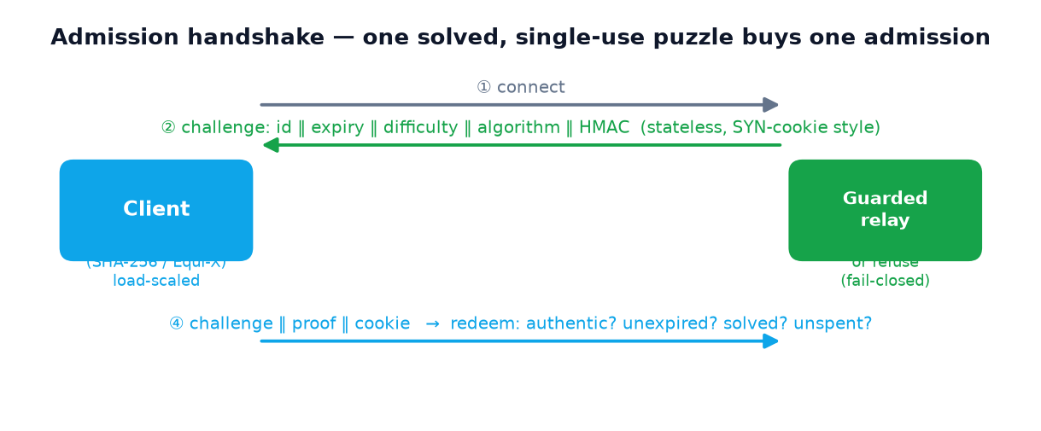
Figure 2. The stateless admission handshake: the server issues a self-authenticating challenge, the client pays the proof of work, and the server verifies authenticity → freshness → work → single-use, each failing closed.

12.1 Load-scaled difficulty
The parking map is bounded to a capacity, and that same capacity is the load signal (load = parked / capacity), complemented by an AIMD controller (Section 14) that watches the rate of admission attempts so that a flood which never successfully parks still raises the price. The load-to-difficulty map is defined as BASE_BITS + MAX_EXTRA_BITS · load, clamped to [8, 20] bits. It fails closed: a non-finite load (for example 0/0 from a reset counter) is priced as full, 20 bits, not as zero — an earlier version that mapped it to the base was the quieter form of the same bug and was corrected (finding F20, Section 32).

13. Proof-of-Work Puzzles
The default puzzle is SHA-256 leading-zero-bits: dependency-free, but the most ASIC/GPU-friendly choice possible, so a hardware attacker clears it far faster than an honest phone. Gyre abstracts the puzzle behind a PowAlgorithm trait with two implementations.
trait PowAlgorithm {
fn tag(&self) -> u8; // wire tag
fn solve(&self, challenge: &[u8;32], bits: u32) -> Vec<u8>; // client pays
fn verify(&self, challenge: &[u8;32], proof: &[u8], bits: u32) -> bool; // server pays (cheap)
}
Sha256Pow : nonce search, 8-byte proof, ~2^bits hashes to solve, one hash to verify.
EquixPow : memory-hard Equi-X; opt-in `equix` Cargo feature (LGPL isolated).
Equi-X is the memory-hard function Tor deployed for exactly this reason [8], combining an Equihash-style solver [9] with the ASIC-resistant HashX function [10]. Because Equi-X is fixed-cost, tunable difficulty is layered on as Tor does it — search nonces until a solution’s hash clears an effort target — which preserves the cheap-to-verify asymmetry. Gyre’s [8, 20]-bit knob maps to a small [0, 3]-bit effort for Equi-X, so the memory-hardness of a single solve, not the bit count, is the cost. The equix/hashx crates are LGPL-3.0, so they ship behind an opt-in build feature: the default build is permissively licensed and never links them; an operator enables the feature and selects it with gyre-rendezvous --pow equix, which fails closed (refuses to start) if the binary was not built with the feature. Verification against the asymmetric SHA-256 default is 256× at the idle floor and ≈65,500× at 16 bits (Section 28). A client-side cap (MAX_ACCEPTED_DIFFICULTY = 24 bits) stops a malicious relay from pinning a client in an unbounded solve.

14. Denial-of-Service Defense in Depth
Beyond admission pricing, the guarded relay enforces a layered set of bounds (Figure 3), each with a discriminating test.
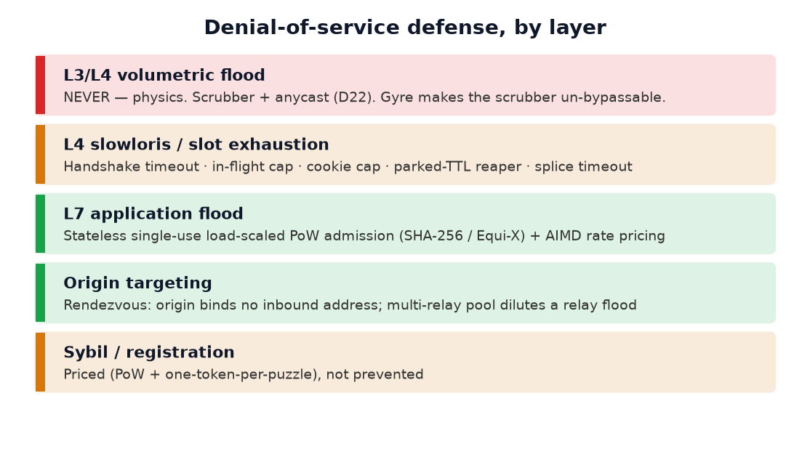
Figure 3. Denial-of-service defense by layer. Volumetric floods are never defended at this layer (D22); everything above it is built and tested.
Table 3. Defense-in-depth bounds (all built and tested).
Bound | Mechanism
Slowloris duration | `handshake_timeout` (default 10 s) wraps the whole admit() future
In-flight count | `max_inflight` semaphore (default 256); excess dropped at accept
Parked count | `capacity` (default 1024); over-cap parks refused (`AtCapacity`)
Parked age | `parked_ttl` reaper (default 60 s) sweeping at half-TTL
Cookie size | `max_cookie_len` (default 128 B), removing capacity×1 MiB amplification
Splice lifetime | `splice_timeout` caps a spliced pair’s total lifetime
Rate (never-park flood) | AIMD effort controller: difficulty = max(occupancy, attempt-rate)
Session hijack | Authenticated cookies: HMAC match + mutual challenge-response
Relay-targeted flood | Multi-relay pool: park on k relays, dilute ~linearly in k
Malicious-relay solve | Client difficulty cap (≤ 24 bits) + time-bounded park dial
Sybil via tokens | One solved puzzle mints ≤ 1 token (finding F14)

15. The Denial-of-Service Taxonomy
Denial of service is not one attack but a stack, and the single most common way a privacy tool overclaims is to blur the layers. Told straight:
Table 4. What Gyre can and cannot do against each DoS class.
Class | Example | Can Gyre help?
Volumetric (L3/L4) | UDP/SYN/amplification saturating the pipe | No, and never — physics; a scrubber’s job (D22), which Gyre’s origin-hiding makes un-bypassable.
Targeted origin flood | Attacker found the server IP and floods it | Yes — by removing the target; the origin binds no inbound address.
Application-layer (L7) | HTTP hammering, connection exhaustion | Yes — by pricing admission; it runs and refuses floods live.
Sybil / registration | Mass fake identities to drown a system | Priced, not prevented — PoW and tokens raise the cost of an identity.

Part V — Authorization and Supporting Mechanisms

16. Capability Tokens (Authorization)
A pre-authorized client may skip the proof-of-work by redeeming an anonymous, single-use capability token — the Privacy Pass model [7] (D15). The token is a verifiable OPRF per RFC 9497 [6]: the client blinds a value, the issuer evaluates it, and the client unblinds to obtain a token the issuer cannot link to the issuance.

16.1 Unlinkability and the key-partitioning defense
Correct unlinkability is subtle and we treat it as such. The issuer proves correct evaluation with a Chaum–Pedersen discrete-log-equality (DLEQ) proof [13] made non-interactive by Fiat–Shamir [14]; the client verifies that proof at unblind time against a public key it pins from the threshold-signed consensus, not from the issuer. This defeats issuer key-partitioning — handing each client a distinct key and re-identifying it at redemption. An earlier, hand-rolled version of this token shipped in base-OPRF mode with no DLEQ proof; a proof-of-concept linked 5 of 5 clients. Adding the DLEQ check and consensus-pinned verification reduced that to 0 of 5, with a negative control confirming a rogue issuer’s proof still verifies against its own key.

16.2 Issuance binding and epochs
Token issuance is itself bound to a solved, single-use admission puzzle (finding F14), so one puzzle mints at most one token and the fast path is not a free Sybil oracle. The issuer key rotates by epoch and the spent set is pruned on rotation, bounding its growth. Costs are small: blind 25µs, issue (with DLEQ) 108µs, unblind (with verification) 150µs, redeem 25µs (Section 28).
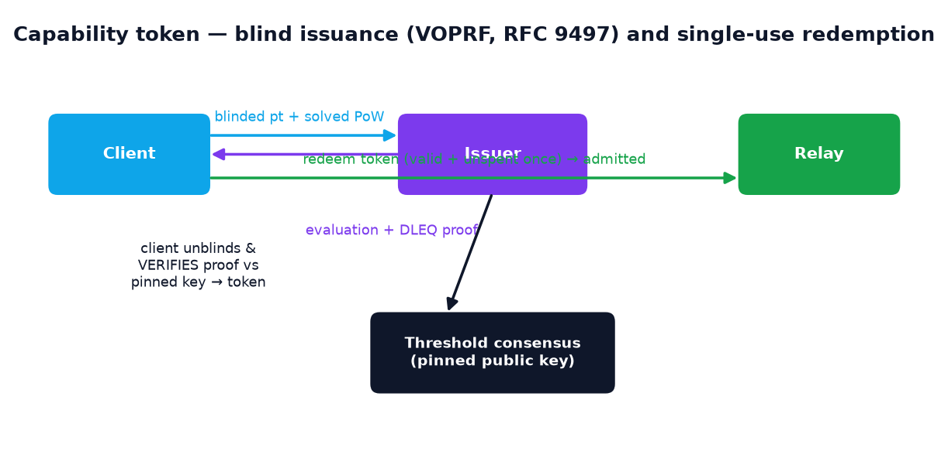
Figure 4. Capability-token issuance (blind VOPRF + DLEQ) and single-use redemption; the client verifies the issuer’s proof against a key pinned from the signed consensus, which defeats issuer key-partitioning.

17. Decentralized Directory and Attestation
The trust locus is a t-of-n threshold-signed consensus of relay descriptors and network parameters, with reproducible-build attestation (D16, Addition 4). No single coercible authority is load-bearing, and a lying or equivocating directory leaves public cryptographic evidence — detection, not prevention. An earlier threshold check that accepted an unsigned document when the threshold was zero was found and fixed (it now fails closed).

18. Private Information Retrieval
A client can fetch a directory record without either server learning which, via an information-theoretic two-server PIR [25] (D18, Addition 6): two query masks differ only at the target index, each alone selects about half the records, and the client XORs the answers to recover the target. It is off by default — downloading the identical signed consensus already leaks nothing and is cheaper — and the privacy holds only under the non-collusion assumption, which Sybil infrastructure threatens. One server answers 256×1 KiB in 1.8µs; the client recovers in 32ns (Section 28).

19. Forward-Secret Sessions
Persistence is addressed with forward-secret, per-context sessions (D14, Addition 2): a symmetric key ratchet advances per message so a captured key exposes one message, and compartmentalized personas make different contexts cryptographically unlinkable. A ratchet step costs 193ns. We are explicit that this contains a compromise, it does not cure one: an actively compromised endpoint reads plaintext regardless, so this is data-minimization and cross-context unlinkability, not endpoint invincibility.

20. Obfuscation and Pluggable Transports
The appearance dimension is covered by a pluggable-transport framework (D13, Addition 1): the first hop can be reshaped to look like random noise (a polymorphic transport driving payloads to high entropy), ordinary TLS, or an LSB-stego carrier. The polymorphic transport is authenticated (encrypt-then-MAC), so a wrong key or tampering is a clean, deterministic error rather than garbage plaintext. We state the honest ceiling: this changes appearance only, has zero anonymity effect, and a uniform-random stream is itself a fingerprint — “unblockable” is not a property any obfuscation can claim.

21. Steganography (situational)
Least-significant-bit steganography is wired as a transport (D17, Addition 5), embedding a payload in the LSBs of a generated cover at ≈24 GiB/s. We are explicit that this is plumbing, not deniability: real deniability needs an innocuous real cover (a genuine photo or audio file) that the fabric does not carry, and LSB embedding is detectable by steganalysis. The mechanism is wired; the dimension’s goal is honestly left uncovered.
Part VI — Coverage and Security Analysis

22. The Thirteen Dimensions of Coverage
Every privacy mechanism hides one dimension of the signal a user emits. Gyre maps thirteen and reports them honestly: ten are covered and wired, one (steganographic existence) is mechanism-only, and two are uncoverable by code — the crowd (social) and the endpoint (physics). Claiming the last two would be the single overclaim that discredits the honest eleven.
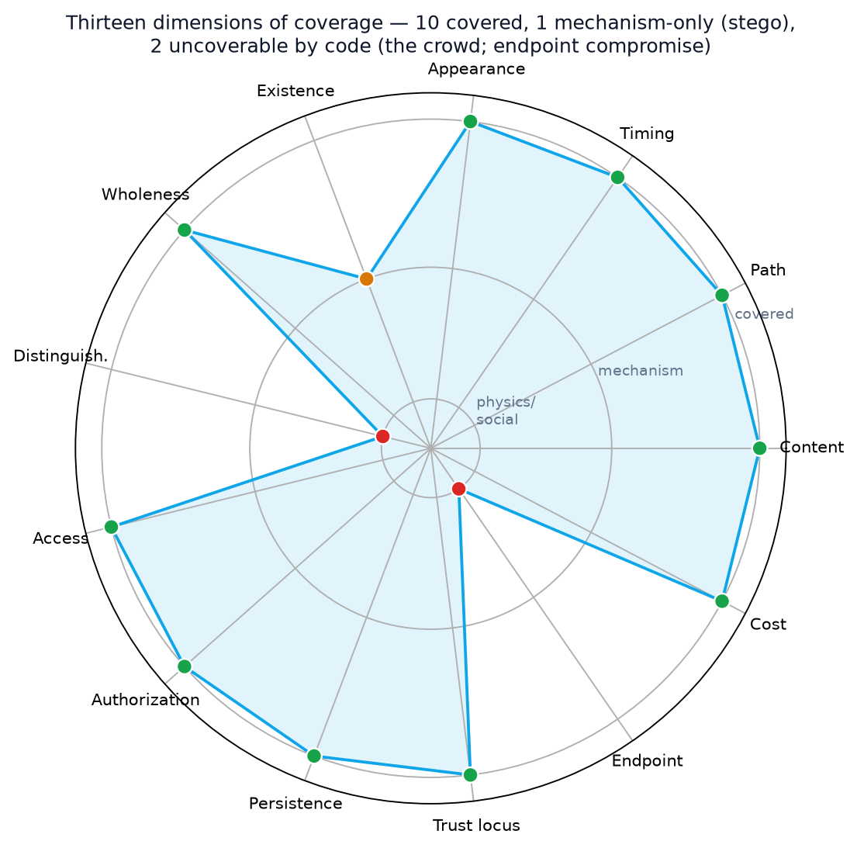
Figure 5. Coverage across the thirteen dimensions. Green = covered and wired; amber = mechanism-only; red = uncoverable by code.
Table 5. The thirteen dimensions.
Dimension | Mechanism in Gyre | Status
Content | Sphinx onion encryption | covered
Path | Onion routing + rendezvous | covered
Timing | Poisson mixing + cover traffic | covered
Appearance | Pluggable authenticated transports | covered
Existence | LSB steganography (synthetic cover) | mechanism-only
Wholeness | Erasure-coded multipath | covered
Distinguishability | The anonymity set / crowd | uncoverable (social)
Access pattern | Two-server IT-PIR | covered
Authorization | VOPRF capability tokens | covered
Persistence | Forward-secret sessions | covered
Trust locus | Threshold consensus + attestation | covered
Endpoint | Hardware / execution isolation | uncoverable (physics)
Cost | Proof-of-work admission | covered

23. Attacks Defended, and How
Table 6. Named attacks and the mechanism that stands between them and the asset.
Attack | Mechanism | Protects | Status
Origin-IP discovery / direct flood | Rendezvous: origin binds no inbound address | system | real, end to end
L7 application flood | Stateless single-use load-scaled PoW admission | system | wired & live
Slowloris / slot exhaustion | Handshake timeout + in-flight/cookie/parked caps | system | built & tested
Rate flood that never parks | AIMD attempt-rate pricing | system | built & tested
Session hijack (leaked cookie) | Authenticated rendezvous | system | built & tested
Issuer-side deanonymisation | VOPRF + DLEQ vs. pinned consensus key | individual | real & tested
Traffic correlation (timing) | Sphinx onion + sealed Loopix delays | individual | real; crowd-gated
Sybil / registration flood | PoW + one-token-per-puzzle pricing | system | priced

24. Security Analysis and Failure Modes
Three design habits bound the system’s failure modes. First, fail closed: every admission check denies by default, an unmeasurable load is priced as full, and an unsupported puzzle algorithm is refused rather than admitted. Second, bound before allocate: the wire parser checks the declared proof length against MAX_PROOF_LEN before slicing or allocating, so a crafted length cannot amplify memory. Third, discriminating tests: each security property is guarded by a test confirmed to fail when its code is reverted, so the test suite proves the property rather than merely exercising the happy path. The guarded-relay code was additionally subjected to an adversarial multi-reviewer audit over wire bounds, algorithm binding, Equi-X effort correctness, replay, and panic reachability, which returned zero confirmed findings.
Part VII — Evaluation

25. Methodology
Anonymity is evaluated with gyre-sim, a discrete-event simulator that drives the real protocol code — real Sphinx onions, real X25519 relay keys, the real Loopix delay sampler, real packet sizes — under a partial observer. The attacker is optimal: flow correlation is an assignment problem, and the attacker scores every candidate pairing by its maximum-likelihood (Erlang) cost and solves it with the Hungarian algorithm, verified against brute force at small sizes. A greedy attacker is run on the identical cost matrix only to quantify how much a weak attacker understates the risk. Measuring against a weak attacker makes anonymity look better than it is; the optimal matcher is the number worth reporting. Flows are multi-packet streams, because a single packet carries almost no timing signal and modelling one packet per flow would flatter the design.

26. Anonymity Results
Figures 6, 7 and 8 and Tables 7–10 give the measured results (150 flows unless noted, chance 0.0067, mean ± standard deviation over independent runs).
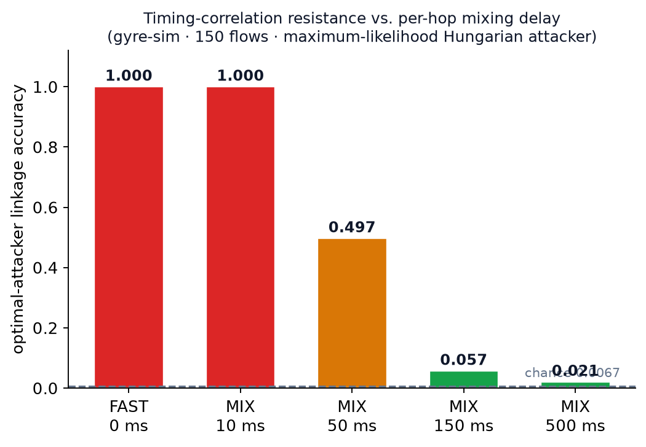
Figure 6. Mixing is the real correlation-resistance lever; useful settings begin around 150 ms/hop.
Table 7. Optimal vs. greedy attacker across per-hop mixing delay.
mix / hop | lane | optimal | greedy | chance
0 ms | FAST | 1.000 | 0.949 | 0.0067
10 ms | MIX | 1.000 | 0.989 | 0.0067
50 ms | MIX | 0.497 | 0.282 | 0.0067
150 ms | MIX | 0.057 | 0.028 | 0.0067
500 ms | MIX | 0.021 | 0.016 | 0.0067

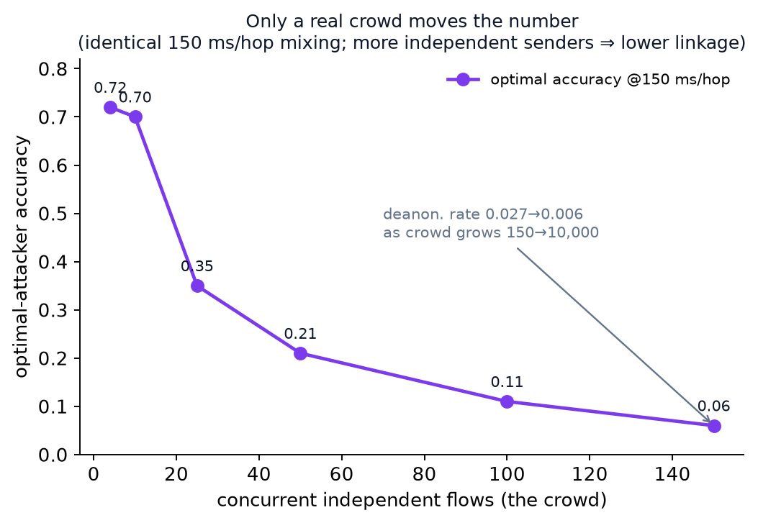
Figure 7. The crowd is the binding constraint: only more real, independent senders move the number.
Table 8. Accuracy vs. crowd size at 150 ms/hop; the accuracy-to-chance ratio does not improve.
flows | optimal accuracy | chance | accuracy vs chance
4 | 0.719 ±0.291 | 0.2500 | 2.9×
10 | 0.612 ±0.267 | 0.1000 | 6.1×
25 | 0.320 ±0.089 | 0.0400 | 8.0×
50 | 0.210 ±0.068 | 0.0200 | 10.5×
100 | 0.097 ±0.014 | 0.0100 | 9.7×
150 | 0.063 ±0.019 | 0.0067 | 9.5×

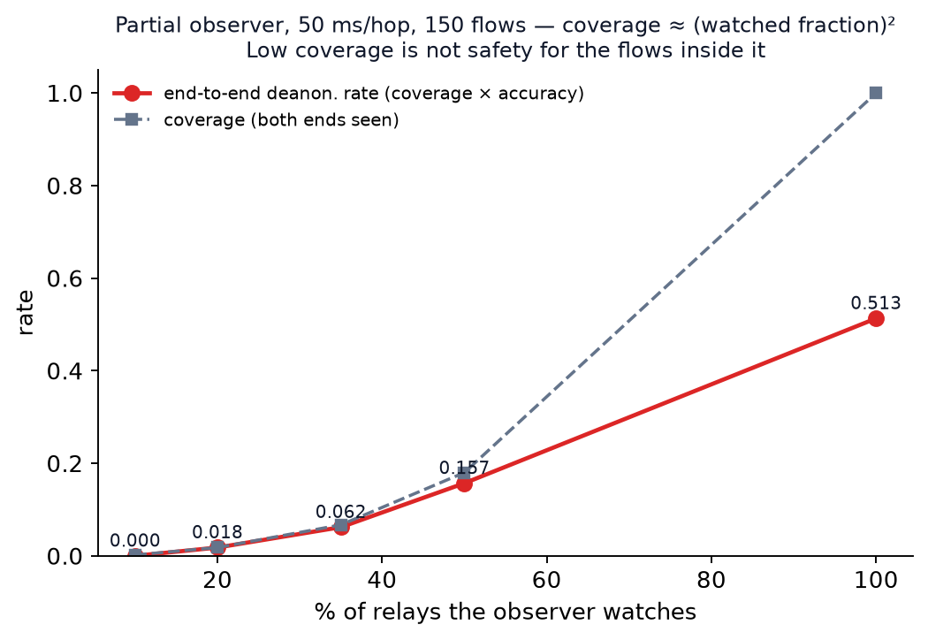
Figure 8. A partial observer needs both ends, so coverage falls off quadratically; but the few flows it does see, it links with near-certainty.
Table 9. Partial observer, 50 ms/hop: end-to-end deanonymisation rate = coverage × accuracy.
relays watched | coverage | linkable | optimal accuracy | deanon rate
10% | 0.002 | 0.2 | n/a | 0.000
20% | 0.018 | 2.6 | 1.000 | 0.018 ±0.007
35% | 0.067 | 10.0 | 0.954 | 0.062 ±0.036
50% | 0.180 | 27.0 | 0.911 | 0.157 ±0.049
100% | 1.000 | 150.0 | 0.513 | 0.513 ±0.047

Table 10. The trilemma, measured: cover traffic costs bandwidth and buys nothing in the accuracy column.
mix / hop | cover/flow | accuracy | p50 latency | p99 latency | overhead
0 ms | 0 | 1.000 | 100 ms | 113 ms | 59.7×
50 ms | 0 | 0.509 | 185 ms | 432 ms | 59.7×
150 ms | 0 | 0.068 | 352 ms | 1102 ms | 59.7×
150 ms | 1 | 0.079 | 352 ms | 1073 ms | 67.1×
150 ms | 3 | 0.072 | 354 ms | 1097 ms | 82.0×

The scale evaluation, with realistic heterogeneous traffic and a 20% observer, runs to 10,000 concurrent flows: the end-to-end deanonymisation rate falls from 0.027 at 150 flows to 0.006 at 10,000 — the number a real crowd moves, which no synthetic cover reproduces.

27. Real-Binary Simulation (Shadow)
A separate evaluation runs the real compiled binaries as independent OS processes under the Shadow network simulator [17], confirming that mixing reorders packets over real TCP across real processes and that the admission gate refuses an application-layer flood in the field. The Shadow runs are deliberately small (8 hosts) and carry no adversary; they test the implementation’s behaviour, not its anonymity, and we keep that distinction explicit — reordering is not anonymity.

28. Microbenchmarks
Table 11. Primitive microbenchmarks (Apple M-series; primitive-only, not end-to-end).
Operation | Cost | Note
Sphinx wrap (build 3-hop onion) | 142 µs | ~7,000 packets/s
Sphinx process (peel one hop) | 44.6 µs | ~22,400 hops/s
Reed–Solomon 4+2 encode | 36.3 µs | 1.68 GiB/s
VOPRF blind (client) | 25.1 µs | —
VOPRF issue (blind-eval + DLEQ) | 107.5 µs | issuer
VOPRF unblind (verify + finalize) | 150.4 µs | client
VOPRF verify (redemption) | 24.5 µs | issuer
PoW solve @16 bits | 3.52 ms | client (one sample)
PoW verify | 15.0 ns | server (one hash)
PoW asymmetry @16 bits / idle 8 bits | 65,500× / 256× | expected, bits named
Forward-secret ratchet step | 193 ns | ~5.2M steps/s
2-server PIR answer / recover | 1.84 µs / 32 ns | 256×1 KiB
LSB stego embed / extract | 2.57 µs / 1.92 µs | 64 KiB cover

29. Honest Reading of the Numbers
Mixing is the real lever and it works, against an optimal attacker, at an honest latency cost the operator dials in. Anonymity is the size of the concurrent crowd, and the ratio of attacker accuracy to blind chance stays roughly an order of magnitude above guessing at every small crowd size measured — the code supplies how hard each guess is, only a crowd supplies how many guesses there are [11]. These figures come from the simulator alone; a true comparison against Tor at scale requires a large Shadow deployment that has not been run. Notably, this methodology corrected the project’s own earlier, weaker harness, whose MIX-lane numbers were roughly 4.5× too optimistic — a correction documented rather than buried.
Part VIII — Engineering

30. Implementation and Testing
Gyre is implemented in Rust (MSRV 1.85) as a workspace of 15 product crates with 225 automated tests (plus 76 more under the optional Equi-X feature). Continuous integration enforces formatting, Clippy linting at deny-warnings, and the full test suite on every push. Testing methodology is deliberate: property-based tests (proptest) include a “parsing arbitrary bytes never panics” property for every untrusted-input parser; fuzz targets exist for the Sphinx parser; and security properties use discriminating tests confirmed to fail when the guarded code is reverted. A recorded lesson is that a property which cannot fail is worthless; several were rewritten after a vacuous NaN property was caught.

31. Deployment and Operations
The guarded rendezvous relay ships as a deployable daemon, gyre-rendezvous, with a companion origin (gyre-origin) and client (gyre-reach). One-click launchers for macOS, Linux, and Windows build and run it locally and open a live web dashboard; the dashboard serves a dependency-free status page (admissions, refusals, parked connections, effort load) that makes the gate’s behaviour visible in real time. Key operator flags:
Table 12. Principal gyre-rendezvous flags and defaults.
Flag | Default | Purpose
--listen | 0.0.0.0:9500 | bind address
--pow | sha256 | puzzle algorithm (sha256 | equix)
--capacity | 1024 | max parked connections = load denominator
--max-inflight | 256 | concurrent admission handshakes
--handshake-timeout-secs | 10 | slowloris bound
--ttl-secs | 30 | challenge lifetime
--parked-ttl-secs | 60 | evict an unmet park by age
--max-cookie-len | 128 | cookie-size cap
--dashboard | 127.0.0.1:9600 | live web status page

The honest deployment scope is stated plainly in the operator documentation: the Shield is TCP-based and useful to one user, so it can go live on any reachable host; the outbound Mixer is not safe to rely on for anonymity until there is a crowd, and the shipped relay uses a per-process random admission key, not the public simulation keys used by the testnet. There is no volumetric defence and the cookie is a bearer secret.

32. Honesty and Corrections Record
A distinctive feature of this project is that its mistakes are documented, with dated corrections, rather than quietly edited away. The most significant:
- The “audited voprf” overclaim. The VOPRF library was described as “audited” in several places; in fact no crate in the tree has an audited released version. The 2021 NCC Group review [24] covered opaque-ke v0.5.0, which predated the voprf extraction. Code lineage is not audit coverage; all such claims were removed with dated notes.
- The GATE was ~4.5× optimistic. The original weak-attacker harness flattered the MIX lane; the optimal-attacker simulator corrected it, and the corrected numbers are the ones reported here (Section 26).
- A VOPRF key-partitioning break (linked 5/5), a load-estimator that failed to the cheapest price rather than fully (F20), a build-blessing check and a consensus-threshold check that failed open at threshold zero, and a silently-truncating directory encoder (F19) were each found by self- or adversarial review and fixed with discriminating tests.
- QUIC was described as wired when it was library-only; the claim was retracted. Anti-overclaim rule 3 — never count cover/decoy traffic as real senders — is enforced in the evaluation.
Part IX — Conclusion

33. Related Work
Gyre stands directly on the mix-network and onion-routing lineage: Chaum’s mixes [1], the Mixminion remailer [20], the Sphinx format [2], Tor [3], and the Loopix [4] and Nym [23] continuous-cover mixnets. Its inbound rotor mirrors Tor onion services and their proof-of-work admission (proposal 327) [8]. Its capability token follows Privacy Pass [7] over the RFC 9497 VOPRF [6]. Its private retrieval follows the PIR literature [25][26]. Its honesty framing is grounded in the anonymity trilemma [5], “Anonymity Loves Company” [11], and Crowds [12]; its threat model takes modern learned correlation attacks [18][19] seriously; and its evaluation follows sound Tor-experimentation practice [17]. Where Gyre differs is integration: it ships the outbound mixer’s dialable mixing and the inbound shield’s complete, deployable DoS admission on one fabric, with every claim measured.

34. Limitations and Future Work
The limits are restated as conclusions. Gyre cannot beat a global passive observer at low latency, cannot manufacture a crowd, cannot help once the endpoint is compromised, and provides no volumetric L3/L4 defence by construction. Its capability token is built on a maintained library but is itself unaudited; this document is written in part to invite that external review. Concrete engineering items are: wiring moving-target ingress into a live dialer; reaching QUIC/MASQUE transport and AS-aware path selection (D21); a hybrid post-quantum key exchange for the onion layer; and scaling the simulator and a Shadow-versus-Tor comparison to the 10⁵-user regime that published mixnet studies reach.

35. Conclusion
Gyre demonstrates that a single relay fabric can host a competitive-by-design outbound mixer and a deployable inbound shield, and that a privacy system can be built honestly — measuring every claim and refusing the overclaims that discredit the field. The inbound rotor is as complete as code can make it. The outbound rotor is built and measured but gated on the one thing code cannot supply: a real, independent crowd. The highest-leverage future work is therefore not more mechanism but external cryptographic review, real deployment, and adoption.
Appendices

Appendix A — Decision Log (D1–D22)
# | Decision
D1 | Two rotors, not one box.
D2 | Rotation is defense, not anonymity.
D3 | Anonymity = unlinkability + crowd.
D4 | Respect the trilemma; target a partial observer.
D5 | Onion capped at 3 hops.
D6 | Mixing + shared cover traffic.
D7 | Erasure multipath = probabilistic middle-path hardening, not a reconstruction threshold (endpoints stay exposed).
D8 | Adaptive per-flow mixing is the performance lever, sealed in the onion.
D9 | Inbound = rendezvous + MTD + PoW + tokens.
D10 | Combine orthogonally (a matrix, not a stack).
D11 | Do not build crypto/transport from scratch.
D12 | The crowd is the hardest problem.
D13 | Obfuscation / pluggable transport.
D14 | Endpoint isolation + data minimization.
D15 | Anonymous credentials.
D16 | Decentralization + attestation (detection, not prevention).
D17 | Deniability / steganography (situational).
D18 | PIR surgical, default OFF.
D19 | Position as integration, not a record-holder.
D20 | Crowd bootstrap is the critical path, not crypto.
D21 | Speed = FAST/MIX lanes + QUIC/MASQUE + AS-aware paths (match or modest win vs modern Tor, not “beat”).
D22 | Trust-topology for closed/enterprise tunnels; MTD serves an authorized set; no L3/L4 volumetric defence.

Appendix B — Parameter Reference
Parameter | Default / value | Where
Onion hops | 3 | D5
Admission difficulty | [8, 20] bits (BASE 8 + MAX_EXTRA 12 × load) | gyre-shield::lib
Client difficulty cap | 24 bits | rendezvous
Challenge length | 77 bytes | admission
Max proof length | 64 bytes | rendezvous
Equi-X effort mapping | [8,20] bits → [0,3] effort bits | pow
Token sizes | element 32, proof 64, output 64, token 96 bytes | token
Default capacity / inflight | 1024 / 256 | RelayConfig
Default TTL / handshake / parked-TTL / cookie | 30 s / 10 s / 60 s / 128 B | RelayConfig

Appendix C — Glossary
- Admission gate. The proof-of-work protocol every connection must pass before it can park or splice.
- Cover traffic. Dummy loop/drop messages that provide unobservability; overhead against an end-to-end correlator.
- DLEQ. Discrete-log-equality proof; here, proof that a VOPRF evaluation used the pinned key.
- Deanonymisation rate. coverage × accuracy; the honest end-to-end anonymity number.
- MTD. Moving-target defense; a keyed, rotating ingress address for an authorized client set.
- Rendezvous. A relay where a dial-out origin and a client meet behind a shared cookie; the origin binds no inbound address.
- VOPRF. Verifiable oblivious pseudorandom function (RFC 9497); the basis of the unlinkable capability token.

References
[1] D. Chaum. Untraceable Electronic Mail, Return Addresses, and Digital Pseudonyms. Communications of the ACM, 24(2), 1981.
[2] G. Danezis and I. Goldberg. Sphinx: A Compact and Provably Secure Mix Format. IEEE Symposium on Security and Privacy, 2009.
[3] R. Dingledine, N. Mathewson, and P. Syverson. Tor: The Second-Generation Onion Router. USENIX Security, 2004.
[4] A. M. Piotrowska, J. Hayes, T. Elahi, S. Meiser, and G. Danezis. The Loopix Anonymity System. USENIX Security, 2017.
[5] D. Das, S. Meiser, E. Mohammadi, and A. Kate. Anonymity Trilemma: Strong Anonymity, Low Bandwidth Overhead, Low Latency — Choose Two. IEEE Symposium on Security and Privacy, 2018.
[6] A. Davidson, A. Faz-Hernandez, N. Sullivan, and C. A. Wood. RFC 9497: Oblivious Pseudorandom Functions (OPRFs) Using Prime-Order Groups. IRTF/CFRG, 2023.
[7] A. Davidson, I. Goldberg, N. Sullivan, G. Tankersley, and F. Valsorda. Privacy Pass: Bypassing Internet Challenges Anonymously. PoPETs, 2018(3).
[8] The Tor Project. Proposal 327: A First Take at PoW Over Introduction Circuits (Equi-X). Tor spec, 2020.
[9] A. Biryukov and D. Khovratovich. Equihash: Asymmetric Proof-of-Work Based on the Generalized Birthday Problem. NDSS, 2016.
[10] tevador. RandomX, HashX, and Equi-X — ASIC-resistant proof-of-work functions. Open-source; Rust ports in the Tor Arti project.
[11] R. Dingledine and N. Mathewson. Anonymity Loves Company: Usability and the Network Effect. WEIS, 2006.
[12] M. K. Reiter and A. D. Rubin. Crowds: Anonymity for Web Transactions. ACM TISSEC, 1(1), 1998.
[13] D. Chaum and T. P. Pedersen. Wallet Databases with Observers. CRYPTO, 1992. (DLEQ proofs.)
[14] A. Fiat and A. Shamir. How to Prove Yourself: Practical Solutions to Identification and Signature Problems. CRYPTO, 1986.
[15] D. J. Bernstein. Curve25519: New Diffie-Hellman Speed Records. PKC, 2006.
[16] I. S. Reed and G. Solomon. Polynomial Codes over Certain Finite Fields. J. SIAM, 8(2), 1960.
[17] R. Jansen, J. Tracey, and I. Goldberg. Once is Never Enough: Foundations for Sound Statistical Inference in Tor Network Experimentation. USENIX Security, 2021.
[18] M. Nasr, A. Bahramali, and A. Houmansadr. DeepCorr: Strong Flow Correlation Attacks on Tor Using Deep Learning. ACM CCS, 2018.
[19] S. E. Oh, T. Yang, N. Mathews, et al. DeepCoFFEA: Improved Flow Correlation Attacks on Tor. IEEE S&P, 2022.
[20] G. Danezis, R. Dingledine, and N. Mathewson. Mixminion: Design of a Type III Anonymous Remailer Protocol. IEEE S&P, 2003.
[21] A. Kerckhoffs. La cryptographie militaire. Journal des sciences militaires, 1883.
[22] S. Jajodia et al. (eds.). Moving Target Defense: Creating Asymmetric Uncertainty for Cyber Threats. Springer, 2011.
[23] Nym Technologies. The Nym Network: A Decentralized Mixnet for Metadata Protection. Whitepaper, 2021.
[24] NCC Group. Public Report: WhatsApp opaque-ke Cryptographic Implementation Review. 2021.
[25] B. Chor, O. Goldreich, E. Kushilevitz, and M. Sudan. Private Information Retrieval. Journal of the ACM, 45(6), 1998.
[26] C. Gentry and Z. Ramzan. Single-Database Private Information Retrieval with Constant Communication Rate. ICALP, 2005.
[27] N. Alexopoulos, A. Kiayias, R. Talviste, and T. Zacharias. MCMix: Anonymous Messaging via Secure Multiparty Computation. USENIX Security, 2017.

