LINUX ASSIGNMENT WORKING PROCEDURE

PRE-PROCEDURE OF EXECUTING LINUX COMMAND

First I have install **ubuntu operating system** and **virtual box** in my windows operating system.

After that I started virtual box and ubantu operating system and clicked on “**Activity**” button and search “**Terminal**” Keyword . Then open Terminal for executing the linux command .

PROCEDURE OF EXECUTING LINUX COMMAND AS PER LINUX-ASSIGNMENT TASK

**TASK 1 - Create a new directory called linux-assignment in your home directory.**

* **Image of home directory before the creating of linux-assignment directory**

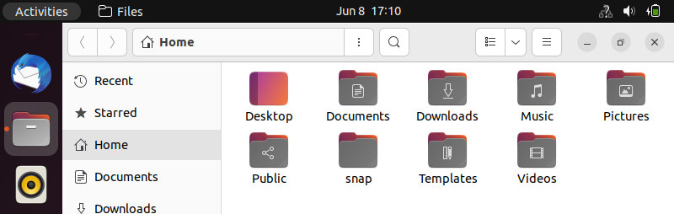

Fig 1.1

In fig 1.1 shows the files presented in home directory before the creating of linux-assignment directory.

* 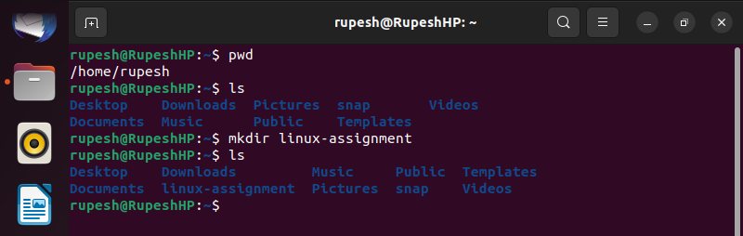Image of command Terminal at the time of creating linux-assignment directory.

First use **pwd** command to view the current working directory.

Then **ls** command used to display a list of all files in **/home** directory. There is not display any **linux-assignment** directory.

Then I have used **mkdir linux-assignment** command for creating new directory.

After executing these command for checking linux-assignment directory created or not used ls command .

And new created “linux-assignment” directory will be dispalayed.

* 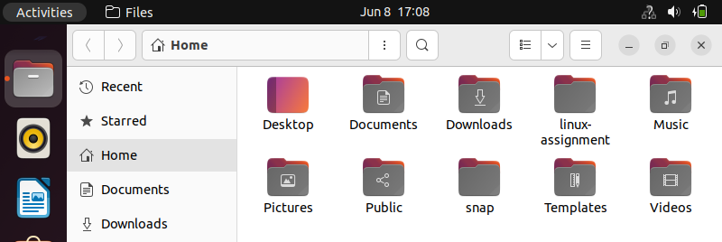**GUI image of after creating linux-assignment directory.**

Fig 1.3

**TASK 2 - Navigate into the linux-assignment directory.**

* 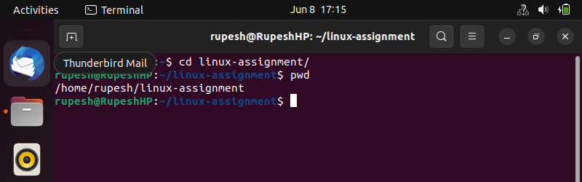**Image of command terminal at the time of navigate into linux-assignment directory**

Fig 2.1

Here I have used **cd** command for changed current directory and goes into **linux- assignment** directory. Then **pwd** command used for checking actually directory change or not ? Means in simple words checking current working directory path/location.

**TASK 3 - Create a new file called instructions.txt.**

* 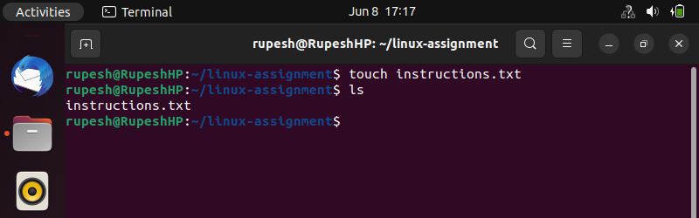**Image of command terminal at the time of creating new text file.**

Fig 3.1

In linux by using **touch** command I have created “instructions.txt” File. Then used **ls** command for checking current working directory files.

* 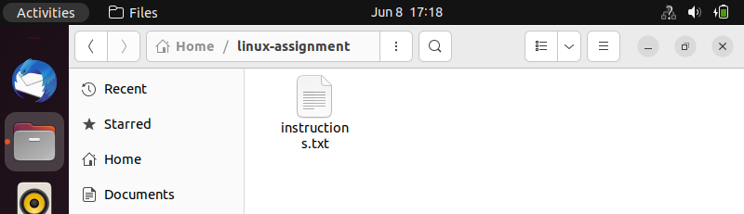**GUI Image of Linux-assignment directory after creating instruction.txt file**

Fig 3.2

**TASK 4 - Write "Hello, World!" into instructions.txt using a command-line.**

* 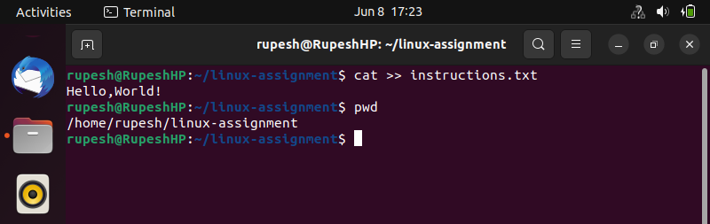**Image of command terminal at the time of write “Hello,World!” text into instruction.txt file.**

Fig 4.1

Here I have used “**cat >> instructions.txt**” command for accessing instructions.txt file for writing “Hello, World!” text (content) in that file.

After written text Pressed “**CTRL + D** “ for saving content in instructions.txt file.

* **GUI Image of instructions.txt file that contents “Hello, World!” text.**

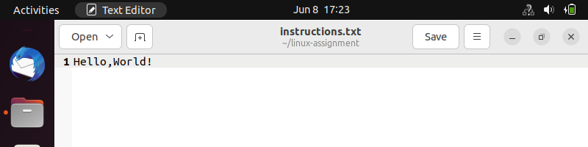

Fig 4.2

**TASK 5 - Display the contents of instructions.txt using a command.**

* 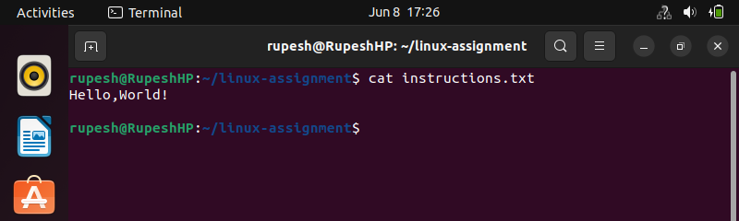**Image of command terminal at the time of display the content of file**

Fig 5.1

For display the content of instructions.txt file I have used cat command such as

“**cat instructions.txt**”

**TASK 6 -** **Rename instructions.txt to greetings.txt.**

* 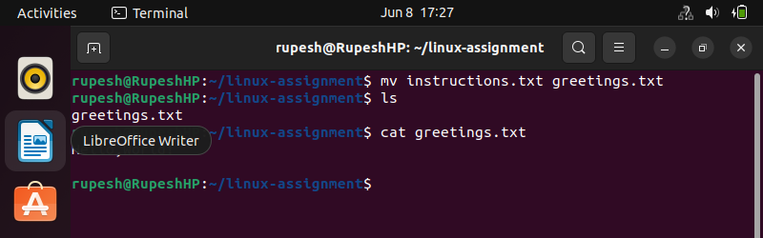**Image of command terminal at the time of rename file name.**

Fig 6.1

The “**mv**” command is used to move file or directory from one location to another location.

But here I have used “**mv**” command for rename the file instructions.txt to greetings.txt. And then “**ls**” command is used for to view the files in linux-assignment directory.

**TASK 7 - Copy greetings.txt to a new file called salutations.txt.**

* 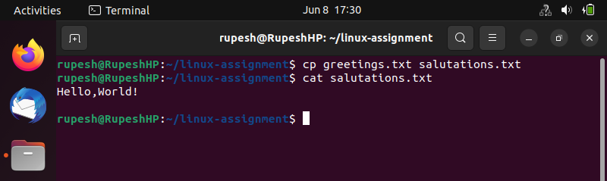 **Image of command terminal at the time of copy the file content into another file.**

Fig 7.1

Here I have used “ **cp greetings.txt salutaions.txt** “ command for copy the greetings.txt file content into newly created salutations.txt file.

And then “ **cat salutations.**txt “ command is used for display the copied content

Of salutation.txt file.

**TASK 8 - Delete greetings.txt.**

* 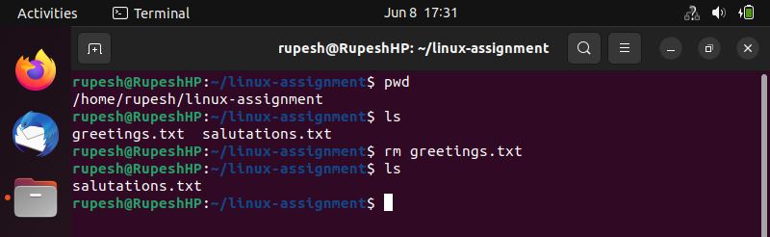**Image of command terminal at the time of delete file.**

Fig 8.1

Here I have first check current directory and which files present in current directory by using “**pwd**” and “**ls**” linux command.

Then for delete greetings.txt file use delete command such as “**rm greeting.txt**”. after using delete command I have again display the “linux-assignment” directory file for cross checking.

**TASK 9 - Create a new directory called archive.**

* 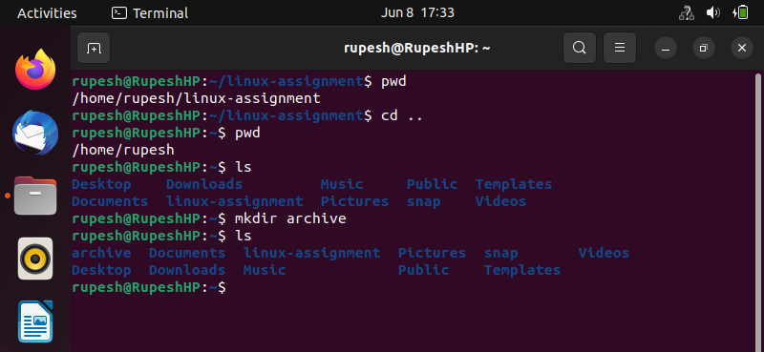**Image of command terminal at the time of create new directory called archive.**

Fig 9.1

Here I have used “**cd ..**” command for go back to the home directory. Then “**mkdir**” command is used to create new directory such as “**archive**”.

* 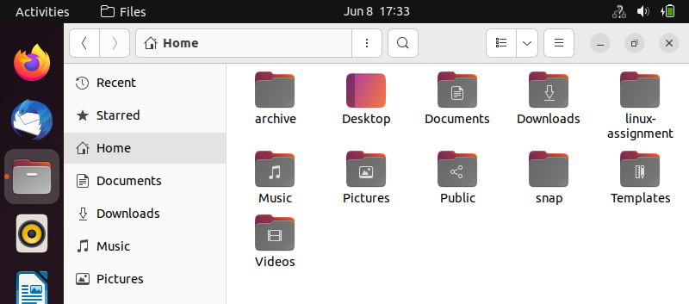**GUI Image create new directory archive.**

Fig 9.2

In fig 9.2 have display the new created “**archive**” directory.

**TASK 10 - Move salutations.txt to the archive directory.**

* 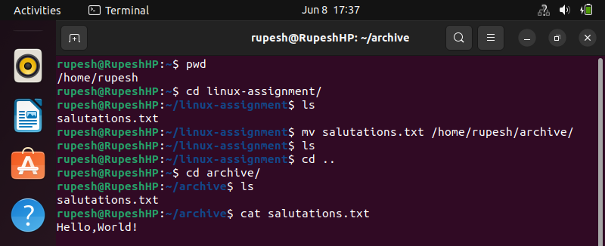**Image of command terminal at the time of moving file into other directory.**

Fig 10.1

For moving salutation.txt file to the archive directory I have used

“**mv salutations.txt /home/rupesh/archive**” command . in that “**mv**” is moving file

command . salutations.txt files moved to /home/rupesh/archive path.

**TASK 11 - Display the current working directory to confirm that salutations.txt is now in the archive directory.**

* **Image of command terminal that can Display Current Working Directory.**

Fig 11.1

For display the current working directory I have used **pwd** command and display the

Content of salutation.txt file use **cat** command.

**TASK 12-** **Navigate back to the linux-assignment directory and create three new empty files named file1.txt, file2.txt, and file3.txt**.

* **Image of command terminal at the time of navigate back to the linux-assignment**

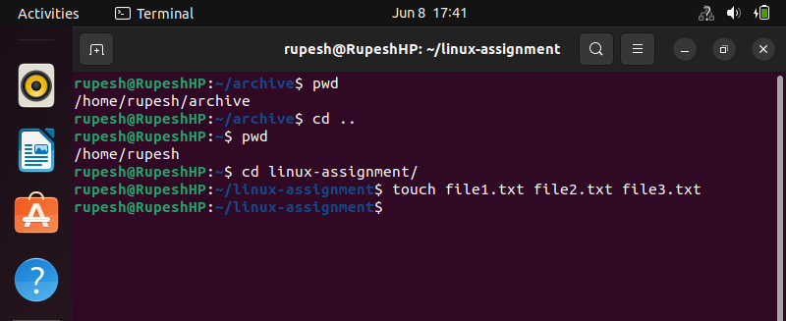**Directory and create empty 3 files.**

Fig 12.1

Here I have used “**cd ..**” command is used to moving back to Home directory.

And then “**cd linux-assignment**” command is used to go into linux-assignment directory.

Fo create file1.txt ,file2.txt and file3.txt empty files used “**touch file1.txt file2.txt file3.txt**” commands.

* 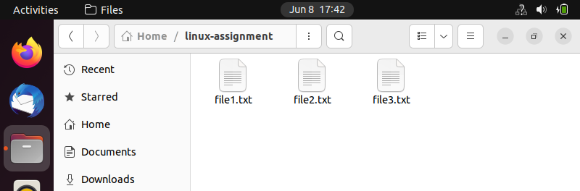**GUI Image of linux_assignment directoery.**

Fig 12.2

**TASK 13-** **Display the list of files in the linux-assignment directory to confirm the creation of the new files.**

* 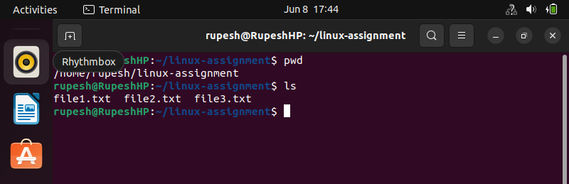**Image of command terminal at the time of displayed linux-assignment directory files.**

Fig 13.1

Here I have used first “**pwd**” command for display the current working directory path.

Then used “**ls**” command for display the linux-assignment directory files such as file1.txt ,file2.txt and file3.txt.

**TASK 14-** **Create a new text file in your home directory named linux-assignment-commands.txt and write down all the commands you used in this assignment.**

* 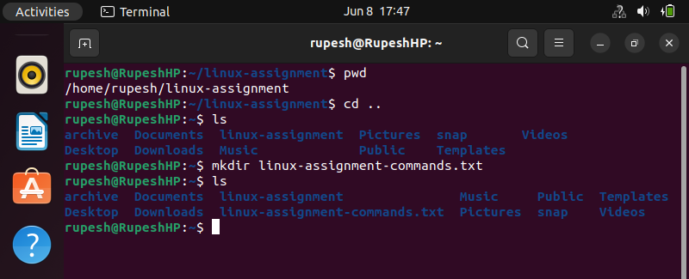**Image of command terminal at the time of create new file.**

Fig 14.1

Here I have created new “ **linux-assignment-commands.txt**” directory using using “**mkdir**” command.