1. What are the Boolean data type's two values? How do you go about writing them?

True, False

2. What are the three different types of Boolean operators?

And, or and Not

3. Make a list of each Boolean operator's truth tables (i.e. every possible combination of Boolean values for the operator and what it evaluate ).

And

True and True = True

True and False = False

False and True = False

False and False = False

OR

True or True = True

True or False = True

False or True = True

False or False = False

Not

Not True = False

Not False = True

4. What are the values of the following expressions?

(5 > 4) and (3 == 5) False

not (5 > 4) True

(5 > 4) or (3 == 5) True

not ((5 > 4) or (3 == 5)) True

(True and True) and (True == False) False

(not False) or (not True) True

5. What are the six different types of reference operators?

==, <, >, <=, >= , !=

6. How do you tell the difference between the equal to and assignment operators?

Equal to is == and assignment is =, Equal to comparing 2 variable while assignment operator is use to assign value to variable.

7. Describe a condition and when you would use one.

When we need to perform logical operation then we use condition.

8. Recognize the following three blocks in this code:

spam = 0

if spam == 10:

print('eggs')

if spam > 5:

print('bacon')

else:

print('ham')

print('spam')

print('spam')

Its print ‘spam’ because very first condition going to fail.

9. Create a programme that prints. If 1 is stored in spam, prints Hello; if 2 is stored in spam, prints Howdy; and if 3 is stored in spam, prints Salutations! if there's something else in spam.

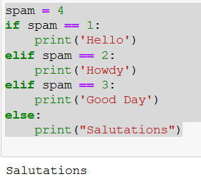

10.If your programme is stuck in an endless loop, what keys can you press?

Ctrl+C or clrl+Z

11. How can you tell the difference between break and continue?

Break: it use to exit block of execution

Continue: is use to skip loop of execution

12. In a for loop, what is the difference between range(10), range(0, 10), and range(0, 10, 1)?

As per range function it will take 3 argument max_limit, min_limit and step

Default value of min_limit =0 and step = 1

So there is no difference above range function

13. Using a for loop, write a short programme that prints the numbers 1 to 10 Then, using a while loop, create an identical programme that prints the numbers 1 to 10.

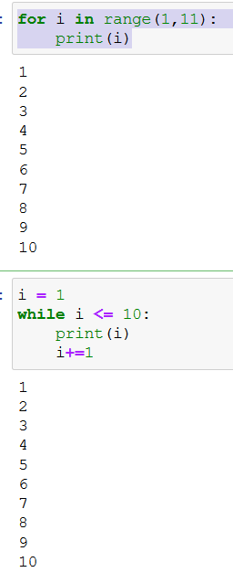

14. If you had a bacon() function within a spam module, how would you call it after importing spam?

from spam import bacon