Predicting FIFA World Cup 2026 Matches with Linear Regression
HIT140 Foundations of Data Science — Assessment 3, Sydney Group 25
Rupesh Ghimire – s403354
Vuong Quoc An - s406838
Gaurav Aryal - s403279
Divya Malla - s406481

1. Aim and data
We asked a simple question: how much can we predict about the outcome of a match in the World Cup 2026 prior to the kick-off? Two linear regressions were created, each having exactly eight predictors. Regression model 2.1 predicts the goal difference in a match (104 rows). Regression model 2.2 predicts the total number of goals scored by one of the teams (208 rows; two for each match).
All data are taken from the FBref Scores & Fixtures table (104 matches, 48 teams). Data cleansing was necessary: four penalty shoot-out results such as "(3) 1-1 (4)" were removed, leaving us with 100 rows. Now we interpret the result in brackets (the final score after extra time), strip off the country code from team name, perform eight integrity checks (104 matches; no duplicate rows, no scores missing, each team participated in three group games). Match ID is just a label and never used as a predictor.
2. Explanatory variables: only what is known before kick-off
Variables of a match should be based only on previous matches. Teams that have never played before have no history at all, so assigning them 0 would mean they are terrible teams. In this case, the following average is used: (goals so far + 2 × tournament average so far) ÷ (matches played + 2). If a team has no history at all, it receives the tournament average, and its own record becomes more and more important with each match played. We checked that our method worked as we simulated random variables slowly using only previous matches and the result was exact match. We were unable to use FIFA rankings as only the ranking we found was posted after the tournament.
The variables of 9–10 candidates were selected based on football common sense, and then using EDA on training matches only (first 83 matches), i.e., the correlation with the target and VIF (all less than 3.5). There are only three families of variables in common between models (less than four).
Model 2.1 (home minus away, 104 rows) | Model 2.2 (team and opponent, 208 rows)
goals scored form (shared) · goals conceded form (shared) · host nation (shared) | own goals conceded form (shared) · host nation (shared) · opponent goals scored form (shared)
points per game · draw rate · rest days · confederation strength (UEFA/CONMEBOL) · knockout match | own failed-to-score rate · opponent goals conceded form (shared) · opponent clean-sheet rate · opponent win rate · listed first on FBref

Three candidates were dropped. “Previous match went to extra time” never varies in the training matches, “tournament day” (|r| = 0.02) and the team’s own goals-scored form (|r| = 0.05) were the weakest. No variable has |r| above 0.4 with its target, so we expected modest accuracy from the start.
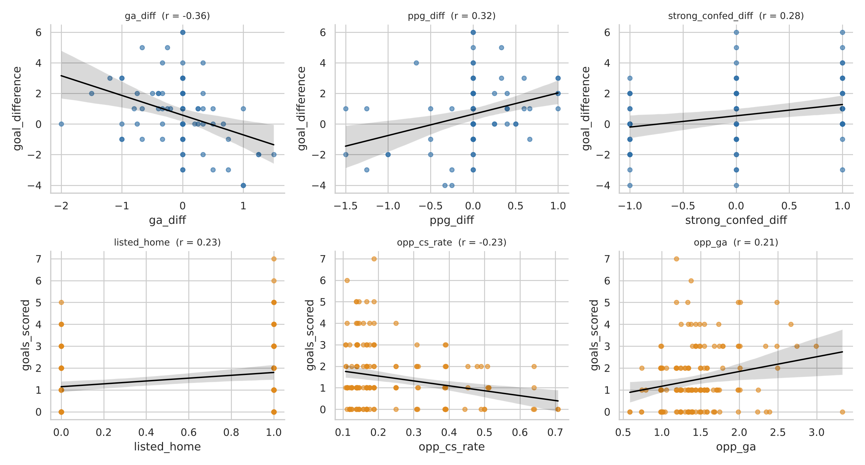
Figure 1. The three variables most related to each target (training matches). Top: goal difference. Bottom: goals scored.
3. Method
Since the data are ordered chronologically, we used the first 80% of matches (83) as our training set and the remaining 21 as our testing set. Any random splits would allow the model to learn from the future. The two team-rows of each match are kept in pairs. Each of the models was evaluated in three different manners: (1) expanding window cross-validation using the training matches; (2) 21 match hold out test set; (3) 56 match rolling backtest where after every 7 matches, we train and predict the next 7 matches. These metrics include MAE, RMSE, and R². The benchmark used is “always predict the training average”.
4. Linear Regression 2.1: goal difference
The model explains 35% of the variance of the training sample (adjusted R² = 0.28, F-test p-value = 0.0001). Three factors are significant independently: host nation (positive impact +2.0 goals), strong confederation (+0.9 goals) and difference of draw rate (p-value = 0.024, but with negative sign, so it is difficult to interpret this variable and we do not use it in our analysis). Host nations win by +1.0 goal on average being listed first. Residual variance is constant (Breusch-Pagan test p-value = 0.93).
But in the case of new matches the situation is different. In the case of 21 hold-out matches the simple linear regression model performs worse than the mean (RMSE 1.95 vs 1.75) and correctly forecasts the winner in only 42% of the non-draw matches. On 56 match backtest sample the simple linear regression performs a little bit better (RMSE 1.89 vs 1.96), but its bootstrap confidence interval for the gain in performance (from -0.27 to +0.43 goals) contains 0.
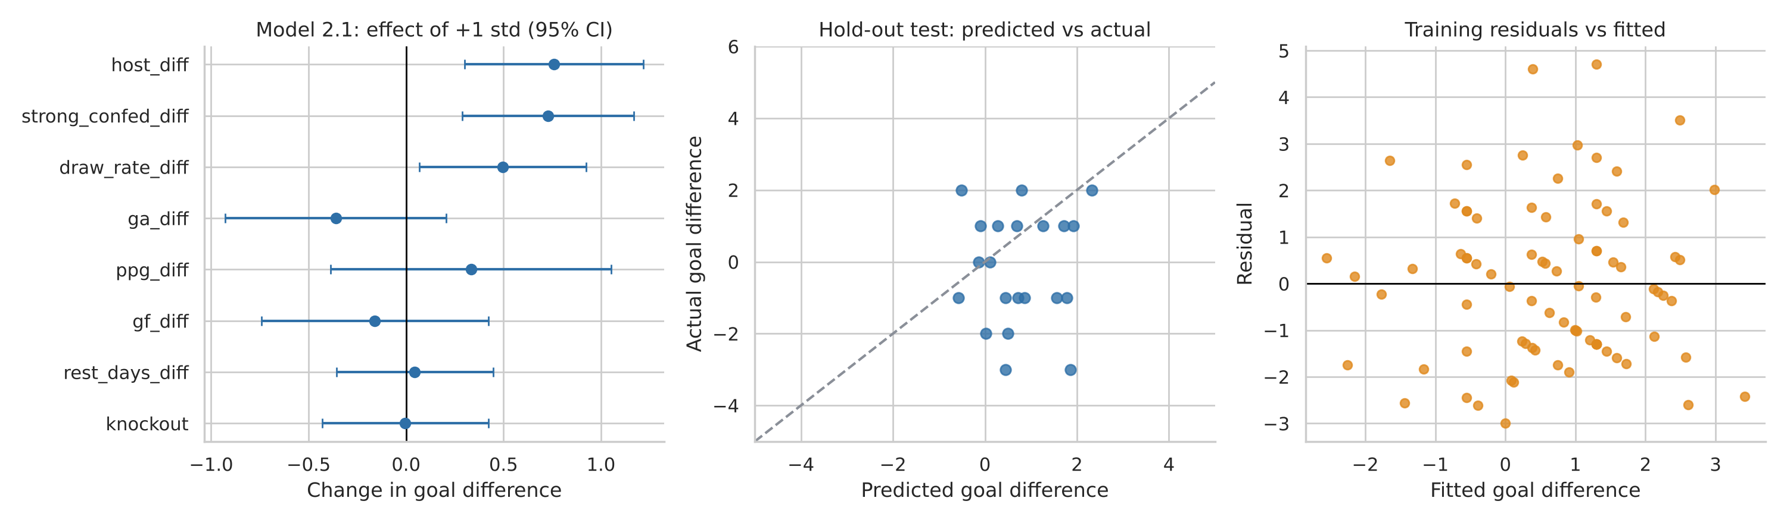
Figure 2. Model 2.1: standardised coefficients with 95% intervals; hold-out predictions; residuals.
5. Linear Regression 2.2: goals scored by a team
The model explains 17% of training variation (adjusted R² = 0.13, p = 0.0003). Being first team added 0.58 goals (teams listed first scored 1.72 goals compared to 1.24 goals; this is a bracket effect, but not home advantage, because all games are neutral) and every additional goal scored by opponents in previous games subtracts 0.57 goals from scoring probability. The variables describing the defensive quality of opponents are oriented as expected (bad defenders concede more goals), but they do not achieve significance on their own. On hold out test data set, the simple model again underperforms average (RMSE = 1.51 vs. 1.32; back-test: RMSE = 1.34 vs. 1.29), and it even predicted a negative number of goals once.
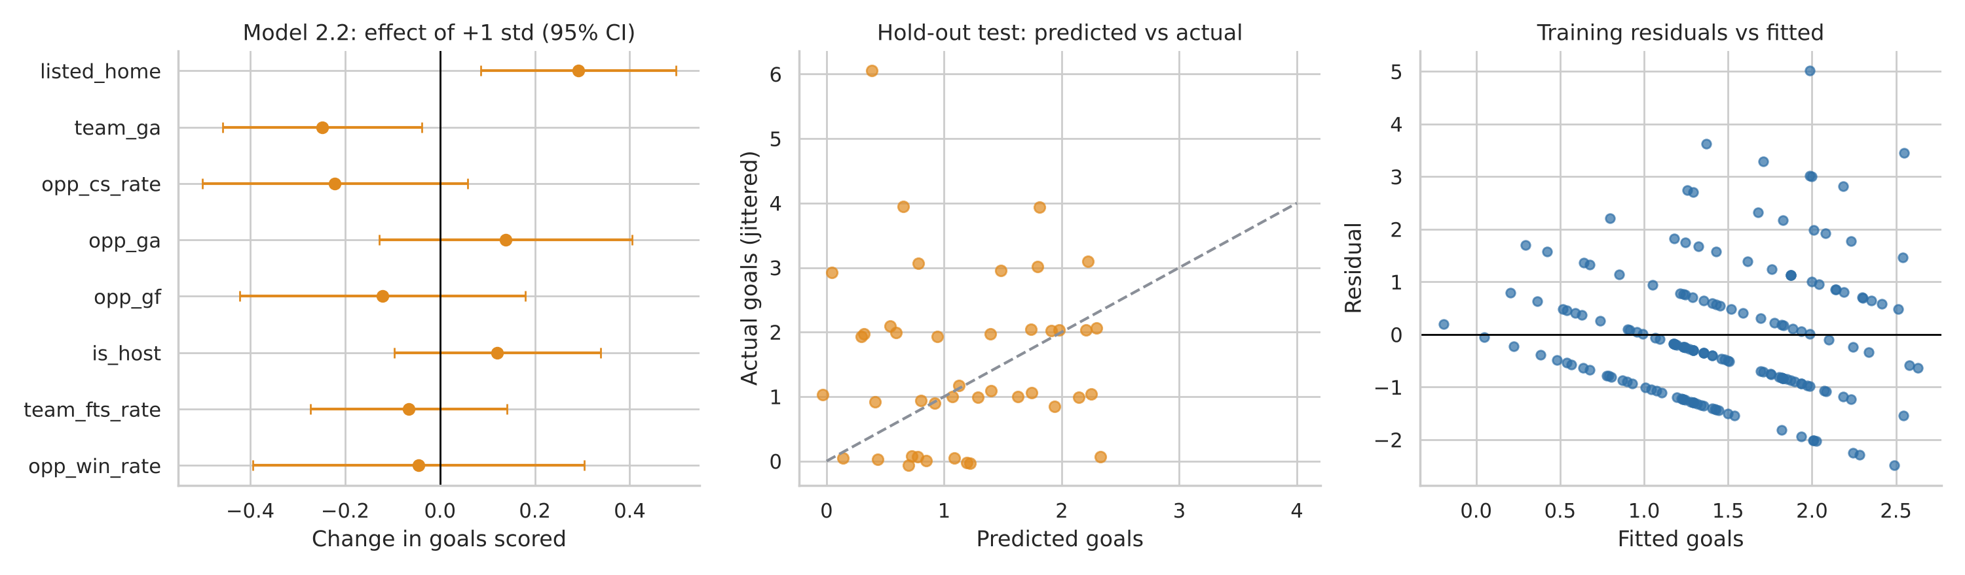
Figure 3. Model 2.2: standardised coefficients with 95% intervals; hold-out predictions; residuals.
6. Improving the models and testing competing algorithms
We considered one change at a time based on its performance on cross validation and the backtest but never the hold-out test. Ridge regression had a positive impact on both the tasks (backtest RMSE 1.89 to 1.78 and 1.34 to 1.27) and shifted R² marginally above zero. In model 2.1, a smaller model using the 4 most influential variables performed best as a linear model (RMSE 1.73), which proved that less is better when there are few matches. Interaction terms did not have a positive effect in either model. Backtest RMSE changed marginally by approximately 0.05 when the shrinkage constant was altered; therefore, results are independent of the shrinkage constant. In goals, we employed Poisson regression since it works for counts and does not predict negative values of goals.
Backtest RMSE (56 matches) | Mean baseline | Linear | Ridge | Random Forest | Grad. Boosting | Poisson
Model 2.1: goal difference | 1.96 | 1.89 | 1.78 | 1.76 | 1.91 | –
Model 2.2: goals scored | 1.29 | 1.34 | 1.27 | 1.30 | 1.34 | 1.25
Table 1. Rolling-backtest RMSE (lower is better). Hold-out results are in the notebook tables.
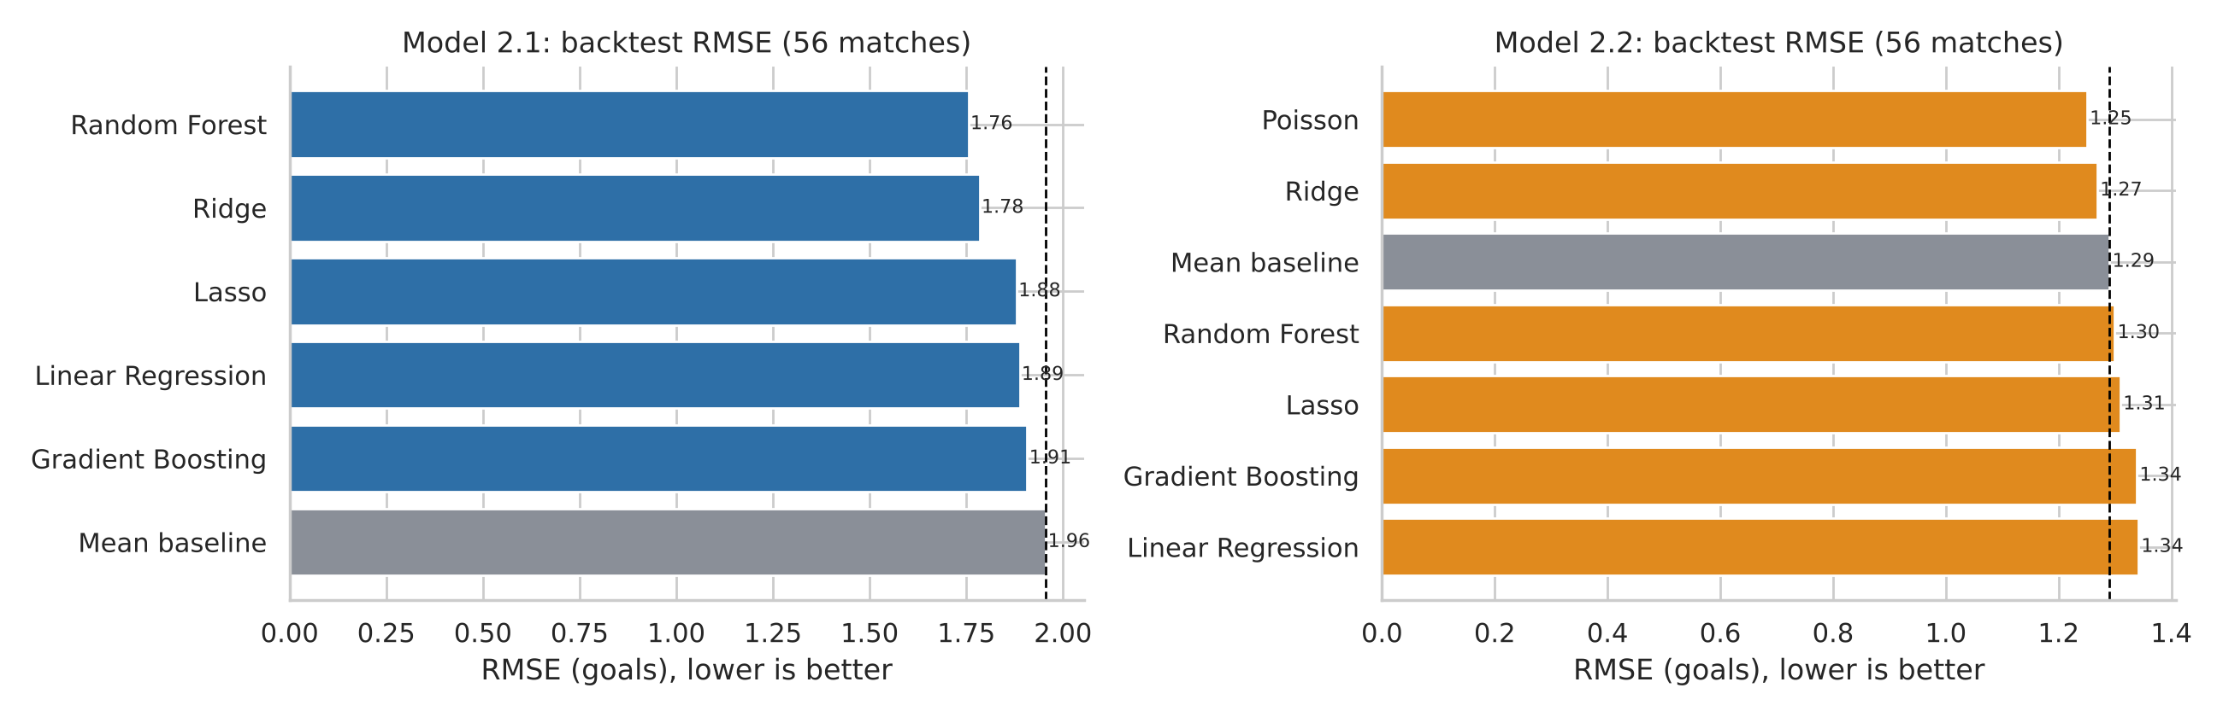
Figure 4. Backtest RMSE for all models; the dashed line is the mean baseline.

