Predicting FIFA World Cup 2026: goal difference and goals scored with multiple linear regression
HIT140 Assessment 3, Objective 2 | Group [NUMBER] | [Name 1] ([ID]), [Name 2] ([ID]), [Name 3] ([ID]), [Name 4] ([ID])
1. Introduction
We built two multiple linear regression models for the 104 matches of the 2026 World Cup: LR 2.1 predicts the goal difference of a match (104 rows) and LR 2.2 predicts the goals scored by one team in a match (208 rows). Each model has exactly 8 explanatory variables that are known before kick-off, and the two models share exactly 4, so together they use 12 different variables. We also tested whether other regression methods predict better.
2. Data sources and why we used more than the recommended three
FBref gives the results and schedule, but not how strong a team was before the tournament. Because most groups will use only the three recommended sites and reach similar findings, we added external sources that describe pre-tournament strength, and learned how to join files with different formats and team spellings (Figure 1): Elo ratings (only the rating before each match), Transfermarkt squad values, the World Cup history table (all matches since 1930, men's tournaments before 2026) and the 2018 and 2022 World Cup statistics (possession, shots, corners, cards, fouls, clean sheets), which show each team's style and are known before 2026 starts. We could not use FIFA rankings (the pages we found were published after the tournament and would leak results), and we did not use any 2026 in-match statistics.
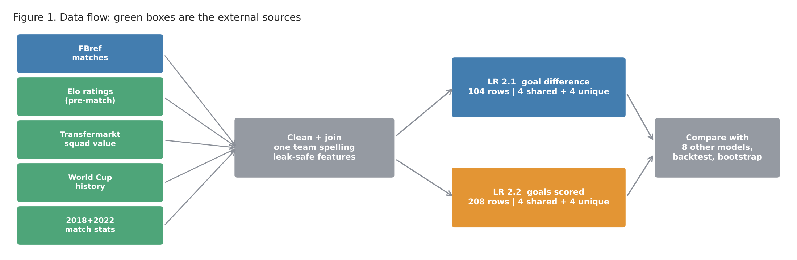
Figure 1. Six files are cleaned, joined with one team spelling, and turned into leak-safe variables.
3. How we chose the variables
Availability audit. We checked every column and kept only what exists before kick-off. The key trap was Elo_after, which contains the result, so we only used it to prove the Elo join was right (a team's Elo after one match equals its Elo before the next: 100% of matches). First matches have no 2026 history, so form is a shrunk average, (goals so far + 2 × tournament average) / (matches so far + 2), instead of zeros. Two leak checks passed: recomputing form by hand from earlier days gives the stored values, and shuffling the results of matches 85-104 changes no feature of matches 1-84.
EDA selection. For each candidate we wrote the expected sign first, then used Pearson correlation and VIF on the first 83 matches only. Shared variables were the four strongest on average across both tasks; unique variables were then picked from separate pools, so the two unique sets cannot overlap. All 16 chosen terms had the expected sign and every VIF was below 5.
Type | LR 2.1 goal difference (home - away) | r | LR 2.2 goals scored (team) | r
Shared (4) | Squad value (log) difference | 0.69 | Squad value (log) difference | 0.55
 | Elo before match, difference | 0.64 | Elo before match, difference | 0.51
 | Earlier World Cups played, difference | 0.55 | Earlier World Cups played, difference | 0.46
 | Historical World Cup goal diff. per match, difference | 0.34 | Historical World Cup goal diff. per match, difference | 0.29
Unique (4) | Possession 2018/22, difference | 0.32 | Own shots per match 2018/22 | 0.25
 | Confederation strength (UEFA/CONMEBOL), difference | 0.28 | Opponent clean-sheet rate in 2026 so far | -0.23
 | Corners 2018/22, difference | 0.23 | Opponent goals conceded per game in 2026 so far | 0.21
 | Fouls 2018/22, difference | -0.14 | Opp. shots on target conceded 2018/22 | 0.13

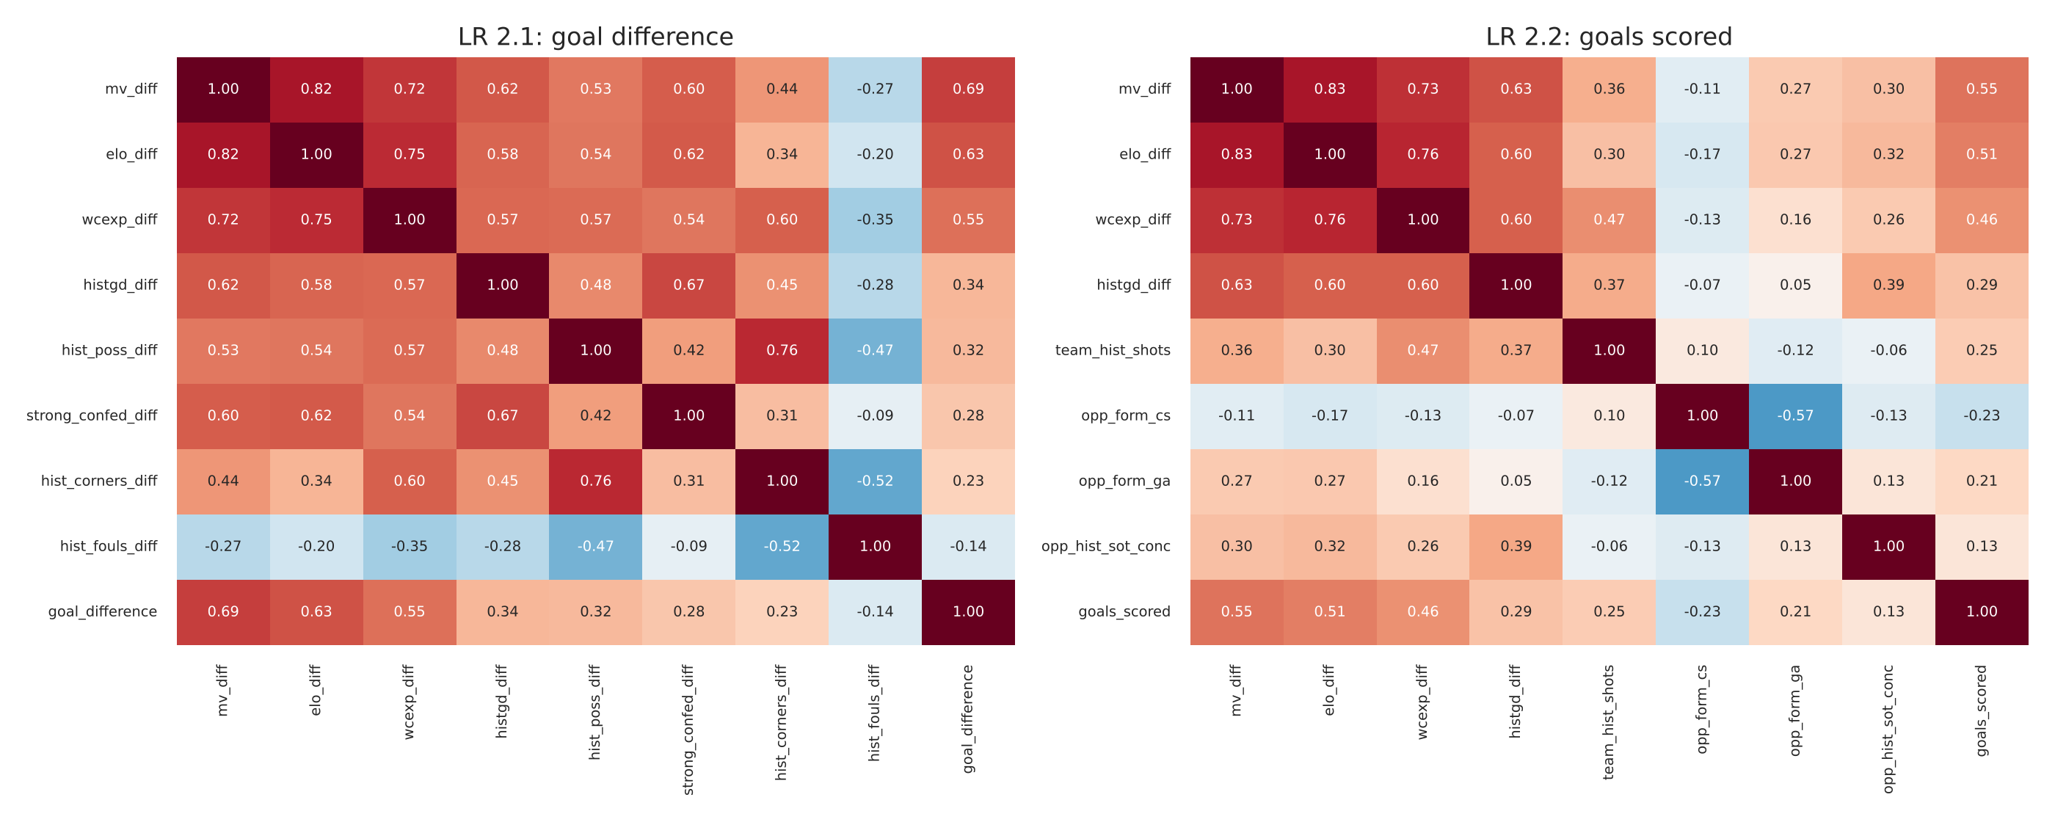
Figure 2. Correlations among the chosen variables and the target (training matches only). The strength variables are linked with each other, which explains the unstable single coefficients later.
4. Method
Matches were split by time: the first 83 matches for training, the last 21 (round of 32 to the final) for testing, so the model never learns from the future. In LR 2.2 both rows of a match always stay on the same side. We used 5-fold cross-validation grouped by match, the hold-out test, and a rolling backtest (re-fitting on all earlier matches and predicting the next 7, for matches 49-104). All steps were fitted on training data only and kept only if cross-validation improved: (1) outlier removal (kept for LR 2.2, CV error 1.228 to 1.181; rejected for LR 2.1 because the big wins are real results), (2) non-linearity check (no squared term was significant, p > 0.05), (3) multicollinearity check (highest VIF 4.8), (4) Yeo-Johnson transformation (kept for LR 2.2 only; it did not improve LR 2.1), (5) z-standardisation (same predictions, comparable coefficients).
5. Results
 | LR 2.1 OLS | Mean baseline | LR 2.2 OLS | Mean baseline
R² / adjusted R² (training) | 0.554 / 0.506 | - | 0.329 / 0.292 | -
Cross-validated RMSE (goals) | 1.559 | 2.171 | 1.179 | 1.417
Test RMSE / MAE, 21 matches | 1.469 / 1.162 | 1.747 / 1.426 | 1.273 / 0.913 | 1.322 / 1.045
Backtest RMSE, 56 matches | 1.335 | 1.956 | 1.248 | 1.293

LR 2.1. The model explains about half of the variation in goal difference and is much better than guessing the average on every measure. It picks the winner in 74% of the 19 non-drawn test matches. Squad value is the clearest driver (+1.3 goals of difference per standard deviation, p < 0.001). Elo and experience have the right sign but wide intervals, because they overlap with squad value (r = 0.82). Confederation strength has a negative coefficient although its simple correlation is positive: once strength is controlled for, a European or South American team is weaker than its rating suggests. This is an effect of correlated variables, not a football rule.
LR 2.2. Goals by one team are much harder to predict (R² 0.33; only 0.06 on the test set). Squad value is again the only clearly significant variable (+0.49 goals per standard deviation, cluster-robust p = 0.001), and the gain over the baseline is small (backtest 1.25 vs 1.29 goals). Variable analysis: with the four shared variables alone the CV error is 1.577 (LR 2.1) and 1.194 (LR 2.2), compared with 1.559 and 1.179 for all eight; the unique variables on their own are barely better than the average. Squad value alone is almost as good as all eight in LR 2.1. So pre-match strength explains most of what can be known, and playing-style variables add little.
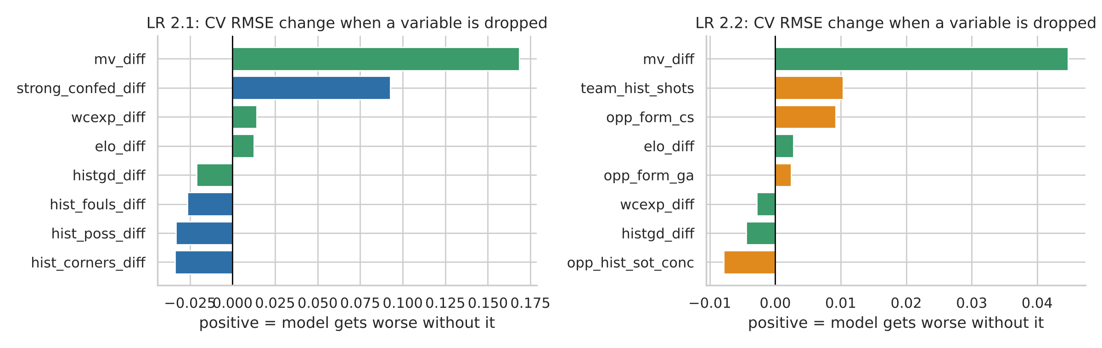
Figure 4. Change in CV error when one variable is dropped (green = shared). Dropping squad value hurts most; most unique variables matter little.
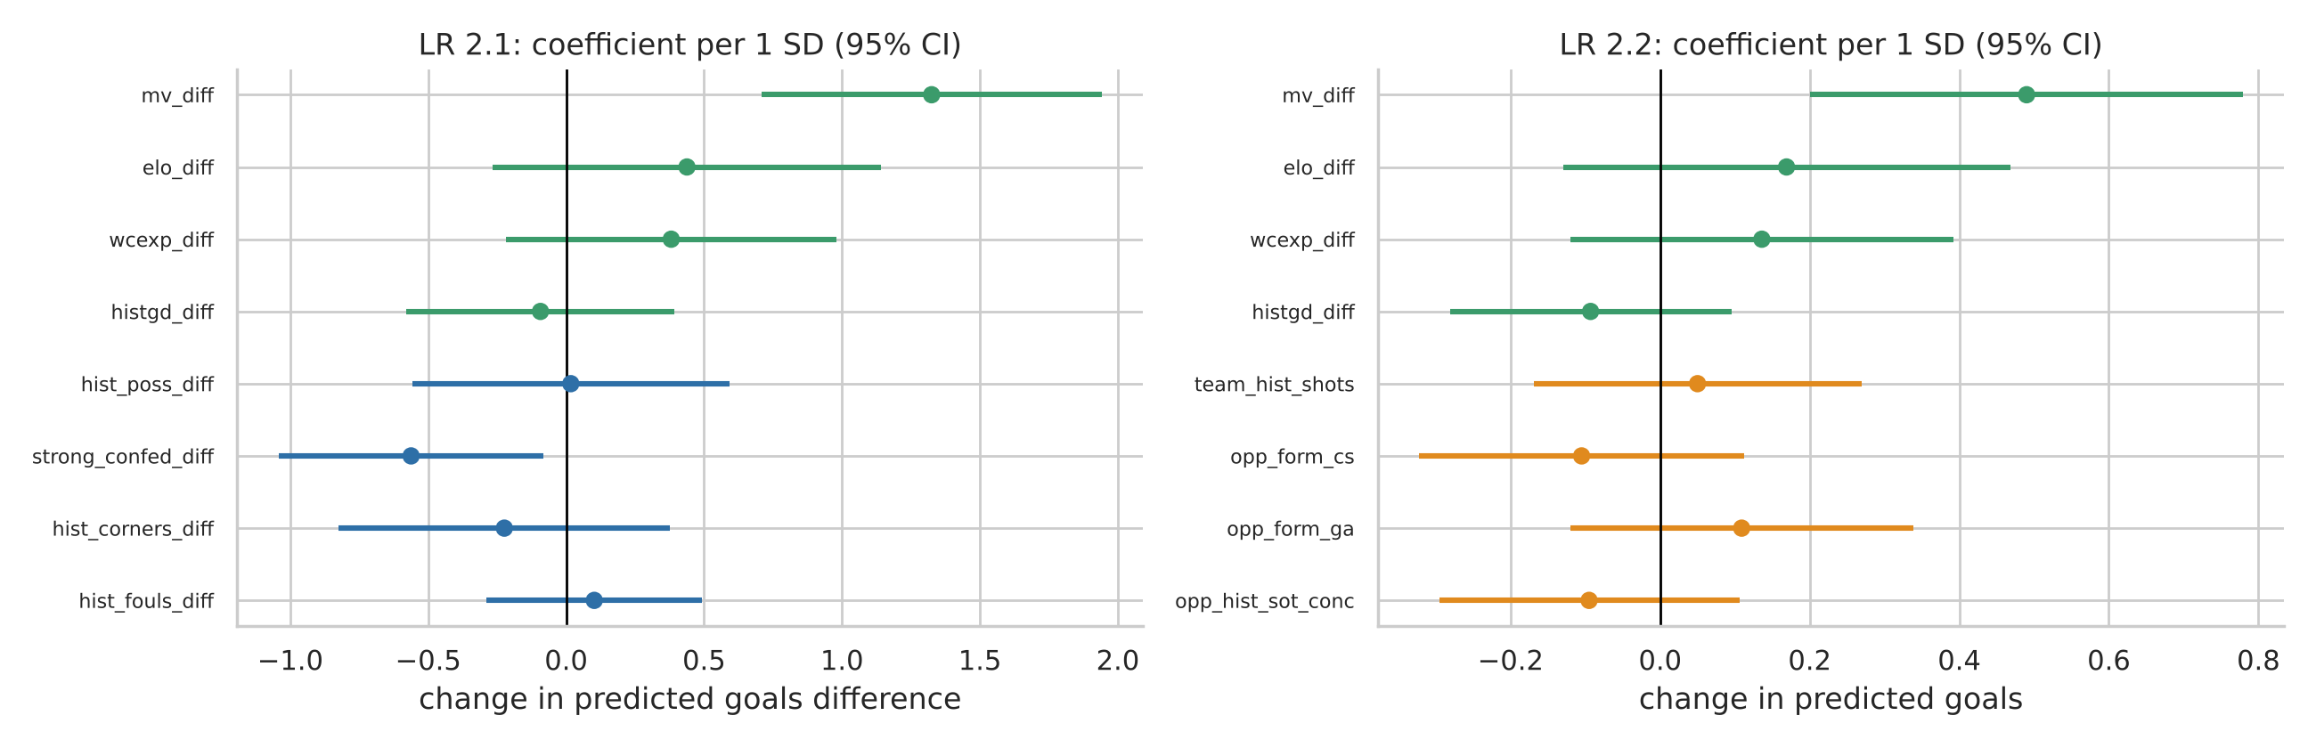
Figure 3. Standardised coefficients with 95% confidence intervals (green = shared variables).
6. Competing models and recommendations
We compared Ridge, Lasso, Elastic Net, kNN, SVR, Random Forest, Gradient Boosting and (for LR 2.2) Poisson regression on exactly the same variables and splits. Settings were tuned inside the training matches only. Figure 5 shows the backtest error.
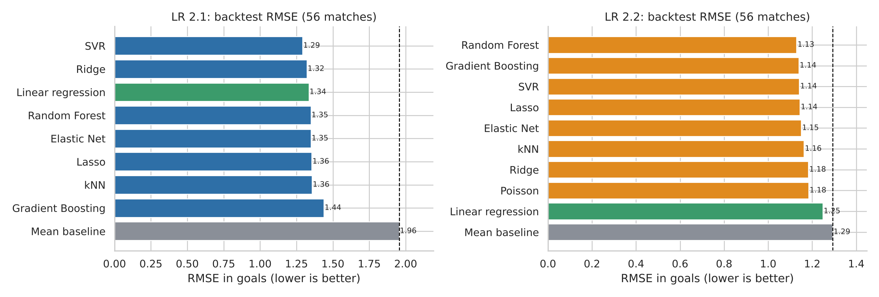
Figure 5. Backtest RMSE for all models (dashed line = mean-only baseline).
LR 2.1: SVR (1.29) is nominally best, but linear regression (1.34) and Ridge (1.32) are almost identical; the bootstrap gain of SVR over linear regression is +0.04 goals (95% CI -0.13 to +0.21), so complexity does not help. LR 2.2: linear regression is barely better than the baseline (gain +0.05, CI -0.06 to +0.17), while Random Forest (1.13) beats it by +0.12 goals (CI +0.02 to +0.21), and penalised linear models and SVR also do better. Recommendation: use Ridge or plain linear regression for goal difference (simple, explainable, as good as anything); for goals scored use a penalised linear model for explanation and Random Forest if lowest error is the aim. Differences between the top models are small compared with the noise of football.
7. Conclusion and limitations
Using external strength data, we predict goal difference clearly better than the average (backtest RMSE 1.34 vs 1.96) and goals scored slightly better. Squad market value is the most useful pre-match variable, and Elo, World Cup experience and history add a little. Limits: only 104 matches (21 for the hold-out), correlated strength variables (so single coefficients must be read with care), 18 teams without 2018/2022 style data (they receive the average), and no 2026 bookmaker odds or match statistics. Code, data and all figures are in the repository linked in the submitted .txt file.

