■ InsightfulCell
PROJECT REPORT
InsightfulCell Project Report
Architecture, design, data model, delivery status and roadmap of a verified data-analysis platform

Document | Project report · release 0.6.0 (Phases 1–6)
Date | 18 October 2026 · updated 19 October 2026 (version 1.1) 21 October 2026 (version 1.2) and 22 October 2026 (version 1.3)
Owner | Rupesh Ghimire
Basis | Source code at commit a3b0b3d (main) · baseline system map v1.1 / PRD v1.2 (7 Oct 2026) for intent · version 1.1 checked against the working tree of 19 Oct 2026 · version 1.2 checked against commit 7c67a4d (21 Oct 2026) · version 1.3 checked against commit 1d29671 and the live AWS deployment (22 Oct 2026)
Companion | InsightfulCell System Test Report (same date)
Classification | Confidential

Document control
Version | Date | Author | Change
1.0 | 18 Oct 2026 | Claude (for Rupesh Ghimire) | First issue, written from the code and the baseline system map
1.1 | 19 Oct 2026 | Claude (for Rupesh Ghimire) | Updated for iterations 17–21: test finding F-01 fixed; sharing the local stack through one tunnel (ADR-038, ADR-039); “See the data” panel and GET /v1/runs/{id}/rows (ADR-040); commit-only git hooks; results of the 19 Oct test run
1.2 | 21 Oct 2026 | Claude (for Rupesh Ghimire) | Updated for iteration 24 and the 21 Oct commits: backup model (Gemini → gpt-4o-mini) and hard model spend cap with a spend ledger (migrations 0011–0012); admin dashboard behind a key; email sign-in link page limited to listed addresses, confirm and show password; 2 MiB body cap on the web proxy (part of F-08); self-hosted S3 in production and an Azure deployment recipe validated locally; results of the 21 Oct test run
1.3 | 22 Oct 2026 | Claude (for Rupesh Ghimire) | Updated for the AWS deployment (22 Oct 2026): the application is live on one EC2 instance behind Caddy with HTTPS, uploads in Amazon S3 through the instance role, nightly database backups to S3, and images built by a GitHub Actions workflow; upload URLs now use the bucket’s regional host; a Playwright journey on the live site; the Azure recipe is superseded

Audience | Use this report to
Product owner / sponsor | Understand what exists, what it is worth and what is left (sections 1, 3, 14–16)
Engineers | Navigate the architecture, components, data model and flows (sections 6–11)
QA and security | Find the controls and where they live (sections 10, 13)
Operations | See the deployment model and what Phase 8 must add (section 12)

Contents
Document control
1. Executive summary
2. Introduction
2.1 Purpose
2.2 Scope
2.3 References
2.4 Definitions
3. Problem statement and objectives
3.1 Problem
3.2 Product vision (from the baseline)
3.3 Objectives and tenets
3.4 Success measures (baseline targets)
4. Stakeholders and users
5. Requirements and delivery status
5.1 Functional requirements
5.2 Non-functional requirements
6. System architecture
6.1 Architectural style
6.2 Containers and components
6.3 Backend layering
6.4 Technology stack
6.5 Key architecture decisions
7. Component design
7.1 Web application (frontend/)
7.2 API service (backend/api)
7.3 Worker and pipeline (backend/worker, pipeline, services/run_executor)
7.4 Analysis engine (backend/engine)
7.5 LLM gateway (backend/llm)
8. Data design
8.1 Database schemas
8.2 Entity-relationship model: tenancy and datasets
8.3 Entity-relationship model: run artefacts
8.4 Entity-relationship model: identity (Better Auth)
8.5 Rules the schema enforces
8.6 Object storage layout and lifecycle
9. Key flows
9.1 Upload
9.2 Analysis run and live progress
9.3 Run state machine
9.4 What the user sees
10. Security architecture
11. AI and model design
12. Deployment and operations
12.1 What Phase 8 must add
13. Quality assurance
14. Project status and progress
14.1 Deviations from the baseline
15. Risks and issues
16. Roadmap and recommendations
17. Conclusion
Appendix A. API catalogue
Appendix B. Repository map

Right-click the table and choose Update Field if page numbers are missing.

1. Executive summary
InsightfulCell is a web platform that turns an uploaded table (CSV, TSV, Excel, Parquet or JSON) into a cleaned dataset, statistically controlled findings, checked charts and maps, and a narrated report in which every number links to an immutable fact. Its positioning is trust: the statistics are computed by deterministic code, a language model only plans and writes, and everything the model produces is validated or verified before anyone sees it.
The project has delivered six of its eight planned phases in about ten days of development (8–17 October 2026): identity and tenancy, uploads, a PostgreSQL-backed job queue with live progress, the full two-phase analysis pipeline, narration with a sentence verifier, and the reading experience (report, dashboard, exports, drill-downs, deletion). Question answering (Phase 7) and production operations (Phase 8) remain. Since 19 October the project has added cost controls for a public demo (a backup model, a hard model spend cap and a key-locked admin dashboard) and a deployment recipe. On 22 October it went live on AWS (app.ic.rgproject.me): one EC2 instance runs the database, API, worker and web app under Docker Compose behind an HTTPS proxy, with uploads in Amazon S3 and nightly backups. No application code changed for it beyond signing upload links for the bucket’s regional host.
Indicator | Value
Release | 0.6.0 (backend and frontend)
Code size | ≈28,200 lines of Python and ≈13,300 lines of TypeScript, plus ≈17,500 lines of tests (21 Oct 2026)
Automated tests | 715 backend tests (93.02% coverage) and 422 frontend tests passing in the full gate on 21 Oct 2026; 719 backend tests on 22 Oct (4 added for S3 upload links; the 530 unit tests re-run and pass); 7 browser tests (5 journeys last run 18 Oct; 2 admin-dashboard tests added 21 Oct, not run here); the full journey re-driven on the live AWS site on 22 Oct
Architecture decisions | 16 architecture decision records (ADR-025 to ADR-040); none yet for the 21 Oct cost controls
Data model | 26 application tables under forced row-level security (5 spend and usage tables reachable only through definer functions), plus Better Auth’s 9 tables
API | 30 public REST operations, one Server-Sent Events stream, one hidden admin endpoint for the web server
Status vs baseline | Phases 0–6 done, plus cost controls and an admin dashboard (21 Oct); deployed to production on AWS (22 Oct), the first part of Phase 8; 7 (Q&A) and the rest of 8 (staging, monitoring, audit log) not started; Release 1 alpha planned 11 Dec 2026

Overall assessment
The foundations are unusually solid for the project’s age: strong tenant isolation, a clean layered backend, provenance on every fact, and broad automated testing. The companion test report finds the security core sound but identifies correctness defects in data cleaning that must be fixed before real users rely on it, and a broken language-model path (F-01, fixed on 19 Oct), and notes that production operations are only partly built: since 22 Oct 2026 the product runs on one AWS host with nightly backups, but staging, monitoring and an audit log are still missing.

2. Introduction

2.1 Purpose
This document describes the InsightfulCell system as built: its goals, architecture, components, data, flows, security and delivery status. It is the reference for anyone joining the project and the basis for release planning.

2.2 Scope
It covers the repository at release 0.6.0: the Next.js web application (frontend/), the FastAPI service and worker sharing one Python package (backend/), scripts and CI. Planned components that are not yet built are labelled as such.

2.3 References
Reference | Description
Baseline system design v1.1 and PRD v1.2 (7 Oct 2026) | Baseline PRD v1.2 and system design; product intent, rules and targets
reports/system_flow.md, reports/explained_system_flow.md | How the system works, component by component: data flows, fallbacks, security
InsightfulCell System Test Report, 18 Oct 2026 | Companion test results, findings and readiness verdict

2.4 Definitions
Term | Definition
Run | One analysis of one dataset version; two jobs (Phase A, Phase B) split at the review gate
Fact | An immutable stored finding (numbers, test, interval, p and q values, tier, provenance, content hash)
Schema card | The masked description of a table that is the only thing a model may see
Lossless / lossy | Whether a cleaning operation can remove or replace information
BFF | Backend-for-frontend: the web server calls the API for the browser
RLS | PostgreSQL row-level security keyed on a transaction-local organisation id

3. Problem statement and objectives

3.1 Problem
People with a spreadsheet want answers, not a statistics course. General-purpose AI assistants produce fluent analyses, but their numbers can be invented, their cleaning is invisible, and sending raw rows to a model is unacceptable for sensitive data. Traditional BI tools are accurate but need a skilled analyst to ask the right questions and prepare the data.

3.2 Product vision (from the baseline)
“Upload a CSV → reviewed cleaning → signal-gated features → statistically controlled insight mining → verified, narrated EDA report → grounded Q&A. Every number shown to a user must trace to an immutable fact.”

3.3 Objectives and tenets
Tenet (priority order) | Design consequence
1. Correctness over fluency | Statistics from code; false-discovery control across the run; charts recomputed; sentences verified
2. Traceability | Facts are append-only with hashes; sentences and charts cite fact ids; plans and decisions are versioned
3. Privacy: raw rows never reach an LLM | Masked schema card; personal-data detection before any call; gateway payload block
4. Simplicity of operation | Modular monolith; PostgreSQL also serves as queue and cache; no new infrastructure without an ADR

3.4 Success measures (baseline targets)
Measure | Target
API availability (from general availability) | 99.5%
Runs that succeed | 98%
Report ready | Half of reports within 3 minutes
Model cost | ≈ $0.26 per run; ≈ $0.015 per question
First-year load | 200 organisations, 2,000 active users, 20,000 runs a month (≈100/hour at peak)
Upload limit | 250 MB per file

4. Stakeholders and users
Stakeholder | Interest | Role in the system
Analyst (primary user) | Fast, trustworthy answers from their own data | owner / admin / analyst: upload, run, review, read, explore
Viewer | Read results others produced | viewer: read reports (role exists; invitations not built)
Organisation owner / admin | Control of members, policy and spend | owner/admin: members, cleaning policy, quotas (partly built)
Product owner / sponsor | Market differentiation through verified analysis | Prioritises phases; accepts releases
Data protection / compliance | No personal data leaves the boundary; auditability | Relies on masking, RLS, append-only records
Operations | Reliable, observable service | Phase 8 scope

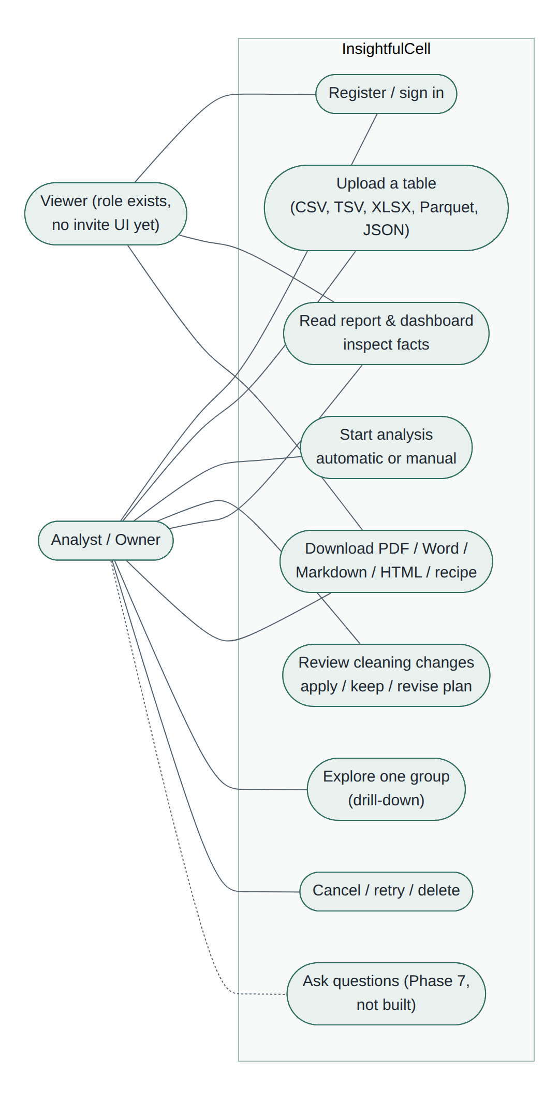
Figure 1. Use cases by actor (dashed: planned).

5. Requirements and delivery status
Status is taken from the code and its tests, not from planning documents. ✓ built and tested, ◐ partial, ○ not started.

5.1 Functional requirements
Area | Requirement | Status | Notes
Identity | Email + password sign-in, Google (optional), email links | ✓ / ✓ / ◐ | Links off by default (ADR-033); when on, a separate page sends them only to EMAIL_LINK_ALLOWED_EMAILS; registration confirms the password; GitHub not built
Identity | Organisations, roles owner/admin/analyst/viewer | ◐ | One personal workspace per user; no invitations UI
Upload | Direct-to-storage multipart upload up to 250 MB, five formats, dedup by content | ✓ | Web-Worker SHA-256, 3 parts in flight, magic bytes, zip-bomb guard
Runs | Queue, live progress, cancel, retry, review gate, expiry, delete | ✓ | Procrastinate on PostgreSQL, SSE with replay and polling fallback
Phase A | Ingest, profile, understand (rules ± model), clean_plan | ✓ | Model path defect F-01 found in testing; fixed 19 Oct 2026 and checked with a live Gemini run
Review | Automatic or manual; apply/keep each change; revise plan in own words; recipe download | ✓ | Automatic is default (ADR-036)
Phase B | clean_apply, geo, features, mine (9 miners, BH-FDR), sensitivity, rank, visualize, report | ✓ | Sequential miners (ADR-032)
Narration | Slots, verifier, repair once, template fallback, summary last, re-narrate | ✓ | Judge off by default
Reading | Report, dashboard, fact inspector, maps, exports (PDF/Word/Markdown/HTML), drill-downs, “See the data” side panel | ✓ | PDF produced by the worker without a browser
Sharing | Open the local stack from another address (a tunnel such as ngrok, a LAN address) | ✓ | Trusted origins (ADR-038); same-origin relays for uploads and live progress (ADR-039)
Cost control | Backup model when the main one fails; hard model spend cap (overall, per provider, per person); admin dashboard with people, usage and spend | ✓ | Added 21 Oct 2026; unit and integration tests; no ADR yet; no live paid call recorded
Questions | Tiered Q&A with closed tools, quotas and answer cache | ○ | Phase 7
Search | Fact full-text search; embeddings (Release 2) | ◐ | tsvector index exists; no search endpoint or embeddings yet

5.2 Non-functional requirements
Quality | Requirement | Status
Security | EdDSA tokens, BFF, forced RLS, policy table, RFC 9457 errors, CSP, 2 MiB proxy body cap | ✓ (rate limits ○)
Privacy | Masked schema card, PII detection, gateway payload block, no values in logs or errors | ✓
Reliability | Checkpoints, idempotency keys, compare-and-set transitions, reaper, reconciler | ✓
Accessibility | Keyboard, focus, labels, 44 px targets, reduced motion, aria-live; axe in tests | ✓
Observability | Structured JSON logs, spend log and admin dashboard ✓; OpenTelemetry, Sentry, metrics, alerts | ◐
Operability | Staging, production deploy, backups, retention, audit log. Production deploy and nightly backups exist since 22 Oct 2026 (one AWS EC2 host); staging, retention and audit log do not | ◐
Performance | Half of reports in 3 minutes | ✓ locally (median 11 s on sample data)

6. System architecture

6.1 Architectural style
A modular monolith shipped as three deployables: a web app, an API and a worker. The API and worker are the same Python package and image with different entry points; they share one database and one object store. The browser talks only to the web app, except for two direct paths: file bytes go straight to object storage through presigned URLs, and progress events stream straight from the API with a run-scoped ticket.
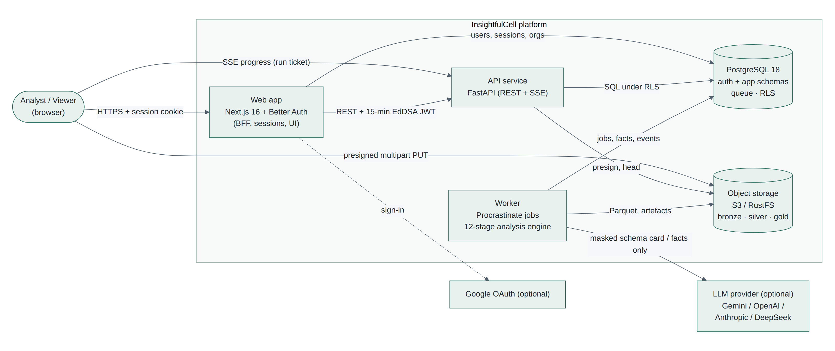
Figure 2. System context: actors, deployables and external services.

6.2 Containers and components
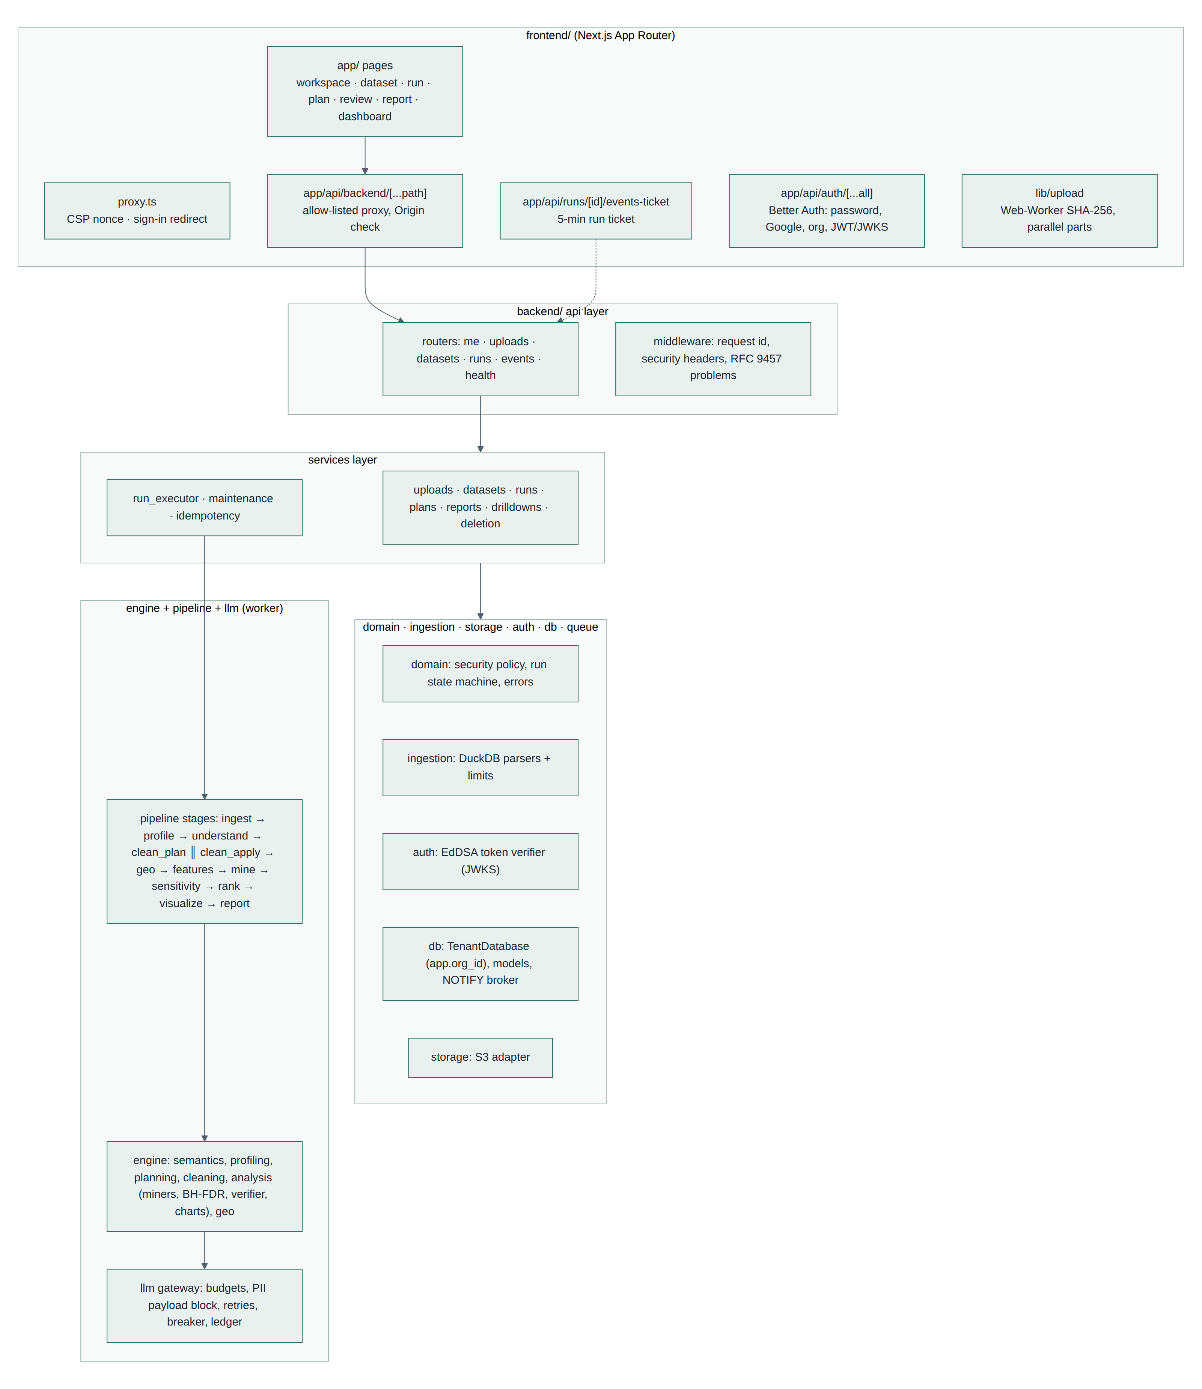
Figure 3. Containers and main components.

6.3 Backend layering
Layer rules are enforced by import-linter (six contracts), not by convention: domain has no I/O; ingestion, storage and auth depend only on domain; db on those; services on db; api on services. The analysis engine sees the outside world only through ports (ArtifactStore, FactRepository, ReferenceStore, LLMTransport).
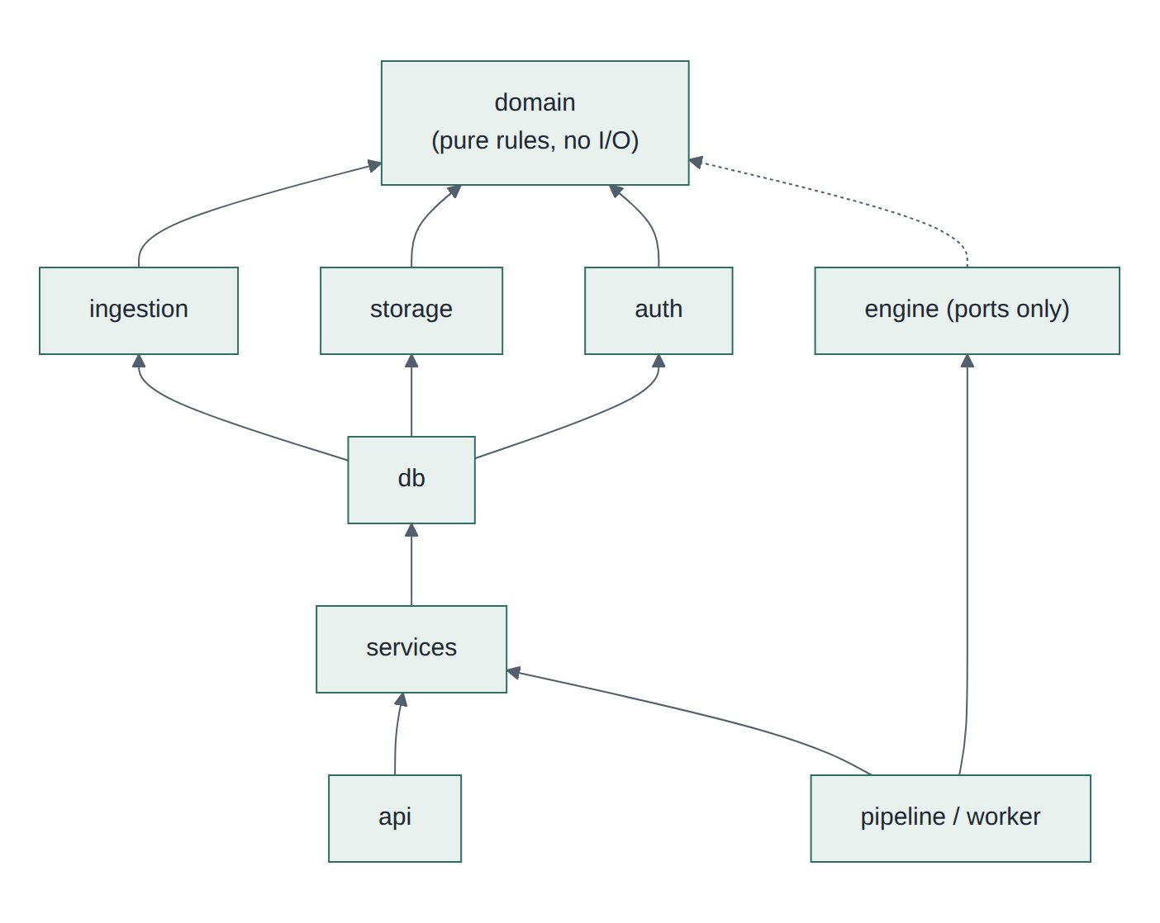
Figure 4. Backend layers (arrows point to allowed dependencies).

6.4 Technology stack
Layer | Choice | Why (from the baseline and ADRs)
Web | Next.js 16.4 (App Router), React 19, TypeScript strict, Tailwind 4 | Server rendering; no tokens in the browser
Sign-in | Better Auth 1.7.7 (organisation + JWT plugins), Ed25519 JWKS | Organisations and roles in our own database
API | FastAPI 0.143, Pydantic 2, uvicorn, SQLAlchemy 2.1 async, psycopg 3 | Same language as the engine; async streaming; generated types
Queue | Procrastinate 3.10 on PostgreSQL | Job and run state in one database
Database | PostgreSQL 18 (RLS, JSONB, full text, LISTEN/NOTIFY, partitions) | One system to secure, back up and isolate tenants in
Files | S3 API (RustFS 1.0 locally, Amazon S3 in production on AWS) | Bytes go to the service built for them
Parsing and statistics | DuckDB 1.5, NumPy, SciPy 1.18, scikit-learn 1.9, RapidFuzz, Shapely | Fast in-process parsing; proven statistics
Models | One gateway; Gemini (default), OpenAI, Anthropic, DeepSeek; optional backup model; hard spend cap; rules fallback | Budgets, privacy checks and accounting in one place (ADR-031)
Exports | Jinja2 HTML, python-docx, fpdf2, resvg | Self-contained files, no browser in the worker
Testing | pytest, vitest + Testing Library + axe, Playwright | Unit to browser coverage in CI

6.5 Key architecture decisions
ADR | Decision
025 | Two top-level applications, backend/ and frontend/ (instead of apps/packages)
026 | Verify uploads in two steps: size and magic bytes at complete, checksum when ingesting
027 | RustFS replaces MinIO for local and CI object storage
028 | Email-and-password registration alongside links and Google
029 | Testers may send sign-in links with their own Resend key (removed 21 Oct 2026)
030 | Runs on a PostgreSQL job queue; live progress streamed straight from the API
031 | One LLM gateway, four interchangeable providers, rules as the complete fallback
032 | Phase B evidence: tested facts, one false-discovery family per run, packaged place data
033 | Sign-in links off until a mail domain is verified
034 | Narration with numeric slots, a sentence verifier, one repair, re-narration
035 | Checked charts and maps, dashboard, HTML export, drill-downs as sub-runs
036 | Automatic and manual review; Markdown/Word/PDF exports; hardening
037 | Deleting runs and datasets (hard delete, delayed file purge)
038 | Trusted origins: the web app and API accept every address the app is served at
039 | Same-origin relays for uploads and live progress when storage or the API is on localhost
040 | “See the data”: the API serves the ingested table a page at a time, personal columns hidden

7. Component design

7.1 Web application (frontend/)
- proxy.ts runs before every page: optimistic sign-in redirect and a per-request CSP nonce (strict-dynamic, frame-ancestors 'none').
- app/api/backend/[...path] is the BFF: allow-lists v1/me|uploads|datasets|runs, refuses mutations whose Origin is not one of the app’s addresses (BETTER_AUTH_URL plus AUTH_TRUSTED_ORIGINS, ADR-038), mints a 15-minute EdDSA token from the session and forwards selected headers. Request bodies over 2 MiB are refused with 413 before the API is called.
- app/api/runs/[id]/events-ticket mints a 5-minute ticket with its own audience for one run’s event stream.
- app/api/auth/[...all] hosts Better Auth: password, Google, organisations, JWKS; /token is disabled so page scripts can never obtain the API token.
- Pages: workspace, dataset, runs, run (live steps), plan, review, recipe, report, dashboard. Server components fetch through a generated, typed OpenAPI client.
- lib/upload: SHA-256 in a Web Worker, parallel presigned part uploads with retry and expired-link recovery.
- components/auth/sign-in-form.tsx: the submit button stays disabled until the page’s scripts have loaded, so the form can never fall back to a plain GET that puts the password in the address bar; every failure shows a message (server unreachable, address not allowed, server error, too many attempts).
- lib/relay.ts with app/api/storage/[...path] and app/api/runs/[runId]/events: same-origin relays used only when the page is opened from another address while storage or the API is on localhost (a tunnel for testers). A deployment with public addresses never uses them (ADR-039).
- components/report/data-sidebar.tsx: “See the data” on the report and dashboard opens a side panel with the table as it was read, 100 rows a page, personal-data columns hidden. It takes 25% of the window by default and is resized (20–90%) by dragging its grip or with the arrow keys (ADR-040).
- app/sign-in/email: the email sign-in link page; links go only to addresses in EMAIL_LINK_ALLOWED_EMAILS, and anyone else is asked to register with a password. Registration asks for the password twice, and password fields have a show/hide toggle.
- app/dashboard with app/api/admin/session: the admin dashboard, off unless ADMIN_DASHBOARD_KEY is set. The key is typed once and exchanged for a short-lived, signed, HttpOnly, SameSite=Strict cookie; wrong keys are throttled. It shows people (names and emails from the sign-in tables), files, analyses, model spend per provider against its own cap, and the configuration without keys.

7.2 API service (backend/api)
- Routers for me, uploads, datasets, runs and the SSE event stream; health and readiness.
- Every tenant query runs in TenantDatabase.transaction(principal), which sets app.org_id for the transaction; the organisation comes only from the verified token.
- One policy table maps role × action (domain/security.py).
- Errors are RFC 9457 problem documents built from DomainError subclasses; unexpected errors become a generic 500 with the request id.
- Mutations take Idempotency-Key; state changes use If-Match with the run’s row version (412 on conflict); lists use keyset pagination.
- GET /v1/runs/{id}/rows serves the ingested table a page at a time (at most 200 rows, permission data:read). The API copies the immutable Parquet artifact once to a private local cache and pages it with DuckDB (one thread, 256 MB); personal-data columns are listed but never read.
- GET /v1/admin/overview serves the admin dashboard: counts and sums across organisations (people by id only). It is hidden from the OpenAPI schema and not forwarded by the BFF; the web server sends X-Admin-Key, compared in constant time, and a missing or wrong key gets 404.

7.3 Worker and pipeline (backend/worker, pipeline, services/run_executor)
- Procrastinate worker on queues standard, large and maintenance; jobs claimed with FOR UPDATE SKIP LOCKED; queueing_lock = run id.
- Each stage is checkpointed by a hash of inputs, configuration and code version, so retries resume where they stopped.
- Maintenance jobs: reconciler (re-defers orphaned runs), stalled-job reaper, review expiry and reminders, upload and idempotency clean-up, partition upkeep, delayed storage purge.
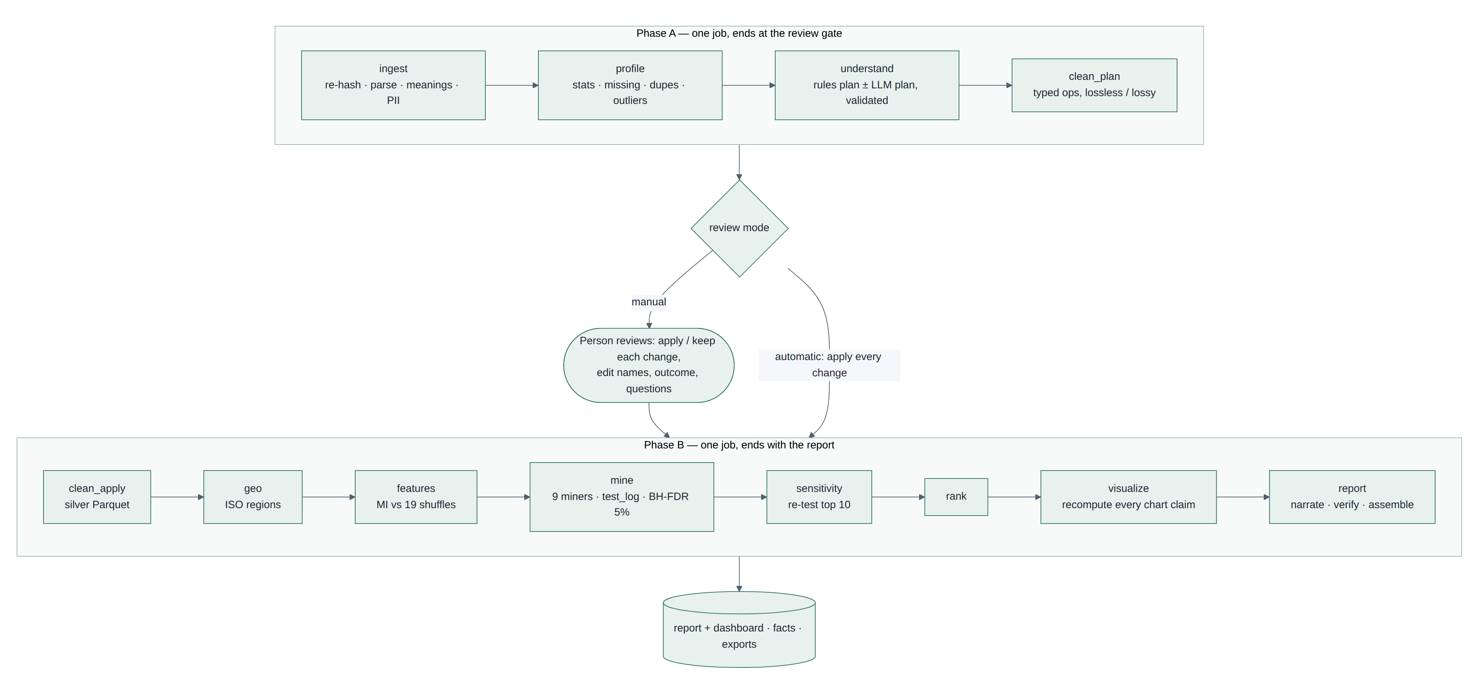
Figure 5. The 12 pipeline stages in two jobs, split at the review gate.

7.4 Analysis engine (backend/engine)
Module | Responsibility
semantics | Column meanings (continuous, nominal, datetime, currency, percentage, identifier, text, geography) and personal-data detection
profiling | Per-column statistics, missing patterns, duplicates, outliers (DuckDB)
schema_card | The masked description sent to a model: no rows, no personal values, no min/max, no cross-column statistics
planning | Plan language, rules planner, validator, merge of model and rule plans, user requests
cleaning | Typed operation catalogue, lossless/lossy classification, previews, policies, SQL and Python recipe
analysis | Signal gate, nine miners, statistics, BH-FDR, sensitivity, ranking, facts, claims, charts, dashboard, narration, verifier
geo | Gazetteer resolution (exact, alias, fuzzy), postcode ranges, point-in-polygon, map projection

7.5 LLM gateway (backend/llm)
The only code path allowed to call a model. It picks the model by purpose, enforces per-run and per-organisation token budgets and a requests-per-minute limit, blocks payloads containing personal data, reserves each attempt’s worst-case cost against hard spend caps (overall, per provider and per person, in AUD; a model without a price is never called), retries with backoff behind a circuit breaker, validates the response against a JSON schema and records every call (tokens, cost, latency, outcome — never prompt text) in llm_calls. When the main model fails, the same request goes once to an optional backup model (for example gpt-4o-mini), never for blocked data or a full overall cap; when both fail, the deterministic fallback for that purpose is used.
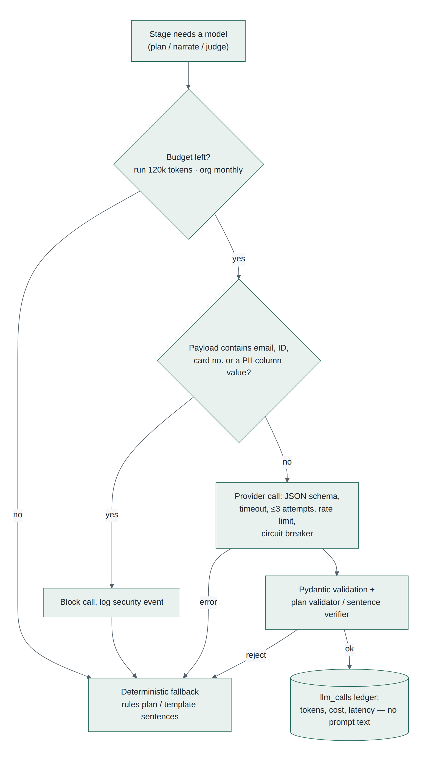
Figure 6. Gateway decision flow for every model call.

8. Data design

8.1 Database schemas
Schema | Owner | Holds
auth | Web app (Better Auth) | user, session, account, verification, organization, member, invitation, jwks, rateLimit
app | API and worker (Alembic, 12 migrations) | Tenancy mirrors, datasets, uploads, runs and their artefacts, plans, facts, test log, reports, verification results, LLM ledger, spend ledger and caps, per-person activity, idempotency, purges
procrastinate | Queue library (vendored, digest-checked) | Jobs, events, periodic defers, workers
ref | Reference data | Catalogue of geographic reference sets (digest-pinned)

8.2 Entity-relationship model: tenancy and datasets
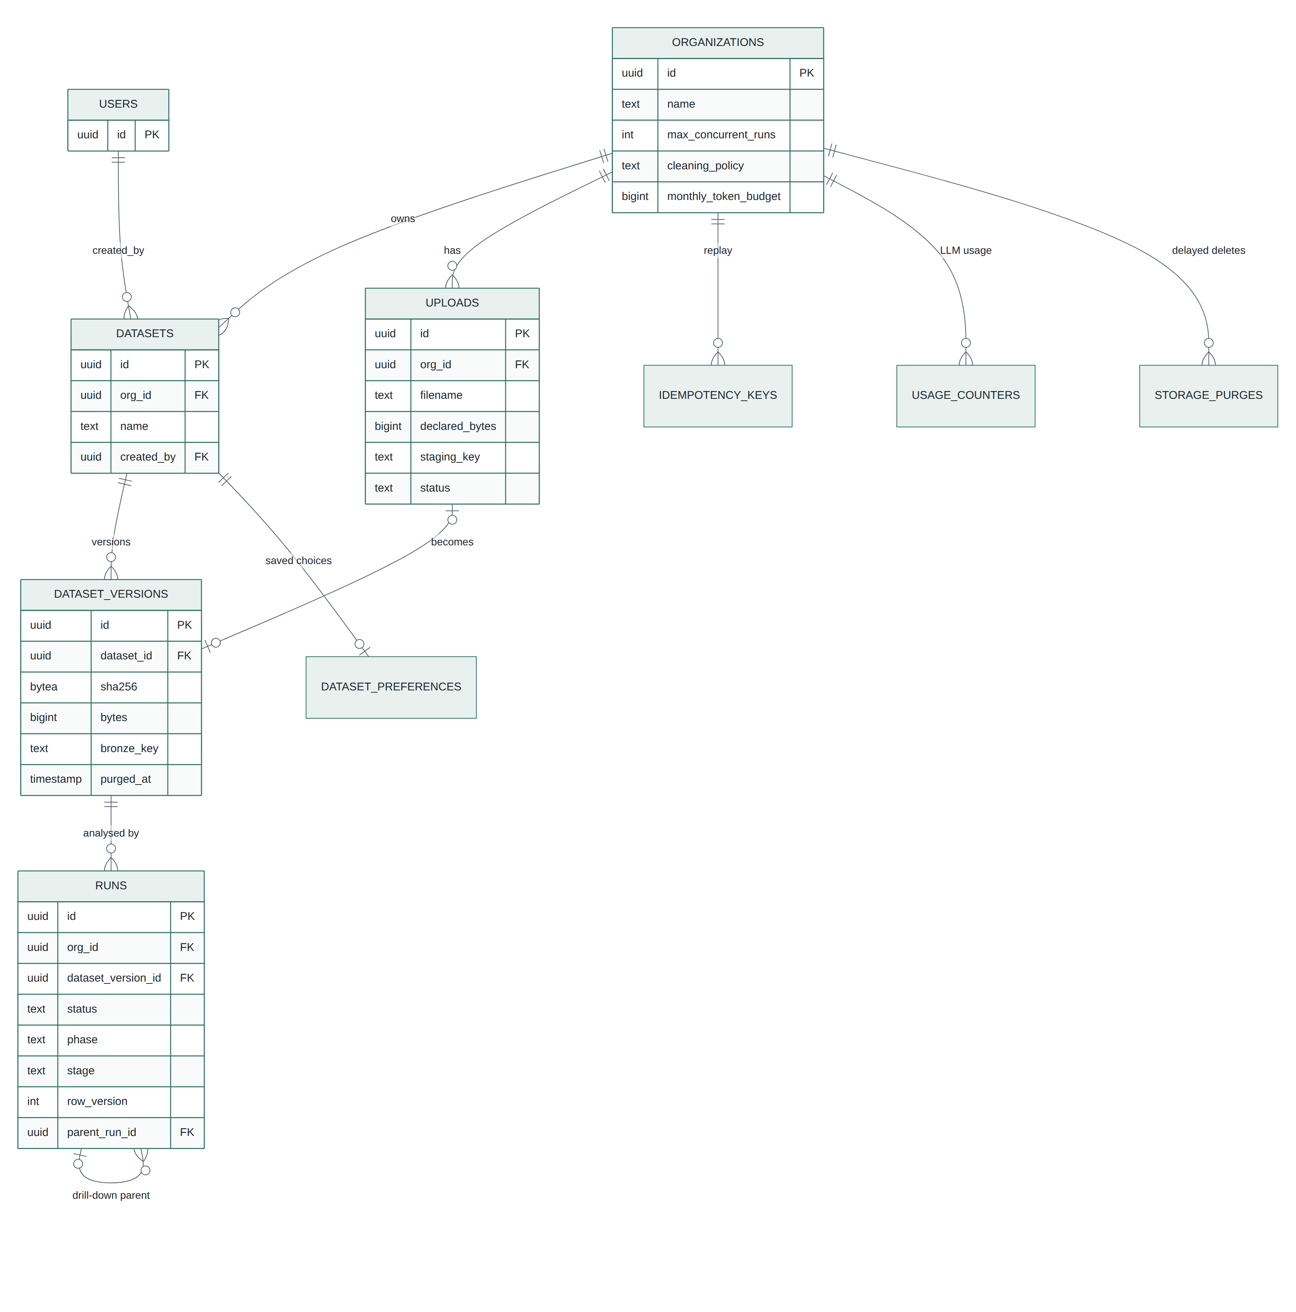
Figure 7. Core entities: organisations, datasets, versions, uploads and runs.

8.3 Entity-relationship model: run artefacts
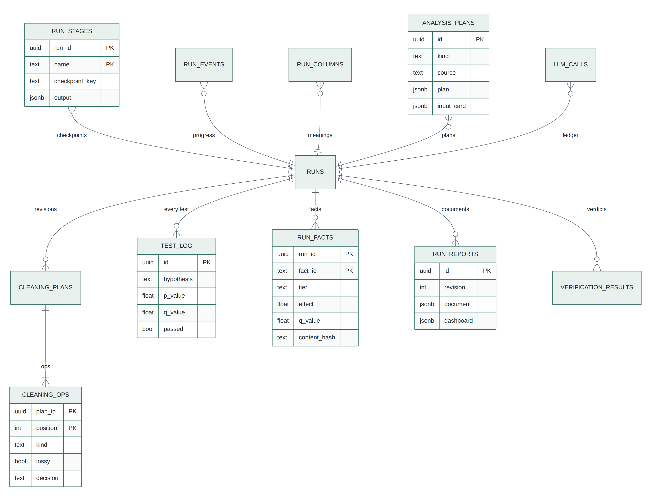
Figure 8. Everything a run produces; facts, test log, events, plans and verdicts are append-only.

8.4 Entity-relationship model: identity (Better Auth)
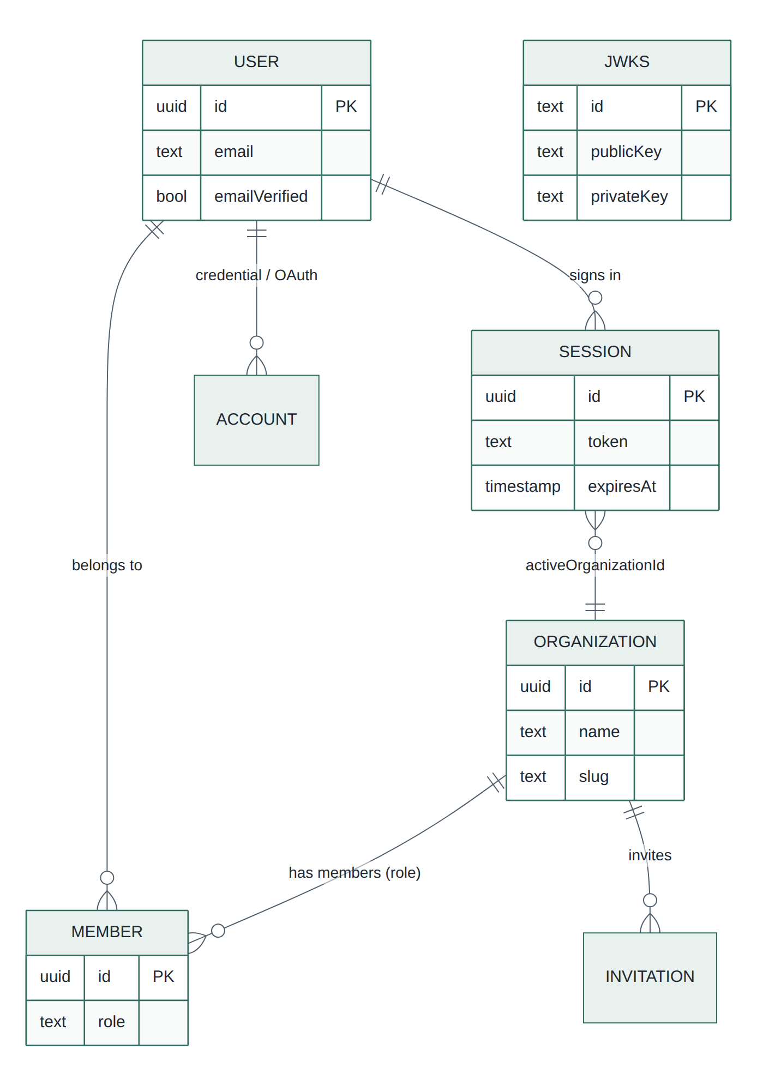
Figure 9. Identity tables in the auth schema; the API never reads them, it verifies tokens instead.

8.5 Rules the schema enforces
- Every tenant table carries org_id, has a forced row-level-security policy, and uses composite foreign keys so a row cannot point across organisations.
- Facts, test log, run events, analysis plans, LLM calls and verification results reject updates and deletes by trigger.
- Run events, test log, LLM calls and verification results are partitioned by month.
- The spend ledger, its holds and running totals, and per-person activity have forced row-level security with no policy and no grant to the application role: only SECURITY DEFINER functions read or write them. The ledger is append-only and kept when runs, datasets or people are deleted, so spending never disappears from a cap.
- UUIDv7 primary keys keep inserts at the end of indexes.
- Login roles: the API connects as a member of ic_app (not the owner, no BYPASSRLS); migrations run as the owner from a separate step.

8.6 Object storage layout and lifecycle
Layer | Key | Contents | Lifetime
Bronze | bronze/{org}/{sha256} | Exact uploaded bytes, content-addressed (same bytes stored once) | Until the dataset is deleted; purge after STORAGEPURGEAFTER_DAYS (7)
Uploads | bronze/{org}/uploads/{id} | Multipart staging object | Moved on completion; abandoned uploads cleaned up
Silver | silver/{org}/{version}/{hash}.parquet | Cleaned table keyed by plan and accepted operations | Rebuildable from bronze + plan
Gold | gold/{org}/{run}/{stage}/{checkpoint}-{artifact} | Stage artefacts keyed by inputs | Life of the run

9. Key flows

9.1 Upload
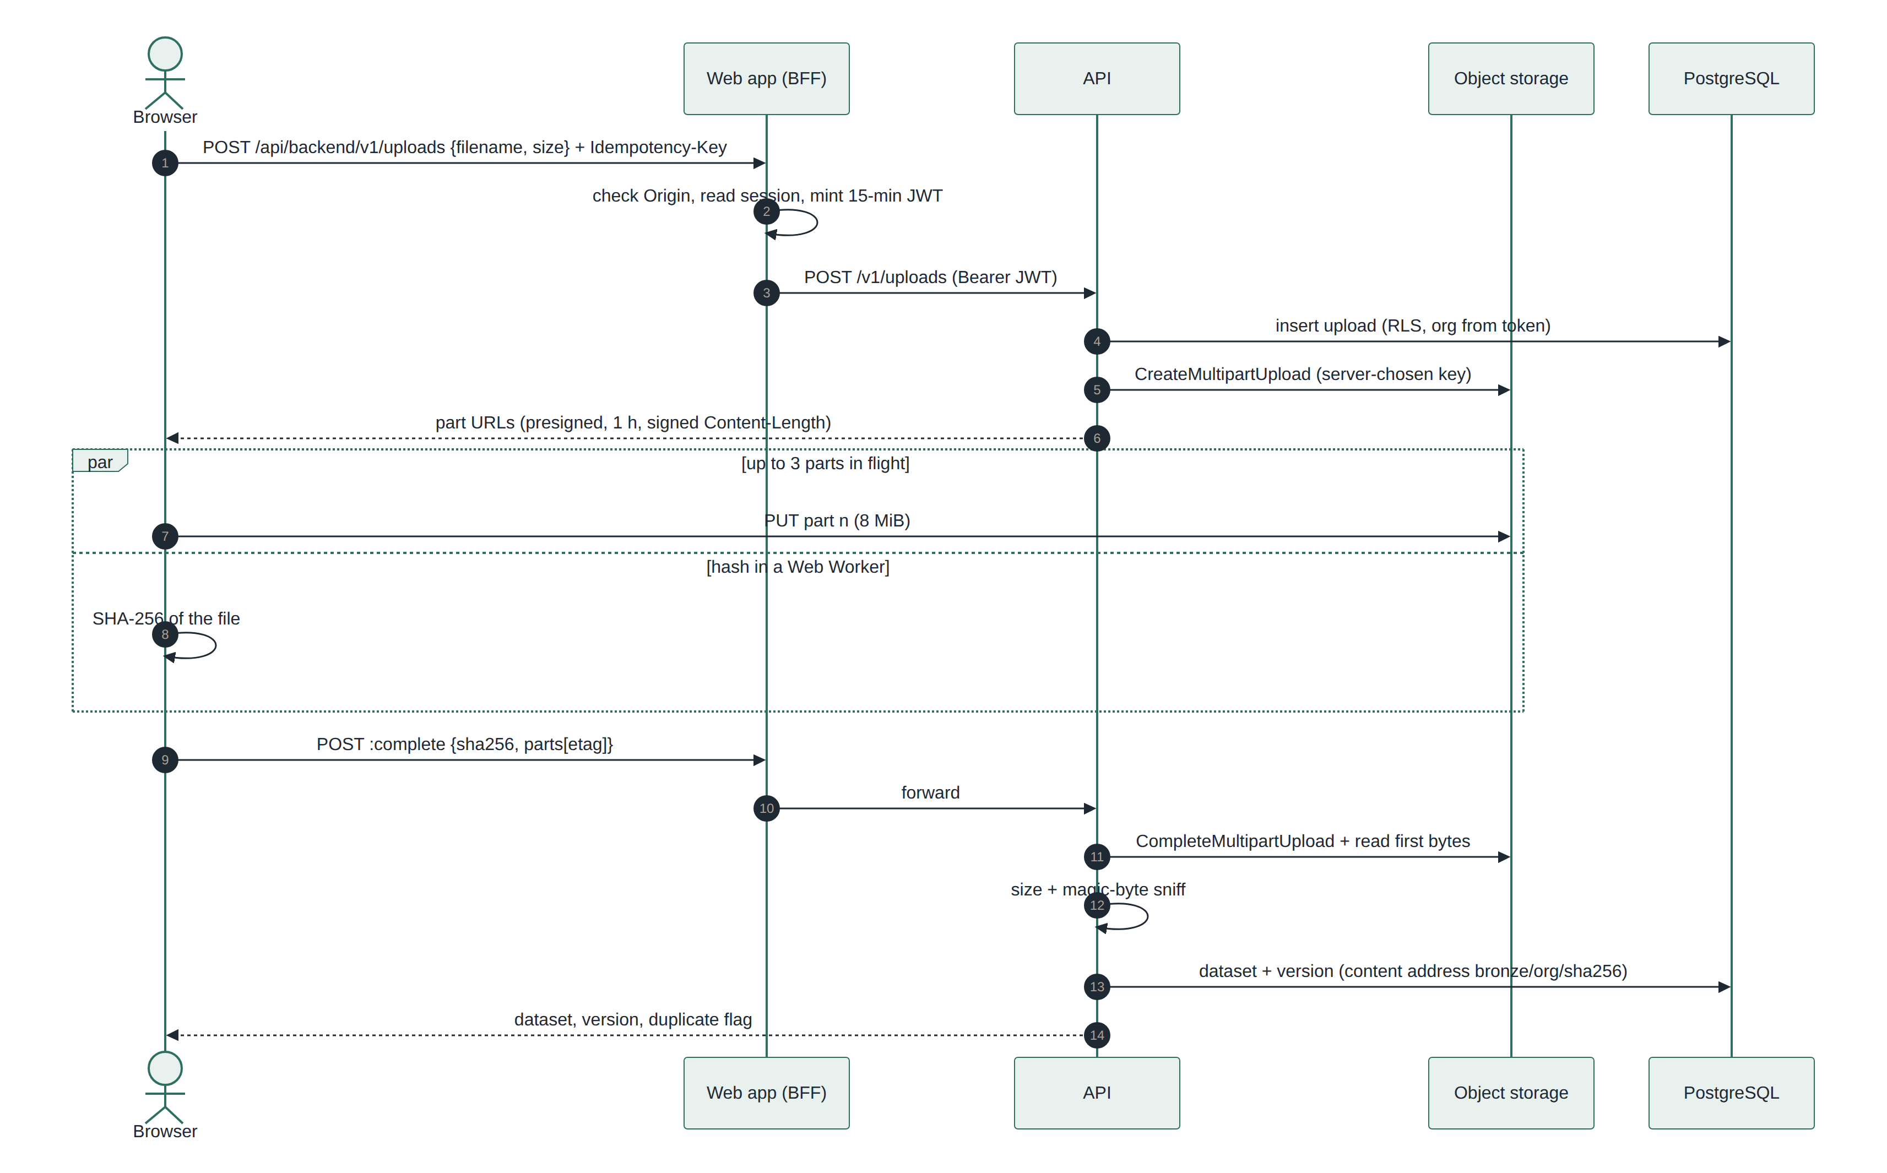
Figure 10. Upload sequence: the bytes never pass through the web app or the API.
Exception (ADR-039): when a tester opens the app through a tunnel while storage is on localhost, each part goes to the web app’s same-origin storage relay, which forwards it unchanged; with public storage the browser uploads straight to storage as shown.

9.2 Analysis run and live progress
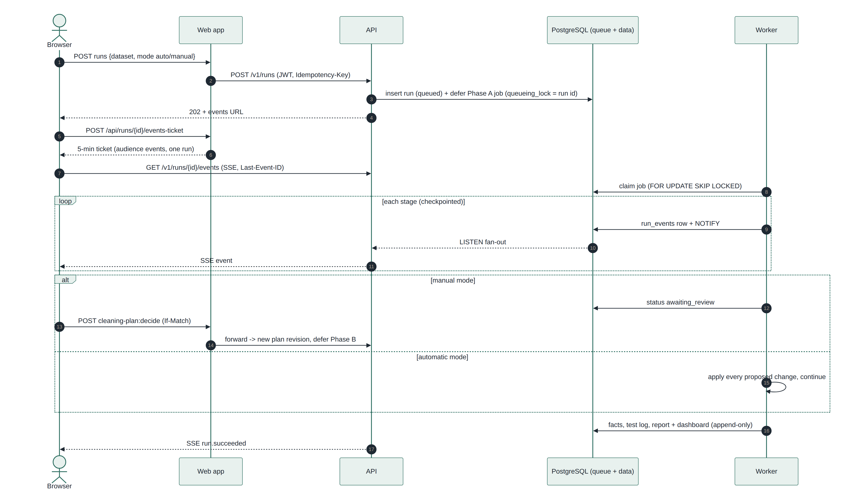
Figure 11. Run sequence: queue, worker, events and the review gate.
From another address while the API is on localhost, live progress goes through the web app’s same-origin events relay (ADR-039); otherwise the browser connects to the API directly.

9.3 Run state machine
Status (where a run is in its life) is kept separate from stage (what it is doing now). Every transition is a compare-and-set update, so two actors can never move the same run.
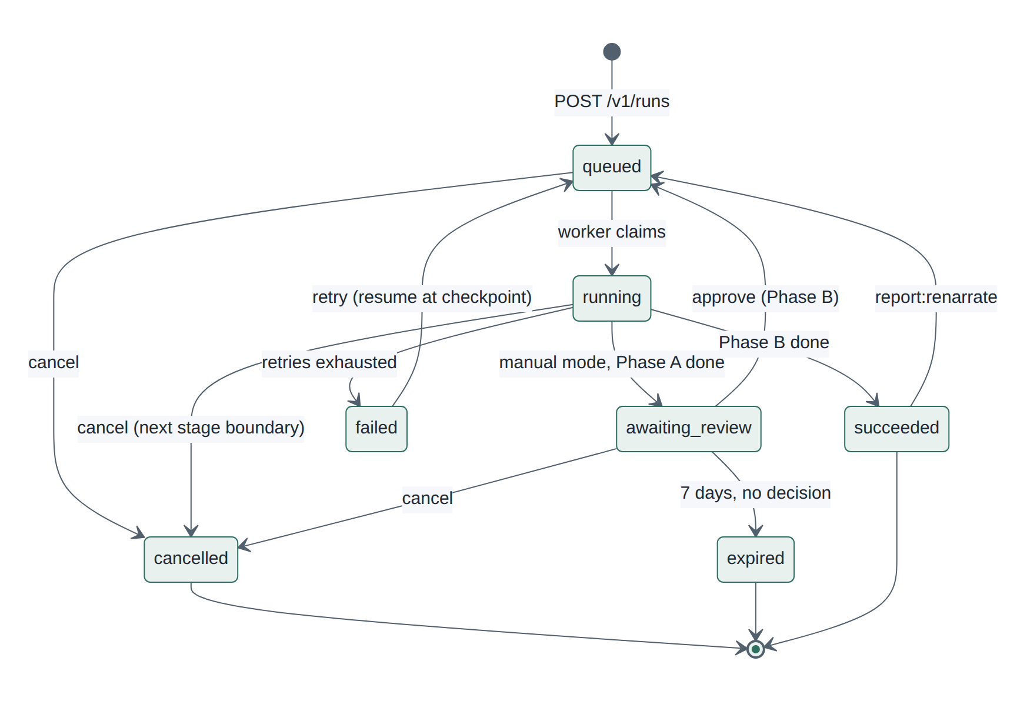
Figure 12. Run states and transitions as implemented in `domain/runs.py`.

9.4 What the user sees
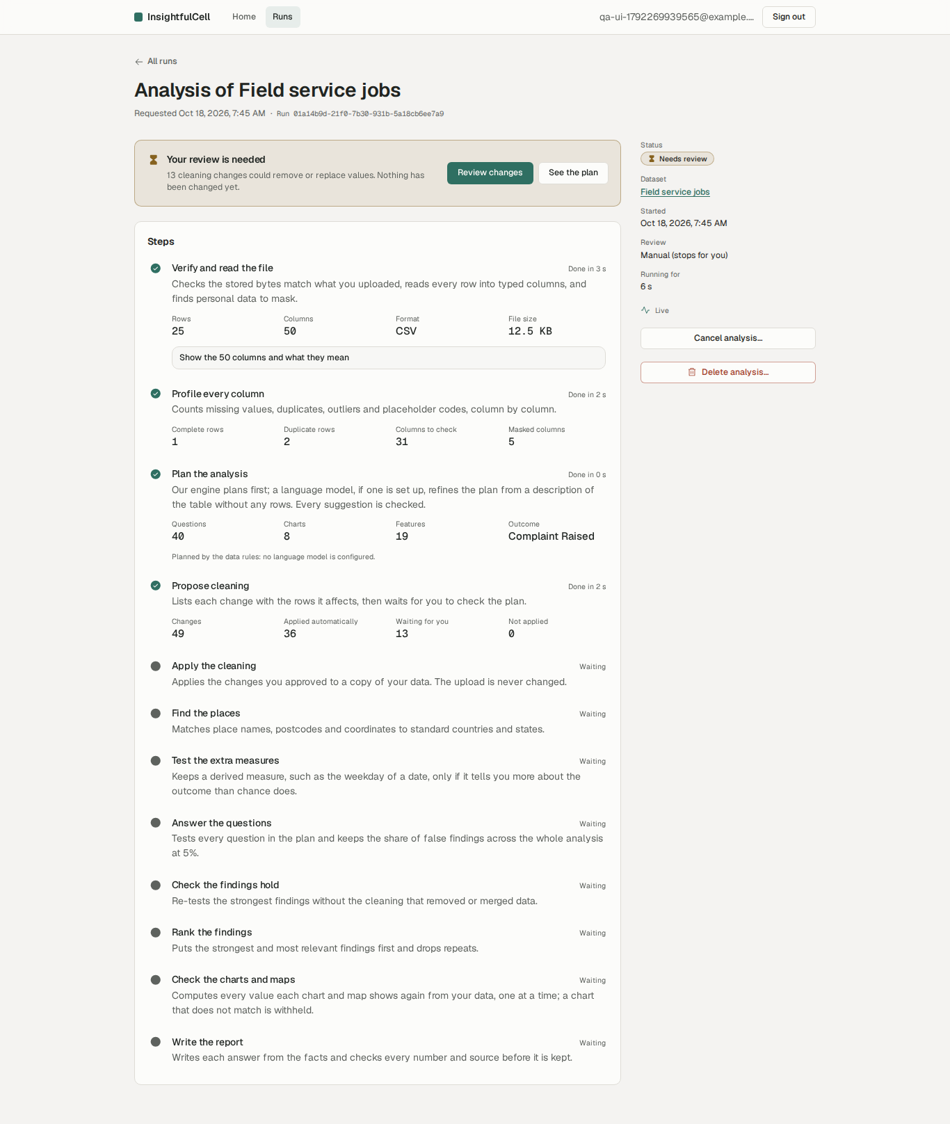
Figure 13. Run page at the review gate (manual mode).
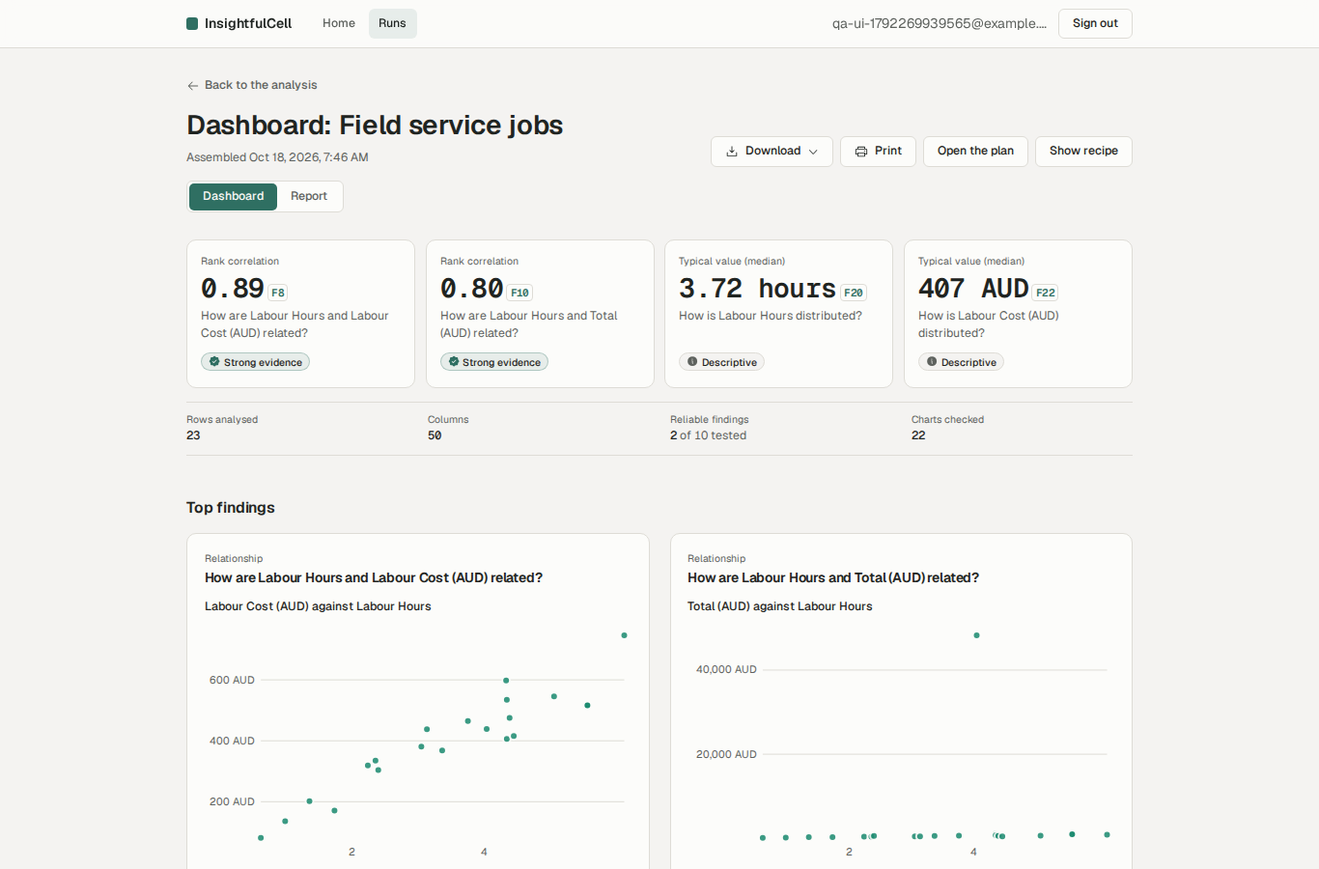
Figure 14. Dashboard of a finished analysis.

10. Security architecture
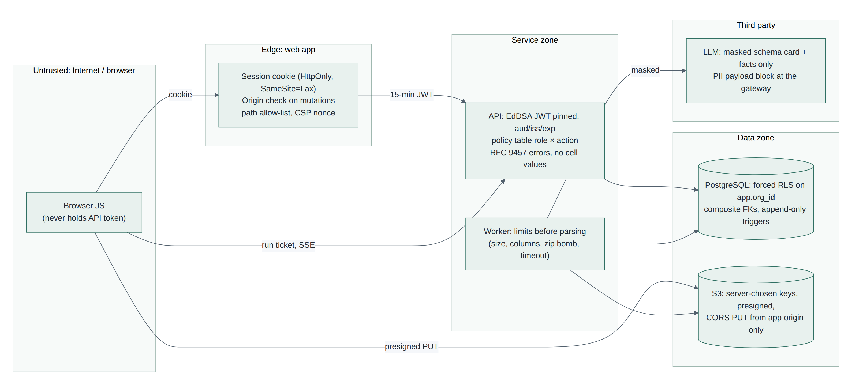
Figure 15. Trust zones and the control at each boundary.
Threat | Control | Where
Impersonation | 15-minute EdDSA JWT, algorithm pinned, issuer/audience/expiry checked offline against JWKS; event tickets bound to one run with their own audience | auth/tokens.py, lib/backend.ts, events-ticket
Token theft in the browser | BFF; Better Auth /token disabled; no JWT header; HttpOnly SameSite=Lax cookie; no session cookie cache | lib/auth-options.ts
Cross-tenant data access | Organisation only from the token; app.org_id per transaction; forced RLS; composite FKs | db/tenant.py, migration 0002
Privilege abuse | One policy table role × action | domain/security.py
CSRF | Origin check on every mutation against the app’s own addresses (BETTER_AUTH_URL plus AUTH_TRUSTED_ORIGINS); SameSite cookies; Better Auth origin check | lib/backend-policy.ts
Request smuggling through the proxy | Path allow-list with segment regex, ≤4 segments, events path denied | lib/backend-policy.ts
Malicious files | Extension allow-list, declared size cap, signed content length, magic bytes, column and row limits, zip-bomb guard, parse timeout; parsing only in the worker | services/uploads.py, ingestion/limits.py
Script injection | React escaping; CSP nonce + strict-dynamic; autoescaped Jinja; exported HTML with no script; recipe quoting | csp.ts, exports/
Personal data to a model | Detection at ingest; masked schema card; gateway payload block; personal-data columns hidden in “See the data” | engine/semantics.py, schema_card.py, llm/gateway.py
Tampering with results | Append-only triggers, content hashes on facts, versioned plans and decisions | migrations 0005–0009
Leaking data in errors and logs | Problem details never include cell values; access log has path only | api/problems.py, middleware.py
Open relays | The storage relay answers only for loopback storage and signed URLs from a trusted origin, caps a part at 64 MiB and returns only the status and ETag; the events relay forwards only the run ticket | app/api/storage, app/api/runs/[runId]/events
Cost abuse | Hard spend caps reserved before each model call under one advisory lock (overall, per provider, per person); unpriced models never called; 2 MiB proxy body cap | llm/gateway.py, services/llm_spend.py, lib/backend-policy.ts
Admin dashboard exposure | Key only on the server (≥ 32 characters); constant-time comparison; signed short-lived HttpOnly SameSite=Strict cookie; wrong keys throttled; API endpoint hidden, answering 404 when off or wrong | lib/admin-session.ts, api/routers/admin.py

Known gaps (detailed in the test report): no per-organisation rate limits, sign-in throttle keyed on X-Forwarded-For (overwritten by Caddy on the AWS host), unused invitation endpoints, no email verification; the proxy body cap was added in iteration 24. The admin dashboard uses one shared key with an in-memory attempt counter and shows every account’s name and email to whoever holds it. A deleted run’s cached table can stay on the API host for up to an hour, never served (ADR-040).

11. AI and model design
Purpose | Model tier (Gemini default) | It sees | It returns | Checked by | Fallback
Plan the analysis | strong (gemini-3.5-flash-lite) | Masked schema card + rules draft | Typed plan (JSON schema) | Plan validator, then the person | Rules plan
Narrate a question | strong | That question’s facts as text | Sentences with numeric slots | Sentence verifier, one repair | Template sentence
Judge (off by default) | fast (gemini-3.1-flash-lite) | One fact and one sentence | Accept / reject | Can only reject | Skipped
Questions (Phase 7) | fast router + strong agent | Question, dictionary, tool schemas | One tool call / ≤3 calls | Verifier | Template answer

- Numbers in narration are slots ({F3.1}) filled by the engine from the fact, so a model cannot write a wrong number.
- The verifier checks citations, stray digits, direction, wording strength against effect-size bands, causal language and missing conditions; over 30% failures in a part switches it to templates.
- Provider choice is configuration; the system runs fully without any model (rules planner, template narration).
- A backup model from another provider (for example gpt-4o-mini) answers when the main one fails, and a hard spend cap covers both: each attempt reserves its worst-case cost first, so the total never passes the cap; past it, runs use the rules. The OpenAI and DeepSeek default models have no built-in price, so under a cap they are used only once priced with LLM_PRICES_JSON.

12. Deployment and operations
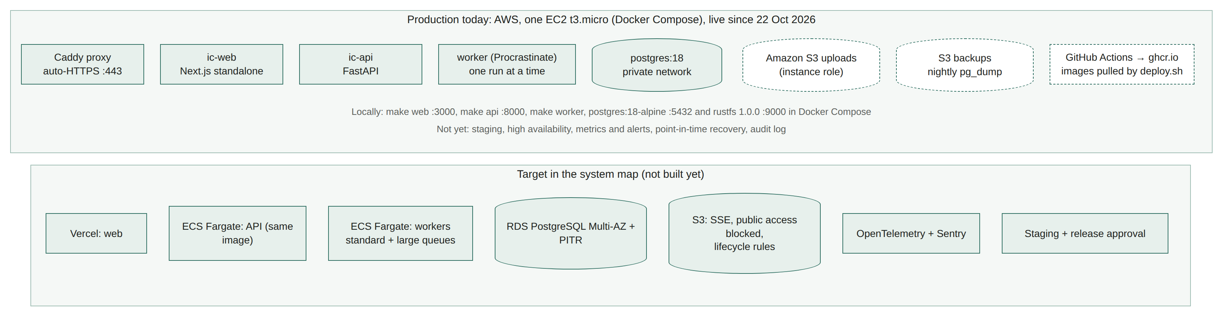
Figure 16. Deployment today (one AWS host) and the target in the baseline.
Environment | Web | API and worker | Data | Status
Local | pnpm dev / standalone | uvicorn, worker process | PostgreSQL 18 + RustFS in Compose | Working
Shared local | next dev through one ngrok tunnel | Local processes | Local Compose | Working for testers (ADR-038, ADR-039)
AWS production (one EC2 t3.micro) | Next.js standalone container behind a shared Caddy proxy (Let’s Encrypt HTTPS) | API and worker containers (one image, pulled from ghcr.io) | PostgreSQL 18 container (private network); Amazon S3 via the instance role; nightly pg_dump to an S3 backups bucket; daily EBS snapshots | Live since 22 Oct 2026 at app.ic.rgproject.me; full journey checked with Playwright
CI | GitHub Actions: lint, types, tests, migrations, contract, e2e, image builds, audits |  |  | Runs on GitHub since 19 Oct; since 22 Oct an Images workflow builds the api, web and web-tools images on every push to main and publishes them to ghcr.io for the server to pull
Preview / staging | Vercel preview | ECS Fargate | RDS single-AZ, S3 | Not started (baseline target)
Production | Vercel | ECS Fargate, scaling on queue age | RDS Multi-AZ + PITR, S3 | Baseline target; production runs on one EC2 host for now

Production since 22 October 2026. The application runs on one AWS EC2 instance (t3.micro, Ubuntu 24.04, 4 GB swap) set up with the deploy/aws kit by the deployment owner. A shared Caddy container owns ports 80 and 443, obtains Let’s Encrypt certificates and routes app.ic.rgproject.me to the web app and api.ic.rgproject.me to the API, unbuffered for the live-progress stream. PostgreSQL 18, the API, the worker and the web app run under Docker Compose; PostgreSQL has no published port.
Releases are pulled, not built, on the server: a GitHub Actions workflow (Images) builds the api, web and web-tools images on every push to main and pushes them to ghcr.io, tagged latest and with the commit SHA. deploy.sh pulls them, creates the database roles (the API’s login role cannot bypass row-level security), runs the migrations and starts the services; IC_IMAGE_TAG=<sha> deploys or rolls back one exact build. Secrets live only in three git-ignored env files on the server, and S3 access comes from the instance role, so there are no storage keys at all.
Uploads go straight from the browser to a private S3 bucket whose CORS rule allows only the app. The only code change for AWS made the API sign part URLs for the bucket’s regional host, because the global host redirects and browsers cannot follow a redirect on a CORS upload. backup.sh streams a nightly pg_dump to a second bucket (30-day expiry), and daily EBS snapshots cover the volume. On 22 October no language model was configured on the host, so the live site plans with the rules and writes template sentences; a 5,000-row file went from upload to report in 14 seconds.

12.1 What Phase 8 must add
- Staging and production environments with infrastructure as code and secrets management.
- OpenTelemetry traces across web, API, queue and worker; Sentry; metrics (RED per endpoint, queue depth and age, stage durations, model cost, verifier rejection rate) and alerts.
- Backups with point-in-time recovery and restore drills; retention (bronze 90 days, partition dropping).
- Append-only audit log; per-organisation rate limits; release flow with manual approval.

13. Quality assurance
Quality gates run locally with make check and in CI, both through the same scripts (scripts/check.sh). Since 19 Oct 2026 the git hooks only format staged files and scan for secrets on commit; a push runs no checks.
Gate | Tooling | Latest result (18 Oct 2026)
Style and lint | ruff, prettier, eslint (next, typescript, jsx-a11y) | Pass
Types | mypy strict (198 files), tsc strict | Pass
Architecture | import-linter, 6 contracts | Pass
Backend tests | pytest unit + integration on real PostgreSQL and S3 | 668 passed, 92.9% coverage
Frontend tests | vitest + Testing Library + axe | 369 passed
Browser journeys | Playwright | 5 of 5 passed
Database | Migrations up/down/up | Pass
Contract | OpenAPI → TypeScript drift check | Pass
Supply chain | pip-audit, pnpm audit, secret scan | No findings

The companion test report adds a deep run of all 52 sample files, a 99-check live security battery, a live model privacy probe and an accessibility walkthrough. Its main findings: tenant isolation and upload security held; cleaning heuristics can change data silently in automatic mode; the model planning path failed (F-01, fixed on 19 Oct); production operations are missing.
Re-run on 19 Oct 2026 after iterations 17–19: 496 backend unit and 179 integration tests, 391 frontend tests (axe included), ruff, mypy, import contracts, eslint, tsc and the production build pass; a live Gemini run through an ngrok tunnel reached the report. make check as a whole and the browser journeys were not re-run.
Full gate on 21 Oct 2026 (scripts/check.sh, PostgreSQL and RustFS running) after the backup model, spend cap and admin dashboard: 715 backend tests at 93.02% coverage and 422 frontend tests (axe included) pass, together with lint, types, import contracts, migrations up/down/up, the API contract, the production build, pnpm audit and the secret scan. pip-audit failed on the committed lock: 9 advisories published since the last gate, in certifi 2026.7.22 (fixed in 2026.10.19) and pillow 12.3.0 (fixed in 13.0.0). An uncommitted uv.lock update to those versions passes pip-audit; the tests were not re-run on it. The browser journeys (now including two admin-dashboard tests) and a live model call were not run.
22 Oct 2026, after the AWS deployment commits: 719 backend tests are collected (4 new tests check the regional host of S3 upload links) and the 530 backend unit tests pass. The integration and frontend suites, make check and the browser journeys were not re-run, since the only application change is in storage/s3.py and the web image’s build heap. Instead, the full journey was driven against the live site with Playwright (register, upload, duplicate check, automatic and manual runs, review gate, report, fact inspector, See the data, dashboard and maps, all four downloads, a drill-down) and every step passed. The committed backend/uv.lock still pins certifi 2026.7.22 and pillow 12.3.0, so the deployed image carries the 9 advisories found on 21 Oct.

14. Project status and progress
# | Phase | Status | Highlights
0 | Foundation and local environment | Done | Compose stack, CI definition, hooks, check scripts
1 | Sign-in, tenancy, API, upload, ingestion | Done | Better Auth BFF, RLS, presigned uploads, DuckDB ingestion
2 | Runs, queue, worker, live progress | Done | Procrastinate, checkpoints, SSE with tickets
3 | Analysis Phase A | Done | Semantics, profile, rules and model planning, cleaning plan, review
4 | Analysis Phase B | Done | Geo, features, nine miners, BH-FDR, sensitivity, rank, facts
5 | Narration and verification | Done | Slots, verifier, repair, fallbacks, re-narration
6 | Charts, dashboard, report, exports, drill-downs | Done | Checked charts and maps, exports, deletion
7 | Question data (tiered Q&A) | Not started | Split view, tiers 0–2, six tools, quotas, answer cache
8 | Running it | Started | Done: production on AWS (one EC2 host, HTTPS, S3, nightly backups, CI-built images). Left: staging, observability, hardening, retention, audit log
R2 | Embeddings and fused search | Not started | pgvector + HNSW

14.1 Deviations from the baseline
Baseline | Built | Reason
apps/* + packages/* layout | backend/ + frontend/ | ADR-025
MinIO locally | RustFS 1.0.0 | ADR-027: image withdrawn
Claude only | Four providers, Gemini default, rules fallback | ADR-031
Eleven Phase B stages | Eight (narrate/verify/assemble inside report) | ADR-032
Miners in a process pool | Sequential | ADR-032: measured faster
Vega-Lite rendering in the browser | Own accessible chart components; spec as download | ADR-035: CSP forbids unsafe-eval
Run pauses only for lossy changes | Automatic (no pause) or manual (always pauses) | ADR-036: owner’s choice; note the tension with tenet 1
Rates per resident, spatial clustering | Shares and averages per region | ADR-035: no population data
Token budgets per run and organisation | Also a hard spend cap in AUD and a backup provider | Public demo budget (21 Oct 2026); no ADR yet
Vercel + ECS Fargate + RDS Multi-AZ | One EC2 instance with Docker Compose, Caddy, PostgreSQL in a container, Amazon S3 | Free-tier cost for a demo; RDS’s master user cannot create the BYPASSRLS role that migration 0001 needs (22 Oct 2026); no ADR yet

15. Risks and issues
ID | Risk / issue | Likelihood | Impact | Mitigation
R1 | Silent data changes in automatic cleaning reach reports (test findings F-02, F-03, F-05) | High | High | Fix heuristics; lossless-only automatic mode; answer-key regression in CI
R2 | Model planning path broken (F-01): fixed 19 Oct 2026 | Closed | High | Fixed (nullable JSON columns store SQL NULL) and checked with a live Gemini run; keep a live smoke test per release
R3 | Production on a single small host (one EC2 t3.micro since 22 Oct 2026): no staging, no high availability, no monitoring or alerts by Release 1 alpha (11 Dec 2026) | Medium | High | Add staging, metrics, alerts and a restore drill; resize the instance when runs queue; consider RDS once the BYPASSRLS migration is tested there
R4 | Abuse: password guessing, resource exhaustion, invitations | Medium | Medium | Rate limits, trusted IP header (Caddy overwrites it on the AWS host), disable unused routes; body cap done
R5 | Rules planner asks the wrong questions on real tables | High | Medium | Outcome suggestion, long-format and derived-column detection; working model path
R6 | Single developer and AI-assisted velocity: knowledge concentration | Medium | Medium | ADRs, a phase tracker, this report, code review before release
R7 | Free-tier model quotas and provider outages | High | Low | Backup model from another provider and deterministic fallbacks; hard spend cap; paid tier for production
R8 | Dependency drift (Next.js, Better Auth majors) | Medium | Medium | Pinned versions, audits in CI, patch file kept small
R9 | Spend cap misconfigured: an unpriced main model is never called, or the cap is spent and reports stay simplified | Medium | Low | Price every configured model (LLM_PRICES_JSON); watch the admin dashboard; treat spend-cap reasons as final for re-narration

16. Roadmap and recommendations
Horizon | Work | Outcome
Next 2 weeks | Fix test-report findings F-02 to F-06, F-12 (F-01 fixed 19 Oct); automate the sample-data answer key; write ADRs for the backup model, spend cap and admin dashboard; commit the dependency update for the 9 advisories (certifi, pillow) and redeploy; add a restore drill and basic monitoring to the AWS host | A closed pilot can start
Before Release 1 alpha (11 Dec 2026) | Phase 7 Q&A; rate limits and auth hardening; staging, tracing, metrics, backups, audit log | Alpha with real users and support
Release 2 beta (12 Mar 2027) | Invitations and roles UI, shared reports, embeddings search, load test at planning load, external penetration test | Team use and scale evidence
General availability (9 Apr 2027) | SLOs (99.5% API, 98% runs), cost controls, compliance documentation | Commercial launch

17. Conclusion
InsightfulCell has built, in a short time, the difficult core that most AI analytics products skip: tenant isolation enforced in the database, provenance for every number, statistical control of false discoveries, charts that are recomputed before display, and a model boundary that keeps raw data private. The system is well structured and well tested at the unit and journey level.
To serve real users with sensitive data, three things must happen next: make data preparation as trustworthy as the statistics that follow it, keep the now-working model path tested live, and build the operational layer (monitoring, backups, rate limits, audit). With those in place the product’s central promise — every number shows its work — is credible and defensible.

Appendix A. API catalogue
Method | Path | Purpose
GET | /healthz, /readyz | Liveness; readiness (database reachable, migrations current)
GET | /v1/me | Who am I, and in which organisation
POST | /v1/uploads | Start an upload and get presigned part URLs
GET | /v1/uploads/{id} | Upload status
POST | /v1/uploads/{id}:presign-parts | Fresh URLs for specific parts
POST | /v1/uploads/{id}:complete | Finish an upload and create the dataset version
POST | /v1/uploads/{id}:abort | Cancel an upload
GET | /v1/datasets, /v1/datasets/{id} | List datasets; one dataset and its versions
DELETE | /v1/datasets/{id} | Delete a dataset, its versions and every analysis
GET / POST | /v1/runs | List runs; start an analysis (202)
GET / DELETE | /v1/runs/{id} | A run with its stages; delete a run
POST | /v1/runs/{id}:cancel, :retry | Cancel; retry from the last checkpoint (If-Match)
GET | /v1/runs/{id}/events | Live progress (SSE, Last-Event-ID replay, run ticket)
GET | /v1/runs/{id}/plan, /recipe | Plan, columns and cleaning plan; Python recipe
POST | /v1/runs/{id}/plan:revise | Plan again with the person’s requests
POST | /v1/runs/{id}/cleaning-plan:decide | Accept or reject each change and approve
GET | /v1/runs/{id}/report, /dashboard | The two documents the UI renders
GET | /v1/runs/{id}/report.html|.pdf|.docx|.md | Downloads
POST | /v1/runs/{id}/report:renarrate | Re-narrate a simplified report after an outage
POST | /v1/runs/{id}/drilldowns | Explore one group as an exploratory sub-run
GET | /v1/runs/{id}/rows | “See the data”: the table as read, a page at a time (≤ 200 rows), personal-data columns hidden
GET | /v1/admin/overview | Admin dashboard figures (web server only, X-Admin-Key; hidden from the OpenAPI schema)

Appendix B. Repository map
Path | Contents
backend/src/insightfulcell/api | FastAPI app, routers, middleware, problem responses, schemas
backend/src/insightfulcell/services | Use cases: uploads, datasets, runs, plans, reports, drilldowns, deletion, executor, maintenance, spend cap, admin
backend/src/insightfulcell/engine | Pure analysis engine (semantics → report), ports
backend/src/insightfulcell/pipeline | Stage wrappers and checkpoints
backend/src/insightfulcell/llm | Gateway, providers, prompts, pricing
backend/src/insightfulcell/{domain,ingestion,storage,auth,db,queue,worker,exports} | Supporting layers
backend/migrations | Alembic migrations 0001–0012
frontend/src/app | Routes, BFF and auth handlers
frontend/src/components, lib | UI components; server and shared logic; generated API types
scripts/, .github/ | Checks, e2e runner, bootstrap, CI
sample_data/ | Synthetic test datasets and answer key

