Forms response chart. Question title: Demographic Information

What is your name?. Number of responses: 37 responses.

Forms response chart. Question title: What is your age?
. Number of responses: 37 responses.

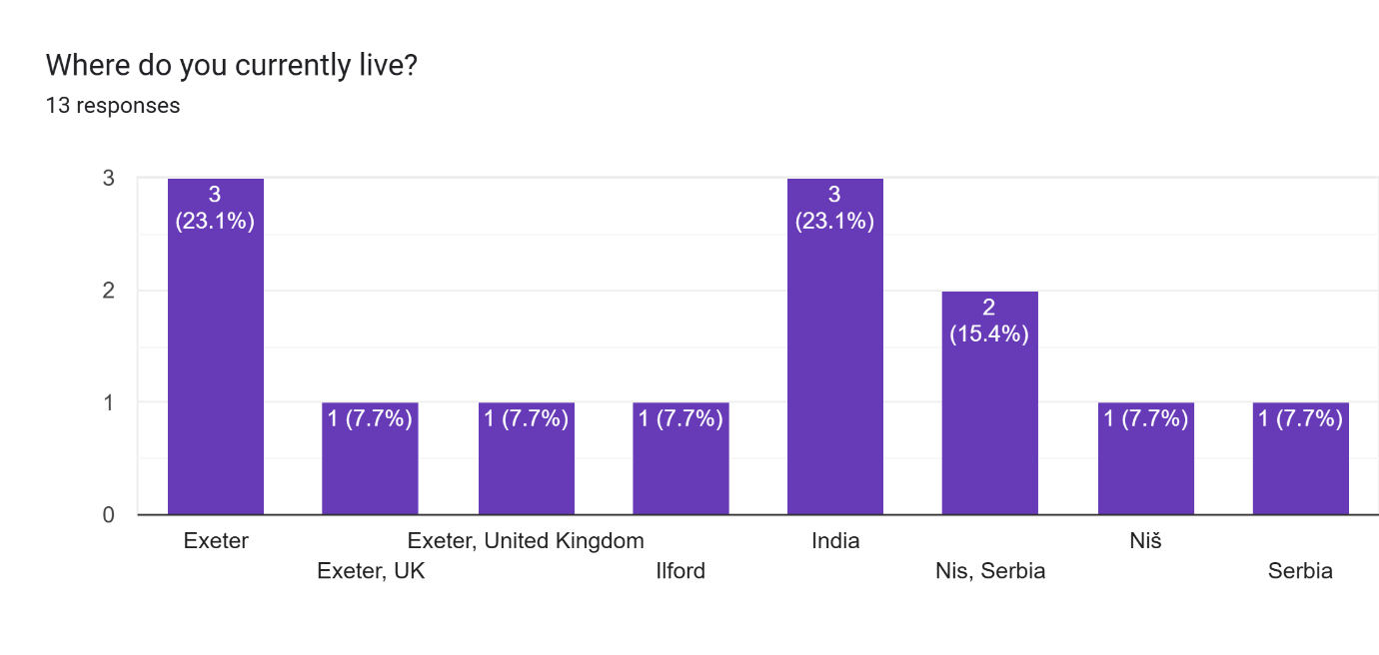

Forms response chart. Question title: Feature Prioritisation


Which feature of Fundra do you find most suitable?. Number of responses: 36 responses.

Forms response chart. Question title: Cross Border Transactions


How important is the ability to perform cross border transactions to you?. Number of responses: 36 responses.

Forms response chart. Question title: Web-based Bank Account Transactions



How often do you foresee using web-based bank account transaction details?
. Number of responses: 37 responses.

Forms response chart. Question title: Sentiment Analysis for Investment Decisions



How likely are you to use sentiment analysis to guide your financial decisions?
. Number of responses: 37 responses.

Forms response chart. Question title: Most Important Feature

Which is the most important feature you are waiting for?. Number of responses: 37 responses.