Final Project Report
PantryBook — Personal Recipe Manager

Project Title
PantryBook — a responsive, browser-based personal recipe manager.

Project Objective
To design and build a complete, responsive website using the HTML, CSS and JavaScript concepts covered in the internship, and to practise a real Git and GitHub workflow — from local version control through to a live deployment on GitHub Pages.

Project Overview
Family recipes are usually scattered across notebooks, screenshots and chat messages. PantryBook gives them one searchable home. The app ships with a starter set of recipes and lets a user search by name or ingredient, filter by course and difficulty, mark favorites, and add, edit or delete their own recipes through a validated form. All data is saved to the browser's localStorage, so a user's changes persist across page reloads without needing a backend server.

Technologies Used
- HTML5 — semantic structure (header, nav, main, aside, section, article, footer) across two pages.
- CSS3 — the box model, Flexbox (header, filter fields), CSS Grid (recipe card grid), custom properties, and media queries for tablet and mobile breakpoints.
- JavaScript (ES6) — arrays and objects as the data model, DOM rendering, event handling, form validation, and the localStorage API.
- Git & GitHub — local version control with staged, incremental commits, and GitHub Pages for deployment.

Main Features
- Live search across recipe names and ingredients.
- Filter by course and difficulty, plus a favorites-only toggle.
- Sort by name, cook time, or difficulty.
- Add, edit and delete recipes with inline form validation (required fields, minimum ingredients/steps, numeric ranges).
- One-click favorite toggle reflected instantly in the stats bar.
- Data persistence via localStorage — nothing is lost on refresh.
- Fully responsive layout, verified on desktop, tablet and mobile viewports.

Website Screenshots
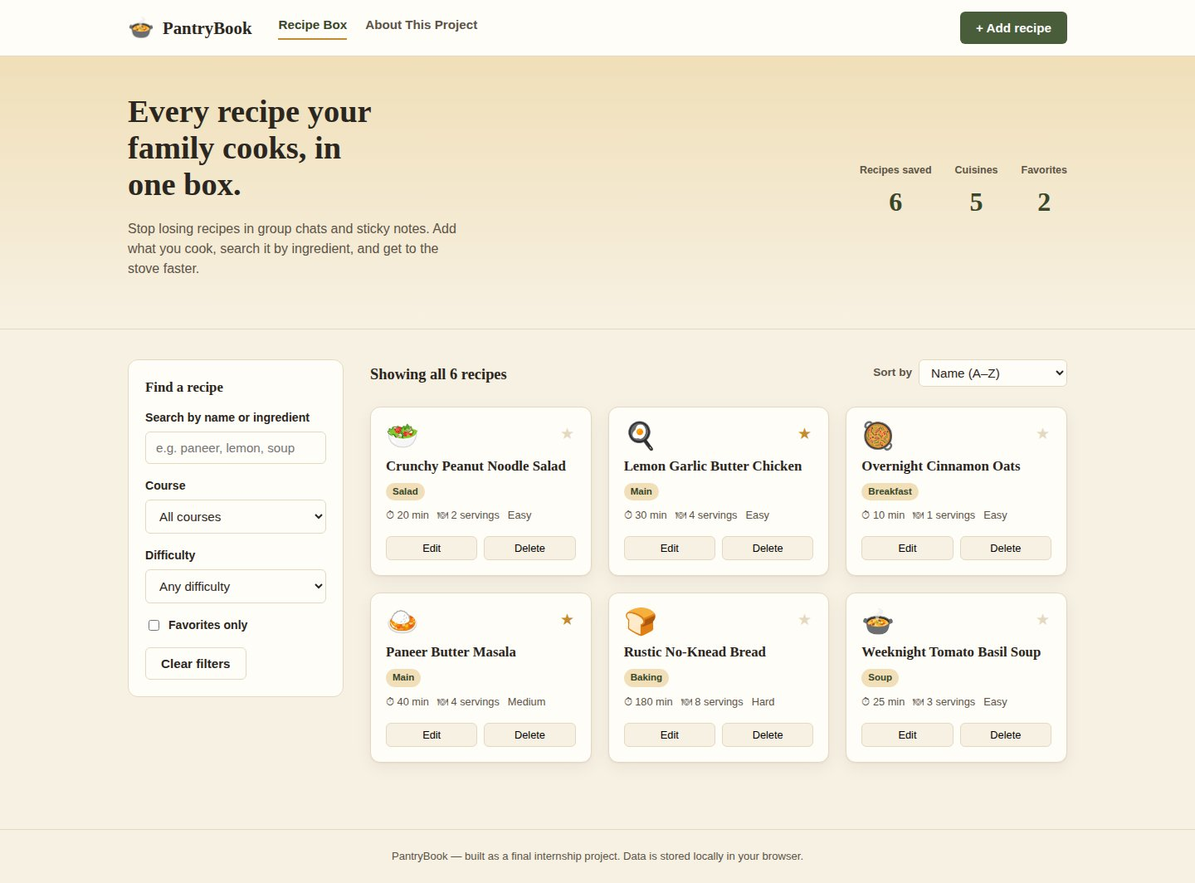
Desktop — Recipe Box home, showing live stats, filters and the recipe grid.
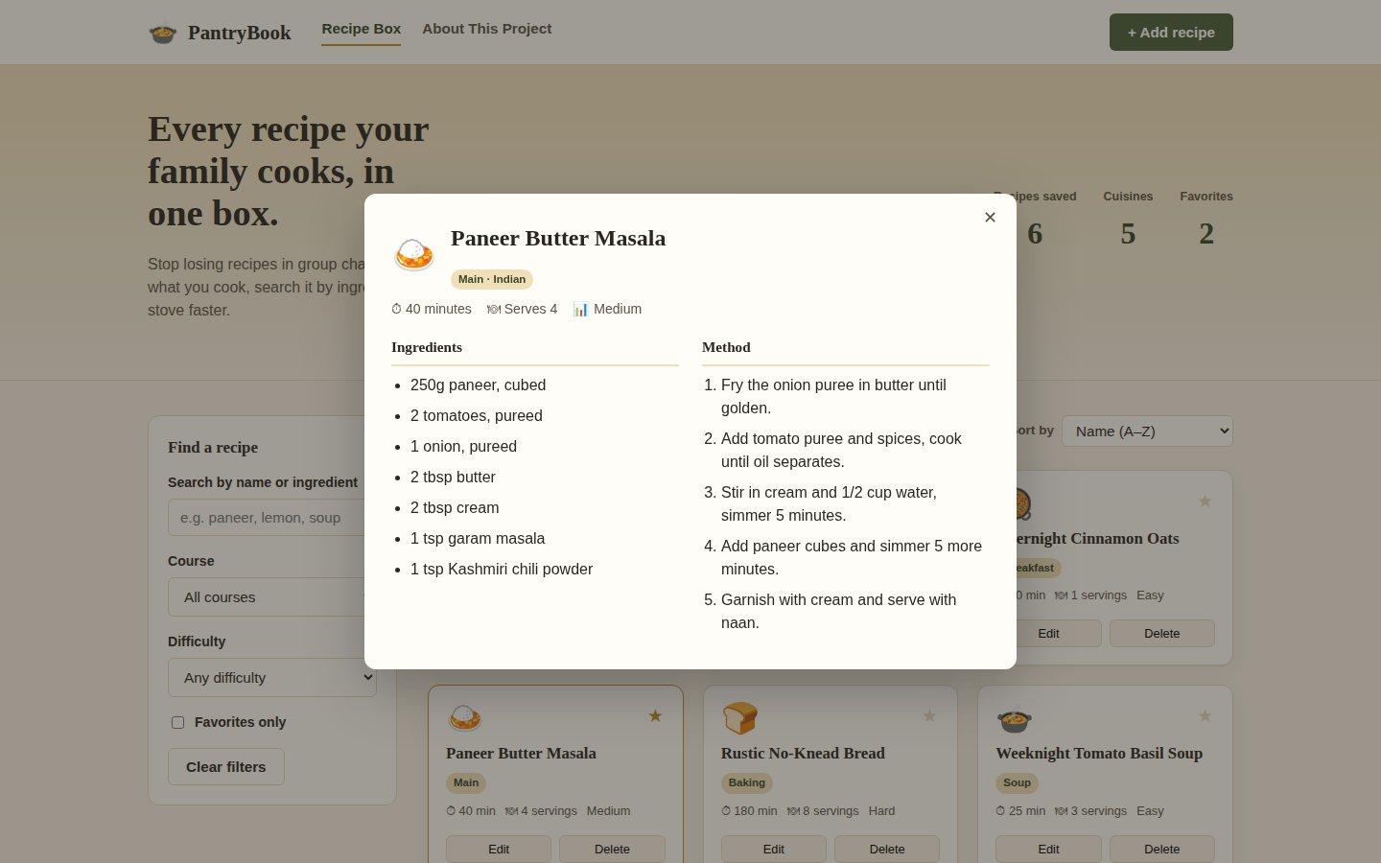
Desktop — recipe detail modal with ingredients and method.
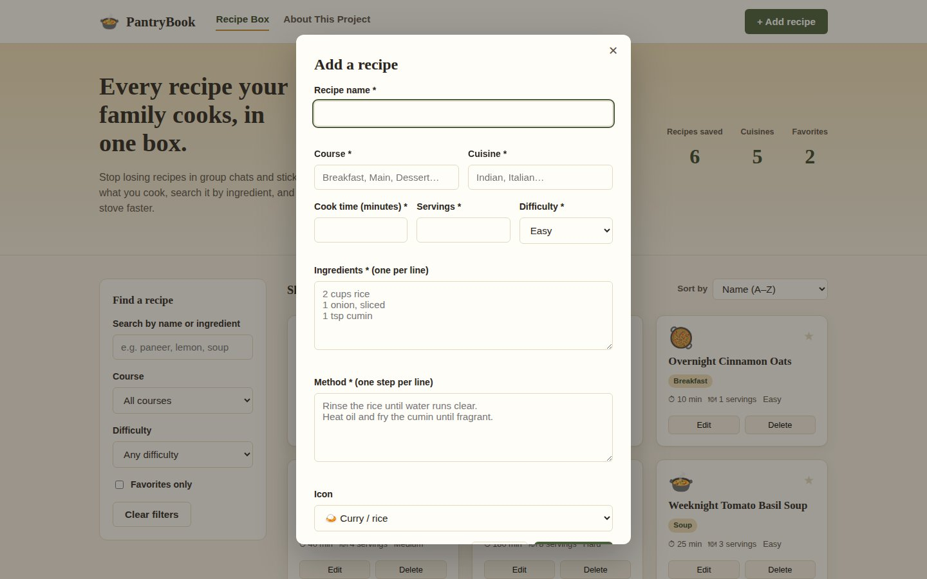
Desktop — validated Add/Edit recipe form.
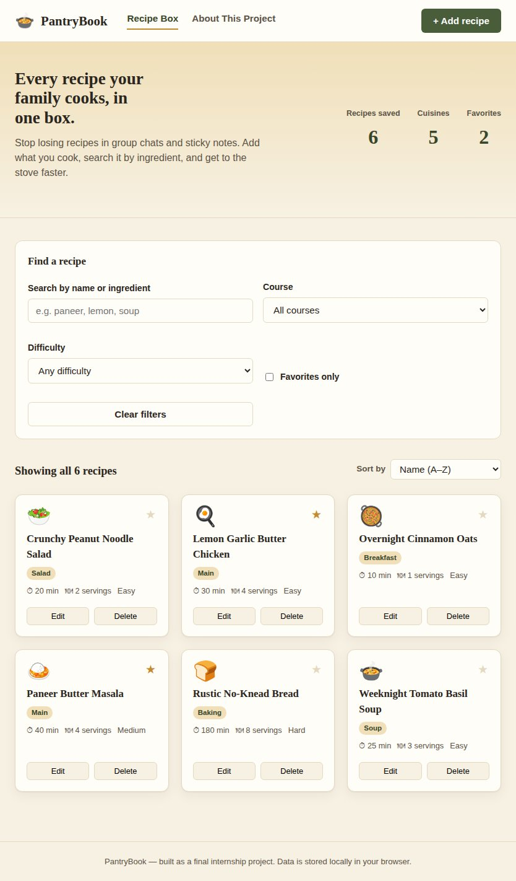
Tablet layout (834px) — filters reflow into a two-column panel.
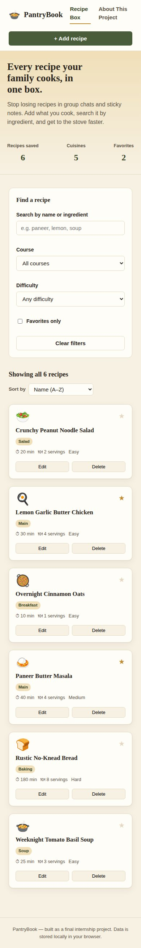
Mobile layout (390px) — single-column, thumb-friendly controls.

GitHub Repository Link
https://github.com/<your-username>/pantrybook (update after pushing — see README for exact push commands)

Live Website Link
https://<your-username>.github.io/pantrybook/ (update after enabling GitHub Pages)

Challenges Faced
- Keeping the filter, search and sort controls working together without re-running redundant DOM renders.
- Designing a card grid that stays legible from a 1440px desktop down to a 375px phone without separate markup.
- Validating a multi-line ingredients/steps textarea without a heavier form library.

Solutions Implemented
- Centralised all list logic in one getFilteredRecipes() function that search, filters and sort all feed into, then a single renderGrid() call re-renders the DOM — avoiding inconsistent state.
- Used CSS Grid with auto-fill/minmax for the card grid and a small set of media query breakpoints (900px, 600px) so the layout reflows rather than being rebuilt per device.
- Split textarea input on newlines, trimmed and filtered empty lines, then checked array length against a minimum before allowing submit, with inline error text per field.

Key Learnings
- How to structure JavaScript around an array of objects as a single source of truth, with the DOM as a pure function of that state.
- Practical Flexbox vs. Grid decisions — Flexbox for one-dimensional rows (header, filters), Grid for the two-dimensional card layout.
- A disciplined Git habit: staging related files together and writing a commit message that describes the change, not just 'update'.

Future Improvements
- Sync recipes to a real backend/database so a collection can be shared across devices.
- Add photo uploads per recipe instead of icon-only cards.
- Add unit conversion and a 'scale servings' control for ingredient quantities.

