12 June 2020 (day 2)

# Completed NI beginner Tutorial

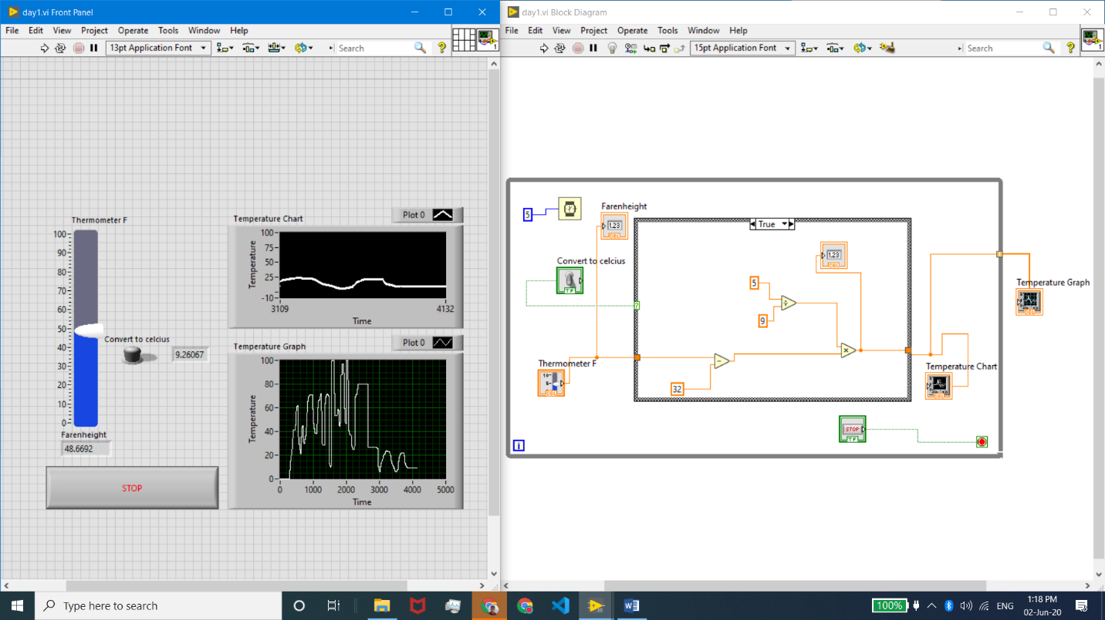<https://www.youtube.com/playlist?list=PLB968815D7BB78F9C> till video no 10 which was relevant for the project.

Topics covered – While loops, case structures, flat sequence, simple mathematical operations, debugging