03 June 2020 (day 3)

# Created a vi to generate a Sine wave

Parameters included:

1. Amplitude
2. Frequency
3. Cycles
4. Offset
5. Sampling
6. 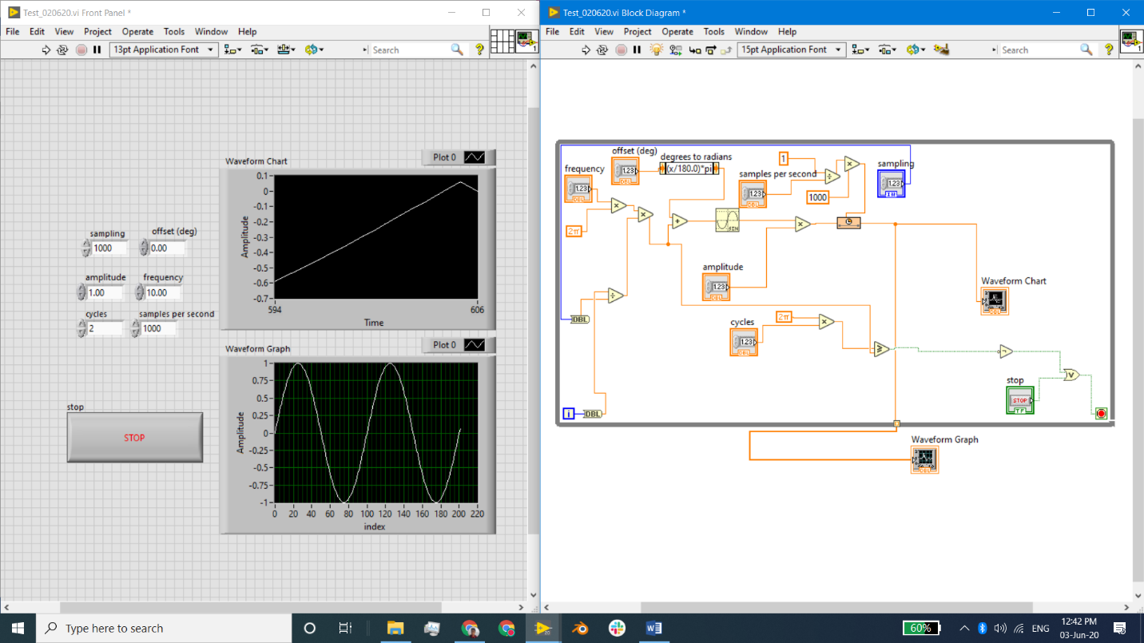Sample rate

# Completed NI beginner Tutorial all videos

<https://www.youtube.com/playlist?list=PLB968815D7BB78F9C> Topics covered – While loops, case structures, flat sequence, simple mathematical operations, debugging, *measurement, PID controller, logging, triggering, signal processing (power spectrum), report generation, DAQ*