08 June 2020 (day 8)

# Created a vi to generates 3 Sine waves and outputs the product

I made a SubVI out of the previous sine wave generator VI to simplify the code. I used a case structure to optionally display different combinations of the 3 waves i.e.

1*2*3 1*2 1*3 1*2 1 2 3

Parameters included:

1. Amplitude
2. Frequency
3. Duration of signal
4. Offset
5. 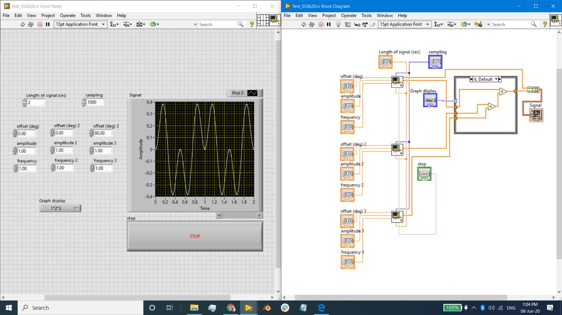Sampling

# Read through Zurich instruments white paper on lock in amplifier

<https://www.zhinst.com/sites/default/files/li_primer/zi_whitepaper_principles_of_lock-in_detection.pdf>

And also watched the accompanying video <https://www.youtube.com/watch?v=ZIjBRA2S0NQ>