DR. RVR NRI UNIVERSITY
WEB DEVELOPMENT PROJECT REPORT

EDUPORTAL
STUDENT ACADEMIC DASHBOARD

Submitted by: GANGIPOGU RUPESH KUMAR
University: DR. RVR NRI UNIVERSITY
Course: B.Tech – CSE (AI & ML)
Academic Level: First Year

Academic Year: 2026–2027

PROJECT REPORT

1. Introduction
EduPortal is a student academic dashboard website designed to present important academic information in one place. The project provides a simple interface through which a student can view profile details, semester performance, attendance percentages, enrolled subjects, examination dates and academic announcements. The supplied project is built as a set of HTML pages connected to a shared CSS file.
The main purpose of the website is to demonstrate how a student portal can organise academic information into clearly labelled sections. The dashboard page gives an overview, while separate pages provide focused information about the student's profile, results, attendance, subjects, examinations and notices.

2. Project Objectives and Main Features
- Provide a dashboard-style overview of student academic information.
- Display student identity, course, semester and academic status.
- Present semester grades, credits and SGPA in tabular form.
- Show subject-wise attendance using percentage values and progress bars.
- List subjects with their course codes and credit values.
- Display an examination timetable with dates and times.
- Show announcements and reminders relevant to students.
- Provide sidebar navigation links between the dashboard areas and individual pages.

3. Technologies Used
HTML5 – Used to define the structure and content of the webpages, including headings, navigation links, sections, tables, text and footer content.
CSS3 – Used through style.css to apply page layout, spacing, typography, colours, borders, shadows, progress bars, grid layout and responsive rules.
No JavaScript, database, server-side language, external image library or external framework is present in the supplied source files. The visible symbols are emoji characters included directly in the HTML.

4. Webpage Description

4.1 Overall Layout and Navigation
The pages use a dashboard structure with a dark navy sidebar and a main content area. The sidebar carries the EduPortal name and links for Dashboard, My Profile, Semester Results, Attendance, Subjects, Examination and Announcements. The main content area contains the page heading and the relevant information panel or sections.

4.2 Dashboard Page
The main dashboard page is titled Academic Dashboard. It includes a welcome message, a compact student identity area, a student profile card, and four summary values: current CGPA (8.6/10), overall attendance (87%), total subjects (6) and credits earned (24). Further down, it presents a semester results table, subject attendance progress bars, subject cards, an examination schedule, announcements and a footer reading “© 2026 EduPortal | Student Academic Dashboard”.

4.3 Profile Page
The profile page contains a Student Information panel with the student's name, student ID, course, semester, academic year and active-student status.

4.4 Semester Results Page
The results page contains a table with subject names, grades and credits for the previous semester. It lists Mathematics II, Programming in C, Engineering Physics and Digital Electronics, followed by an SGPA value of 8.6.

4.5 Attendance Page
The attendance page shows percentages for Mathematics III (92%), Data Structures (85%), Digital Logic (78%) and Python Programming (90%). Horizontal progress bars use green, blue and orange fills to represent the displayed values.

4.6 Subjects Page
The subjects page presents four subject cards: Data Structures (CS301, 4 credits), Python Programming (CS302, 4 credits), Mathematics III (MA301, 4 credits) and Digital Logic (EC301, 3 credits).

4.7 Examination Page
The examination page displays a timetable with subject, date and time columns. The listed examinations are Mathematics III on 10 Nov 2026 at 9:30 AM, Data Structures on 13 Nov 2026 at 9:30 AM, and Python Programming on 16 Nov 2026 at 1:30 PM.

4.8 Announcements Page
The announcements page contains three notices: Internal Examination, Attendance Reminder and Assignment Submission. Each notice includes a short instruction or reminder.

4.9 Styling and Responsive Behaviour
The supplied CSS sets the page font to Arial, uses a light blue-grey body background (#f3f6fb), dark text (#26344a), and a navy sidebar (#172554). Panels and subject cards use white backgrounds, rounded corners and subtle shadows or borders. Tables use light separators and pale header backgrounds. The stylesheet also defines a responsive breakpoint at 650 pixels: the sidebar becomes full width, navigation links become inline-block elements, main content padding is reduced, the subject grid becomes one column and table text becomes smaller.

5. Actual Webpage Output
The following figures reproduce the browser screenshots supplied with the project. They are included as evidence of the output captured in the student's browser. The screenshots show the dashboard from top to bottom; the browser interface and desktop taskbar remain visible because they are part of the supplied captures.
Screenshot 1 – Dashboard top and student summary
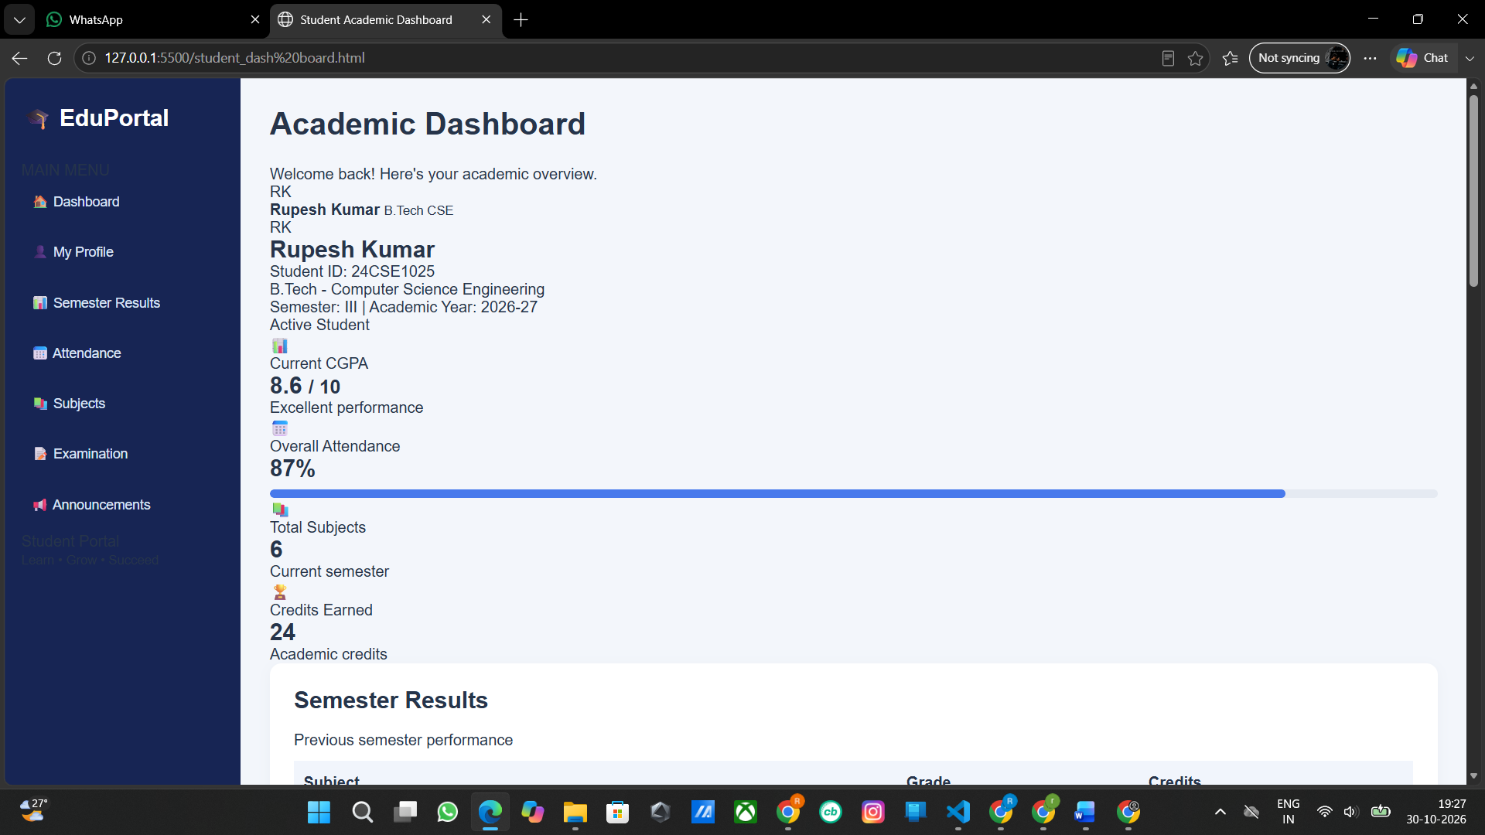
Screenshot 2 – Semester results and subject attendance
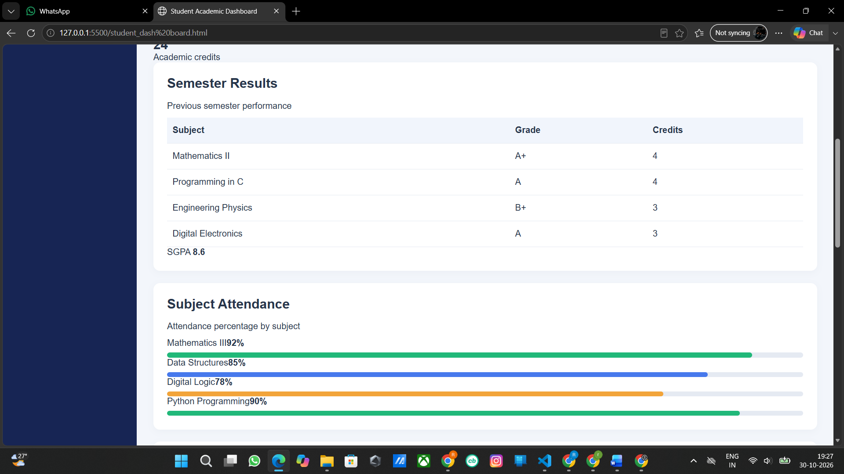

Screenshot 3 – Subject cards and examination section
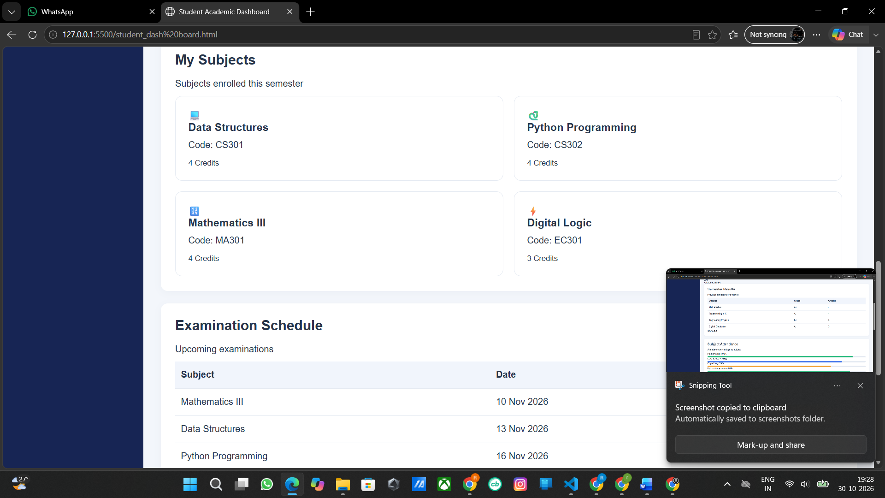
Screenshot 4 – Examination timetable, announcements and footer
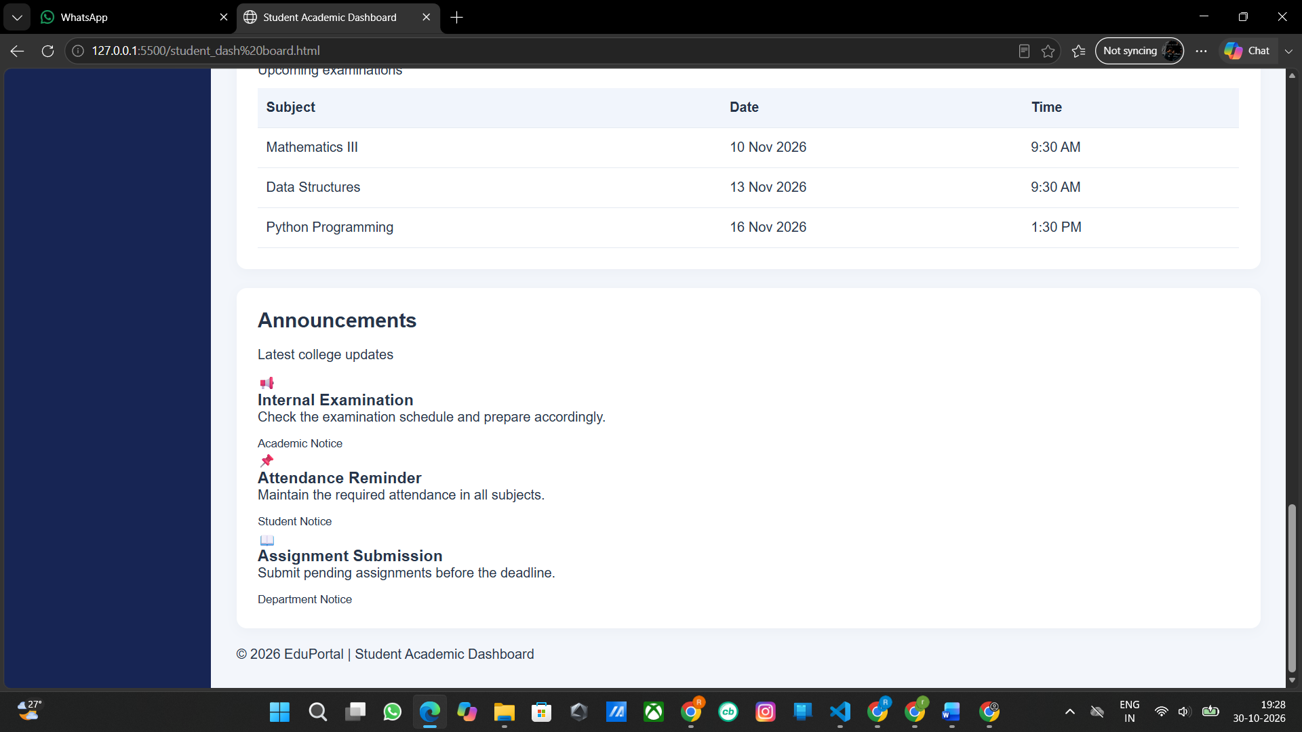

6. Output Explanation
The supplied screenshots show the EduPortal page in a desktop browser. A navy vertical sidebar remains on the left while the main page uses a pale background. The first capture shows the dashboard heading and student summary. The next captures show the results table and coloured attendance bars, followed by subject cards and the examination timetable. The final capture shows the announcements and the copyright footer. The information is organised vertically so that the user can scroll through the full dashboard.
The screenshots are the student's own browser captures and have not been recreated or altered. They document the actual visible output supplied for this report. A fresh independent browser render could not be performed in this document-generation environment; therefore the report does not claim that the screenshots were newly captured here.

7. Source Code
The source listings below are transcribed directly from the files supplied for this project. Original content and filenames are retained. The code is placed in a compact monospaced font to keep indentation and line order readable.

Main Dashboard (student_dash board.html)

<!DOCTYPE html>
<html lang="en">
<head>
<meta charset="UTF-8">
<meta name="viewport" content="width=device-width, initial-scale=1.0">
<title>Student Academic Dashboard</title>
<link rel="stylesheet" href="style.css">
</head>
<body>

<div class="dashboard">

<aside class="sidebar">
<h2>🎓 EduPortal</h2>
<p class="menu-title">MAIN MENU</p>

<a href="#overview" class="active">🏠 Dashboard</a>
<a href="#profile">👤 My Profile</a>
<a href="#results">📊 Semester Results</a>
<a href="#attendance">📅 Attendance</a>
<a href="#subjects">📚 Subjects</a>
<a href="#exams">📝 Examination</a>
<a href="#announcements">📢 Announcements</a>

<div class="sidebar-bottom">
<p>Student Portal</p>
<small>Learn • Grow • Succeed</small>
</div>
</aside>

<main class="main-content" id="overview">

<header class="topbar">
<div>
<h1>Academic Dashboard</h1>
<p>Welcome back! Here's your academic overview.</p>
</div>
<div class="student-mini">
<span class="avatar">RK</span>
<div>
<strong>Rupesh Kumar</strong>
<small>B.Tech CSE</small>
</div>
</div>
</header>

<section class="profile-card" id="profile">
<div class="profile-avatar">RK</div>
<div class="profile-info">
<h2>Rupesh Kumar</h2>
<p>Student ID: 24CSE1025</p>
<p>B.Tech - Computer Science Engineering</p>
<p>Semester: III | Academic Year: 2026-27</p>
</div>
<span class="status">Active Student</span>
</section>

<section class="stats-grid">
<div class="stat-card">
<span>📊</span>
<p>Current CGPA</p>
<h2>8.6 <small>/ 10</small></h2>
<p class="green">Excellent performance</p>
</div>

<div class="stat-card">
<span>📅</span>
<p>Overall Attendance</p>
<h2>87%</h2>
<div class="progress">
<div class="bar blue" style="width:87%"></div>
</div>
</div>

<div class="stat-card">
<span>📚</span>
<p>Total Subjects</p>
<h2>6</h2>
<p>Current semester</p>
</div>

<div class="stat-card">
<span>🏆</span>
<p>Credits Earned</p>
<h2>24</h2>
<p>Academic credits</p>
</div>
</section>

<section class="content-grid">

<div class="panel" id="results">
<h2>Semester Results</h2>
<p class="subtitle">Previous semester performance</p>

<table>
<thead>
<tr>
<th>Subject</th>
<th>Grade</th>
<th>Credits</th>
</tr>
</thead>
<tbody>
<tr>
<td>Mathematics II</td>
<td><span class="grade">A+</span></td>
<td>4</td>
</tr>
<tr>
<td>Programming in C</td>
<td><span class="grade">A</span></td>
<td>4</td>
</tr>
<tr>
<td>Engineering Physics</td>
<td><span class="grade">B+</span></td>
<td>3</td>
</tr>
<tr>
<td>Digital Electronics</td>
<td><span class="grade">A</span></td>
<td>3</td>
</tr>
</tbody>
</table>
<div class="result-footer">
SGPA <strong>8.6</strong>
</div>
</div>

<div class="panel" id="attendance">
<h2>Subject Attendance</h2>
<p class="subtitle">Attendance percentage by subject</p>

<div class="attendance-item">
<div class="progress-label">
<span>Mathematics III</span><strong>92%</strong>
</div>
<div class="progress">
<div class="bar green-bar" style="width:92%"></div>
</div>
</div>

<div class="attendance-item">
<div class="progress-label">
<span>Data Structures</span><strong>85%</strong>
</div>
<div class="progress">
<div class="bar blue" style="width:85%"></div>
</div>
</div>

<div class="attendance-item">
<div class="progress-label">
<span>Digital Logic</span><strong>78%</strong>
</div>
<div class="progress">
<div class="bar orange" style="width:78%"></div>
</div>
</div>

<div class="attendance-item">
<div class="progress-label">
<span>Python Programming</span><strong>90%</strong>
</div>
<div class="progress">
<div class="bar green-bar" style="width:90%"></div>
</div>
</div>
</div>

</section>

<section class="panel subjects-panel" id="subjects">
<h2>My Subjects</h2>
<p class="subtitle">Subjects enrolled this semester</p>

<div class="subjects-grid">
<div class="subject-card">
<span class="subject-icon">💻</span>
<h3>Data Structures</h3>
<p>Code: CS301</p>
<small>4 Credits</small>
</div>
<div class="subject-card">
<span class="subject-icon">🐍</span>
<h3>Python Programming</h3>
<p>Code: CS302</p>
<small>4 Credits</small>
</div>
<div class="subject-card">
<span class="subject-icon">🔢</span>
<h3>Mathematics III</h3>
<p>Code: MA301</p>
<small>4 Credits</small>
</div>
<div class="subject-card">
<span class="subject-icon">⚡</span>
<h3>Digital Logic</h3>
<p>Code: EC301</p>
<small>3 Credits</small>
</div>
</div>
</section>

<section class="content-grid bottom-grid">

<div class="panel" id="exams">
<h2>Examination Schedule</h2>
<p class="subtitle">Upcoming examinations</p>

<table>
<thead>
<tr>
<th>Subject</th>
<th>Date</th>
<th>Time</th>
</tr>
</thead>
<tbody>
<tr>
<td>Mathematics III</td>
<td>10 Nov 2026</td>
<td>9:30 AM</td>
</tr>
<tr>
<td>Data Structures</td>
<td>13 Nov 2026</td>
<td>9:30 AM</td>
</tr>
<tr>
<td>Python Programming</td>
<td>16 Nov 2026</td>
<td>1:30 PM</td>
</tr>
</tbody>
</table>
</div>

<div class="panel" id="announcements">
<h2>Announcements</h2>
<p class="subtitle">Latest college updates</p>

<div class="announcement">
<span class="notice-icon">📢</span>
<div>
<h3>Internal Examination</h3>
<p>Check the examination schedule and prepare accordingly.</p>
<small>Academic Notice</small>
</div>
</div>

<div class="announcement">
<span class="notice-icon">📌</span>
<div>
<h3>Attendance Reminder</h3>
<p>Maintain the required attendance in all subjects.</p>
<small>Student Notice</small>
</div>
</div>

<div class="announcement">
<span class="notice-icon">📖</span>
<div>
<h3>Assignment Submission</h3>
<p>Submit pending assignments before the deadline.</p>
<small>Department Notice</small>
</div>
</div>
</div>

</section>

<footer>
<p>© 2026 EduPortal | Student Academic Dashboard</p>
</footer>

</main>
</div>

</body>
</html>

Dashboard Entry Page (index.html)

<!DOCTYPE html>
<html lang="en">
<head>
<meta charset="UTF-8">
<meta name="viewport" content="width=device-width, initial-scale=1.0">
<title>Student Academic Dashboard</title>
<link rel="stylesheet" href="style.css">
</head>
<body>

<div class="dashboard">

<aside class="sidebar">
<h2>🎓 EduPortal</h2>
<p class="menu-title">MAIN MENU</p>

<a href="#overview" class="active">🏠 Dashboard</a>
<a href="#profile">👤 My Profile</a>
<a href="#results">📊 Semester Results</a>
<a href="#attendance">📅 Attendance</a>
<a href="#subjects">📚 Subjects</a>
<a href="#exams">📝 Examination</a>
<a href="#announcements">📢 Announcements</a>

<div class="sidebar-bottom">
<p>Student Portal</p>
<small>Learn • Grow • Succeed</small>
</div>
</aside>

<main class="main-content" id="overview">

<header class="topbar">
<div>
<h1>Academic Dashboard</h1>
<p>Welcome back! Here's your academic overview.</p>
</div>
<div class="student-mini">
<span class="avatar">RK</span>
<div>
<strong>Rupesh Kumar</strong>
<small>B.Tech CSE</small>
</div>
</div>
</header>

<section class="profile-card" id="profile">
<div class="profile-avatar">RK</div>
<div class="profile-info">
<h2>Rupesh Kumar</h2>
<p>Student ID: 24CSE1025</p>
<p>B.Tech - Computer Science Engineering</p>
<p>Semester: III | Academic Year: 2026-27</p>
</div>
<span class="status">Active Student</span>
</section>

<section class="stats-grid">
<div class="stat-card">
<span>📊</span>
<p>Current CGPA</p>
<h2>8.6 <small>/ 10</small></h2>
<p class="green">Excellent performance</p>
</div>

<div class="stat-card">
<span>📅</span>
<p>Overall Attendance</p>
<h2>87%</h2>
<div class="progress">
<div class="bar blue" style="width:87%"></div>
</div>
</div>

<div class="stat-card">
<span>📚</span>
<p>Total Subjects</p>
<h2>6</h2>
<p>Current semester</p>
</div>

<div class="stat-card">
<span>🏆</span>
<p>Credits Earned</p>
<h2>24</h2>
<p>Academic credits</p>
</div>
</section>

<section class="content-grid">

<div class="panel" id="results">
<h2>Semester Results</h2>
<p class="subtitle">Previous semester performance</p>

<table>
<thead>
<tr>
<th>Subject</th>
<th>Grade</th>
<th>Credits</th>
</tr>
</thead>
<tbody>
<tr>
<td>Mathematics II</td>
<td><span class="grade">A+</span></td>
<td>4</td>
</tr>
<tr>
<td>Programming in C</td>
<td><span class="grade">A</span></td>
<td>4</td>
</tr>
<tr>
<td>Engineering Physics</td>
<td><span class="grade">B+</span></td>
<td>3</td>
</tr>
<tr>
<td>Digital Electronics</td>
<td><span class="grade">A</span></td>
<td>3</td>
</tr>
</tbody>
</table>
<div class="result-footer">
SGPA <strong>8.6</strong>
</div>
</div>

<div class="panel" id="attendance">
<h2>Subject Attendance</h2>
<p class="subtitle">Attendance percentage by subject</p>

<div class="attendance-item">
<div class="progress-label">
<span>Mathematics III</span><strong>92%</strong>
</div>
<div class="progress">
<div class="bar green-bar" style="width:92%"></div>
</div>
</div>

<div class="attendance-item">
<div class="progress-label">
<span>Data Structures</span><strong>85%</strong>
</div>
<div class="progress">
<div class="bar blue" style="width:85%"></div>
</div>
</div>

<div class="attendance-item">
<div class="progress-label">
<span>Digital Logic</span><strong>78%</strong>
</div>
<div class="progress">
<div class="bar orange" style="width:78%"></div>
</div>
</div>

<div class="attendance-item">
<div class="progress-label">
<span>Python Programming</span><strong>90%</strong>
</div>
<div class="progress">
<div class="bar green-bar" style="width:90%"></div>
</div>
</div>
</div>

</section>

<section class="panel subjects-panel" id="subjects">
<h2>My Subjects</h2>
<p class="subtitle">Subjects enrolled this semester</p>

<div class="subjects-grid">
<div class="subject-card">
<span class="subject-icon">💻</span>
<h3>Data Structures</h3>
<p>Code: CS301</p>
<small>4 Credits</small>
</div>
<div class="subject-card">
<span class="subject-icon">🐍</span>
<h3>Python Programming</h3>
<p>Code: CS302</p>
<small>4 Credits</small>
</div>
<div class="subject-card">
<span class="subject-icon">🔢</span>
<h3>Mathematics III</h3>
<p>Code: MA301</p>
<small>4 Credits</small>
</div>
<div class="subject-card">
<span class="subject-icon">⚡</span>
<h3>Digital Logic</h3>
<p>Code: EC301</p>
<small>3 Credits</small>
</div>
</div>
</section>

<section class="content-grid bottom-grid">

<div class="panel" id="exams">
<h2>Examination Schedule</h2>
<p class="subtitle">Upcoming examinations</p>

<table>
<thead>
<tr>
<th>Subject</th>
<th>Date</th>
<th>Time</th>
</tr>
</thead>
<tbody>
<tr>
<td>Mathematics III</td>
<td>10 Nov 2026</td>
<td>9:30 AM</td>
</tr>
<tr>
<td>Data Structures</td>
<td>13 Nov 2026</td>
<td>9:30 AM</td>
</tr>
<tr>
<td>Python Programming</td>
<td>16 Nov 2026</td>
<td>1:30 PM</td>
</tr>
</tbody>
</table>
</div>

<div class="panel" id="announcements">
<h2>Announcements</h2>
<p class="subtitle">Latest college updates</p>

<div class="announcement">
<span class="notice-icon">📢</span>
<div>
<h3>Internal Examination</h3>
<p>Check the examination schedule and prepare accordingly.</p>
<small>Academic Notice</small>
</div>
</div>

<div class="announcement">
<span class="notice-icon">📌</span>
<div>
<h3>Attendance Reminder</h3>
<p>Maintain the required attendance in all subjects.</p>
<small>Student Notice</small>
</div>
</div>

<div class="announcement">
<span class="notice-icon">📖</span>
<div>
<h3>Assignment Submission</h3>
<p>Submit pending assignments before the deadline.</p>
<small>Department Notice</small>
</div>
</div>
</div>

</section>

<footer>
<p>© 2026 EduPortal | Student Academic Dashboard</p>
</footer>

</main>
</div>

</body>
</html>

Student Profile (profile.html)

<!DOCTYPE html>
<html lang="en">
<head>
<meta charset="UTF-8">
<meta name="viewport" content="width=device-width, initial-scale=1.0">
<title>My Profile</title>
<link rel="stylesheet" href="style.css">
</head>
<body>
<div class="dashboard">
<aside class="sidebar">
<h2>🎓 EduPortal</h2>
<a href="index.html">🏠 Dashboard</a>
<a href="profile.html">👤 My Profile</a>
<a href="results.html">📊 Semester Results</a>
<a href="attendance.html">📅 Attendance</a>
<a href="subjects.html">📚 Subjects</a>
<a href="exams.html">📝 Examination</a>
<a href="announcements.html">📢 Announcements</a>
</aside>
<main class="main-content">
<h1>My Profile</h1>
<div class="panel">
<h2>Student Information</h2>
<p><b>Name:</b> Raghu Kumar</p>
<p><b>Student ID:</b> 24CSE1025</p>
<p><b>Course:</b> B.Tech CSE</p>
<p><b>Semester:</b> III</p>
<p><b>Academic Year:</b> 2026-27</p>
<p><b>Status:</b> Active Student</p>
</div>
</main>
</div>
</body>
</html>

Semester Results (results.html)

<!DOCTYPE html>
<html lang="en">
<head>
<meta charset="UTF-8">
<meta name="viewport" content="width=device-width, initial-scale=1.0">
<title>Semester Results</title>
<link rel="stylesheet" href="style.css">
</head>
<body>
<div class="dashboard">
<aside class="sidebar">
<h2>🎓 EduPortal</h2>
<a href="index.html">🏠 Dashboard</a>
<a href="profile.html">👤 My Profile</a>
<a href="results.html">📊 Semester Results</a>
<a href="attendance.html">📅 Attendance</a>
<a href="subjects.html">📚 Subjects</a>
<a href="exams.html">📝 Examination</a>
<a href="announcements.html">📢 Announcements</a>
</aside>
<main class="main-content">
<h1>Semester Results</h1>
<div class="panel">
<h2>Previous Semester</h2>
<table>
<tr><th>Subject</th><th>Grade</th><th>Credits</th></tr>
<tr><td>Mathematics II</td><td>A+</td><td>4</td></tr>
<tr><td>Programming in C</td><td>A</td><td>4</td></tr>
<tr><td>Engineering Physics</td><td>B+</td><td>3</td></tr>
<tr><td>Digital Electronics</td><td>A</td><td>3</td></tr>
</table>
<h3 style="margin-top:20px">SGPA: 8.6</h3>
</div>
</main>
</div>
</body>
</html>

Attendance Report (attendance.htm)

<!DOCTYPE html>
<html lang="en">
<head>
<meta charset="UTF-8">
<meta name="viewport" content="width=device-width, initial-scale=1.0">
<title>Attendance</title>
<link rel="stylesheet" href="style.css">
</head>
<body>
<div class="dashboard">
<aside class="sidebar">
<h2>🎓 EduPortal</h2>
<a href="index.html">🏠 Dashboard</a>
<a href="profile.html">👤 My Profile</a>
<a href="results.html">📊 Semester Results</a>
<a href="attendance.html">📅 Attendance</a>
<a href="subjects.html">📚 Subjects</a>
<a href="exams.html">📝 Examination</a>
<a href="announcements.html">📢 Announcements</a>
</aside>
<main class="main-content">
<h1>Attendance Report</h1>
<div class="panel">
<h2>Subject Attendance</h2>
<p>Mathematics III — 92%</p>
<div class="progress"><div class="bar green-bar" style="width:92%"></div></div>
<br>
<p>Data Structures — 85%</p>
<div class="progress"><div class="bar blue" style="width:85%"></div></div>
<br>
<p>Digital Logic — 78%</p>
<div class="progress"><div class="bar orange" style="width:78%"></div></div>
<br>
<p>Python Programming — 90%</p>
<div class="progress"><div class="bar green-bar" style="width:90%"></div></div>
</div>
</main>
</div>
</body>
</html>

My Subjects (subjects.html)

<!DOCTYPE html>
<html lang="en">
<head>
<meta charset="UTF-8">
<meta name="viewport" content="width=device-width, initial-scale=1.0">
<title>My Subjects</title>
<link rel="stylesheet" href="style.css">
</head>
<body>
<div class="dashboard">
<aside class="sidebar">
<h2>🎓 EduPortal</h2>
<a href="index.html">🏠 Dashboard</a>
<a href="profile.html">👤 My Profile</a>
<a href="results.html">📊 Semester Results</a>
<a href="attendance.html">📅 Attendance</a>
<a href="subjects.html">📚 Subjects</a>
<a href="exams.html">📝 Examination</a>
<a href="announcements.html">📢 Announcements</a>
</aside>
<main class="main-content">
<h1>My Subjects</h1>
<div class="subjects-grid">
<div class="subject-card">
<h3>Data Structures</h3>
<p>Code: CS301</p><small>4 Credits</small>
</div>
<div class="subject-card">
<h3>Python Programming</h3>
<p>Code: CS302</p><small>4 Credits</small>
</div>
<div class="subject-card">
<h3>Mathematics III</h3>
<p>Code: MA301</p><small>4 Credits</small>
</div>
<div class="subject-card">
<h3>Digital Logic</h3>
<p>Code: EC301</p><small>3 Credits</small>
</div>
</div>
</main>
</div>
</body>
</html>

Examination Schedule (exams.html)

<!DOCTYPE html>
<html lang="en">
<head>
<meta charset="UTF-8">
<meta name="viewport" content="width=device-width, initial-scale=1.0">
<title>Examination Schedule</title>
<link rel="stylesheet" href="style.css">
</head>
<body>
<div class="dashboard">
<aside class="sidebar">
<h2>🎓 EduPortal</h2>
<a href="index.html">🏠 Dashboard</a>
<a href="profile.html">👤 My Profile</a>
<a href="results.html">📊 Semester Results</a>
<a href="attendance.html">📅 Attendance</a>
<a href="subjects.html">📚 Subjects</a>
<a href="exams.html">📝 Examination</a>
<a href="announcements.html">📢 Announcements</a>
</aside>
<main class="main-content">
<h1>Examination Schedule</h1>
<div class="panel">
<table>
<tr><th>Subject</th><th>Date</th><th>Time</th></tr>
<tr><td>Mathematics III</td><td>10 Nov 2026</td><td>9:30 AM</td></tr>
<tr><td>Data Structures</td><td>13 Nov 2026</td><td>9:30 AM</td></tr>
<tr><td>Python Programming</td><td>16 Nov 2026</td><td>1:30 PM</td></tr>
</table>
</div>
</main>
</div>
</body>
</html>

Announcements (announcements.html)

<!DOCTYPE html>
<html lang="en">
<head>
<meta charset="UTF-8">
<meta name="viewport" content="width=device-width, initial-scale=1.0">
<title>Announcements</title>
<link rel="stylesheet" href="style.css">
</head>
<body>
<div class="dashboard">
<aside class="sidebar">
<h2>🎓 EduPortal</h2>
<a href="index.html">🏠 Dashboard</a>
<a href="profile.html">👤 My Profile</a>
<a href="results.html">📊 Semester Results</a>
<a href="attendance.html">📅 Attendance</a>
<a href="subjects.html">📚 Subjects</a>
<a href="exams.html">📝 Examination</a>
<a href="announcements.html">📢 Announcements</a>
</aside>
<main class="main-content">
<h1>Announcements</h1>
<div class="panel">
<h3>📢 Internal Examination</h3>
<p>Check the examination schedule and prepare accordingly.</p>
<hr style="margin:18px 0">
<h3>📌 Attendance Reminder</h3>
<p>Maintain the required attendance in all subjects.</p>
<hr style="margin:18px 0">
<h3>📚 Assignment Submission</h3>
<p>Submit pending assignments before the deadline.</p>
</div>
</main>
</div>
</body>
</html>

CSS – style.css

* {
margin: 0;
padding: 0;
box-sizing: border-box;
}

body {
font-family: Arial, sans-serif;
background: #f3f6fb;
color: #26344a;
}

.dashboard {
display: flex;
min-height: 100vh;
}

.sidebar {
width: 245px;
flex-shrink: 0;
background: #172554;
padding: 25px 18px;
}

.sidebar h2 {
color: white;
margin-bottom: 30px;
}

.sidebar a {
display: block;
text-decoration: none;
color: #dce5f7;
padding: 13px 10px;
margin-bottom: 7px;
border-radius: 7px;
font-size: 14px;
}

.sidebar a:hover {
background: #3158b7;
color: white;
}

.main-content {
flex: 1;
min-width: 0;
padding: 30px;
}

.main-content h1 {
margin-bottom: 25px;
}

.panel {
background: white;
padding: 25px;
margin-bottom: 22px;
border-radius: 12px;
box-shadow: 0 3px 14px #1c31510a;
}

.panel h2 {
margin-bottom: 18px;
}

.panel p {
margin-bottom: 12px;
}

table {
width: 100%;
border-collapse: collapse;
}

th, td {
padding: 14px 10px;
border-bottom: 1px solid #e5eaf2;
text-align: left;
}

th {
background: #f1f5fc;
}

.progress {
height: 9px;
background: #e5eaf2;
border-radius: 10px;
overflow: hidden;
margin-top: 8px;
}

.bar {
height: 100%;
border-radius: 10px;
}

.blue {
background: #4779ec;
}

.green-bar {
background: #21b879;
}

.orange {
background: #f2a43a;
}

.subjects-grid {
display: grid;
grid-template-columns: repeat(2, minmax(0, 1fr));
gap: 18px;
}

.subject-card {
background: white;
padding: 22px;
border-radius: 12px;
border: 1px solid #e5eaf2;
}

.subject-card h3 {
margin-bottom: 10px;
}

@media (max-width: 650px) {
.dashboard {
flex-direction: column;
}

.sidebar {
width: 100%;
}

.sidebar a {
display: inline-block;
padding: 9px;
font-size: 12px;
}

.main-content {
padding: 16px;
}

.subjects-grid {
grid-template-columns: 1fr;
}

table {
font-size: 12px;
}

th, td {
padding: 9px 5px;
}
}

8. Observations and Implementation Notes
- The dashboard entry file index.html and student_dash board.html contain the same dashboard markup in the supplied files.
- The attendance page is named attendance.htm, but the sidebar links in the HTML use attendance.html. The link will not resolve to the supplied attendance.htm file unless the filename or link target is made consistent.
- The profile.html file displays the name “Raghu Kumar”, while the dashboard markup displays “Rupesh Kumar”. These values are retained as supplied and should be checked before final college submission.
- The dashboard page contains class names for several advanced dashboard components, but style.css does not define dedicated styling for every one of those class names. As a result, some dashboard elements may appear with default browser styling in the supplied screenshot.
- The CSS media query supports a narrower screen layout, but the supplied output screenshots show a desktop browser view.
- No external image assets are referenced in the supplied HTML. The visible icons are inline emoji, so no missing external image files were identified from the submitted source set.

9. Conclusion
The EduPortal Student Academic Dashboard project demonstrates the basic use of HTML5 and CSS3 to build a multi-page academic information website. Through this project, I learned how to structure webpages, create navigation links, organise information using sections and tables, and apply CSS for layout, colours, spacing and responsive behaviour. I also gained practical experience in connecting multiple HTML pages through a shared stylesheet. The project provides a foundation for future improvements such as adding JavaScript interactions, real student data and database connectivity.

10. Student Details
Name: GANGIPOGU RUPESH KUMAR
University: DR. RVR NRI UNIVERSITY
Course: B.Tech – CSE (AI & ML)
Year: First Year
Project: EduPortal – Student Academic Dashboard

