DR. RVR NRI UNIVERSITY
WEB DEVELOPMENT PROJECT REPORT
FITZONE – GYM WEBSITE
A Project Report on HTML5 and CSS3

Student Name | GANGIPOGU RUPESH KUMAR
University | DR. RVR NRI UNIVERSITY
Course | B.Tech – CSE (AI & ML)
Year | First Year
Academic Project Submission

1. Project Title
FITZONE – Gym Website. The project title is identified from the page heading and the website title in the supplied HTML source code.

2. Introduction
FITZONE is a front-end website for a gym and fitness centre. It presents workout options, trainer categories, membership prices, available facilities, a weekly class schedule, and a registration form. The purpose of the website is to give visitors a simple place to explore the gym’s services and view membership choices before entering their contact details in the registration form.
The webpage uses a clear section-based layout. Visitors can move between the main areas using the navigation links at the top of the page. The design uses a dark header and hero area, orange action buttons, white content cards, and a dark footer.

3. Technologies Used
- HTML5: Defines the webpage structure and content, including the header, navigation links, main sections, cards, form controls, and footer.
- CSS3: Controls the visual design, including colors, spacing, typography, grid layout, card shadows, button hover effects, smooth scrolling, and a media query for smaller screens.
No JavaScript, external framework, database, or server-side technology is included in the supplied source files.

4. Webpage Description

4.1 Header and Navigation Bar
The header displays the text “💪FITZONE” on the left and navigation links on the right. The links are Home, programs, Trainers, Pricing, and Register. They point to the corresponding section IDs in the page. The header uses a dark-cyan background, white text, flexible alignment, and spacing between items. Navigation links change to orange when the pointer hovers over them.

4.2 Home / Hero Section
The home section contains the main message “BUILD YOUR BEST BODY”, the supporting line “Train Hard . Stay Strong . Live Healthy”, and an orange “Join Now” button. The section has a dark blue-grey background, white centred text, and generous padding. The heading uses a responsive font size through CSS clamp(). In the supplied HTML, the Join Now control is a button and is not configured with a link or click action.

4.3 Workout Programs
The Workout Programs section displays three cards: Strength Training, Cardio Fitness, and Yoga & Flexibility. The cards are arranged in a three-column CSS grid on the rendered desktop page.

4.4 Trainers
The Trainers section contains three cards labelled Strength Coach, Cardio Coach, and Yoga Instructor. These labels introduce the trainer categories offered by the gym website.

4.5 Membership Plans
The Membership Plans section presents three options: Basic at 999/- per month, Standard at 1,499/- per month, and Premium at 2,499/- per month. Each plan includes a “Choose Plan” link that points to the registration section.

4.6 Facilities and Class Schedule
The Facilities & Class Schedule section lists Modern Equipment, Locker Rooms, and Personal Training. A separate Class Schedule section lists Mon – Yoga, Wed – Cardio, and Fri – Strength. Both areas use the same card styling and grid arrangement.

4.7 Registration Form
The Registration Form contains fields for full name, email address, phone number, and an additional text entry with the placeholder “select text”. It also includes a membership dropdown with Basic, Standard, and Premium options, followed by a submit button. The fields are marked required. The supplied code does not connect this form to a backend, database, or email service, so it provides the front-end form interface only.

4.8 Footer
The footer displays “© 2026 FITZONE GYM | All Rights Reserved” in white text on a dark background. The text is centred with padding around it.

4.9 Overall Styling and Layout
The CSS applies a universal margin and padding reset and uses border-box sizing. The body uses Arial, sans-serif, a white background, and dark-slate-blue text. The content cards have white backgrounds, rounded corners, padding, and soft shadows. When a pointer hovers over a card, it moves slightly upward and its shadow becomes stronger. Buttons use orange backgrounds and become darker and slightly larger on hover. Smooth scrolling is enabled for in-page navigation.
The stylesheet includes a media query at a maximum width of 768 pixels that centres the header content. The supplied CSS does not change the three-column card grid to fewer columns at that breakpoint, so the mobile layout may need further refinement for narrow screens.

5. Actual Webpage Output
The following screenshots were captured by rendering the supplied HTML together with the supplied CSS in a Chromium browser at a desktop viewport width of 1440 pixels. The full page is divided into consecutive screenshot panels so that the complete rendered webpage is visible in the report. No webpage content or styling was invented for these screenshots.

Actual Webpage Output – Screenshot 1 of 3
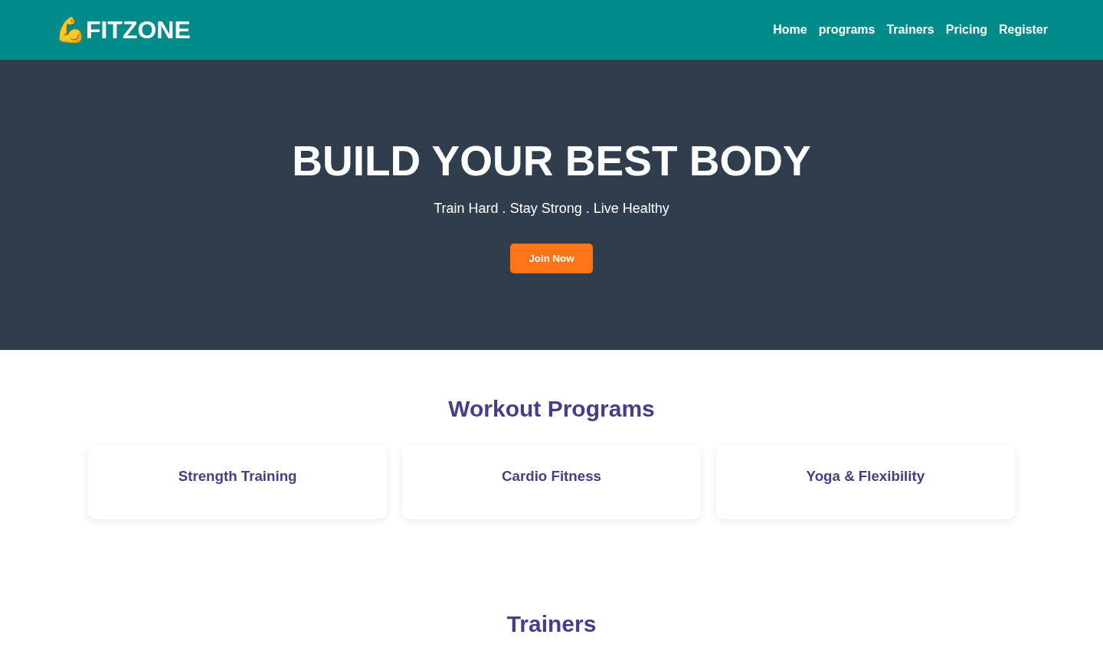

Actual Webpage Output – Screenshot 2 of 3
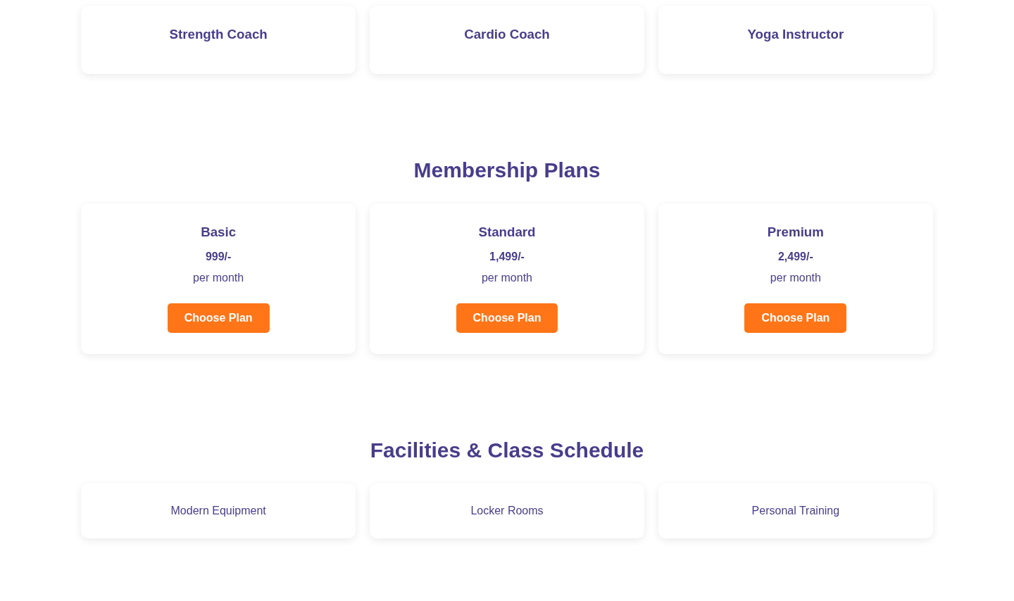

Actual Webpage Output – Screenshot 3 of 3
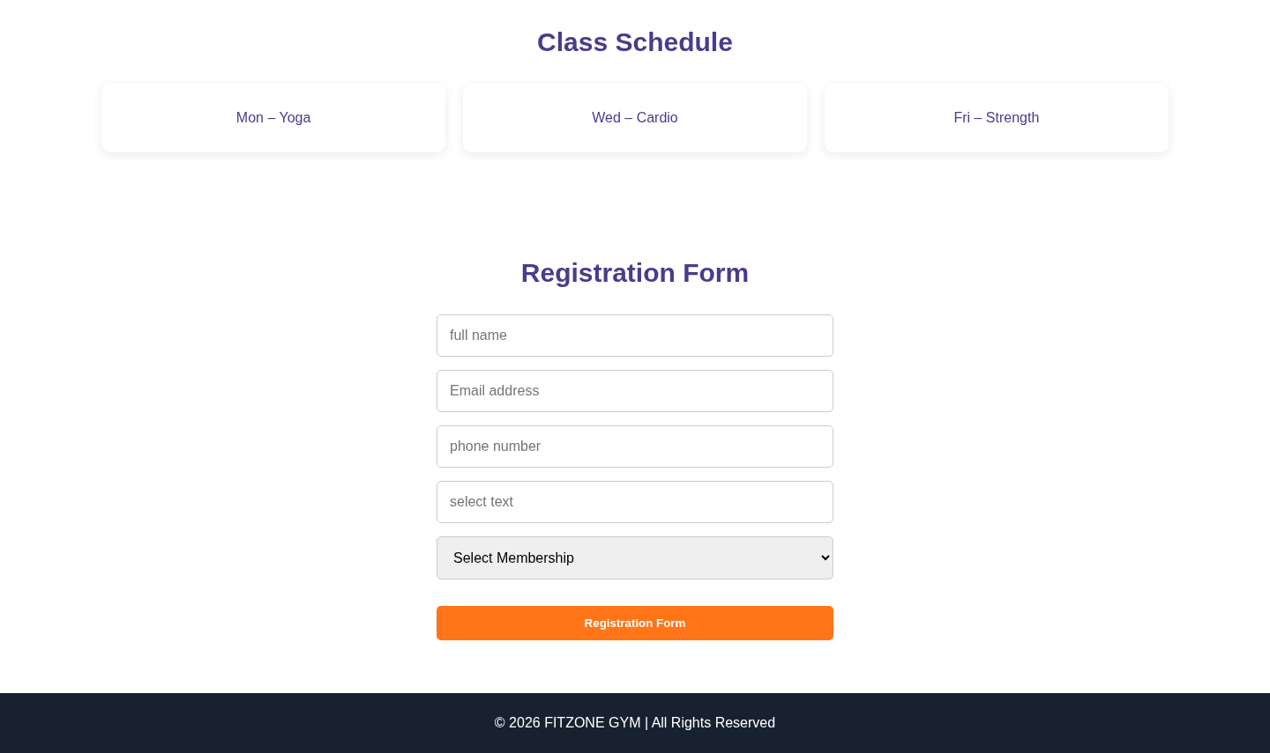

6. Output Explanation
The rendered output shows the FITZONE gym website as one vertically scrolling webpage. At the top, the dark-cyan header presents the gym name and section navigation. Below it, the dark hero banner draws attention to the main fitness message and Join Now button. The Workout Programs, Trainers, Membership Plans, Facilities, and Class Schedule areas appear as groups of white cards on a light background. The membership cards show the monthly prices and provide links to the registration area.
Further down the page, the registration form appears as a vertically arranged set of input fields and a membership selection dropdown. The page ends with a dark footer containing the copyright statement. The rendered page contains no photographic or other external image assets because the supplied HTML does not include image elements or image URLs. The dumbbell symbol beside FITZONE is a text emoji.

7. Conclusion
By developing this project, I learned how HTML5 can be used to organize a webpage into meaningful sections and how CSS3 can be used to style those sections with colors, spacing, grids, cards, and hover effects. I also practised creating navigation links, membership information, and a basic registration form. This project helped me understand the basic process of building and presenting a front-end website.

8. Source Code
The complete HTML and CSS source code supplied for this report is included below. The source is reproduced without changing its functionality.

8.1 Complete HTML Code (index.html)
<!DOCTYPE html>
<html lang="en">
<head>
<title>fitzone</title>
<meta charset="UTF-8">
<link rel="stylesheet" href="style.css">
</head>
<body>
<header>
<h1>💪FITZONE</h1>
<nav>
<a href="#home">Home</a>
<a href="#programs">programs</a>
<a href="#trainers">Trainers</a>
<a href="#pricing">Pricing</a>
<a href="#register">Register</a>
</nav>
</header>
<main>
<section id="home" class="hero">
<h1>BUILD YOUR BEST BODY</h1>
<p>Train Hard . Stay Strong . Live Healthy</p>
<button id="#register" class="btn">Join Now</button>
</section>

<section id="programs">

<h2>Workout Programs</h2>
<div class="cards">

<div class="card">
<h3>Strength Training</h3>
</div>
<div class="card">

<h3>Cardio Fitness</h3>
</div>
<div class="card">
<h3>Yoga & Flexibility</h3>
</div>
</div>
</section>

<section id="trainers">
<h2>Trainers</h2>
<div class="cards">
<div class="card">
<h3>Strength Coach</h3>
</div>
<div class="card">
<h3>Cardio Coach</h3>
</div>
<div class="card">
<h3>Yoga Instructor</h3>
</div>
</div>
</section>

<section id="pricing">
<h2>Membership Plans</h2>
<div class="cards">
<div class="card">
<h3>Basic</h3>
<h4>999/-</h4>
<p>per month</p>
<a href="#register" class="btn">Choose Plan</a>
</div>

<div class="card">

<h3>Standard</h3>
<h4>1,499/-</h4>
<p>per month</p>
<a href="#register" class="btn">Choose Plan</a>
</div>

<div class="card">
<h3>Premium</h3>
<h4>2,499/-</h4>
<p>per month</p>
<a href="#register" class="btn">Choose Plan</a>
</div>
</div>
</section>

<section>
<h2>Facilities & Class Schedule</h2>
<div class="cards">

<p class="card">Modern Equipment</p>
<p class="card">Locker Rooms</p>
<p class="card">Personal Training</p>
</div>
</section>
<section>

<h2>Class Schedule</h2>
<div class="cards">
<p class="card">Mon – Yoga</p>
<p class="card">Wed – Cardio</p>
<p class="card">Fri – Strength</p>
</div>
</section>

<section id="register">
<h2>Registration Form</h2>

<form>
<input type="text" placeholder="full name" required>
<input type="email" placeholder="Email address" required>
<input type="tel" placeholder="phone number" required>
<input type="text" placeholder="select text" required>

<select required>
<option value="">Select Membership</option>
<option>Basic</option>
<option>Standard</option>
<option>Premium</option>
</select>

<button type="submit" class="btn">Registration Form</button>
</form>
</section>
</main>
<footer>
<p>© 2026 FITZONE GYM | All Rights Reserved</p>
</footer>
</body>

</html>

8.2 Complete CSS Code (style.css)

* {
margin: 0;
padding: 0;
box-sizing: border-box;
}
header
{
background-color: darkcyan;
color: white;
padding: 20px 5%;
display: flex;
justify-content: space-between;
align-items: center;
flex-wrap: wrap;
gap: 20px;
}

html {
scroll-behavior: smooth;
}
body {
font-family: Arial, sans-serif;
background: white;
color: darkslateblue;
}
header span {
color: #ff7518;
}
nav {
display: flex;
gap: 15px;
flex-wrap: wrap;
}
nav a {
color: white;
text-decoration: none;
font-weight: bold;
transition: color 0.3s;
}
nav a:hover {
color: #ff7518;
}
.hero {
background: #303d4c;
color: white;
text-align: center;
padding: 100px 20px;
}
.hero h1 {
font-size: clamp(32px, 5vw, 55px);
font-weight: 900;
}
.hero p {
margin: 20px 0;
font-size: 18px;
}
.btn {
display: inline-block;
background: #ff7518;
color: white;
border: none;
padding: 12px 24px;
margin-top: 15px;
border-radius: 5px;
text-decoration: none;
font-weight: bold;
cursor: pointer;
transition: 0.3s;
}
.btn:hover {
background: #d95400;
transform: scale(1.05);
}
section {
padding: 60px 8%;
text-align: center;
}
section h2 {
font-size: 30px;
margin-bottom: 30px;
}
.cards {
display: grid;
}
.cards {
display: grid;
grid-template-columns: repeat(3, 1fr);
gap: 20px;
}
.card {
background: white;
padding: 30px 20px;
border-radius: 10px;
box-shadow: 0 3px 12px #00000015;
transition: 0.3s;
}
.card h3 {
margin-bottom: 15px;
}
.card p {
margin: 12px 0;
}
.card:hover {
transform: translateY(-8px);
box-shadow: 0 8px 20px #00000025;
}
form {
max-width: 450px;
margin: auto;
display: flex;
flex-direction: column;
gap: 15px;
}
input, select {
width: 100%;
padding: 14px;
border: 1px solid #ccc;
border-radius: 5px;
font-size: 16px;
}
input:focus, select:focus {
outline: 2px solid #ff7518;
}
footer {
background: #17212f;
color: white;
text-align: center;
padding: 25px;
}
@media (max-width: 768px) {
header {
justify-content: center;
text-align: center;
}}
nav {
justify-content: center;
}

