DR. RVR NRI UNIVERSITY
WEB DEVELOPMENT PROJECT REPORT
FOODIE'S CORNER – FOOD MENU WEBSITE
A Project Report on HTML5 and CSS3

Student Name | GANGIPOGU RUPESH KUMAR
University | DR. RVR NRI UNIVERSITY
Course | B.Tech – CSE (AI & ML)
Year | First Year
Academic Project Submission

1. Project Title
FOODIE'S CORNER – Food Menu Website. The browser title in the supplied HTML is “Food menu”, and the main visible website heading is “Foodie's Corner”.

2. Introduction
Foodie's Corner is a simple food menu webpage designed to display a small selection of food and drink items with their prices. Its purpose is to help visitors view the available menu items quickly in one place. The page presents four menu cards with pictures, item names, and prices, followed by a short thank-you message.
The website uses a warm colour theme and a clean card-based layout. The food photographs help visitors identify each item, while the prices are displayed clearly below the item names.

3. Technologies Used
- HTML5: Creates the structure and content of the page, including the header, menu heading, food cards, images, item names, prices, and footer.
- CSS3: Controls the page colours, font, alignment, spacing, flexible menu layout, card appearance, image sizing, shadows, rounded corners, and hover effect.
The supplied source does not use JavaScript, a CSS framework, a database, or a server-side technology.

4. Webpage Description

4.1 Header
The header appears at the top of the page. It displays the title “Foodie's Corner” and the tagline “Delicious food,Happy Mood”. The header has a burnt-orange background (#b45309), white text, and 20 pixels of padding.

4.2 Menu Heading
Below the header, the page displays the heading “Our special menu”. It is styled in a dark brown-orange colour (#92400e) with margin spacing around it.

4.3 Food Menu Cards
The menu contains four cards arranged in a horizontal flexible layout on the rendered desktop page. Each card has a white background, a width of 200 pixels, 15 pixels of padding, rounded corners, and a light box shadow. The cards are separated by a 20-pixel gap. The flex layout can wrap cards when the available width is smaller.
- Veg pizza – 199/-: The card shows a pizza photograph, the name “veg pizza”, and the price 199/-.
- Burger – 99/-: The card shows a burger photograph, the name “Burger”, and the price 99/-.
- Biryani – 300/-: The card shows a biryani photograph, the name “Biryani”, and the price 300/-.
- Milk shake – 89/-: The card shows a milkshake photograph, the name “Milk shake”, and the price 89/-.
Each image fills the width of its card, has a fixed height of 130 pixels, uses object-fit: cover, and has rounded corners. Item names use a dark text colour (#292524). Prices use bold burnt-orange text. When the pointer hovers over a card, the card scales up slightly.

4.4 Footer
At the bottom of the content, the footer displays “Thank you ! Visit Again 💖”. It uses the same burnt-orange background as the header, white text, 10 pixels of padding, and a top margin.

4.5 Overall Styling
The body has no outer margin, uses Arial, Helvetica, or a sans-serif fallback font, and has a pale peach background (#fff3e8). Text is centred across the page. The overall colour palette combines pale peach, burnt orange, dark brown, white cards, and dark text. The page is a single menu screen and does not contain a navigation bar, buttons, registration form, or interactive ordering controls.

5. Actual Webpage Output
The screenshot below was captured by rendering the supplied HTML and CSS together in a Chromium browser at a desktop viewport width of 1440 pixels. All four supplied image files were loaded into the webpage during rendering. The screenshot therefore shows the actual page structure, text, colours, cards, and food photographs from the provided project files.
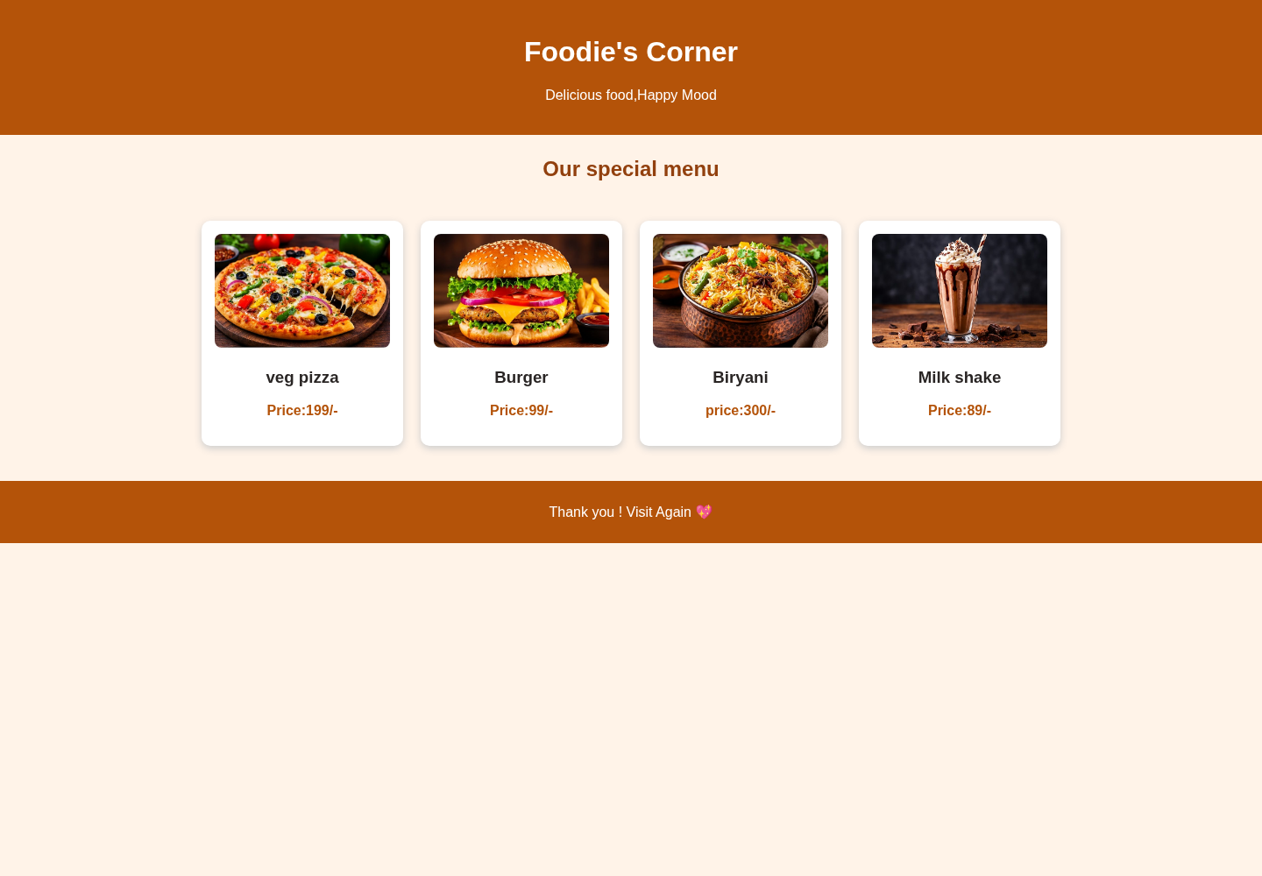

6. Output Explanation
The output begins with an orange header containing the website name and tagline. The “Our special menu” heading appears underneath on the pale peach page background. Four white menu cards are displayed in one row on the desktop screenshot. Each card contains a food photograph, its name, and its price. The cards have rounded corners and soft shadows, making them stand out from the background. The page ends with an orange footer containing the thank-you message.
The supplied photographs for pizza, burger, biryani, and milkshake were successfully loaded in the rendered output. No missing external image or resource was observed during the screenshot capture.

7. Conclusion
By developing this project, I learned how HTML5 can be used to organize webpage content and how CSS3 can improve its appearance through colours, spacing, flexible layouts, images, cards, shadows, and hover effects. I also learned how to display menu information in a clear and attractive way. This project helped me understand the basic steps involved in creating a front-end website.

8. Source Code
The complete HTML and CSS source code used to render the webpage is reproduced below. The code is included as supplied, without functional changes.

8.1 Complete HTML Code (index(1).html)
<!DOCTYPE html>
<html lang="en">
<head>
<title>Food menu</title>
<meta charset="UTF-8">
<link rel="stylesheet" href="style.css">
</head>
<body>
<header>
<h1>Foodie's Corner</h1>
<p>Delicious food,Happy Mood</p>
</header>
<h2>Our special menu</h2>
<div class="menu">
<div class="food">
<img src="pizza.jpg.jpeg" alt="pizza">
<h3>veg pizza</h3>
<p>Price:199/-</p>
</div>
<div class="food">
<img src="burger.jpg.jpeg" alt="burger">
<h3>Burger</h3>
<p>Price:99/-</p>
</div>

<div class="food">
<img src="biryani.jpg.jpeg" alt="biryani">
<h3>Biryani</h3>
<p>price:300/-</p></div>

<div class="food">
<img src="milkshake.jpg.jpeg" alt="milk shake">
<h3>Milk shake</h3>
<p>Price:89/-</p>
</div>

</div>
<footer>
<p>Thank you ! Visit Again 💖</p>
</footer>
</body>
</html>

8.2 Complete CSS Code (style(1).css)
body{
margin: 0;
font-family: Arial, Helvetica, sans-serif;
background-color: #fff3e8;
text-align: center;
}
header{
background-color: #b45309;
color: white;
padding: 20px;
}
h2{
color: #92400e;
margin: 25px;
}
.menu{
display: flex;
justify-content: center;
flex-wrap: wrap;
gap: 20px;
padding: 20px;
}
.food{
background-color: white;
width: 200px;
padding: 15px;
border-radius: 10px;
box-shadow: 0 3px 8px #ccc;
}
.food img {
width: 100%;
height: 130px;
object-fit: cover;
border-radius: 8px;

}

.food h3 {
color: #292524;

}
.food p {
color: #b45309;
font-weight:bold ;
}
.food:hover{
transform: scale(1.05);
}
footer{
background-color: #b45309;
color: white;
padding: 10px;
margin-top: 20px;
}

9. Supplied Files Note
The uploaded file named “foodweb.html” contains CSS stylesheet text and is identical to the uploaded “style(1).css” file. The webpage HTML is in “index(1).html”. For the actual render and this report, the HTML file and the matching CSS stylesheet were paired, and the four supplied JPEG images were used. The duplicate CSS-content file was not treated as a separate HTML page.

