DR. RVR NRI UNIVERSITY
WEB DEVELOPMENT PROJECT REPORT

EDUPORTAL
STUDENT ACADEMIC DASHBOARD

Submitted by: GANGIPOGU RUPESH KUMAR
University: DR. RVR NRI UNIVERSITY
Course: B.Tech – CSE (AI & ML)
Academic Level: First Year

Academic Year: 2026–2027

PROJECT REPORT

1. Introduction
EduPortal is a student academic dashboard website designed to present important academic information in one place. The project provides a simple interface through which a student can view profile details, semester performance, attendance percentages, enrolled subjects, examination dates and academic announcements. The supplied project is built as a set of HTML pages connected to a shared CSS file.
The main purpose of the website is to demonstrate how a student portal can organise academic information into clearly labelled sections. The dashboard page gives an overview, while separate pages provide focused information about the student's profile, results, attendance, subjects, examinations and notices.

2. Project Objectives and Main Features
- Provide a dashboard-style overview of student academic information.
- Display student identity, course, semester and academic status.
- Present semester grades, credits and SGPA in tabular form.
- Show subject-wise attendance using percentage values and progress bars.
- List subjects with their course codes and credit values.
- Display an examination timetable with dates and times.
- Show announcements and reminders relevant to students.
- Provide sidebar navigation links between the dashboard areas and individual pages.

3. Technologies Used
HTML5 – Used to define the structure and content of the webpages, including headings, navigation links, sections, tables, text and footer content.
CSS3 – Used through style.css to apply page layout, spacing, typography, colours, borders, shadows, progress bars, grid layout and responsive rules.
No JavaScript, database, server-side language, external image library or external framework is present in the supplied source files. The visible symbols are emoji characters included directly in the HTML.

4. Webpage Description

4.1 Overall Layout and Navigation
The pages use a dashboard structure with a dark navy sidebar and a main content area. The sidebar carries the EduPortal name and links for Dashboard, My Profile, Semester Results, Attendance, Subjects, Examination and Announcements. The main content area contains the page heading and the relevant information panel or sections.

4.2 Dashboard Page
The main dashboard page is titled Academic Dashboard. It includes a welcome message, a compact student identity area, a student profile card, and four summary values: current CGPA (8.6/10), overall attendance (87%), total subjects (6) and credits earned (24). Further down, it presents a semester results table, subject attendance progress bars, subject cards, an examination schedule, announcements and a footer reading “© 2026 EduPortal | Student Academic Dashboard”.

4.3 Profile Page
The profile page contains a Student Information panel with the student's name, student ID, course, semester, academic year and active-student status.

4.4 Semester Results Page
The results page contains a table with subject names, grades and credits for the previous semester. It lists Mathematics II, Programming in C, Engineering Physics and Digital Electronics, followed by an SGPA value of 8.6.

4.5 Attendance Page
The attendance page shows percentages for Mathematics III (92%), Data Structures (85%), Digital Logic (78%) and Python Programming (90%). Horizontal progress bars use green, blue and orange fills to represent the displayed values.

4.6 Subjects Page
The subjects page presents four subject cards: Data Structures (CS301, 4 credits), Python Programming (CS302, 4 credits), Mathematics III (MA301, 4 credits) and Digital Logic (EC301, 3 credits).

4.7 Examination Page
The examination page displays a timetable with subject, date and time columns. The listed examinations are Mathematics III on 10 Nov 2026 at 9:30 AM, Data Structures on 13 Nov 2026 at 9:30 AM, and Python Programming on 16 Nov 2026 at 1:30 PM.

4.8 Announcements Page
The announcements page contains three notices: Internal Examination, Attendance Reminder and Assignment Submission. Each notice includes a short instruction or reminder.

4.9 Styling and Responsive Behaviour
The supplied CSS sets the page font to Arial, uses a light blue-grey body background (#f3f6fb), dark text (#26344a), and a navy sidebar (#172554). Panels and subject cards use white backgrounds, rounded corners and subtle shadows or borders. Tables use light separators and pale header backgrounds. The stylesheet also defines a responsive breakpoint at 650 pixels: the sidebar becomes full width, navigation links become inline-block elements, main content padding is reduced, the subject grid becomes one column and table text becomes smaller.

5. Actual Webpage Output
The following figures reproduce the browser screenshots supplied with the project. They are included as evidence of the output captured in the student's browser. The screenshots show the dashboard from top to bottom; the browser interface and desktop taskbar remain visible because they are part of the supplied captures.
Screenshot 1 – Dashboard top and student summary
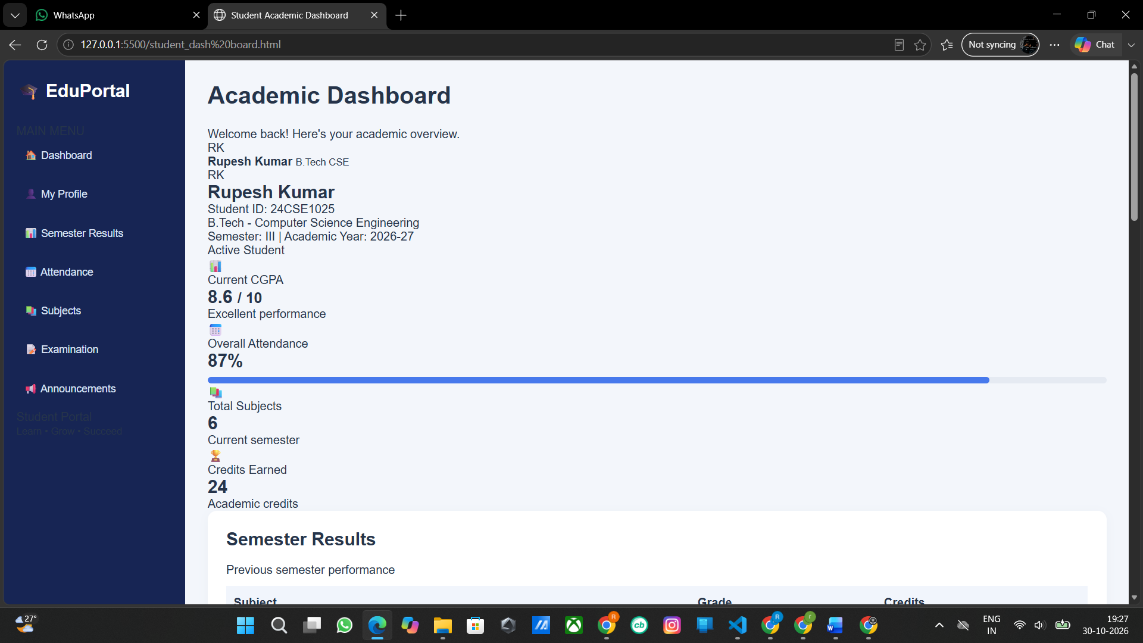
Screenshot 2 – Semester results and subject attendance
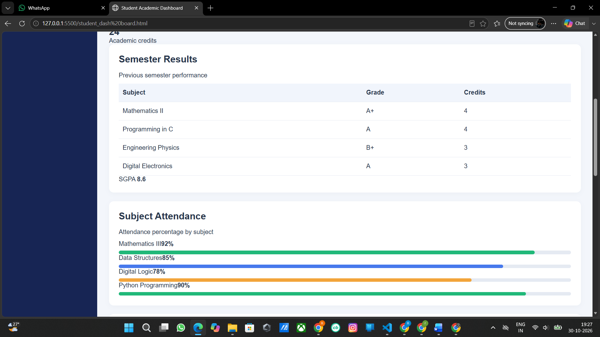

Screenshot 3 – Subject cards and examination section
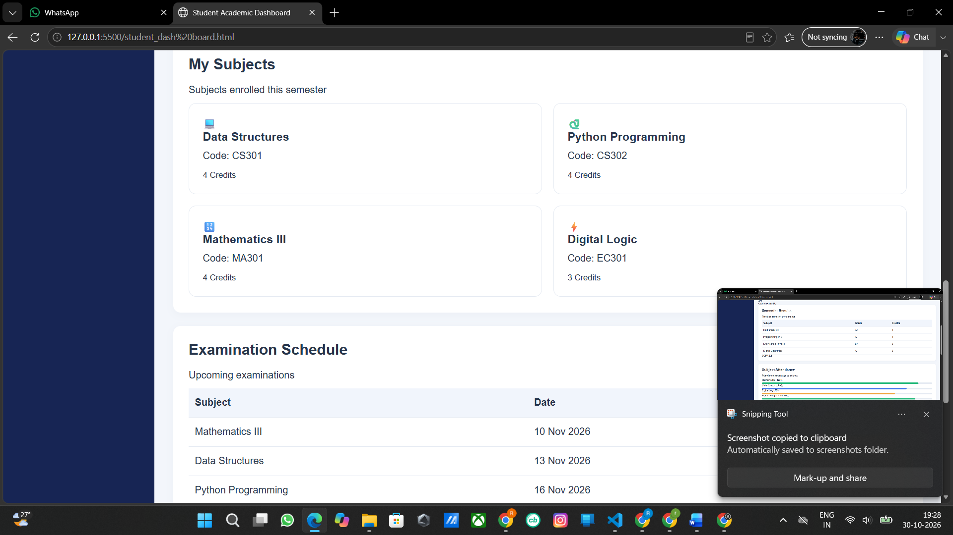
Screenshot 4 – Examination timetable, announcements and footer
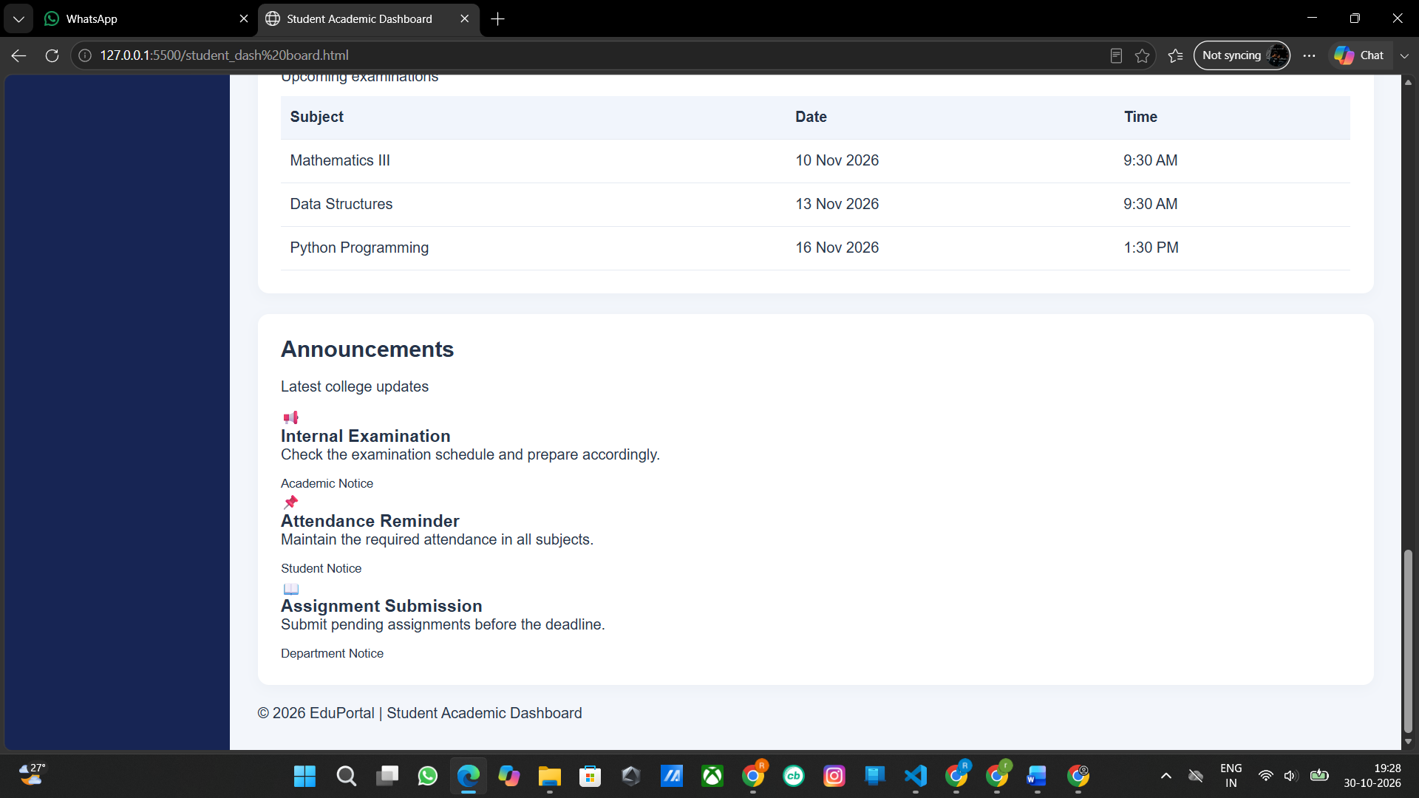

6. Output Explanation
The supplied screenshots show the EduPortal page in a desktop browser. A navy vertical sidebar remains on the left while the main page uses a pale background. The first capture shows the dashboard heading and student summary. The next captures show the results table and coloured attendance bars, followed by subject cards and the examination timetable. The final capture shows the announcements and the copyright footer. The information is organised vertically so that the user can scroll through the full dashboard.
The screenshots are the student's own browser captures and have not been recreated or altered. They document the actual visible output supplied for this report. A fresh independent browser render could not be performed in this document-generation environment; therefore the report does not claim that the screenshots were newly captured here.

7. Source Code
The source listings below are transcribed directly from the files supplied for this project. Original content and filenames are retained. The code is placed in a compact monospaced font to keep indentation and line order readable.

Main Dashboard (student_dash board.html)

<!DOCTYPE html>
<html lang="en">
<head>
<meta charset="UTF-8">
<meta name="viewport" content="width=device-width, initial-scale=1.0">
<title>Student Academic Dashboard</title>
<link rel="stylesheet" href="style.css">
</head>
<body>

<div class="dashboard">

<aside class="sidebar">
<h2>🎓 EduPortal</h2>
<p class="menu-title">MAIN MENU</p>

<a href="#overview" class="active">🏠 Dashboard</a>
<a href="#profile">👤 My Profile</a>
<a href="#results">📊 Semester Results</a>
<a href="#attendance">📅 Attendance</a>
<a href="#subjects">📚 Subjects</a>
<a href="#exams">📝 Examination</a>
<a href="#announcements">📢 Announcements</a>

<div class="sidebar-bottom">
<p>Student Portal</p>
<small>Learn • Grow • Succeed</small>
</div>
</aside>

<main class="main-content" id="overview">

<header class="topbar">
<div>
<h1>Academic Dashboard</h1>
<p>Welcome back! Here's your academic overview.</p>
</div>
<div class="student-mini">
<span class="avatar">RK</span>
<div>
<strong>Rupesh Kumar</strong>
<small>B.Tech CSE</small>
</div>
</div>
</header>

<section class="profile-card" id="profile">
<div class="profile-avatar">RK</div>
<div class="profile-info">
<h2>Rupesh Kumar</h2>
<p>Student ID: 24CSE1025</p>
<p>B.Tech - Computer Science Engineering</p>
<p>Semester: III | Academic Year: 2026-27</p>
</div>
<span class="status">Active Student</span>
</section>

<section class="stats-grid">
<div class="stat-card">
<span>📊</span>
<p>Current CGPA</p>
<h2>8.6 <small>/ 10</small></h2>
<p class="green">Excellent performance</p>
</div>

<div class="stat-card">
<span>📅</span>
<p>Overall Attendance</p>
<h2>87%</h2>
<div class="progress">
<div class="bar blue" style="width:87%"></div>
</div>
</div>

<div class="stat-card">
<span>📚</span>
<p>Total Subjects</p>
<h2>6</h2>
<p>Current semester</p>
</div>

<div class="stat-card">
<span>🏆</span>
<p>Credits Earned</p>
<h2>24</h2>
<p>Academic credits</p>
</div>
</section>

<section class="content-grid">

<div class="panel" id="results">
<h2>Semester Results</h2>
<p class="subtitle">Previous semester performance</p>

<table>
<thead>
<tr>
<th>Subject</th>
<th>Grade</th>
<th>Credits</th>
</tr>
</thead>
<tbody>
<tr>
<td>Mathematics II</td>
<td><span class="grade">A+</span></td>
<td>4</td>
</tr>
<tr>
<td>Programming in C</td>
<td><span class="grade">A</span></td>
<td>4</td>
</tr>
<tr>
<td>Engineering Physics</td>
<td><span class="grade">B+</span></td>
<td>3</td>
</tr>
<tr>
<td>Digital Electronics</td>
<td><span class="grade">A</span></td>
<td>3</td>
</tr>
</tbody>
</table>
<div class="result-footer">
SGPA <strong>8.6</strong>
</div>
</div>

<div class="panel" id="attendance">
<h2>Subject Attendance</h2>
<p class="subtitle">Attendance percentage by subject</p>

<div class="attendance-item">
<div class="progress-label">
<span>Mathematics III</span><strong>92%</strong>
</div>
<div class="progress">
<div class="bar green-bar" style="width:92%"></div>
</div>
</div>

<div class="attendance-item">
<div class="progress-label">
<span>Data Structures</span><strong>85%</strong>
</div>
<div class="progress">
<div class="bar blue" style="width:85%"></div>
</div>
</div>

<div class="attendance-item">
<div class="progress-label">
<span>Digital Logic</span><strong>78%</strong>
</div>
<div class="progress">
<div class="bar orange" style="width:78%"></div>
</div>
</div>

<div class="attendance-item">
<div class="progress-label">
<span>Python Programming</span><strong>90%</strong>
</div>
<div class="progress">
<div class="bar green-bar" style="width:90%"></div>
</div>
</div>
</div>

</section>

<section class="panel subjects-panel" id="subjects">
<h2>My Subjects</h2>
<p class="subtitle">Subjects enrolled this semester</p>

<div class="subjects-grid">
<div class="subject-card">
<span class="subject-icon">💻</span>
<h3>Data Structures</h3>
<p>Code: CS301</p>
<small>4 Credits</small>
</div>
<div class="subject-card">
<span class="subject-icon">🐍</span>
<h3>Python Programming</h3>
<p>Code: CS302</p>
<small>4 Credits</small>
</div>
<div class="subject-card">
<span class="subject-icon">🔢</span>
<h3>Mathematics III</h3>
<p>Code: MA301</p>
<small>4 Credits</small>
</div>
<div class="subject-card">
<span class="subject-icon">⚡</span>
<h3>Digital Logic</h3>
<p>Code: EC301</p>
<small>3 Credits</small>
</div>
</div>
</section>

<section class="content-grid bottom-grid">

<div class="panel" id="exams">
<h2>Examination Schedule</h2>
<p class="subtitle">Upcoming examinations</p>

<table>
<thead>
<tr>
<th>Subject</th>
<th>Date</th>
<th>Time</th>
</tr>
</thead>
<tbody>
<tr>
<td>Mathematics III</td>
<td>10 Nov 2026</td>
<td>9:30 AM</td>
</tr>
<tr>
<td>Data Structures</td>
<td>13 Nov 2026</td>
<td>9:30 AM</td>
</tr>
<tr>
<td>Python Programming</td>
<td>16 Nov 2026</td>
<td>1:30 PM</td>
</tr>
</tbody>
</table>
</div>

<div class="panel" id="announcements">
<h2>Announcements</h2>
<p class="subtitle">Latest college updates</p>

<div class="announcement">
<span class="notice-icon">📢</span>
<div>
<h3>Internal Examination</h3>
<p>Check the examination schedule and prepare accordingly.</p>
<small>Academic Notice</small>
</div>
</div>

<div class="announcement">
<span class="notice-icon">📌</span>
<div>
<h3>Attendance Reminder</h3>
<p>Maintain the required attendance in all subjects.</p>
<small>Student Notice</small>
</div>
</div>

<div class="announcement">
<span class="notice-icon">📖</span>
<div>
<h3>Assignment Submission</h3>
<p>Submit pending assignments before the deadline.</p>
<small>Department Notice</small>
</div>
</div>
</div>

</section>

<footer>
<p>© 2026 EduPortal | Student Academic Dashboard</p>
</footer>

</main>
</div>

</body>
</html>

Dashboard Entry Page (index.html)

<!DOCTYPE html>
<html lang="en">
<head>
<meta charset="UTF-8">
<meta name="viewport" content="width=device-width, initial-scale=1.0">
<title>Student Academic Dashboard</title>
<link rel="stylesheet" href="style.css">
</head>
<body>

<div class="dashboard">

<aside class="sidebar">
<h2>🎓 EduPortal</h2>
<p class="menu-title">MAIN MENU</p>

<a href="#overview" class="active">🏠 Dashboard</a>
<a href="#profile">👤 My Profile</a>
<a href="#results">📊 Semester Results</a>
<a href="#attendance">📅 Attendance</a>
<a href="#subjects">📚 Subjects</a>
<a href="#exams">📝 Examination</a>
<a href="#announcements">📢 Announcements</a>

<div class="sidebar-bottom">
<p>Student Portal</p>
<small>Learn • Grow • Succeed</small>
</div>
</aside>

<main class="main-content" id="overview">

<header class="topbar">
<div>
<h1>Academic Dashboard</h1>
<p>Welcome back! Here's your academic overview.</p>
</div>
<div class="student-mini">
<span class="avatar">RK</span>
<div>
<strong>Rupesh Kumar</strong>
<small>B.Tech CSE</small>
</div>
</div>
</header>

<section class="profile-card" id="profile">
<div class="profile-avatar">RK</div>
<div class="profile-info">
<h2>Rupesh Kumar</h2>
<p>Student ID: 24CSE1025</p>
<p>B.Tech - Computer Science Engineering</p>
<p>Semester: III | Academic Year: 2026-27</p>
</div>
<span class="status">Active Student</span>
</section>

<section class="stats-grid">
<div class="stat-card">
<span>📊</span>
<p>Current CGPA</p>
<h2>8.6 <small>/ 10</small></h2>
<p class="green">Excellent performance</p>
</div>

<div class="stat-card">
<span>📅</span>
<p>Overall Attendance</p>
<h2>87%</h2>
<div class="progress">
<div class="bar blue" style="width:87%"></div>
</div>
</div>

<div class="stat-card">
<span>📚</span>
<p>Total Subjects</p>
<h2>6</h2>
<p>Current semester</p>
</div>

<div class="stat-card">
<span>🏆</span>
<p>Credits Earned</p>
<h2>24</h2>
<p>Academic credits</p>
</div>
</section>

<section class="content-grid">

<div class="panel" id="results">
<h2>Semester Results</h2>
<p class="subtitle">Previous semester performance</p>

<table>
<thead>
<tr>
<th>Subject</th>
<th>Grade</th>
<th>Credits</th>
</tr>
</thead>
<tbody>
<tr>
<td>Mathematics II</td>
<td><span class="grade">A+</span></td>
<td>4</td>
</tr>
<tr>
<td>Programming in C</td>
<td><span class="grade">A</span></td>
<td>4</td>
</tr>
<tr>
<td>Engineering Physics</td>
<td><span class="grade">B+</span></td>
<td>3</td>
</tr>
<tr>
<td>Digital Electronics</td>
<td><span class="grade">A</span></td>
<td>3</td>
</tr>
</tbody>
</table>
<div class="result-footer">
SGPA <strong>8.6</strong>
</div>
</div>

<div class="panel" id="attendance">
<h2>Subject Attendance</h2>
<p class="subtitle">Attendance percentage by subject</p>

<div class="attendance-item">
<div class="progress-label">
<span>Mathematics III</span><strong>92%</strong>
</div>
<div class="progress">
<div class="bar green-bar" style="width:92%"></div>
</div>
</div>

<div class="attendance-item">
<div class="progress-label">
<span>Data Structures</span><strong>85%</strong>
</div>
<div class="progress">
<div class="bar blue" style="width:85%"></div>
</div>
</div>

<div class="attendance-item">
<div class="progress-label">
<span>Digital Logic</span><strong>78%</strong>
</div>
<div class="progress">
<div class="bar orange" style="width:78%"></div>
</div>
</div>

<div class="attendance-item">
<div class="progress-label">
<span>Python Programming</span><strong>90%</strong>
</div>
<div class="progress">
<div class="bar green-bar" style="width:90%"></div>
</div>
</div>
</div>

</section>

<section class="panel subjects-panel" id="subjects">
<h2>My Subjects</h2>
<p class="subtitle">Subjects enrolled this semester</p>

<div class="subjects-grid">
<div class="subject-card">
<span class="subject-icon">💻</span>
<h3>Data Structures</h3>
<p>Code: CS301</p>
<small>4 Credits</small>
</div>
<div class="subject-card">
<span class="subject-icon">🐍</span>
<h3>Python Programming</h3>
<p>Code: CS302</p>
<small>4 Credits</small>
</div>
<div class="subject-card">
<span class="subject-icon">🔢</span>
<h3>Mathematics III</h3>
<p>Code: MA301</p>
<small>4 Credits</small>
</div>
<div class="subject-card">
<span class="subject-icon">⚡</span>
<h3>Digital Logic</h3>
<p>Code: EC301</p>
<small>3 Credits</small>
</div>
</div>
</section>

<section class="content-grid bottom-grid">

<div class="panel" id="exams">
<h2>Examination Schedule</h2>
<p class="subtitle">Upcoming examinations</p>

<table>
<thead>
<tr>
<th>Subject</th>
<th>Date</th>
<th>Time</th>
</tr>
</thead>
<tbody>
<tr>
<td>Mathematics III</td>
<td>10 Nov 2026</td>
<td>9:30 AM</td>
</tr>
<tr>
<td>Data Structures</td>
<td>13 Nov 2026</td>
<td>9:30 AM</td>
</tr>
<tr>
<td>Python Programming</td>
<td>16 Nov 2026</td>
<td>1:30 PM</td>
</tr>
</tbody>
</table>
</div>

<div class="panel" id="announcements">
<h2>Announcements</h2>
<p class="subtitle">Latest college updates</p>

<div class="announcement">
<span class="notice-icon">📢</span>
<div>
<h3>Internal Examination</h3>
<p>Check the examination schedule and prepare accordingly.</p>
<small>Academic Notice</small>
</div>
</div>

<div class="announcement">
<span class="notice-icon">📌</span>
<div>
<h3>Attendance Reminder</h3>
<p>Maintain the required attendance in all subjects.</p>
<small>Student Notice</small>
</div>
</div>

<div class="announcement">
<span class="notice-icon">📖</span>
<div>
<h3>Assignment Submission</h3>
<p>Submit pending assignments before the deadline.</p>
<small>Department Notice</small>
</div>
</div>
</div>

</section>

<footer>
<p>© 2026 EduPortal | Student Academic Dashboard</p>
</footer>

</main>
</div>

</body>
</html>

Student Profile (profile.html)

<!DOCTYPE html>
<html lang="en">
<head>
<meta charset="UTF-8">
<meta name="viewport" content="width=device-width, initial-scale=1.0">
<title>My Profile</title>
<link rel="stylesheet" href="style.css">
</head>
<body>
<div class="dashboard">
<aside class="sidebar">
<h2>🎓 EduPortal</h2>
<a href="index.html">🏠 Dashboard</a>
<a href="profile.html">👤 My Profile</a>
<a href="results.html">📊 Semester Results</a>
<a href="attendance.html">📅 Attendance</a>
<a href="subjects.html">📚 Subjects</a>
<a href="exams.html">📝 Examination</a>
<a href="announcements.html">📢 Announcements</a>
</aside>
<main class="main-content">
<h1>My Profile</h1>
<div class="panel">
<h2>Student Information</h2>
<p><b>Name:</b> Raghu Kumar</p>
<p><b>Student ID:</b> 24CSE1025</p>
<p><b>Course:</b> B.Tech CSE</p>
<p><b>Semester:</b> III</p>
<p><b>Academic Year:</b> 2026-27</p>
<p><b>Status:</b> Active Student</p>
</div>
</main>
</div>
</body>
</html>

Semester Results (results.html)

<!DOCTYPE html>
<html lang="en">
<head>
<meta charset="UTF-8">
<meta name="viewport" content="width=device-width, initial-scale=1.0">
<title>Semester Results</title>
<link rel="stylesheet" href="style.css">
</head>
<body>
<div class="dashboard">
<aside class="sidebar">
<h2>🎓 EduPortal</h2>
<a href="index.html">🏠 Dashboard</a>
<a href="profile.html">👤 My Profile</a>
<a href="results.html">📊 Semester Results</a>
<a href="attendance.html">📅 Attendance</a>
<a href="subjects.html">📚 Subjects</a>
<a href="exams.html">📝 Examination</a>
<a href="announcements.html">📢 Announcements</a>
</aside>
<main class="main-content">
<h1>Semester Results</h1>
<div class="panel">
<h2>Previous Semester</h2>
<table>
<tr><th>Subject</th><th>Grade</th><th>Credits</th></tr>
<tr><td>Mathematics II</td><td>A+</td><td>4</td></tr>
<tr><td>Programming in C</td><td>A</td><td>4</td></tr>
<tr><td>Engineering Physics</td><td>B+</td><td>3</td></tr>
<tr><td>Digital Electronics</td><td>A</td><td>3</td></tr>
</table>
<h3 style="margin-top:20px">SGPA: 8.6</h3>
</div>
</main>
</div>
</body>
</html>

Attendance Report (attendance.htm)

<!DOCTYPE html>
<html lang="en">
<head>
<meta charset="UTF-8">
<meta name="viewport" content="width=device-width, initial-scale=1.0">
<title>Attendance</title>
<link rel="stylesheet" href="style.css">
</head>
<body>
<div class="dashboard">
<aside class="sidebar">
<h2>🎓 EduPortal</h2>
<a href="index.html">🏠 Dashboard</a>
<a href="profile.html">👤 My Profile</a>
<a href="results.html">📊 Semester Results</a>
<a href="attendance.html">📅 Attendance</a>
<a href="subjects.html">📚 Subjects</a>
<a href="exams.html">📝 Examination</a>
<a href="announcements.html">📢 Announcements</a>
</aside>
<main class="main-content">
<h1>Attendance Report</h1>
<div class="panel">
<h2>Subject Attendance</h2>
<p>Mathematics III — 92%</p>
<div class="progress"><div class="bar green-bar" style="width:92%"></div></div>
<br>
<p>Data Structures — 85%</p>
<div class="progress"><div class="bar blue" style="width:85%"></div></div>
<br>
<p>Digital Logic — 78%</p>
<div class="progress"><div class="bar orange" style="width:78%"></div></div>
<br>
<p>Python Programming — 90%</p>
<div class="progress"><div class="bar green-bar" style="width:90%"></div></div>
</div>
</main>
</div>
</body>
</html>

My Subjects (subjects.html)

<!DOCTYPE html>
<html lang="en">
<head>
<meta charset="UTF-8">
<meta name="viewport" content="width=device-width, initial-scale=1.0">
<title>My Subjects</title>
<link rel="stylesheet" href="style.css">
</head>
<body>
<div class="dashboard">
<aside class="sidebar">
<h2>🎓 EduPortal</h2>
<a href="index.html">🏠 Dashboard</a>
<a href="profile.html">👤 My Profile</a>
<a href="results.html">📊 Semester Results</a>
<a href="attendance.html">📅 Attendance</a>
<a href="subjects.html">📚 Subjects</a>
<a href="exams.html">📝 Examination</a>
<a href="announcements.html">📢 Announcements</a>
</aside>
<main class="main-content">
<h1>My Subjects</h1>
<div class="subjects-grid">
<div class="subject-card">
<h3>Data Structures</h3>
<p>Code: CS301</p><small>4 Credits</small>
</div>
<div class="subject-card">
<h3>Python Programming</h3>
<p>Code: CS302</p><small>4 Credits</small>
</div>
<div class="subject-card">
<h3>Mathematics III</h3>
<p>Code: MA301</p><small>4 Credits</small>
</div>
<div class="subject-card">
<h3>Digital Logic</h3>
<p>Code: EC301</p><small>3 Credits</small>
</div>
</div>
</main>
</div>
</body>
</html>

Examination Schedule (exams.html)

<!DOCTYPE html>
<html lang="en">
<head>
<meta charset="UTF-8">
<meta name="viewport" content="width=device-width, initial-scale=1.0">
<title>Examination Schedule</title>
<link rel="stylesheet" href="style.css">
</head>
<body>
<div class="dashboard">
<aside class="sidebar">
<h2>🎓 EduPortal</h2>
<a href="index.html">🏠 Dashboard</a>
<a href="profile.html">👤 My Profile</a>
<a href="results.html">📊 Semester Results</a>
<a href="attendance.html">📅 Attendance</a>
<a href="subjects.html">📚 Subjects</a>
<a href="exams.html">📝 Examination</a>
<a href="announcements.html">📢 Announcements</a>
</aside>
<main class="main-content">
<h1>Examination Schedule</h1>
<div class="panel">
<table>
<tr><th>Subject</th><th>Date</th><th>Time</th></tr>
<tr><td>Mathematics III</td><td>10 Nov 2026</td><td>9:30 AM</td></tr>
<tr><td>Data Structures</td><td>13 Nov 2026</td><td>9:30 AM</td></tr>
<tr><td>Python Programming</td><td>16 Nov 2026</td><td>1:30 PM</td></tr>
</table>
</div>
</main>
</div>
</body>
</html>

Announcements (announcements.html)

<!DOCTYPE html>
<html lang="en">
<head>
<meta charset="UTF-8">
<meta name="viewport" content="width=device-width, initial-scale=1.0">
<title>Announcements</title>
<link rel="stylesheet" href="style.css">
</head>
<body>
<div class="dashboard">
<aside class="sidebar">
<h2>🎓 EduPortal</h2>
<a href="index.html">🏠 Dashboard</a>
<a href="profile.html">👤 My Profile</a>
<a href="results.html">📊 Semester Results</a>
<a href="attendance.html">📅 Attendance</a>
<a href="subjects.html">📚 Subjects</a>
<a href="exams.html">📝 Examination</a>
<a href="announcements.html">📢 Announcements</a>
</aside>
<main class="main-content">
<h1>Announcements</h1>
<div class="panel">
<h3>📢 Internal Examination</h3>
<p>Check the examination schedule and prepare accordingly.</p>
<hr style="margin:18px 0">
<h3>📌 Attendance Reminder</h3>
<p>Maintain the required attendance in all subjects.</p>
<hr style="margin:18px 0">
<h3>📚 Assignment Submission</h3>
<p>Submit pending assignments before the deadline.</p>
</div>
</main>
</div>
</body>
</html>

CSS – style.css

* {
margin: 0;
padding: 0;
box-sizing: border-box;
}

body {
font-family: Arial, sans-serif;
background: #f3f6fb;
color: #26344a;
}

.dashboard {
display: flex;
min-height: 100vh;
}

.sidebar {
width: 245px;
flex-shrink: 0;
background: #172554;
padding: 25px 18px;
}

.sidebar h2 {
color: white;
margin-bottom: 30px;
}

.sidebar a {
display: block;
text-decoration: none;
color: #dce5f7;
padding: 13px 10px;
margin-bottom: 7px;
border-radius: 7px;
font-size: 14px;
}

.sidebar a:hover {
background: #3158b7;
color: white;
}

.main-content {
flex: 1;
min-width: 0;
padding: 30px;
}

.main-content h1 {
margin-bottom: 25px;
}

.panel {
background: white;
padding: 25px;
margin-bottom: 22px;
border-radius: 12px;
box-shadow: 0 3px 14px #1c31510a;
}

.panel h2 {
margin-bottom: 18px;
}

.panel p {
margin-bottom: 12px;
}

table {
width: 100%;
border-collapse: collapse;
}

th, td {
padding: 14px 10px;
border-bottom: 1px solid #e5eaf2;
text-align: left;
}

th {
background: #f1f5fc;
}

.progress {
height: 9px;
background: #e5eaf2;
border-radius: 10px;
overflow: hidden;
margin-top: 8px;
}

.bar {
height: 100%;
border-radius: 10px;
}

.blue {
background: #4779ec;
}

.green-bar {
background: #21b879;
}

.orange {
background: #f2a43a;
}

.subjects-grid {
display: grid;
grid-template-columns: repeat(2, minmax(0, 1fr));
gap: 18px;
}

.subject-card {
background: white;
padding: 22px;
border-radius: 12px;
border: 1px solid #e5eaf2;
}

.subject-card h3 {
margin-bottom: 10px;
}

@media (max-width: 650px) {
.dashboard {
flex-direction: column;
}

.sidebar {
width: 100%;
}

.sidebar a {
display: inline-block;
padding: 9px;
font-size: 12px;
}

.main-content {
padding: 16px;
}

.subjects-grid {
grid-template-columns: 1fr;
}

table {
font-size: 12px;
}

th, td {
padding: 9px 5px;
}
}

8. Observations and Implementation Notes
- The dashboard entry file index.html and student_dash board.html contain the same dashboard markup in the supplied files.
- The attendance page is named attendance.htm, but the sidebar links in the HTML use attendance.html. The link will not resolve to the supplied attendance.htm file unless the filename or link target is made consistent.
- The profile.html file displays the name “Raghu Kumar”, while the dashboard markup displays “Rupesh Kumar”. These values are retained as supplied and should be checked before final college submission.
- The dashboard page contains class names for several advanced dashboard components, but style.css does not define dedicated styling for every one of those class names. As a result, some dashboard elements may appear with default browser styling in the supplied screenshot.
- The CSS media query supports a narrower screen layout, but the supplied output screenshots show a desktop browser view.
- No external image assets are referenced in the supplied HTML. The visible icons are inline emoji, so no missing external image files were identified from the submitted source set.

9. Conclusion
The EduPortal Student Academic Dashboard project demonstrates the basic use of HTML5 and CSS3 to build a multi-page academic information website. Through this project, I learned how to structure webpages, create navigation links, organise information using sections and tables, and apply CSS for layout, colours, spacing and responsive behaviour. I also gained practical experience in connecting multiple HTML pages through a shared stylesheet. The project provides a foundation for future improvements such as adding JavaScript interactions, real student data and database connectivity.

10. Student Details
Name: GANGIPOGU RUPESH KUMAR
University: DR. RVR NRI UNIVERSITY
Course: B.Tech – CSE (AI & ML)
Year: First Year
Project: EduPortal – Student Academic Dashboard

DR. RVR NRI UNIVERSITY
WEB DEVELOPMENT PROJECT REPORT
FOODIE'S CORNER – FOOD MENU WEBSITE
A Project Report on HTML5 and CSS3

Student Name | GANGIPOGU RUPESH KUMAR
University | DR. RVR NRI UNIVERSITY
Course | B.Tech – CSE (AI & ML)
Year | First Year
Academic Project Submission

1. Project Title
FOODIE'S CORNER – Food Menu Website. The browser title in the supplied HTML is “Food menu”, and the main visible website heading is “Foodie's Corner”.

2. Introduction
Foodie's Corner is a simple food menu webpage designed to display a small selection of food and drink items with their prices. Its purpose is to help visitors view the available menu items quickly in one place. The page presents four menu cards with pictures, item names, and prices, followed by a short thank-you message.
The website uses a warm colour theme and a clean card-based layout. The food photographs help visitors identify each item, while the prices are displayed clearly below the item names.

3. Technologies Used
- HTML5: Creates the structure and content of the page, including the header, menu heading, food cards, images, item names, prices, and footer.
- CSS3: Controls the page colours, font, alignment, spacing, flexible menu layout, card appearance, image sizing, shadows, rounded corners, and hover effect.
The supplied source does not use JavaScript, a CSS framework, a database, or a server-side technology.

4. Webpage Description

4.1 Header
The header appears at the top of the page. It displays the title “Foodie's Corner” and the tagline “Delicious food,Happy Mood”. The header has a burnt-orange background (#b45309), white text, and 20 pixels of padding.

4.2 Menu Heading
Below the header, the page displays the heading “Our special menu”. It is styled in a dark brown-orange colour (#92400e) with margin spacing around it.

4.3 Food Menu Cards
The menu contains four cards arranged in a horizontal flexible layout on the rendered desktop page. Each card has a white background, a width of 200 pixels, 15 pixels of padding, rounded corners, and a light box shadow. The cards are separated by a 20-pixel gap. The flex layout can wrap cards when the available width is smaller.
- Veg pizza – 199/-: The card shows a pizza photograph, the name “veg pizza”, and the price 199/-.
- Burger – 99/-: The card shows a burger photograph, the name “Burger”, and the price 99/-.
- Biryani – 300/-: The card shows a biryani photograph, the name “Biryani”, and the price 300/-.
- Milk shake – 89/-: The card shows a milkshake photograph, the name “Milk shake”, and the price 89/-.
Each image fills the width of its card, has a fixed height of 130 pixels, uses object-fit: cover, and has rounded corners. Item names use a dark text colour (#292524). Prices use bold burnt-orange text. When the pointer hovers over a card, the card scales up slightly.

4.4 Footer
At the bottom of the content, the footer displays “Thank you ! Visit Again 💖”. It uses the same burnt-orange background as the header, white text, 10 pixels of padding, and a top margin.

4.5 Overall Styling
The body has no outer margin, uses Arial, Helvetica, or a sans-serif fallback font, and has a pale peach background (#fff3e8). Text is centred across the page. The overall colour palette combines pale peach, burnt orange, dark brown, white cards, and dark text. The page is a single menu screen and does not contain a navigation bar, buttons, registration form, or interactive ordering controls.

5. Actual Webpage Output
The screenshot below was captured by rendering the supplied HTML and CSS together in a Chromium browser at a desktop viewport width of 1440 pixels. All four supplied image files were loaded into the webpage during rendering. The screenshot therefore shows the actual page structure, text, colours, cards, and food photographs from the provided project files.
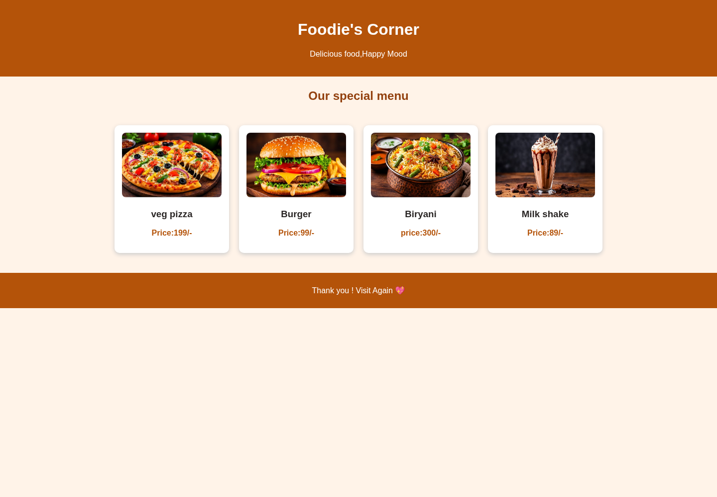

6. Output Explanation
The output begins with an orange header containing the website name and tagline. The “Our special menu” heading appears underneath on the pale peach page background. Four white menu cards are displayed in one row on the desktop screenshot. Each card contains a food photograph, its name, and its price. The cards have rounded corners and soft shadows, making them stand out from the background. The page ends with an orange footer containing the thank-you message.
The supplied photographs for pizza, burger, biryani, and milkshake were successfully loaded in the rendered output. No missing external image or resource was observed during the screenshot capture.

7. Conclusion
By developing this project, I learned how HTML5 can be used to organize webpage content and how CSS3 can improve its appearance through colours, spacing, flexible layouts, images, cards, shadows, and hover effects. I also learned how to display menu information in a clear and attractive way. This project helped me understand the basic steps involved in creating a front-end website.

8. Source Code
The complete HTML and CSS source code used to render the webpage is reproduced below. The code is included as supplied, without functional changes.

8.1 Complete HTML Code (index(1).html)
<!DOCTYPE html>
<html lang="en">
<head>
<title>Food menu</title>
<meta charset="UTF-8">
<link rel="stylesheet" href="style.css">
</head>
<body>
<header>
<h1>Foodie's Corner</h1>
<p>Delicious food,Happy Mood</p>
</header>
<h2>Our special menu</h2>
<div class="menu">
<div class="food">
<img src="pizza.jpg.jpeg" alt="pizza">
<h3>veg pizza</h3>
<p>Price:199/-</p>
</div>
<div class="food">
<img src="burger.jpg.jpeg" alt="burger">
<h3>Burger</h3>
<p>Price:99/-</p>
</div>

<div class="food">
<img src="biryani.jpg.jpeg" alt="biryani">
<h3>Biryani</h3>
<p>price:300/-</p></div>

<div class="food">
<img src="milkshake.jpg.jpeg" alt="milk shake">
<h3>Milk shake</h3>
<p>Price:89/-</p>
</div>

</div>
<footer>
<p>Thank you ! Visit Again 💖</p>
</footer>
</body>
</html>

8.2 Complete CSS Code (style(1).css)
body{
margin: 0;
font-family: Arial, Helvetica, sans-serif;
background-color: #fff3e8;
text-align: center;
}
header{
background-color: #b45309;
color: white;
padding: 20px;
}
h2{
color: #92400e;
margin: 25px;
}
.menu{
display: flex;
justify-content: center;
flex-wrap: wrap;
gap: 20px;
padding: 20px;
}
.food{
background-color: white;
width: 200px;
padding: 15px;
border-radius: 10px;
box-shadow: 0 3px 8px #ccc;
}
.food img {
width: 100%;
height: 130px;
object-fit: cover;
border-radius: 8px;

}

.food h3 {
color: #292524;

}
.food p {
color: #b45309;
font-weight:bold ;
}
.food:hover{
transform: scale(1.05);
}
footer{
background-color: #b45309;
color: white;
padding: 10px;
margin-top: 20px;
}

9. Supplied Files Note
The uploaded file named “foodweb.html” contains CSS stylesheet text and is identical to the uploaded “style(1).css” file. The webpage HTML is in “index(1).html”. For the actual render and this report, the HTML file and the matching CSS stylesheet were paired, and the four supplied JPEG images were used. The duplicate CSS-content file was not treated as a separate HTML page.

DR. RVR NRI UNIVERSITY
WEB DEVELOPMENT PROJECT REPORT
FITZONE – GYM WEBSITE
A Project Report on HTML5 and CSS3

Student Name | GANGIPOGU RUPESH KUMAR
University | DR. RVR NRI UNIVERSITY
Course | B.Tech – CSE (AI & ML)
Year | First Year
Academic Project Submission

1. Project Title
FITZONE – Gym Website. The project title is identified from the page heading and the website title in the supplied HTML source code.

2. Introduction
FITZONE is a front-end website for a gym and fitness centre. It presents workout options, trainer categories, membership prices, available facilities, a weekly class schedule, and a registration form. The purpose of the website is to give visitors a simple place to explore the gym’s services and view membership choices before entering their contact details in the registration form.
The webpage uses a clear section-based layout. Visitors can move between the main areas using the navigation links at the top of the page. The design uses a dark header and hero area, orange action buttons, white content cards, and a dark footer.

3. Technologies Used
- HTML5: Defines the webpage structure and content, including the header, navigation links, main sections, cards, form controls, and footer.
- CSS3: Controls the visual design, including colors, spacing, typography, grid layout, card shadows, button hover effects, smooth scrolling, and a media query for smaller screens.
No JavaScript, external framework, database, or server-side technology is included in the supplied source files.

4. Webpage Description

4.1 Header and Navigation Bar
The header displays the text “💪FITZONE” on the left and navigation links on the right. The links are Home, programs, Trainers, Pricing, and Register. They point to the corresponding section IDs in the page. The header uses a dark-cyan background, white text, flexible alignment, and spacing between items. Navigation links change to orange when the pointer hovers over them.

4.2 Home / Hero Section
The home section contains the main message “BUILD YOUR BEST BODY”, the supporting line “Train Hard . Stay Strong . Live Healthy”, and an orange “Join Now” button. The section has a dark blue-grey background, white centred text, and generous padding. The heading uses a responsive font size through CSS clamp(). In the supplied HTML, the Join Now control is a button and is not configured with a link or click action.

4.3 Workout Programs
The Workout Programs section displays three cards: Strength Training, Cardio Fitness, and Yoga & Flexibility. The cards are arranged in a three-column CSS grid on the rendered desktop page.

4.4 Trainers
The Trainers section contains three cards labelled Strength Coach, Cardio Coach, and Yoga Instructor. These labels introduce the trainer categories offered by the gym website.

4.5 Membership Plans
The Membership Plans section presents three options: Basic at 999/- per month, Standard at 1,499/- per month, and Premium at 2,499/- per month. Each plan includes a “Choose Plan” link that points to the registration section.

4.6 Facilities and Class Schedule
The Facilities & Class Schedule section lists Modern Equipment, Locker Rooms, and Personal Training. A separate Class Schedule section lists Mon – Yoga, Wed – Cardio, and Fri – Strength. Both areas use the same card styling and grid arrangement.

4.7 Registration Form
The Registration Form contains fields for full name, email address, phone number, and an additional text entry with the placeholder “select text”. It also includes a membership dropdown with Basic, Standard, and Premium options, followed by a submit button. The fields are marked required. The supplied code does not connect this form to a backend, database, or email service, so it provides the front-end form interface only.

4.8 Footer
The footer displays “© 2026 FITZONE GYM | All Rights Reserved” in white text on a dark background. The text is centred with padding around it.

4.9 Overall Styling and Layout
The CSS applies a universal margin and padding reset and uses border-box sizing. The body uses Arial, sans-serif, a white background, and dark-slate-blue text. The content cards have white backgrounds, rounded corners, padding, and soft shadows. When a pointer hovers over a card, it moves slightly upward and its shadow becomes stronger. Buttons use orange backgrounds and become darker and slightly larger on hover. Smooth scrolling is enabled for in-page navigation.
The stylesheet includes a media query at a maximum width of 768 pixels that centres the header content. The supplied CSS does not change the three-column card grid to fewer columns at that breakpoint, so the mobile layout may need further refinement for narrow screens.

5. Actual Webpage Output
The following screenshots were captured by rendering the supplied HTML together with the supplied CSS in a Chromium browser at a desktop viewport width of 1440 pixels. The full page is divided into consecutive screenshot panels so that the complete rendered webpage is visible in the report. No webpage content or styling was invented for these screenshots.

Actual Webpage Output – Screenshot 1 of 3
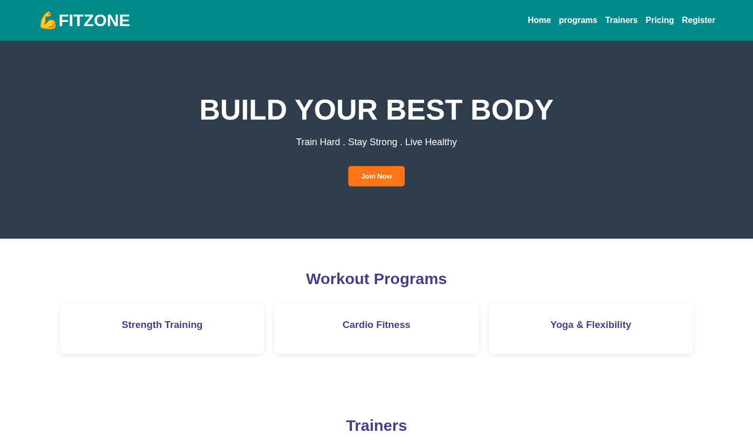

Actual Webpage Output – Screenshot 2 of 3
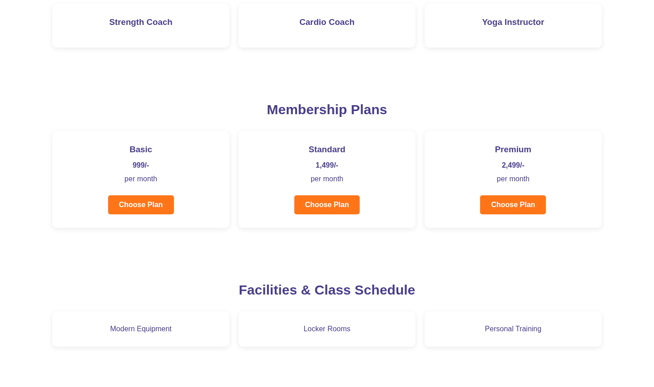

Actual Webpage Output – Screenshot 3 of 3
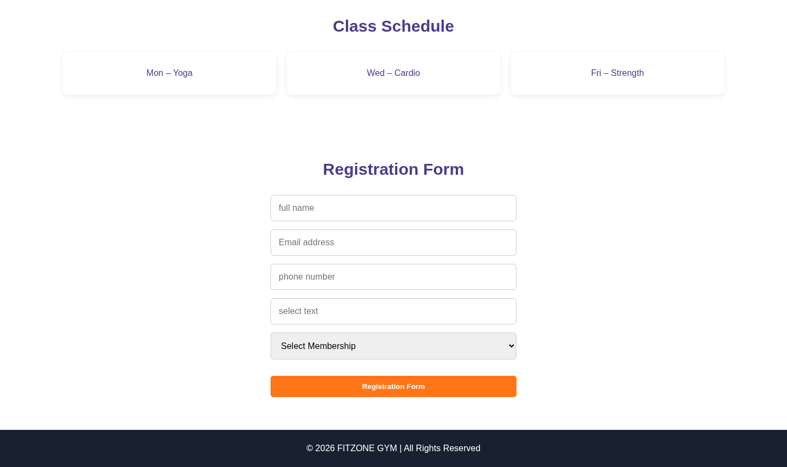

6. Output Explanation
The rendered output shows the FITZONE gym website as one vertically scrolling webpage. At the top, the dark-cyan header presents the gym name and section navigation. Below it, the dark hero banner draws attention to the main fitness message and Join Now button. The Workout Programs, Trainers, Membership Plans, Facilities, and Class Schedule areas appear as groups of white cards on a light background. The membership cards show the monthly prices and provide links to the registration area.
Further down the page, the registration form appears as a vertically arranged set of input fields and a membership selection dropdown. The page ends with a dark footer containing the copyright statement. The rendered page contains no photographic or other external image assets because the supplied HTML does not include image elements or image URLs. The dumbbell symbol beside FITZONE is a text emoji.

7. Conclusion
By developing this project, I learned how HTML5 can be used to organize a webpage into meaningful sections and how CSS3 can be used to style those sections with colors, spacing, grids, cards, and hover effects. I also practised creating navigation links, membership information, and a basic registration form. This project helped me understand the basic process of building and presenting a front-end website.

8. Source Code
The complete HTML and CSS source code supplied for this report is included below. The source is reproduced without changing its functionality.

8.1 Complete HTML Code (index.html)
<!DOCTYPE html>
<html lang="en">
<head>
<title>fitzone</title>
<meta charset="UTF-8">
<link rel="stylesheet" href="style.css">
</head>
<body>
<header>
<h1>💪FITZONE</h1>
<nav>
<a href="#home">Home</a>
<a href="#programs">programs</a>
<a href="#trainers">Trainers</a>
<a href="#pricing">Pricing</a>
<a href="#register">Register</a>
</nav>
</header>
<main>
<section id="home" class="hero">
<h1>BUILD YOUR BEST BODY</h1>
<p>Train Hard . Stay Strong . Live Healthy</p>
<button id="#register" class="btn">Join Now</button>
</section>

<section id="programs">

<h2>Workout Programs</h2>
<div class="cards">

<div class="card">
<h3>Strength Training</h3>
</div>
<div class="card">

<h3>Cardio Fitness</h3>
</div>
<div class="card">
<h3>Yoga & Flexibility</h3>
</div>
</div>
</section>

<section id="trainers">
<h2>Trainers</h2>
<div class="cards">
<div class="card">
<h3>Strength Coach</h3>
</div>
<div class="card">
<h3>Cardio Coach</h3>
</div>
<div class="card">
<h3>Yoga Instructor</h3>
</div>
</div>
</section>

<section id="pricing">
<h2>Membership Plans</h2>
<div class="cards">
<div class="card">
<h3>Basic</h3>
<h4>999/-</h4>
<p>per month</p>
<a href="#register" class="btn">Choose Plan</a>
</div>

<div class="card">

<h3>Standard</h3>
<h4>1,499/-</h4>
<p>per month</p>
<a href="#register" class="btn">Choose Plan</a>
</div>

<div class="card">
<h3>Premium</h3>
<h4>2,499/-</h4>
<p>per month</p>
<a href="#register" class="btn">Choose Plan</a>
</div>
</div>
</section>

<section>
<h2>Facilities & Class Schedule</h2>
<div class="cards">

<p class="card">Modern Equipment</p>
<p class="card">Locker Rooms</p>
<p class="card">Personal Training</p>
</div>
</section>
<section>

<h2>Class Schedule</h2>
<div class="cards">
<p class="card">Mon – Yoga</p>
<p class="card">Wed – Cardio</p>
<p class="card">Fri – Strength</p>
</div>
</section>

<section id="register">
<h2>Registration Form</h2>

<form>
<input type="text" placeholder="full name" required>
<input type="email" placeholder="Email address" required>
<input type="tel" placeholder="phone number" required>
<input type="text" placeholder="select text" required>

<select required>
<option value="">Select Membership</option>
<option>Basic</option>
<option>Standard</option>
<option>Premium</option>
</select>

<button type="submit" class="btn">Registration Form</button>
</form>
</section>
</main>
<footer>
<p>© 2026 FITZONE GYM | All Rights Reserved</p>
</footer>
</body>

</html>

8.2 Complete CSS Code (style.css)

* {
margin: 0;
padding: 0;
box-sizing: border-box;
}
header
{
background-color: darkcyan;
color: white;
padding: 20px 5%;
display: flex;
justify-content: space-between;
align-items: center;
flex-wrap: wrap;
gap: 20px;
}

html {
scroll-behavior: smooth;
}
body {
font-family: Arial, sans-serif;
background: white;
color: darkslateblue;
}
header span {
color: #ff7518;
}
nav {
display: flex;
gap: 15px;
flex-wrap: wrap;
}
nav a {
color: white;
text-decoration: none;
font-weight: bold;
transition: color 0.3s;
}
nav a:hover {
color: #ff7518;
}
.hero {
background: #303d4c;
color: white;
text-align: center;
padding: 100px 20px;
}
.hero h1 {
font-size: clamp(32px, 5vw, 55px);
font-weight: 900;
}
.hero p {
margin: 20px 0;
font-size: 18px;
}
.btn {
display: inline-block;
background: #ff7518;
color: white;
border: none;
padding: 12px 24px;
margin-top: 15px;
border-radius: 5px;
text-decoration: none;
font-weight: bold;
cursor: pointer;
transition: 0.3s;
}
.btn:hover {
background: #d95400;
transform: scale(1.05);
}
section {
padding: 60px 8%;
text-align: center;
}
section h2 {
font-size: 30px;
margin-bottom: 30px;
}
.cards {
display: grid;
}
.cards {
display: grid;
grid-template-columns: repeat(3, 1fr);
gap: 20px;
}
.card {
background: white;
padding: 30px 20px;
border-radius: 10px;
box-shadow: 0 3px 12px #00000015;
transition: 0.3s;
}
.card h3 {
margin-bottom: 15px;
}
.card p {
margin: 12px 0;
}
.card:hover {
transform: translateY(-8px);
box-shadow: 0 8px 20px #00000025;
}
form {
max-width: 450px;
margin: auto;
display: flex;
flex-direction: column;
gap: 15px;
}
input, select {
width: 100%;
padding: 14px;
border: 1px solid #ccc;
border-radius: 5px;
font-size: 16px;
}
input:focus, select:focus {
outline: 2px solid #ff7518;
}
footer {
background: #17212f;
color: white;
text-align: center;
padding: 25px;
}
@media (max-width: 768px) {
header {
justify-content: center;
text-align: center;
}}
nav {
justify-content: center;
}

