**Problem 4:**

**Questions:**

1. The domain() function is the data range upon which the scale is calculated.

What does d3.selectAll("tbody tr")[0].length-1 mean?

Ans: The total number of rows tr in the body of the table. Here in this example = 51

So,

d3.selectAll("tbody tr")[0].length-1 = **50**

Domain range : 0 to 50

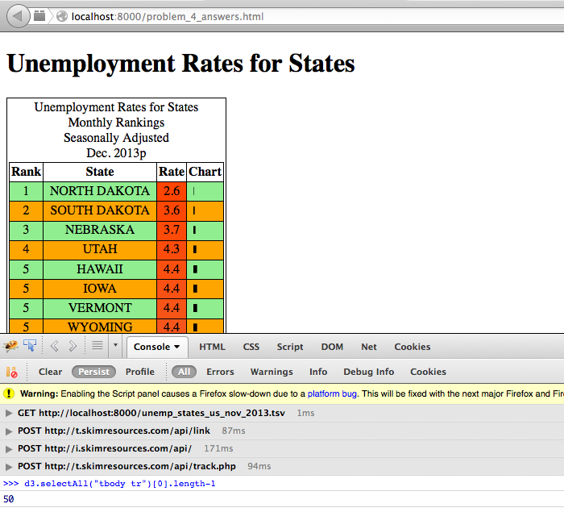

2. Add the snippet in your code. Describe, in words, what the following function calls return: color(0),color(10) and color(150)?

Ans:

**var** color **=** d3.scale.linear() .domain([0, tbody.selectAll("tr")[0].length**-**1]) .interpolate(d3.interpolateRgb) .range(["orangered", "silver"])

i. color(0) returns the start color range. Here the color starts from Orange





ii. color(10) returns 10th value in the color range from Orange to Silver based on the Interpolated RGB value.





iii. color(150) returns the interpolated value which is above the range of 0 to 50





3. If the array passed to domain() was the minimum and maximum rate values, how would that change the scale? In what situations would this be appropriate?

Ans:

Passing the Domain Range from Minimum Rate value = 2.6 and Mazimum value = 9.0

