How This Project Works
Playwright Agents, from User Story to CI
A short guide to how this repo turns a user story into Playwright tests, runs them, fixes ("heals") the ones that fail, and runs them in CI.

1. The pipeline at a glance
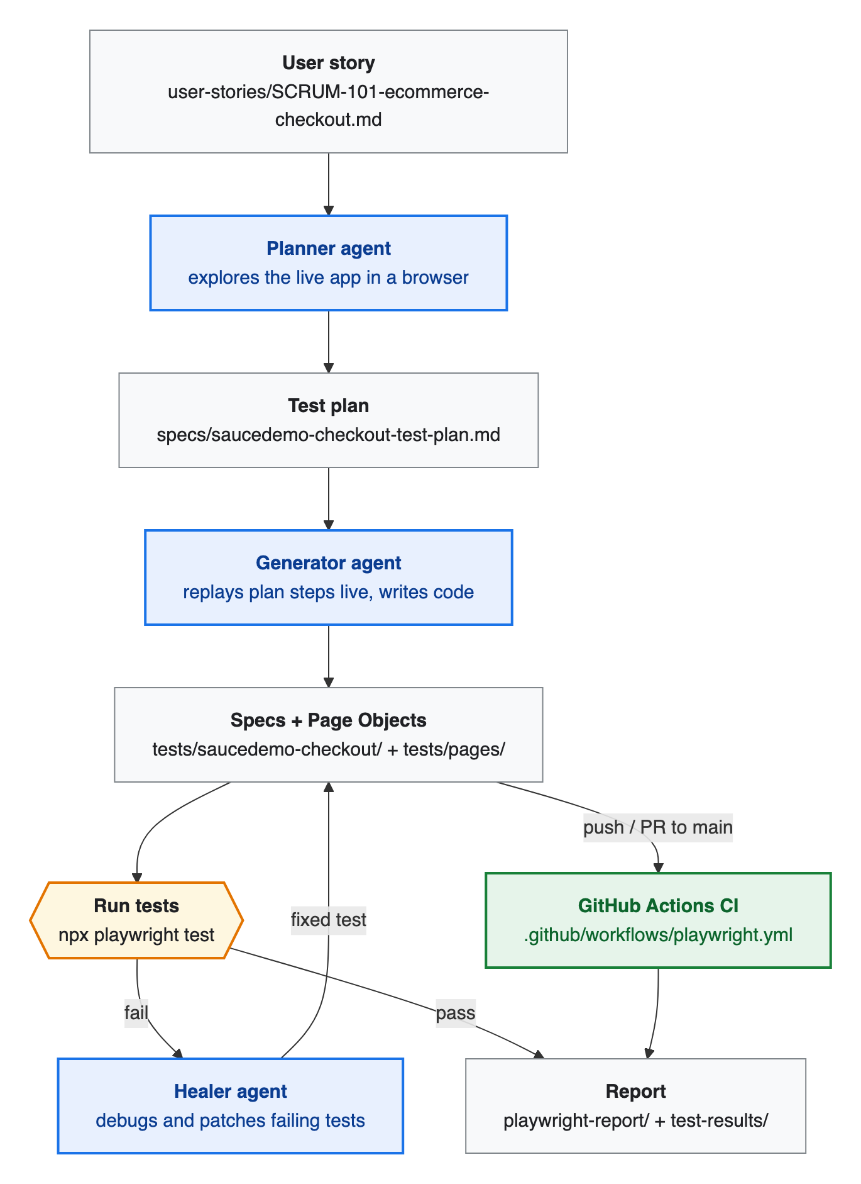
Figure 1 — End-to-end pipeline. Blue boxes are AI agents; green is CI.
Stage | Input | Who does it | Output
1. Requirements | Feature idea | Human / PO | user-stories/SCRUM-101-ecommerce-checkout.md
2. Plan | User story + live app | Planner agent | specs/saucedemo-checkout-test-plan.md
3. Generate | Test plan | Generator agent | tests/saucedemo-checkout/*.spec.ts
4. Execute | Specs | Playwright runner | Pass/fail + traces, screenshots, videos
5. Heal | Failing tests | Healer agent | Patched specs
6. Report | Results | Agent / human | test-results/ report, HTML report
7. CI | Push / PR | GitHub Actions | HTML report artifact

2. What "Playwright agents" are
Playwright (v1.56+) ships three AI agent definitions — planner, generator and healer — that an AI coding assistant (Claude Code, VS Code Copilot, etc.) runs. Each agent is a prompt file plus access to a Playwright MCP server, which gives the AI a real browser to click, type, inspect the DOM and run tests.
They are set up once with:
npx playwright init-agents --loop=claude # or --loop=vscode / --loop=opencode
This generates:
- .claude/agents/playwright-test-planner.md, playwright-test-generator.md, playwright-test-healer.md — the agent prompts and tool permissions
- .mcp.json — registers the playwright-test MCP server (browser + test-runner tools)
- a seed test (tests/seed.spec.ts) — the starting point the agents use to set up the page (e.g. log in)
Note: These generated files are not committed to this repo. The agents were used in an earlier session to produce the plan, the original specs and the healing pass (the report names playwright-test-healer, and the plan still references tests/seed.spec.ts). Since then, the seed test has been replaced by the setup project in playwright.config.ts + tests/fixtures/auth.setup.ts. To run the agents again, run init-agents and add a seed test (or point the agents at auth.setup.ts).

3. How each agent is triggered and what it does
Agents are triggered manually from the AI assistant's chat by naming them in a prompt. Claude Code picks the agent from .claude/agents/ and gives it the MCP browser tools. Nothing triggers them automatically — not git hooks, and not CI. Figure 2 on the next page shows the sequence.
Agent | Example prompt | What it does | Output
Planner | "Use the planner agent to create a test plan for the checkout flow in user-stories/SCRUM-101…" | Runs the seed test, explores the app in a real browser, maps every acceptance criterion to scenarios with steps and expected results | Markdown plan in specs/
Generator | "Use the generator agent to generate tests from specs/saucedemo-checkout-test-plan.md" | Runs each plan step in the browser so selectors and assertions are checked against the real DOM, then writes the code | *.spec.ts files
Healer | "Use the healer agent to fix the failing tests" | Runs the suite, reads errors, traces and the page snapshot, finds the root cause, patches and reruns. If the app itself is broken, marks the test test.fixme instead of hiding the bug | Patched specs

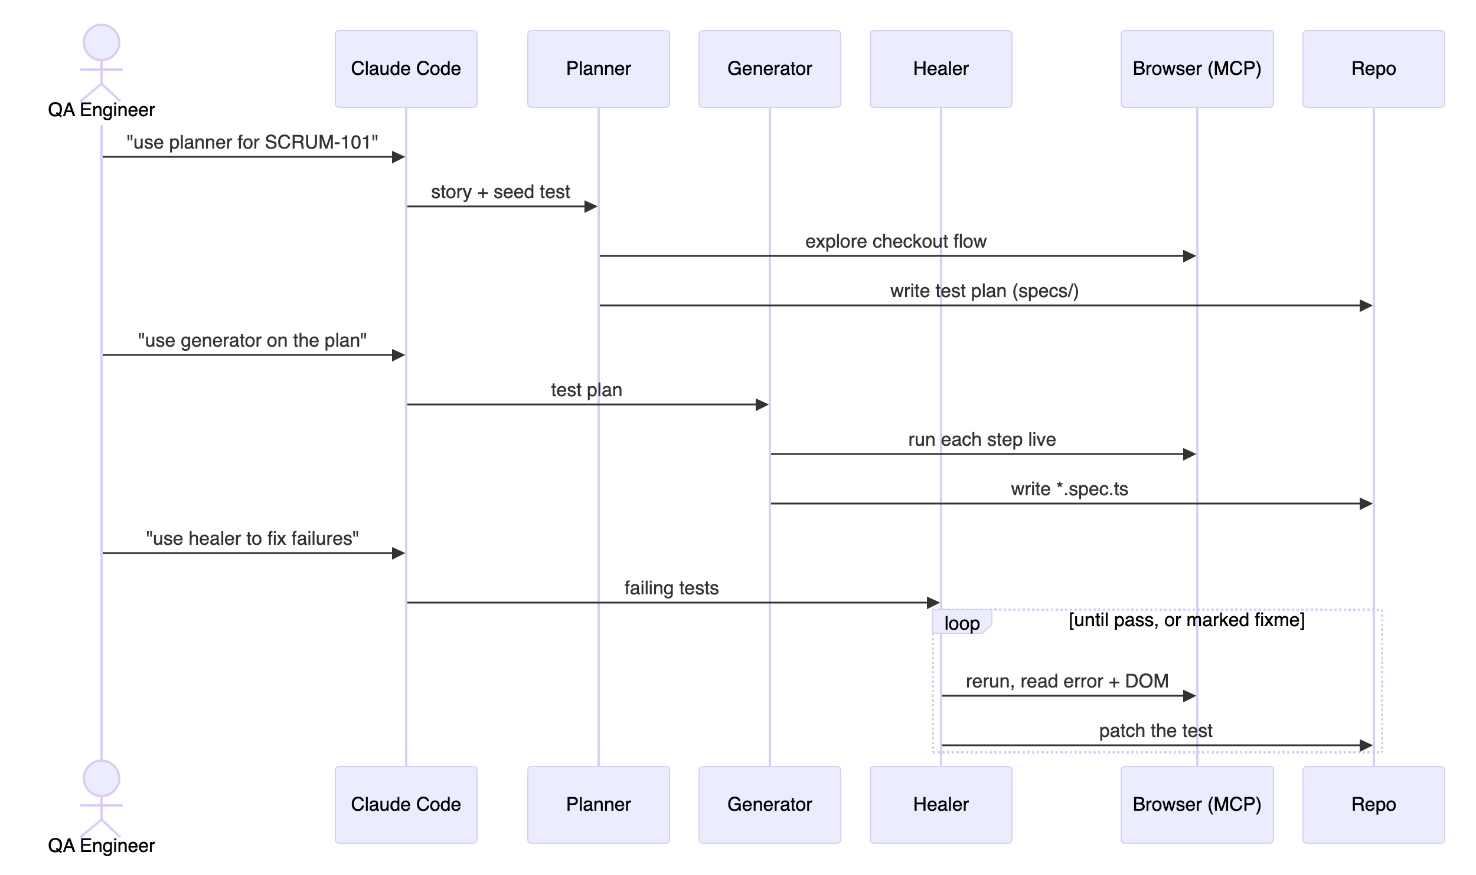
Figure 2 — How a QA engineer triggers each agent from Claude Code.

Real healing example from this project
From the original test report: 18 of 20 tests passed on the first run, and 20 of 20 after healing.
Failure | Root cause | Healer fix
complete-checkout-flow.spec.ts — payment info not found | Fragile CSS selector .summary_value | Changed to [data-test="payment-info-value"] / shipping-info-value
order-completion.spec.ts — text mismatch | Expected "Pony Express"; the app says "…as fast as the pony…" | Assertion changed to toContainText("pony")

4. How the generated code is organized
After generation, the code was refactored into a maintainable framework:
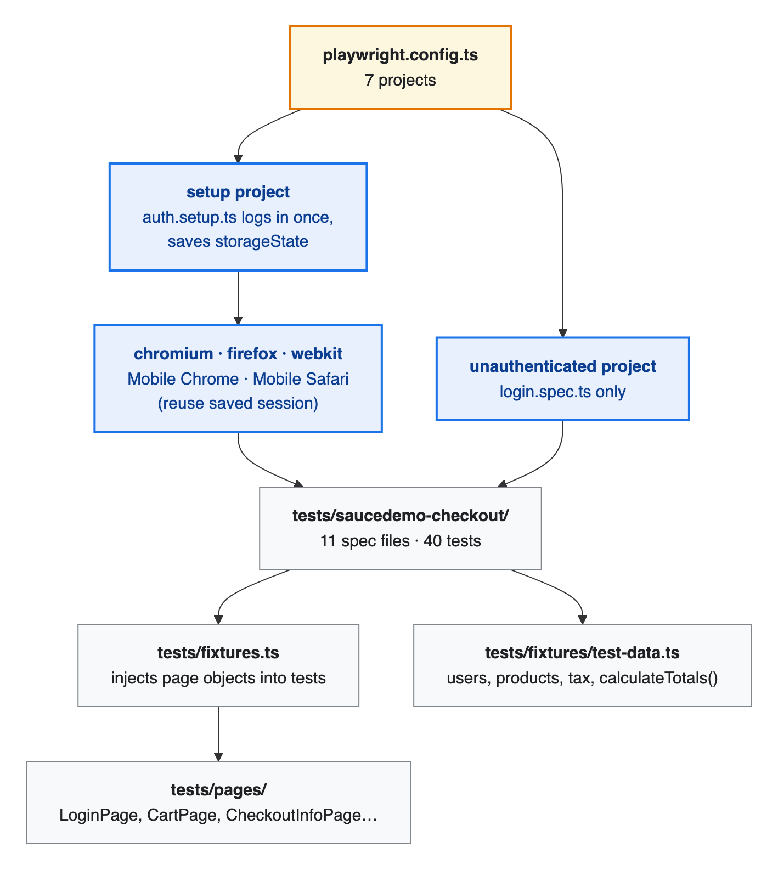
Figure 3 — Test framework structure.
- Page Object Model — each SauceDemo page is a class wrapping its data-test locators and actions.
- Custom fixtures (tests/fixtures.ts) — tests receive cartPage, productsPage, … as parameters.
- Auth once, reuse everywhere — the setup project logs in once and the browser projects reuse the session.
- Cross-browser and mobile — the browser/device projects each run the whole suite (latest run: 174 passed, 11 skipped by design).

5. How CI works
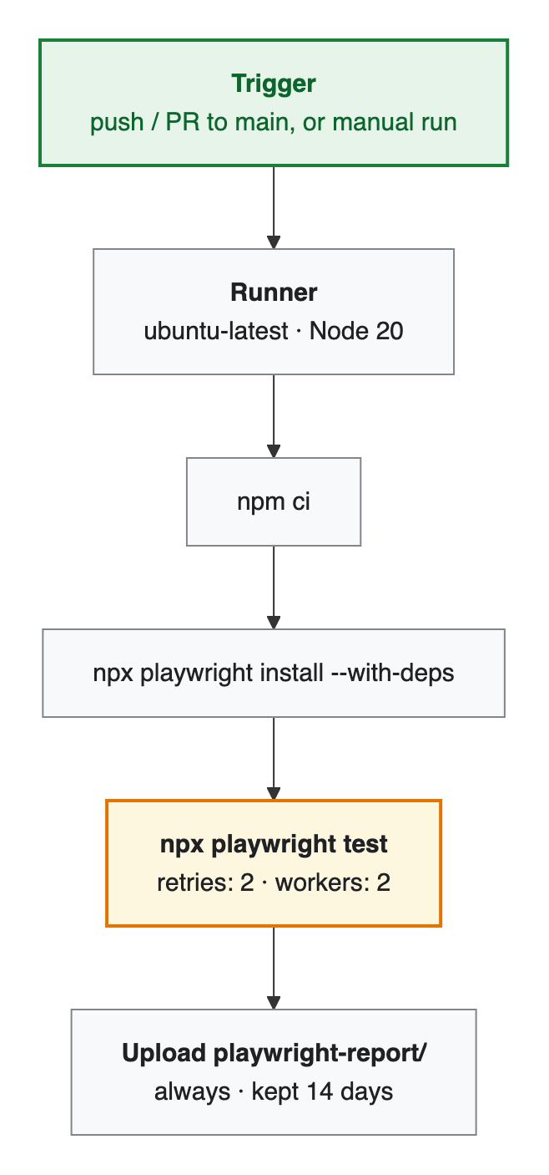
Figure 4 — GitHub Actions pipeline (.github/workflows/playwright.yml).
- Triggers: push and pull_request to main, plus manual workflow_dispatch.
- Runs the full 7-project matrix. When CI=true, the config turns on forbidOnly, 2 retries (which handles flaky network calls to the public site) and 2 workers.
- Evidence: traces on first retry, plus screenshots and video on failure. The HTML report is uploaded as an artifact even when tests fail.
- CI does not run the AI agents. It only runs the tests. Healing is a step a developer runs locally: when CI goes red, they download the report, ask the healer agent to fix the failing tests, and push the fix.

6. Quick start
npm install && npx playwright install
npm test # full matrix
npm run test:chromium # one browser
npm run test:ui # interactive UI mode
npm run report # open the HTML report

# optional: re-enable the AI agents
npx playwright init-agents --loop=claude

