PROJECT BASED LEARNING REPORT
HOSPITAL MANAGEMENT SYSTEM
Submitted by:
Rupesh Singh
Roll Number :- 1/24/SET/BCS/117

Under the Guidance of: Faculty Name: Dr. Lenin
Department of Computer Science and Engineering
Manav Rachna International Institute of Research and Studies
Academic Year: 2025–2026

ABSTRACT
The Hospital Management System automates hospital operations such as patient registration, appointments, doctor allocation, treatment history management, and billing. It uses DBMS concepts to ensure efficient storage, processing, and retrieval of hospital data.

INTRODUCTION
A Hospital Management System (HMS) is a computerized system for storing and managing medical and administrative data. This project applies DBMS concepts like relations, normalization, and SQL operations.

OBJECTIVES
- To simulate hospital patient flow using Data Structures.
- To manage normal patients using Queue (FIFO).
- To prioritize emergency patients using Priority Queue.
- To use Deque for special or VIP cases.
- To design a working model of real hospital flow without a database.
- To improve efficiency in patient handling.
- To develop a structured program in C

SYSTEM ANALYSIS
The system enhances hospital data management, reduces redundancy, improves access speed, and maintains relational integrity using foreign keys.

ER DIAGRAM AND SCHEMA DESIGN
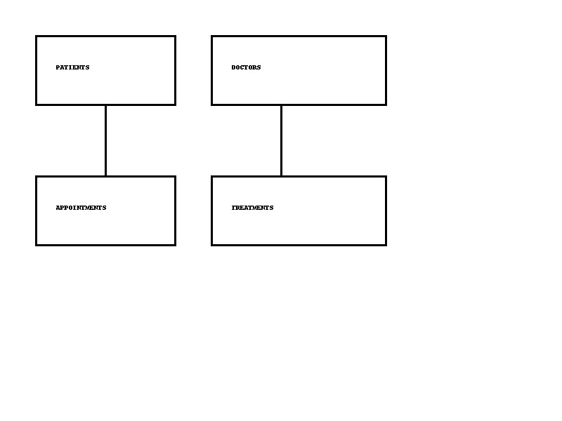
Entities include:
- Patients
- Doctors
- Appointments
- Treatments
Key Relationships:
- A patient can have multiple appointments.
- A doctor attends multiple patients.
- Treatment records link patients and doctors.

IMPLEMENTATION
Database: MySQL Interface: Python/C
Tables:
Patients: Patient_ID, Name, Age, Phone
Doctors: Doctor_ID, Name, Specialization
Appointments: Appt_ID, Patient_ID, Doctor_ID, Date, Time
Treatments: Treat_ID, Patient_ID, Doctor_ID, Diagnosis, Prescription

RESULTS AND DISCUSSION
The HMS allows efficient hospital workflow execution, supports multi-user access, reduces manual errors, and increases operational speed.

CONCLUSION AND FUTURE WORK
Future improvements: automated billing, biometric login, cloud-based system, and AI-based diagnosis suggestions.

REFERENCES
• Hospital Workflow Management Research Articles – Various online academic sources explaining patient flow, triage systems, and hospital queue management.
• C Programming Documentation:
https://en.cppreference.com/
• Data Structure Tutorials:
https://www.geeksforgeeks.org/data-structures/

