ChatGPT Friend or Foe?
Rupesh Thapa

Abstracts
When was the paper published?
What was solved/happened?
What were the performance issues/measures?
What method did they adopt?
Are any issues left to be addressed?

Keywords: Chatbot, Chatgpt, Artificial Intelligence,
- Introduction
Artificial Intelligence (AI) has revolutionized our everyday lives with brilliant operators that can perform different capacities. One such operator is the chatbot, an AI program that employs Natural Language Processing (NLP) and assumption investigation to reenact human discussion. Separated from entertaining individuals, chatbots are valuable in instruction, trade, well-being, and amusement. They can diminish benefit costs and handle numerous clients at the same time, giving locks in and effective help.

In trade, chatbots have ended up the favored channel for client administrations as they offer more locks in answers than inactive FAQ records. They can increase representative efficiency and energize more individuals to utilize administrations. Chatbots give comfortable and proficient help to clients, specifically reacting to their issues. Hence, chatbots are a basic innovation for businesses and people alike.

  - What is a chatbot? And short history
Chatbot, short for chatterbot, is a computer program that employs artificial intelligence (AI) and natural language processing (NLP)to reenact discussions with human clients through voice commands or content chats, particularly over the web. Chatbots are not as they were for amusement but are valuable in instruction, commerce, and e-commerce. They are well known due to points of interest for clients and designers, such as stage freedom, moment accessibility, solid installment integration, and notice frameworks. Chatbots can be coordinated into gather discussions, have constrained information prerequisites, and information is effectively transferable. Designers take advantage from communication unwavering quality, quick advancement iterations, and restricted plan endeavors.

Chatbot first ELIZA (named after the fictional Eliza Doolittle) was developed by computer scientist and MIT professor name Joseph Weizenbaum in the mid-1960s. As per the study, Alan Turing's paper on Computing Apparatus and Insights in 1950, presented the concept of the Turing Test to decide in case a machine had human-like insights. The entry at that point goes on to portray the improvement of a few chatbots, counting ELIZA, Repel, Jabberwacky, Dr. Sbaitso, ALICE, and SmarterChild, and their different applications and functionalities. The section moreover notes that Siri, a virtual right hand, was discharged by Apple in 2011 and employs common dialect handling and machine learning to perform different assignments.

Citation needed;

  - What are the significances of chatbot?
Chatbots are a pivotal mechanical progression (like Apple Siri and Alexa Amazon) that empowers businesses to communicate with clients utilizing fake insights and machine learning. As the number of chatbots on Facebook Messenger has expanded from 100,000 to over 400,000, it is obvious that this innovation is the favored channel for client administrations. By contributing in chatbots, companies can boost worker efficiency and empower more individuals to utilize their administrations. Chatbot helps in different sectors, for instance Improved Customer Service, Natural Language Conversations, Challenges and Opportunities, Systematic Literature Review. There are numerous significances of chatbot some are:

- Chatbots are the following vital mechanical headway that permits businesses to empower clients to communicate with informing frameworks with fake insights and machine learning innovation. This innovation is the foremost favored channel for client administrations.
- Chatbots can increase worker efficiency and empower more individuals to utilize administration.
- Chatbots have ended up progressively well-known due to the quick headway of the versatile gadget showcase and the advancement of informing stages over the past few long time, together with the included client benefits of having a recognizable interface, no requirement for downloading or introducing any additional application, and 24/7 accessibility.
- Researchers and developers have developed chatbots with different design techniques in response to advances in artificial intelligence, machine learning, and natural language processing techniques. This enables them to be more effective than conventionally designed chatbots.
- The ability of chatbots to understand user requests, process them, generate appropriate responses, and maintain a conversation with users still remains a challenge, despite improvements in technology.

  - What are types of chatbot?
Types of chatbot can be divided into three parts with its sub-group according to this study. Types of chatbot with its sub-group and its tasks are mentioned below in the table:
Types | Sub-Group | Tasks
Structure | Flow Chatbot  Artificial Intelligence  Hybrid | Flow chatbot means a tree-based chatbot which gives a fixed reply and only answers to questions which are already in the database set by developer. Flow chatbot incorporate button, catchphrases, and catchphrases rather than free composing to drive the client down the predefined way.  Chatbot with artificial intelligence has the capacity to overhaul its information and  recognition from past discussions and users’ involvement, letting the  clients lock in more openly.  This sort of chatbot combines the concepts of Flow and AI chatbots. This chatbot can get it and communicate with clients but remains within the  design decided by the engineer.
Purpose | Functionality  Fun | This chatbots have fixed capacities depending on the engineer (i.e., chatbot for  learning, individual right hand, update, online shop right hand, etc.).  chatbot that aiming as it were for amusement (i.e., recreations, funbot, etc.).
Audience | Generalist  Specialist | This chatbot has common information that we can inquire about specifically. I.e., Siri  created by Apple, and Cortana created by Microsoft. Both Chatbots can help us unravel common issues such as looking for eateries, areas, and more.  This chatbot centers on one compelled thing and do that one thing amazingly.  well (i.e., chatbots that are utilized to serve clients online when requesting things).

  - What is ChatGPT ? Discuss along with its history and differences with normal chatbots.
Chat Generative Pre-Trained Transformer (ChatGpt) is one of the powerful AI tool which is in high demand today’s date. ChatGpt is a machine learning algorithm demonstration created by Open AI, which has taken the entire world of Natural Language Processing (NLP) by storm to associate with clients. ChatGpt assists users by writing essays, e-mails, code, letter and so on also answer questions.

Firstly, there was a GPT-1 model discharged by OpenAI before the discharge of GPT-2. In 2018, GPT-1 was discharged with 117 million parameters, which was a noteworthy change over the dialect models that were accessible at the time. It was an essential milestone for the development of large-scale language models.

In February 2019, GPT-2 was released and was a noteworthy advancement over its forerunner, GPT-1. It contained 1.5 billion parameters, i.e., 10 times bigger than GPT-1. This bigger demonstrate estimate permitted GPT-2 to produce more coherent and relevantly important content.

GPT-3 was discharged in June 2020 and was indeed more considerable advancement over GPT-2. GPT-3 had 175 billion parameters, making it the biggest dialect demonstration ever made at the time of its discharge. GPT-3 was able to perform a wide run of common dialect errands, counting dialect interpretation, question-answering, and indeed composing imaginative fiction.

Due to huge success of GPT-3, GPT-4 was discharged in September 2021 and has indeed more parameters than GPT-3, with 6 trillion parameters. This expanded show estimate empowers me to create indeed more practical and coherent dialect, as well as perform more complex normal dialect handling errands.

ChatGpt apart from other chatbots is its ability to understand content. ChatGPT is its moved-forward exactness compared with conventional NLP apparatuses. Unlike conventional NLP models, which regularly depend on rule-based approaches and depend on human-defined lexicons and language structure, ChatGPT employments profound learning calculations to memorize from the information it is prepared on. This comes about in a demonstration that's competent of producing more human-like reactions, as well as recognizing designs in dialect that conventional NLP models may miss.

  - How chatGPT works? Explain with diagram.

ChatGPT could be an open device created by OpenAI that employs GPT innovation to perform a wide extent of text-based demands, such as creating common dialect reactions to basic and progressed questions, writing essays, and tending to efficiency issues. GPT could be a dialect show created by OpenAI that employs generative, unsupervised pretraining and discriminative, directed fine-tuning to refine its concepts. Its capacity to perform a wide extent of language-based assignments, counting interpretation, address replying, and content era, sets it separated. ChatGPT's normal dialect handling capabilities make it a perfect apparatus for dealing with essential client benefit requests, possibly valuable within the legitimate calling and might help with evaluating and giving input on understudy assignments. It reached over one million special clients within one week of its dispatch, demonstrating its value and ubiquity. The innovation may have critical impacts on different businesses and possibly diminish the time required to compose inquire about papers. Its versatility, capacity to utilize information effectively, and create human-like dialect make it an interesting and noteworthy development within the field of common dialect preparing and fake insights. This is how ChatGPT works:

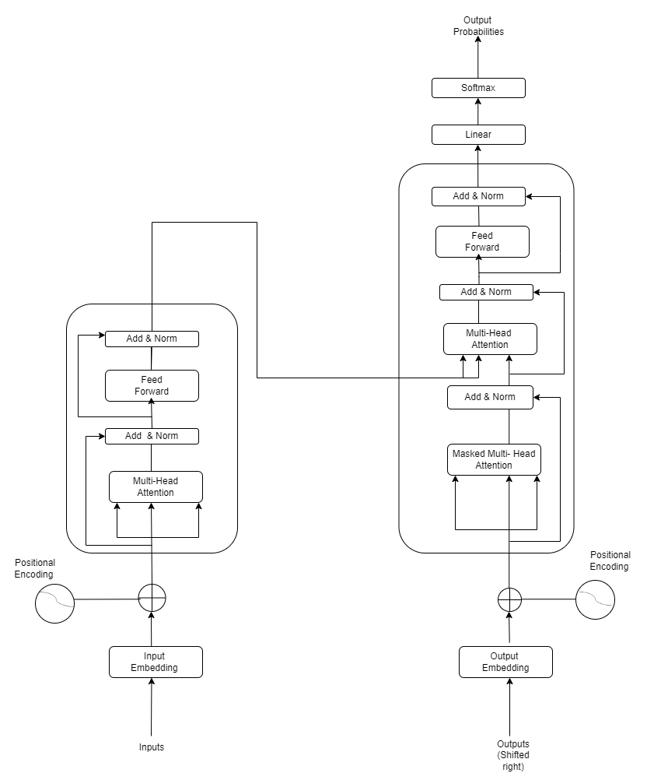
Figure 1: The Transformer – model architecture

Encoder and Decoder Stacks:
Encoder:
The design of the encoder in a transformer show comprises of N=6 indistinguishable layers, each with two sub-layers: multi-head self-attention and completely associated feed-forward. Leftover associations and layer normalization are utilized to assist stabilize preparation. All sub-layers and inserting layers create yields of measurement dmodel = 512 to empower the utilize of remaining associations.
Decoder:
The decoder within the transformer demonstrates N=6 layers, each with three sub-layers. It employs leftover associations, layer normalization, and adjusted self-attention sub-layers to go to known yields from the encoder stack. This guarantees forecasts for position i depend as it were on known yields at positions less than i.

Attention:
A compatibility function of the query with the corresponding key computes the weight attached to each value in the output.

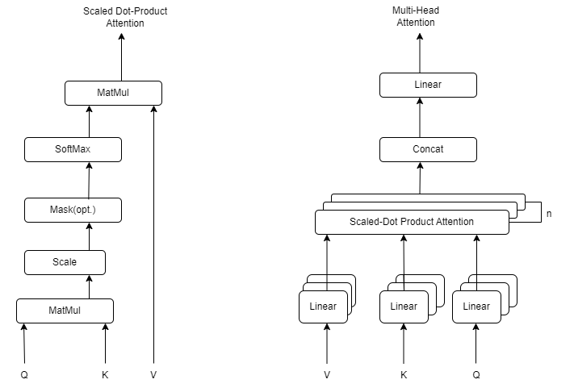

Figure 2: (Left) Scaled Dot-Product Attention. (Right) Multi-Head Attention consists of several attention layers running in parallel.

Scaled Dot-Product Attention:
Single dot-product attention is a type of attention mechanism used in neural networks, particularly in the Transformer architecture, which is commonly used for natural language processing tasks.

In single dot-product attention, there are three inputs: a query vector Q, a set of key vectors K, and a set of value vectors V. These three inputs are typically obtained from the output of previous layers in the neural network.

The attention mechanism computes the dot product between the query vector Q and each key vector K, and then applies a softmax function to obtain a set of weights that determine how much attention should be given to each value vector V. Specifically, the softmax function is applied to the dot product of Q and K divided by the square root of the dimensionality of the key vectors. This produces a set of weights that sum to 1 and can be interpreted as the importance of each value vector V for the given query Q.

The final output of the attention mechanism is a weighted sum of the value vectors V, where the weights are determined by the softmax of the dot product of the query vector Q and the key vectors K. This output is then passed to the next layer of the neural network for further processing.

Multi-Head Attention:
Multi-head attention is a technique utilized in neural systems, especially within the Transformer architecture, which is commonly utilized for natural language processing assignments. It expands the single dot-product attention mechanism to progress its expressiveness and capture more complex connections between inputs.

In multi-head attention, the input query vector Q, key vectors K, and value vectors V are to begin with linearly projected h times with distinctive learned linear projections to get h sets of questions, keys, and values, each with a decreased dimensionality. At that point, the dot product attention mechanism is connected to each of the h sets of anticipated questions, keys, and values in parallel, creating h sets of yield values.

The output values from each attention head are then concatenated and passed through another learned linear projection to get the ultimate output of the multi-head attention mechanism. This last output is at that point passed to another layer of the neural network for encouraging handling.

2. Literature reivew
Reivew of more than 10 papers from journal (2019-2023)

Discuss
ChatGPT and its applications
Industry applications>> education, health, medicine, industry, research
NLP Applications >> content generation, text summarization, machine translation, QA,…
chatGPT and its Pros / Cons / limitations
ChatGPT and its technical implementation with diagram
ChatGPT and its comparison with other AI-based chatbots
ChatGPT and performance issues
- Analysis
Analyze using 10 or more papers
Critically analyze >> cross-check statement presented in one paper with that in another paper, present your opinion as well.
3.1 Ethical issues
3.2 Trust issues
3.3 Accountability issue

- Conclusion
Present your final verdicts / recommendations based on your study

