**ChatGPT Friend or Foe?**

Author: Rupesh Thapa

Abstracts:

This paper provides a brief introduction to chatGPT, including its various field areas, applications, and capabilities, as well as its creation and operation. The main ideas of many works have been examined and discussed. Along with the areas where chatGPT can be improved, the limits are also addressed.

Keywords: Chatbot, Chatgpt, Artificial Intelligence, Machine Learning, Natural Language Processing

1. Introduction

Our daily lives have been altered by intelligent machines that can carry out a variety of tasks thanks to artificial intelligence (AI). One such operator is the chatbot, an AI program that mimics human conversation using Natural Language Processing (NLP) and assumption investigation. Apart from amusing people, chatbots are useful for trade, education, well-being, and entertainment. They can cut down on benefits expenditures and manage several clients simultaneously while providing excellent assistance[1].

Compared to inactive FAQ entries, chatbots have become the preferred method for customer service in the business world. They can boost employee productivity and encourage more people to use administration. Clients receive friendly, knowledgeable assistance from chatbots that are tailored to their needs. Consequently, chatbots are a fundamental breakthrough for both consumers and enterprises[1].

* 1. What is a chatbot? And short history

A chatbot, sometimes known as a chatterbot, is a computer program that uses AI and NLP to simulate conversations with human clients using voice commands or content dialogues, notably over the internet. Instead of being used for entertainment, chatbots are now used in commerce, instruction, and online shopping. Due to their benefits for users and designers, like stage independence, instant accessibility, strong installment integration, and notice frameworks, they are highly known. Chatbots have limited information requirements, may be coordinated into group discussions, and effectively communicate information. Designers benefit from consistent communication, rapid iterations of development, and constrained planning efforts[2].

The first chatbot, called ELIZA, was created by computer scientist and MIT professor Joseph Weizenbaum in the middle of the 1960s. It was named after the fictional Eliza Doolittle. According to the study, Alan Turing introduced the Turing Test in his 1950 paper Computing Apparatus and Insights to determine whether a machine has human-like insights. The article then describes the development of several chatbots, including ELIZA, Repel, Jabberwacky, Dr. Sbaitso, ALICE, and SmarterChild, as well as their various uses and features. The section also mentions that Siri, Apple's 2011 release of a virtual right hand, uses machine learning and common dialect processing to carry out many tasks[2].

* 1. What are the significances of chatbot?

Like Apple Siri and Amazon Alexa, chatbots are a crucial mechanical development that enables businesses to engage with customers using fictitious data and machine learning. Given that there are now over 400,000 chatbots on Facebook Messenger, up from 100,000 previously, this technology is preferred for customer service. Businesses can increase employee productivity and encourage more people to use their services by integrating chatbots. Improved Customer Service, Natural Language Conversations, Challenges and Opportunities, and Systematic Literature Review are just a few areas where chatbots are helpful[3].

There are many purposes for chatbots, some of which include:

* The next significant technological advance that enables organizations to provide customers with access to informative systems with fabricated insights and machine learning technology is chatbots. The most popular route for customer services is this innovation[3].
* Chatbots can boost employee productivity and encourage more people to use administration[3].
* Due to the recent rapid development of messaging platforms and the market for portable devices, as well as the added client benefits of having a recognizable user interface, no need to download or install any additional applications, and 24/7 accessibility, chatbots have become increasingly popular[3].
* As AI, machine learning, and NLP tools have advanced, researchers and developers have created chatbots using a variety of design methodologies. They are therefore more efficient than chatbots that are made in the traditional way[3].
* Despite advancements in technology, it is still difficult for chatbots to comprehend user requests, process them, produce acceptable replies, and carry on a discussion with consumers[3].
  1. What are types of chatbot?

According to the study, there are three main categories for chatbot types, each with a sub-group within it[4].

The following table lists chatbot types along with their respective subgroups and tasks:

|  |  |  |
| --- | --- | --- |
| Types | Sub-Group | Tasks |
| Structure | Flow Chatbot    Artificial Intelligence  Hybrid | A "flow chatbot" is a tree-based chatbot that only responds to inquiries that are already included in the database that the developer has established. Instead of letting the client write freely, flow chatbots use buttons, catchphrases, and catchphrases to guide the client along the specified path[4].  AI-powered chatbots can update knowledge and recognition based on previous conversations and human participation, enabling their users to connect more openly[4].  The ideas of Flow and AI chatbots are combined in this type of chatbot. This chatbot can understand and interact with customers, yet it sticks to the engineer's designs[4]. |
| Purpose | Functionality  Fun | Depending on the engineer, these chatbots have fixed capacities (e.g., chatbot for learning, personal assistance, update, online shopping assistance, etc.)[4].  chatbot that aiming as it were for amusement (i.e., recreations, funbot, etc.)[4]. |
| Audience | Generalist  Specialist | This chatbot contains general information that we may explicitly enquire about. Specifically, Apple built Siri, while Microsoft created Cortana. Both chatbots may assist in resolving everyday problems like finding restaurants, locations, and more[4].  This chatbot focuses on one required task and does that task well (i.e., chatbots used to assist customers who make requests online)[4]. |

* 1. What is ChatGPT? Discuss along with its history and differences with normal chatbots.

One of the potent AI technologies in today's market is Chat Generative Pre-Trained Transformer (ChatGpt), which is highly sought after. To connect with customers, Open AI's ChatGpt machine learning algorithm demonstration has taken the Natural Language Processing (NLP) industry by storm. Users may get help from ChatGpt by asking questions and getting essays, emails, code, and other writing assistance[5].

First off, OpenAI released a GPT-1 model with 117 million parameters in 2018, which represented a significant improvement over the dialect models that were then available. It was a crucial turning point in the creation of extensive language models[6].

The introduction of GPT-2 in February 2019 marked a significant improvement over GPT-1. Its parameter was 1.5 billion, making it 10 times larger than GPT-1. GPT-2 was able to generate more logical and pertinently significant information[7].

GPT-3 was discharged in June 2020 and was indeed more considerable advancement over GPT-2. GPT-3 had 175 billion parameters, making it the biggest dialect demonstration ever made at the time of its discharge. GPT-3 was able to perform a wide run of common dialect errands, counting dialect interpretation, question-answering, and indeed composing imaginative fiction[8].

Due to the success of GPT-3, GPT-4 was released in September 2021 with 6 trillion parameters. This increased show estimate gives me the ability to produce dialect that is both more practical and clearer and to handle more intricate typical dialect handling tasks[9].

The capacity to understand sets ChatGpt distinct from other chatbots. ChatGPT's advantage over traditional NLP tools is its improved accuracy. Traditional NLP models, which frequently rely on rule-based strategies and depend on lexicons and linguistic structures established by humans, ChatGPT uses deep learning computations to memorize the data it is trained on. This manifests itself in a presentation that is capable of eliciting more human-like emotions and identifying linguistic patterns that more traditional NLP models would overlook[5].

* 1. How chatGPT works? Explain with diagram.

ChatGPT could be an open device created by OpenAI that employs GPT innovation to perform a wide extent of text-based demands, such as creating common dialect reactions to basic and progressed questions, writing essays, and tending to efficiency issues. GPT could be a dialect show created by OpenAI that employs generative, unsupervised pretraining and discriminative, directed fine-tuning to refine its concepts. Its capacity to perform a wide extent of language-based assignments, counting interpretation, address replying, and content era, sets it separated. The standard dialect handling features of ChatGPT make it an ideal tool for addressing customer service demands. It may also be used in legal calls and may aid in analyzing and providing feedback on student projects. Within a week of being sent out, it reached over a million clients, proving its usefulness and pervasiveness. The discovery could have a significant impact on various industries and could shorten the time needed to write research papers. It is an intriguing and important advancement in the field of common dialect preparation and fake insights because of its adaptability, ability to use information effectively, and ability to build human-like dialects[10].

Here's how ChatGPT functions:

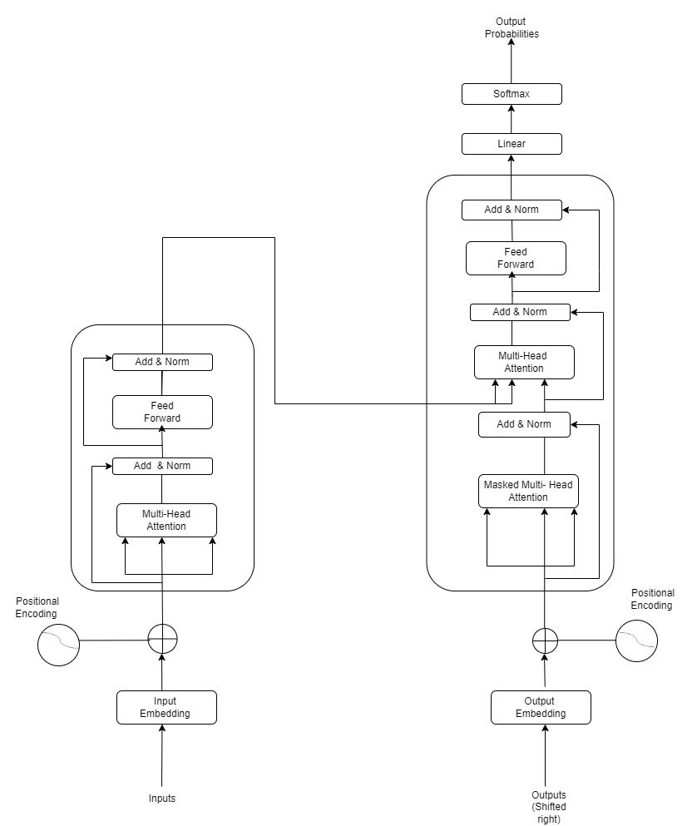

Figure 1: The Transformer – model architecture[10].

Encoder and Decoder Stacks:

Encoder:

The encoder is designed with N=6 indistinguishable layers, each with two sublayers: multi-head self-attention and entirely associated feed-forward. To aid in the construction of the stabilizer, leftover associations and layer normalization are used. To enable the use of remaining associations, all sub-layers and inserting layers produce yields of measurement dmodel = 512[10].

Decoder:

N=6 layers with three sublayers each are displayed by the transformer's decoder. It uses adjusted self-attention sub-layers, layer normalization, and leftover associations to go to known yields from the encoder stack. This ensures that predictions for the position *i* rely on, in a sense, yields at positions lower than *i*[10].

Attention:

The weight assigned to each value in the result is determined by a compatibility function between the query and the relevant key[10].

Figure 2: (Left) Scaled Dot-Product Attention. (Right) Multi-Head Attention consists of several attention layers running in parallel[10].

Scaled Dot-Product Attention:

The single dot-product is The Transformer architecture, which is frequently used for natural language processing tasks, and uses attention as one type of attention mechanism[10].

Three inputs are used in single dot-product attention: a query vector *Q*, a collection of key vectors *K*, and a collection of value vector *V*. Usually, the output of the neural network's previous layers is used to generate these three inputs[10].

The dot product between each key vector *K* and the query vector *Q* is calculated by the attention mechanism, and the resulting weights are used to define how much attention should be paid to each value vector *V*. The softmax function is specifically used for the dot product of *Q* and *K* split by the square root of the key vectors' dimensionality. This results in a collection of weights that add up to 1, which represents the significance of every value vector *V* for the specified query *Q*[10].

The value vectors *V* are combined as the attention mechanism's final output, and their weights are decided by the softmax of the dot product of the key vectors *K* and the query vector *Q*. The next layer of the neural network receives this output and processes it further[10].

Multi-Head Attention:

The Transformer architecture, which is frequently used for tasks involving natural language processing, is one neural system that makes use of the multi-head attention technique. To increase the expressiveness of the single dot-product attention mechanism and capture more nuanced relationships between inputs, it expands on it[10].

The input query vector *Q*, key vectors *K*, and value vectors *V* are linearly projected h times using unique learnt linear projections in multi-head attention to produce h sets of queries, keys, and values, each with a reduced dimensionality. At that moment, h sets of yield values are generated by simultaneously connecting the dot product attention mechanism to each of the h sets of anticipated questions, keys, and values[10].

To obtain the final output of the multi-head attention mechanism, the output values from each attention head are then added together and put through another learnt linear projection. This final output is then sent to a different layer of the neural network for further treatment[10].

1. Literature review

The utilization of ChatGPT in education is still in its exploratory arrange and there's constrained investigation on its applications in this setting. However, a few significant articles have been recognized in Google Scholar, which recommends that ChatGPT can be an important asset in higher instruction. It can progress composing aptitudes, summarizing data, and diagram thoughts, sparing time and making strides in the quality of work. Besides, it can identify language structure and style errors, making the composed substance more comprehensible [11].

Kasneci et al. (2023) found that ChatGPT can aid understudies to create inquiries about abilities by giving them data and assets on a specific subject. It can recommend unfamiliar perspectives and present understudies to modern investigation points, empowering them to pick up distant a much better; higher; stronger; improved" stronger understanding and assessment of the subject matter[12]. Within the medical instruction field, Kung et al. (2023) have found that ChatGPT can help with clinical decision-making because it produces precise answers in restorative permitting exams[13]. Rudolph et al. (2023) have distinguished a few focal points of ChatGPT, counting its capacity to produce human-like discussions, its speed and proficiency, and its cost-effectiveness since no human labor is required[14].

However, the utilization of ChatGPT in instruction has moreover raised a few concerns. As with any unused innovation, particularly when the assessment of information or aptitudes is intervened by innovation, questions have been raised almost the legitimacy of the learning involvement (García-Peñalvo, 2023)[15]. There are concerns that understudies may copy, and glue writings created by ChatGPT without fundamentally analyzing what has been highlighted or chosen from a source, without citing the first sources, and without recognizing the potential for literary theft. This issue makes ChatGPT-produced content unacceptable for scholarly composing (García-Peñalvo, 2023)[15]. Issues of copyright infringement location in write-ups produced by ChatGPT have been raised, also how to recognize between reality and fiction content produced (Chatterjee & Dethlefs, 2023; Khalil & Er, 2023)[16]. Teachers are progressively stressed that understudies may utilize ChatGPT to create their composed assignments because it has been illustrated to produce reports in a matter of seconds without being identified by plagiarization locators. In any case, Atlas (2023) has contended that it could be a myth that unveiling the utilization of GPT-3 (dialect show made by OpenAI) would be considered plagiarization, and he showed that plagiarization really alludes to displaying somebody else’s thoughts as you possess without giving legitimate credit to the source[11]. In this manner, when utilizing GPT-3, creators or understudies ought to make it clear that the show was utilized and cite or reference it fittingly.

Khalil and Er (2023) conducted an exploration to decide whether copyright infringement location instruments might identify expositions composed utilizing ChatGPT and found that of the 50 expositions tried, 40 had a similitude score of 20% or less, illustrating a tall degree of creativity[17]. So also, Susnjak (2022) utilized ChatGPT in a test to evaluate its capacity to lock in basic considering instead of basically data recovery, and the comes about were exceedingly exact and exact, as well as consistently coherent[18]. In differentiation, Dowling, and Lucey (2023) famous that although ChatGPT has points of interest for creating thoughts and recognizing information, it is weaker when it comes to writing blends and making suitable testing systems within the setting of fund inquiries about[19].

As a result of these concerns, a few schools have chosen to piece ChatGPT, as understudies may utilize it to consequently deliver assignments or other coursework (Ropek, 2023)[20]. Be that as it may, endeavoring to anticipate or boycott its utilization will not address the basic issue of understudies looking for ways to balk the learning preparation. Instep, it is important for teachers to supply clear rules on the fitting utilization of ChatGPT, emphasizing the significance of basic investigation and appropriate quotations of sources. Furthermore, as the investigation on the applications of ChatGPT in instruction proceeds to advance, it is vital to investigate its potential benefits and restrictions, whereas guaranteeing that it is utilized in a moral and capable way. Eventually, the utilization of ChatGPT in instruction ought to be seen as a tool to improve understudy learning and engagement, instead of as an easy route or substitution for the learning handle[20].

Another zone that ChatGPT has appeared to guarantee is dialect learning and education. Concurring to Liu et al. (2022), ChatGPT can be utilized as an apparatus to bolster dialect learners by generating target dialect sentences that can be utilized for honing and assessment. This could help learners to move forward with their composing and talking abilities by giving them a demonstration of sentence structure, lexicon utilization, and language structure. Also, ChatGPT can be utilized to naturally create questions and tests for dialect learners, which can help evaluate their understanding of the dialect and recognize ranges for enhancement[20].

At long last, ChatGPT has moreover been utilized within the field of client benefit and back. Agreeing with Lin et al. (2022), ChatGPT can be used to make robotized chatbots that can help clients with their requests and issues. These chatbots can be prepared with a vast amount of information and can give fast and precise reactions to client questions, which can help progress client fulfillment and decrease the workload of client benefit agents. Additionally, ChatGPT can be prepared to get its common dialect input and give personalized suggestions to clients, based on their past intelligence, and buy history[20].

The technical implementations of ChatGPT incorporate the utilization of a transformer-based neural network architecture, pre-training with unsupervised learning, fine-tuning assignments with directed learning, and meta-learning. The transformer-based architecture incorporates an arrangement of self-attention layers that permit the model to capture the conditions between distinctive parts of a content arrangement. Pre-training with unsupervised learning includes preparing the show on a huge corpus of content information to memorize the fundamental structure and designs of dialect. Amid fine-tuning, the demonstration is prepared on a littler labeled dataset for a particular assignment, which permits it to adjust to the new task with fair many illustrations. A meta-learning approach, where the show is prepared to quickly learn unused assignments with constrained information by learning how to memorize. These specialized usages are what empower ChatGPT to be an effective few-shot and one-shot learner and to generalize well to a wide run of natural language processing tasks[8].

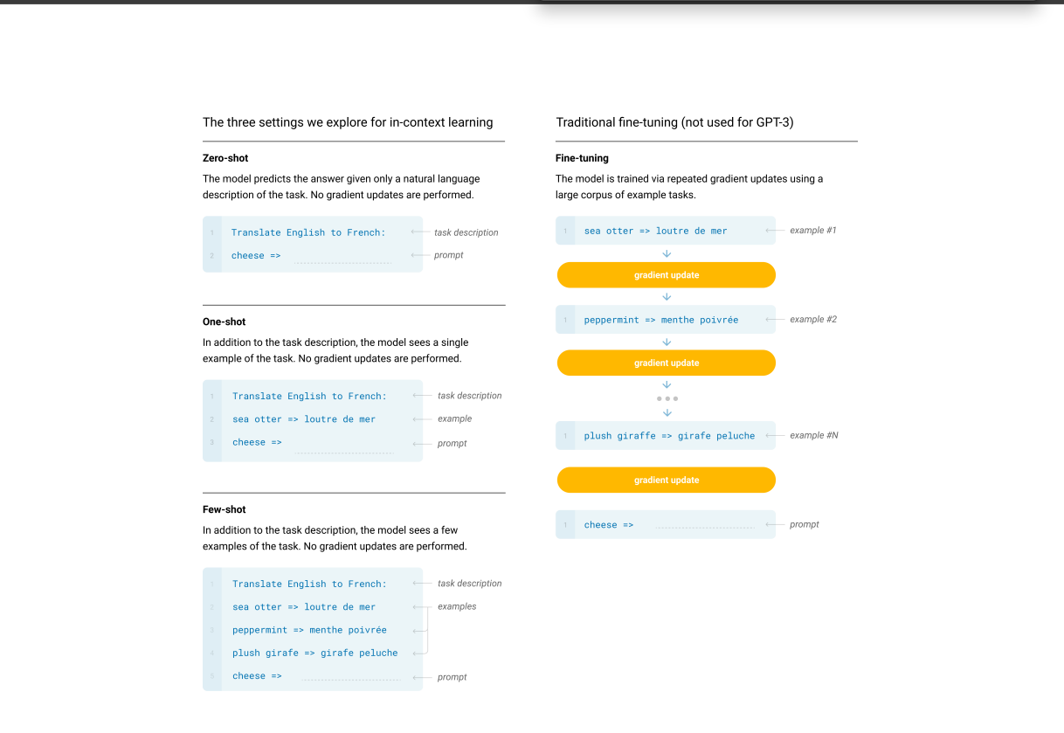

Figure 3: Context Learning of ChatGPT[8]

Figure 4: Technical Implementation of ChatGPT[8]

Fine-tuning (FT):

The process of overhauling a pre-trained show by providing a specific dataset for a desired assignment is known as fine-tuning. FT necessitates a substantial dataset and runs the risk of impoverished generalization, potential information exploitation, and unwarranted comparisons to human execution. GPT-3 was not optimized in this study because task-agnostic execution was the main emphasis, but FT may be a viable direction for future research[8].

Few-Shot (FS):

Few-Shot refers to a scenario in which the model is subjected to numerous showings of the assignment at induction time without any weight overhauls. This approach reduces the need for task-specific knowledge and reduces the likelihood that one may memorize an excessively small dispersion from a large but limited fine-tuning dataset. Modern fine-tuned models have far more unpleasant results than this method, though. There is still a little amount of task-specific information needed. This method is like few-shot learning in other ML scenarios, where it entails learning based on a broad range of tasks and then swiftly adapting to a contemporary assignment[8].

One-Shot (1S):

One example of the task is allowed in the setting of 1s, along with a depiction of the task in common speech. When giving out tasks to individuals, such as when creating a dataset using a human specialist service like Mechanical Turk, this parameter is frequently used. One feature that distinguishes 1S from few-shot and zero-shot is how closely it resembles how people communicate their needs[8].

Zero-Shot (0S):

With no allowed exhibits, 0s comprises what would be considered a common dialect instruction for an errand. The biggest obstacle to this tactic is that it provides the most comfort and energy-boosting potential. Zero-shot is the most like how individuals complete various assignments, whereas it can be challenging for people to arrange themselves on a task without prior examples[8].

Zero-shot, one-shot and few-shot, contrasted with traditional fine-tuning:

To complete an assignment with a dialect demonstration, this figure compares traditional fine-tuning with zero-shot, one-shot, and few-shot solutions. The latter three solutions involve what are essentially forward passes during testing, and in a few-shot scenario, the presentation is often given with a few dozen examples[8].

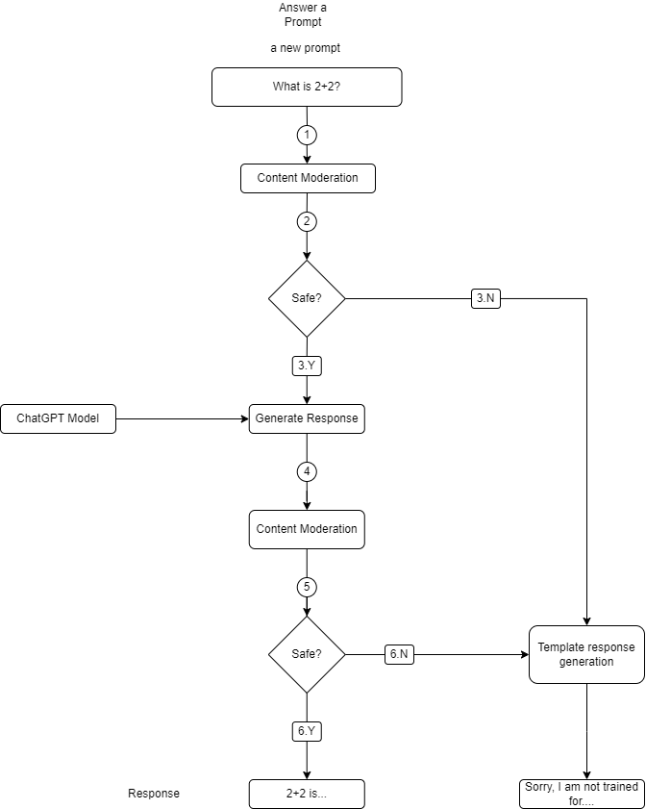

Figure 5: This figure shows how ChatGPT gives the response?

ChatGPT has demonstrated cutting-edge performance in a variety of research areas and real-world applications, including language interpretation, content summarization, and others.

Several of the problems are:

Constrained spaces:

The preparation data for GPT-3 is gathered from a variety of sources but is still limited to a particular range of domains. This suggests that GPT-3 may struggle with tasks that call for information unique to a certain area or with languages that are poorly represented in its preparation materials[21].

Quality issues:

The preparation materials for the GPT-3 are extensive and varied, there is no guarantee that they will be of high quality. For instance, the data may have errors or anomalies that can influence how the model runs[21].

Need for differences:

Although GPT-3 uses a different language and set of points for preparing information, it may nevertheless require distinct representational properties. For instance, insufficient representation of specific communities or societies in the provided data may result in predispositions in the model's returns[21].

Need for control over information determination:

There is limited control over which information points are included, GPT-3's prepared material is organically chosen based on factors including relevance and quality. This could make it difficult to address problems or tendencies when gathering information[21].

Restricted generalizability:

 GPT-3 can produce incredible results in normal dialect but may still struggle with tasks that call for more general knowledge or thought. For instance, GPT-3 may struggle with tasks that call for common sense reasoning or the ability to connect seemingly unrelated bits of information[21].

Need for standardized measurements:

It might be challenging to compare various dialect models because there is no agreed-upon set of metrics for measuring dialect models. Though often used, metrics like perplexity and precision do not fundamentally cover all aspects of a model's execution[21].

Restricted information accessibility:

Finding high-quality datasets that are pricey enough to provide an in-depth analysis of a dialect demonstration might be challenging. Many existing datasets are typically sparse or exclusive to a particular assignment or space[21].

Trouble of assignments:

Some tasks, like using common sense or knowing common dialects, are inherently difficult and may not have precise standards or gold standards for evaluation[21].

Demonstrate inclinations:

Dialect models might exhibit tendencies that are difficult for typical assessment metrics to fully reflect. For instance, if a demonstration's perplexity score is poor, it may in fact elicit angry or damaging language[21].

Rapidly evolving field:

New models and techniques are often developed in the rapidly evolving field of natural language processing. Comparing models that were created using multiple methods or datasets can be difficult as a result[21].

The SuperGLUE benchmark and the Common Dialect Understanding Evaluation (Glue) benchmark are examples of efforts being made to develop more uniform standards for dialect models despite these difficulties. We will gain a far better knowledge of the benefits and drawbacks of various dialect models and progress the area of natural language processing by moving forward with these benchmarks and evaluating models on a variety of assignments.

Reivew of more than 10 papers from journal (2019-2023)

Discuss

ChatGPT and its applications

Industry applications>> education, health, medicine, industry, research

NLP Applications >> content generation, text summarization, machine translation, QA,…

chatGPT and its Pros / Cons / limitations

ChatGPT and its technical implementation with diagram

ChatGPT and its comparison with other AI-based chatbots

ChatGPT and performance issues

1. Analysis

Analyze using 10 or more papers

Critically analyze >> cross-check statement presented in one paper with that in another paper, present your opinion as well.

3.1 Ethical issues

3.2 Trust issues

3.3 Accountability issue

Bias and ethical considerations must be considered when using GPT-3 for natural language processing. Here are a few essential points to bear in mind:

Bias:

GPT-3 can reinforce and even strengthen societal prejudices, just like any machine learning model. This could be particularly problematic for natural language processing due to the possibility of bias or discrimination in language itself. To reduce bias, it's essential to train GPT-3 on a variety of representative datasets and to regularly verify for and correct any biased model output[22].

Fairness:

GPT-3 can raise concerns about bias and justice, especially when decisions are based on the outcomes of natural language processing. For instance, if a chatbot is being used to assess job prospects, it's imperative to ensure that it isn't discriminating against specific people based on factors like color or gender[22].

Privacy:

Due to the possibility that GPT-3 could generate extraordinarily sensitive data based on user inputs, privacy concerns are highlighted. It's critical to carefully consider privacy issues when using GPT-3 and to implement safety measures to protect user data[22].

Transparency:

Due to its extreme complexity and opacity, GPT-3 may be difficult to understand and interpret. Lack of transparency may make it challenging to identify and address any biases or mistakes in the model, raising concerns about accountability and responsibility[22].

Dual use:

Finally, it's crucial to consider GPT-3's possible dual use in both advantageous and detrimental circumstances. Although GPT-3 has many applications in natural language processing, it could also be abused to disseminate rumors or foster animosity[22].

All things considered, it's important to use GPT-3 for natural language processing with caution and to be aware of any potential ethical ramifications and risks. By being aware of them and taking action to lessen them, we can address these problems.

1. Conclusion

Present your final verdicts / recommendations based on your study

A very potent open AI language model, ChatGPT is useful in a variety of fields. It offers information in accordance with how it is set up, and data is added to the database in accordance with the input it gets. It can comprehend and produce human-like language after being educated on a vast text database to assist users in finding answers to their questions.

However, unlike people, ChatGPT is not motivated by emotional bonds or by the desire to get or give advantages. It only helps users by answering their questions in accordance with the prompts that are given.

Thus, ChatGPT is merely a program that is created to be useful and deliver information to the best of my ability; it is neither a friend nor a foe.

# References

[1] E. Adamopoulou and L. Moussiades, ‘Chatbots: History, technology, and applications’, *Machine Learning with Applications*, vol. 2, p. 100006, Dec. 2020, doi: 10.1016/j.mlwa.2020.100006.

[2] E. Adamopoulou and L. Moussiades, ‘An Overview of Chatbot Technology’, in *IFIP Advances in Information and Communication Technology*, Springer, 2020, pp. 373–383. doi: 10.1007/978-3-030-49186-4_31.

[3] S. Mohamad Suhaili, N. Salim, and M. N. Jambli, ‘Service chatbots: A systematic review’, *Expert Systems with Applications*, vol. 184. Elsevier Ltd, Dec. 01, 2021. doi: 10.1016/j.eswa.2021.115461.

[4] N. Haristiani, ‘Artificial Intelligence (AI) Chatbot as Language Learning Medium: An inquiry’, in *Journal of Physics: Conference Series*, Institute of Physics Publishing, Dec. 2019. doi: 10.1088/1742-6596/1387/1/012020.

[5] V. Goar, N. S. Yadav, and P. S. Yadav, ‘Conversational AI for Natural Language Processing: An Review of ChatGPT’, *International Journal on Recent and Innovation Trends in Computing and Communication*, vol. 11, no. 3s, pp. 109–117, Mar. 2023, doi: 10.17762/ijritcc.v11i3s.6161.

[6] P. P. Ray, ‘ChatGPT: A comprehensive review on background, applications, key challenges, bias, ethics, limitations and future scope’, *Internet of Things and Cyber-Physical Systems*, vol. 3. KeAi Communications Co., pp. 121–154, Jan. 01, 2023. doi: 10.1016/j.iotcps.2023.04.003.

[7] I. Solaiman *et al.*, ‘OpenAI Report Release Strategies and the Social Impacts of Language Models’, 2019.

[8] T. B. Brown *et al.*, ‘Language Models are Few-Shot Learners’, May 2020, [Online]. Available: http://arxiv.org/abs/2005.14165

[9] OpenAI, ‘GPT-4 Technical Report’, Mar. 2023, [Online]. Available: http://arxiv.org/abs/2303.08774

[10] A. Vaswani *et al.*, ‘Attention Is All You Need’, Jun. 2017, [Online]. Available: http://arxiv.org/abs/1706.03762

[11] S. Atlas, ‘DigitalCommons@URI DigitalCommons@URI ChatGPT for Higher Education and Professional Development: A ChatGPT for Higher Education and Professional Development: A Guide to Conversational AI Guide to Conversational AI Terms of Use’, 2023.

[12] E. Kasneci *et al.*, ‘ChatGPT for Good? On Opportunities and Challenges of Large Language Models for Education’.

[13] T. H. Kung *et al.*, ‘Performance of ChatGPT on USMLE: Potential for AI-assisted medical education using large language models’, *PLOS Digital Health*, vol. 2, no. 2, p. e0000198, Feb. 2023, doi: 10.1371/journal.pdig.0000198.

[14] ‘ChatGPT: Bullshit spewer or the end of traditional assessments in higher education?’, *Journal of Applied Learning & Teaching*, vol. 6, no. 1, Jan. 2023, doi: 10.37074/jalt.2023.6.1.9.

[15] F. J. García-Peñalvo, ‘La percepción de la Inteligencia Artificial en contextos educativos tras el lanzamiento de ChatGPT: disrupción o pánico’, *Education in the Knowledge Society (EKS)*, vol. 24, p. e31279, Feb. 2023, doi: 10.14201/eks.31279.

[16] J. Chatterjee and N. Dethlefs, ‘This new conversational AI model can be your friend, philosopher, and guide. and even your worst enemy’, *Patterns*, vol. 4, no. 1. Cell Press, Jan. 13, 2023. doi: 10.1016/j.patter.2022.100676.

[17] M. Khalil and E. Er, ‘Will ChatGPT get you caught? Rethinking of Plagiarism Detection’. [Online]. Available: https://www.ithenticate.com/

[18] T. Susnjak, ‘ChatGPT: The End of Online Exam Integrity?’, Dec. 2022, [Online]. Available: http://arxiv.org/abs/2212.09292

[19] M. Dowling and B. Lucey, ‘ChatGPT for (Finance) research: The Bananarama Conjecture’, *Financ Res Lett*, vol. 53, May 2023, doi: 10.1016/j.frl.2023.103662.

[20] M. Halaweh, ‘ChatGPT in education: Strategies for responsible implementation’, *Contemp Educ Technol*, vol. 15, no. 2, p. ep421, Mar. 2023, doi: 10.30935/cedtech/13036.

[21] V. Goar, N. S. Yadav, and P. S. Yadav, ‘Conversational AI for Natural Language Processing: An Review of ChatGPT’, *International Journal on Recent and Innovation Trends in Computing and Communication*, vol. 11, no. 3s, pp. 109–117, Mar. 2023, doi: 10.17762/ijritcc.v11i3s.6161.

[22] R. Imamguluyev, ‘The Rise of GPT-3: Implications for Natural Language Processing and Beyond’, *International Journal of Research Publication and Reviews*, vol. 4, no. 3, pp. 4893–4903, Mar. 2023, doi: 10.55248/gengpi.2023.4.33987.