DAY 1

1. What is the differences between var, let and const?

If var is declared inside a function, it is only accessible within that function. It is hoisted to the top of their scope and initialized with undefined. It can be redeclared and reassigned.

Should avoid var in modern javascript as ‘let’ and ‘const’ provide better control over scope and are more predictable.

Variable declared in let is only accessible withing the block(within {} brackets) in which it is defined. It is hoisted to the top of their block and not initialized so referencing them before declaration causes a ‘RefrenceError’. It can also be reassigned but cant be redeclared within the same scope.

Used when the variable may need to be reassigned.

Const is block – scoped similar to let. Also hoisted to the top of their block but not initialized. Cant be reassigned but in object or array the contents of the object or array can still be modified which means reference to the object/ array remains constant but the values it holds can change.

Used when you want to declare a variable that will not change its reference.

1. What are the differences between == and === in JavaScript?

Use === for most comparisons to avoid unexpected results due to type coercion.

Use == only when you specifically want type coercion to happen.

Can you explain what a "callback function" is in JavaScript and provide an example of how it is used?

A callback function is a function passed into another function to be executed later, allowing you to handle tasks that take time without stopping other part of your code.

Commonly used in asynchronous programming where tasks run in background without blocking the main code execution.

Example:

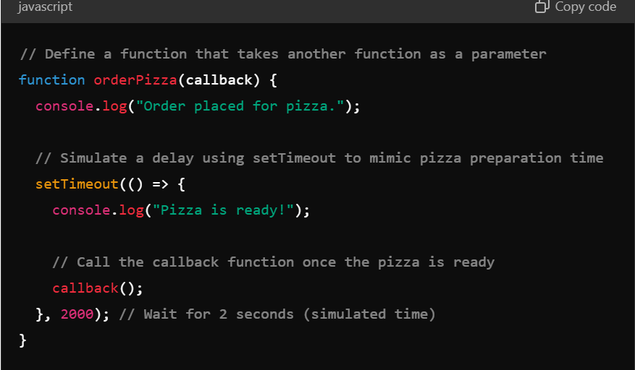

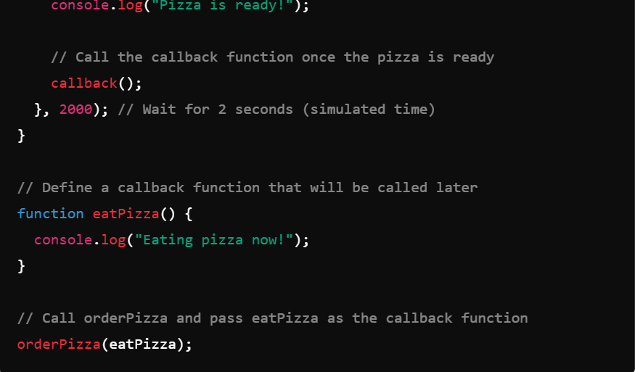

1. What is the difference between `null` and `undefined` in JavaScript?

null: Assigned intentionally to indicate "no value" or "empty."

undefined: Indicates a variable has been declared but not yet assigned a value, or a function does not return anything.

1. What is the difference between function declarations and function expressions in JavaScript?

Function Declaration: Hoisted, so it can be used before its definition in the code.

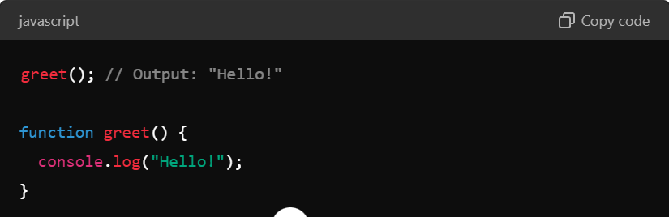

Function Expression: Not hoisted, so it can only be used after its definition.

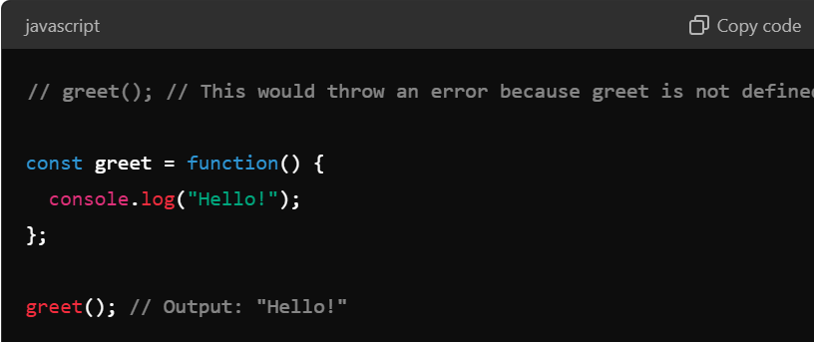

1. What are parameters and arguments in a function? How are they different?

Parameters: Variables in the function definition. When you define a function, you specify parameters to define what values the function expects.

Arguments: Actual values supplied when the function is called. When you call the function, you provide arguments to supply those values.

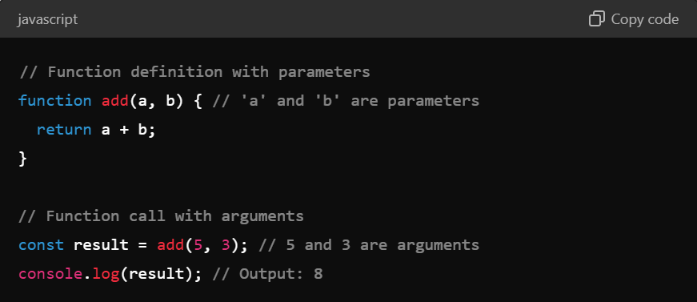

1. What is scope in JavaScript, and what are the different types of scope?

Scope in JavaScript refers to the context within which variables and functions are accessible. It determines where variables and functions can be referenced and modified.

Global Scope: Variables and functions are accessible throughout the entire code.

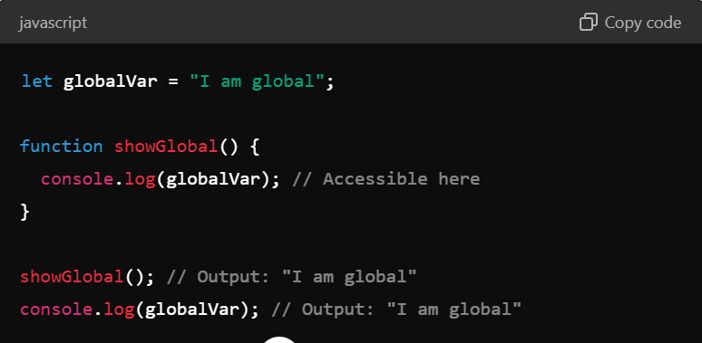

Local Scope (Function Scope): Variables are only accessible within the function they are declared in.

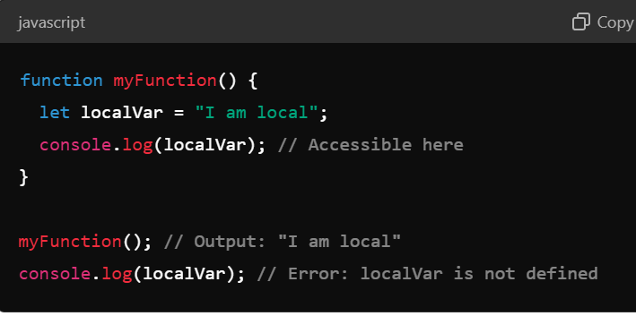

Block Scope: Variables declared with let or const are only accessible within the block they are declared in.

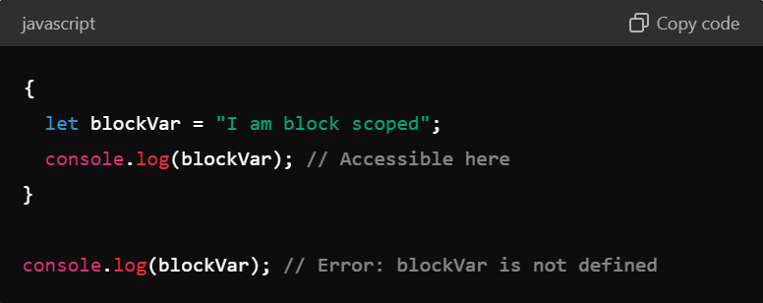

DAY 2

1. What are the different types of conditional statements in JavaScript, and how do they help control the flow of a program? Provide examples of if, else if, else, and switch statements.

if: Checks if a condition is true and executes code if it is.

else if: Checks additional conditions if the previous ones were false.

else: Executes code if none of the previous conditions were true.

switch: Executes code based on the value of an expression and matches it to different cases.

1. What is the syntax of a for loop in JavaScript, and how does it differ from while and do...while loops? Provide examples of each loop type.

for Loop: Best for a known number of iterations. It integrates initialization, condition, and iteration in one line.

while Loop: Best for an unknown number of iterations where the condition is evaluated before each iteration.

do...while Loop: Similar to while, but the condition is evaluated after the code block has executed, ensuring the code block runs at least once.

Today my grandma tole me “khutta vaye jutta kati kati” tho she stayed widow till date from back to more than 20 to 25 yrs ig just to make me feel alright and it touched my every entire nerve