Kinetic modelling of Pb and Cu removal and PAH degradation
Equations, tables and figures for the manuscript. Source data: Data_1.xlsx. Highlighted text marks details to be filled in by the authors.

1. Basis of the analysis
Removal of Pb and Cu, each supplied as the nitrate and the chloride salt, by isolates SS1, SS2 and SR3 was measured on days 1, 3, 5, 7, 15 and 30. Residual pyrene, fluorene and fluoranthene were measured on days 1, 3 and 5. Initial concentration, solution volume and biomass dose were not available, so the amount of metal removed (q_{t}) is expressed as percentage removal rather than mg g⁻¹; q_{e} is therefore reported in %, k₂ in %⁻¹ day⁻¹ and h in % day⁻¹. If these quantities become available, q_{t} (mg g⁻¹) = C₀(%R/100)V/m; this is a constant rescaling, so R² is unchanged.
The PAH values decrease with time and were treated as the residual amount of PAH (C_{t}). Because the first-order model is fitted as ln C_{t} versus t, the rate constant does not depend on the units of C_{t} or on knowing C₀.

2. Kinetic models (draft methods text)
Metal removal was described by the pseudo-second-order (PSO) model of Ho:
$\frac{dq_{t}}{dt}=k_{2}(q_{e}−q_{t})^{2}$ (1)
where q_{t} and q_{e} are the removal at time t and at equilibrium, and k₂ is the PSO rate constant. Integration with q_{t} = 0 at t = 0 gives the linear form used in Figs. 1–4; q_{e} and k₂ are obtained from the slope (1/q_{e}) and intercept (1/k₂q_{e}²) of t/q_{t} versus t, and the initial removal rate is h = k₂q_{e}²:
$\frac{t}{q_{t}}=\frac{1}{k_{2}q_{e}^{2}}+\frac{1}{q_{e}}t$ (2)
Because t appears on both axes of Eq. (2), its coefficient of determination tends to overstate the quality of fit. The PSO parameters were therefore also estimated by nonlinear least-squares fitting of the integrated form, Eq. (3), and the residual error is reported as RMSE = [Σ(q_{t,exp} − q_{t,cal})²/n]^{1/2} with n = 6:
$q_{t}=\frac{k_{2}q_{e}^{2}t}{1+k_{2}q_{e}t}$ (3)
PAH degradation was described by first-order kinetics, where C₀ and C_{t} are the PAH amounts initially and at time t. k₁ is the negative slope of ln C_{t} versus t (Figs. 5–7) and t_{1/2} is the half-life. Regressions used all sampling days (n = 6 for metals, n = 3 for PAHs) and were not forced through the origin.
$ln C_{t}=ln C_{0}−k_{1}t$ (4)
$t_{1/2}=\frac{ln 2}{k_{1}}$ (5)

3. Tables
Table 1 Pseudo-second-order kinetic parameters for Pb and Cu removal by isolates SS1, SS2 and SR3 (q expressed as % removal).
Metal salt | Isolate | q_{e,exp} (%) | Linear form, Eq. (2) |  |  |  | Nonlinear form, Eq. (3)
Metal salt | Isolate | q_{e,exp} (%) | q_{e,cal} (%) | k₂ (%⁻¹ day⁻¹) | h (% day⁻¹) | R² | q_{e,cal} (%) | k₂ (%⁻¹ day⁻¹) | R² | RMSE (%)
Pb nitrate | SS1 | 91.87 | 95.5 | 9.59 × 10⁻⁴ | 8.75 | 0.4918 | 124.6^{b} | 4.58 × 10⁻⁴ | 0.045 | 22.44
 | SS2 | 96.53 | 116.9^{b} | 1.51 × 10⁻³ | 20.62 | 0.8880 | 119.4^{b} | 1.64 × 10⁻³ | 0.756 | 15.47
 | SR3 | 93.26 | 102.2^{b} | 1.18 × 10⁻³ | 12.33 | 0.6388 | 88.0 | 3.10 × 10⁻³ | 0.244 | 25.57
Pb chloride | SS1 | 97.00 | 98.5 | 2.67 × 10⁻³ | 25.87^{d} | 0.8919 | 73.1 | 2.23 × 10⁻² | 0.246 | 13.62
 | SS2 | 96.40 | 97.7 | 1.22 × 10⁻² | 116.15 | 0.9966 | 93.5 | 2.22 × 10⁻² | 0.754 | 5.37
 | SR3 | 95.60 | 115.5^{b} | 1.40 × 10⁻³ | 18.73 | 0.9068 | 115.3^{b} | 1.43 × 10⁻³ | 0.468 | 18.07
Cu nitrate | SS1 | 82.50 | 99.5 | 1.73 × 10⁻³ | 17.10 | 0.9371 | 102.0^{b} | 1.65 × 10⁻³ | 0.872 | 8.69
 | SS2 | 79.80 | 88.8 | 1.74 × 10⁻³ | 13.71^{d} | 0.7323 | 57.6 | 2.85 × 10⁻² | 0.122 | 15.83
 | SR3 | 29.70 | 23.5 | 6.22 × 10⁻² | 34.31 | 0.5999 | 35.3 | n.d.^{c} | 0.000 | 13.88
Cu chloride | SS1 | 16.00 | 50.5 | 3.90 × 10⁻⁴ | 0.99^{d} | 0.2580 | 29.5 | 1.97 × 10⁻³ | 0.805 | 3.16
 | SS2 | 2.10 | 2.0 | n.d.ª | n.d.ª | 0.9871 | 5.3 | n.d.^{c} | 0.000 | 4.91
 | SR3 | 1.50 | 1.3 | n.d.ª | n.d.ª | 0.9013 | 4.1 | n.d.^{c} | 0.000 | 2.65

q_{e,exp}: removal measured at day 30 (end of experiment). n.d.: not determined.
ª Negative intercept in the t/q_{t} versus t plot, so k₂ and h cannot be calculated.
^{b} Calculated q_{e} exceeds 100% removal and is physically unattainable.
^{c} No time dependence resolved: the best nonlinear fit is effectively a constant (R² ≈ 0).
^{d} Linear and nonlinear k₂ differ more than four-fold; the rate constant is poorly determined by these data.
Table 2 First-order kinetic parameters for PAH degradation by isolates SS1, SS2 and SR3.
PAH | Isolate | k₁ (day⁻¹) | Intercept | t_{1/2} (day) | R²
Pyrene | SS1 | 0.1323 | 3.1049 | 5.24 | 0.9781
 | SS2 | 0.2747 | 2.8075 | 2.52 | 0.9777
 | SR3 | 0.4024 | 4.8135 | 1.72 | 0.8908ª
Fluorene | SS1 | 0.0362 | 2.5694 | 19.13 | 0.9998
 | SS2 | 0.2597 | 4.6699 | 2.67 | 0.8109ª
 | SR3 | 0.1788 | 2.4491 | 3.88 | 0.9423
Fluoranthene | SS1 | 0.0747 | 2.5743 | 9.28 | 0.9718
 | SS2 | 0.0756 | 4.3632 | 9.17 | 0.8820ª
 | SR3 | 0.0328 | 2.2573 | 21.14 | 0.5705ª

C_{t} = residual PAH as recorded; ln C_{t} regressed on t for days 1, 3 and 5 (n = 3); k₁ = −slope; intercept = ln C_{t} extrapolated to t = 0; t_{1/2} = ln 2/k₁.
ª R² < 0.90: degradation is not described by a single first-order rate. Pyrene (SR3), fluorene (SS2) and fluoranthene (SS2) accelerate after day 3, consistent with a lag phase; fluoranthene with SR3 changes little over 5 days.

4. Figures
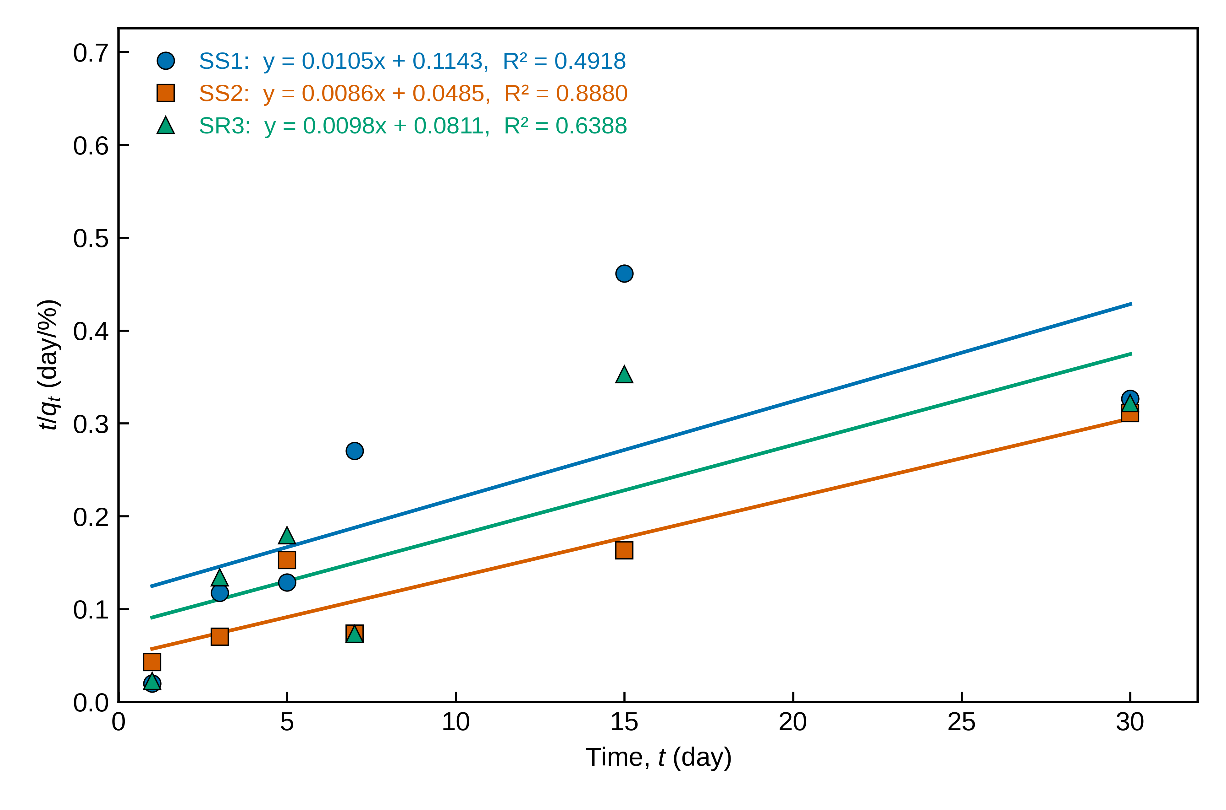
Fig. 1. Pseudo-second-order kinetic plot (t/q_{t} versus t) for Pb removal from lead nitrate solution by isolates SS1, SS2 and SR3 [initial Pb concentration = __ mg L⁻¹; biomass dose = __; pH = __; temperature = __ °C]. q_{t} is expressed as % removal. Lines are least-squares fits; the equation and R² are shown for each isolate.
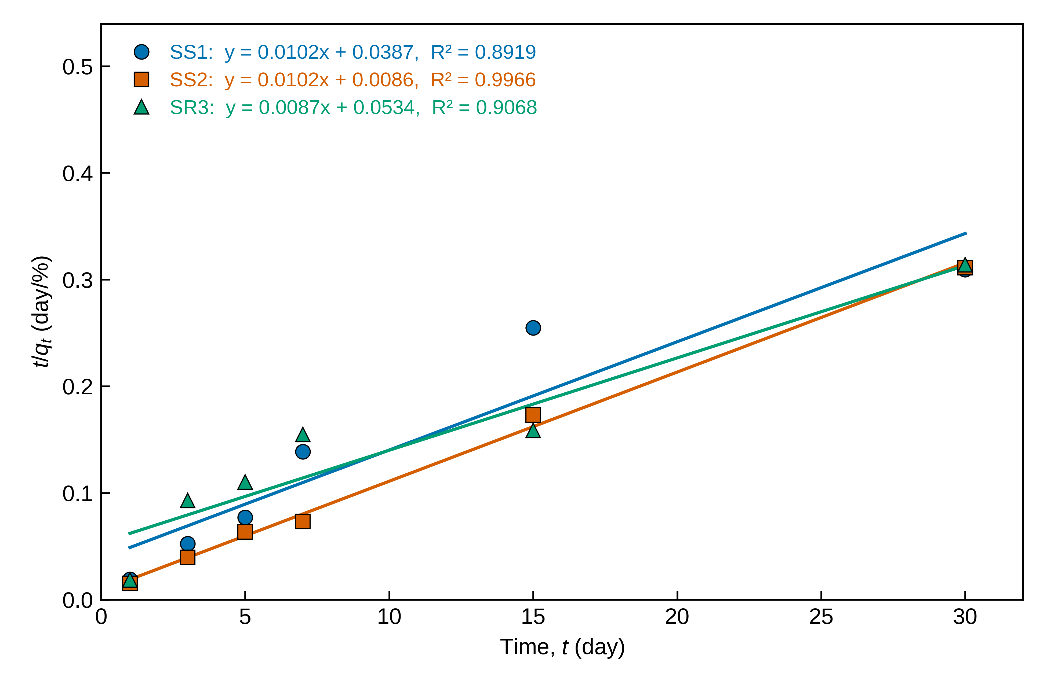
Fig. 2. Pseudo-second-order kinetic plot (t/q_{t} versus t) for Pb removal from lead chloride solution by isolates SS1, SS2 and SR3 [initial Pb concentration = __ mg L⁻¹; biomass dose = __; pH = __; temperature = __ °C]. q_{t} is expressed as % removal. Lines are least-squares fits; the equation and R² are shown for each isolate.
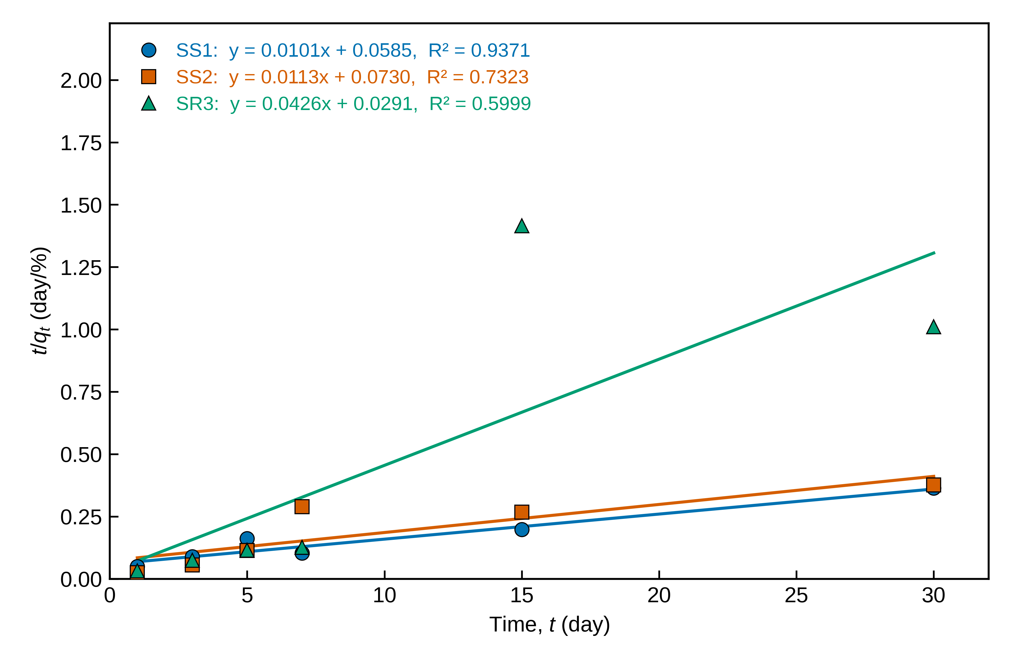
Fig. 3. Pseudo-second-order kinetic plot (t/q_{t} versus t) for Cu removal from copper nitrate solution by isolates SS1, SS2 and SR3 [initial Cu concentration = __ mg L⁻¹; biomass dose = __; pH = __; temperature = __ °C]. q_{t} is expressed as % removal. Lines are least-squares fits; the equation and R² are shown for each isolate.
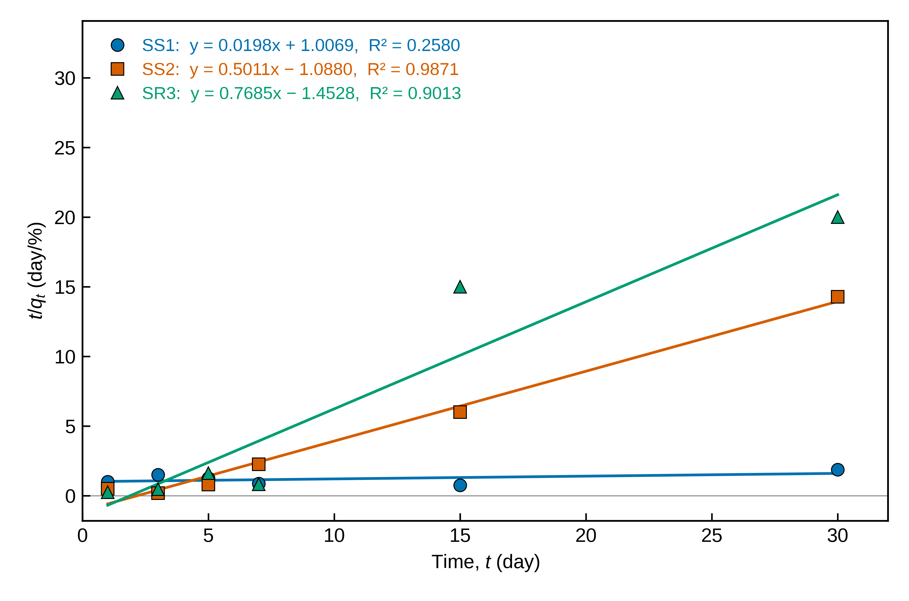
Fig. 4. Pseudo-second-order kinetic plot (t/q_{t} versus t) for Cu removal from copper chloride solution by isolates SS1, SS2 and SR3 [initial Cu concentration = __ mg L⁻¹; biomass dose = __; pH = __; temperature = __ °C]. q_{t} is expressed as % removal. Lines are least-squares fits; the equation and R² are shown for each isolate.
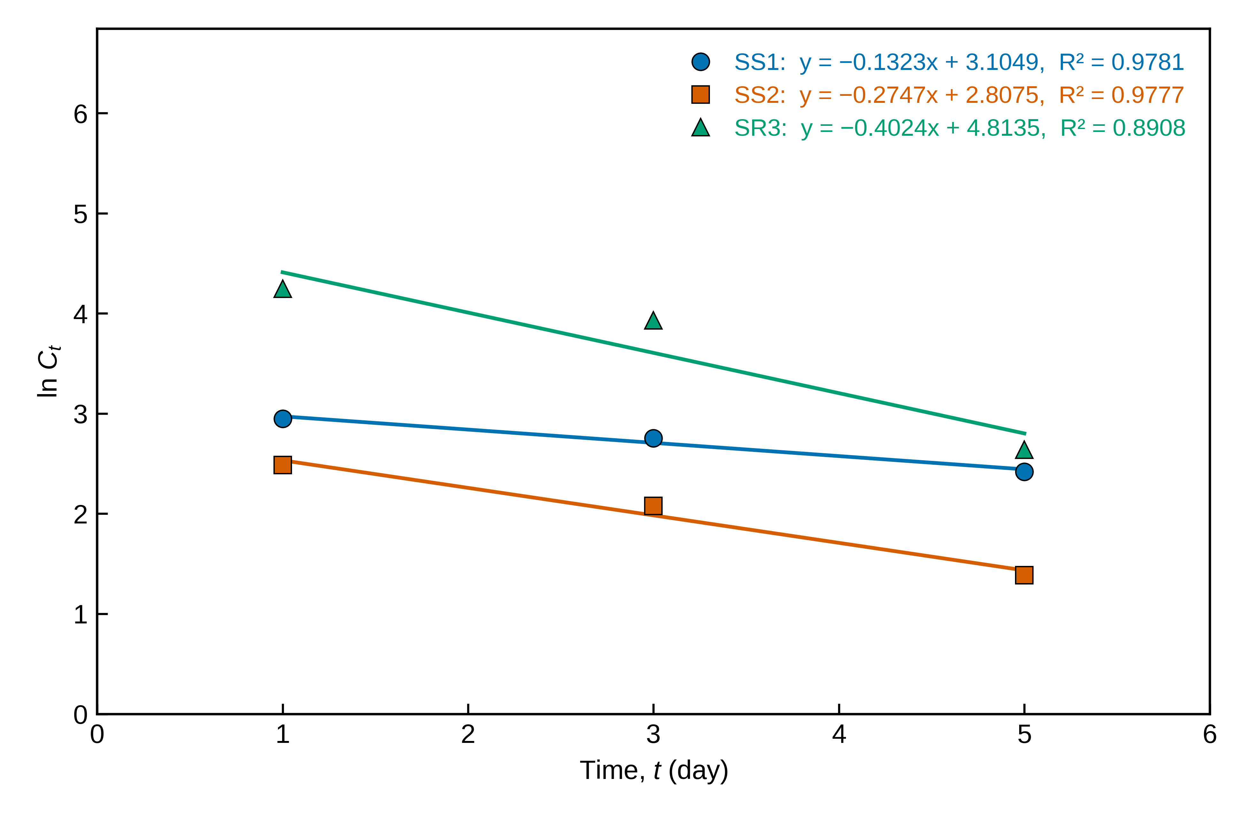
Fig. 5. First-order kinetic plot (ln C_{t} versus t) for pyrene degradation by isolates SS1, SS2 and SR3 [initial pyrene concentration = __ mg L⁻¹; inoculum = __; temperature = __ °C]. C_{t} is the residual PAH as recorded. Lines are least-squares fits; the equation and R² are shown for each isolate.
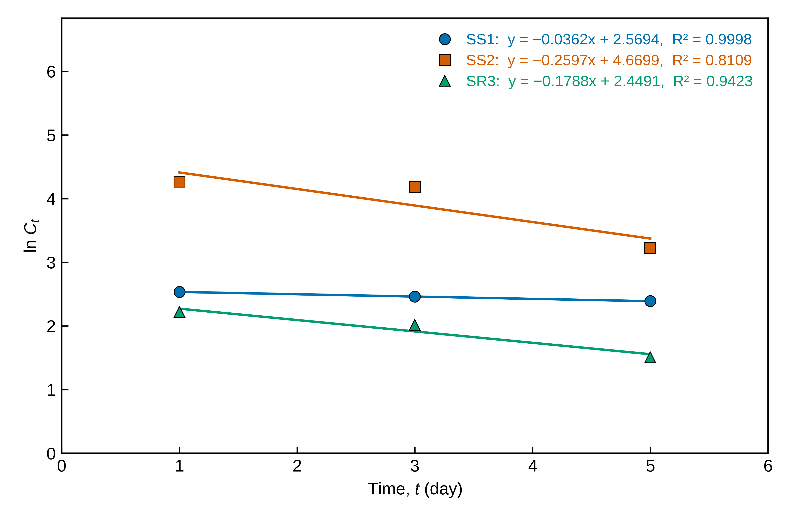
Fig. 6. First-order kinetic plot (ln C_{t} versus t) for fluorene degradation by isolates SS1, SS2 and SR3 [initial fluorene concentration = __ mg L⁻¹; inoculum = __; temperature = __ °C]. C_{t} is the residual PAH as recorded. Lines are least-squares fits; the equation and R² are shown for each isolate.
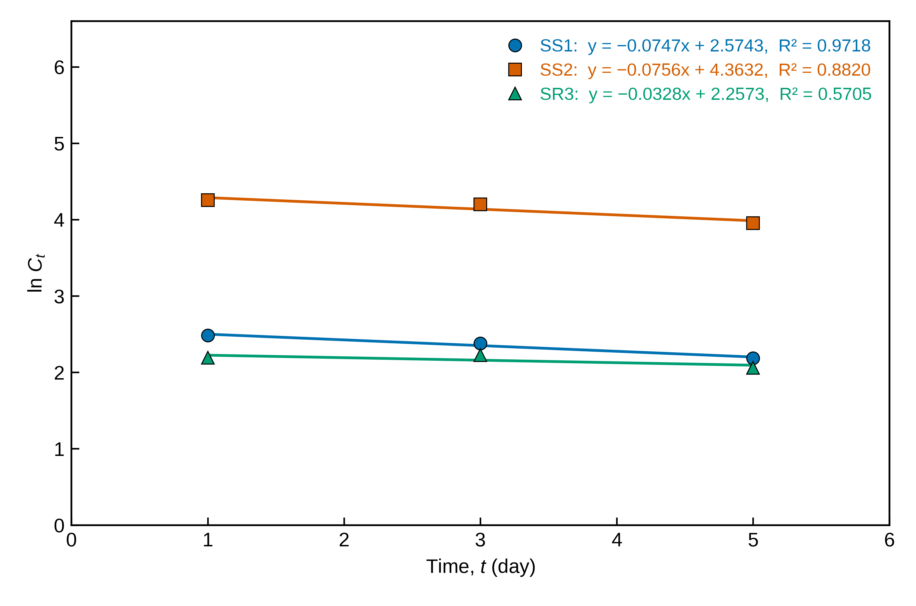
Fig. 7. First-order kinetic plot (ln C_{t} versus t) for fluoranthene degradation by isolates SS1, SS2 and SR3 [initial fluoranthene concentration = __ mg L⁻¹; inoculum = __; temperature = __ °C]. C_{t} is the residual PAH as recorded. Lines are least-squares fits; the equation and R² are shown for each isolate.

5. Notes for the authors (not for publication)
- Check the standard deviations before submission. In Data_1.xlsx, 11 of the 12 SD columns for the metals repeat the values of a different experiment: five pairs are identical (for example, lead nitrate–SS1 and copper chloride–SS1 both read 1.8, 1.6, 1.5, 1.3, 1.2, 1.5), and copper nitrate–SS1 has the lead chloride–SS1 values in a different order. The kinetic fits do not use SD, but any SD reported in the paper should be verified against the replicate measurements.
- PSO describes few of these series well: only 4 of 12 reach nonlinear R² ≥ 0.75 (Pb nitrate–SS2, Pb chloride–SS2, Cu nitrate–SS1, Cu chloride–SS1). The text should not claim that PSO describes the data generally.
- Several series rise and fall sharply between consecutive samples (e.g., Pb nitrate–SR3: 27.9% at day 5, 95.8% at day 7, 42.5% at day 15, 93.3% at day 30; Cu nitrate–SR3 falls from 55.5% to 10.6% between days 7 and 15), far more than the reported SD of 0.3–2.3%. PSO cannot represent this, and reviewers will ask whether it reflects biology (uptake–release cycles) or sampling and analysis.
- Linear R² is higher than nonlinear R² in 11 of 12 series. The clearest case is Cu chloride–SS2: linear R² = 0.987, although removal never exceeds 16% and the nonlinear R² is 0.000. Reporting both, as in Table 1, pre-empts this objection.
- PAH fits rest on three time points each (one degree of freedom), so R² values near 1 are weak evidence. If the initial PAH concentration is known, percentage degradation can also be reported.
- Cr and Zn are not in Data_1.xlsx. Fluoranthene is included because it is in the file; drop it if it is outside the paper’s scope.
- Avoid concluding that a PSO fit proves chemisorption. Fill in the highlighted conditions in the captions, renumber figures, tables and equations to match the manuscript, and use “fluorene” (the PAH), not “fluorine”.

