Kinetic modelling of heavy metal removal and PAH degradation
Equations, tables and figures for the manuscript. Source data: Heavy_metal_removal-Pah_degradation_data_N1.xlsx. Highlighted text marks details to be filled in by the authors.

1. Basis of the analysis
Removal of Cr, Cu, Pb and Zn by isolates BS1, BWd, BW3 and BR1, and degradation of pyrene and fluorene by isolates BS1, BW3 and BR1, were measured on days 1, 3, 5 and 7. Initial concentration, solution volume and biomass dose were not available, so the amount removed (q_{t}) is expressed as percentage removal rather than mg g⁻¹. Accordingly, q_{e} is reported in %, k₂ in %⁻¹ day⁻¹ and h in % day⁻¹. If these quantities become available, q_{t} (mg g⁻¹) = C₀(%R/100)V/m. This is a constant rescaling: R² is unchanged, q_{e} scales by C₀V/(100m) and k₂ by its inverse.

2. Kinetic models (draft methods text)
Heavy metal removal was described by the pseudo-second-order (PSO) model of Ho:
$\frac{dq_{t}}{dt}=k_{2}(q_{e}−q_{t})^{2}$ (1)
where q_{t} and q_{e} are the removal at time t and at equilibrium, and k₂ is the PSO rate constant. Integration with q_{t} = 0 at t = 0 gives the linear form used in Figs. 1–4, from which q_{e} and k₂ are obtained from the slope (1/q_{e}) and intercept (1/k₂q_{e}²) of t/q_{t} versus t; h is the initial removal rate:
$\frac{t}{q_{t}}=\frac{1}{k_{2}q_{e}^{2}}+\frac{1}{q_{e}}t, h = k_{2}q_{e}^{2}$ (2)
Because t appears on both axes of Eq. (2), its coefficient of determination tends to overstate the quality of fit. The PSO parameters were therefore also estimated by nonlinear least-squares fitting of the integrated form, Eq. (3), and the residual error is reported as RMSE = [Σ(q_{t,exp} − q_{t,cal})²/n]^{1/2} with n = 4:
$q_{t}=\frac{k_{2}q_{e}^{2}t}{1+k_{2}q_{e}t}$ (3)
PAH degradation was described by first-order kinetics, where C₀ and C_{t} are the PAH concentrations initially and at time t, obtained from the percentage degradation D; k₁ is the slope of ln(C₀/C_{t}) versus t (Figs. 5–6) and t_{1/2} is the half-life. All regressions used days 1, 3, 5 and 7 and were not forced through the origin.
$ln(\frac{C_{0}}{C_{t}})=k_{1}t, \frac{C_{t}}{C_{0}}=1−\frac{D}{100}$ (4)
$t_{1/2}=\frac{ln 2}{k_{1}}$ (5)

3. Tables
Table 1 Pseudo-second-order kinetic parameters for heavy metal removal by isolates BS1, BWd, BW3 and BR1 (q expressed as % removal).
Metal | Isolate | q_{e,exp} (%) | Linear form, Eq. (2) |  |  |  | Nonlinear form, Eq. (3)
Metal | Isolate | q_{e,exp} (%) | q_{e,cal} (%) | k₂ (%⁻¹ day⁻¹) | h (% day⁻¹) | R² | q_{e,cal} (%) | k₂ (%⁻¹ day⁻¹) | R² | RMSE (%)
Cr | BS1 | 16.48 | 17.6 | n.d.ª | n.d.ª | 0.8035 | 28.2 | 7.32 × 10⁻² | 0.185 | 6.79
 | BWd | 21.64 | 23.1 | 5.23 × 10⁻¹ | 278.4^{d} | 0.9749 | 25.0 | 1.12 × 10⁻¹ | 0.653 | 1.57
 | BW3 | 10.94 | 11.6 | n.d.ª | n.d.ª | 0.7579 | 19.3 | 2.93 × 10⁻¹ | 0.024 | 6.37
 | BR1 | 20.79 | 22.2 | 1.77 | 872.7^{d} | 0.9633 | 24.3 | 1.29 × 10⁻¹ | 0.499 | 1.93
Cu | BS1 | 60.94 | 62.1 | n.d.ª | n.d.ª | 0.9898 | 66.8 | 1.20 × 10⁻¹ | 0.395 | 3.12
 | BWd | 9.32 | 8.8 | n.d.ª | n.d.ª | 0.8532 | 18.6 | n.d.^{c} | 0.000 | 6.38
 | BW3 | 36.97 | 43.7 | 5.21 × 10⁻² | 99.6 | 0.8749 | 50.8 | 2.06 × 10⁻² | 0.514 | 7.20
 | BR1 | 23.20 | 24.1 | 1.38 | 797.5^{d} | 0.9891 | 24.9 | 2.82 × 10⁻¹ | 0.472 | 1.10
Pb | BS1 | 83.48 | 114.3^{b} | 3.33 × 10⁻³ | 43.6 | 0.7495 | 109.4^{b} | 4.14 × 10⁻³ | 0.645 | 12.02
 | BWd | 97.56 | 102.2^{b} | 2.36 × 10⁻² | 246.9 | 0.9973 | 98.1 | 3.98 × 10⁻² | 0.824 | 2.97
 | BW3 | 81.90 | 88.9 | 2.31 × 10⁻² | 182.8 | 0.9967 | 92.5 | 1.69 × 10⁻² | 0.949 | 2.62
 | BR1 | 81.69 | 140.8^{b} | 1.64 × 10⁻³ | 32.5 | 0.9126 | 137.1^{b} | 1.85 × 10⁻³ | 0.945 | 5.71
Zn | BS1 | 64.39 | 86.4 | 4.24 × 10⁻³ | 31.7 | 0.9816 | 86.6 | 4.16 × 10⁻³ | 0.979 | 2.08
 | BWd | 72.67 | 94.7 | 6.01 × 10⁻³ | 53.9 | 0.9549 | 97.1 | 5.82 × 10⁻³ | 0.897 | 5.97
 | BW3 | 64.44 | 85.1 | 7.58 × 10⁻³ | 54.9 | 0.8865 | 90.3 | 6.84 × 10⁻³ | 0.757 | 9.56
 | BR1 | 47.89 | 60.6 | 8.36 × 10⁻³ | 30.7 | 0.9732 | 59.2 | 9.09 × 10⁻³ | 0.933 | 2.52

q_{e,exp}: removal measured at day 7 (end of experiment). n.d.: not determined.
ª Negative intercept in the t/q_{t} versus t plot, so k₂ and h cannot be calculated; removal decreased at the later sampling time(s).
^{b} Calculated q_{e} exceeds 100% removal and is physically unattainable; removal had not levelled off within 7 days.
^{c} Removal declined continuously after day 3; no finite rate constant describes these data (R² ≈ 0).
^{d} Intercept close to zero, so linear k₂ and h are highly sensitive to it; linear k₂ differs more than four-fold from the nonlinear estimate.
Table 2 First-order kinetic parameters for PAH degradation by isolates BS1, BW3 and BR1.
PAH | Isolate | k₁ (day⁻¹) | Intercept | t_{1/2} (day) | R²
Pyrene | BS1 | 0.0254 | 0.1121 | 27.34 | 0.9706
 | BW3 | 0.0345 | 0.1305 | 20.12 | 0.9419
 | BR1 | 0.0232 | 0.0711 | 29.87 | 0.9721
Fluorene | BS1 | 0.6382ª | 3.0997 | 1.09ª | 0.9992
 | BW3 | 0.5516 | 0.8461 | 1.26 | 0.9844
 | BR1 | 0.6290ª | 2.2672 | 1.10ª | 0.7325

ln(C₀/C_{t}) = −ln(1 − D/100); regression not forced through the origin; t_{1/2} = ln 2/k₁. Positive intercepts indicate a rapid initial loss before day 1.
ª More than 97% of fluorene was degraded by day 1, so k₁ and t_{1/2} describe only the residual (<3%) fraction; at ≥99.8% degradation the logarithmic transform is sensitive to analytical error (SD 0.8–0.9%).

4. Figures
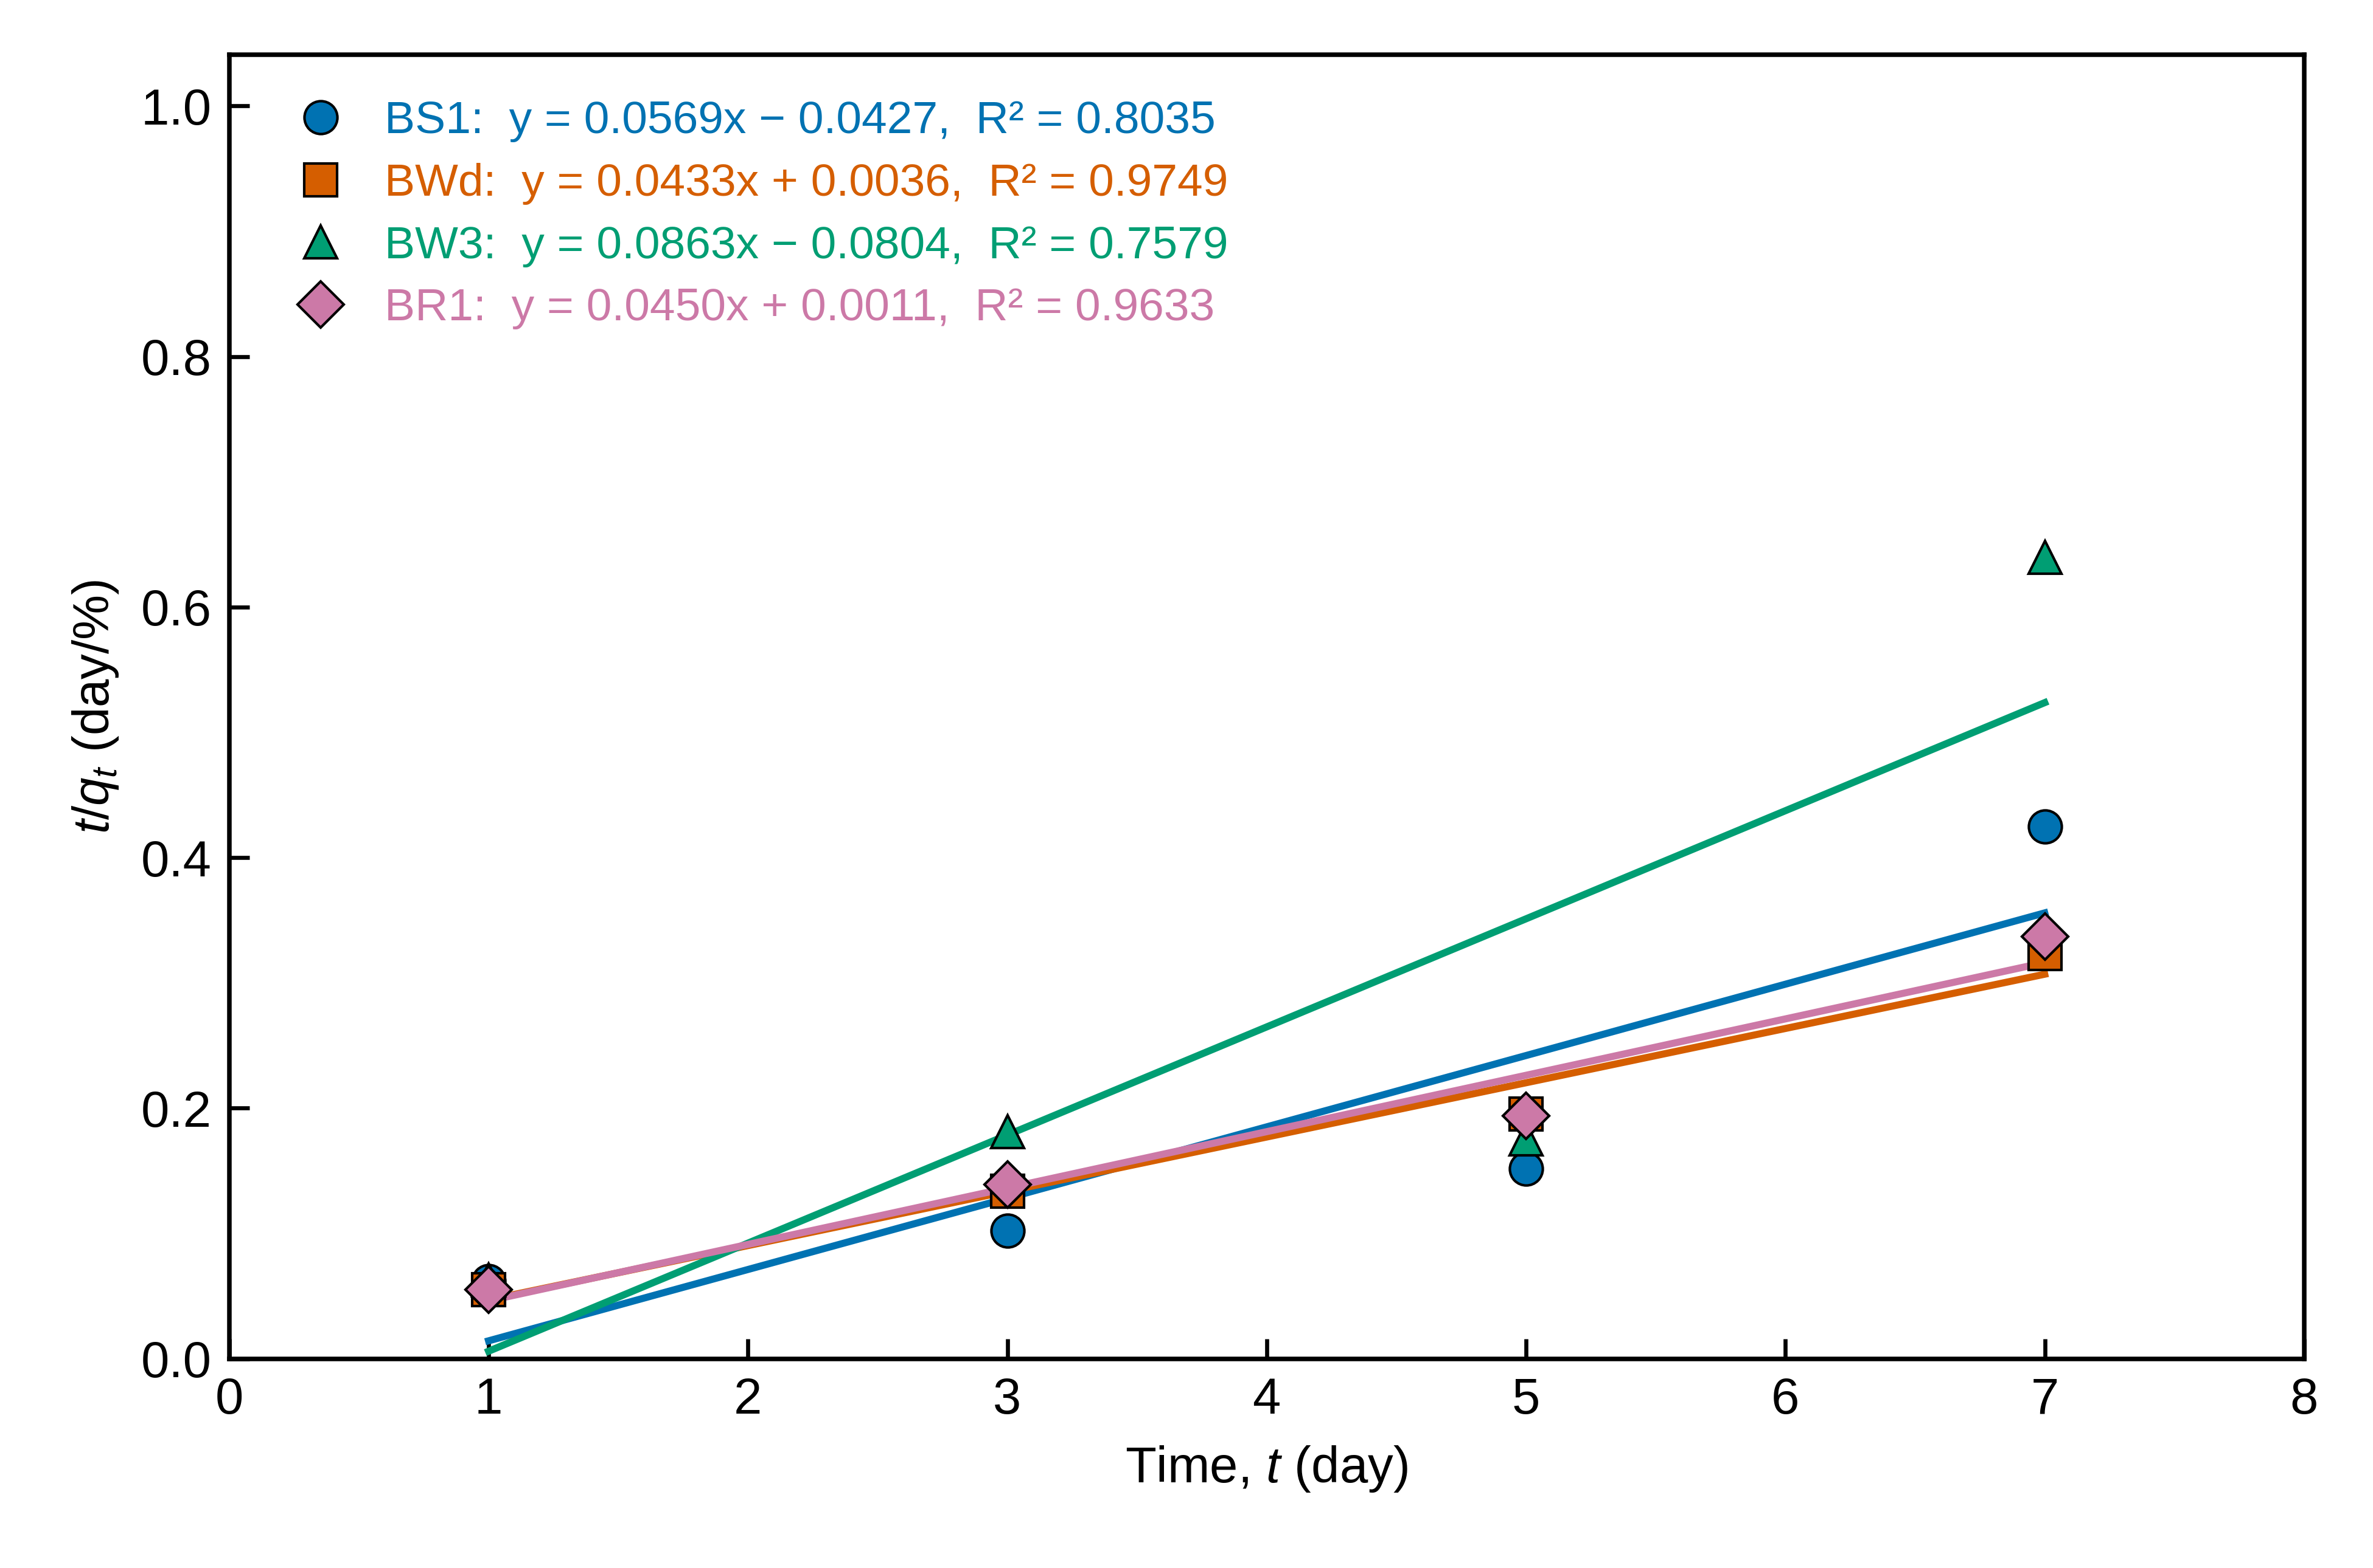
Fig. 1. Pseudo-second-order kinetic plot (t/q_{t} versus t) for chromium (Cr) removal by isolates BS1, BWd, BW3 and BR1 [initial Cr concentration = __ mg L⁻¹; biomass dose = __; pH = __; temperature = __ °C]. q_{t} is expressed as % removal. Lines are least-squares fits; equations and R² are shown for each isolate.
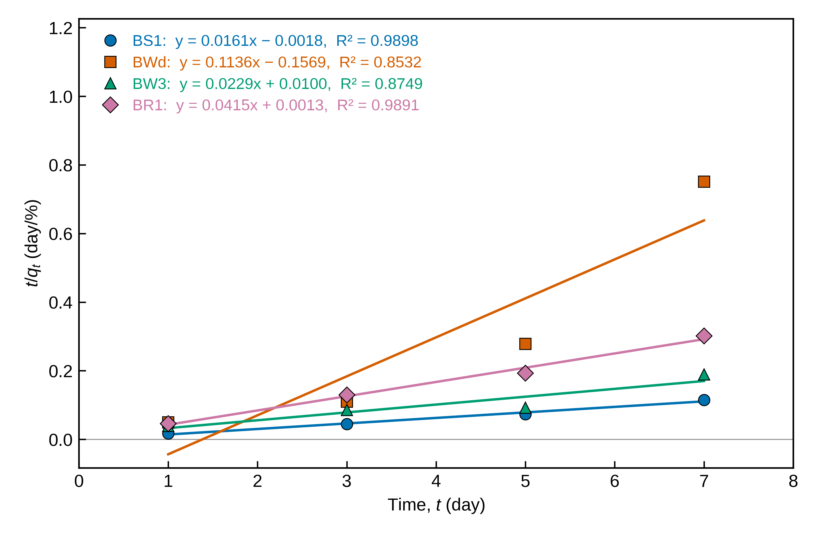
Fig. 2. Pseudo-second-order kinetic plot (t/q_{t} versus t) for copper (Cu) removal by isolates BS1, BWd, BW3 and BR1 [initial Cu concentration = __ mg L⁻¹; biomass dose = __; pH = __; temperature = __ °C]. q_{t} is expressed as % removal. Lines are least-squares fits; equations and R² are shown for each isolate.
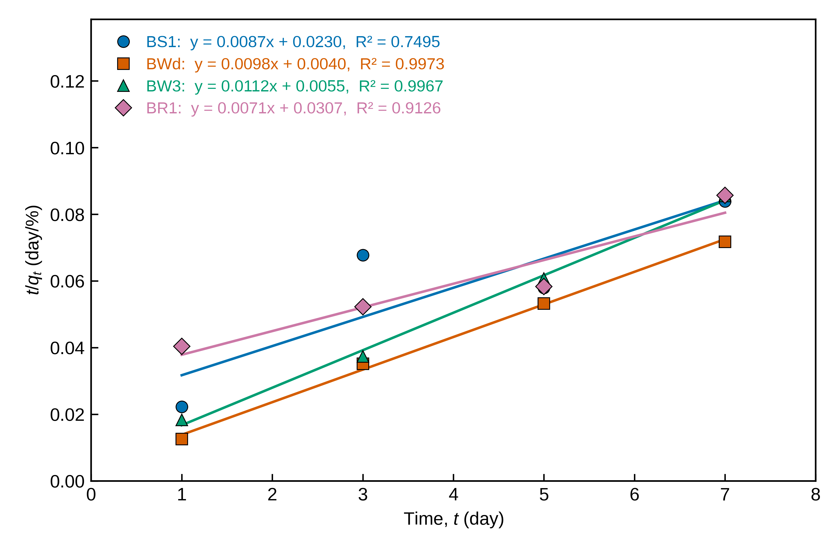
Fig. 3. Pseudo-second-order kinetic plot (t/q_{t} versus t) for lead (Pb) removal by isolates BS1, BWd, BW3 and BR1 [initial Pb concentration = __ mg L⁻¹; biomass dose = __; pH = __; temperature = __ °C]. q_{t} is expressed as % removal. Lines are least-squares fits; equations and R² are shown for each isolate.
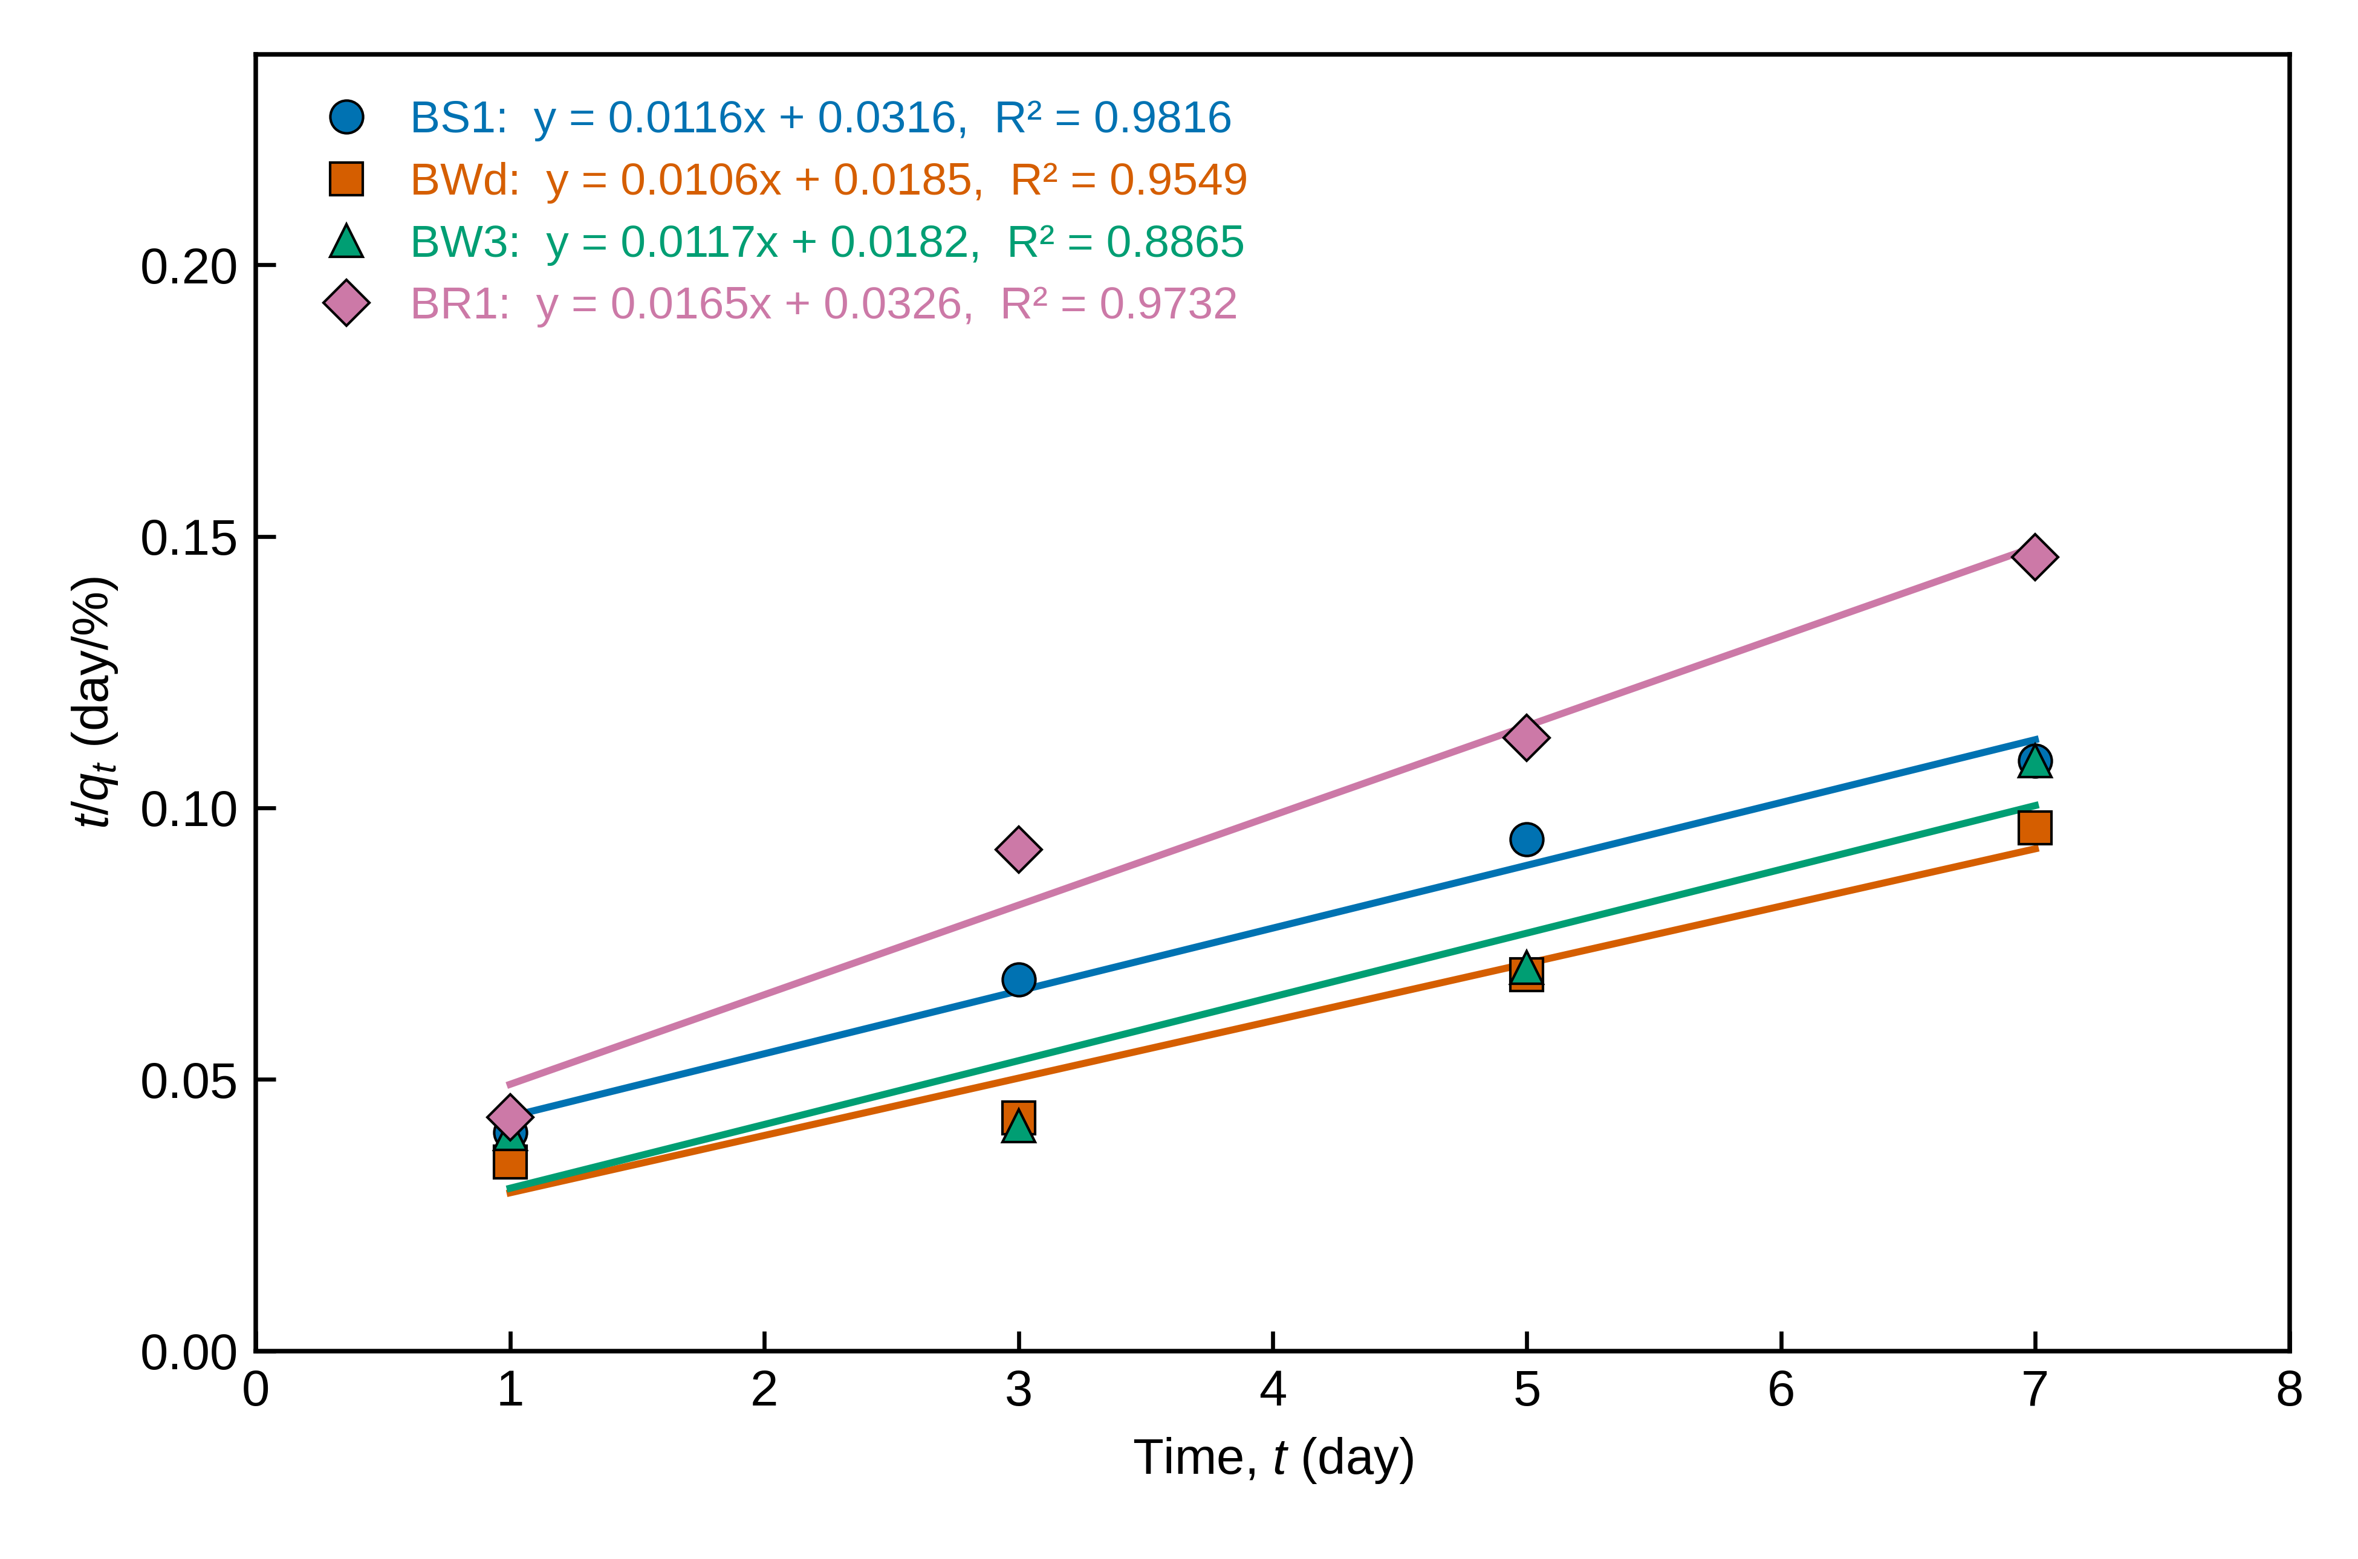
Fig. 4. Pseudo-second-order kinetic plot (t/q_{t} versus t) for zinc (Zn) removal by isolates BS1, BWd, BW3 and BR1 [initial Zn concentration = __ mg L⁻¹; biomass dose = __; pH = __; temperature = __ °C]. q_{t} is expressed as % removal. Lines are least-squares fits; equations and R² are shown for each isolate.
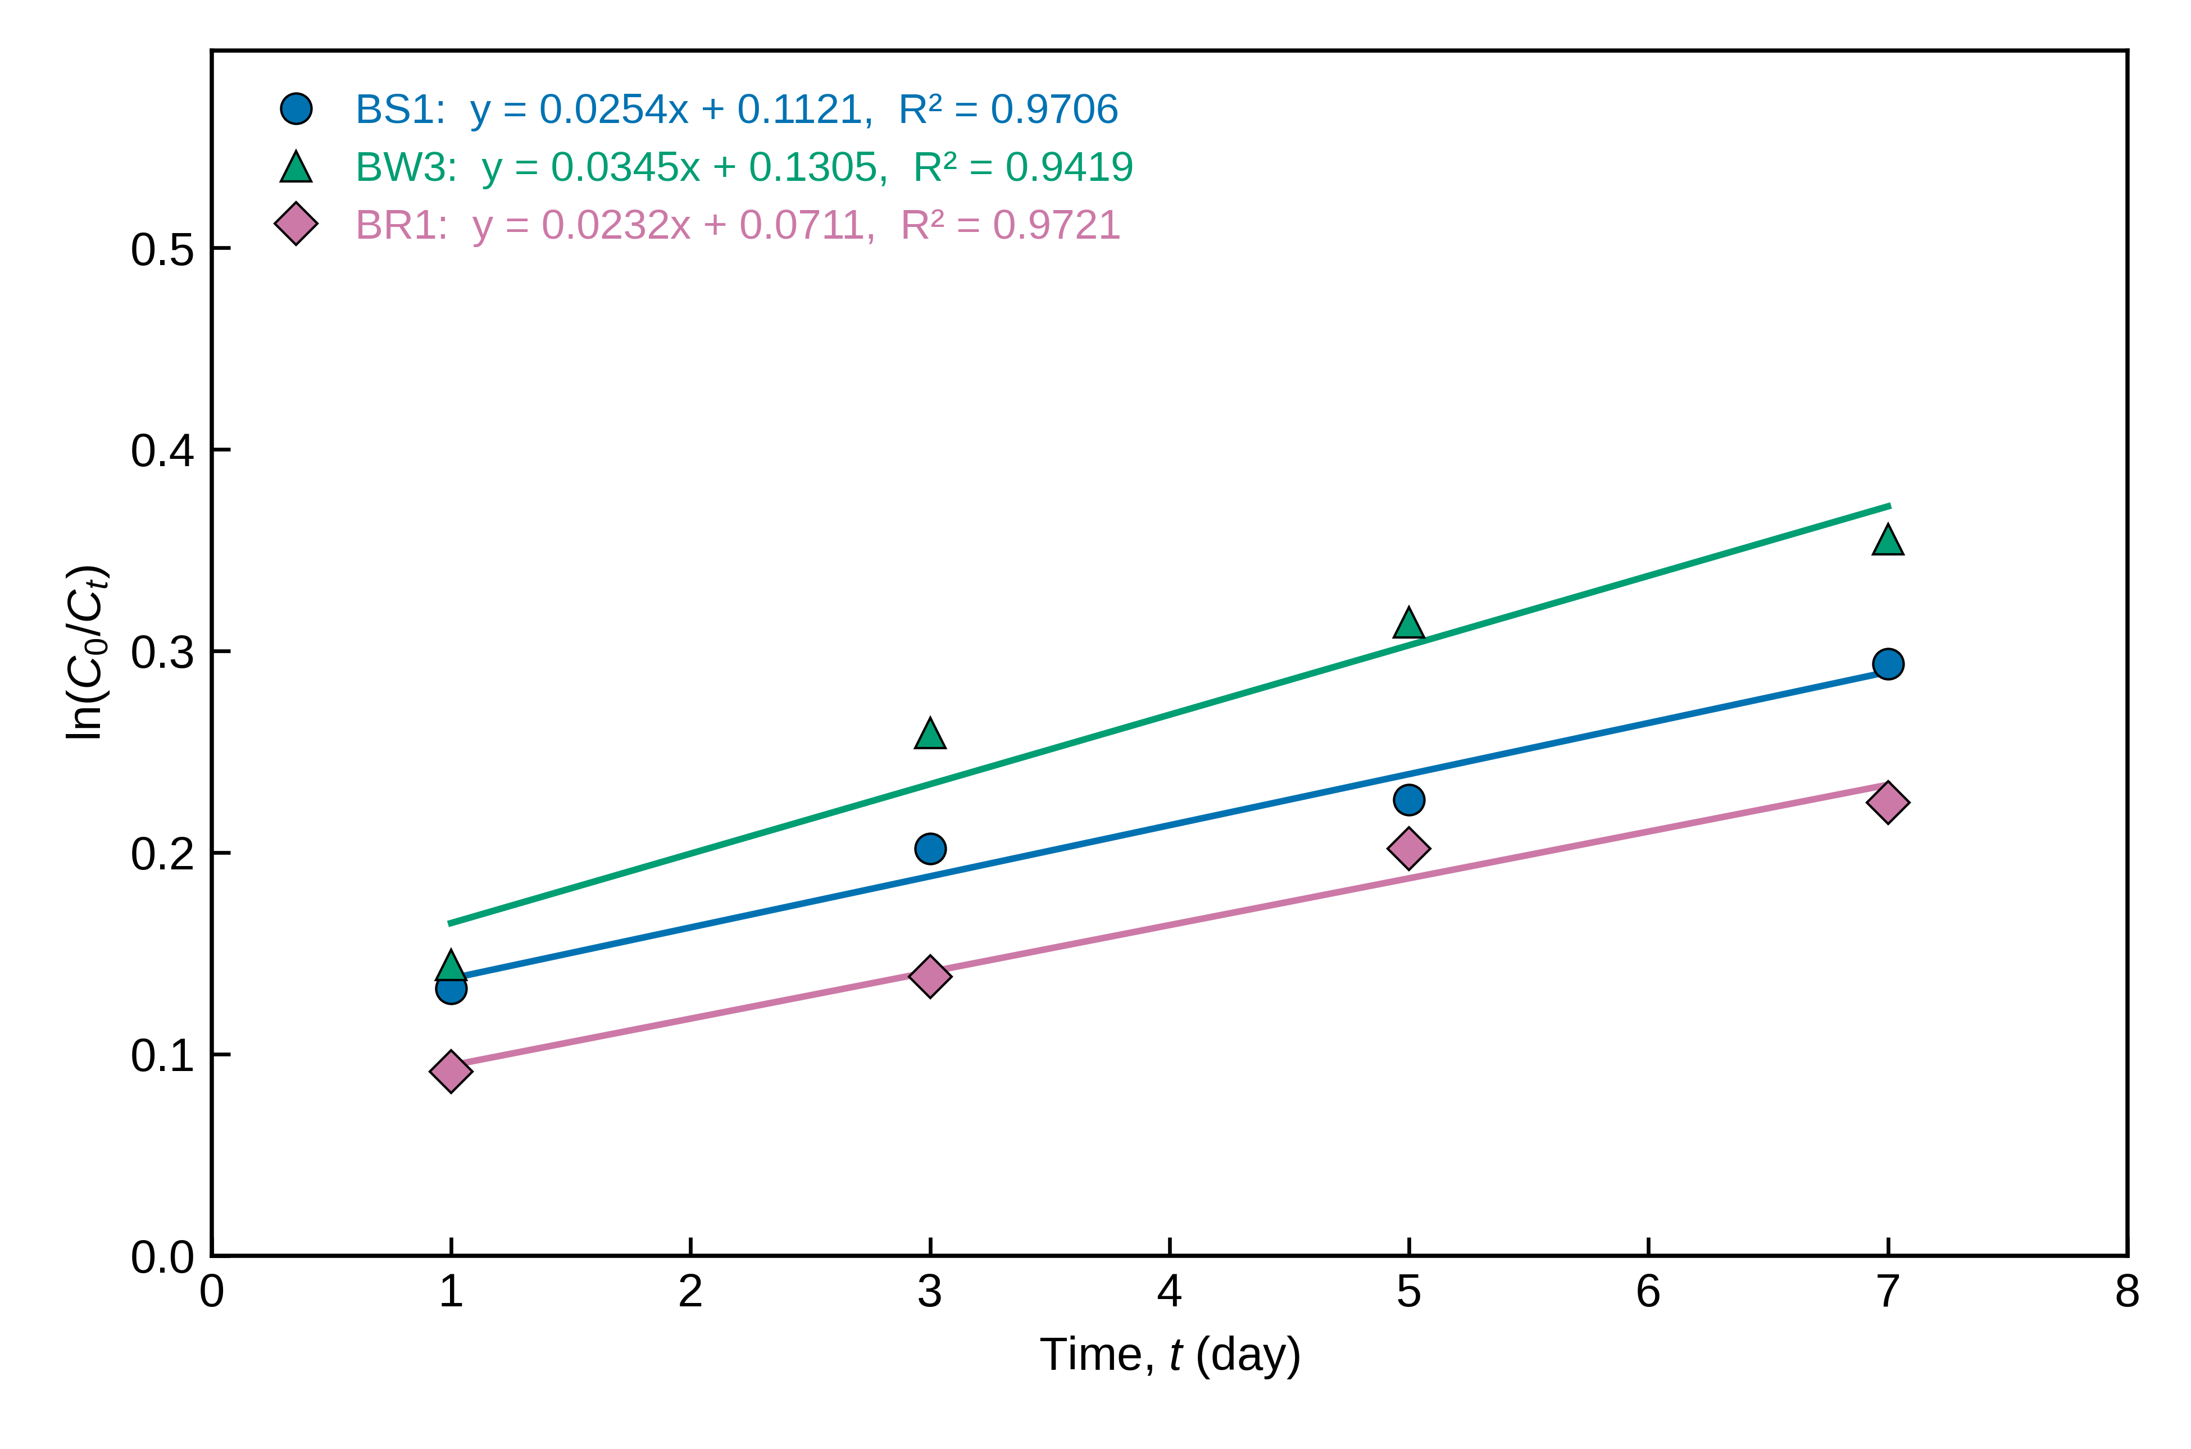
Fig. 5. First-order kinetic plot (ln(C₀/C_{t}) versus t) for pyrene degradation by isolates BS1, BW3 and BR1 [initial pyrene concentration = __ mg L⁻¹; inoculum = __; temperature = __ °C]. Lines are least-squares fits; equations and R² are shown for each isolate.
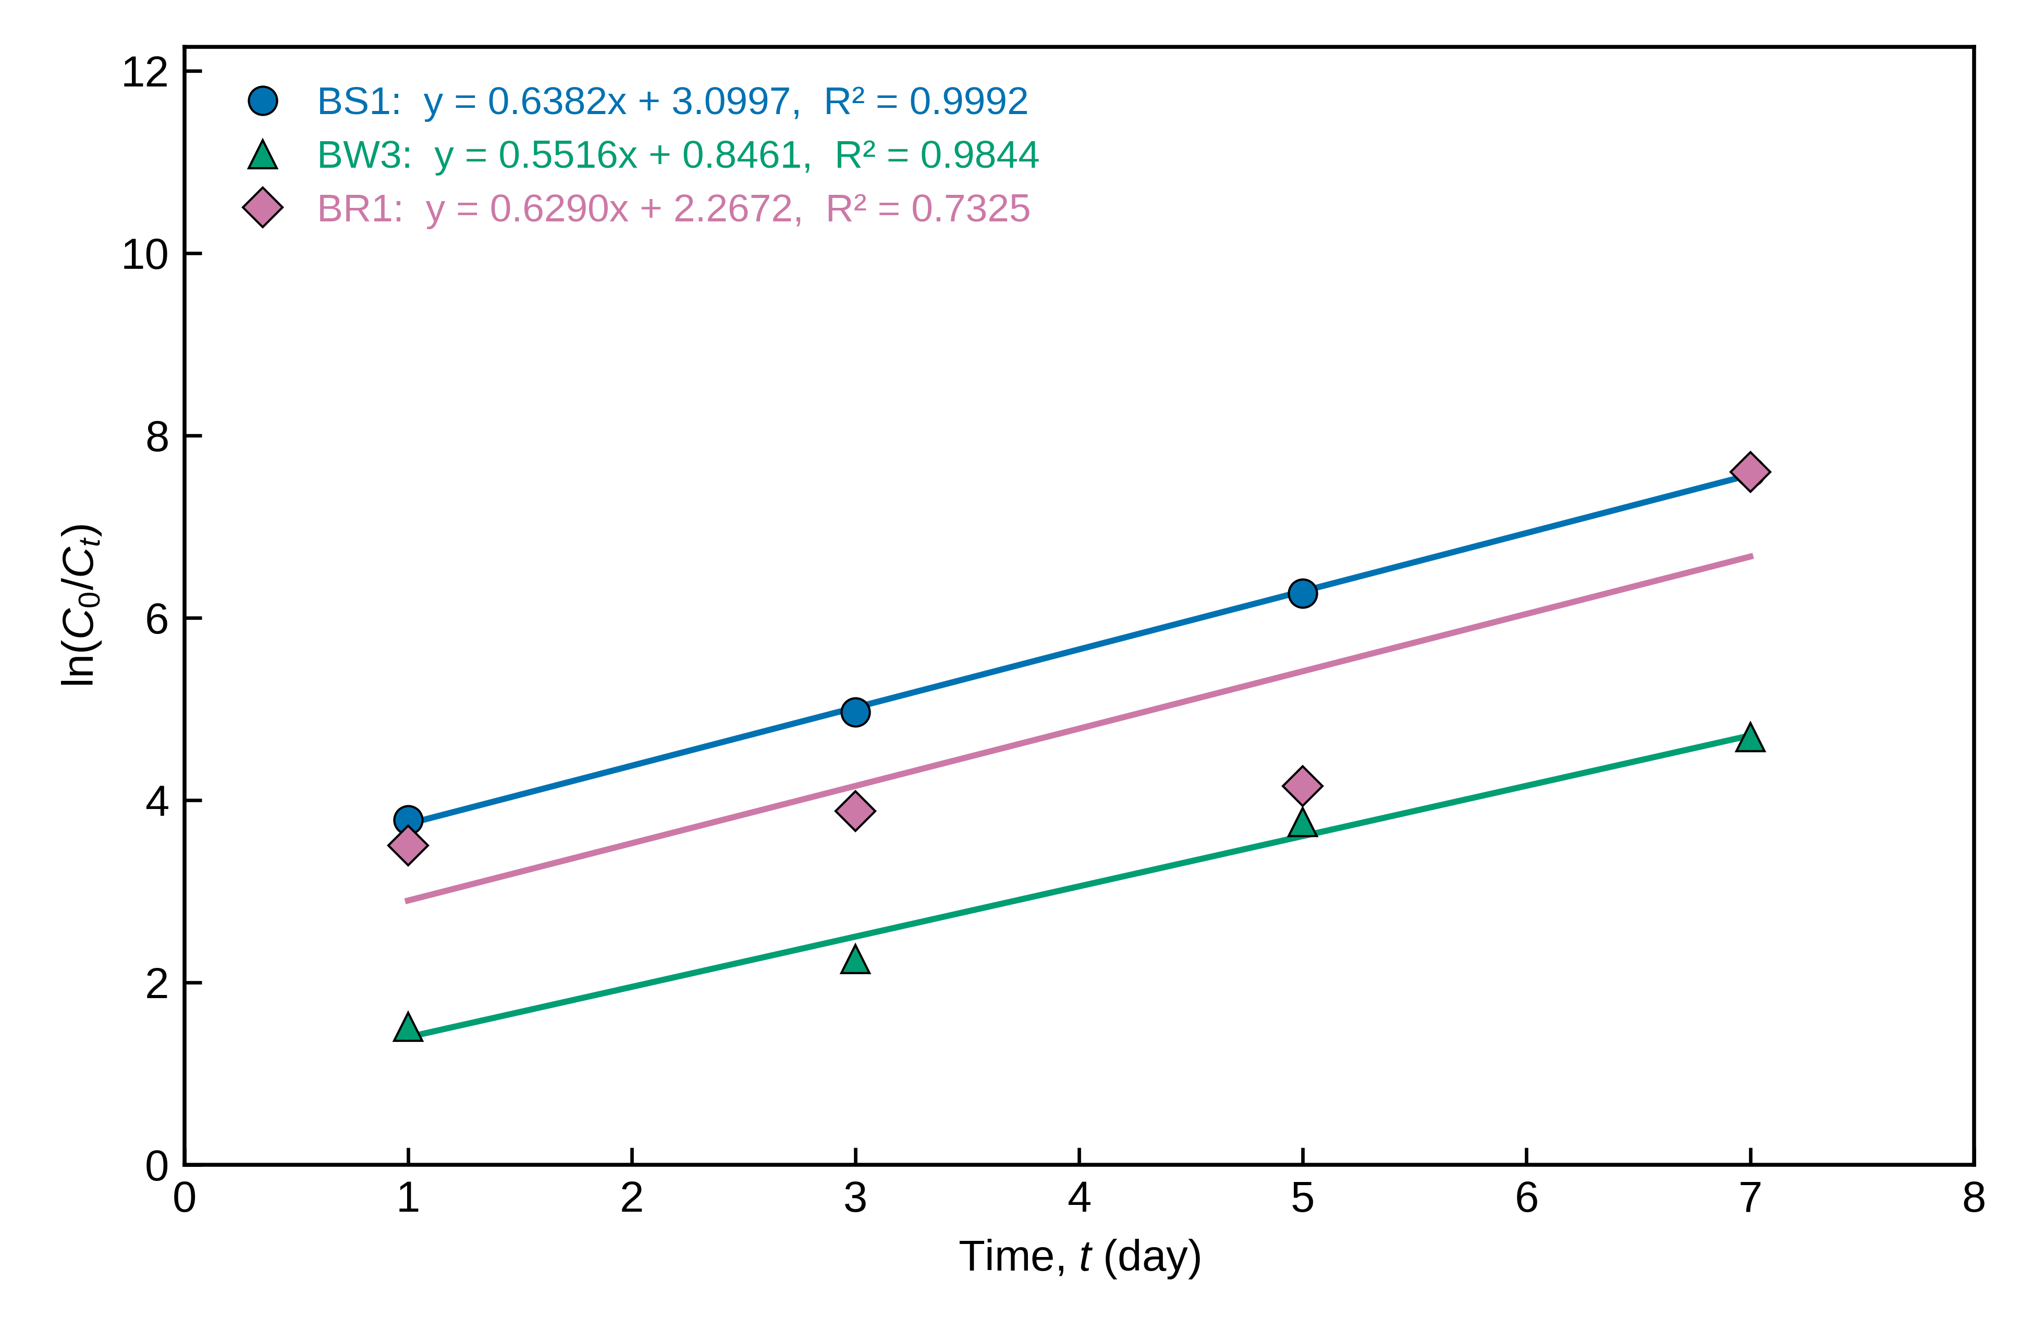
Fig. 6. First-order kinetic plot (ln(C₀/C_{t}) versus t) for fluorene degradation by isolates BS1, BW3 and BR1 [initial fluorene concentration = __ mg L⁻¹; inoculum = __; temperature = __ °C]. Lines are least-squares fits; equations and R² are shown for each isolate.

5. Notes for the authors (not for publication)
- PSO describes Zn removal by BS1, BWd and BR1 and Pb removal by BWd and BW3 reasonably well (nonlinear R² 0.82–0.98). Cr and Cu are not well described (nonlinear R² ≤ 0.65), so the text should not claim that PSO fits all metals.
- Removal fell between day 5 and day 7 for all four isolates with Cr and Cu, and for Zn with BW3. This is likely metal release (cell lysis, pH drift or desorption) and is worth discussing as a finding. If an uptake-phase description is wanted, the models can be refitted on days 1–5, stated explicitly in the methods.
- Linear R² values (Figs. 1–4) are higher than the nonlinear ones in 15 of 16 series, often substantially (e.g., Cr–BWd 0.975 vs 0.653), because t sits on both axes. Reporting both, as in Table 1, pre-empts a common reviewer objection.
- Avoid concluding that a good PSO fit proves chemisorption; fit quality alone does not establish the mechanism.
- Fluorene was almost completely removed by day 1 with BS1 and BR1. If an uninoculated (abiotic) control was run, report it to show that the loss was biological; fluorene is semi-volatile and sorbs to glass and biomass.
- Fill in the highlighted experimental conditions in the figure captions and renumber figures, tables and equations to match the manuscript. Use “fluorene” (the PAH), not “fluorine”.

