Kinetics of heavy-metal removal and PAH degradation
Methods, results and tables for the manuscript — DRAFT
Status of this draft. Prepared from the two lab data files (Heavy metal removal-Pah degradation data N1.xlsx is the main data set; Data 1.xlsx is treated as a supplementary set). Text in [square brackets] must be completed by the authors because the data files do not contain it. All numbers in the text and tables are taken from the accompanying calculation workbook. The final page lists items to resolve before submission.

2.x Kinetic modelling
Removal of Cr, Cu, Pb and Zn was followed on days 1, 3, 5 and 7 for four treatments [define BS1, BWd, BW3 and BR1], and degradation of pyrene and fluorene over the same period for three treatments (BS1, BW3, BR1). Values are means of [n = ?] replicates with their standard deviation (SD) [add experimental conditions: medium, initial concentrations, temperature, pH, biomass or adsorbent dose].
Metal removal was described with the pseudo-second-order model [1–3]:
dq_{t}/dt = k₂(q_{e} − q_{t})² (1)
where q_{t} and q_{e} are the amounts removed at time t and at equilibrium and k₂ is the rate constant. Integration with q_{t} = 0 at t = 0 and rearrangement gives the linear form used in [4]:
t/q_{t} = 1/(k₂q_{e}²) + t/q_{e} (2)
so that q_{e} = 1/slope and k₂ = slope²/intercept of a plot of t/q_{t} against t. The initial removal rate is
h = k₂q_{e}² = 1/intercept (3)
Because initial concentration, volume and biomass dose are not part of the data set, q_{t} is expressed as the measured removal (%); q_{e} is therefore in % and k₂ in %⁻¹ day⁻¹. [If C₀, V and m are available, convert to mg g⁻¹ and update the tables.]
Degradation of the PAHs was described by first-order kinetics,
ln(C_{t}/C₀) = −kt + c (4)
with C_{t}/C₀ = 1 − D/100, where D is the percentage degraded, and the half-life
t_{½} = ln 2/k (5)
Parameters were obtained by ordinary least-squares regression of the linear forms (Eqs. 2 and 4). Linearisation changes the error structure of the data and tends to raise R² [5], so the pseudo-second-order fits were cross-checked by a direct nonlinear least-squares fit of q_{t} = q_{e}²k₂t/(1 + q_{e}k₂t) (Table S1); the coefficient of determination of that fit, R²_{NL}, is given beside the linearised R². Confidence limits of k use Student’s t with n − 2 degrees of freedom. A negative intercept of the t/q_{t} plot (negative k₂) was taken to mean that the model does not apply, and a fitted q_{e} above 100 % to mean that the plateau is not defined by the data. [Calculations: Microsoft Excel, verified independently in Python/NumPy.]

3. Results

3.1 Heavy-metal removal
Removal differed strongly between metals (Fig. S1). By day 7, Pb removal was 81.7–97.6 % and Zn removal 47.9–72.7 %, whereas Cr removal was low (10.9–33.0 %) and Cu removal varied widely between treatments (9.3–68.0 %). In 12 of the 16 metal–treatment series removal was not strictly increasing with time. All eight Cr and Cu series peaked on day 3 or 5 and then fell (for example Cr–BS1: 33.0 % on day 5 and 16.5 % on day 7, a difference of more than 30 SD).
The pseudo-second-order parameters are given in Table 1 and the linearised plots, with regression equations, in Figs. 1–4. With four time points per series (two degrees of freedom), the intercept of the t/q_{t} plot differs significantly from zero (95 %) only for Pb–BR1 and Zn–BS1; k₂ and h are therefore indicative in all other series, whereas q_{e}, which depends on the slope, is better determined.
Zinc and lead. For Zn all four treatments gave plausible plateaus (q_{e} = 60.6–94.7 %), linearised R² of 0.8865–0.9816 and R²_{NL} of 0.757–0.979, with k₂ between 4.24 × 10⁻³ and 8.36 × 10⁻³ %⁻¹ day⁻¹. For Pb the plots were straight for BWd and BW3 (R² = 0.9973 and 0.9967; R²_{NL} = 0.824 and 0.949), but only BW3 gave q_{e} below 100 % (88.9 %). For Pb–BS1, BWd and BR1 the fitted q_{e} (114.3, 102.2 and 140.8 %) exceeds the physical maximum of a percentage, so these plateaus are extrapolations rather than measured values. Zn (all treatments) and Pb–BW3 are the cases in which the pseudo-second-order model is adequately supported (R²_{NL} ≥ 0.75 and q_{e} ≤ 100 %).
Chromium and copper. The model is not supported for these metals. Four series (Cr–BS1, Cr–BW3, Cu–BS1, Cu–BWd) have a negative intercept, hence k₂ < 0, and are reported as n.a. in Table 1. In the other four (Cr–BWd, Cr–BR1, Cu–BW3, Cu–BR1) the linearised R² is high (0.875–0.989) but R²_{NL} is only 0.47–0.65: the straightened plot hides the fall in removal after day 5. Their k₂ values are also unstable; for Cr–BR1 the linearised fit gives 1.77 and the nonlinear fit 0.129 %⁻¹ day⁻¹, and for Cu–BR1 1.38 and 0.282, respectively. The decline after the peak [desorption or re-release of the metal, a change in speciation or sampling effects — authors to discuss] is not described by a model in which removal rises monotonically to a plateau.
Table 1. Pseudo-second-order kinetic parameters for the removal of Cr, Cu, Pb and Zn (linearised fit, q_{t} = removal %).
Metal | Treatment | k₂ (%⁻¹ day⁻¹) | q_{e} (%) | R² | h (% day⁻¹) | R²_{NL}
Chromium | BS1 | n.a. | n.a. | 0.8035 | n.a. | 0.185
 | BWd | 0.523 | 23.1 | 0.9749 | 278.4 | 0.653
 | BW3 | n.a. | n.a. | 0.7579 | n.a. | 0.024
 | BR1 | 1.77 | 22.2 | 0.9633 | 872.7 | 0.499
Copper | BS1 | n.a. | n.a. | 0.9898 | n.a. | 0.395
 | BWd | n.a. | n.a. | 0.8532 | n.a. | 0.000^{b}
 | BW3 | 5.21 × 10⁻² | 43.7 | 0.8749 | 99.6 | 0.514
 | BR1 | 1.38 | 24.1 | 0.9891 | 797.5 | 0.472
Lead | BS1 | 3.33 × 10⁻³ | 114.3ª | 0.7495 | 43.6 | 0.645
 | BWd | 2.36 × 10⁻² | 102.2ª | 0.9973 | 246.9 | 0.824
 | BW3 | 2.31 × 10⁻² | 88.9 | 0.9967 | 182.8 | 0.949
 | BR1 | 1.64 × 10⁻³ | 140.8ª | 0.9126 | 32.5 | 0.945
Zinc | BS1 | 4.24 × 10⁻³ | 86.4 | 0.9816 | 31.7 | 0.979
 | BWd | 6.01 × 10⁻³ | 94.7 | 0.9549 | 53.9 | 0.897
 | BW3 | 7.58 × 10⁻³ | 85.1 | 0.8865 | 54.9 | 0.757
 | BR1 | 8.36 × 10⁻³ | 60.6 | 0.9732 | 30.7 | 0.933
k₂, q_{e} and R² from t/q_{t} = 1/(k₂q_{e}²) + t/q_{e} (Eq. 2; 4 points, 2 d.f.); h = k₂q_{e}²; R²_{NL}: coefficient of determination of a direct nonlinear fit of q_{t}.
n.a., not applicable: negative intercept, i.e. k₂ < 0 (uncorrected values in Table S1). ª q_{e} > 100 %: extrapolated plateau above the physical maximum.
The intercept differs from zero at 95 % confidence only for Pb–BR1 and Zn–BS1; k₂ and h are indicative elsewhere.
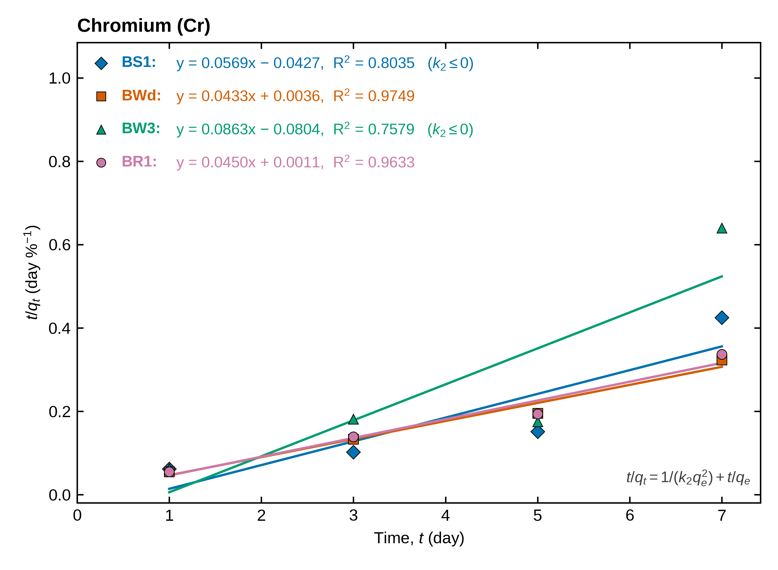
Figure 1. Linearised pseudo-second-order plots (t/q_{t} versus t) for the removal of chromium by treatments BS1, BWd, BW3 and BR1 (symbols: measured values; lines: least-squares fits). The regression equation and R² of each line are written on the graph; q_{t} is the removal in %. (k₂ ≤ 0) marks fits with a negative intercept, for which the model does not apply.
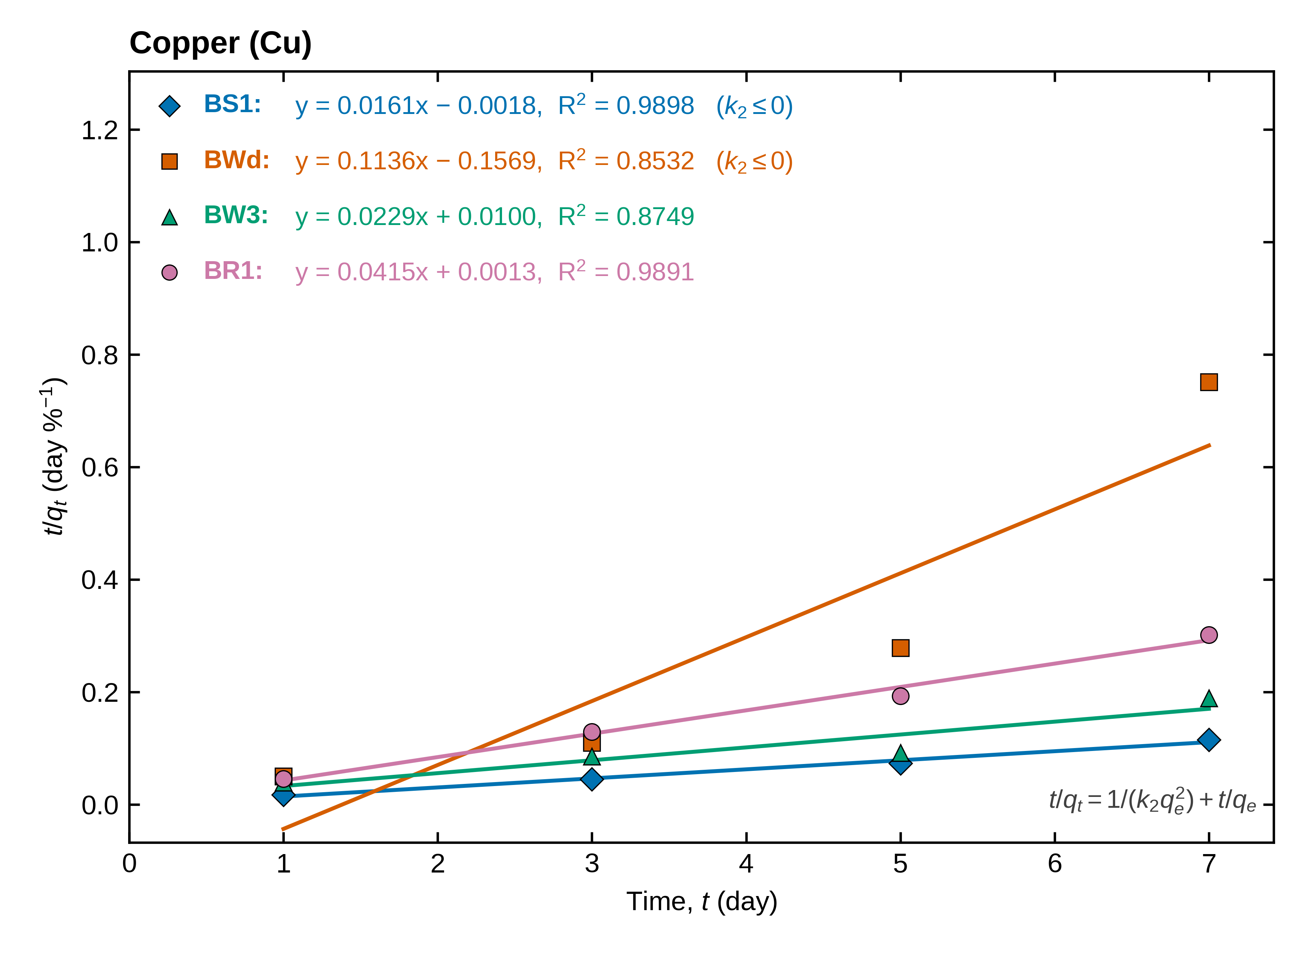
Figure 2. Linearised pseudo-second-order plots (t/q_{t} versus t) for the removal of copper by treatments BS1, BWd, BW3 and BR1 (symbols: measured values; lines: least-squares fits). The regression equation and R² of each line are written on the graph; q_{t} is the removal in %. (k₂ ≤ 0) marks fits with a negative intercept, for which the model does not apply.
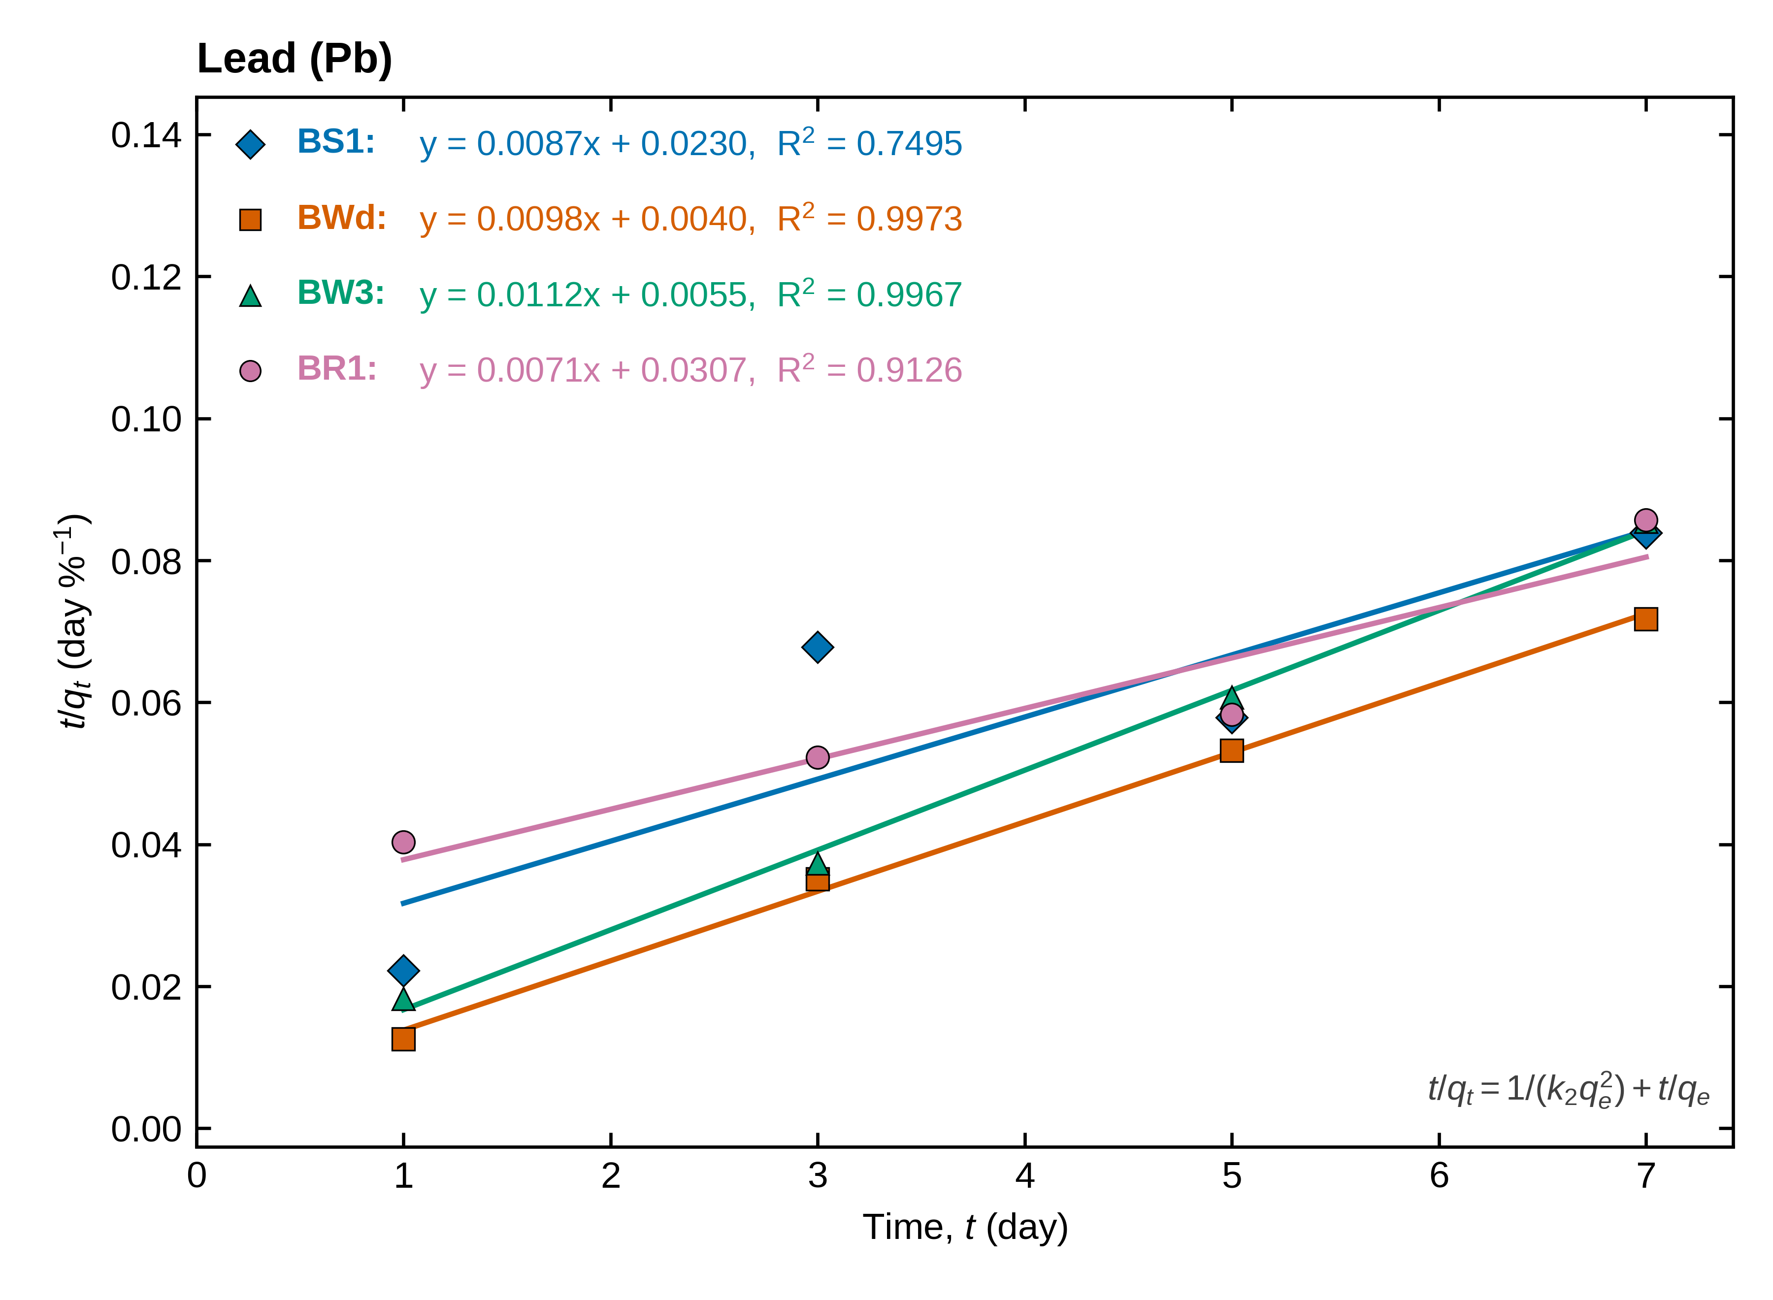
Figure 3. Linearised pseudo-second-order plots (t/q_{t} versus t) for the removal of lead by treatments BS1, BWd, BW3 and BR1 (symbols: measured values; lines: least-squares fits). The regression equation and R² of each line are written on the graph; q_{t} is the removal in %.
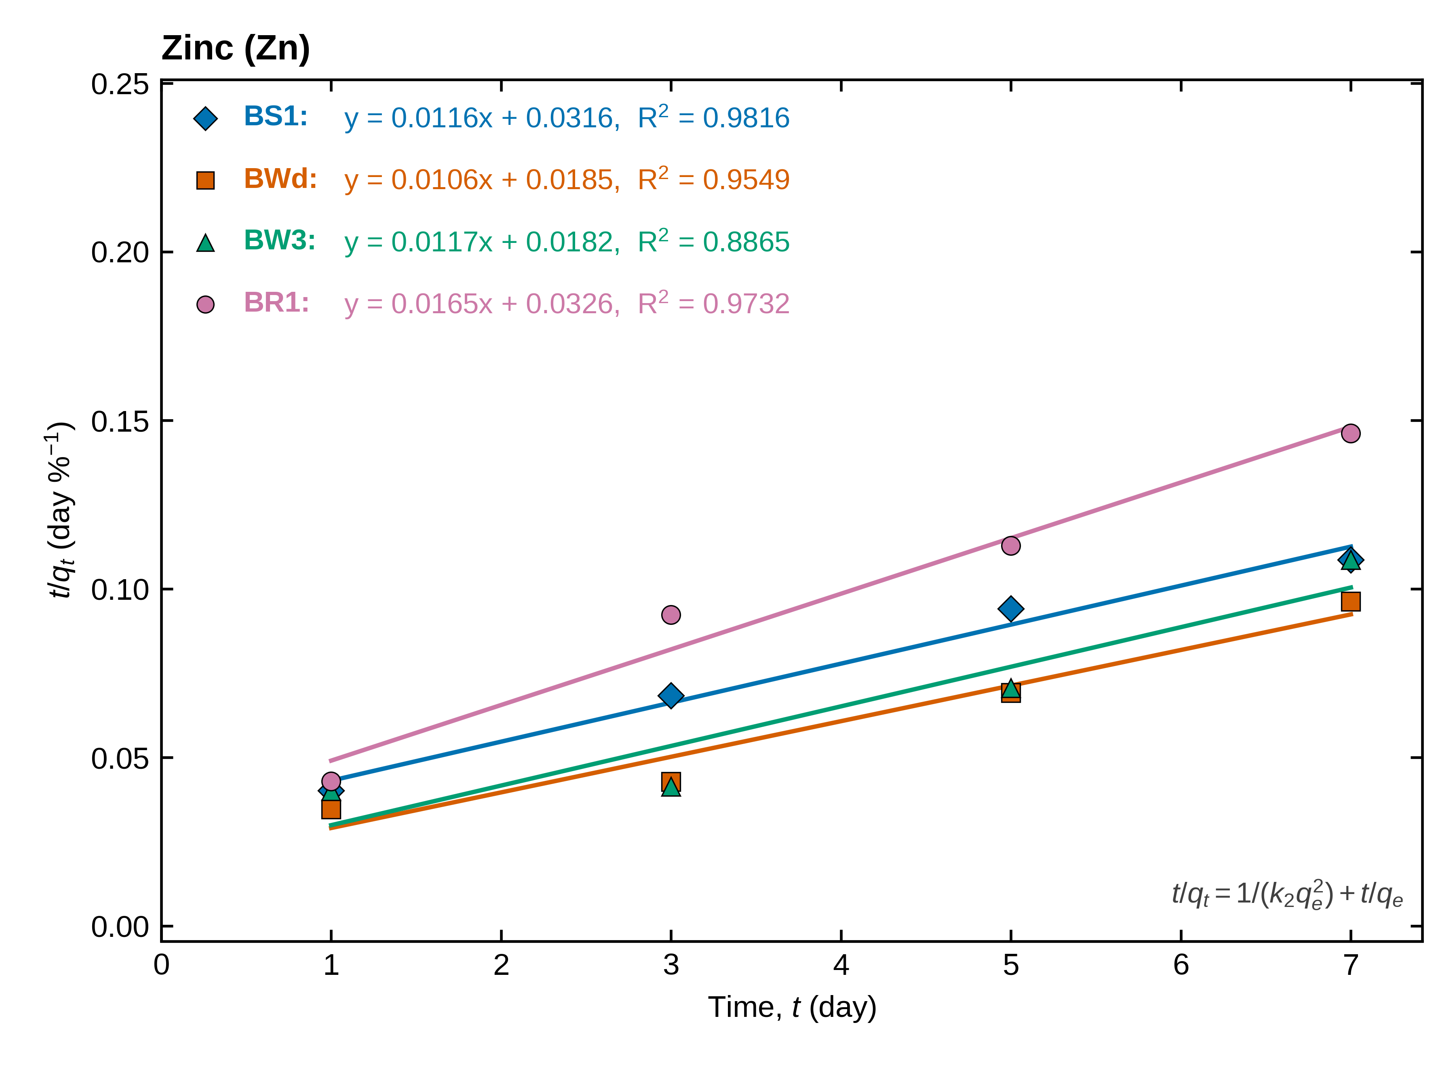
Figure 4. Linearised pseudo-second-order plots (t/q_{t} versus t) for the removal of zinc by treatments BS1, BWd, BW3 and BR1 (symbols: measured values; lines: least-squares fits). The regression equation and R² of each line are written on the graph; q_{t} is the removal in %.

3.2 PAH degradation
Pyrene degradation was slow and steady (for example BW3: 13.4 % on day 1 and 29.9 % on day 7), whereas fluorene was degraded almost completely: 77.9–97.7 % had already disappeared by day 1 and 99.1–99.95 % by day 7 (Fig. S1). First-order parameters are given in Table 2 and Figs. 5 and 6.
Pyrene. First-order kinetics described pyrene degradation well (R² = 0.942–0.972), with k = 0.0232–0.0345 day⁻¹ and t_{½} = 20.1–29.9 days; the fastest treatment was BW3 and the slowest BR1. The intercepts are close to zero (c = −0.07 to −0.13), as expected if the first-order law holds from t = 0. However, the 95 % intervals of k for the three treatments overlap (0.0119–0.0388; 0.0084–0.0605; 0.0112–0.0352), so with four time points the ranking of treatments is a trend, not a demonstrated difference.
Fluorene. The regression gave k = 0.552–0.638 day⁻¹ and t_{½} = 1.09–1.26 days. These values must be read with care. Because most of the fluorene had gone before the first sample, the fitted intercepts are strongly negative (c = −0.85 to −3.10); the line does not pass through ln(C_{t}/C₀) = 0 at t = 0, so k describes the slower tail after day 1, and the initial loss was faster than a single first-order rate implies. Forcing the line through the origin gives k = 0.713–1.229 day⁻¹ (t_{½} = 0.56–0.97 days; Table S4). For BR1 the fit is poor (R² = 0.73) and the 95 % interval of k includes zero. The half-life of fluorene is therefore of the order of one day or less, and cannot be resolved more finely with the present sampling schedule.
Table 2. First-order kinetic parameters for the degradation of pyrene and fluorene.
Compound | Treatment | k (day⁻¹) | t_{½} (day) | R² | 95 % CI of k (day⁻¹) | c
Pyrene | BS1 | 0.0254 | 27.34 | 0.9706 | 0.0119 to 0.0388 | −0.112
 | BW3 | 0.0345 | 20.12 | 0.9419 | 0.0084 to 0.0605 | −0.130
 | BR1 | 0.0232 | 29.87 | 0.9721 | 0.0112 to 0.0352 | −0.071
Fluorene | BS1 | 0.6382 | 1.09 | 0.9992 | 0.5839 to 0.6925 | −3.100
 | BW3 | 0.5516 | 1.26 | 0.9844 | 0.3401 to 0.7631 | −0.846
 | BR1 | 0.6290 | 1.10 | 0.7325 | −0.5276 to 1.7855 | −2.267
ln(C_{t}/C₀) = −kt + c (Eq. 4), least squares over days 1, 3, 5, 7 (2 d.f.); C_{t}/C₀ = 1 − degradation (%)/100; t_{½} = ln 2/k; CI: 95 % confidence interval of k (Student t, 2 d.f.).
Fluorene was already 78–98 % degraded at the first sampling (day 1): c is far from zero and k and t_{½} describe the day 1–7 tail only (see text and Table S4).
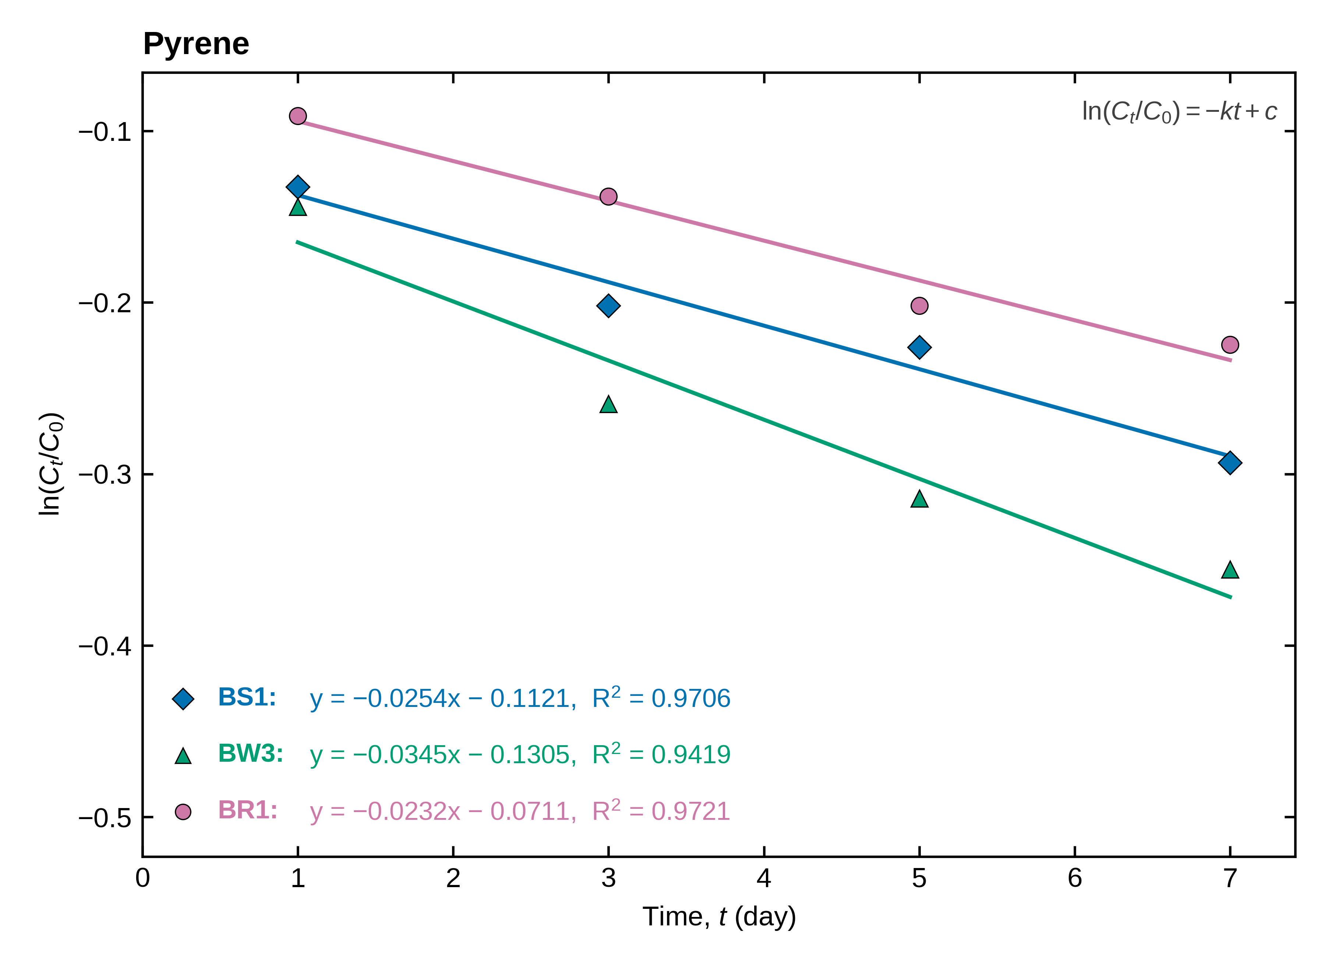
Figure 5. Linearised first-order plots (ln(C_{t}/C₀) versus t) for the degradation of pyrene by treatments BS1, BW3 and BR1 (symbols: measured values; lines: least-squares fits; equation and R² written on the graph). C_{t}/C₀ = 1 − degradation (%)/100.
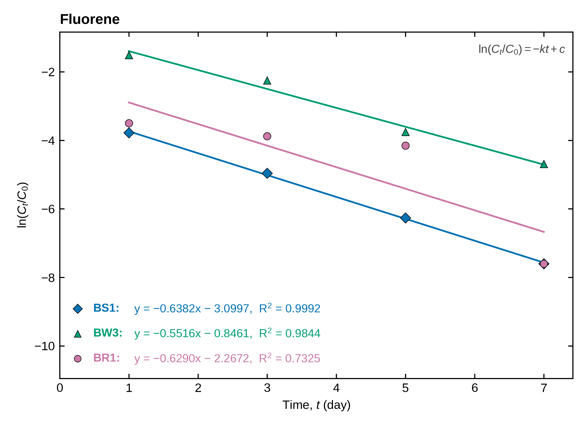
Figure 6. Linearised first-order plots for the degradation of fluorene by treatments BS1, BW3 and BR1. Note the strongly negative intercepts: most of the fluorene was degraded before the first sampling on day 1.

Supplementary material

S1 Nonlinear cross-check of the pseudo-second-order fits (main data set)
Table S1. Linearised versus nonlinear pseudo-second-order fits (main data set).
Metal | Treatment | q_{e} lin. (%) | q_{e} nonlin. (%) | k₂ lin. (%⁻¹ day⁻¹) | k₂ nonlin. (%⁻¹ day⁻¹) | R² lin. | R² nonlin.
Chromium | BS1 | 17.6 | 28.2 | −7.59 × 10⁻² | 7.32 × 10⁻² | 0.8035 | 0.185
 | BWd | 23.1 | 25.0 | 0.523 | 0.112 | 0.9749 | 0.653
 | BW3 | 11.6 | 19.3 | −9.26 × 10⁻² | 0.293 | 0.7579 | 0.024
 | BR1 | 22.2 | 24.3 | 1.77 | 0.129 | 0.9633 | 0.499
Copper | BS1 | 62.1 | 66.8 | −0.142 | 0.120 | 0.9898 | 0.395
 | BWd | 8.8 | 18.6 | −8.22 × 10⁻² | n.i. | 0.8532 | 0.000
 | BW3 | 43.7 | 50.8 | 5.21 × 10⁻² | 2.06 × 10⁻² | 0.8749 | 0.514
 | BR1 | 24.1 | 24.9 | 1.38 | 0.282 | 0.9891 | 0.472
Lead | BS1 | 114.3 | 109.4 | 3.33 × 10⁻³ | 4.14 × 10⁻³ | 0.7495 | 0.645
 | BWd | 102.2 | 98.1 | 2.36 × 10⁻² | 3.98 × 10⁻² | 0.9973 | 0.824
 | BW3 | 88.9 | 92.5 | 2.31 × 10⁻² | 1.69 × 10⁻² | 0.9967 | 0.949
 | BR1 | 140.8 | 137.1 | 1.64 × 10⁻³ | 1.85 × 10⁻³ | 0.9126 | 0.945
Zinc | BS1 | 86.4 | 86.6 | 4.24 × 10⁻³ | 4.16 × 10⁻³ | 0.9816 | 0.979
 | BWd | 94.7 | 97.1 | 6.01 × 10⁻³ | 5.82 × 10⁻³ | 0.9549 | 0.897
 | BW3 | 85.1 | 90.3 | 7.58 × 10⁻³ | 6.84 × 10⁻³ | 0.8865 | 0.757
 | BR1 | 60.6 | 59.2 | 8.36 × 10⁻³ | 9.09 × 10⁻³ | 0.9732 | 0.933
lin.: linearised fit (uncorrected, so negative k₂ values are shown); nonlin.: direct least-squares fit of q_{t} = q_{e}t/(b + t), b = 1/(k₂q_{e}). n.i., not identifiable: the optimiser ran to the edge of the search range (b → 0), i.e. the data decline and no monotonic plateau exists.

S2 Supplementary data set (Data 1): Pb and Cu salts and PAHs
Data 1 reports Pb and Cu as nitrate and chloride salts for three treatments (SS1, SS2, SR3) on days 1, 3, 5, 7, 15 and 30, and pyrene and fluorene on days 1, 3 and 5. Its treatment codes differ from the main data set, so it is analysed separately. Only 4 of the 12 metal series have R²_{NL} ≥ 0.5 without hitting the search boundary (Pb (nitrate)–SS2, Pb (chloride)–SS2, Cu (nitrate)–SS1, Cu (chloride)–SS1); the others are irregular or fall after a peak (Fig. S2, Table S2). Copper chloride removal is only 1–20 %, with SD comparable to the signal, so little can be concluded for it. [Decide whether to include these data in the article.]
Table S2. Pseudo-second-order parameters, supplementary data set (Data 1; q_{t} = removal %, days 1–30).
Salt | Treatment | k₂ (%⁻¹ day⁻¹) | q_{e} (%) | R² | h (% day⁻¹) | R²_{NL}
Lead nitrate | SS1 | 9.59 × 10⁻⁴ | 95.5 | 0.4918 | 8.8 | 0.045
 | SS2 | 1.51 × 10⁻³ | 116.9ª | 0.8880 | 20.6 | 0.756
 | SR3 | 1.18 × 10⁻³ | 102.2ª | 0.6388 | 12.3 | 0.244
Lead chloride | SS1 | 2.67 × 10⁻³ | 98.5 | 0.8919 | 25.9 | 0.246
 | SS2 | 1.22 × 10⁻² | 97.7 | 0.9966 | 116.2 | 0.754
 | SR3 | 1.40 × 10⁻³ | 115.5ª | 0.9068 | 18.7 | 0.468
Copper nitrate | SS1 | 1.73 × 10⁻³ | 99.5 | 0.9371 | 17.1 | 0.872
 | SS2 | 1.74 × 10⁻³ | 88.8 | 0.7323 | 13.7 | 0.122
 | SR3 | 6.22 × 10⁻² | 23.5 | 0.5999 | 34.3 | 0.000^{b}
Copper chloride | SS1 | 3.90 × 10⁻⁴ | 50.5 | 0.2580 | 1.0 | 0.805
 | SS2 | n.a. | n.a. | 0.9871 | n.a. | 0.000
 | SR3 | n.a. | n.a. | 0.9013 | n.a. | 0.000^{b}
Symbols as in Table 1. n.a.: negative intercept (k₂ < 0). ª q_{e} > 100 %. ^{b} R²_{NL}: nonlinear optimiser at the edge of the search range (not identifiable).
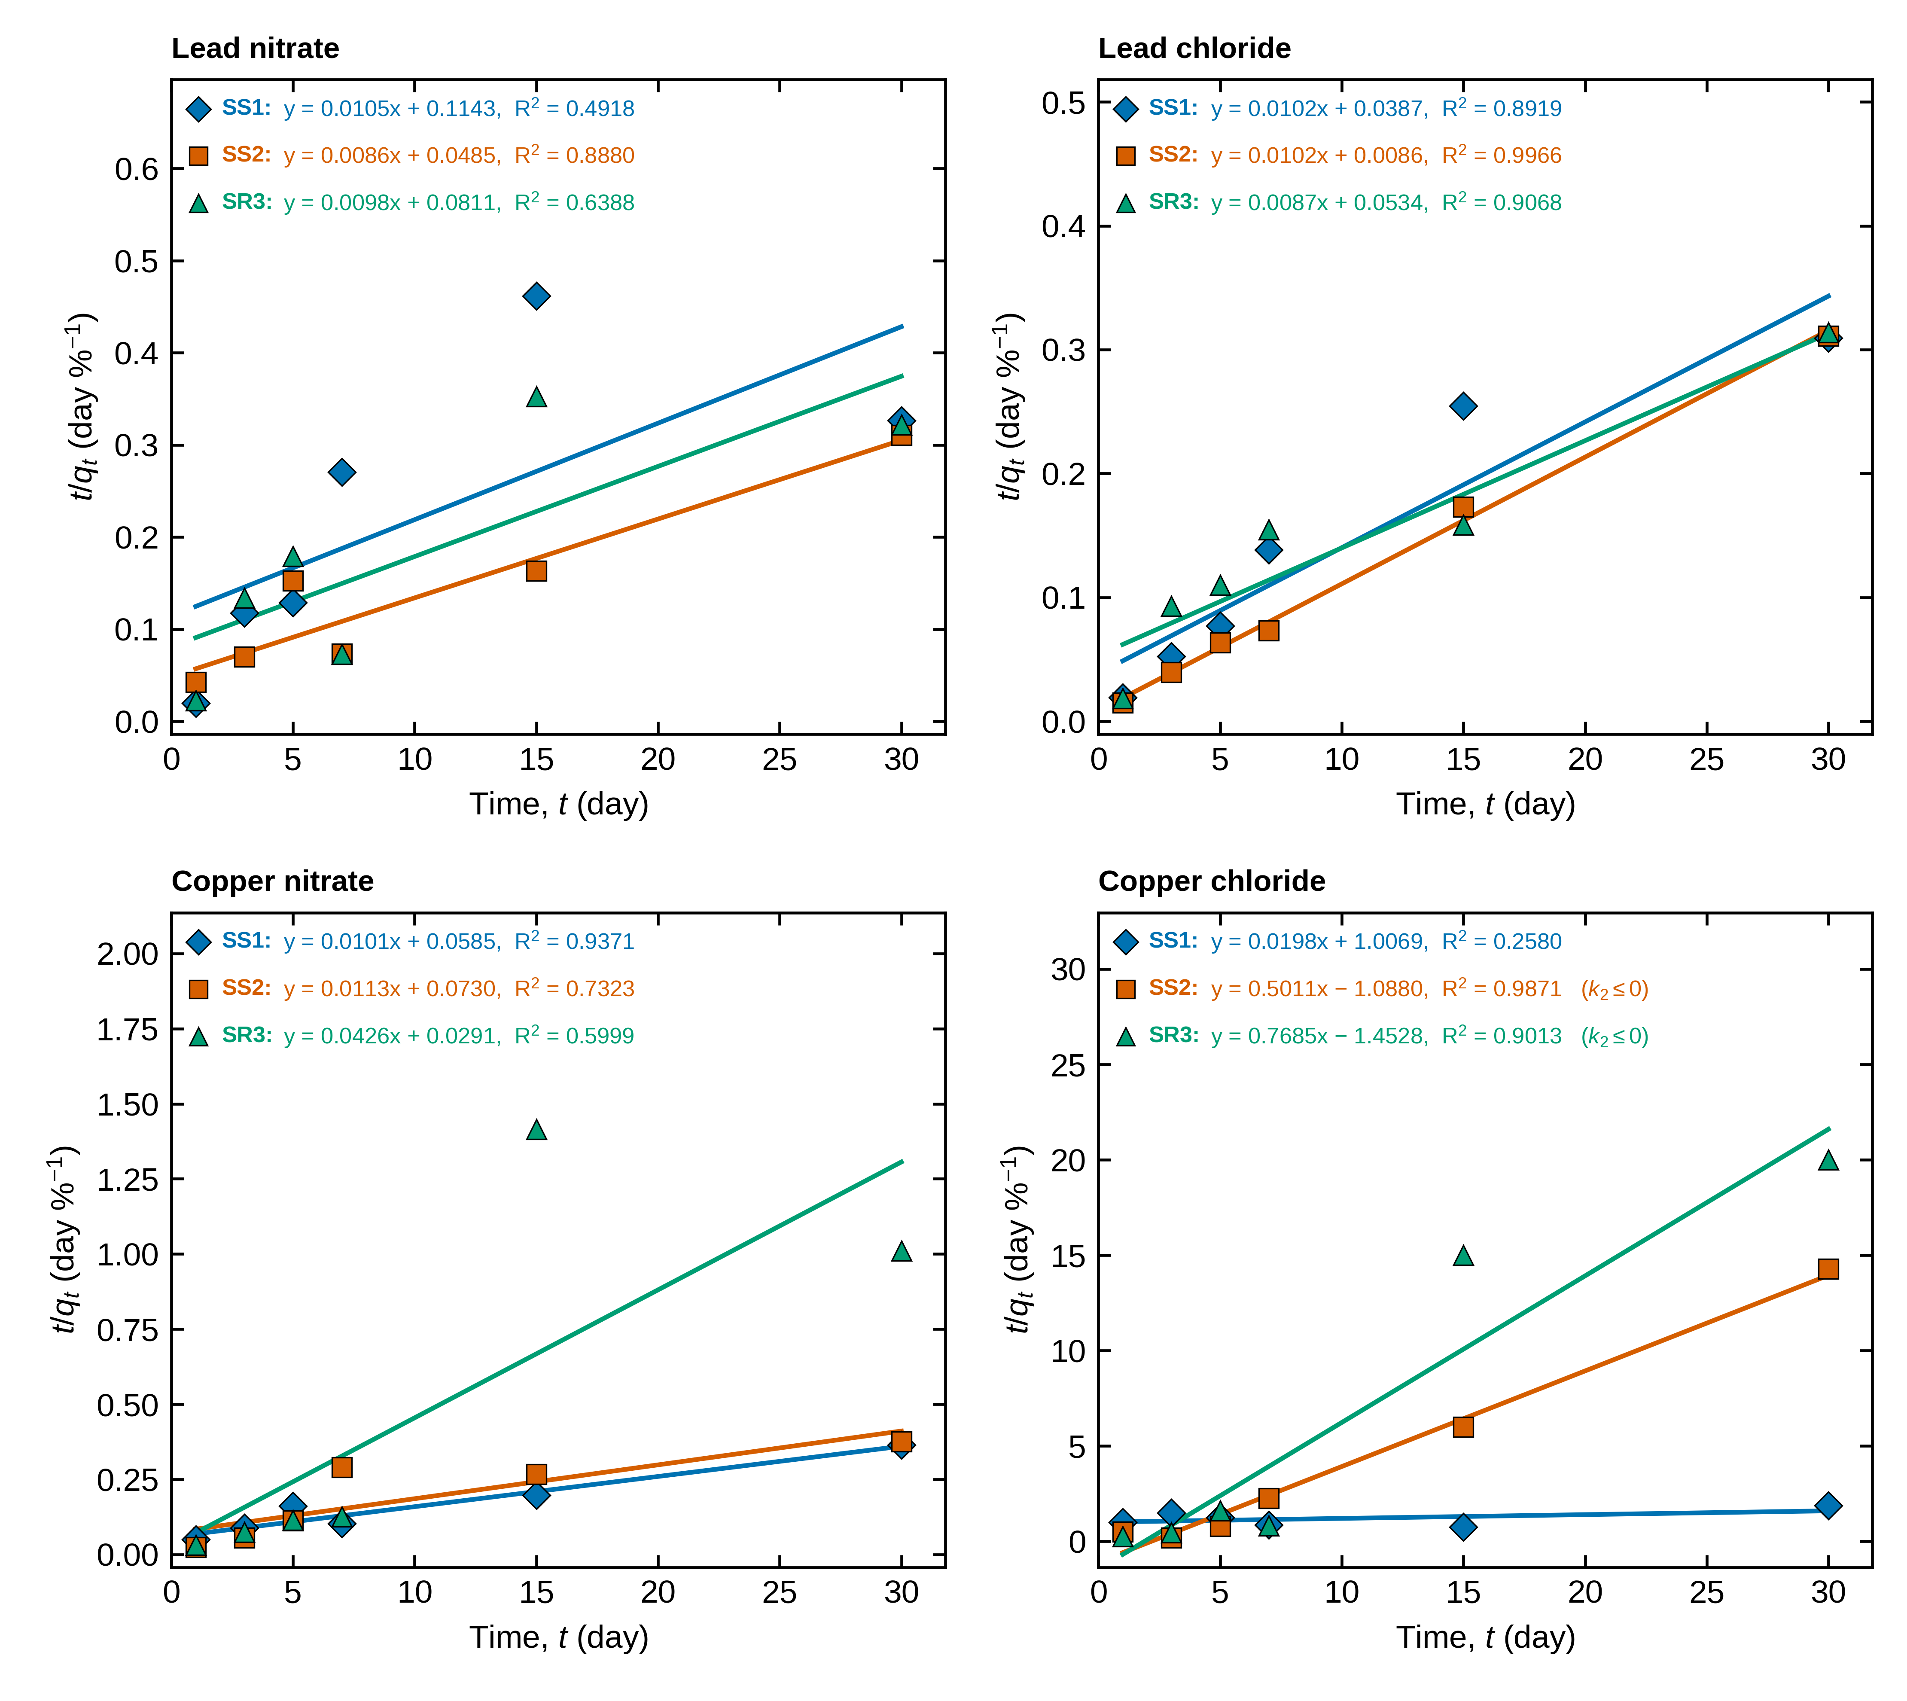
Figure S2. Linearised pseudo-second-order plots (t/q_{t} = 1/(k₂q_{e}²) + t/q_{e}) for Pb and Cu nitrate and chloride, treatments SS1, SS2 and SR3 (Data 1). Equation and R² are written on each line.
Table S3. First-order parameters, supplementary data set (Data 1; values interpreted as % remaining — to be confirmed).
Compound | Treatment | k (day⁻¹) | t_{½} (day) | R² | 95 % CI of k (day⁻¹) | c
Pyrene | SS1 | 0.1323 | 5.24 | 0.9781 | −0.1194 to 0.3841 | −1.500
 | SS2 | 0.2747 | 2.52 | 0.9777 | −0.2530 to 0.8023 | −1.798
 | SR3 | 0.4024 | 1.72 | 0.8908 | −1.3878 to 2.1925 | 0.208
Fluorene | SS1 | 0.0362 | 19.13 | 0.9998 | 0.0302 to 0.0423 | −2.036
 | SS2 | 0.2597 | 2.67 | 0.8109 | −1.3335 to 1.8529 | 0.065
 | SR3 | 0.1788 | 3.88 | 0.9423 | −0.3834 to 0.7409 | −2.156
Only three time points (days 1, 3, 5; 1 d.f.): R² and the confidence intervals are indicative only. The Data 1 PAH values decrease with time, so they are read as % remaining (C_{t}/C₀ = value/100). Fluoranthene, also in Data 1, was not analysed.
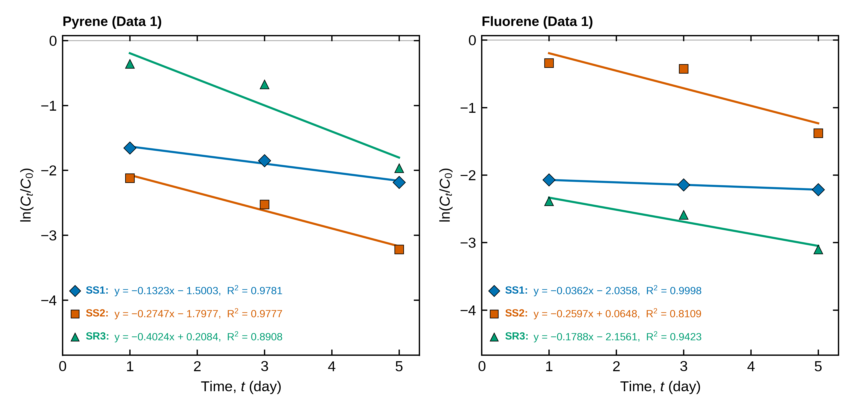
Figure S3. Linearised first-order plots for pyrene and fluorene, Data 1 (values interpreted as % remaining; three time points).

S3 Sensitivity of the first-order fit to the intercept, and measured data
Table S4. First-order rate constants with a free intercept and forced through the origin (main data set).
Compound | Treatment | k free (day⁻¹) | k origin (day⁻¹) | t_{½} free (day) | t_{½} origin (day) | R² origin
Pyrene | BS1 | 0.0254 | 0.0467 | 27.34 | 14.84 | 0.067
 | BW3 | 0.0345 | 0.0593 | 20.12 | 11.69 | 0.299
 | BR1 | 0.0232 | 0.0368 | 29.87 | 18.86 | 0.537
Fluorene | BS1 | 0.6382 | 1.2286 | 1.09 | 0.56 | −0.123
 | BW3 | 0.5516 | 0.7127 | 1.26 | 0.97 | 0.874
 | BR1 | 0.6290 | 1.0608 | 1.10 | 0.65 | 0.279
Origin: ln(C_{t}/C₀) = −kt, i.e. c = 0 (requires no day-0 sample). R² origin = 1 − SSE/SST on ln(C_{t}/C₀); it is not comparable with the free-intercept R², and is low or negative when the data do not follow first-order kinetics from t = 0.
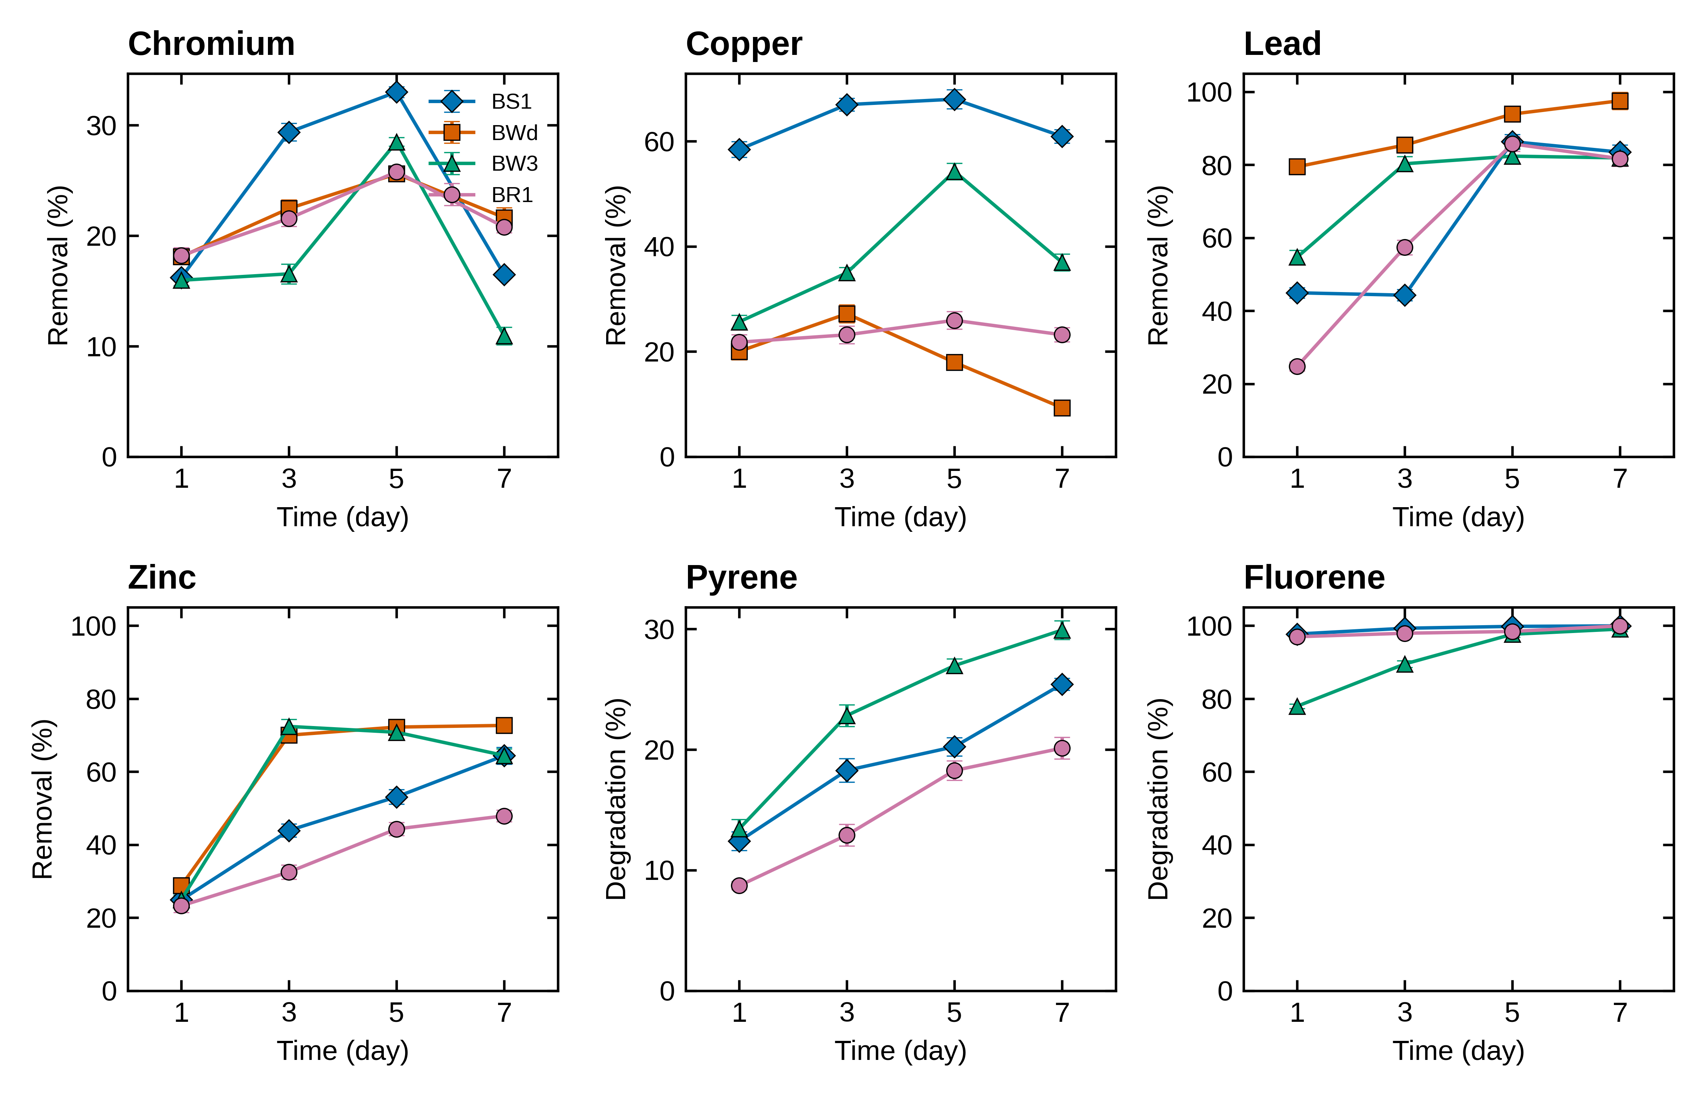
Figure S1. Measured metal removal and PAH degradation (mean ± SD) for the main data set. Cr and Cu removal peaks at day 3–5 and then falls in every treatment.

Items to resolve before submission
1. Define the treatments and the experiment. BS1, BWd, BW3, BR1 (and SS1, SS2, SR3) are not described in the files. The Methods need their definition, the matrix (water, soil, sediment), initial concentrations, temperature, pH, dose and the number of replicates behind each SD.
2. Units. Only percentages are available, so q_{e} is in % and k₂ in %⁻¹ day⁻¹; these cannot be compared numerically with the mg g⁻¹ values in the reference paper. If C₀, volume and dose exist, the fits should be repeated in mg g⁻¹.
3. Cr and Cu do not follow the model. Four of eight series give a negative k₂, and the others have R²_{NL} of about 0.5 despite a high linearised R². Claiming pseudo-second-order kinetics for these metals would be hard to defend to a reviewer. The decline after day 3–5 is real within the data and needs a mechanistic explanation or a check of the sampling.
4. Lead q_{e} above 100 %. Pb–BS1, BWd and BR1 give plateaus of 102–141 %, which are physically impossible for a removal percentage.
5. Few time points. Four points per line leave two degrees of freedom; reviewers usually expect five or six, and a day-0 sample. Linearised R² values near 0.99 from four points should not be presented as proof of a mechanism.
6. Fluorene. 78–98 % is gone by day 1, so its rate constant is not resolved. If the experiment can be repeated, add early samples (for example 0, 6, 12, 24 h).
7. Data 1 integrity. 5 pairs of SD columns in Data 1 are identical sequences in different blocks (for example 1.8, 1.6, 1.5, 1.3, 1.2, 1.5 for lead nitrate SS1 and copper chloride SS1). This may be a copy-paste; please check against the lab notebook. The Data 1 PAH values fall with time and were read as % remaining, which needs confirmation.
8. References. Refs. [2–4] were checked against the reference list of the sample article; refs. [1] and [5] are given from memory and must be verified before submission.

References
[1] Ho YS, McKay G (1999) Pseudo-second order model for sorption processes. Process Biochem 34:451–465.
[2] Ho YS, McKay G (2000) The kinetics of sorption of divalent metal ions onto sphagnum moss peat. Water Res 34:735–742.
[3] Ho YS (2003) Removal of copper ions from aqueous solution by tree fern. Water Res 37:2323–2330.
[4] Zewail TM, Yousef NS (2015) Kinetic study of heavy metal ions removal by ion exchange in batch conical air spouted bed. Alexandria Eng J 54:83–90.
[5] Tran HN, You SJ, Hosseini-Bandegharaei A, Chao HP (2017) Mistakes and inconsistencies regarding adsorption of contaminants from aqueous solutions: a critical review. Water Res 120:88–116.

