**Credentials🡪 username: admin, password: admin**

**Hosted on🡪 http://rupeshkumar-3150001-covidtracker.surge.sh/**

**Modules:**

* Dashboard Module

**Components:**

Dashboard Module:

1. ContentComponent—Has routeroutlet in it
2. DashboardComponent- To show menus, top bar, title-bar
3. Menus🡪 MenusComponent –For menus
4. Menus 🡪 MenuItemComponent—For Menu item icons
5. PanelComponent🡪 For panel items
6. StatusBarComponent-> For footer statusbar component
7. TitleBarComponent 🡪 For logo and and menus.
8. TopBarComponent --🡪 It includes the top bar component like SignIn and SignOut button
9. Users🡪SignInComponent

**Project Description:**

1. As a user, he should see 3 menu items or tabs: Dashboard, Latest news, Precautions

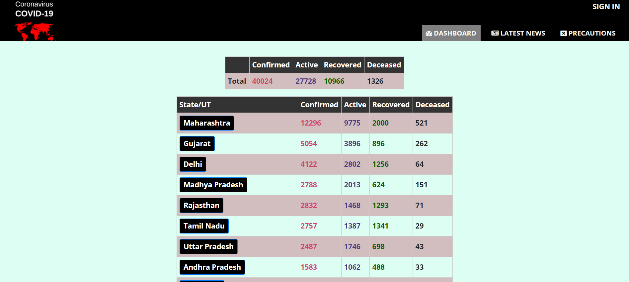

1. The **dashboard** will show the details of the states of India with the total no. of cases reported, active, recovered and deceased. A normal UI which shows these details on the main dashboard screen. Dashboard should be the default screen for any user.

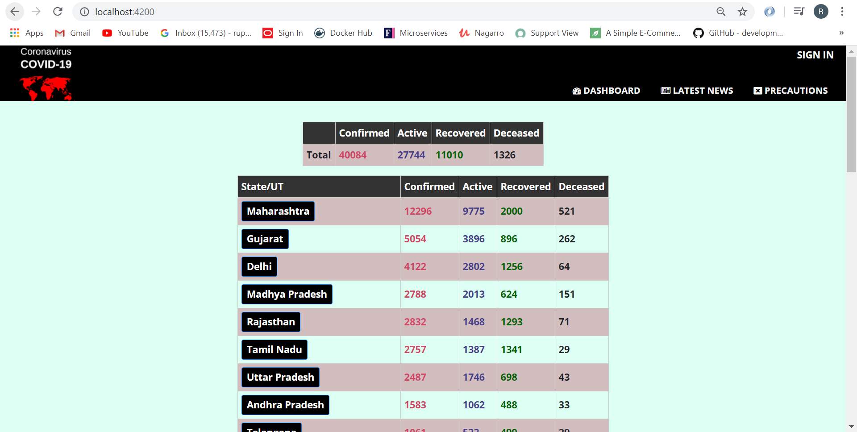

1. On clicking on any state name, the user should see all the districts information as well.

Please note that the district information is appearing at the bottom

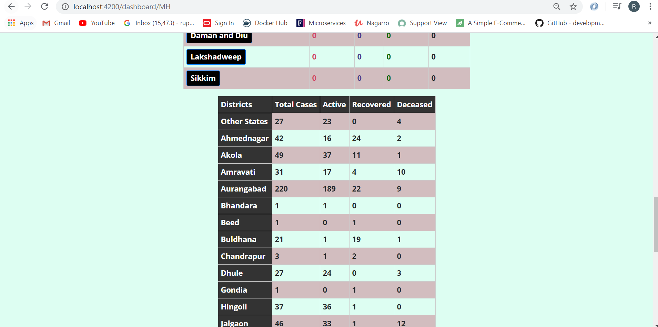

1. The **latest news** screen will have the details of the news posted by the admin.

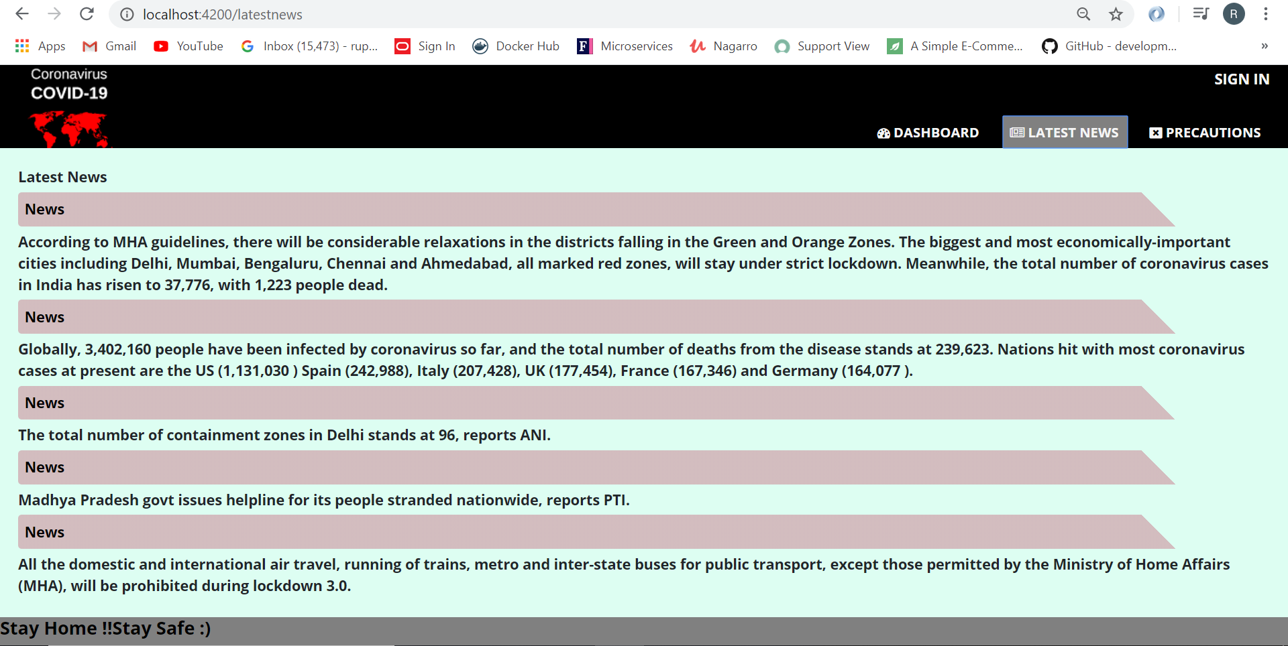

1. **Precautions** will have some general precautionary measures for the user regarding covid.

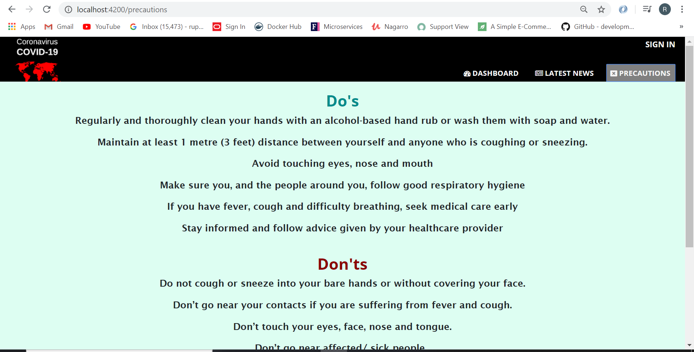

1. For an admin, we need to create an admin login screen.

On clicking on SignIn, admin will get the login screen

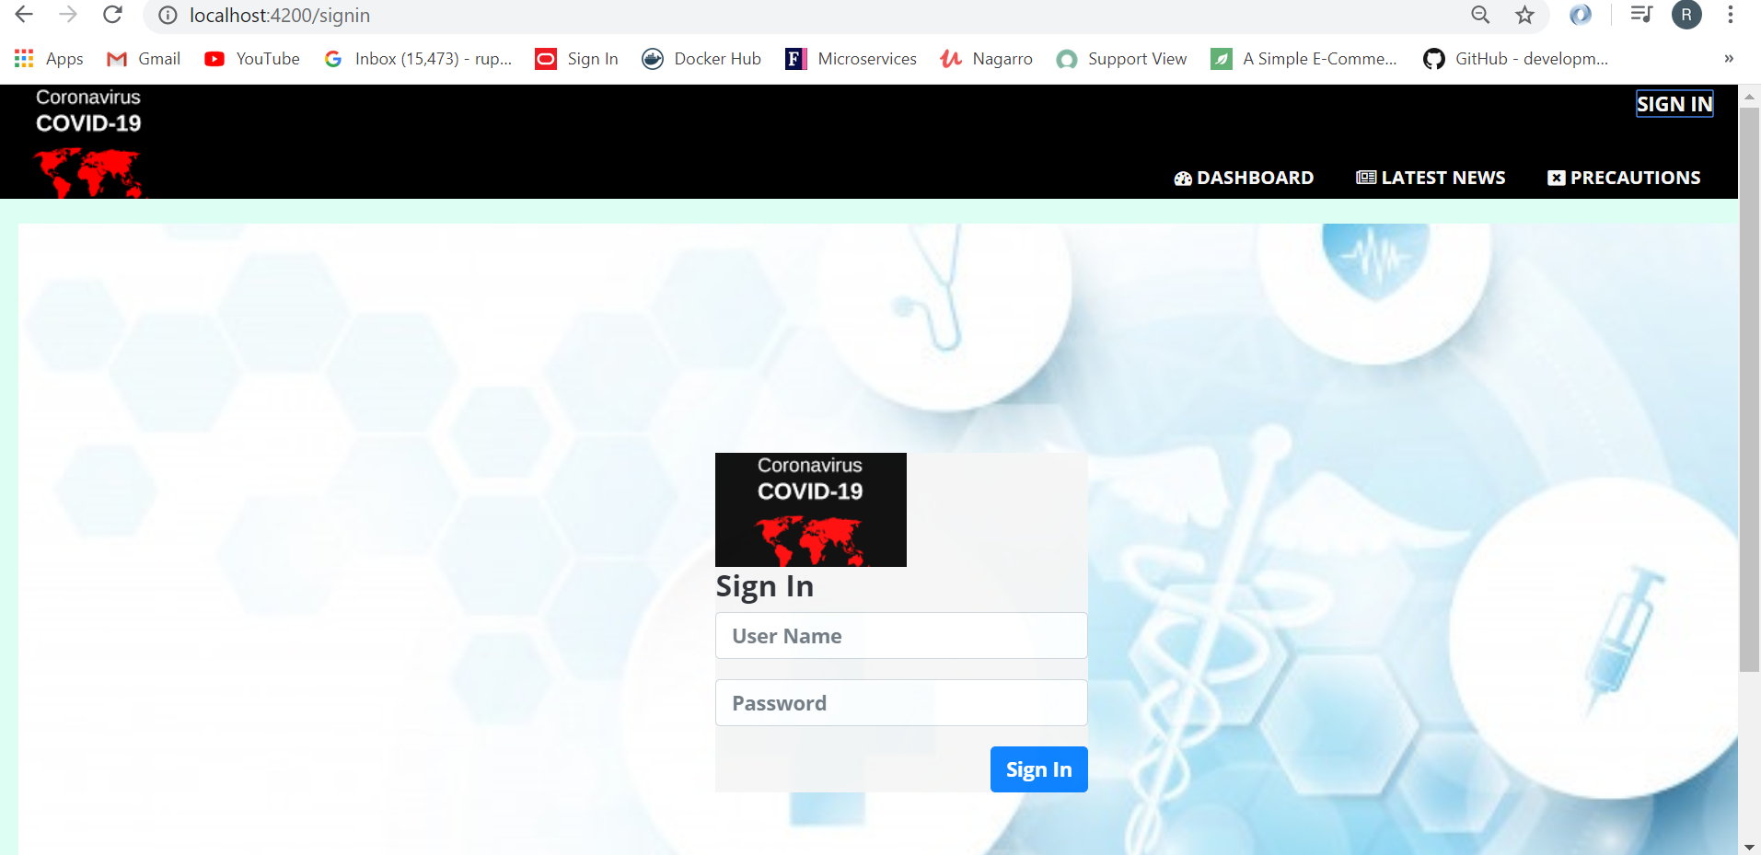

1. As an admin, I should be able to login and logout of the application.  Upon refresh, the user should not be logged out. Think in terms of session management in the browser.

As soon as the user login, it redirects to page where he can post news and signout option appears at the top;

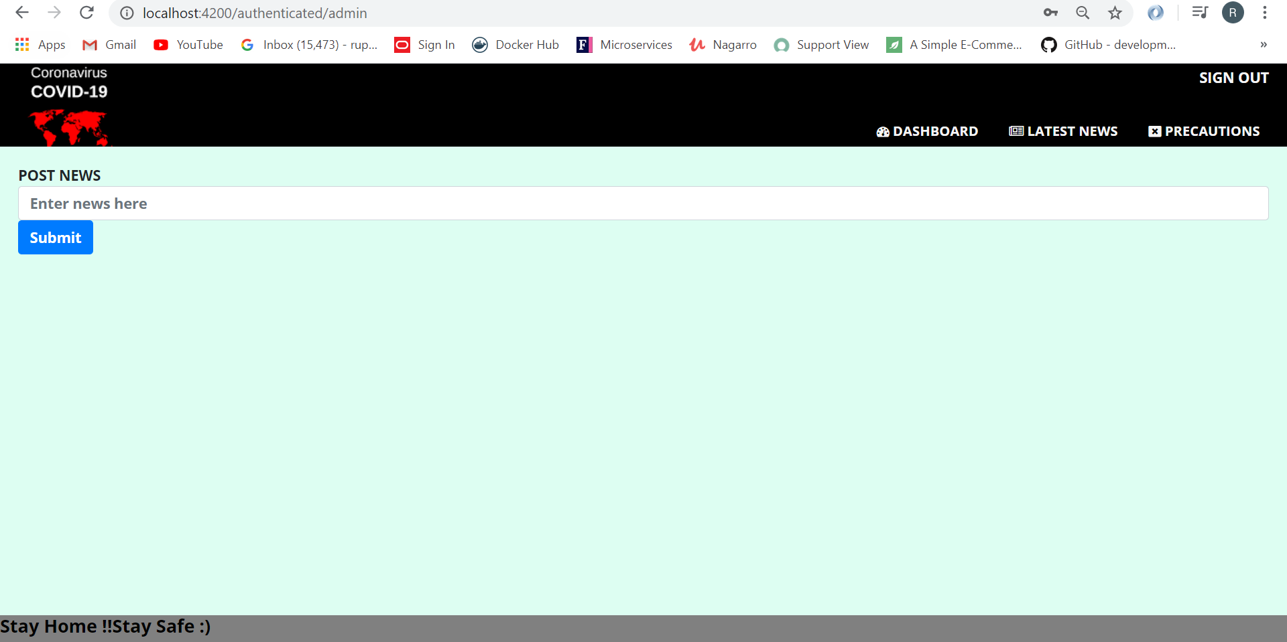

1. As an admin, he can add news to the application.

Reactive form is used for the news



1. Upon saving this news, the general user should be able to view the news.

