**FRONT END ENGINEERING-II**

Project Report

Semester-IV(Batch-2022)

**Digital And Analog Clock Using Tailwind And JavaScript**

**Supervised By: Submitted By:**

Mr. Raveesh Samkaria Rupindeep Singh

2210990750(G31)

**Department of Computer Science and Engineering**

**Chitkara University Institute of Engineering & Technology, Chitkara University, Punjab**

**Abstract**

This project report details the development of a dynamic digital analog clock website, employing HTML, Tailwind CSS, and JavaScript. The website showcases a functional digital analog clock, providing users with real-time display of time. The project emphasizes user engagement and intuitive navigation, aiming to effectively demonstrate the functionality of the digital analog clock while delivering a seamless user experience. Through responsive design and accessibility enhancements, the project underscores the commitment to providing inclusive and exceptional digital experiences.

**Table Of Content**

|  |  |  |
| --- | --- | --- |
| **Sr No.** | **Section** | **Page No.** |
| **1.** | Introduction | 4 |
| **2.** | Problem Statement | 5 |
| **3.** | Technical Details | 7 |
| **4.** | File Structure | 8 |
| **5.** | Result | 9 |
| **6.** | References | 22 |

**Introduction**

This project report chronicles the conception and execution of a digital analog clock website, tailored to resonate with the demands of today's digital landscape. In an era where online presence is pivotal for businesses to captivate their audience, crafting an aesthetically pleasing and intuitive website holds utmost significance. This narrative encapsulates the journey of developing and deploying a front-end website dedicated to showcasing the prowess of a digital analog clock, merging HTML, Tailwind CSS, and JavaScript seamlessly.

The website acts as a virtual gateway for users, offering them an immersive experience with a real-time digital analog clock display. Its purpose is to captivate visitors while providing a functional utility, embodying the essence of modern design aesthetics and technological innovation. By harmonizing strategic design principles and user-centric navigation, the website endeavors to captivate and engage users, effectively communicating the essence of the digital analog clock while projecting the agency's distinct brand identity and expertise.

This introduction sets the stage for a deeper exploration into the project's intricacies, delineating the technical nuances of website development and design philosophies adopted. Through subsequent sections, the report will dissect pivotal features, design methodologies, and implementation strategies employed during the project's lifecycle. Furthermore, it will unravel the challenges encountered along the way and the ingenious solutions devised to surmount them, offering invaluable insights for future endeavors in digital analog clock development.

In essence, this project serves as a testament to the harmonious fusion of design and technology, epitomizing the agency's unwavering commitment to delivering unparalleled digital experiences. It stands as a beacon of innovation, embodying the agency's ethos of pushing the boundaries of creativity and functionality to cater to the evolving needs of its clientele and stakeholders in the digital realm.

**Problem Statement**

In the realm of digital analog clock development, establishing a captivating online presence is paramount for attracting users and showcasing the clock's unique features and capabilities. However, crafting a front-end website that adeptly communicates the essence of the digital analog clock while ensuring intuitive navigation presents several challenges.

Primarily, developers face the task of striking a delicate equilibrium between creativity and functionality. While it's imperative to highlight the clock's innovative design through visually striking interfaces, it's equally crucial to maintain user-friendliness and provide concise information to visitors.

Moreover, designing a responsive website that seamlessly adjusts to diverse devices and screen sizes is a formidable hurdle. With the ubiquity of smartphones and tablets, users demand a consistent and optimized browsing experience across all platforms. Failing to meet this expectation could lead to a loss of users and credibility for the digital analog clock.

Additionally, ensuring accessibility for all users, including those with disabilities, is of utmost concern. Developers must adhere to accessibility guidelines to ensure that their websites are usable by individuals with varying needs, such as implementing features compatible with screen readers for visually impaired users.

In essence, the challenge at hand revolves around creating a front-end website for a digital analog clock that harmonizes creativity with functionality, offers seamless responsiveness across devices, adheres to accessibility standards, and optimizes performance to deliver an exceptional user experience. Addressing these challenges will be pivotal in accomplishing the project's objectives and ensuring the success of the digital analog clock's online presence.

**Technical Details**

The front-end website for the Analog And Digital Clock was constructed with a minimalist approach, employing only essential technologies to ensure a streamlined user experience. Here are the primary technical details of the project:

* **HTML Structure:** The website's structure was crafted using semantic HTML mark up to enhance accessibility and clarity. Each page was organized with appropriate tags to facilitate straightforward navigation and readability.
* **CSS Styling:** Cascading Style Sheets (CSS) were utilized for styling the website's layout, typography, and color schemes. Custom CSS rules were applied to maintain a consistent visual design across the site while optimizing load times and code simplicity.
* **Responsive Design:** Responsive design principles were implemented to ensure the website's compatibility with various devices and screen sizes. Media queries and flexible layouts were employed to adapt the content and design elements responsively without reliance on frameworks.
* **JavaScript:** JavaScript served as the backbone for the digital analog clock's dynamic functionality. Through JavaScript, real-time clock updates were achieved, providing users with accurate time display. Additionally, JavaScript facilitated interactive features, enhancing user engagement and interactivity on the website. Careful optimization of JavaScript code ensured smooth performance and compatibility across different browsers and devices, elevating the overall user experience.

**File Structure**

* **index.html:** This file serves as the main entry point for the website. It contains the HTML mark-up defining the structure and content of the web pages. Within this file, sections such as the header, navigation bar, main content area, footer, and any additional elements are defined.
* **Style.css:** The CSS file contains the styling rules that dictate the visual presentation of the website. This includes defining colours, fonts, layout properties, and any other stylistic elements. Selectors within this file target specific HTML elements or classes to apply the desired styles.
* **Script.js:** **The script.js file serves as the backbone of the digital analog clock's dynamic functionality, orchestrating its behavior and interactions. Within this file, JavaScript functions are meticulously crafted to enable real-time updates and interactive features essential for the clock's operation. These functions are finely tuned to ensure accurate time display and seamless user interaction.**
* **image folder:** This folder contains all the images used throughout the website. Images may include logos, background images, or any other visual assets required to enhance the design and content presentation. Proper organization within this folder helps maintain the clarity and accessibility of image resources.

**Code:**

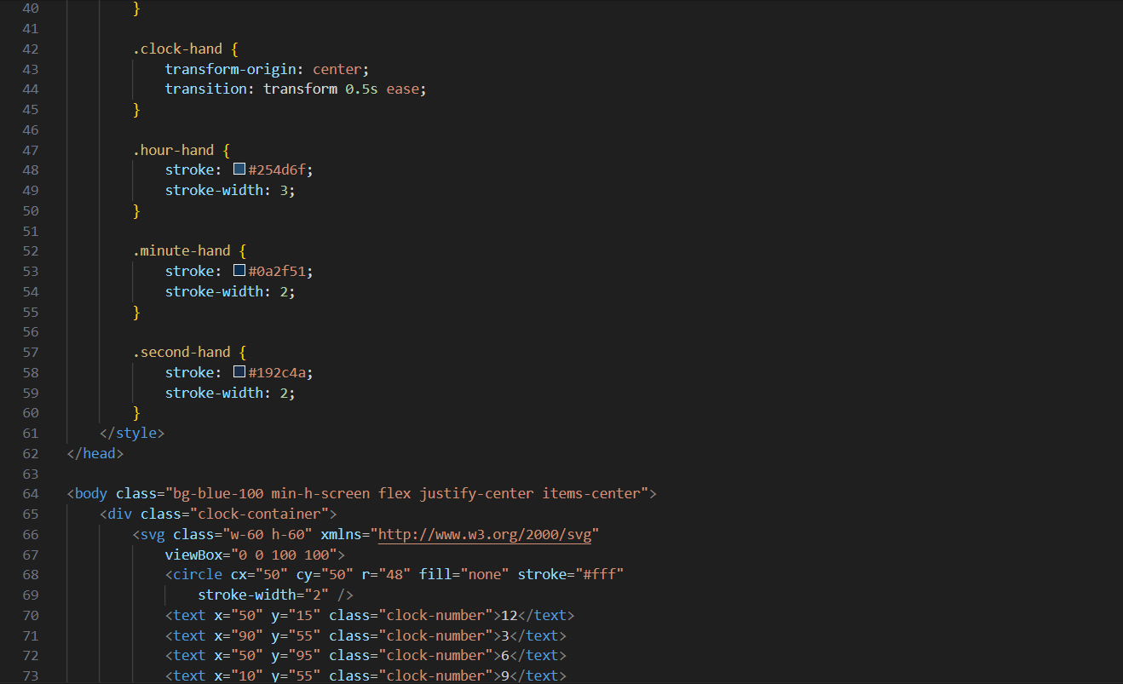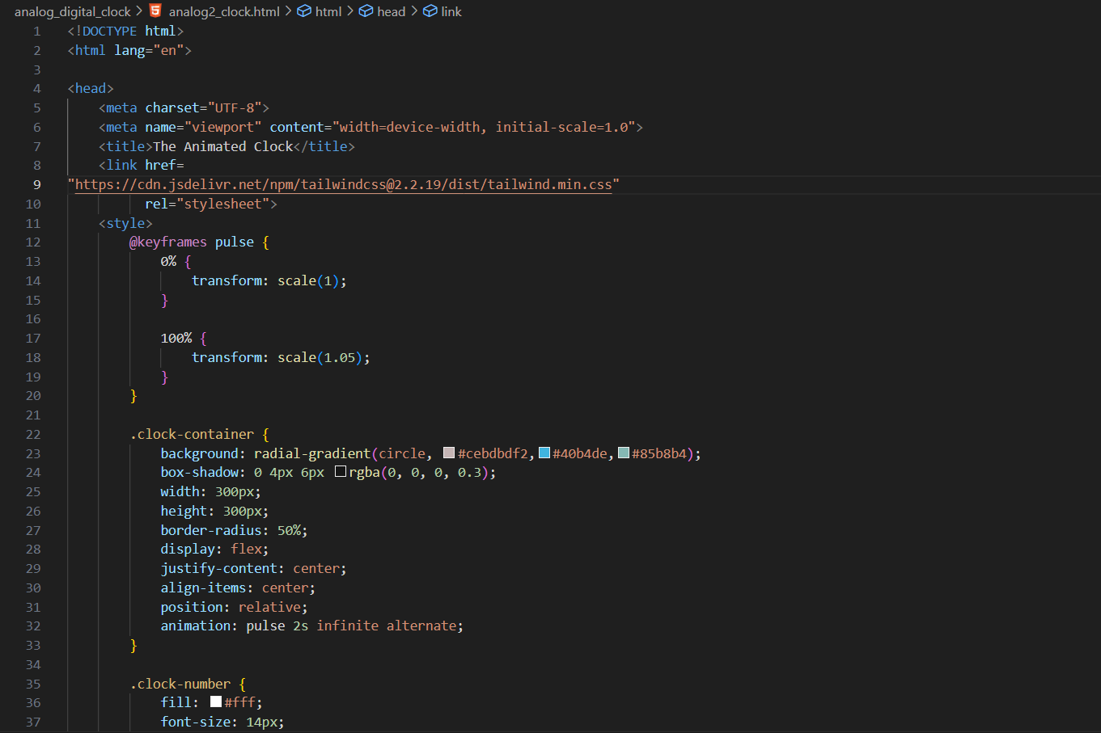

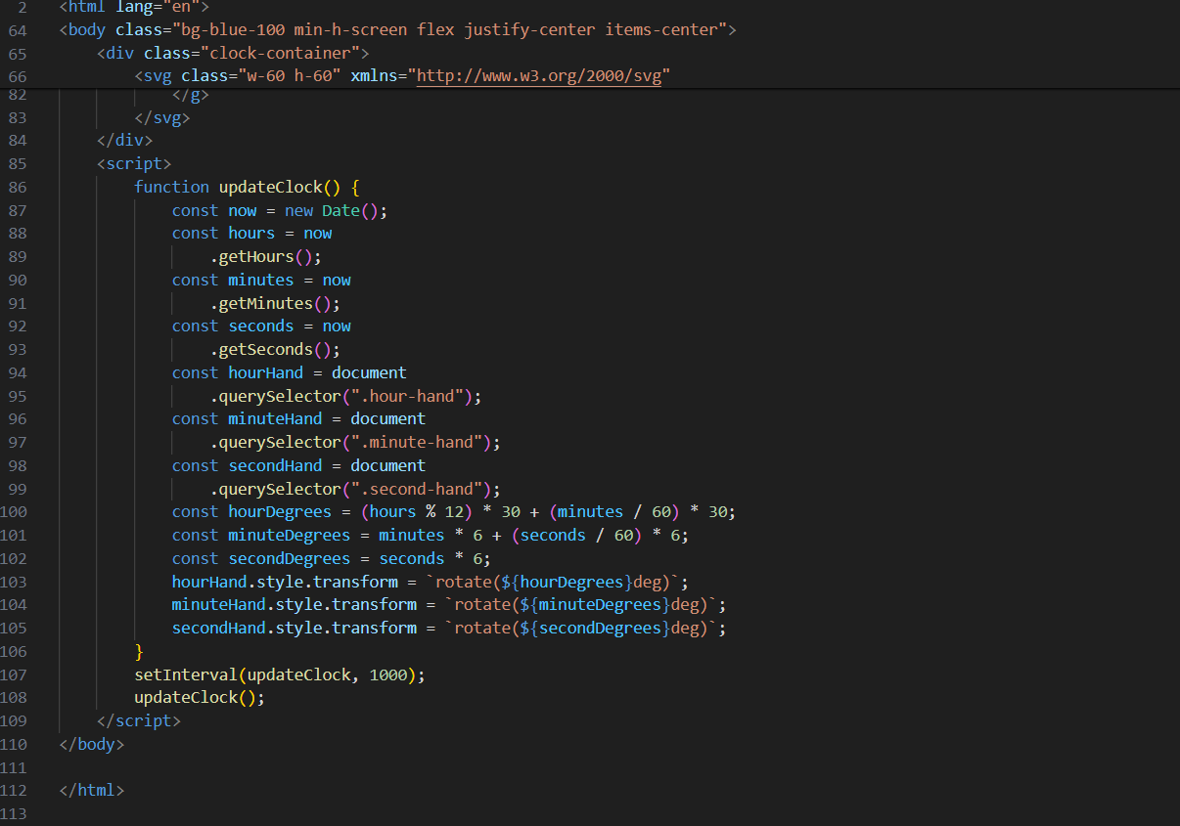

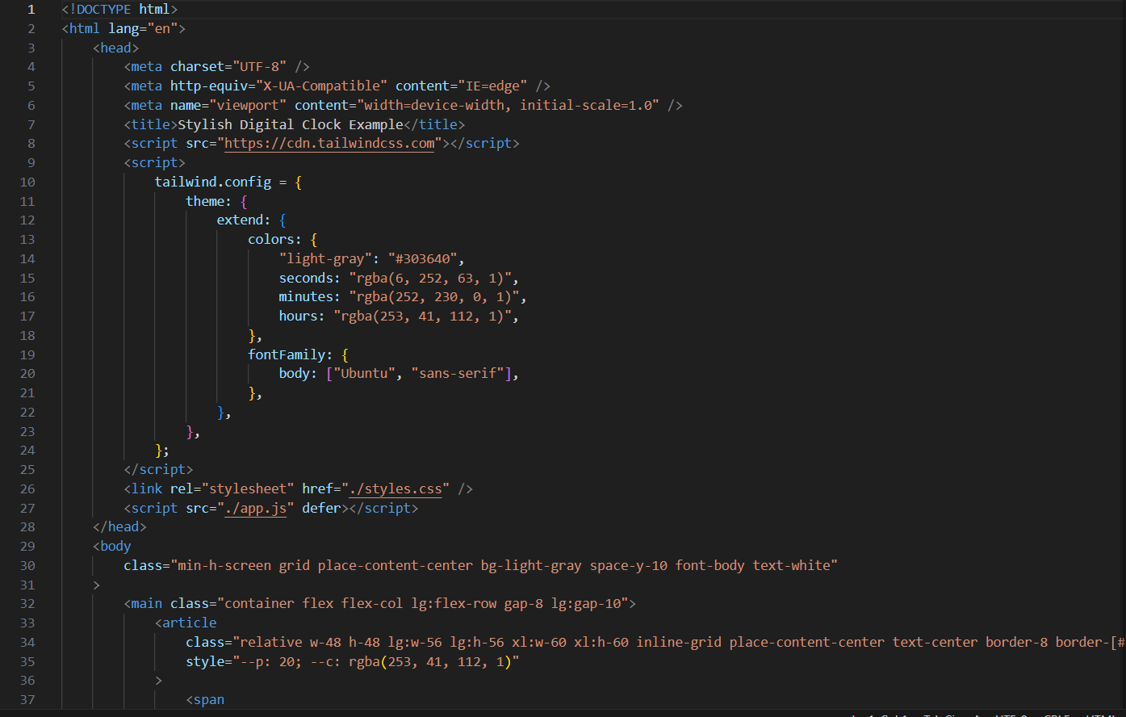

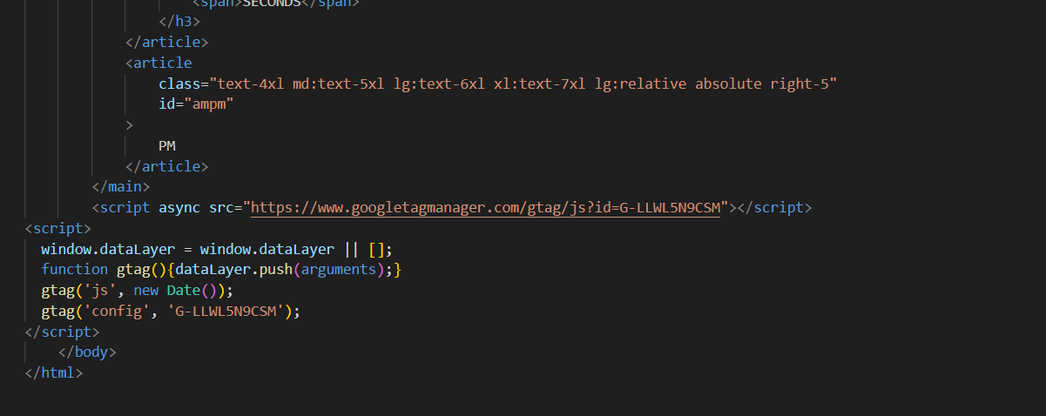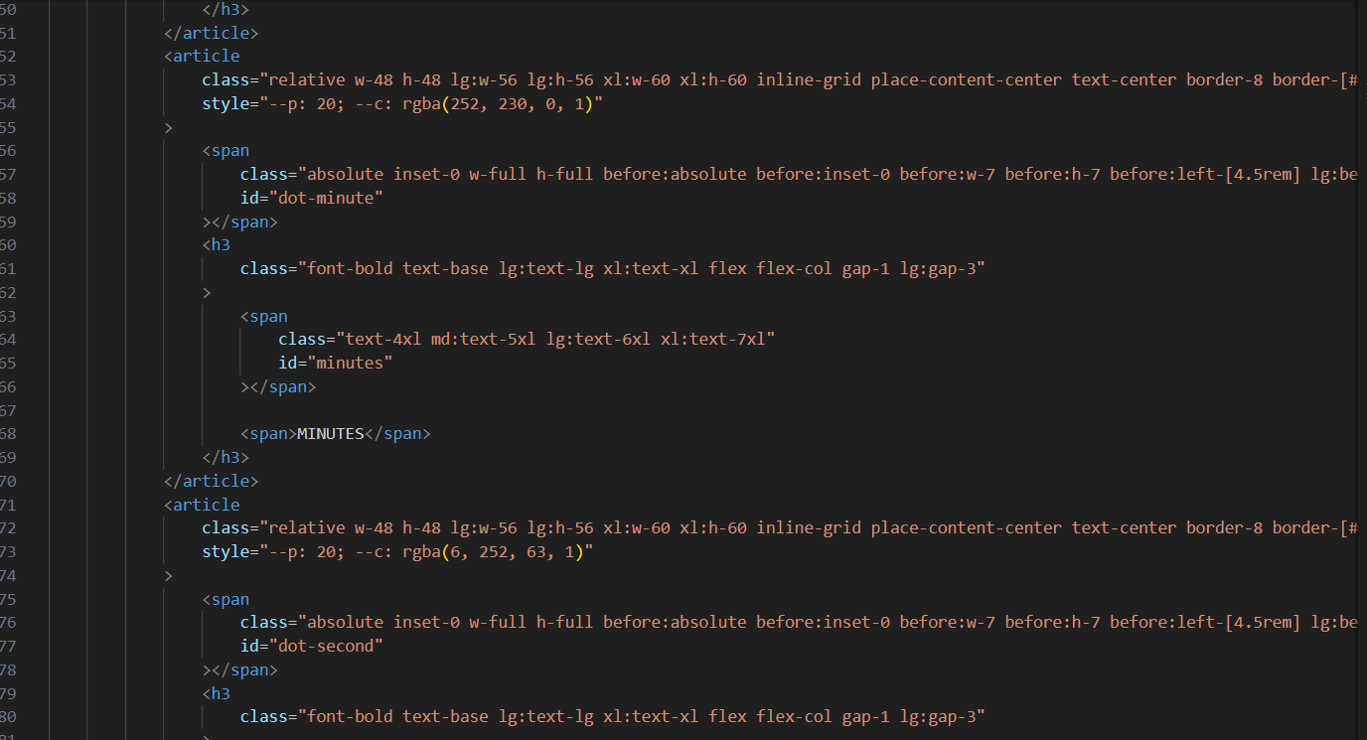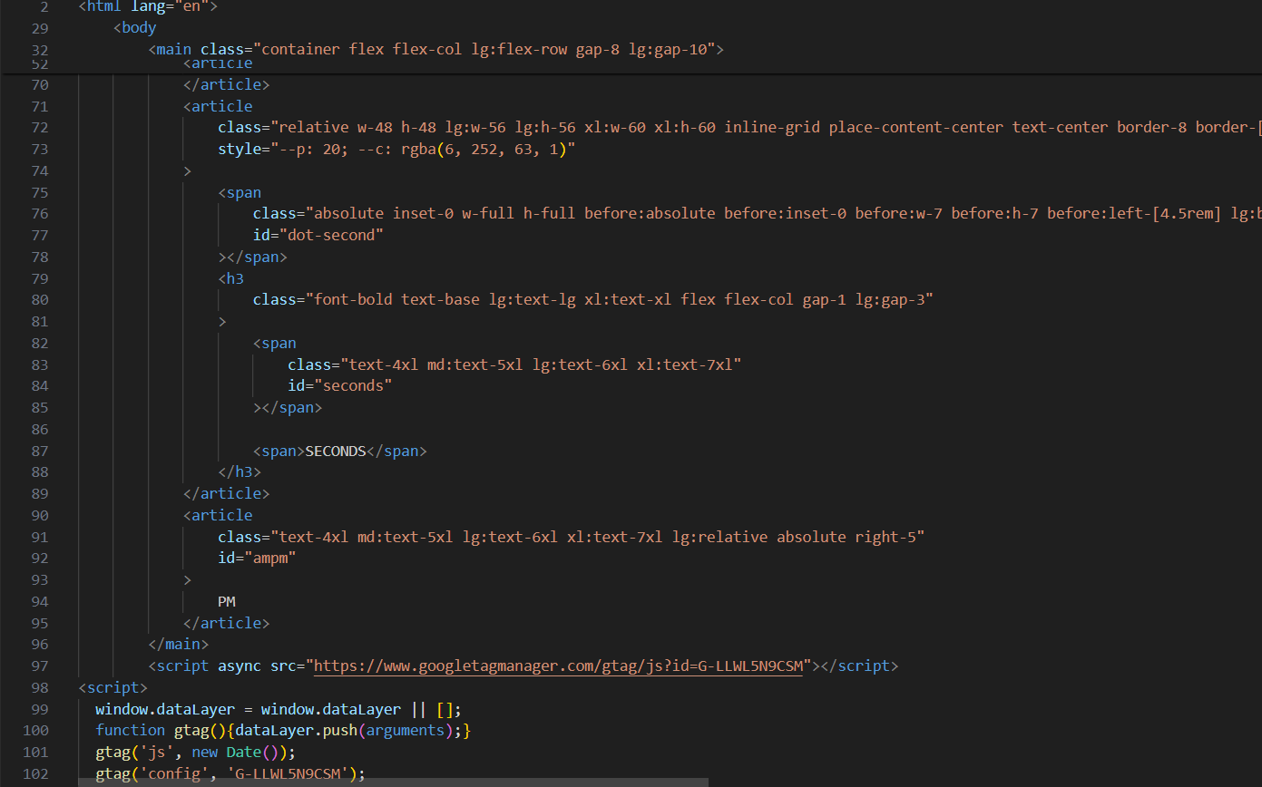

**REFERENCES**

1. https://tailwindcss.com
2. [www.w3schools.com](http://www.w3schools.com)
3. https://fonts.google.com